**Course Learning Journal**

**COM 968-32: Statistics for Social Research 4**

**(Spring 2025, Sub-term A)**

**Dr. Peter Abraham Airewele, (PhD-Core 5)**

**Omega Graduate School**

**Professor**

**Dr. Sean Taladay, EdD**

**March 2nd, 2025**

**Assignment # 4. Course Learning Journal**

The journal is a written reflection of your learning journey while working on each course. The Learning Journal integrates the essential elements of the course within your professional field of interest. The objective of the course journal is to produce a degree of acculturation, integrating new ideas into your existing knowledge of each course. This is also an opportunity to communicate with your professor insights gained as a result of the course. The course learning journal should be 3-5 pages in length and should include the following sections: 1. Introduction –Summarize the intent of the course, how it fits into the graduate program as a whole, and the relevance of its position in the curricular sequence.

2. Personal Growth - Describe your personal growth–how the course stretched or challenged you– and your progress in mastery of course content and skills during the week and through subsequent readings – what new insights or skills you gained.

3. Reflective Entry - Add a reflective entry that describes the contextualization (or adaptation and relevant application) of new learning in your professional field. What questions or concerns have surfaced about your profes sional field as a result of your study?

4. Conclusion – Evaluate the effectiveness of the course in meeting your professional, religious, and educational goals.Top of Form

**1) Introduction –**Summarize the intent of the course, how it fits into the graduate program, and the relevance of its position in the curricular sequence.

**Introduction**

The Course Learning Journal, (CLJ) presents a summary archive or dossier of what the doctoral student has learned, observed, and researched during virtual or independent classes, through group interactions, and project simulations (Auger & Normand, 2024; Kelter, 2024), and personal research studies. The Statistics for Social Research 1 to 4, (SSR 4) consists of four levels of Assignment research studies namely: Assignment #1: Class and Student Discussion; Assignment #2: Developmental Reading Log; Assignment #3: Instructor Assignment; and Assignment #4: Core Learning Journal (CLJ). The CLJ reveals that the Statistics for Social Research studies are modeled along a practical model of logical, and mathematically deductive (Duan et al., 2024; Eka et al., 2024), or survey-driven results and outcomes.

In the SSR, statistical principles and practice are quite relevant in the modern academic and professional landscape. This makes statistics study fit squarely into the student’s learning goals and objectives, (Tao, et al., 2022) and the practical skills expectations. The seminar methodology includes instructions on the use of the PSSR (Reichard, 2024), the PSPP™ statistical software package, Microsoft Excel (Reichard ~~& Taladay,~~ 2024), and other statistical software and tools.

Statistics for Social Research, SSR is a strategic instructional learning program designed within the doctoral curriculum. It ensures the doctoral student has the advanced statistical skills and tools necessary to conduct rigorous social research. It empowers students to analyze data effectively, draw meaningful conclusions, and contribute to the broader social science and the society or community by exploring complex statistical concepts and their practical applications. The student can reproduce his understanding of fundamental statistical concepts and integrate them to demonstrate the ability to apply them to real-world situations and research problems.

The SSR is deeply rooted in various statistical techniques (Hadfield, et al., 2022), including t-tests, parametric and non-parametric tests, and data visualization methods such as histograms and box-whisker plots. Others include the Split groups of dependent variable data based on independent variables, the significant difference, and correlational procedures using statistical software. Furthermore, there are the post-hoc and the Interpreting of results of statistical procedures. There is a broad range of statistical activities, the conducting of significant differences and correlational procedures, and the use of statistical software like the PSPP™ and the PSSR statistical software (EZ SPSS Tutorial, 2024; Reichard, 2025) to analyze and interpret the results of statistical procedures.

**2. Personal Growth** - Describe your personal growth–how the course stretched or challenged you– and your progress in mastery of course content and skills during the week and through subsequent readings – what new insights or skills you gained.

The Statistics for Social Research study is a transformative experience (Fullan, 2014; Jones, 2023), and it has significantly expanded the doctoral student's knowledge and challenged one's critical thinking. The mathematical concepts, particularly complex equations (Fithian, 2023), initially presented a sharp learning curve. However, one has made substantial progress in mastering statistical precepts (Kouzes & Posner, 2023), to overcome these challenges through consistent practice, guided instruction, and collaborative discussions.

One of the most touching aspects of the course was the hands-on experience with statistical software like SPSS. By conducting various statistical tests such as linear regression, Mann-Whitney U,

and Chi-squared analysis (Okoye & Hosseini, 2024), one has gained a deep understanding of the

Underlying principles and practical applications. The ability to analyze real-world datasets and interpret the results has significantly enhanced the student's problem-solving skills. Furthermore, the course has broadened his perspective on statistical research.

By exploring and mastering diverse research methodologies and statistical techniques, which are challenging, the student has developed a strong foundation in parametric and non-parametric methods. The in-depth study of t-tests, z-tests, and simple linear regression has also given him the tools to analyze complex data and draw meaningful conclusions. Perhaps most importantly, this course has fostered a sense of intellectual curiosity and a lifelong passion for learning. The opportunity to engage with challenging material and collaborate with peers (Shatz, 2024), has been genuinely inspiring. It is exciting to apply the knowledge and skills gained from this course to future academic and professional endeavors.

**3. Reflective Entry**- Add a reflective entry that describes the contextualization (or adaptation and relevant application) of new learning in your professional field. What questions or concerns have surfaced about your professional field because of your study?

Intriguing is how statistics cut across several social science and science disciplines. For example, Figure 3.1, on page 6**,** shows that thethe mean deviation is very popular and has practical usefulness in economics, commerce, and actuarial sciences. Standard Deviation is the positive square root of the arithmetic mean of the squares of the deviations of a given observation of their arithmetic mean. Standard deviation is practically more useful in statistical analysis than mean deviation (Bhardwaj & Sharma, 2013).

**Some Interesting statistical illustrations and visualizations:**

Statistical software like the PSSR, SPSS (IBM) R, SAS, DataTab, Stata, and Minitab (Litt, 2024; Kelter, 2024), each show different data analytical capabilities and can easily generate smart results and solutions from complex statistical data. They are time and cost-effective.

**Method of least squares**

The regression line is obtained using the method of least squares. Any line y = a + bx that we draw through the points gives a predicted or fitted value of y for each value of x in the data set. For a particular value of x the vertical difference between the observed and fitted value of y is known as the deviation, or residual (Fig. 3.1). The method of least squares finds the values of a and b that minimize the sum of the squares of all the deviations. This gives the following formulae for calculating a and b:

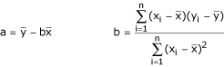

**Regression Lines & Standard Deviation** (Graphical Illustrations) **Figure 3.1.**

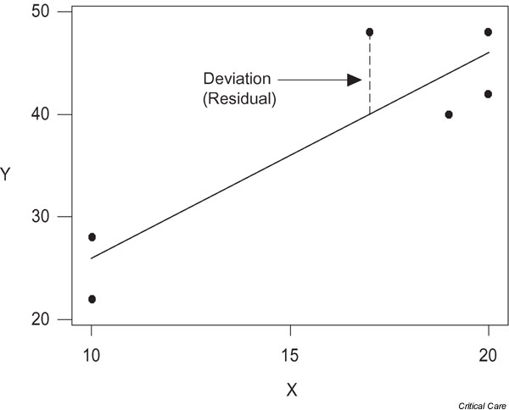

**Analysis of variance**

The method of least squares minimizes the sum of squares of the deviations of the points about the regression line. Consider the small data set illustrated in Fig. 3.2. This figure shows that, for a particular value of x, the distance of y from the mean of y (the total deviation) is the sum of the distance of the fitted y value from the mean (the deviation explained by the regression) and the distance from y to the line (the deviation not explained by the regression) (Bewick et al., 2003):

**Analysis of Variance Figure 3.2**

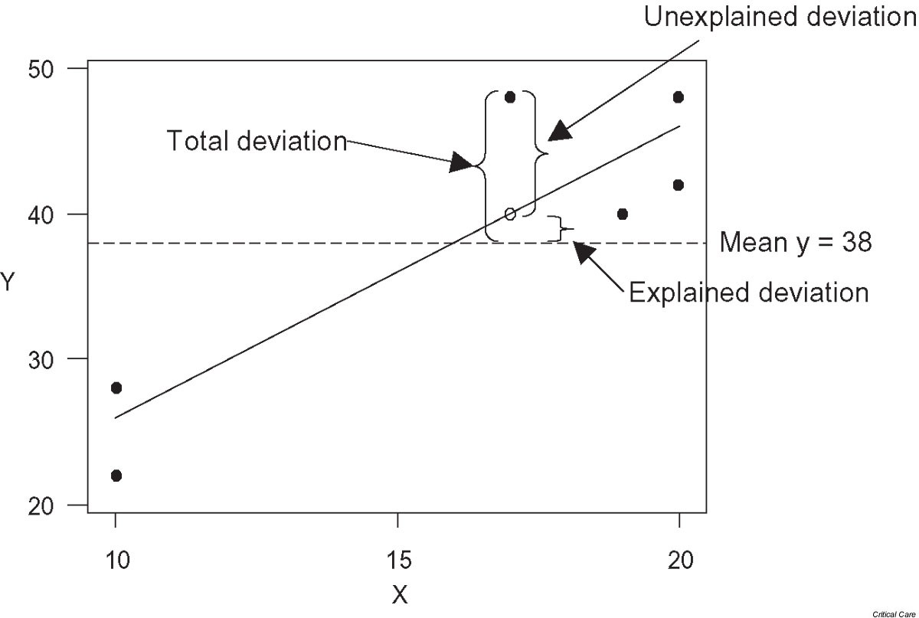

**Point of Note:**

**The Graphs in Figures 3.1 and 3.2 are** culled from Critical Care / (Bewick et al., 2003)

They are for illustration and visualization purposes only.

**In Figure 3.1**, the regression line was obtained by minimizing the sums of squares of all of the deviations.

Usually, these values would be calculated using a statistical package or the statistical functions on a calculator (Bewick et al., 2003).

**The purpose of Figures 3.1 and 3.2** is to illustrate or demonstrate the effectiveness of generating statistical data, equations, and diagrams by digital statistical software compared to traditional manual statistics. Software are time, program and cost effective.

**Reflective entry contd:**

Some reflective entry experiences are gathered from the combination of asymmetric and symmetric formats of virtual lectures from OGS professors. Modern statistics is more study and practice-based. The participatory learning style and the group interactions with the professors and fellow students also present some creative, innovative impact on the students. In addition,

any topics discussed or given as assignments are adequately analyzed either individually, or as a group and given critical assessment and evaluation individually during assignment-study research.

The digital landscape, the intersection of marketing and statistics has become more significant than ever, 60% of marketers believe that data-driven marketing is crucial to the success of their strategies. This precision leads to higher engagement rates and improved ROI. Data provides valuable insights into customer preferences and trends, enabling marketers to adapt their strategies quickly and effectively (Chakraborty, 2024). Modern organizations incorporate digital statistical applications in their operational services. This is through designated software programs. Many academia and modern organizations train on statistical software to facilitate their services and operations.

Some of the concerns are the use of traditional statistics on manual statistical Excel or spreadsheets which are time and resource-consuming. Digital statistical software and tools are seen as ideal to accelerate complex statistical data computations. However, additional training on statistical software will be required to engage and facilitate more complex research studies, either applicable as computerized software or standalone tools or calculator gadgets now and in the future.

**4) Conclusion**—Evaluate the course's effectiveness in meeting your professional, religious, and educational goals.

While the validity of any statistical analysis is much sought after, acknowledging the

fundamental changeability in practical data is crucial. The statistical analysis and computations of measures of central tendency (mean, mode, and median) and dispersion (range, variance, and standard deviation), Linear regression, ANOVA, t-test, etc can be facilitated or accelerated by digital software and digital calculators. They are also cost, program, and time effective.

The knowledge and skills gained from this course will undoubtedly be beneficial in one's

future educational endeavors. It is pertinent to utilize these statistical techniques in real-world problems, such as climate change and socio-economic issues, and to contribute to the data-driven decision-making process in both the Christian and the secular world. By staying updated on statistical methods and software advancements, the doctoral student will be more active at the forefront of data analysis and interpretation. The Statistics for Social Research course has ignited a passion for data-driven inquiry.

One of the most significant takeaways from this course is the importance of data quality validation and the limitations of statistical models. Exploring statistical software like PSSR, SPSS (IBM) R, SAS, DataTab, Stata, and Minitab, the PSPP™ statistical software package and Microsoft Excel has broadened the student's skill sets, enabling him to conduct complex statistical analysis, (Fernandez, 2014; Ashton, 2013) and to visualize, simulate, and test data computational validity effectively.

Studies show that modern religious institutions of learning embrace statistical computations by software. They are fashioned along medium or corporate ventures, especially in the nonprofit sectors. Well-established nonprofit Christian organizations routinely utilize statistical data surveys (Branson & Martinezto, 2023) to inform the demographics regarding donors, sponsorship, Church attendance, and sermon preferences. These measures are seen as constructive steps in the right direction. Especially when such religious organizations are poised to develop their membership (on the line) or to assess the congregation's reactionary responses to religious and political situations surrounding them. Perhaps, to ensure the prevailing pastoral messages on the pulpit and social media are well understood and create the right vibes and impact. ~~Moreover,~~ the analyzed data are used to determine how the members' social behavioral patterns and economic standing or issues are also influencing their decision-making preferences, and choices in their religious contributions and general welfare without violating their privacy.

**Works Cited**

Ashton, J. C. (2013). Experimental power comes from influential theories, which is the real

problem in null hypothesis testing. *Nature Reviews Neuroscience*, *14*(8), 585–585.

Auger, V., & Normand, A. (2024). Data simulations for advancing psychological research:

Insights, preparations, and investigations. *International Journal of Psychology*.

Bewick, V., Cheek, L., & Ball, J. (2003). Statistics review 7: Correlation and regression. *Critical*

*Care.*

Bhardwaj, A. N. K. U. R., & Sharma, K. (2013). Comparative study of various measures of

Dispersion. *Journal of Advances in Mathematics*, *1*(1).

Branson, M. L., & Martinez, J. F. (2023). *Churches, cultures, and Leadership: A practical*

*Theology of congregations and ethnicities*. InterVarsity Press. Hade, W. (2023).

Contextualization or Syncretism? The Use of Other-Faith Worship Forms in the Bible

and Insider Movements, written by Derek Brotherson. *Mission Studies*, *40*(1), 177–178.

Chakraborty, P. (2024). Win Savvy. The Intersection of Marketing and Statistics: Trends for

2024. https://www.winsavvy.com/about-winsavvy/.

Duan, R., Liang, C. J., Shaw, P. A., Tang, C. Y., & Chen, Y. (2024). Testing the missing at

Random assumption in generalized linear models in the presence of instrumental variables. *Scandinavian Journal of Statistics*, *51*(1), 334-354.

Eka, A. P. B., Bakri, A. A., & Yuliyani, L. (2024). Utilizing linear regression to forecast the

Stock price fluctuations of top-rated companies. *Jurnal Info Sains: Informatika dan Sains*, *14*(01), 551 559. https:ejournal.sea institute. Or.id/index/Info Sains/article

/view/4041/3235.

EZ SPSS Tutorials (2024).- Simple Linear Regression in SPSS, Including Interpretation. Built

With Generated Press.

Fernandez, K. (2014, September 26). What is sampling error [Video]? YouTube.

https://www.youtube.com/watch?v=uGuWrPFStdg [Seminal] [Time = 2:49]

Hatcher, L. (2013). *Advanced statistics in research: Reading, understanding, and Writing up*

*data analysis results.*

Fithian, W. (2023). Statistics 210A: Theoretical Statistics (Fall 2023) Department of Statistics

Evans Hall University of California, Berkeley, CA 94720. Statistics 210A: Theoretical Statistics (Fall 2023) (berkeley.edu).

Fullan, M. (2023). Principal 2.0: Three Keys to Maximizing Impact. John Wiley & Sons.

Hadfield, C., Tyson, N., & Goodall, J. (2022). Master Class. Random Sampling Explained: What

Is Random Sampling?

Jones, L. G. (2023). Matters of Faith and Trust: The Role of Institutions in Creating

Communities that Flourish. *North Carolina Medical Journal*, *84*(3).

Kelter, R. (2024). The Bayesian simulation study (BASIS) framework for simulation studies in

statistical and methodological research. *Biometrical Journal*, *66*(1), 2200095.

Kelter, R. (2024). The Bayesian simulation study (BASIS) framework for simulation studies in

statistical and methodological research. *Biometrical Journal*, *66*(1), 2200095.

Kouzes, J. M., & Posner, B. Z. (2023). The leadership challenge: How to make extraordinary

Things happen in organizations. John Wiley & Sons.Low, J. J., & Ayoko, O. B. (2020). The

Litt, S. (2024). Shortlist of the 10 Best Statistical Analysis Software Options—the CFO Club.

Financial Planning & Analysis.

Okoye, K., & Hosseini, S. (2024). Chi-Squared (X2) Statistical Test in R. In *R Programming: Statistical Data Analysis in Research* (pp. 211–223). Singapore: Springer Nature Singapore.

Reichard, J. (2024). Statistics as a Language: Overview of Statistical Test and Hypothesis

Testing. Video Tutorial.

Shatz, I. (2024). Assumption-checking rather than (just) testing: The importance of visualization and effect size in statistical diagnostics. *Behavior Research Methods*, *56*(2), 826–845.

Tao, T., Hadfield, C., Tyson, N., & Goodall, J. (2022). Master Class. Random Sampling Explained:

What Is Random Sampling? https://www.masterclass.com/articles /Random sampling#1RmMlGTJYZSylXeY3Luthv.