**COM 968-32: Statistics for Social Research III**

**(Spring 2025, Sub-term A)**

**Assignment No. 1**

**Dr. Peter Abraham Airewele, DSL**

**Omega Graduate School**

**Professor**

**Dr. Sean Taladay, Ed.D**

**February 20, 2025**

**1. Course Essential Elements**

Assignment #1 – Core Essential Elements

Answer the following questions in short answer format and be prepared to discuss them with

your classmates in the virtual residency or the discussion forum.

1. Why are quasi-experimental designs sometimes called “Split-Group Comparison” designs?

2. What are post-hoc procedures in statistical analysis, and why do they provide important

context for hypothesis testing?

3. How does linear regression relate to correlational statistical procedures?

4. What is an ANOVA procedure, and how might it be used in quasi-experimental designs?

How does it differ from an independent T-Test?

**1) Why are quasi-experimental designs sometimes called “Split-Group**

**Comparison” designs?**

The quasi-experiments are sometimes called split-groups because both analyze the differences in statistical groups of the cause and effect in the group data analysis. The similar, analytical definitions between them unfold their similarity and differences. A quasi-experimental design “aims to establish a cause-and-effect relationship between variables. However, a quasi-experiment does not rely on random assignments. Instead, subjects are assigned to groups based on non-random criteria (Thomas, 2020). Meanwhile, Split-plot designs are commonly used in experimental settings where there are two or more factors, and at least one of them requires larger experimental units compared to the other(s). This situation often arises in agricultural, industrial, and business experiments where certain treatments are harder or more expensive to apply (Nguyen, 2020).

**2. What are post-hoc procedures in statistical analysis, and why do they provide important**

**context for hypothesis testing?**

Post-hoc means ‘after this. Simply put, a post-hoc analysis refers to a Statistical analysis specified after a study has been concluded and the data collected. A post-hoc test is done to identify exactly which groups differ from each other. Therefore, such tests are also called multiple comparison tests (Charlesworth Author Services, 2022).

The Post-hoc analysis aims to find patterns after the study has been completed and to find results that weren’t the primary objective. Thus, all analyses conducted after an experiment was completed that were not preplanned are considered post-hoc analyses. Post hoc studies can, therefore, be performed on aggregated data from previous trials. To determine where the differences came from, a post hoc test is used after finding a statistically significant result. Post-hoc tests may be used to assess differences among multiple groups while avoiding experiment-wise errors. Several post hoc tests have been formulated, and the majority of them yield similar results (Pamplona, 2022).

**3. How does linear regression relate to correlational statistical procedures?**

In statistical terms, we use correlation to denote the association between two quantitative variables. We also assume that the association is linear, that one variable increases or decreases, a fixed amount for a unit increase or decreases in the other. The other technique that is often used in these circumstances is regression, which involves estimating the best straight line to summarize the association.

The degree of association is measured by a correlation coefficient, denoted by r. It is sometimes called Pearson’s correlation coefficient after its originator and is a measure of linear association. If a curved line is needed to express the relationship, other and more complicated measures of the correlation must be used. The correlation coefficient is measured on a scale that varies from + 1 through 0 to – 1. A complete correlation between two variables is expressed by either + 1 or -1. When one variable increases as the other increases, the correlation is positive; when one decreases as the other increases, it is negative (BMJ Publications, 2025)

The regression line is obtained using the method of least squares. Any line y = a + bx that we draw through the points gives a predicted or fitted value of y for each value of x in the data set. For a particular value of x the vertical difference between the observed and fitted value of y is known as the deviation or residual (Fig. [8](https://pmc.ncbi.nlm.nih.gov/articles/PMC374386/#F8)). The method of least squares finds the values of a and b that minimize the sum of the squares of all the deviations. This gives the following formulae for calculating a and b:

Figure 8.

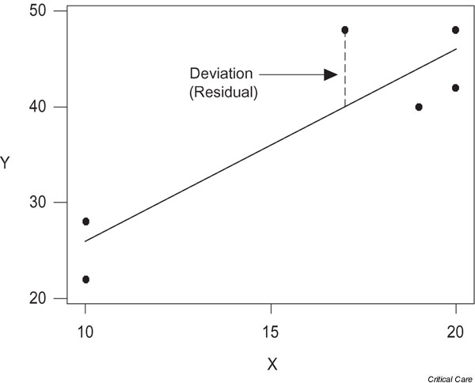

**Point of Note:**

The graph in Figure 8 is culled from Critical Care / Bewick et al., 2003).

In Figure 8, the regression line obtained by minimizing the sums of squares of all of the deviations.

Usually, these values would be calculated using a statistical package or the statistical functions on a calculator (Bewick et al., 2003).

**4. What is an ANOVA procedure, and how might it be used in quasi-experimental**

**designs? How does NOVA differ from an independent T-Test?**

ANOVA, Analysis of Variance, is a test used to determine differences between research results from three or more unrelated samples or groups. You might use ANOVA when you want to test a particular hypothesis between groups, determining – in using one-way ANOVA – the relationship between an independent variable and one quantitative dependent variable. An example could be examining how the level of employee training impacts customer satisfaction ratings. Here, the independent variable is the level of employee training; the quantitative dependent variable is customer satisfaction. You would use ANOVA to help you understand how employees of different training levels – for example, beginner, intermediate, and advanced – with the null hypothesis for the test being that they have the same customer satisfaction ratings. If there is a statistically significant result, it means the null hypothesis is rejected – meaning the employee groups performed differently. The key word in ‘Analysis of Variance’ is the last one. ‘Variance’ represents the degree to which numerical values of a particular variable deviate from its overall mean. You could think of the dispersion of those values plotted on a graph, with the average being at the center of that graph. The variance provides a measure of how scattered the data points are from this central value (Capenter, 2025).

The *t*-test is a method that determines whether *two* populations are statistically different from each other, whereas ANOVA determines whether *three or more* populations are statistically different from each other. Both of them look at the difference in means and the spread of the distributions (i.e., variance) across groups; however, the ways that they determine the statistical significance are different. These tests are performed when 1) the samples are independent of each other and 2) have (approximately) normal distributions or when the sample number is high (e.g., > 30 per group). More samples are better, but the tests can be performed with as few as 3 samples per condition (Ray Biotech, 2018).

**Works Cited**

Bewick, V, Cheek, L, Ball, J. (2003). Statistics Review 7: Correlation and Regression.

National Library of Medicine, National Center for Biotechnology Information.

Carpenter, A. (2025). What is ANOVA (Analysis of Variance) Testing? Qualtrics Publications,

2025. https://www.qualtrics.com/experience-management/research/anova/.

Charlesworth Author Services (2022) Significance and Use of Ad hoc Analysis Studies..

<https://www.cwauthors.com/article/significance-and-use-of-post-hoc-analysis-studies>.

Thomas, L. (2020). Quasi-Experimental Design, Definition, Types & Examples. Published by

Scribbr, 2020 and 2024. <https://www.scribbr.com/methodology/quasi->

experimental design/.

Nguyen, M. (2020). A Guide on Data Analysis. Bookdown. <https://bookdown.org/mike/data>

_analysis /https://bookdown.org/mike/data_analysis/split-plot-designs.html.

Pamplona, F. (2022). Post-Hoc Analysis: Process and Types of Tests. Understand what

Post-hoc analysis is how to find valuable data and patterns after the study has been completed. <https://mindthegraph.com/blog/post-hoc-analysis/>.

Ray Biotech (2018) t-test & ANOVA (Analysis of Variance). <https://www.raybiotech.com/t-test->

Anova.