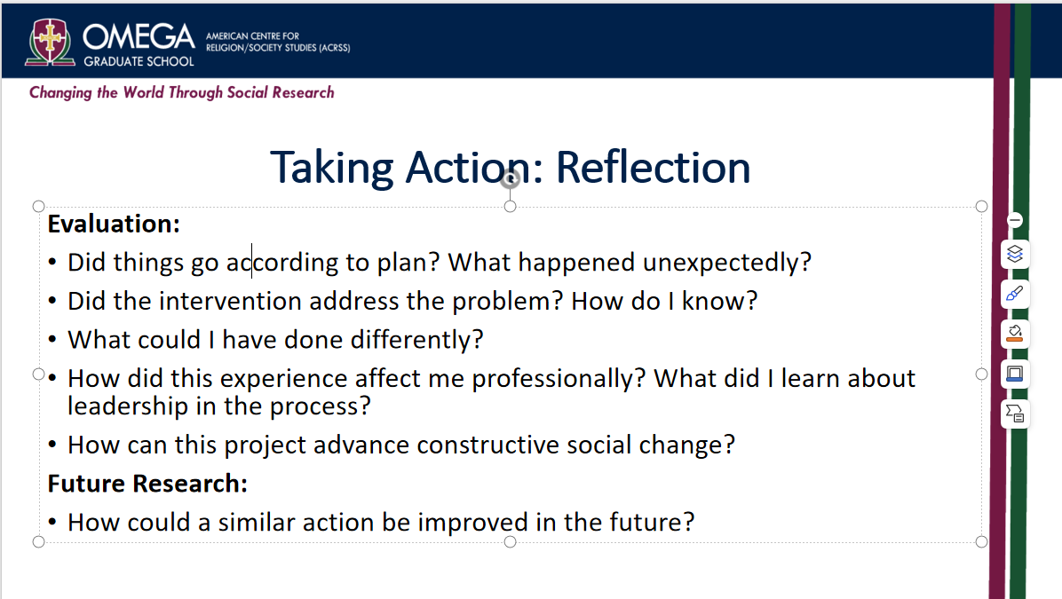

**ASSESSMENT AND EVALUATION OF YOUR PROJECT**

*Here are some criteria for assessing Action Research Projects:

* Transparency: How transparent the research process is
* Authenticity: How authentic the research claims are based on observation
* Treatment: How suitable the action taken is
* Execution: How well the action was taken
* Usefulness: How applicable the action is to the situation
* Practicality: How easy the action is to use
* Flexibility: How adaptable the action is to current practice
* Effectiveness: How well the action achieves its intended results
* Acceptability: How well the action inspires trust in its value
* Leader ability: How well did I function and grow as a leader in the entire process of planning, designing, and implementing the project as an intervention?
* Keep “Field Journal” like an ethnographer would.
* Assessment and evaluation is on how successful you observed the project to be.
* ***Chi-Squared analysis*** is the only way to utilize feedback. That is a special arrangement dictated by the necessity of your research. I will help you pursue that should you need it for your assessment.

**An ethnographer's field journal** is a crucial tool for documenting observations, reflections, and insights during fieldwork. Here are the essential elements to include:

1. **Date and Time**: Each entry should begin with the date and time to provide context for the observations.

2. **Location**: Document the site or setting of the observations, including specific details about the environment.

3. **Participants**: Note who is present in the fieldwork setting, including their names (if applicable), roles, relationships, and relevant demographics.

4. **Context**: Describe the broader social, cultural, or historical context that may influence the interactions and behaviors observed.

5. **Observations**: Provide detailed descriptions of what is happening, including actions, dialogues, behaviors, and interactions. Aim for rich, vivid detail that captures the essence of the moment.

6. **Reflections and Interpretations**: Write down personal thoughts, feelings, and interpretations about what is observed. This might include questions that arise, insights gained, or connections made to theoretical frameworks.

7. **Methodological Notes**: Document the methods used during the observations, including any challenges faced or adjustments made to the research approach.

8. **Ethical Considerations**: Record any ethical concerns or dilemmas encountered during the fieldwork, as well as how they were addressed.

9. **Incidents or Anecdotes**: Include notable incidents, stories, or interactions that stand out, as these can be insightful for analysis later on.

10. **Visual and Sensory Details**: If relevant, note any visual elements (like drawings or sketches) or sensory experiences (sounds, smells) that enhance the richness of the documentation.

11. **Emerging Themes**: As fieldwork progresses, start identifying emerging themes or patterns that could be important for later analysis.

12. **Personal Responses**: Reflect on your emotional and intellectual reactions to what you are witnessing, as these can provide valuable insights into your positionality and bias.

13. **Follow-Up Questions**: List any questions that emerge during your observations that could inform future data collection or further investigation.

14. **Interviews/Conversations**: Include transcripts or summaries of any informal conversations or interviews with participants.

15. **Future Plans**: Document plans for follow-up, additional observations, or specific areas you wish to explore in subsequent entries.

By including these elements, an ethnographer can create a comprehensive and valuable resource for analysis and reporting, aiding both reflective practice and the overall research process.