SR 920-52 Action Research Project Practicum (Spring 2025, Sub term A)

Omega Graduate School

Action Research Project Practicum

Assignment #1

Organizational Development for Social Change

Grace Godfrey

Professor, Dr Mcclane

February 14th, 2025

Delivery and Evaluation Plan

# **Framework and Coordination for Delivery of The Plan**

The following implementation and governance structures will be implemented to actualize this strategic plan. They include internal and external coordination and execution mechanisms for effective, efficient, and timely implementation of objectives and activities described in the strategic plan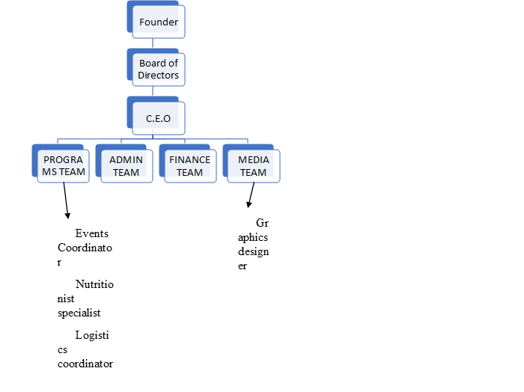

|  |  |  |  |  |
| --- | --- | --- | --- | --- |
| To Improve access to basic services to the most vulnerable | | | |  |
| STRATEGIES | ACTIVITIES | EXPECTED RESULTS | RESPONSIBLE |  |
| * Training Programs for internal & external stakeholders on the small businesses for economic growth * Increase income for economic growth * Create more jobs * Improve resource utilization and efficiency | * Conduct a needs assessment at the home level; refine the needs assessment form * Reach out to the group leaders/chiefs/local authorities to identify the beneficiaries * Admission into the GSO database | * 35 needs assessments are done per year * At least 25 going-to-school children supported at the end of 5 years * In five years, there should be a significant decrease in people living in poverty * Higher-income levels * Reduced poverty rates | Programs Team Leader |  |
| * Feeding programs are to be ongoing as we continue fighting poverty | Organize feeding events for every region involved as we decrease the number of beneficiaries. | * one feeding event per region per year targeting 100 vulnerable families to be reduced by 50% | programs Team Leader |  |
| * To enhance the Welfare of the vulnerable and impact their involvement in the community | | | |  |
| * STRATEGIES | * ACTIVITIES | * EXPECTED RESULTS | * RESPONSIBLE |  |
| * Communicate on community integration activities to: * Protect and support all communities, including the most vulnerable. * Raise awareness and be actively involved in policy-making. * Examine community networks and their role in fostering cooperative action. * Address child abuse with a multifaceted approach involving education and support systems. * Implement recommendations at the societal, community, institutional, relationship, and individual levels. | * Inviting families and friends to GSO social events (Adults and kids) * Inviting entrepreneurs and professionals to social events * Community interventions in collaboration with the legal justice system * Welfare activities that address societal needs and improve quality of life * Community engagement, network building, and cooperative action * Active participation in decision-making and project implementation * Collaboration with the health department to bring about change, especially for health and well-being. | * 2 events are organized for 300 people every year * 20 entrepreneurs attend each year * Enhanced economic opportunities * Effected Community * Promoted Family Stability | Programs Team Leader |  |
| * Legal, counseling, and family therapy better support women's right to inherit (Advocacy) | * Identify and list possible legal and counseling partners * Define the process of engaging counseling and legal partners * Legal engagement of partners' documents as per documented guidelines * Representation of needy cases in court, especially for widows' marital properties * Organize a counseling session in each GSO event from the panel of experts * Do referrals to the relevant institution depending on the needs | * 2 legal and 3 counselors added to the GSO panel of experts * Guideline document for engagement of legal experts * 3 cases are represented by GSO per year * Leadership commitment * Clear vision and strategy * Process improvement | Admin Team Leader |  |
| Capacity Building | * Organize sex education and Hygiene training at every GSO event * Outsource and distribute hygiene care packages in schools * Identify business skills needs and conduct skills pieces of training per event * Support linkage to markets | * 300 most vulnerable trained per year * 400 Hygiene care packages distributed per school session * At least 3 skills training are offered per event * At least 1 product linked to the market per year | Program Team Leader |  |
| To be a dynamic and sustainable organization for social change | | | |  |
| STRATEGIES | ACTIVITIES | EXPECTED RESULTS | RESPONSIBLE |  |
| Media and visibility | * Develop short clips and videos of success stories * Update website and social media | * 10 success story published on the website and social media sites every quarter | Media Team Leader |  |
| Resource Mobilization | * Identify and develop potential business ideas (IGAs) for GSO (land purchase, farming, and table banking). Juice making/value addition budget and proposal for funding of GSO | * Business ideas generated and implemented by 2028 * At least Ksh. 2,000,000 mobilized from partners per year | CFO      CFO |  |
|  |  |  |  |  |

# Work Cited

Adabanya, U., Awosika, A., Moon, J. H., Reddy, Y. U., & Ugwuja, F. (2023). Changing a Community: A Holistic View of the Fundamental Human Needs and Their Public Health Impacts. Cureus, 15(8), e44023. https://doi.org/10.7759/cureus.44023

Anderson, D. L. (2023). Organization Development. SAGE Publications.

Bishal Patangia & Vijaya R. (2023). Unpacking the Past and Charting the Future: A Comprehensive Review of Organizational Development Trends and Predictions. USHUS Journal of Business Management, 22(2), 1–14. https://doi.org/10.12725/ujbm.63.1

Burnison, G., & Wiley, J. (2022). The 5 graces of life and leadership. Wiley.

Cooper, R. B., & Zmud, R. W. (2021). Information technology implementation research: A technological diffusion approach. Management Science, 36(2), 123–139.

Duarte, A., Dias, P., Ruão, T., & Andrade, J. G. (2023). Perspectives on workplace communication and well-being in hybrid work environments. Business Science Reference.

eker, C., Kaya, A., & Bahçelerli, N. (2024). Integrating organizational theories with sustainable development. IGI Global.

Gabriel, K. K. (2022). Organizational Development, Organizational Culture, and Organizational Change. SSRN Electronic Journal, 1(1).

Jumawan. (2023). Strategy organization development: Analysis competence, work environment, and leader style. “Entrepreneurship on Global Economic Development in the Era of Society 5.0,” E-ISSN 2985-7910.

Kukartsev, V., Shutkina, E., Moiseeva, K., Korpacheva, L., & Kireev, T. (2022, June 1). Methods and Tools for Developing an Organization Development Strategy. IEEE Xplore. https://doi.org/10.1109/IEMTRONICS55184.2022.

Lasserre, P., & Monteiro, F. (2022). Global strategic management (5th ed.). Bloomsbury Publishing.

Lasserre, P., & Monteiro, F. (2023). Global strategic management. Bloomsbury Publishing. (Original work published 2002)

Machado, C., & J. Paulo Davim. (2020). Entrepreneurship and organizational innovation. In management and industrial engineering. Springer Nature AG 2020. https://doi.org/10.1007/978-3-030-19289-1

Martha Auteur Golensky, & Auteur, M. A. (2020). Strategic leadership and management in nonprofit organizations: theory and practice. Oxford University Press.

Organization development: Practice that non-profit organizations must do managing the Thungtamsao community. (2020a). Kasetsart Journal of Social Sciences. https://doi.org/10.34044/j.kjss.2020.41.3.05

Osh, D. (2024). CEO Potential. Varlinx, LLC.

Payal Nanjiani. (2024). Make it to the top. CRC Press.

Péntek, B. (2020). Conflict management in the non-profit sphere. mapping the conflict management practices of an organization providing social services. Erdélyi Társadalom, 18(2), 37–49. https://doi.org/10.17177/77171.247

Richardson, K., Burrell, D. N., Lewis, E. J., Nobles, C., Wright, J. B., Sabie-Aridi, A. S., & Andrus, D. N. (2022). An Exploration of Organizational Development and Change in Technical Organizations to Support Sustainability. International Journal of Smart Education and Urban Society (IJSEUS), 13(1), 1–14. https://doi.org/10.4018/IJSEUS.311047

Tapia Andrés & Polonskaia, A. (2020). The 5 disciplines of inclusive leaders: Unleashing the power of all of us. Berrett-Koehler Publishers, Incorporated.

Yuan Liao, & Thomas, D. C. (2020). Cultural intelligence in the world of work: past, present, future. Springer.

# Appendix A from the paper: Role of Social Work Interventions in Enhancing Social Health Outcomes: A Systematic Study by Dr. Aarti Padole (Talekar), Volume 2, Issue 12, December 2024.

# their References

1. Choi, S., & Kim, Y. (2019). Community development and social work: Building stronger communities for improved health outcomes. Journal of Community Practice, 27(2), 121-138. https://doi.org/10.1080/10705422.2019.1580557.
2. Green, L., & Cummings, P. (2020). Social work with families: Strategies for improving child welfare and health. Journal of https://doi.org/10.1080/10522158.2020.1731625 the 21st Family Social Work, 23(1), 50-68.
3. Holman, C., & Rinehart, S. (2021). Advocating for marginalized populations: Social work practice in the century. Journal of https://doi.org/10.1080/02650533.2021.1888397 to Social Work Practice, 35(3), 310-324.
4. Johnson, P. F., & Martinez, A. (2022). Substance abuse recovery and social work: A systems approach intervention. Social Work in Mental Health, 20(4), 189-205. https://doi.org/10.1080/15332985.2022.2041432
5. Klein, S. J., & Reese, P. T. (2020). Social capital and community health: The impact of social work interventions on mental and physical well-being. Health and Social Work, 45(2), 137-148. <https://doi.org/10.1093/hsw/hlaa038>
6. Association of Social Workers (NASW). (2021). Social work interventions for vulnerable populations: A guide to improving social health outcomes. NASW Press. Populations.
7. Peterson, L., & Singh, A. R. (2019). The role of social work in addressing health disparities among vulnerable Journal of Social https://doi.org/10.1080/10437797.2019.1652458 Work Education, 55(3), 526-541.
8. W., & Williams, H. (2018). Integrating substance abuse treatment with social work: Best practices and models for success. Journal of Addiction & Social Work, 22(2), 142-158. https://doi.org/10.1080/15332600.2018.1431487
9. Williams, L. G., & Hunter, R. T. (2021). Social work and community-based mental health care: Examining effective models of intervention. Journal of Community Health, 34(4), 411-425. https://doi.org/10.1007/s10900-021-00945-7