Statistics for Social Research II

David D. Reedy

Omega Graduate School

February 13, 2024

Professor

Dr. Sean Taladay

Assignment

Developmental Readings
Review Assignment #3, the course essential elements, assigned readings, and recommended readings to identify selections of books and scholarly articles to identify and select developmental reading sources and entries.
- Refer to the “Student Guide to Developmental Readings” for updated information on sample comments, rubrics, and key definitions related to developmental readings.

Source One:
Hahs-Vaughn, D. L. (2020). Statistical concepts—a first course (1st ed.). Routledge.
Comment 1:
Quote/Paraphrase:
“First, the normal distribution is a standard curve because it is always (a) symmetric around the mean, (b) unimodal, and (c) bell-shaped.” (Hahs-Vaughn, 2020, p. 121) It has only one mode and is bell shaped curve. (p. 121) Rarely is it a perfect distribution with mean, median, and mode exactly same… there is a range in which the distribution is considered normal. (p.121) Normal distribution represents a “family of curves” distinct to the values of the mean and the variance but all will have one mode and bell shape. (p. 122) An important characteristic of the standard distribution is that it allows us the ability to determine “…the area above any value, the area below any value, or the area between any two values under the curve with area being understood as a percentage. (p. 123) “A fifth characteristic is that any normally distributed variable, regardless of the mean and variance, can be converted into a unit normally distributed variable. Thus, our Wechsler Intelligence Scales, as denoted by Χ ~ N(100,225), can be converted into z ~ N(0,1). Conceptually this transformation is done by moving the curve along the Χ axis until it is centered at a mean of 0 (by subtracting out the original mean) and then by stretching or compressing the distribution until it has a variance of 1 (remember, however, that the shape of the distribution does not change during the standardization process, only those values on the Χ axis). “This is the reason we only need the unit normal distribution table to determine areas under the curve rather than a table for every member of the normal distribution family.” (p. 124)
Essential Element: This relates to the essential element parametric statistics as it deals with the normal distribution which is a required assumption for these tests.
Additive/Variant Analysis: This material is additive to my understanding of the normal distribution. I had previously been aware that with comprehensive measurements of human populations most behaviors will fall into this pattern. This material is useful for helping to understand how different samples can be compared with they both follow the normal distribution as well as how one can begin to break down percentages for particular ranges of values on variables.
Contextualization: The process of standardization across different normal distributions is new information for me. This makes sense of some of the reading I had done before related to “z-scores” and why parametric statistics have stronger predictive capability than non-parametric statistics that have to evaluate non-normally distribute data. I could see how this might be helpful taking my hypothetical study into account. Let us say that we have a group of young adults N=45 who have failed to launch and agree to undergo my intervention training. So, I collected data on the 45 individuals prior to the training. But what if only 38 take the training? If the data were normally distributed, I would still be able to reliable compare the results from the two groups using parametric studies.

Source Two:
Willard, C. A. (2020). Statistical methods (2nd ed.). Routledge.
Comment 2:
Quote/Paraphrase
“Previously, we used the z-statistic in testing hypotheses about the population mean (μ). However, the z-test requires knowing the value of the population standard deviation (σ) – information that is, in fact, not usually known.” A
t-test is used to test hypotheses about population means when standard deviation is not known. (Willard, 2020, p. 133) “The t-distribution, like the z-distribution, is theoretical, symmetrical, and bell-shaped, but the appearance of the curve changes according to the size of the sample. The z-distribution is based on an inﬁnite number of cases resulting in what we refer to as the normal distribution curve. However, with small samples the curve will be shaped differently. The t-distribution is actually a family of curves, one for each sample size. The particular t-distribution that we use will be based on the degrees of freedom associated with the sample.” (p. 133-134) “Remember, if a problem indicates that a researcher is looking for score increases or decreases, then assume a one-tailed test. If the researcher is simply looking for an effect with no indication of direction, then assume a two-tailed test.” (p. 138)
Essential Element: This material relates to the essential elements of parametric statistics and T-test.

Additive/Variant Analysis: This material is additive to my understanding of parametric testing and the utilization of the t-test. I have not previously examined the use of t-tests, so this material is helpful for my understanding of its purpose, possibilities, and when it may be used.
Contextualization: The material here is helpful in introducing several key aspects of the t-test. First, it is a parametric test requiring that the distribution be symmetrical and bell shaped (unimodal). Also, this is a test that is useful for a smaller sample size, which might be found in a dissertation. Also important here is the note that there is a one-tailed and a two-tailed test. So looking at the same hypothetical scenario I have been working with regarding a study of GenZ young adults who fail to launch, if I were measuring to see if an educational intervention was effective I would employ a one tailed t-test if my data were normal and met the other assumptions of the t-test.
Comment 3:
Quote/Paraphrase
The author explains the importance of significance levels and provides a table for critical t-values needed to reject a null hypothesis. This table involves an intersection of degrees of freedom and then provides significance levels for one-tailed and two-tailed tests. The author suggests that if the exact degree of freedom is not listed to use the next-lowest. To reject a null hypothesis the t-value must exceed the listed critical value or the difference in the means could be related to chance or random sampling not matching the population. (pp. 134-135)

Essential Element: This material relates to the essential elements of parametric statistics and T-test.
Additive/Variant Analysis: This material is additive to my understanding parametric statistics and t-tests. This adds another layer of understanding to the material above.
Contextualization: This material is helpful in that it helps me begin to comprehend what it is we are testing for. The test is examining the difference between the variables. Given that in different sample measurements it would be expected that the means will be somewhat different anyway, the purpose of this, and other tests, is to see if the difference is statistically significant. The formulas, which software will calculate for me, will provide a t-value which compared to the chart as the author directs will demonstrate if the difference is great enough to be considered statistically significant and likely not due to chance.
Comment 4:
Quote/Paraphrase
“Degrees of freedom: An adjustment factor used to estimate population parameters more accurately.” (p. 288) Degrees of freedom (df) are a correction factor applied to the denominator in statistical calculations to adjust for sample size, helping to estimate population values more accurately. This adjustment increases the standard deviation and is used in more advanced statistical methods, where it is typically calculated based on sample size or the number of datasets included in the analysis. (p. 84) Degrees of freedom (df) are used to correct for underestimation when estimating population parameters, such as the standard deviation, from sample data. The correction increases the accuracy of estimates. In the case of the t-distribution for a single sample, df is calculated as n−1n - 1n−1, where nnn is the sample size. For example, if the sample size is 16, the degrees of freedom would be 15. The specific df to use depends on the statistical procedure, sample size, and the number of data sets involved. (p. 134)
Essential Element: This material relates to the essential elements of parametric statistics and T-test.
Additive/Variant Analysis: This material is additive contributing to the information the previous two entries.
Contextualization: Degrees of freedom adjust for the fact that when estimating for the mean we lose one degree of freedom (one variable cannot change) because at least one value must be fixed to maintain the correct calculation. The adjustment increases the standard deviation, which appears to be a technique to account for small sample size where the variance is likely smaller than if one could measure if examining an entire population. Increasing the standard deviation would then make the sample more like the expected variance in the population and hence help the analysis to be more accurate. An important piece of information here is that the calculations to compute df can be more complicated than n-1 depending on “the statistical procedure, the sample size, and the number of datasets.” So, it will be important to pay attention to how df is calculated depending on the statistical test employed.
Comment 5:
Quote/Paraphrase
One sample t-test: “The one-sample t test is a test of a hypothesis about a population mean (μ) when the population standard deviation (σ) is not known. This test is used when researchers want to know (1) if a sample is representative of a population and/or (2) if a particular treatment or condition has a signiﬁcant effect.” (p. 136)
Two sample t-test: Compares the means between two groups. (p. 147) i.e., a drug effectiveness where one group gets the medication and the other a placebo. (p. 147) “You measure each sample on some aspect of behavior and calculate a mean for each sample. You then determine the difference between those means (M1– M2) and record it. You then repeat this process over and over, drawing all possible random samples of size n1 and n2 and recording only the difference between their means. These difference between means values are then arranged into a frequency distribution, called the sampling distribution of the difference between means.” (p. 147)
Related samples t-test: “Like the independent samples t test, the t test for a related samples design also involves making comparisons between two sets of scores. However, with this design, either the scores are from the same subjects (repeated measures), or two samples are related in some other logical way, such as the scores for husbands and wives (matched pairs). Because the computation of the t-statistic is the same for both types, we will limit our discussion to the type used most commonly: repeated measures. A repeated measures study involves pre- and post-testing of the same subjects after some treatment intervention.” (p. 160)
Essential Element: This material relates to the essential elements of parametric statistics and T-test.
Additive/Variant Analysis: This material is additive to my understanding of the t-test, the various iterations of it, and when they should be used.
Contextualization: Related to my hypothetical research project into GenZ young adults who fail to launch, evaluating the effectiveness of a hypothetical educational intervention, one might consider a one sample test be used given we are looking to see if a “…treatment…has a significant effect.” But reading on it appears that a related samples t-test would be more effective given there will likely be a pre-assessment and then a post-assessment. It is important to note the emphasis on not knowing the standard deviation. This makes the t-test a useful tool because it would be difficult to know explicit standard deviation of the population group (in my hypothetical study the GenZ individuals in the state of Texas). One would think a sample will demonstrate more variability than the entire population, which would most likely be more clustered around the mean. It is helpful for trusting the reliability of the t-test to know it is designed to take this into account.
Comment 6:
Quote/Paraphrase
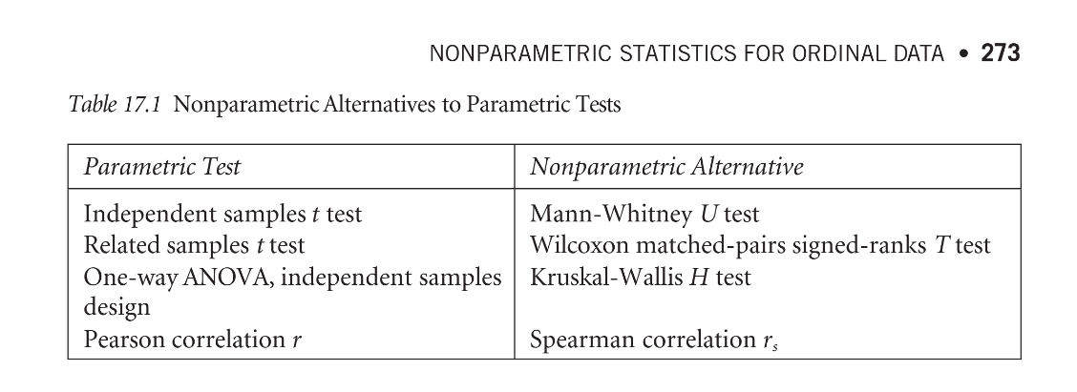
(p. 273)
“The Wilcoxon matched-pairs signed-ranks T test would be the appropriate test to use in place of the related samples t test if only ordinal data is available or if parametric assumptions cannot be met. Recall that there are two types of the related samples t test. The matched pairs design involves a set of scores that have been logically paired together, such as the scores for a set of twins. The repeated measures design involves pre- and post-testing of the same participants. The Wilcoxon matched-pairs signed-ranks T test can be used as a nonparametric choice for either of these designs.” (P. 276) “For this test, we will begin with a pair of scores, either from the same subjects or matched for some logical reason. We will then determine the difference between the two sets of scores, rank the difference scores, identify the ranked differences with either a positive or negative sign, and then sum the positive and negative ranks. The null hypothesis for a two-tailed test is that both samples came from populations with the same distribution of scores. If the null hypothesis were true, then the sum of the positive ranks should approximately equal the sum of the negative ranks for our two groups. The alternative hypothesis is, of course, that the population distributions are not equal. A one-tailed alternative hypothesis would specify that the sum of either the positive or negative ranks for one group would be greater than those for the other group.” (P. 276)
Essential Element: This chart relates to the essential elements parametric and non-parametric statistics.
Additive/Variant Analysis: This material is additive and essential to my understanding of the use of parametric and non-parametric statistics.
Contextualization: This chart is basic but essential instruction in which test is appropriate to the research design and the data set generated. With the hypothetical research project I have been working with through this course I would anticipate that I would be dealing with a small sample size where no only would the standard deviation of the sample be different from the population, but the data collected itself would likely not be normalized and meet the assumptions necessary for parametric tests. So, most likely the appropriate test for the data collected for this research project would require using Wilcoxon matched-pairs signed-ranks T test.
The hypothetical design I have been working with involves identifying Lutheran Church – Missouri Synod families who have GenZ young adults who have failed to launch who reside in the state of Texas and providing an educational intervention for parents with a follow-on measurement seeking to examine the effectiveness of that intervention to for instance help the parents motivate their young adult to enter the workforce. I could examine how confident the parents felt before the intervention and after the intervention using a Likert-type scale. This would be matching pairs or matched data in this case before and after. It is ordinal data, and I would anticipate it would not be normally distributed due to probably small sample size. Given the inevitable process of change in human life over time, the test would evaluate if the observed change was statistically significant enough to support the effectiveness of the intervention.
Comment 7:
Quote/Paraphrase
The Pearson R is used to examine “…linear relationships between variables measured on interval or ratio scales.” (p. 236) As one variable changes, if another changes, the strength of the correlation is interpreted based on the “proportion of variance the two variables have in common.” (p.239-240) “If there is a correlation between two variables, then the scores tend to change together in predictable ways. As X changes, Y also tends to change in a predictable way.” (p. 240) An aspect of the test involves the coefficient of nondetermination which informs as to the “…proportion of variability that is not common variance.” (p. 240) However, the author reminds us that correlation does not equate to causation that one factor is changing the other, only that if one factor changes one can anticipate the other to change. The change could be caused by an outside and non-observed or measured force. (pp. 241-242) The authors state this test is used to test for the reliability and validity of a testing instrument as well as predicting. If there is a strong correlation between two variables one can use the score of one variable to predict the score of the other variable. The stronger the relationship the stronger the prediction. (p. 243)
Essential Element: This material relates to the essential element Pearson R.
Additive/Variant Analysis: This material is additive to my understanding of when this test should be utilized and how it should be faithfully utilized.
Contextualization: Applying this material to my hypothetical research project examining GenZ young adults who have failed to launch where I seek to provide an educational intervention for parents to assist their children to launch, I could research pre-existing relationships with the children. For instance, I might research the relationship between how much financial support parents are providing compared to workforce participation among GenZ adults in the Texas District. Collecting this data and using this test could indicate that the more financial support the parents give their children the less they are likely to enter the workforce. The trick here would be to avoid concluding that reducing financial support would have a positive impact on forcing their children out into the world. For instance, my previous literature review on the subject speaks a lot toward motivation and anxiety as a paralyzing force as a definite force in this problem and I would anticipate that reduction of financial support my increase anxiety. But if the research upheld the negative correlation, it could be used as an effective argument with parents to motivate them to be involved in the educational intervention in that I could predict that as their children move into the workforce their financial dependency on the parent would reduce.

Source Three:
Bratina, D., & Faganel, A. (2024). Understanding gen z and gen x responses to influencer communications. Administrative Sciences, 14(2), 33. https://doi.org/10.3390/admsci14020033
Comment 8:
Quote/Paraphrase
Abstract: “The increased popularity of social media has greatly affected the marketing-communications activities of companies. This study seeks to understand how influencers promoting products affect their followers’ purchasing intentions and attitudes towards endorsed products. Our main interest is to get an insight into differences between two generations (X and Z). We construct a structural model, based on the theory of credibility. Findings suggest that influencer endorsements have an impact on both age groups, with a more noticeable effect observed in the younger generation. The loyalty towards influencers emerges as a constructive intermediary factor, amplifying the influence of credibility on purchasing intentions across both generations. When considering attitudes towards the brands endorsed by the influencers, loyalty’s impact is comparatively modest. The results provide a building block in understanding the influencers’ activities in marketing-communications, and how they can be used for communication with different generations.” (Bratina and Faganel, 2024, p. 1)
“Loyalty is manifested by a repeated pattern of purchases of the same brand within a product category (Bowen and Chen 2001).” (p. 3) “The mediating variable loyalty has been operationalized using three questions: “I will continue following [SMI]”, “I will follow [SMI] as long as relevant content is provided”, “I will recommend [SMI] to others”. (p. 5) “H3a. Loyalty mediates the positive effect of attractiveness on purchase intentions. H3b. Loyalty mediates the positive effect of attractiveness on attitudes. H3c. Loyalty mediates the positive effect of trustworthiness purchase intentions. H3d. Loyalty mediates the positive effect of trustworthiness on attitudes. H3e. Loyalty mediates the positive effect of expertise on purchase intentions. H3f. Loyalty mediates the positive effect of expertise on attitudes. H3g. Loyalty has a positive effect on purchase intentions. H3h. Loyalty has a positive effect on attitudes.” (Bratina and Faganel, 2024, p. 7)
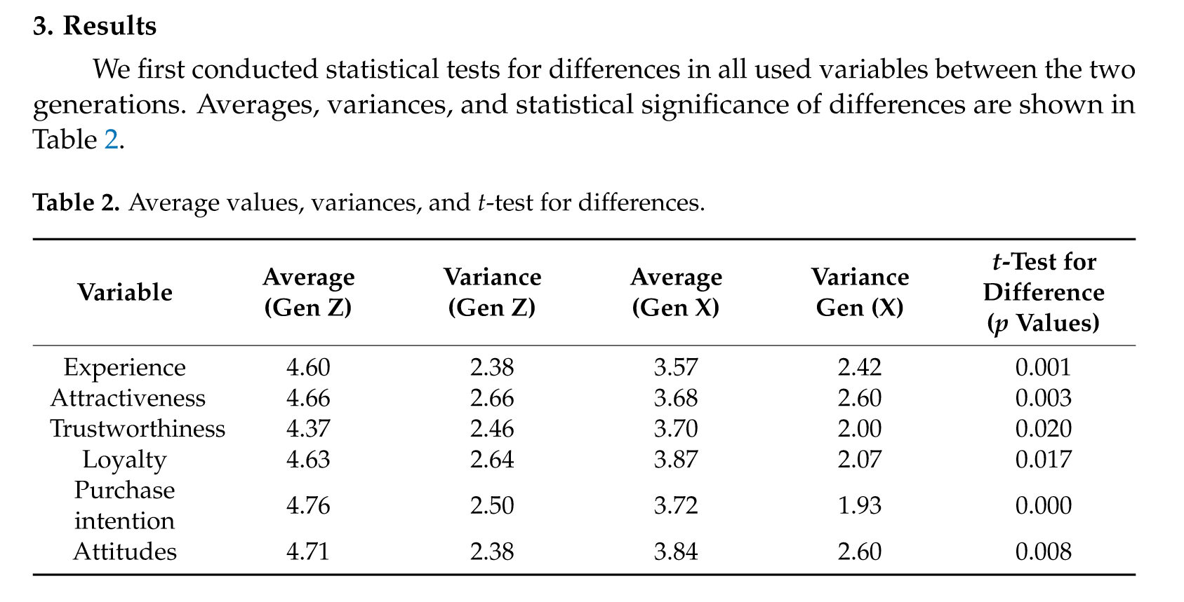
(p. 8)
“Direct effect of loyalty on purchase intention has a value of 0.47 and is statistically significant (p < 0.000, H3g), while the direct effect of Loyalty on Attitude has a value of −0.02 and is not significant (H3h).” (p. 9) ““As per previous research, loyalty does have a mediating effect on purchase intentions and attitudes for expertise and attractiveness. Our research shows no mediating effect of loyalty on attractiveness and trustworthiness towards attitude.” (p. 9)
Essential Element: This material relates to the essential elements of parametric statistics and T-test.
Additive/Variant Analysis: This material is additive to my understanding of how to employ a t-test to evaluate research data.
Contextualization: While this article examines how social media influence impacts attitudes and purchasing intentions toward sponsored products comparing GenZ and Gen X, here I will look only at the issue of loyalty to explore why and how the researchers employ the t-test to examine their data and justify their results.
It would have been helpful for this examination if the authors had specified the t-test utilized. But given they measured loyalty for each separate generation comparing the means it is likely they utilized an independent samples t-test. Loyalty was measured based on three behaviors: continued following, relevance-based following (contingency), and recommendation to others. The results of the t-test on the collected data indicated statistical significance only for a direct effect of loyalty on the intention to purchase the recommended product. But loyalty itself did not demonstrate a statistically significant impact on other areas of the study such as the evaluation of the expertise of the social media influencer.
The study is looking at several dimensions that the authors think have an impact and may be different from GenZ and GenX. The categories they examine are informed by their literature review of previous research. A key take away for my learning at this point is twofold: the power of this statistical analysis to look capture actual interactions between networked ideas, as well as some insight into how to operationalize a behavior to that it can be measured for potential impact.
Source Four:
Matthias, C., Bu, C., Cohen, M., Jones, M. V., & Hearn, J. H. (2024). The role of mindfulness in stress, productivity, and wellbeing of foundation year doctors: A mixed-methods feasibility study of the mindful resilience and effectiveness training programme. BMC Medical Education, 24, 1–15. https://doi.org/10.1186/s12909-024-05810-7
Comment 9:
Quote/Paraphrase
ABSTRACT: Medical Foundation Year (FY) doctors demonstrate greater psychological distress compared with the general population and other student groups. This feasibility study investigated FY doctors’ perceptions of mindfulness and the impact of a mindful resilience and effectiveness training (MRET) programme on stress, wellbeing, and performance. Methods: Mixed-methods study utilising a questionnaire (study 1, N = 144) and a pre-post analysis design of MRET programme (study 2, N = 13), along with focus groups (N = 7). Results: In study 1 28.5% of FY’s reported using mindfulness. All five mindfulness facets were significantly, and positively, associated with mental wellbeing (p < 0.05). Acting with awareness (AA) and non-reactivity (NR) were significantly, positively associated with a challenge responses to stress (p < 0.05). Threat and loss appraisals were negatively associated with AA, NR, and non-judging (p < 0.01). Perceived productivity was positively associated with mindfulness facets: describing, AA, and NR (p < 0.001). In study 2, there were significant increases in wellbeing and mindfulness facets observing, describing, AA, and NR, and threat appraisals decreased (p < 0.05). The main themes identified across the focus group included Reframed Mindset, Values-Based Action, Embodied Leadership and Pedagogy. Conclusions: There exists a relationship between mindfulness, psychological wellbeing, and performance in FYs. The MRET prorgamme improved psychological wellbeing and reduced threat appraisals. Future work could focus resources on enhancing the skills of AA and NR, as this may be sufficient to bring about meaningful improvements in wellbeing, perceived productivity, and cognitive reappraisal of stressful life events.” (Matthias et al., 2024, p. 1)
“Pearsons’s correlations coefficients were calculated (Table 2) to assess the relationships between mindfulness (FFMQ-SF), mental wellbeing (WEMWB), perceived productivity and appraisal of stressful life events (ALE).” (p. 4)
“Mindfulness and mental wellbeing: There were significant positive relationships between all five mindfulness facets and mental wellbeing: OB (r (142) = 0.18, p < 0.5, DS (r (142) = 0.36, p < 0.001), AA (r (142) = 0.48, p < 0.001), NJ (r (142) = 0.34, p < 0.001) and NR (r (142) = 0.44, p < 0.001).” (p. 4)
“Mindfulness and appraisals of life events: There were significant positive relationships between, challenge and two mindfulness facets: AA (r (142) = 0.19, p < 0.5,) and NR ( r (272) = 0.15, p = 0.001). There were significant negative relationships between threat and mindfulness facets: AA (r (142) =-0.34, p < 0.001), NJ (r (142) = − 0.22, p < 0.5), and NR (r (142) = − 0.23 p < 0.5), and loss and mindfulness facets: DS (r (142) = − 0.19, p < 0.5), AA (r (142) = − 0.21, p < 0.5), and NJ ( r (142) = − 0.33, p < 0.001).” (p. 4)
Essential Element: This relates to the essential element Pearson’s R.
Additive/Variant Analysis: This material is additive to my understanding of correlational research and the utilization of Pearson’s R.
Contextualization: This research provides a helpful framework for examining why and how Pearson’s R is used in social research. While a mixed methods approach, I am going to focus on the part of the research where Pearson’s R was applied.
The sample size of 144 was a large study which would likely justify a parametric test with the variables having normal distribution. Also, the study is looking to examine the strength of a relationship between mindfulness and mental wellbeing and between mindfulness and performance. The utilized questionnaire (FFMQ-SF) and found it uses a five question Likert scale from never/rarely true to often/always true. (p.3) This is confusing to me in that I understand Likert scales to produce ordinal data, and my understanding is that Pearson’s R would require interval data though if a sample size were large enough the spread between the measurement scale would narrow to approximate interval data. (Frost, 2017)
Looking at their results, the strongest correlations were between acting with awareness (r = 0.48, p<0.001) and non-reactivity (r=0.44, p<0.001) on mental wellbeing, where the stronger the behaviors were corresponding to a stronger self-perception of wellbeing. Both of these scores indicate a positive correlation that is moderate, in that if falls near the middle of the range between 0 and +1. Both have very low p values indicating that the correlations are highly unlikely to have occurred because of random variation in the sample.
Again, the emphasis on a correlation test reinforces the caution of concluding that cultivating awareness of action will increase mental wellbeing as the causal factor because other variables may the actual cause of the increase. But this could indicate a place for possible future research to test if indeed cultivating deliberate awareness before acting increases participants’ perception of their well-being.
The evaluation of the data demonstrated a statistically significant relationship between mindfulness and perceiving stress as a threat with more mindful people less likely to see stress as threatening. Again, this demonstrates a relationship exists but not necessarily a causal one and if a causal one not necessarily indicated the direction of the influence. It could be that individuals who are naturally stress tolerant have more mental energy to be mindful. But it would indicate an area that could be further explored. For instance, with my appreciation of the MBTI, I would wonder if folks who are hardwired to be more cognitive dominant vs emotionally dominant would test out when looking at mindfulness and seeing stress as a threat.
Source Five:
Nie, Z., Waheed, M., Kasimon, D., & Abas, W. A. B. W. (2023). The role of social network analysis in social media research. Applied Sciences, 13(17), 9486. https://doi.org/10.3390/app13179486

Comment 10:
Quote/Paraphrase
Abstract: “Previous studies regarding social interactions commonly adopt research methods that investigate causal relationships between variables. The existing approaches often utilize variables derived from general contexts, aiming to apply them universally across diverse situations. However, social interactions, including the usage of social media, are intricately woven within the immediate social context. The interpretability of these generalized variables has been attenuated by the dynamic and transient nature of social contexts; these variables have diverse impacts on social interactions. Consequently, researchers have been diligently seeking new variables relevant to specific social contexts in order to complement the existing generalized ones. However, the ever-changing nature of social contexts poses a challenge, impeding researchers from exhaustively defining all variables that influence social interactions. To address this complexity, this study proposes social network analysis as a suitable research method capable of capturing the ever-evolving dynamics of social interactions, including social media usage. Furthermore, this study puts forth hypotheses that specifically explore the role of individual social networks in social media research, with the aim of stimulating future investigations that center on the interactive and dynamic nature of social media usage.” (Nie et al., 2023, p. 1)
The authors state that their survey of recent research social interactions and social media often employ methods that require data to be normal, assuming stable and general scenarios. (p. 2) They also state that the central limit theorem requires a large data set to confirm normality and that most research is on smaller groups. (p. 5) And social factors are interactive, more a matrix of interactions than independent factors complicating traditional statistical methods to explore. (p. 5) When collecting data from respondents, often their reports present overlapping concepts and blurred concepts which are also impacted by blurred and selective memory. (p. 5)
The author’s advocate for the value of using a more advanced method such as social network analysis rather than just depending on non-parametric testing. (p. 2) The argue this method works better with relational data and can better explore independence than models that require individual and independent data points. (pp. 2-3) The focus is on structure capturing clustering which can demonstrate relationship directions and trends. (pp. 6-10)
Essential Element: This material relates to the essential elements of parametric testing and non-parametric testing especially in relationship to normality.
Additive/Variant Analysis: This material is additive to my understanding of normality as well as parametric and non-parametric testing. It illustrates the importance of and difficulty of securing normal data and presents an alternative method beyond traditional non-parametric testing.
Contextualization: I find this methodology very intriguing. It is an advanced model different from traditional parametric and non-parametric studies. However, it resonates with a systems-based understanding of society and the reality that most human behavior take place as interactions not just between individuals but also between people on a micro to macro level. (p. 6) The concept of entropy is used to describe the uncertainty or unpredictability of these behaviors inside our social networks. (p. 6) The method provides statistical formulas to measure entropy to indicate how much information is needed to understand a range of possible behaviors. (p. 6) Probability analysis comes into play because enough individuals are observed operating within their environment “discernible and recurring patterns” can begin to emerge that can be graphed indicating relationships. (p. 7) This type of method can still utilize hypothesis testing as expressed in the following: “H1: The structural features of edges/2-stars/3-stars/triangles are more likely to occur regarding direct interaction on social media in the given social network.” (p. 11) Hypotheses would be constructed to reflect a particular expected structure reflecting interactions.
This material serves as a revelation that other potentially objective, interpretive, and predictive methods exist and are being developed than may be more powerful for analysis than traditional parametric and non-parametric studies. While the information in the article is not sufficient to teach the skills to employ this specific method, it does encourage me to file this away as a potential resource for future employment and learning, especially if I desire to looking into a highly integrated and interactive/networked set of behaviors within a population.
Source Six:
Toma, S. G., & Hudea, O. S. (2024). Generation Z students’ perceptions on the abilities, skills and competencies required in the age of artificial intelligence systems. Amfiteatru Economic, 26(65), 162–180. https://doi.org/10.24818/EA/2024/65/162
Comment 11:
Quote/Paraphrase
Abstract:
“The knowledge economy promotes the use of information and communication technology and highly skilled labour on a large scale. The past decades have witnessed a continuous fall in the importance of unskilled sectors and a rise in skilled sectors combined with the emphasis on skills and competencies. Being highly familiar with the use of technology, Generation Z students are very interested in raising their chances of employability in the current digital society. The purpose of this research was to identify and analyse Generation Z students’ perceptions on the abilities, skills and competencies required in the age of artificial intelligence systems. In this respect, the authors used a quantitative research method through an online survey. A total number of 352 questionnaires from students who graduated from full-time undergraduate programs within a Romanian faculty were validated. The data were processed using the SPSS 17.0 statistical software, the subsequent viability tests and analyses involving the use of Cronbach's Alpha coefficient, the Principal Component Analysis, respectively, the correlational analysis. From a theoretical point of view, the paper contributes to the enrichment of the scientific literature regarding the new relationships between human capital and the era of artificial intelligence systems, offering a new perspective on the structure of the needed abilities, skills, and competencies in the digital society. From a practical point of view, the results of the study provide solutions for improving the educational process by adapting academic programs to the demands of the digital society. The results of the research show that, on the one hand, sensorial, cognitive, and psychomotor abilities, and, on the other hand, general knowledge, business and management, and technical skills and competencies, are playing a key role in today’s era of artificial intelligence systems.” (Toma and Hudea, 2024, pp. 162-163)
“H1: Gen Z students consider sensorial, cognitive, and psychomotor abilities to be the most important in the age of AI systems.” (p. 166)
“A total number of 352 questionnaires were validated from graduates (80 out of 432 graduates were not Gen Z members, sent incomplete responses or did not answer), with a response rate of 81.48%, confirming the quality of the survey (Hox and De Leeuw, 1994).” (p. 168) “…this study deals with three very large datasets grouped around three ordinal variables, based on common characteristics,…” These included abilities related to cognitive/psychomotor/physical, 2. skills/competencies 3. contribution of study program strengthening various skills and abilities (p.168)
PC 1.1 = Sensorial Ability
PC 1.2 = Cognitive Ability
PC 1.3 = Psychomotor Ability (p. 171)
PC 3.1 = General knowledge skill and competencies acquired in higher education
PC 3.2 = Technical skills acquired in higher education
PC 3.3 = Business and Management skills and competencies acquired in higher education. (p. 173)

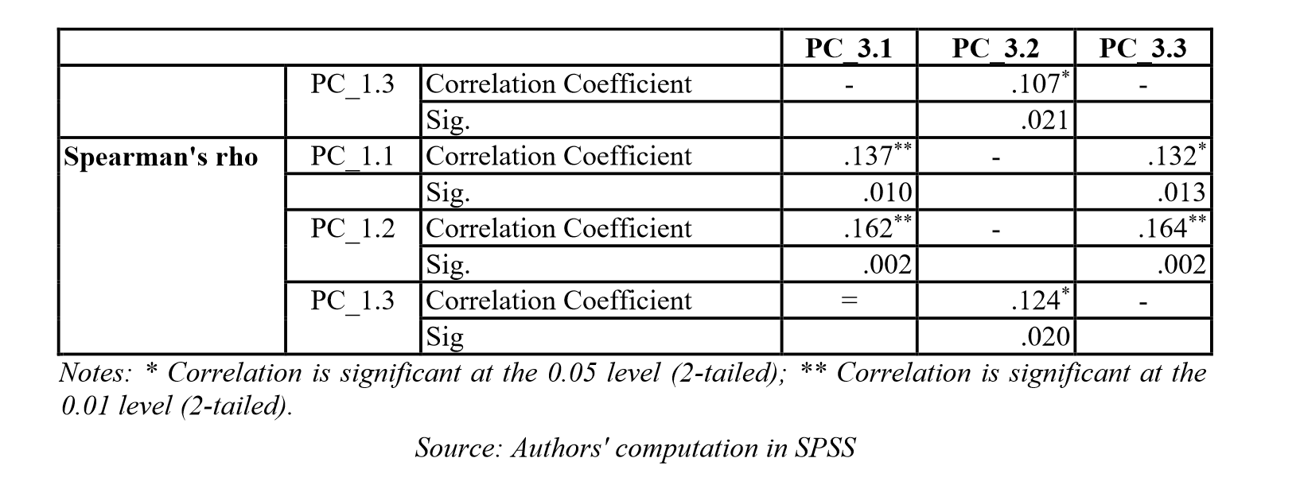
(p. 175)
“Thus, there is, as expected, a quite low correlation between PC_1.1 and PC_3.1, respectively, PC_3.3, between PC_1.2 and PC_3.1, respectively, PC_3.3 and between PC_1.3 and PC_3.2, such values being statistically significant, at a significance level of 1%, respectively, 5%, the results being similar for both coefficients, with slightly higher values for Spearman's rho. This means that there is a correlation, although not strong or even medium, between specific sensorial abilities and general knowledge skills and competences (Engineering and Technology, Mathematics and Science, Arts and Humanities) acquired during higher education studies, respectively Business and Management skills and competences acquired during higher education studies, on one hand, and between psychomotor abilities and general knowledge skills and competences (Engineering and Technology, Mathematics and Science, Arts and Humanities) acquired during higher education studies, respectively Business and Management skills and competences acquired during higher education studies, on the other hand, the same kind of relationship being encountered when coming about cognitive abilities in relation to technical skills and competences acquired during higher education studies.” (Toma and Hudea, 2024, p. 13)
Essential Element: This material is related to the essential elements parametric and nonparametric statistics and Pearson’s R and its non-parametric equivalent Spearman’s rho.
Additive/Variant Analysis: This material is additive to my understanding of Why, when, and how to apply a particular correlation test to a particular data set.
Contextualization: For the purpose of learning more about Pearson’s R I am limiting my exploration to the intersection of what the study labels as PC 1 and PC 3 in conjunction with H1.
Examining if sensorial, cognitive, and psychomotor abilities are related to general knowledge, technical skills, and business training, the results indicated a low yet statistically significant correlation between specific sensorial, cognitive, and psychomotor skills and learning acquired during higher education. The authors interpret this to support the hypothesis that GenZ students consider sensorial, cognitive, and psychomotor skills to important for the utilization of artificial intelligence in their professional and personal lives supporting the author’s conclusions that educational processes should adapt to include enhancing these skills alongside traditional elements. I am not sure the low correlation would necessarily justify the expenditure of resources to shift a focus, but possibly these may be additional factors worthy of consideration. For instance, PC 1.1 sensorial ability and 3.2 technical skills acquired in higher education the relationship is almost negligible. As sensory ability increases this is a possibility technical skills increase slightly but the association is weak and hence the predictability is low. So, investing in sensory training may have a negligible effect on technical skills.
As to why Spearman’s rho is utilized, one must consider the nature of the data. Measuring sensorial, cognitive, and psychomotor ability would not necessarily be a linear relationship which is required by Pearson’s R. For instance, one could posit that a small increase in cognitive ability could have a large impact on improvement in an AI environment whereas hand eye coordination might have a smaller impact. However, depending on the type of interface use, hand eye coordination could be more important than cognitive development. For instance, I would expect differences if traditional input devices such as a keyboard and mouse were compared to the new Apple Vision Pro.
Source Seven:
Hamdi, M., Indarti, N., Manik, H. F. G. G., & Lukito-Budi, A. S. (2023). Monkey see, monkey do? Examining the effect of entrepreneurial orientation and knowledge sharing on new venture creation for Gen Y and Gen Z. Journal of Entrepreneurship in Emerging Economies, 15(4), 786–807. https://doi.org/10.1108/JEEE-08-2021-0302
Comment 12:
Quote/Paraphrase
Abstract: “Purpose – This study aims to examine the effect of entrepreneurial intention and attitude towards knowledge sharing on new business creation by comparing two generations, Y generation (millennials) and Z generation (post-millennial). In addition, the current study uses a social cognitive theory as a point of departure to test the research hypotheses. Design/methodology/approach – This study deploys a quantitative approach (hypothetic-deductive approach) by surveying 300 respondents representing the two Indonesian generations. The questionnaire consisting of demographic items (age, education, etc.) and variables was the primary research instrument. This study used regression analysis, a Wald test for examining the proposed hypotheses and a t-test to provide a deeper analysis of the findings. Findings – Findings from the current study show that Gen Y is still seeking a balance for their learning sources by involving in their social environments as well as exploring the digital world. In contrast, Gen Z is much more dominant in the independence to learn things that interest them. They have less dependency on social patrons but prioritize themselves as the leading model. (p. 786)
“H1a. The individual entrepreneurial orientation positively affects the new venture creation. (p. 791)
“H1b. The attitude towards knowledge sharing positively affects the new venture creation.” (p. 791)
“Table 5 presents the results of hypotheses testing. The individual entrepreneurial orientation and attitude towards knowledge sharing have a significant positive effect on creating a new venture (b = 0.331, p < 0.001; b = 0.219, p < 0.05), respectively. Thus, the H1a and H1b are supported. In the context of this study, individuals who have high entrepreneurial orientation (i.e., innovativeness, proactiveness and risk-taking) and a positive attitude towards knowledge-sharing activities are more likely to establish a new business. These findings are also consistent with previous studies (Koe, 2016; Bolton and Lane, 2012; Donbesuur et al.,202). Consequently, the entrepreneurial orientation and attitude towards knowledge sharing need to be cultivated seriously by universities and various educational institutions so that they are able to initiate and create a new venture. This cultivation process can be done by involving various relevant role models for each generational cohort with an appropriate approach.”
“In addition to the hypotheses testing, this study also undertook a deeper analysis using an independent sample t-test on specific characteristics of the Gen Y and the Gen Z that differentiate the degree of new venture creation (NVC). The characteristics include digital literacy, training attendance on venture creation and experience in running the business. The t-test consists of two consecutive tests: between-group (test NVC perception between Gen Y and Gen Z) and within-group test (test variation detail of the NVC in both groups). (p. 798)
The authors report that the t-test indicated no significant difference between Gen Y and Gen Z in their perceptions of new venture creation, regardless of their levels of digital literacy, training attendance, or business experience. Similar there was no significant difference in the mean scores for new venture creation in the within-group study compared to digital literacy for either Gen Y or Gen Z. Both have similar views of entrepreneurship. (p. 798)
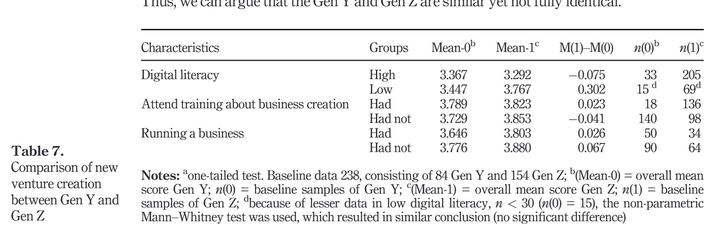
(p. 798)
Essential Element: This material relates to the essential elements parametric and nonparametric statistics and t-test and its nonparametric equivalent Mann-Whitney test.
Additive/Variant Analysis: This material is additive to my understanding of parametric and nonparametric statistics and how normality impacts which type of statistics should be utilized. The material also helps me to understand which type of test is best utilized to evaluate a particular data set.
Contextualization: Here in the graphic we have a specific reference that the means were evaluated using the Mann-Whitney U test. Even though sample group in most categories was high enough to utilize parametric statistics, because one important sample was below the threshold (digital literacy), the Mann-Whitney U test was utilized to provide a more accurate assessment of the data.
Obviously looking at the chart one can see there is a difference in the means, but the application of the test indicates that the differences are not great enough to be statistically significant. Thus, even though there are differences between the digital literacy level of each group (or training or experience) their perceptions of new business startups remained similar. Yet both groups with business experience felt more ready to start a new business when they receive additional training (Gen Y -- low: 3.147, high: 3.539) (Gen Z – low 3.106, high 3.562) compared to the impact of training on those who did not already have business experience. Thus, training would be expected to have a greater impact on those already running a business compared to those who have no business experience in enabling someone to start a new business on their own.

Works Cited
Bratina, D., & Faganel, A. (2024). Understanding gen z and gen x responses to influencer communications. Administrative Sciences, 14(2), 33. https://doi.org/10.3390/admsci14020033
Hahs-Vaughn, D. L. (2020). Statistical concepts—A first course (1st ed., p. null). Routledge.
Hamdi, M., Indarti, N., Manik, H. F. G. G., & Lukito-Budi, A. S. (2023). Monkey see, monkey do? Examining the effect of entrepreneurial orientation and knowledge sharing on new venture creation for Gen Y and Gen Z. Journal of Entrepreneurship in Emerging Economies, 15(4), 786–807. https://doi.org/10.1108/JEEE-08-2021-0302
Matthias, C., Bu, C., Cohen, M., Jones, M. V., & Hearn, J. H. (2024). The role of mindfulness in stress, productivity, and wellbeing of foundation year doctors: A mixed-methods feasibility study of the mindful resilience and effectiveness training programme. BMC Medical Education, 24, 1–15. https://doi.org/10.1186/s12909-024-05810-7
Nie, Z., Waheed, M., Kasimon, D., & Abas, W. A. B. W. (2023). The role of social network analysis in social media research. Applied Sciences, 13(17), 9486. https://doi.org/10.3390/app13179486
Toma, S. G., & Hudea, O. S. (2024). Generation z students’ perceptions on the abilities, skills and competencies required in the age of artificial intelligence systems. Amfiteatru Economic, 26(65), 162–180. https://doi.org/10.24818/EA/2024/65/162
Willard, C. A. (2020). Statistical methods (2nd ed., p. 1). Routledge.

