Research for 21st Century Scholarship (SR953): Assignment#2

Brooks V. Nyemah

OMEGA Graduate School

February 16, 2025

Professor: Caroline Geer, Ph.D.

Assignment #2 – Exercise

Submit to DIAL using the OGS Assignment Template to create a document containing the

following:

1. Obtain a library card from one local municipal library and one university or college

library. Insert a picture of the library card into your Assignment document.

2. Locate and establish a working relationship with one research librarian in each library.

Provide the name and location of the libraries and research librarians you selected.

3. Practice your online research skills in ProQuest, Google Scholar, Google Books, and Open Access These and Dissertations to create a starter Works Cited reference list

in APA 7 format.

a. Use the OGS Library User’s Guide (2020) RESEARCH DATABASE

PASSWORDS to access the ProQuest database. Find a research journal article

related to a topic of interest. Download it and provide an APA formatted

bibliographic reference for the article: Last Name, First name initials. (Year).

Article title in sentence case. Journal Title, Vol.#(Issue #), pp. page range.

Double spaced in a .5-inch hanging indent.

b. Use Google Scholar (https://scholar.google.com) Find a research journal article

related to a topic of interest. Download it and provide an APA formatted

bibliographic reference for the article like the ProQuest article.

c. Use Google Books (https://books.google.com) and find a book within the last 5

years about a topic of interest. Download it and provide an APA formatted

bibliographic reference for the book: Last Name, First name initials. (Year). Book

title in sentence case and italicized. Publisher. Double spaced in a .5 inch

hanging indent.

d. Use Open Access These and Dissertations (https://oatd.org) find a dissertation

within the last 5 years about a topic of interest. Download it and provide an APA

formatted bibliographic reference for the dissertation: Last Name, First name

initials. (Year). Dissertation title in sentence case and italicized. [Doctoral

Dissertation] Name of School. Double spaced in a .5 inch hanging indent.

1. Library card, Urbandale Public Library. Please see library card.

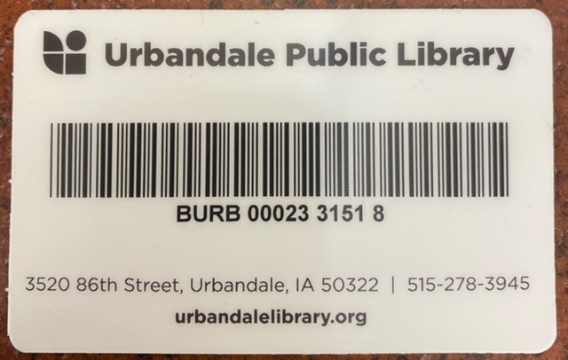

Librarian with who I established a relationship. Please see the call card.

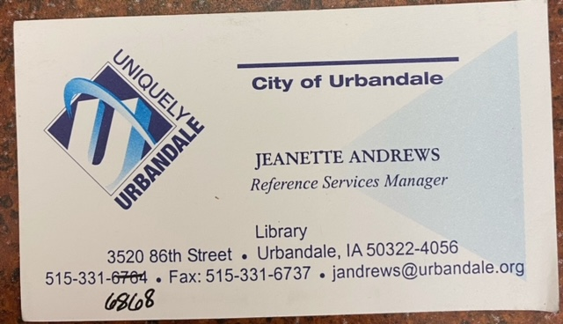

I contacted the Des Moines Area Community College Urban Campus to build a relationship with the research library. Unfortunately, I was told that since I am not a school student, they would only give me access to physical items in their library, but I would have no access to electronic materials. I was not able to get access to a library card or electronic materials.

1. I did establish a relationship with Jeanette Andrews, a reference services manager at the Urbandale Public Library, located at 3520 86th Street in the Des Moines area of Iowa.

I did not establish any relationship with a librarian from a college or university as instructed because of these colleges and universities' policies regarding individuals who are not students.

1. ProQuest, Google Scholars, Google Books, Open Assess (Dissertation)
2. OGS’s Library ProQuest Article:

Kundzina, al at (2023). General Fundraising Trends among Universities Patrons and

Entrepreneurs to Promote Sustainability of Universities. Sustainability.

Retrieved from ProQuest. ProQuest

1. Google Article:

Hugo, H (2022). Crowdfunding in Higher Education: Evidence from the UK

Universities. SPRINGER NATURE. Volume#83, P. 547-575

1. Google Book:

Worth, M. J. (2022). Comprehensive Fundraising Campaigns: New Directions for

Colleges and universities. Rowman and Littlefield. London

1. Christian, K.M. (2024). Identifying Demographic Variables that Can Predict Alumni

Giving at a Regional Comprehension Four-Year Universities in the South.

Doctoral Dissertation. Sam Houston University. Retrieved from ProQuest.

Dissertation

**References:**

Christian, K. M. (2024). Identifying Demographic VAriables that can Predict Alumni Giving at a Reginal Comprehension Four-Yera University in the South. *ProQuest*.

Hugo, H. M. (2022). Crowdfunding in Higher Education: Evidence from UK Universities. *SPRINGER NATURE*, 547-575.

Kundzina, L. R. (2023). General Fundraising Trends among University Patrons and Entrepreneurs to Promote the Sustainability of Universities. *Sustainability*.

Worth, M. J. (2022). *Comprehensive Fundraising Campaign: New Directions for Colleges and Universities.* London: Rowman and Littlefield.