**RESEARCH FOR 21ST CENTURY ASSIGNMENT #2 EXERCISE**

Anthony W. Brown, MA CSFP

Omega Graduate School

Caroline Geer, Ph.D., M.A., M.L.I.S., Instructor

February 16, 2025

Assignment #2 – Exercise

Submit to DIAL using the OGS Assignment Template to create a document containing the

following:

1. Obtain a library card from one local municipal library and one university or college

library. Insert a picture of the library card into your Assignment document.

2. Locate and establish a working relationship with one research librarian in each library.

Provide the name and location of the libraries and research librarians you selected.

3. Practice your online research skills in ProQuest, Google Scholar, Google Books, and

SR-953 Research for 21st Century 6

© 2022 Omega Graduate School. All rights reserved. Revised July 2023

and Open Access These and Dissertations to create a starter Works Cited reference list

in APA 7 format.

a. Use the OGS Library User’s Guide (2020) RESEARCH DATABASE

PASSWORDS to access the ProQuest database. Find a research journal article

related to a topic of interest. Download it and provide an APA formatted

bibliographic reference for the article: Last Name, First name initials. (Year).

Article title in sentence case. Journal Title, Vol.#(Issue #), pp. page range.

Double spaced in a .5 inch hanging indent.

b. Use Google Scholar (https://scholar.google.com) Find a research journal article

related to a topic of interest. Download it and provide an APA formatted

bibliographic reference for the article like the ProQuest article.

c. Use Google Books (https://books.google.com) and find a book within the last 5

years about a topic of interest. Download it and provide an APA formatted

bibliographic reference for the book: Last Name, First name initials. (Year). Book

title in sentence case and italicized. Publisher. Double spaced in a .5 inch

hanging indent.

d. Use Open Access These and Dissertations (https://oatd.org) find a dissertation

within the last 5 years about a topic of interest. Download it and provide an APA

formatted bibliographic reference for the dissertation: Last Name, First name

initials. (Year). Dissertation title in sentence case and italicized. [Doctoral

Dissertation] Name of School. Double spaced in a .5 inch hanging indent.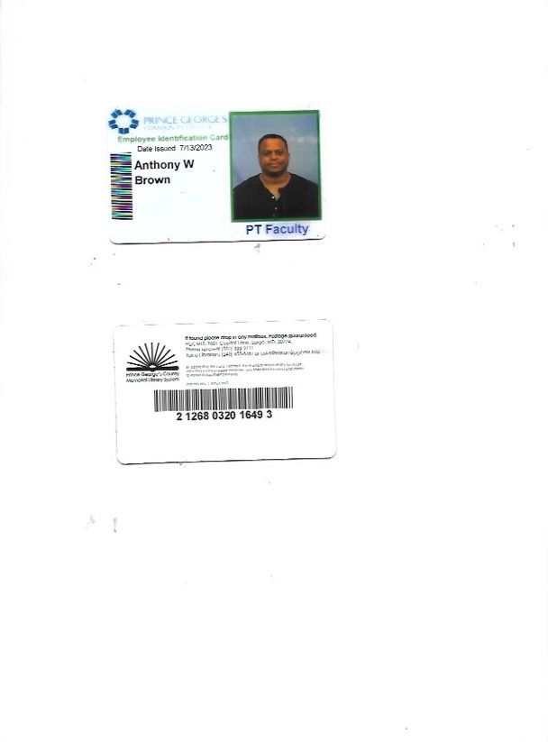

## Enoch Pratt Free Library eCard confirmation

|  |  |  |  |  |
| --- | --- | --- | --- | --- |
| |  | | --- | | Enoch Pratt Free Library <sirsi@pac.epfl.net> | | Fri, Jan 31, 12:00 PM |  |  |
| |  | | --- | | to me | | | |

Welcome to Enoch Pratt Free Library!  
  
Please note your eCard number below as it may be required to access our services. We recommend saving this email in case you forget your eCard number.  
  
Pratt eCard number: 24170900152026  
  
Find eBooks, eMagazines, eAudiobooks, movies, and more here: <https://www.prattlibrary.org/elibrary/>.  
If you would like to upgrade your card to check out physical materials or use our computers, please visit any branch and present identification.  
Thank you for using Enoch Pratt Free Library.

1. Card above is my work Identification for the Prince George’s Community College which gives me access to the library as faculty.
2. Card two is from Prince George’s County Memorial Library System. I obtained the card from the location in Hyattsville, MD. It can used at any public Library location in the County. This library has the most user-friendly resources online when researching.
3. Card three is the email confirmation from the Central Library in Baltimore City. I have a contact at this library which is one of the best researchers around. Mr. Shaw is retired from the San Francisco Public Library and relocated to Baltimore where he now works. This contact included for support in tedious research.

Jaimee McRoberts:

Learning Commons Director

Prince George’s Community College

Library & Learning Resources

Accokeek Hall

Telephone: 301-546-0214

Jaimee McRoberts: Contact

E-mail: mcrobejn@pgcc.edu

Central Library

400 Cathedral Street

Baltimore, MD 21201

Enoch Pratt Free Library

(410) 396 5430

Stewart Shaw: Research Contact

Prince George’s County Memorial Library System

Hyattsville Branch

6530 Adelphi Road

Hyattsville, MD 20782

(240) 455-5451

Heather Jackson: Contact

Works Cited Reference List

**ProQuest**

Ogles, B. M., Carlston, D., Hatfield, D., Melendez, G., Dowell, K., & Fields, Ogles, B. M., Carlston, D., Hatfield, D., Melendez, G., Dowell, K., & Fields, S. A. (2006). The role of fidelity and feedback in the wraparound approach. *Journal of Child and Family Studies*, *15*, 114-128.

**Google Scholar**

Kober, N. (2001). It Takes More Than Testing: Closing the Achievement Gap. A Report of the Center on Education Policy.

**Google Books**

The Science of Learning and Development: Enhancing the Lives of All Young People. (2021). United Kingdom: Taylor & Francis.

**Open Access**

Trejo, J. (2024). The effects of community school partnerships on students and educators in five urban high schools: A view from the field (Doctoral dissertation, Alverno College). https://alverno.omeka.net/items/show/938