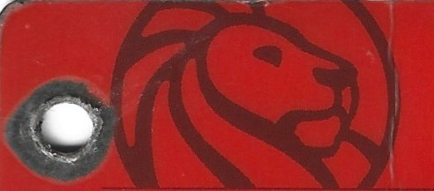
New York
Public
Library
KNOWLEDGE is POWER


Tyrone N. Cheeseboro
02/16/25
Roosevelt Island Public Library
504 Main Street
New York, NY 10044
212-308-6243
Research Librarian – Mr. Carlos Chavez

- Name & title of the person I spoke with and Name & address of the college:
Roosevelt Island Public Library - 504 Main Street New York, NY 10044 212-308-6243
Research Librarian – Mr. Carlos Chavez

- Exactly what the person asked and the person’s response: College

Research Librarian - Ms. Fannie Ouyang
Associate Director of Access and Engagement
Barnard Library & Academic Information Services (BLAIS)
Milstein Center, Room 212 | Barnard College
3009 Broadway, New York, NY 10027.

I explained to the person that I was a student, and I needed to obtain a college library card to do research. She said the Barnard Library does not offer library cards to unaffiliated users.

Proquest:
Jewell, J.O., Maynes, M. J., Lieberman, R. C., & Emigh, R.J. (2024). Virtual issues: Race in the United States in Social Science History. Social Science History, 48(3), 593-600.
Google Scholar:
Flanagin, A., Frey T., & Christiansen, S. L. (2021). Reporting off Race and Ethnicity in Medical and Science Journals. JAMA, 326(7), 621-627.
Google Books:
Davis, D.W., & Wilson, C.W (2021). Racial Resentment in the Political Mind. University of Chicago Press.
Open Access These and Dissertations:
Triguero, R.M. (2024). Colorblind Ethnocentrism: Racialized Imagined Communities in Western Europe and the United States. (Doctoral Dissertation). Columbia University.

