SR-953: Research for 21st Century Scholarship

Milkias Taye Gutema

Omega Graduate School

Date (February 16, 2025)

Professor

Dr. Caroline Geer

Assignment #2 – Exercise

Submit to DIAL using the OGS Assignment Template to create a document containing the

following:

1. Obtain a library card from one local municipal library and one university or college

library. Insert a picture of the library card into your Assignment document.

2. Locate and establish a working relationship with one research librarian in each library.

Provide the name and location of the libraries and research librarians you selected.

3. Practice your online research skills in ProQuest, Google Scholar, Google Books, and

Open Access These and Dissertations to create a starter Works Cited reference list

in APA 7 format.

a. Use the OGS Library User’s Guide (2020) RESEARCH DATABASE

PASSWORDS to access the ProQuest database. Find a research journal article

related to a topic of interest. Download it and provide an APA formatted

bibliographic reference for the article: Last Name, First name initials. (Year).

Article title in sentence case. Journal Title, Vol.#(Issue #), pp. page range.

Double spaced in a .5 inch hanging indent.

b. Use Google Scholar (https://scholar.google.com) Find a research journal article

related to a topic of interest. Download it and provide an APA formatted

bibliographic reference for the article like the ProQuest article.

c. Use Google Books (https://books.google.com) and find a book within the last 5

years about a topic of interest. Download it and provide an APA formatted

bibliographic reference for the book: Last Name, First name initials. (Year). Book

title in sentence case and italicized. Publisher. Double spaced in a .5 inch

hanging indent.

d. Use Open Access These and Dissertations (https://oatd.org) find a dissertation

within the last 5 years about a topic of interest. Download it and provide an APA

formatted bibliographic reference for the dissertation: Last Name, First name

initials. (Year). Dissertation title in sentence case and italicized. [Doctoral

Dissertation] Name of School. Double spaced in a .5 inch hanging indent.

Assignment Response

1. I got two library ID card, one from Ethiopian Graduate School of Theology (EGUST) and one from Aberhot public library in Addis Ababa.

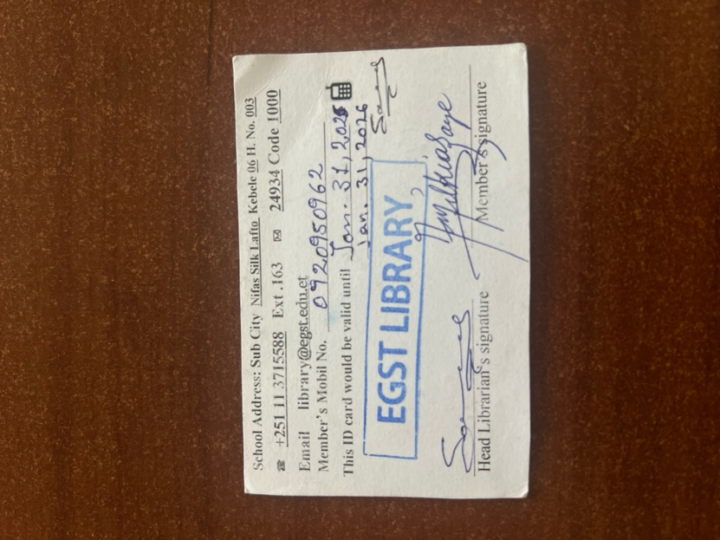

1. I stablished a working relationship with EGUST chief librarian, her name is Sara Demisse. In abrehot library they do not have such a service, but they just told me in the day I visited their library the librarian who is in duty will support me.
2. Practice online research skills
   1. ProQuest database

Watt, W. (2009). Facilitative social change leadership theory: 10 recommendations toward effective leadership. Journal of Leadership Education, Vol. 8 (Issue 2), 50-71.

* 1. Google Scholar (<https://scholar.google.com>)

Avelino, F. (2021). Theories of power and social change. Power contestations and their implications for research on social change and innovation. Journal of Political Power, Vol. 14 (No. 3), 425-448.

* 1. Google Books (<https://books.google.com>)

Tabassum, H. (2022). *Theories of social change*. K. K. Publications.

* 1. Open Access These and Dissertations (<https://oatd.org>)

Paulos, M. (2024). *Virtual space for change: Youth activism on twitter*. (Doctoral Dissertation) University of Calgary.

WORKS CITED

Avelino, F. (2021). Theories of power and social change. Power contestations and their implications for research on social change and innovation. Journal of Political Power, Vol. 14 (No. 3), 425-448.

Paulos, M. (2024). *Virtual space for change: Youth activism on twitter*. (Doctoral Dissertation) University of Calgary.

Tabassum, H. (2022). *Theories of social change*. K. K. Publications.

Watt, W. (2009). Facilitative social change leadership theory: 10 recommendations toward effective leadership. Journal of Leadership Education, Vol. 8 (Issue 2), 50-71.