Brent Dixon, SR 953-12, Research for 21st Century Scholarship, Assignment #2 – Core Essential Elements – Exercise, 11/21/2024 1

SR 953-12: Research for 21st Century Scholarship

Brent Dixon

Omega Graduate School

November 21, 2024

Professor

Dr. David Ward

Brent Dixon, SR 953-12, Research for 21st Century Scholarship, Assignment #2 – Core Essential Elements – Exercise, 11/21/2024 2
2. Exercise
Assignment #2 – Exercise
Submit to DIAL using the OGS Assignment Template to create a document containing the
following:
1. Obtain a library card from one local municipal library and one university or college
library. Insert a picture of the library card into your Assignment document.
2. Locate and establish a working relationship with one research librarian in each library.
Provide the name and location of the libraries and research librarians you selected.
3. Practice your online research skills in ProQuest, Google Scholar, Google Books, and and Open Access These and Dissertations to create a starter Works Cited reference list
in APA 7 format.
a. Use the OGS Library User’s Guide (2020) RESEARCH DATABASE
PASSWORDS to access the ProQuest database. Find a research journal article
related to a topic of interest. Download it and provide an APA formatted
bibliographic reference for the article: Last Name, First name initials. (Year).
Article title in sentence case. Journal Title, Vol.# (Issue #), pp. page range.
Double spaced in a .5 inch hanging indent.
b. Use Google Scholar (https://scholar.google.com) Find a research journal article
related to a topic of interest. Download it and provide an APA formatted
bibliographic reference for the article like the ProQuest article.

Brent Dixon, SR 953-12, Research for 21st Century Scholarship, Assignment #2 – Core Essential Elements – Exercise, 11/21/2024 3
c. Use Google Books (https://books.google.com) and find a book within the last 5
years about a topic of interest. Download it and provide an APA formatted
Bibliographic reference for the book: Last Name, First name initials. (Year). Book
title in sentence case and italicized. Publisher. Double spaced in a .5 inch
hanging indent.

d. Use Open Access These and Dissertations (https://oatd.org) find a dissertation
within the last 5 years about a topic of interest. Download it and provide an APA
formatted bibliographic reference for the dissertation: Last Name, First name
initials. (Year). Dissertation title in sentence case and italicized. [Doctoral
Dissertation] Name of School. Double spaced in a .5 inch hanging indent.

Brent Dixon, SR 953-12, Research for 21st Century Scholarship, Assignment #2 – Core Essential Elements – Exercise, 11/21/2024 4
1. Obtain a library card from one local municipal library and one university or college
library. Insert a picture of the library card into your Assignment document.
One local municipal library -
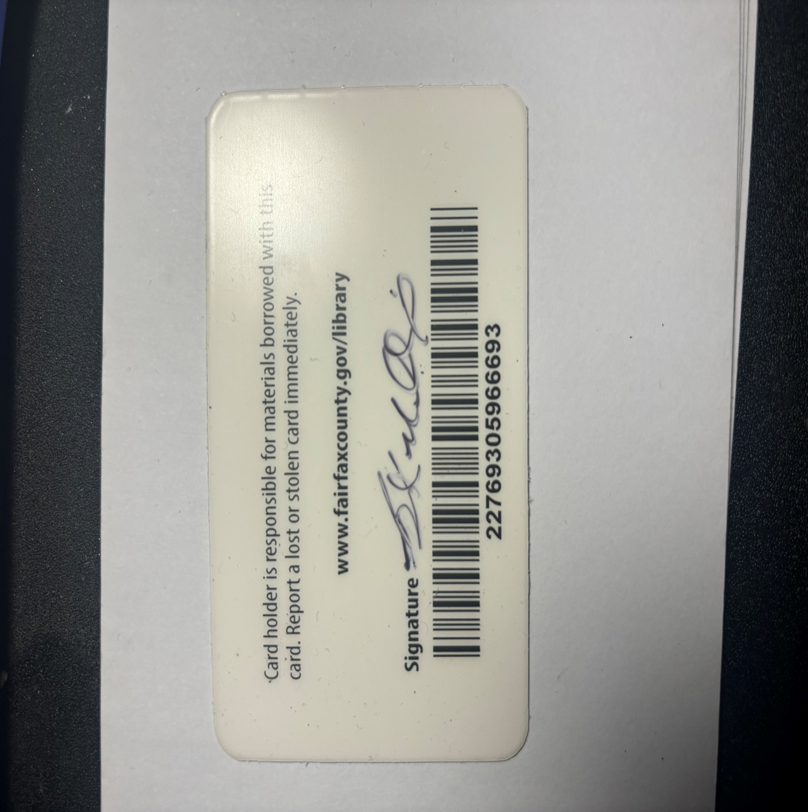

Brent Dixon, SR 953-12, Research for 21st Century Scholarship, Assignment #2 – Core Essential Elements – Exercise, 11/21/2024 5

One virtual university or college library –
https://ask.library.strayer.edu/search/?q=virtual%20library%20card&t=0
2. Locate and establish a working relationship with one research librarian in each library.
Provide the name and location of the libraries and research librarians you selected.
library@strayer.edu
Author: This guide was authored by Durell S. Thompson.
Created: November 2021
Library: Business writing: Home. Home - Business Writing - Library at Strayer University. (n.d.). https://library.strayer.edu/buswrit

Brent Dixon, SR 953-12, Research for 21st Century Scholarship, Assignment #2 – Core Essential Elements – Exercise, 11/21/2024 6
3. Practice your online research skills in ProQuest, Google Scholar, Google Books, and Open Access These and Dissertations to create a starter Works Cited reference list
in APA 7 format.
https://journals.asm.org/doi/abs/10.1128/mbio.01539-17
Bosch, G., & Casadevall, A. (2017). Graduate biomedical science education needs a new philosophy. MBio, 8(6), 10-1128.
b. Use Google Scholar (https://scholar.google.com) Find a research journal article
related to a topic of interest.
https://journals.sagepub.com/doi/abs/10.1037/1089-2680.9.2.169
Hogan, R., & Kaiser, R. B. (2005). What we know about leadership. Review of general psychology, 9(2), 169-180.

Brent Dixon, SR 953-12, Research for 21st Century Scholarship, Assignment #2 – Core Essential Elements – Exercise, 11/21/2024 7
c. Use Google Books (https://books.google.com) and find a book within the last 5
years about a topic of interest.
Vinje, Nils N.V. 2020. 30 Day Leadership Playbook
Your Guide to Becoming the Leader You Have Always Wanted to Be
Glide Consulting DBA 30 Day Leadership
d. Use Open Access These and Dissertations (https://oads.org) find a dissertation
within the last 5 years about a topic of interest.
http://ijds.org/Volume16/IJDSv16p533-552Donohue7308.pdf
Donohue, W. J., Lee, A. S. J., Simpson, S., & Vacek, K. (2021). Impacts of the COVID-19 pandemic on doctoral students’ thesis/dissertation progress. International Journal of Doctoral Studies, 16, 533.

Brent Dixon, SR 953-12, Research for 21st Century Scholarship, Assignment #2 – Core Essential Elements – Exercise, 11/21/2024 8
WORKS CITED
Vinje, N. (2020). 30 Day Leadership Playbook: Your Guide to Becoming the Leader You Have Always Wanted to Be. United States: Glide Consulting DBA 30 Day Leadership.
Bosch, G., & Casadevall, A. (2017). Graduate biomedical science education needs a new philosophy. MBio, 8(6), 10-1128.
Akçayır, G., & Akçayır, M. (2018). The flipped classroom: A review of its advantages and challenges. Computers & Education, 126, 334-34
Hogan, R., & Kaiser, R. B. (2005). What we know about leadership. Review of general psychology, 9(2), 169-180.
Applebee, A. N., Langer, J. A., Nystrand, M., & Gamoran, A. (2003). Discussion-based approaches to developing understanding: Classroom instruction and student performance in middle and high school English. American Educational research journal, 40(3), 685-730.
Google. (n.d.). Google books Ngram Viewer. Google Books. https://books.google.com/ngrams/graph?year_start=1800&year_end=2019&corpus=26&smoothing=7&case_insensitive=on&content=andragogy
Chehayeb, R. J., SenthilKumar, G., Saade, Z., Marin, B. G., Aghagoli, G., & Virji, A. Z. (2022). Examining the first peer-to-peer mentorship program (F1Doctors) for international medical students. Journal of interdisciplinary studies in education, 11(1), 102-125.
Chi, T., Cheng, L., & Zhang, Z. (2023). Global prevalence and trend of anxiety among graduate students: A systematic review and meta‐analysis. Brain and Behavior, 13(4), e2909.
Dietary Guidelines Advisory Committee. (2010). US Department of Agriculture and US Department of Health and Human Services. Nutrition and Your Health: Dietary Guidelines for Americans.
Donohue, W. J., Lee, A. S. J., Simpson, S., & Vacek, K. (2021). Impacts of the COVID-19 pandemic on doctoral students’ thesis/dissertation progress. International Journal of Doctoral Studies, 16, 533.
Forrester, N. (2023). Fed up and burnt out:‘quiet quitting’hits academia. Nature, 615(7953), 751-753.
Hyun, J. K., Quinn, B. C., Madon, T., & Lustig, S. (2006). Graduate student mental health: Needs assessment and utilization of counseling services. Journal of College Student Development, 47(3), 247-266.
Oswalt, S. B., & Riddock, C. C. (2007). What to do about being overwhelmed: Graduate students, stress and university services. College Student Affairs Journal, 27(1), 24-44.
Posselt, J. (2021). Discrimination, competitiveness, and support in US graduate student mental health. Studies in Graduate and Postdoctoral Education, 12(1), 89-112.
Pressley, T. A. (2017). Educational leadership: benefits of stepping outside the classroom. Advances in Physiology Education, 41(3), 454-456.
Woolston, C. (2022). ‘Not even enough money for food’: graduate students face cash crunch.
White, K. (2019). Publications Output: US Trends and International Comparisons. Science & Engineering Indicators 2020. NSB-2020-6. National Science Foundation.

