SR 953-12: Research for 21st Century Scholarship (Fall 2024, Subterm A)

Semaj Zachary

Omega Graduate School

September 12, 2024

Professor

Dr. Ward and Dr. Geer

Use this page to copy and paste the assignment details

I chose to go to the library in Washington, DC, at the Martin Luther King Jr. location. The research librarian there I chose was Maryann. The other library I chose was the Parkside Library located on South College’s campus. There I met with Jon, he’s a librarian who also specializes in APA as well. Below you will see a picture of my library card from each. I was a student at South College, so my student ID is also the library card.

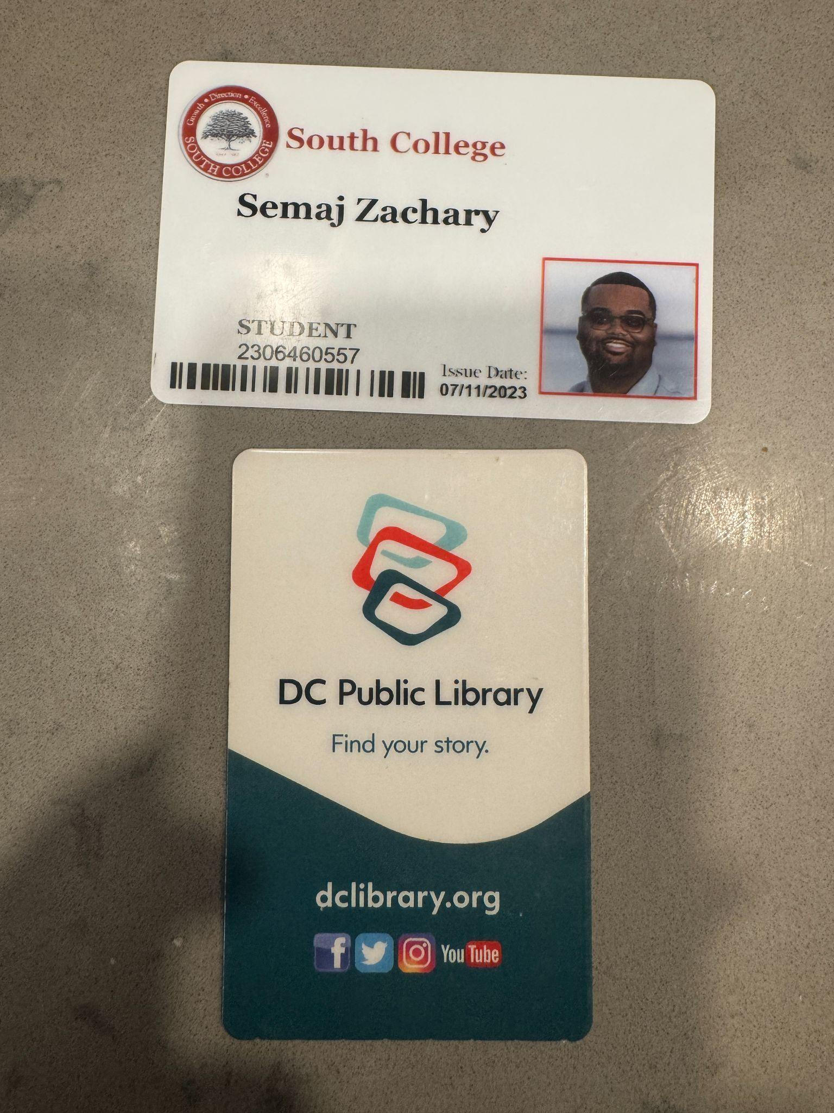

WORKS CITED

Cooper, T. (2021). Teacher perceptions of E-learning during Covid-19 in low-and-high-income schools. Theses, Dissertations and Capstones. https://mds.marshall.edu/etd/1378/

Du, J., & Anderson, J. D. (2003). Technology and Quality of Education: Does Technology Help Low-Income and Minority Students in Their Academic Achievements?. U. Ill. JL Tech. & Pol'y, 1.

Du, J., Sansing, W., Yu, C. (2004). The Impact of Technology Use on Low-Income and Minority Students' Academic Achievements: Educational Longitudinal Study of 2002. (n.p.): ERIC Clearinghouse.

Ferguson, L. L. (2023). School Leaders' Role in Dismantling the Digital Divide: Technology Use for Black K-8 Students Attending Low-Income Schools. United States: Drexel University.

Maria, R. R. S. (2011). IDENTITY FORMATION AND "OTHERING":: URBAN HIGH SCHOOL STUDENTS DISCUSS TECHNOLOGY ACCESS IN A LOW-INCOME, URBAN HIGH SCHOOL. International Journal of Arts & Sciences, 4(21), 103-114. https://www.proquest.com/scholarly-journals/identity-formation-othering-urban-high-school/docview/1315164005/se-2