Research for 21st Century Scholarship

Michael B. Bowe

Omega Graduate School

09/25/2024

Professor

Dr. David Ward

Assignment

1.

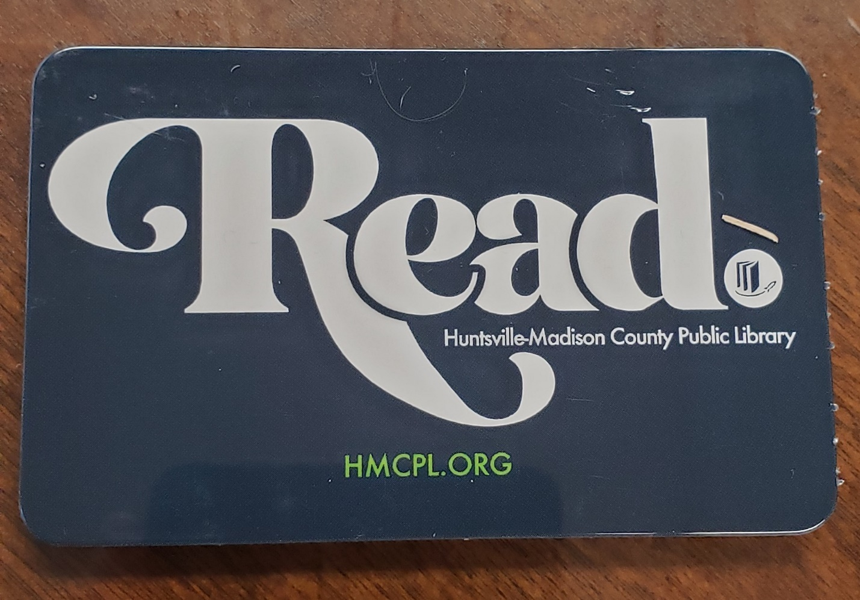Here is a picture of the library card from the Huntsville Public Library. While the public library is not focused on scholarship, the staff there is very helpful with interlibrary loans. They said they could find a book if I needed it and have it within a few weeks.

2.

I am an alumnus of three universities.

Amridge University: Terence Sheridan, Director of Library services

Liberty University: staff contact unknown

Memphis Seminary: Ed Hughes, Librarian

Each of these libraries offer books, articles and dissertation search helps.

3.

a:

Williams, D. K. (2019). When Science Turned Secular: The Mainline Protestant Abandonment of Natural Theology and the Secularization of American Colleges in the Early Twentieth Century. *Fides et Historia*, 51(2), 1–12.

b.

Flatt, K. N., Haskell, D. M., & Burgoyne, S. (2018). Secularization and Attribution: How Mainline Protestant Clergy and Congregants Explain Church Growth and Decline. *Sociology of Religion*, 79(1), 78–107.

c:

Burge, R. (2023*) The Nones: Where They Came From, Who They Are, and Where They Are Going*, Fortress Press.

d.

Ferguson, J. W. (2024). *Mega-Church or Mega-Sect* (Order No. 30988303). Available from ProQuest Dissertations & Theses Global.