SR-953: Research for 21st Century Scholarship

Obed Alcime

Omega Graduate School

September 07, 2024

Professor

Dr. Ward

Assignment #2 – Exercise
Submit to DIAL using the OGS Assignment Template to create a document containing the following:
1. Obtain a library card from one local municipal library and one university or college
library. Insert a picture of the library card into your Assignment document.

2. Locate and establish a working relationship with one research librarian in each library.
Provide the name and location of the libraries and research librarians you selected.

3. Practice your online research skills in ProQuest, Google Scholar, Google Books, and Open Access These and Dissertations to create a starter Works Cited reference list
in APA 7 format.

a. Use the OGS Library User’s Guide (2020) RESEARCH DATABASE
PASSWORDS to access the ProQuest database. Find a research journal article
related to a topic of interest. Download it and provide an APA formatted
bibliographic reference for the article: Last Name, First name initials. (Year).
Article title in sentence case. Journal Title, Vol.# (Issue #), pp. page range.
Double spaced in a .5 inch hanging indent.

b. Use Google Scholar (https://scholar.google.com) Find a research journal article
related to a topic of interest. Download it and provide an APA formatted
bibliographic reference for the article like the ProQuest article.

c. Use Google Books (https://books.google.com) and find a book within the last 5
years about a topic of interest. Download it and provide an APA formatted
bibliographic reference for the book: Last Name, First name initials. (Year). Book
title in sentence case and italicized. Publisher. Double spaced in a .5 inch
hanging indent.

d. Use Open Access These and Dissertations (https://oatd.org) find a dissertation
within the last 5 years about a topic of interest. Download it and provide an APA
formatted bibliographic reference for the dissertation: Last Name, First name
initials. (Year). Dissertation title in sentence case and italicized. [Doctoral
Dissertation] Name of School. Double spaced in a .5 inch hanging indent.

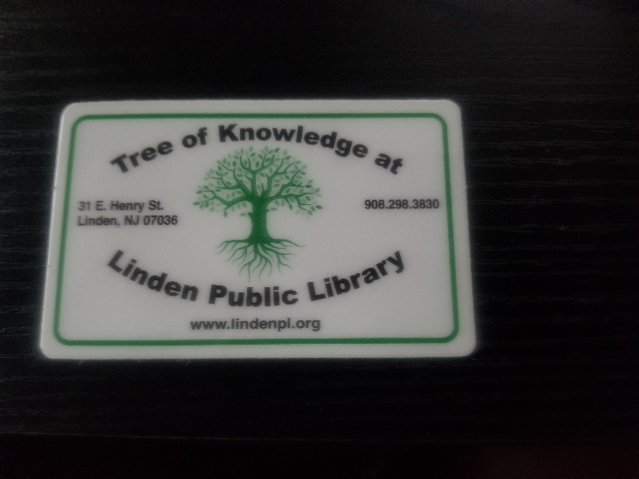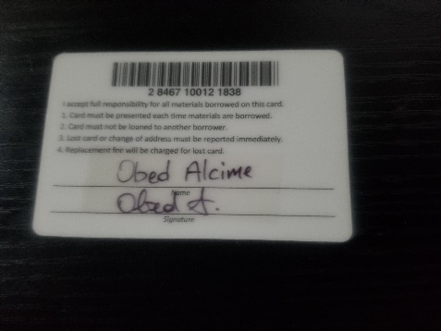
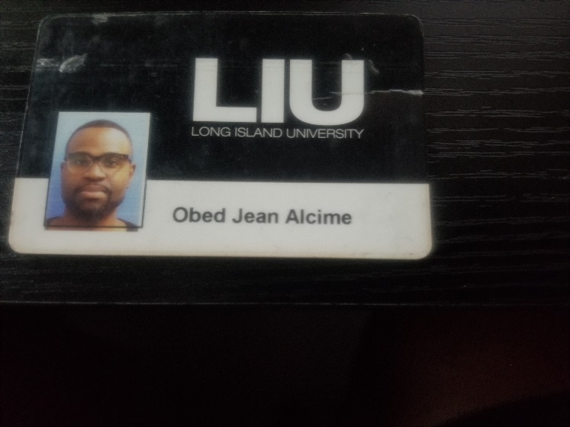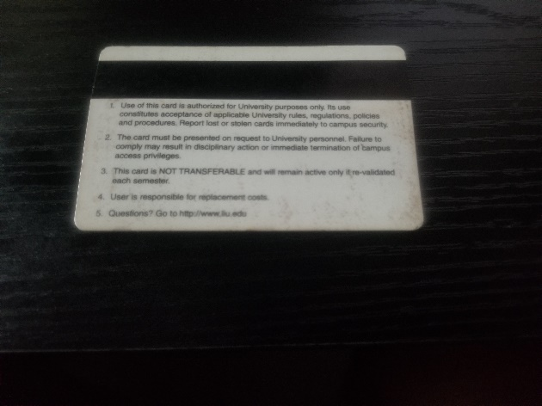

Librarian List
Lisa McClure, Librarian
Linden Free Public Library- Linden, NJ

Constance Woo, Librarian LIU
Long Island University- Brooklyn Campus Library- Brooklyn, NY

WORKS CITED

Melé Domènec, & Joan, F. (2017). Christian Ethics and Spirituality in Leading Business Organizations: Editorial Introduction: JBE. Journal of Business Ethics, 145(4), 671-679. https://doi.org/10.1007/s10551-016-3323-3
Zadroga, A. (2021). Professional Ethics of Social Entrepreneurs: The Perspective of Christian Personalist Ethics. Verbum Vitae, 39(2), 495-513.
Morgen Witzel. (2019). The ethical leader: why doing the right thing can be the key to competitive advantage. Bloomsbury Publishing Plc.
Holmes, J. M. (2023). Ethical Leadership: A Phenomenological Study of Administrators' Principles for Ethical Decision-Making. (Doctoral Dissertation). Liberty University.
‌

