SR 953-12: Research for 21st Century Scholarship (Fall 2024, Subterm A)

Lewis McCarter

Omega Graduate School

September 7, 2024

Professor

Dr. David Ward

Assignment #2 – Exercise
Submit to DIAL using the OGS Assignment Template to create a document containing the following:
1. Obtain a library card from one local municipal library and one university or college library. Insert a picture of the library card into your Assignment document.
2. Locate and establish a working relationship with one research librarian in each library. Provide the name and location of the libraries and research librarians you selected.
3. Practice your online research skills in ProQuest, Google Scholar, Google Books, and and Open Access These and Dissertations to create a starter Works Cited reference list in APA 7 format.
a. Use the OGS Library User’s Guide (2020) RESEARCH DATABASE PASSWORDS to access the ProQuest database. Find a research journal article related to a topic of interest. Download it and provide an APA formatted bibliographic reference for the article: Last Name, First name initials. (Year). Article title in sentence case. Journal Title, Vol.#(Issue #), pp. page range. Double spaced in a .5 inch hanging indent.
b. Use Google Scholar (https://scholar.google.com) Find a research journal article related to a topic of interest. Download it and provide an APA formatted bibliographic reference for the article like the ProQuest article.
c. Use Google Books (https://books.google.com) and find a book within the last 5 years about a topic of interest. Download it and provide an APA formatted bibliographic reference for the book: Last Name, First name initials. (Year). Book title in sentence case and italicized. Publisher. Double spaced in a .5 inch hanging indent.
d. Use Open Access These and Dissertations (https://oatd.org) find a dissertation within the last 5 years about a topic of interest. Download it and provide an APA formatted bibliographic reference for the dissertation: Last Name, First name initials. (Year). Dissertation title in sentence case and italicized. [Doctoral Dissertation] Name of School. Double spaced in a .5 inch hanging indent.

- 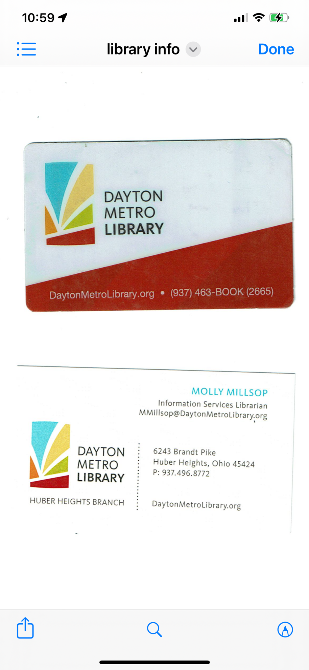 I have a “State of Ohio” library care coming in the mail which will give me access to all public libraries in Ohio including the state colleges and universities. This information was provided by the reference librarian I met with from Sinclair Community College.
- Molly Millsop, Information Services Librarian, Dayton Metro Library-Huber Heights Branch (branch research librarian)
Julie McDaniel, Student Success Librarian (research librarian), Sinclair Community College

Boas, S. V. (2024). The Importance of the Nicean Creed for Christian Identity: A Theological–Pastoral Reading from the Philosophy of Austin and Lakatos. Religions, 15(4), 447.

Hong, R. C. (2020). Black Dignity / White Fragility -An Extended Review. Christian Scholar's Review, 49(3), 281-286.

Harris, A. L. (2020). Is Christianity the White Man's Religion? How the Bible Is Good News for People of Color. United States: InterVarsity Press.

Hatter, J. (2021) Slavery, the Enslaved, and the Gospel of Matthew: A Narrative, Social-Scientific Study. Dissertations. Loyola University Chicago.

WORKS CITED

Boas, S. V. (2024). The Importance of the Nicean Creed for Christian Identity: A Theological–Pastoral Reading from the Philosophy of Austin and Lakatos. Religions, 15(4), 447.
Hatter, J. (2021) Slavery, the Enslaved, and the Gospel of Matthew: A Narrative, Social-Scientific Study. Dissertations. Loyola University Chicago.

Harris, A. L. (2020). Is Christianity the White Man's Religion? How the Bible Is Good News for People of Color. United States: InterVarsity Press.
Hong, R. C. (2020). Black Dignity / White Fragility -An Extended Review. Christian Scholar's Review, 49(3), 281-286.

