Research for 21st Century Scholarship

Dr. Darrell D. Cummings

Omega Graduate School

October 12, 2024

Professor

Dr. David Ward

**Assignment #2 – Exercise**

Submit to DIAL using the OGS Assignment Template to create a document containing the following:

1. Obtain a library card from one local municipal library and one university or college

library. Insert a picture of the library card into your Assignment document.

2. Locate and establish a working relationship with one research librarian in each library.

Provide the name and location of the libraries and research librarians you selected.

3. Practice your online research skills in ProQuest, Google Scholar, Google Books, and

Open Access These and Dissertations to create a starter Works Cited reference list

in APA 7 format.

a. Use the OGS Library User’s Guide (2020) RESEARCH DATABASE

PASSWORDS to access the ProQuest database. Find a research journal article

related to a topic of interest. Download it and provide an APA formatted

bibliographic reference for the article: Last Name, First name initials. (Year).

Article title in sentence case. Journal Title, Vol.#(Issue #), pp. page range.

Double spaced in a .5 inch hanging indent.

b. Use Google Scholar (https://scholar.google.com) Find a research journal article

related to a topic of interest. Download it and provide an APA formatted

bibliographic reference for the article like the ProQuest article.

c. Use Google Books (https://books.google.com) and find a book within the last 5

years about a topic of interest. Download it and provide an APA formatted

bibliographic reference for the book: Last Name, First name initials. (Year). Book

title in sentence case and italicized. Publisher. Double spaced in a .5 inch

hanging indent.

d. Use Open Access These and Dissertations (https://oatd.org) find a dissertation

within the last 5 years about a topic of interest. Download it and provide an APA

formatted bibliographic reference for the dissertation: Last Name, First name

initials. (Year). Dissertation title in sentence case and italicized. [Doctoral

Dissertation] Name of School. Double spaced in a .5 inch hanging indent.

1.





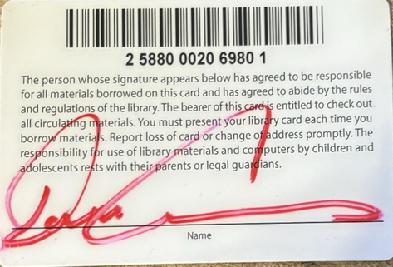

**Research Librarian**

Kimberly

(301) 645-1395

2.



**Research Librarian**

Amy Spitz

Email: aspitz@csmd.edu

(301) 934-7626

3.

A.)

[Robert C. Rogers](https://pubmed.ncbi.nlm.nih.gov/?term=Rogers%20RC%5BAuthor%5D) and [Taunya M. Tinsley](https://pubmed.ncbi.nlm.nih.gov/?term=Tinsley%20TM%5BAuthor%5D)

Black Pastors’ Experiences of Occupational and Life Stress During COVID-19 in the USA, Journal of Religion and Health, Volume 63, pages 685–703, (2024)

Curry, M. 2021

Resilience of Black Pastors Serving Impoverished Urban Communities in the United States. Grand Canyon University ProQuest Dissertations & Theses,  2021. (28769900). page 108-110

B.)

[Robert C. Rogers](https://pubmed.ncbi.nlm.nih.gov/?term=Rogers%20RC%5BAuthor%5D) and [Taunya M. Tinsley](https://pubmed.ncbi.nlm.nih.gov/?term=Tinsley%20TM%5BAuthor%5D)

# Black Pastors’ Experiences of Occupational and Life Stress During COVID-19 in the USA,

# Journal of Religion and Health, Volume 63, pages 685–703, (2024)

C.)

# Lewis, E. 2021

# 

# A Case Study of the Wellness Practices of Black Pastors Providing Emotional Support

# 

# from the Frontlines. North Carolina Agricultural and Technical State University ProQuest

# 

# Dissertations & Theses, 28643884.

D.)

Bang, S. ( 2021).

Clergy Self-Care for Cross-Racially/Cross-Culturally Appointed Pastors in the United Methodist Church. Fordham University ProQuest Dissertations & Theses, (28541944) page 42-43 (Doctoral Dissertation)

WORKS CITED