SR 953 Research for 21st Century Scholarship

Donovan A. McFarlane

Omega Graduate School

August 22, 2024

Professor

Dr. Ward David Ward

Assignment #2: Exercise
Submit to DIAL using the OGS Assignment Template to create a document containing the
following:
1. Obtain a library card from one local municipal library and one university or college library. Insert a picture of the library card into your Assignment document.
ANSWER:
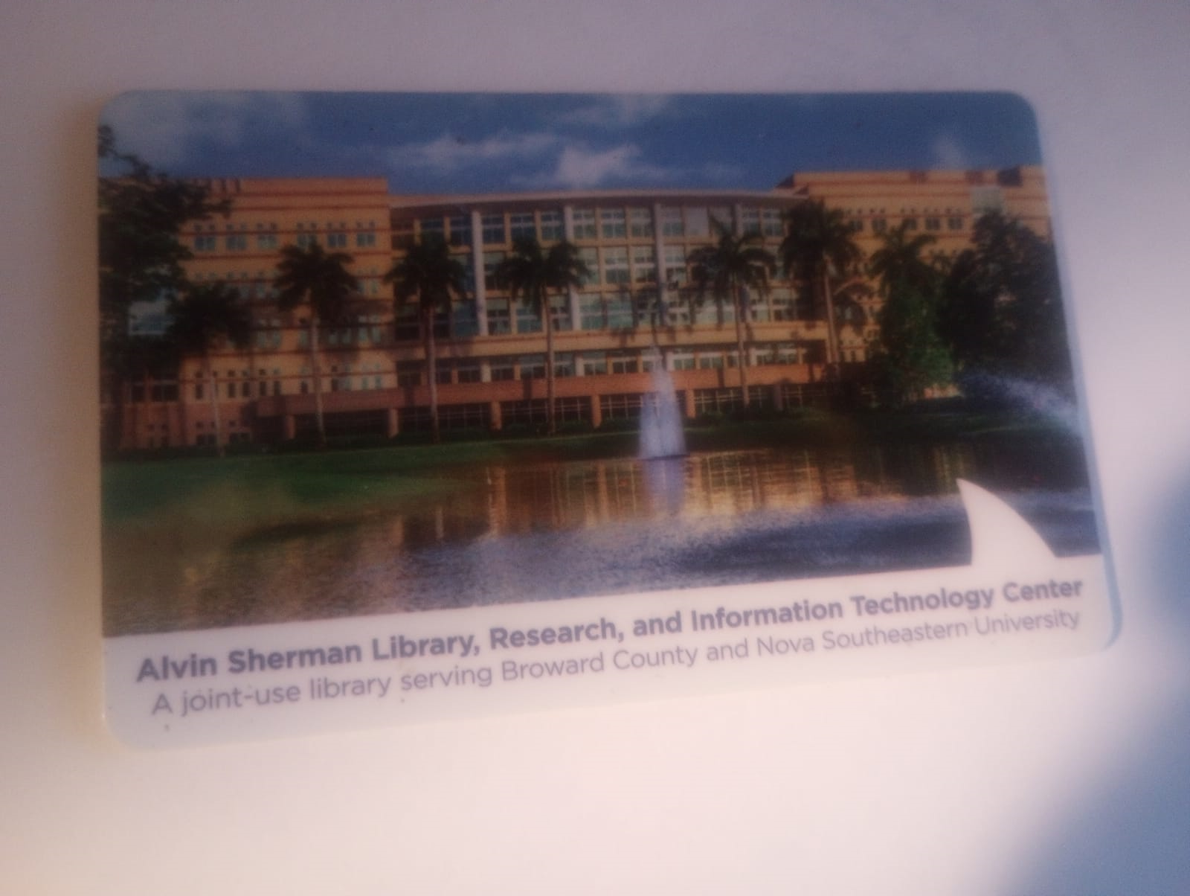

2. Locate and establish a working relationship with one research librarian in each library. Provide the name and location of the libraries and research librarians you selected.
ANSWER:
- Alvin Sherman Library, Research, and Information Technology Center
Nova Southeastern University
3100 Ray Ferrero Jr. Blvd. Fort Lauderdale, Davie, FL 33314
Research Librarian: Nora
- Steven and Dorothea Green Library
Florida International University
11200 SW 8th St, Miami, FL 33199
Research Librarian:
- St. Thomas University Library
16400 NW 32nd Ave, Opa Locka, FL 33054
Research Librarian: Mary
3. Practice your online research skills in ProQuest, Google Scholar, Google Books, and Open Access These and Dissertations to create a starter Works Cited reference list in APA 7 format.
a. Use the OGS Library User’s Guide (2020) RESEARCH DATABASE PASSWORDS to access the ProQuest database. Find a research journal article related to a topic of interest. Download it and provide an APA formatted bibliographic reference for the article: Last Name, First name initials. (Year). Article title in sentence case. Journal Title, Vol.#(Issue #), pp. page range. Double spaced in a .5 inch hanging indent.
ANSWER:
Saodi, S., Alshahrani, S. H., Jumanazarov, U., Al-Khafaji, F., & Jumintono, J. (2024). Culturally embedded education: Investigating moral intelligence and self-awareness in teachers from Islamic schools in Jakarta. International Journal of Society, Culture & Language, 12(2), 37-45. doi:https://doi.org/10.22034/ijscl.2024.2008412.3120.
b. Use Google Scholar (https://scholar.google.com) Find a research journal article related to a topic of interest. Download it and provide an APA formatted bibliographic reference for the article like the ProQuest article.
ANSWER:
Tamm, A., Tulviste, T., & Martinson, G. (2020). Teachers’ personal values, age, and educational setting shape their socialisation values. Journal of Beliefs & Values, 41(3), 322-330.
c. Use Google Books (https://books.google.com) and find a book within the last 5 years about a topic of interest. Download it and provide an APA formatted bibliographic reference for the book: Last Name, First name initials. (Year). Book title in sentence case and italicized. Publisher. Double spaced in a .5 inch hanging indent.
ANSWER:
Keddie, A. (2020). Teaching boys: Developing classroom practices that work. Routledge.
d. Use Open Access These and Dissertations (https://oatd.org) find a dissertation within the last 5 years about a topic of interest. Download it and provide an APA formatted bibliographic reference for the dissertation: Last Name, First name initials. (Year). Dissertation title in sentence case and italicized. [Doctoral Dissertation] Name of School. Double spaced in a .5 inch hanging indent.
ANSWER:
Adkins, A.M. (2020). What they take out of the Classroom: Values, compassion, and lessons that last. [Doctoral Dissertation] University of Akron. Retrieved from http://rave.ohiolink.edu/etdc/view?acc_num=akron1592325557127208.

