**Developmental Reading Study**

SR 958-42: Research Design and Methodology II (Fall 2024, Sub-term A)

**(Fall 2024, Sub-term A)**

**Assignment No. 11**

**Dr. Peter Abraham Airewele, DSL**

**Omega Graduate School**

**Professor**

**Dr. Sean Taladay, Edd**

**November 10, 2024**

**Assignment #2: Developmental Reading Log**

1. Create Developmental Readings from seminal sources and scholarly peer-reviewed

journal articles. Review instructions for Assignment #3, the course essential elements,

and course readings to identify selections of books and journals to create entries.

a. Refer to the "Student Guide to Developmental Readings" in the General

Helps folder for updated information on sample comments, the grading rubric,

and key definitions related to developmental readings.

**Introduction**

Given the critical nature of research design and methodology in this study, the significance of Linear regression will be determined to verify how they can be used to predict the capital market and the stock exchange in industrial business growth, and performance metrics. Attention will be given to Case study analysis (Gallagher, 2024; KIEU & MINH, 2024), how it can be channeled to supplement or complement the research design, process and completion, and the roles they play in thesis and dissertation. Moreover, this study seeks to assess and examine how writing a thesis or dissertation (Sileyew, 2019; Tomaszewski et al., 2020) from introduction to conclusion can be simplified without being a herculean task. Other areas of interest in the study will be Ethnography research referred to as descriptive anthropology research (Plodder & Hamann, 2021), its ability to provide artefacts, data storage, transformation and interpretive functions, despite the modest awareness about it in most organizations. The four common qualitative approaches, namely, narrative and phenomenology, case study, and ethnography, will be assessed to determine their attributes in data and information they generate, and the design visualizations they provide to organizations.

**Source One:** Tomaszewski, L. E., Zarestky, J., & Gonzalez, E. (2020). Planning qualitative research: Design and decision making for new researchers. *International journal of qualitative methods*, *19*, 1609406920967174.

**Comment 1:** The four common qualitative approaches, narrative and phenomenology case study and ethnography are critical especially in their data and design visualizations.

**Quote/Paraphrase:** For researchers, the choice of qualitative approach and subsequent alignment among problems, research questions, data collection, and data analysis can be particularly tricky. The four common qualitative approaches, case study, ethnography, narrative, and phenomenology, demonstrating how each approach is linked to specific types of data collection and analysis- enabling comparisons among approaches and the internal consistency within each approach (Tomaszewski et al., 2020). Abstract.

**Essential Elements:** Researchers, qualitative approach, subsequent alignment among problems, research questions, data collection, and data analysis, qualitative approaches, case study, ethnography, narrative, and phenomenology.

**Additive/Variant Analysis:** The additives are the “four approaches, case study, ethnography, narrative, and phenomenology, demonstrating the internal consistency within each approach.” They show their relevance in research designs.  Most times, they form part of the dissertation processes. They contribute data and information to them.

**Contextualization:**  Modern organizations incorporate the four qualitative narratives in their research design programs or projects. Sometimes, each is treated as standalone task, like carrying out a case study experimentation report. Others are ethnography (descriptive anthropology) or phenomenology (studying human experiences or movements).

**Comment 2:** Ethnography research, referred to as descriptive anthropology research has lot to offer in artefacts, data storing, transforming and interpreting despite its modest awareness.

**Quote/Paraphrase:** Ethnographic research is the product of multiple practices. It is an assemblage of interviewing, recording, reading, documenting, and working with data—transcribing, storing, transforming, sharing, labelling, coding, sequencing, comparing, interpreting, visualizing, and quoting. Although all these practices are integral to the process of producing ethnographic knowledge, only a few of them are addressed in methodological textbooks or seminars. (Plodder, & Hamann, 2021).

**Essential Elements:** Ethnographic research, an assemblage of interviewing, recording, reading, documenting, and working with data transcribing, storing, sharing, labelling, coding, sequencing, comparing, interpreting, visualizing, and quoting.

**Additive/Variant Analysis:** The variant is “although all these practices are integral to the process of producing ethnographic knowledge, only a few of them are addressed in methodological textbooks or seminars.” While century artifacts are pricey during auctions, the scientific study in ethnography and anthropology are not. Perhaps, this may be due to mass migration, urbanization and social civilization, perhaps people don’t show appetite for anthropology and old artefacts.

**Contextualization:** Ethnography, descriptive anthropology is deeply associated with sociological theories and model frameworks. Their theories seem to have some intersections with humanity, culture and society of research organizations. However, research studies and data management derived from them will still be attractive to academia and research organizations now and the future.

**Source Two:** KIEU, Q. T., & MINH, H. (2024) Handbook for Professional Preparation of Research Papers & Dissertations.

**Comment 3:**  The writing of a thesis or dissertation from introduction to conclusion can be a herculean task, and effective planning can help to overcome this.

**Quote/Paraphrase:** In a research paper, the key elements include i) Introduction of research context, comprehensive overview, defining the main topic, and emphasizing its importance, ii) Present the Research Problem or research gaps, iii) Delimiting the Research Scope. iv) Put a clear and concise thesis statement at the end of the introduction that summarizes the main research points. It is crucial to keep in mind that the thesis statement reflects the findings of the investigation and provides a cogent conclusion for the introduction (KIEU & MINH, 2024).

**Essential Element:** Research paper, key elements, research context, comprehensive overview, Research Problem or research gaps, Delimiting the Research Scope, Stating Research Purpose and Objectives, thesis, cogent conclusion, introduction.

**Additive/Variant Analysis:** The additive is, “Stating Research Purpose and Objectives clearly formulates a roadmap for the study.” The “roadmap” sets the goals, timelines and perhaps the benchmarks in the study journey. These elements highlighted may differ in approach to some research design. They should convey the data and information validated.

**Contextualization:** The research thesis or dissertation in most cases will include, the Literature Reviews, theoretical formulations, arguments, and statistical models. Others are the historical context, background and sociological theory, secular or faith-based analysis (in some cases). Moreover, there is the central pilot project or program scheme, ethical considerations, intervention design and conclusion reflecting the findings, outcomes and future interventions.

**Comment 4:** Most times, Case studies are smaller in research design, process and completion. Their statement of reference or corporate requirements are not as elaborate in timeline, content and context compared to Thesis and Dissertation.

**Quote/Paraphrase:** Case studies are bounded systems created by researchers. As Katherine Jocher writes, “Case study presumes a well-defined problem. That is, an inclusive study is made of a certain person, a particular community, a situation or episode. Digital phenomenon challenges Jocher’s notion of a well-defined problem not particularly effective for the spreadable (Jenkins, 2013). Rather, as a type of qualitative research, case studies attend to combinations of causes (Goetz and Mahoney, 2012, p. 5). Case study brings digital researchers’ choices into explicit discussion. Introduction (Gallagher, 2024, para. 1 to 16). 

**Essential Elements:** Case studies, bounded systems, problem. Digital phenomenon, challenges, spreadable qualitative research, case studies combinations, digital researchers’ choices, explicit discussion.

**Additive/Variant Analysis:** The variant is, “Case studies are bounded systems”. Case studies are not bounded systems in all situations. Case studies may be bounded in quantitative studies that require standard criteria, or requirement, or statement of prescribed requirement. Perhaps bounded by statement of standard or purpose. Case studies are not bounded in qualitative and descriptive study research. They may require assessing open ended questions and may resort to multi-dimensional study outcomes.

**Contextualization:** Case studies require professional research study and writing skills. The set boundaries of references are not fixed, they must be flexible to carry out extensive studies. The studies undertaken must be backed up by descriptive, categorical, and quantitative data analysis, when and where necessary.

**Source Three:** Waisapy, J. Y. (2024). Influence of Strategic Planning on Banking Performance via Differentiation Strategy. *Mimico*, *1*(7), 65-77.

**Comment 5:** Strategic differentiation is mostly explored by corporate entrepreneurs in their attempt to stimulate growth, niche marketing and competitive advantage.

**Quote/Paraphrase:** Multiple linear regression analysis was employed to evaluate the relationship between strategic planning, strategic differentiation, and business performance. The research findings indicate that strategic planning significantly influences strategic differentiation in the context of the banking industry. The implications of these findings are that banks implementing effective strategic planning tend to adopt better differentiation strategies, thereby enhancing their performance in facing intense market competition. This provides valuable contributions to understanding the relationship between strategic planning, strategic differentiation, and business performance in the banking market (Waisapy, 2024).

**Essential Elements:** Multiple linear regression analysis, relationship between strategic planning, strategic differentiation, and business performance, banking context, competitive position.

**Additive/Variant Analysis:** The additive is, “banks implementing effective strategic planning tend to adopt better differentiation strategies, thereby enhancing their performance in facing intense market competition.” Strategic planning is long term planning associated with banking or business differentiation.

**Contextualization:**  Banking or business differentiation strategies involve devising or attaching specific quality services or product branding to sure up their competitive advantage. It requires perhaps marked-up, or marked-down pricing, which are distinctive from other competitors’ pricing or brands. They add up to create niche marketing or branding to stimulate competitive pricing in one’s business or services industry.

**Comment 6:** Linear regression can be used to predict the capital market and the stock exchange industrial business growth, and performance metrics.

**Quote/Paraphrase:** The capital market is an organized system that processes securities such as shares, bonds, debentures, and other securities issued by governments and private companies using the services of intermediaries, commission agents, and underwriters (Bakri et al., 2023). Linear regression allows analysts and investors to identify linear relationships between independent variables (predictors) and dependent variables (stock prices) and use these relationships to make predictions about future value based on historical data (Harianto et al., 2023). However, applying linear regression in the context of stock price prediction requires a deep understanding of market dynamics and the ability to select and process relevant variables (Sudirjo et al., 2023), predict price fluctuations, a critical aspect that can determine an investor's success in achieving profits. (Eka, 2024) Abstract. Introduction.

**Essential Elements:** Linear regression, predict the capital market, the stock exchange, industrial business growth, performances, shares, bonds, debentures intermediaries, commission agents, and underwriters.

**Additive/Variant Analysis:** The additive is, “Linear regression allows analysts and investors to identify linear relationships between independent variables (predictors) and dependent variables (stock prices) based on historical data.” It implies the critical nature of independent variables as market predictors, and dependent variables representing the stock prices.

**Contextualization:** In the equation below:

* 𝚼=𝒂+𝒃𝟏𝝌𝟏+𝒃𝟐𝝌𝟐+⋯+𝒃𝒏𝝌𝒏:

Y is the dependent variable, which depends on the value of X (independent variable). The value of “a” is a constant and “b” is a regression coefficient of variable X. To get the value of a and b against the value of variable X. The markets’ independent variables (predictors) and the dependent variables (stock prices) are set in linear regression outlines and in statistical computations. The conclusion is presented in qualitative, descriptive charts or graphs, to enable their decision process, and public digital visualizations, etc. (Eka et al, 2024).

**Source Four:** Kronthaler, F., & Zöllner, S. (2021). Data analysis with RStudio. 

**Comment 7:** The RStudio is an integrated development environment for R, a programming language for statistical computing and graphics. It is available in two formats: i) RStudio Desktop, ii) and the RStudio Server which runs on a remote server accessible by a web browser.

**Quote/Paraphrase:** RStudio can easily be used for data analysis, descriptive statistics, creating graphics, testing hypotheses, ANOVA and regression. It provides exercises with solutions. RStudio can be installed and used to test hypotheses, run an analysis of variance and regressions, deepen the learned content, and tasks are included with the solutions (Kronthaler & Zöllner, 2021).

**Essential Elements:** RStudio, data analysis, descriptive statistics, creating graphics, testing hypotheses, ANOVA and regression, exercises with solutions, to test hypotheses, run an analysis of variance and regressions, deepen the learned content.

**Additive/Variant Analysis:** The additive is, “RStudio can easily be used for data analysis, descriptive statistics, creating graphics, testing hypotheses.” It shows its multidimensional features in statistical software. It is user friendly, and can be installed and used in the office and privately.

**Contextualization:** Modern organizations find the RStudio very useful statistical software. It is programming, cost and time effective. Upon inputting the data, they are processed as output results and solutions, promptly especially for decision making.

**Comment 8:** The SPSS statistical software is significant and attractive to the academia, and organizations. It has integrated linear and regression analytical interface models.

**Quote/Paraphrase:** Traditionally, linear regression modeling in the program Statistical Package for the Social Sciences (SPSS) is carried out using the REGRESSION procedure, which is capable of fitting linear models and computing a variety of model fit statistics.- The LINEAR procedure provides an effective, new solution to linear regression modeling in SPSS in comparison to the traditional REGRESSION procedure; where the LINEAR procedure functions well as the latter’s substitute. That is, LINEAR provides almost everything found in the traditional procedure, but it also offers additional, typically more advanced, features not available in REGRESSION (Yang, 2013).

**Essential Elements:** Linear regression modeling, Statistical Package for the Social Sciences (SPSS), REGRESSION procedure, The LINEAR procedure.

**Additive/Variant Analysis:** The additive is **“**The LINEAR procedure provides an effective, new solution to linear regression modeling in SPSS in comparison to the traditional REGRESSION procedure.” These combined effects make the SPSS a valuable statistical model to academia and several organizations. It simplifies complex data analytics.

**Contextualization:** The goal of simple linear regression is to build a model that will allows the use of the value of one continuous variable (for example a SAT score) to predict the value of another continuous variable (for example a Psychology exam score). The variable that is used to predict another variable is the independent (or predictor) variable. The variable that we want to predict is the dependent (or outcome or criterion) variable.

**IBM SPSS STATISTICS DATA EDITOR** Figure 4.1

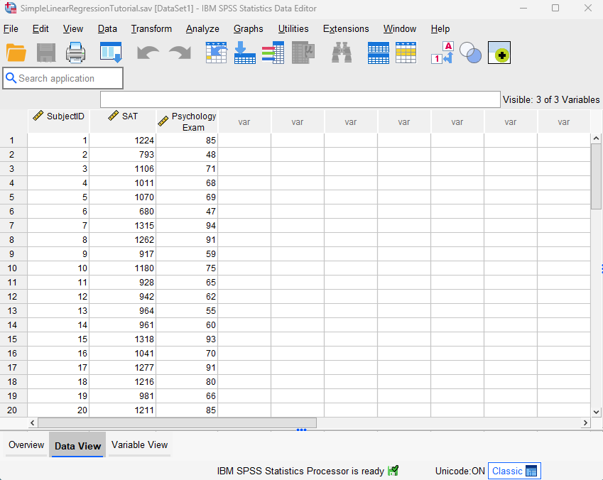

**Figure 4.2**

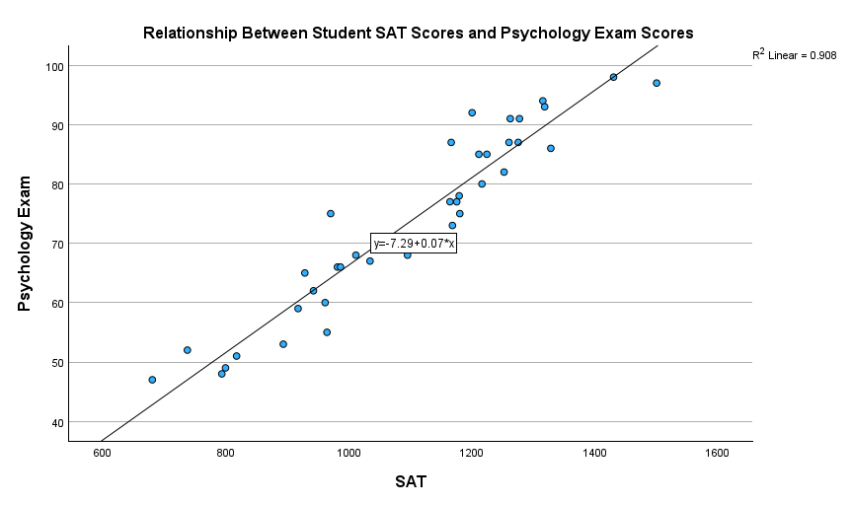

**Figure 4.3**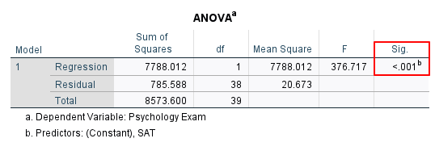

**Figure 4.4**

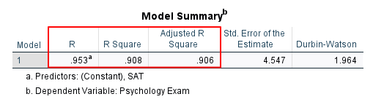

**Figure 4.5**

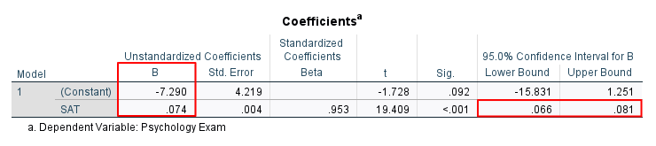

**Key**

* **Figures 4.1 to 4.5** are culled from: EZ SPSS Tutorials (2024)-

Simple Linear Regression in SPSS, Including Interpretation. Built

with Generated Press.

* The Figures reflect the simple data entry stage in Figure 4.1 on Sat, and Psychology scores of students.
* The plot graph in Figure 4.2 shows variables on slope, and intersecting variables. Figure 4.3 shows the Analysis of variance (ANOVA): a collection of statistical models and their associated estimation procedures (such as the "variation" among and between groups).
* Figures 4.4 and 4.5 show summary and the coefficients of the dependent variables.
* The SPSS is very user friendly, very illustrative, cost and time effective, compared to manual inductive and deductive computations.

**Source Five:**  Kumar, A. (2024) Understanding Statistical Analysis: Techniques and Applications By simplilearn.com/what-is-statistical-analysis-article.

**Comment 9:** Statistical analysis translates raw data into meaningful information for decision making, process in multidimensional services and industries.

**Quote/Paraphrase:** Statistical analysis is the process of collecting and analyzing data in order to discern patterns and trends. The 6 types of statistical analysis are i) Descriptive Analysis: involves collecting, interpreting, analyzing, and summarizing data to present them in the form of charts, graphs, and tables. ii) Inferential Analysis studies the relationship between different variables or makes predictions for the whole population. iii) Predictive Analysis analyzes data to derive past trends and predict future events on the basis of them (data mining, data modelling, and artificial intelligence. iv) Prescriptive Analysis prescribes the best course of action based on the results. v) Exploratory Data Analysis analyzes the potential relationships within the data. vi) Causal Analysis focuses on determining the cause-and-effect relationship between different variables within the raw data (Kumar, 2024).

**Essential Elements:** Statistical analysis, collecting and analyzing data, Descriptive Analysis, Inferential Analysis, Predictive Analysis, Prescriptive Analysis, Exploratory Data Analysis, Causal Analysis.

**Additive/Variant Analysis:** Statistical analysis is the process of collecting and analyzing data in order to discern patterns and trends.” Sometimes statistical simulation is required to create study visualization of the analysis. It enables management and employees to see and understand their novel plans. Moreover, to make the right decisions in their areas of business, and investment interests.

**Contextualization:**  Data analysis, sampling and interpretation convey easy understanding of the issues or situation at hand. Most times, the market trends or patterns often require large data analysis. This is designed to streamline the data in to useable or applicable multiple but simple information.

**Comment 10:** Microsoft excel or Google spread sheet can be utilized to facilitate data analysis especially in business accounting and auditing, and are comparable to the advanced and sophisticated statistical software even when they are not similar.

**Quote/Paraphrase:** Applied social science projects that involve many interviews produce a vast amount of data or text that is difficult to structure and analyze systematically. Computer-assisted qualitative data analysis software is too advanced and sophisticated when all we want is to sort and structure the text. A new method, using Microsoft Word and Excel, has been developed. The method produces a flexible Word document of interview data separated into logical chapters and subchapters. All text is coded, and the codes correspond with headings in the final document. Systematic manual coding ensures that all the content is coded, not just words or terms that are extracted from the text (Ose, 2016).

**Essential Element:** Applied social science projects, Computer-assisted qualitative data analysis software, Microsoft Word and Excel, logical chapters and subchapters, Systematic manual coding.

**Additive/Variant Analysis:** The variant is “Computer-assisted qualitative data analysis software is too advanced and sophisticated when all we want is to sort and structure the text.” Computer generated spread sheet, and accounting software like the Intuit/QuickBooks, Gusto pay roll, Oracle NetSuite, etc., are not too advanced to manage or utilize even when you have sophisticated data entries. However, they require specific data entry skills to utilize them effectively.

**Contextualization:**  Modern accounting software like Quick books, Gusto and Net suite can handle large scale accounting data. They are cost and time effective and generate large accounting spreadsheet data and reports very quickly.

The skills to use this software are not complicated because the software are user friendly.

**Source Six:**  Ravid, R. (2024). *Practical statistics for educators*. Rowman & Littlefield.

**Comment 11:** The standard requirements of any methods of data sampling used are sampling integrity, validity, and reality in sampling research.

**Quote/Paraphrase:**  The majority of research studies in education are designed to study population by using representative samples. In selecting a simple random sample, every member of the population has an equal and independent chance of being selected for inclusion in the sample. In systematic sampling every Kth member (e.g, every fifth or 10th person is selected. In stratified sample, population is divided into subgroups (e.g, strata) and then random sampling is taken. This is extensively used in marketing research studies. In convenience or incidental sample, accessible sample from researcher’s own classroom or school is used. (Ravid, 2024).

**Essential Elements:**  Population, representative samples, a simple random sample, systematic sampling, stratified sample, convenience or incidental sample.

**Additive/Variant Analysis:**  The additive is, “The majority of research studies in education are designed to study population by using representative samples. In simple sample, every member of the population has an equal and independent chance of being selected for inclusion in the sample.” The three striking clauses i) Samples are “representative, ii) they have equal and independent chance, iii) of being selected for inclusion.” It does imply that every sample experiment must demonstrate the integrity of validation and reality.

**Contextualization:** In any form of sampling method in a given population, be it simple random, systematic, stratified sample, convenience or incidental sample, the researcher must observe the standard requirements and validity. Some form of accuracy of 0.95 or 95% with an error not more than 0.05 or 5% is required. The data samples must be representative, have equal and independent chance of being selected, and inclusion.

**Comment 12:**  Statistical significance assesses whether one’s findings are due to random chance. Effect size measures the magnitude of the difference between two groups or the strength of the relationship between two variables.

**Quote/Paraphrase:**  The proper interpretation of a study’s results requires both excellent understanding of good methodological practices and deep knowledge of prior results, aided by the availability of effect sizes. Careful attention to study design and methodology will increase the likelihood of obtaining statistical significance and may enhance the ability of investigators/readers to accurately interpret results. It is important to convey research findings in ways that are clear to both the research community and to the public. At a minimum, this requires inclusion of standard effect size data in research reports. Proper selection of measures and careful design of studies are foundational to the interpretation of a study’s results. The ability to draw useful conclusions from a study is increased when investigators enhance the methodological quality of their work (Glaros, 2024).

**Essential Elements:**  Proper interpretation, good methodological practices, deep knowledge, the availability of effect sizes. Careful attention to study design and methodology, statistical significance, the ability of investigators/readers, convey research findings, research community, Proper selection of measures.

**Additive/Variant Analysis:**  The additive is “The ability to draw useful conclusions from a study is increased when investigators enhance the methodological quality of their work.” It is mostly the second and third party, the consultant and the stakeholders/readers with some expertise that determine the statistical significance or magnitude of the methodological practice in place upon valid testing. Statistical significance is not the least interesting in given research, according to some classic opinions.

**Contextualization:** It is right to qualify a well conducted statistical experiment with either statistical significance or effect size- the statistical magnitude. Either description in this study exemplifies some values and validity in each research study and the methodological practices involved in the study. They demonstrate levels of veracity in given study research methodologies.

**Conclusion**

Study shows that Linear regression are not only used in statistical computations, they are utilized in statistical software programs (Eka et al., 2024; EZ SPSS, 2024) to provide answers to questions and issues of interest (See Figures 4.1 to 4.5, on pg. 13 and 14, SPSS integrated Linear Regression illustrations). Moreover, they can be used to predict the capital market and the stock exchange (Waisapy, 2024), for industrial business growth, and performance metrics. The issues of Case study analysis (Gallagher, 2024) are seen as not wholly as “bounded systems”, they are subject to open-ended surveys and qualitative research designs. Prominent in the study are the fundamental principles of writing a thesis or dissertation (Gallagher, 2024; KIEU & MINH, 2024) from introduction to conclusion and can actually be simplified. Microsoft excel and Google spread sheet are arguably ubiquitous and can be utilized (Ose, 2016) to facilitate data analysis especially in business accounting and auditing, and should be seen as complimentary to the advanced and sophisticated statistical software.The study discovers that there is the urgent need for organizations to invest on skill training to perfect the use of statistical software like the RStudio, IBM-SPSS statistical software (Kumar, 2024; Kronthaler, & Zöllner, 2021) accounting software like Intuitive Quick Book, Net Suite, Gusto, etc. These sets of software play very significant roles in business, and financial accounting and auditing. They are attractive to the academia, and organizations. The SPSS has integrated linear and regression analytical interface models. RStudio is an integrated development environment for R, a programming language for statistical computing and graphics. It is available in two formats: RStudio Desktop, and the RStudio Server which runs on a remote server accessible by a web browser. The key to mastering this software are simple skill training in data analytics, and data entry management, and the skill sets are crucial.

**Works Cited**

Eka, A. P. B., Bakri, A. A., & Yuliyani, L. (2024). Utilizing linear regression to forecast the

stock price fluctuations of top-rated companies. *Jurnal Info Sains: Informatika dan Sains*, *14*(01), 551 559.https:ejournal.seaninstitute.or.id/index.php/Info Sains/article

/view/4041/3235.

EZ SPSS Tutorials (2024)- Simple Linear Regression in SPSS, Including Interpretation. Built

with Generated Press.

Gallagher, J. R. (2024). *Case Study Research in the Digital Age*. Taylor & Francis.

Glaros, A. G. (2024). Statistical significance, clinical importance and effect sizes: Enhancing

understanding of a study's results. *Journal of Oral Rehabilitation*.

KIEU, Q. T., & MINH, H. (2024) Handbook for Professional Preparation of Research Papers &

Dissertations.

Kronthaler, F., & Zöllner, S. (2021). Data analysis with RStudio. *Data Analysis with RStudio*.

Kumar, A. (2024) Understanding Statistical Analysis: Techniques and Applications By

simplilearn.com/what-is-statistical-analysis-article.

Ose, S. O. (2016). Using Excel and Word to structure qualitative data. *Journal of Applied Social*

*Science*, *10*(2), 147-162.

Plodder, A., & Hamann, J. (2021). Practices of ethnographic research: Introduction to the special

issue. *Journal of Contemporary Ethnography*, *50*(1), 3-10.

Ravid, R. (2024). *Practical statistics for educators*. Rowman & Littlefield.

Sileyew, K. J. (2019). *Research design and methodology* (Vol. 7). Cyberspace.

Tomaszewski, L. E., Zarestky, J., & Gonzalez, E. (2020). Planning qualitative research: Design

and decision making for new researchers. *International journal of qualitative*

*methods*, *19*, 1609406920967174.

Waisapy, J. Y. (2024). Influence of Strategic Planning on Banking Performance via Differentiation Strategy. *Mimico*, *1*(7), 65-77.

Yang, H. (2013). The case for being automatic: introducing the automatic linear modeling

(LINEAR) procedure in SPSS statistics. *Multiple Linear Regression Viewpoints*, *39*(2), 27-37.

Hadfield, C., Tyson, N., & Goodall, J. (2022). Master Class. Random Sampling Explained: What

Is Random Sampling?

Mohanasundari, S. K., Pratheeba, S., Preethi, S., Kasturi, V. K., Peter, M., Guru, P., & Dayal, E.

D. (2023). Key disparities between quantitative and qualitative research methodologies.

Privitera, G. J. (2024). *Research methods for the behavioral sciences*. Sage Publications.

Ravid, R. (2024). *Practical statistics for educators*. Rowman & Littlefield.

Reichard, J. (2024). Statistics as a Language: Overview of Statistical Test and Hypothesis

Testing. Video Tutorial.

Tao, T., Hadfield, C., Tyson, N., & Goodall, J. (2022). Master Class. Random

Sampling Explained: What Is Random Sampling? https://www.masterclass.com/articles

/random-sampling#1RmMlGTJYZSylXeY3Luthv.

Yashaswi, G. (2024) Discrete Vs. Continuous Data: Everything You Need To Know

Explore the differences between discrete and continuous data and their impact on

business decisions and customer insights.