**COM 968-32 : Statistics for Social Research II**

**(Fall 2024, Sub-term A)**

**Assignment No. 1**

**Dr. Peter Abraham Airewele, DSL**

**Omega Graduate School**

**Professor**

**Dr. Sean Taladay, Ed.D**

**November 4, 2024**

Answer the following questions in short answer format and be prepared to discuss them with your classmates in the virtual residency or the discussion forum.

1. What is the difference between quasi-experimental and correlational designs? Which design has an independent variable and a dependent variable? Which design uses two continuous variables?
2. How might your selected instrument, such as a validated psychometric survey, help determine which quantitative design to use for a dissertation? Why are Likert-style surveys typically based on variables at the ordinal or interval scale?
3. What are the scales and subscales used on survey instruments? Do all surveys have subscales? Why or why not?
4. Describe construct validity and internal reliability of quantitative survey instruments. Why is it best practice to use a validated survey instead of a researcher-created survey in dissertation research?
5. Why is an interview protocol or a questionnaire used in basic qualitative studies? How can a researcher ensure their qualitative instruments align with their research questions?

**Introduction**

Writing and defending a dissertation is the final stage of a doctoral program, where a student produces a substantial piece of original research and then presents and defends it orally to a committee of faculty members. The student demonstrates the mastery of the subject matter and research methodologies. Based on this premise, the study presents some of the fundamental statistical research elements required in a dissertation, the research design and methodology (Dima, 2018; Jebb et al 2021) for creating the research study, the statistical content and context. The analytical process requires utilizing where necessary some of the experimental, quasi-experimental and correlational designs. Moreover, choosing a research question that aligns with your field of study is relevant, and has potential for significant contribution to knowledge. Some of the essential elements include the design differentiation involving ascertaining data variations. Others include study instrument validation, hypothesis formulation and statements of assumptions (Wallwey & Kajfez, 2023; Robinson, 2018) perhaps, taken as true without proof or evidence, unstated idea that supports a conclusion or is assumed to be valid. The use of the validated psychometric and the Likert style surveys will be critically assessed, to ensure the best practice in the conduct of a validated survey, use of interview protocol or questionnaire qualitative instruments align with the research design and methodology.

**1)** What is the difference between quasi-experimental and correlational designs? Which design has an independent variable and a dependent variable? Which design uses two continuous variables?

The crucial difference between quasi-experimental and correlational designs is that while both examine relationships between variables, a quasi-experimental design attempts to establish

a causal relationship by comparing groups, even without random assignment, while correlational design simply looks for associations between variables without manipulating them. This means it cannot establish causation; essentially, a quasi-experiment has more control over variables than a correlational study, but less control than a true experiment. Unlike a true experiment, participants are not randomly assigned to groups in a quasi-experiment, often relying on pre-existing groups.

Correlational research focuses on observing relationships without intervening, while quasi-experimental research involves some manipulation but lacks full experimental control.

**Figure 1.1**

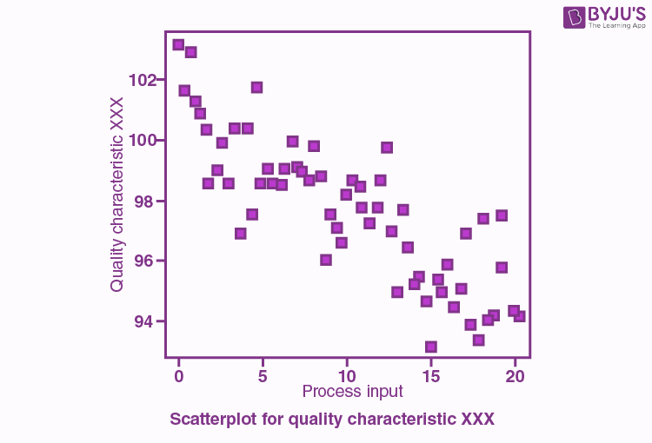

**Point of Note:**

* **Figures 1.1, 1.2 and 1.3** are culled from: BYJU’s https://byjus.com/maths/scatter-plot/.
* The figures illustrate the dynamic flow of dependent and independent variables.

An experimental research design utilizes both an independent variable (the manipulated variable) and a dependent variable (the measured variable that is expected to change based on the manipulation of the independent variable). However, A quasi-experimental design includes both dependent and independent variables.

The Scatter plots are used to display the relationship between two continuous variables X

and Y. The Scatter plots are graphs that present the relationship between two variables in a

dataset. It represents data points on a two-dimensional plane or on a Cartesian system. The

independent variable or attribute is plotted on the X-axis, while the dependent variable is plotted on the Y-axis. These plots are often called scatter graphs or scatter diagrams.

The given data below shows the number of games played and scores obtained in each instance.

**Figure 1. 2**

|  |  |  |  |  |  |  |  |  |  |  |
| --- | --- | --- | --- | --- | --- | --- | --- | --- | --- | --- |
| No. of games | 3 | 5 | 2 | 6 | 7 | 1 | 2 | 7 | 1 | 7 |
| Scores | 80 | 90 | 75 | 80 | 90 | 50 | 65 | 85 | 40 | 100 |

**Solution:**

X-axis or horizontal axis in Figure 1.3 show: Number of games

Y-axis or vertical axis: Scores

The scatter graph is shown below: Figure 1.3

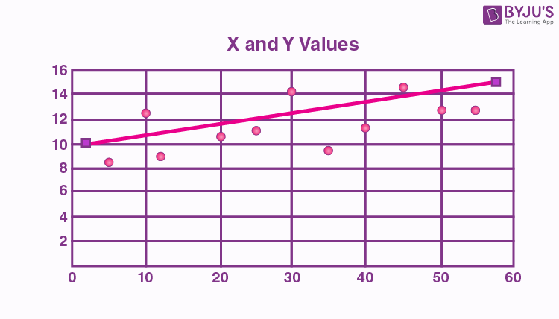

**2)** How might your selected instrument, such as a validated psychometric survey, help determine which quantitative design to use for a dissertation? Why are Likert-style surveys typically based on variables at the ordinal or interval scale?

A well-validated psychometric survey is selected based on the criteria that clearly defines the hypotheses one is measuring. It outlines the specific variables and their relationships, which helps to identify the dependent and independent variables in the study, guiding the selection of appropriate statistical tests (e.g., correlations, regressions, ANOVAs). Moreover, the Psychometric surveys often specify the level of measurement (nominal, ordinal, interval, ratio) for each variable, which is crucial for selecting the appropriate statistical analysis. The other criterion for selection is the validated psychometric survey can significantly influence the quantitative design chosen for a dissertation by providing a clear framework for measuring the key constructs of the study. Thereby guiding the selection of appropriate statistical analyses and ultimately shaping the overall research design based on the specific data structure and characteristics of the survey instrument.

Why are Likert-scale surveys typically based on variables at the ordinal or interval scale?

Likert-scale surveys are typically based on variables at the ordinal scale because they present a ranked order of responses. They allow respondents to indicate their level of agreement or opinion on a statement. But the distance between each point on the scale is not necessarily equal, meaning you cannot assume equal intervals between categories like you would with interval data. The key points are that Likert scales provide a clear hierarchy of responses, like "strongly disagree," "disagree," "neutral," "agree," and "strongly agree," where each category is ranked relative to the others. While the categories are ordered, the difference between "agree" and

"strongly agree" might not be the same as the difference between "disagree" and "strongly disagree". Due to the ordinal nature, certain statistical analyses that assume equal intervals (like calculating a true mean) might not be appropriate with Likert scale data. Individual Likert-type questions are generally considered ordinal data, because the items have clear rank order, (Younas & Porr, 2024; Streiner et al., 2024) but don't have an even distribution. Overall Likert scale scores are sometimes treated as interval data. These scores are considered to have directionality and even spacing between them.

**3)** What are scales and subscales used on survey instruments? Do all surveys have subscales? Why or why not?

In survey instruments, "scales" refer to a set of answer options used to measure a specific concept or attribute, while "subscales" are smaller sections within a larger scale, each measuring a distinct facet of that broader concept; not all surveys have subscales, as they are primarily used when a complex construct needs to be examined through multiple dimensions.

A scale is a standardized way to quantify responses on a survey, usually using a numerical or verbal rating system like a Likert scale (e.g., "strongly agree" to "strongly disagree"). Each question within a scale is designed to measure the same underlying concept (Dima, 2018; Jebb et al 2021) allowing researchers to calculate a single score representing the respondent's overall attitude or perception on that topic. When a complex concept has multiple facets, a survey might use subscales to measure each facet separately. For example, a survey assessing "job satisfaction" could have subscales for "workload," "relationships with colleagues," and "salary".

Each subscale would consist of several questions specifically related to that aspect, and the scores from each subscale can be analyzed individually to gain deeper insights.

Do all surveys have subscales? Why or why not: Certainly not, it is not necessary to have subscales in all surveys because, in a simple construct-survey involving a survey which is measured in a straightforward concept with only one primary dimension, there's no need for subscales. Sometimes researchers might only be interested in the overall level of a construct, not the specific aspects within it. Subscales allow for some levels of understanding of a complex concept by examining its different components. When analyzing data, researchers can compare the scores across different subscales to identify areas of strength or weakness within a broader construct.

**4)** Describe construct validity and internal reliability of quantitative survey instruments. Why is it best practice to use a validated survey instead of a researcher-created survey in dissertation research?

Construct validity refers to the extent to which a quantitative survey instrument accurately measures the theoretical concept or construct it intends to capture. The internal reliability indicates how consistently the different items within a survey measure the same underlying construct (Meyerson, & Tryon, 2003; Michalopoulou, 2017) ensuring consistency in responses across the instrument.

Using a validated survey is the best practice in dissertation research because there is established reliability and validity. The validated surveys have undergone rigorous testing and refinement to ensure they accurately measure the intended construct, providing a higher level of confidence in the data collected compared to a researcher-created survey. There is comparison to

existing research. Using a well-established survey allows for comparison of the findings with previous studies in the same field, enhancing the generalizability of the results. In essence there is a reduced risk of measurement error. A validated survey has already addressed potential biases

and ambiguities in question wording minimizing the risk of misinterpretations by respondents. It has greater credibility and rigor in its application. Choosing a validated survey demonstrates a commitment to sound research methodology (Wallwey & Kajfez, 2023; Robinson, 2018) and strengthens the credibility of the dissertation.

The vital point about this is that there is construct validity and internal reliability. Convergent validity indicates that the survey items measuring the same construct are highly correlated with each other. It demonstrates that the survey items are not correlated with measures of different, unrelated constructs.

**5)** Why is an interview protocol or a questionnaire used in basic qualitative studies? How can a researcher ensure their qualitative instruments align with their research questions?

An interview protocol or questionnaire is used in basic qualitative studies to provide a structured framework for guiding the conversation during an interview. Ensuring that key topics and areas of interest are covered while still allowing for open-ended responses and in-depth exploration of participants' perspectives and experiences on a subject, which is the core of qualitative research. There is a focus on meaning and understanding, and the qualitative research aims to understand the subjective meaning participants attach to their experiences. And the interview protocol helps the researcher delve deeper into these meanings through open-ended questions. Moreover, there is systematic data collection, it allows for flexibility, and a protocol which ensures that all participants are asked about similar topics. It enables comparisons across interviews and better data analysis. The protocol can include prompts or follow-up questions to

encourage participants to elaborate on their responses and provide rich details. A well-designed protocol can help ensure that interviews are conducted in a respectful and sensitive manner, covering all necessary aspects of informed consent and participant privacy.

To ensure qualitative instruments align with research questions, a researcher should: carefully craft open-ended questions that directly probe the key concepts and themes outlined in the research questions. To regularly review and refine the instrument based on the research objectives. To utilize a matrix or table to visualize the connection between questions and research questions and seek feedback from peers or experts to identify potential misalignments; making sure the data collected through the instrument can effectively answer the intended questions. To clearly define the research questions by starting to formulate well-defined, focused research questions that clearly state the central inquiry of the study. Moreover, it is ensured that there is a theoretical framework to guide the development of the qualitative instrument ensuring the questions are aligned with the key concepts and variables within the framework.

However, it is advised to design open-ended questions, to formulate interview questions or observation protocols that allow for rich, detailed responses from participants. To avoid leading or closed-ended questions one has to create a question matrix, by developing a table that maps each research question to the specific interview questions or observation points designed to address it, facilitating a visual understanding of alignment. And a pilot testing will be necessary to conduct a pilot study with a small sample to test the effectiveness of the qualitative instrument. Peer review is required by sharing the instrument with other researchers or experts in the field to get feedback on whether the questions accurately capture the intended research focus and are aligned with the research questions. Moreover, the context is considered to ensure the language used in the instrument is appropriate for the participants' cultural background and

level of understanding, there is flexibility during data collection to avoid bias in the final analysis.

**Conclusion**

This study unfolds the new trends in research design and research methodology required in conducting modern academic dissertation. The essential elements of design differentiation and instrument and experimental validation revealed in the process of conducting a dissertation offered new study insight. The seeming differences between the quasi-experimental and correlational designs on grounds of both examining relationships between variables were explored. While the quasi-experimental design attempts to establish a causal relationship by comparing groups, even without random assignment, the correlational design simply looks for associations between variables without manipulating them. A well-validated psychometric survey is found to be an indispensable tool (Dima, 2018) at clearly defining the hypotheses one is measuring. It outlines the specific dependent and independent variables in the study (Meyerson & Tryon, 2003; Kaiser, 2024)  guiding the selection of appropriate statistical tests (e.g., correlations, regressions, ANOVAs). And this is crucial for selecting the appropriate statistical analysis (Leong & Said, 2024) ultimately shaping the overall research design based on the specific data structure and characteristics of the survey instrument. Moreover, the use of a validated survey is further emphasized as the best practice in dissertation research (Kaiser, 2024) because there is established reliability and validity providing a higher level of confidence in the data collected, analyzed and evaluated.

**Works Cited**

Dima, A. L. (2018). Scale validation in applied health research: Tutorial for a 6-step R-based

psychometrics protocol. *Health psychology and behavioral medicine*, *6*(1), 136-161.

Friborg, O., Martinussen, M., & Rosenvinge, J. H. (2006). Likert-based vs. semantic differential-

based scorings of positive psychological constructs: A psychometric comparison of two versions of a scale measuring resilience. *Personality and Individual Differences*, *40*(5), 873-884.

Jebb, A. T., Ng, V., & Tay, L. (2021). A review of key Likert scale development advances:

1995–2019. *Frontiers in psychology*, *12*, 637547.

Kaiser, R. (2024). *Research Interviews: A Practical Guide to Qualitative Data Collection with*

*Experts in Political Science*. Springer Nature.

Leung, S. O. (2011). A comparison of psychometric properties and normality in 4-, 5-, 6-, and

11-point Likert scales. *Journal of social service research*, *37*(4), 412-421.

Lim, W. M. (2024). What is qualitative research? An overview and guidelines. *Australasian*

*Marketing Journal*, 14413582241264619.

Leong, S. Y., & Said, H. (2024). Development and refinement of the interview protocol:

interview questions for international school teacher retention. *Int J Eval & Res Educ*, *13*(5), 3017-3027.

Meyerson, P., & Tryon, W. W. (2003). Validating Internet research: A test of the psychometric

equivalence of Internet and in-person samples. *Behavior research methods, instruments, & computers*, *35*, 614-620.

Michalopoulou, C. (2017). Likert scales require validation before application-another cautionary

tale. *Bulletin of Sociological Methodology/Bulletin de Méthodologie*

*Sociologique*, *134*(1), 5-23.

Robinson, M. A. (2018). Using multi‐item psychometric scales for research and practice in

human resource management. *Human resource management*, *57*(3), 739-750.

Streiner, D. L., Norman, G. R., & Cairney, J. (2024). *Health measurement scales: a practical*

*guide to their development and use*. Oxford university press.

Wallwey, C., & Kajfez, R. L. (2023). Quantitative research artifacts as qualitative data collection

techniques in a mixed methods research study. *Methods in Psychology*, *8*, 100115.

Younas, A., & Porr, C. (2024). A step-by-step approach to developing scales for survey

research. *Nurse researcher*, *32*(3).