Statistics for Social Research II

Derrick Snow

Omega Graduate School

Aug 17, 2024

Professor

Dr. Taladay

Assignment #1: Discussion Questions
Answer the following questions in short answer format and be prepared to discuss them with your classmates in the virtual residency or the discussion forum.
1) What is the purpose of assumptions tests and what do they tell us about a given sample of data?
2) How are histograms and box-whisker plots helpful when evaluating a sample against a normal distribution?
3) How does normality help inform whether we can use parametric (generalizable to the target population) vs nonparametric procedures (applicable only to the sample)?
4) Determine when to use a t-test and Pearson’s r or their nonparametric equivalents to test hypotheses.
5) Navigate to OGS’s Practical Statistics for Social Research (PSSR) tool. Click on “Example Datasets” and load the “Dependent t-Test: Achievement Scores” dataset. Click on “Descriptives” and then on “Assumptions”. What do the histograms and box and whisker plots tell you about the normality of the samples? Now, click on “Tools and Options” and then “Generate Normal Distributions”. Re-run the “Descriptives” and “Assumptions”. How are the normal distributions different from the original samples?

1) What is the purpose of assumptions tests and what do they tell us about a given sample of data?

The purpose of assumptions tests is to test our assumptions about the data. We can test our assumptions by identifying the characteristics of our data (Terrell, 2021). Do we have a random sample? What is the level of measurement of our variables? What is the shape of our data? Is it normally distributed? What are we trying to test with our data? Based on the findings of our assumptions we would come to know what statistical methods we could use in our analysis of the data.

2) How are histograms and box-whisker plots helpful when evaluating a sample against a normal distribution?

Histograms and box-whisker plots visually show us the distribution of the data (Frankfort-Nachmias, et al, 2021), which then helps determine if the data is in an approximate normal distribution. If our data fit the normal distribution, we could use parametric statistics to analyze and test our data. We can also use descriptive statistics to identify the distribution by examining the mean, median, standard deviation, skewness and kurtosis.

3) How does normality help inform whether we can use parametric (generalizable to the target population) vs nonparametric procedures (applicable only to the sample)?

Normality or normal distributions of the data inform what statistics could be used, parametric if normal, and non-parametric if non-normal distribution (Sheskin, 2011). We are usually interested in inferential statistics, and from our sample data findings, can infer our population. If we meet the assumption of random sampling and normal distribution, then we use parametric statistics and can infer to our larger population. If not, then we use nonparametric statistics and could only infer to our sample.

4) Determine when to use a t-test and Pearson’s r or their nonparametric equivalents to test hypotheses.

If one is seeking to identify if there is a difference between two sets of data from the same sample, then the t-test is used if the data has a normal distribution, or Wilcoxson Signed Rank if the data is not normally distributed. When we are interested in seeing if there is a relationship between two variables, correlation, and if our data is normally distributed, we use Pearson r and Spearman’s Rank Correlation if our data does not meet the normal distribution.

5) Navigate to OGS’s Practical Statistics for Social Research (PSSR) tool. Click on “Example Datasets” and load the “Dependent t-Test: Achievement Scores” dataset. Click on “Descriptives” and then on “Assumptions”. What do the histograms and box and whisker plots tell you about the normality of the samples? Now, click on “Tools and Options” and then “Generate Normal Distributions”. Re-run the “Descriptives” and “Assumptions”. How are the normal distributions different from the original samples?

The histogram and box-and-whiskers plot inform us of the shape of the distribution, allowing us to examine whether it falls into an approximately normal distribution.
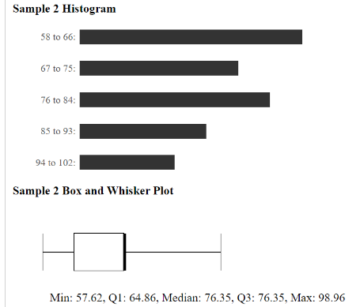
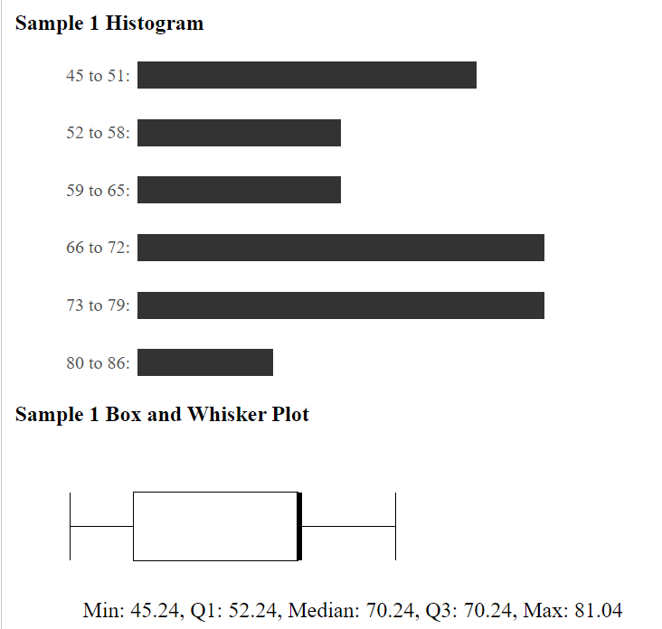
Sample 1 shows a non-normal distribution with a wider distribution (spread on histogram and spread of the box on the boxplot) and has high frequency to the left of a normal distribution which indicates as outliers. Sample 2 also shows a non-normal distribution, but the spread of the data is tighter but is also skewed to the right.

After running the normal distribution feature of the tool, the difference from the original sample (above) and normal distribution is quite clear.
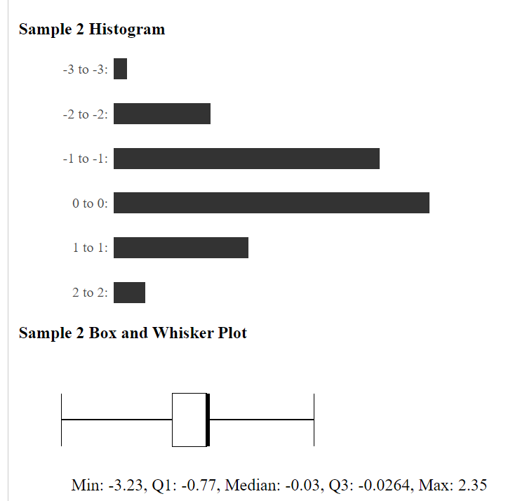
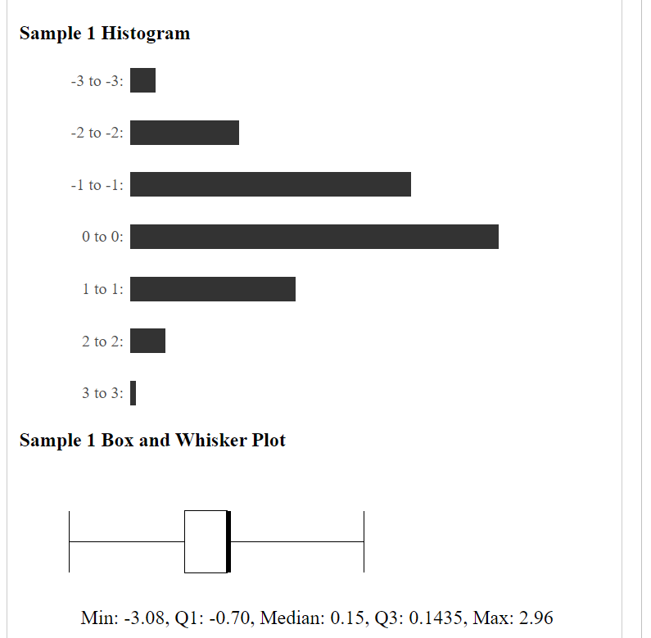
Sample 1 and sample 2 very much show a normal distribution based on the histograms and the Box and Whiskers Plot, they take the shape of the bell curve.

WORKS CITED

Frankfort-Nachmias, C., Leon-Guerrero, A., & Davis, G. (2021). Social Statistics for a Diverse Society. Sage Publications.
Sheskin, D. J. (2011). Handbook of Parametric and Nonparametric Statistical Procedures. Chapman and hall/CRC.
Terrell, S. R. (2021). Statistics Translated: A Step-by-Step Guide to Analyzing and Interpreting Data. Guilford Publications.

