SR 958-32: Research Design and Methodology I
(Fall 2024, Sub-term A)

Assignment #2: Developmental Reading

Dr. Peter Abraham Airewele DSL
Omega Graduate School
September 21, 2024

Professor

Dr. Sean Taladay EdD

Assignment #2 – Developmental Readings
Complete developmental readings using a combination of the following types of resources:
1. Minimum of two (2) Research Design textbooks (Statistics books addressing
Research Design can be used, e.g., Statistics Translated (Terrell) to address key
elements introduced in the syllabus and videos.
2. Minimum of two (2) journal articles that use research design and analysis as a key
part of the research.
3. Minimum of two (2) journal articles that address research methodology and
concepts addressed in this course.
4. Remaining sources (journals) that identify recent content that identifies research
in your area of interest, contributes to your understanding and gaps in the
literature, or your preliminary understanding of proposed dissertation research
knowledge in the subject area.

Introduction
Research Design Methodology incorporates statistical design methodology as its principal integral constituent. It focuses on rudimentary dissertations, theses, research, and development studies through quantitative data assessment, from top to bottom or vice versa, and descriptive qualitative exploration of bottom-to-top approaches, respectively.
Development Reading Studies is an open-ended format of extensive research learning designed to teach students various scientific research designs and methodologies. They led to interdisciplinary social research developed from the bottom to the top to produce a dissertation (Taladay et al., 2024).
This study takes a critical look into the major elements of Research Design Methodology 1, comprising Methodology Distinction, Problem Formulation, and Research Questions. Others are Research Design Alignment and the Dissertation Structure. The compelling goal and objective are to analyze complex-looking data into easily comprehensible data and information utilizing quantitative and qualitative statistics, quasi-experiments versus experimental, correlational, discreet, and continuous data analysis and information. These data in the process are assessed and explored (where necessary). That is to offer information and answers to questions posed, and issues of socio-economic concern (Poynting, 2024; Sheskin, 2011), in population migration targeting, utilizing income census demographics, income brackets, school enrolments, gender unemployment and pay disparities, or unequal gender access to healthcare, based on socio-political or economic considerations, logical and coherent information, and outcomes.
Source One: Terrel, S.R. (2021). Statistics translated: A step-by-step guide to analyzing and interpreting data. Second Edition. New York. The Guilford Press. [Seminal] [Amazon-Preview].https://www.amazon.com/Statistics-Translated-Second-Step-Step/.
Comment 1: Simplifying the logical and characteristic elements and features of statistics, (like accounting and mathematics, which people tend to shy away from) is finally appealing to modern academia, professionals, and writers, long overdue.
Quote/Paraphrase: Roping the reader in with humor and real-world case examples, Terrell prepares students and practitioners to become informed consumers of statistics so that they can make decisions based on data and understand decisions others have made. He identifies six simple steps and guides readers to master them--from identifying a researchable problem to stating a hypothesis; identifying independent and dependent variables; and selecting, computing, and interpreting appropriate statistical tests. All techniques are demonstrated manually and with the help of SPSS software (Terrel, 2021).
Essential Elements: Roping the reader in with humor, real-world case examples, students and practitioners, researchable problems to stating a hypothesis; identifying independent and dependent variables; and selecting, computing, and interpreting appropriate statistical tests, All techniques are demonstrated both manually and with the help of SPSS software.
Additive/Variant Analysis: The additive, “Roping the reader in with humor and real-world case examples”, speaks volumes. Terrence restates the facts about what academia ought to have done to simplify statistics and make it likable for more than 30 years. Statistics, like math and accounting, are being demystified and taught in schools. Perhaps, introducing statistics in all courses or programs as compulsory electives is required.
Contextualization: The study and application of statistical data and methodology are inevitable. Profit and nonprofit organizations are desperate to fill vacancies in jobs related to Statistics, Mathematics, and Accounting. During the onboarding and shadowing of new employees, they are now trained in basic statistics, maths, and accounting models to facilitate their logical thinking processes whether they have to utilize such skills or not, currently or in the future.
Comment 2: The conceptual analysis of the Research Design Methodology unveils its definitions in policy and operational services.
Quote/Paraphrase: A research design, or a research strategy, is a plan to answer questions (McCombes, 2019). The framework includes the methods and procedures to collect, analyze, and interpret data. In other words, the research design describes how the researcher will investigate the central problem of the research and is, thus, part of the research proposal. Many people confuse research design and methodology. The difference is that while the former outlines how to approach the problem, the latter states how to implement the design. Both are crucial in building a thesis statement (Bourikas, 2024, para. 1-5).
Essential Elements: A research design, research strategy, set of questions, framework, methods and procedures, collect, analyze, and interpret data, the central problem of the research, research proposal.
Additive/Variant Analysis: The additive “research design is characterized as a “research strategy, research plan or proposal plan, consisting of methods and procedures to collect, analyze and interpret data” to information. Moreover, the analysis depicts the significance of the Research design methodology.
Contextualization: In a modern organization, research design is embraced to determine the approach to the problem or issues of concern. Moreover, Research methodology provides statistical tools and strategies to implement or provide answers to the questions posed. Knowledge of these differences facilitates statistical-oriented projects with deadlines.

Source Two: Sheskin, D.J. (2011). Handbook of parametric and nonparametric statistical
procedures. (5th ed.). Chapman & Hall/CRC. [Seminal] [Amazon-Preview].
Comment 3: The knowledge and skills in three core statistical variables, univariate, bivariate, and multivariate, are crucial in statistical computations.
Quote/Paraphrase: Parametric and Nonparametric Statistical Procedures provide researchers, teachers, and students with an all-inclusive reference on univariate, bivariate, and multivariate statistical procedures. The field of statistics is divided into two prominent cases: Descriptive statistics consists of methods and procedures for presenting and summarizing data in tables, charts, measures of central tendencies, measures of association, and correlations. Inferential statistics employ data to draw inferences and derive conclusions to make predictions (Sheskin, D.J. (2011).
Essential Elements: Parametric and Nonparametric Statistical Procedures, univariate, bivariate, and multivariate statistical procedures, Descriptive measures of central tendencies, measures of association and correlations, Inferential statistics, conclusions, and predictions.
Additive/Variant Analysis: The additive is “univariate,” while descriptive statistics “focuses on a single variable at a time to describe characteristics of samples.”
Meanwhile, bivariate inferential statistics compares two variables and their relationships and aims to make predictions about a population. Multivariate inferential statistics, a complex form of statistical analysis, compares three or more variables' relationships and aims to make predictions about a population.
Contextualization: The data characteristics above simplify the definition and application of utilizing three variables: univariate, bivariate, and multivariate. The univariate is mainly used in qualitative data or descriptive analysis. Bivariate and multivariate data tend to be used in two or multiple data variables.

Comment 4: The Parametric and Non-Parametric statistics show the typical relationship and differences between data and non-data distribution.
Quote/Paraphrase: “Parametric” is used to refer to parameters of the resultant datasets (distribution) that supposedly assume that the sample (mean, standard deviations, etc.) is normally distributed. At the same time, the “non-parametric” tests (usually measured in median) are referred to as “distribution-free” tests, given the fact that the supporting methods assume that the analyzed datasets follow a specific but not specified distribution (Okoye & Hosseini, 2024). Abstract.
Essential Elements: Parametric, parameters, resultant, mean, standard deviations, and non-parametric tests.
Additive/Variant Analysis: The additive “parametric” data refers to a set of data distributions in mean averages and standard deviations.”. “Non-parametric are distribution free” consisting of the median or independent variables. The two statistical approaches may look different, but they seem to serve similar purposes of determining the outcome of a specific group or population analysis.
Contextualization: In a frequency distribution or measures of central tendencies, the mean is the average of a set of values. The median refers to the central value.
The mode refers to the value that’s repeated most often. Each function is proper, depending on the social or scientific program or project.

Source Three: Mukherjee, S. P., Chattopadhyay, A. K., & Sinha, B. K. (2018). Statistical
Methods in social research. Springer. https://doi.org/10.1007/978-981-13-2146-7. [Amazon-Preview].
Comment 5: Statistics tend to fill in the gaps that mere observations and journals cannot. Instead, it provides some inductive and deductive inferences aligned to graphs, charts, and statistically formulated answers to questions asked.
Quote/Paraphrase: The social sciences cover diverse phenomena arising in society, the economy, and the environment, some of which are too complex to allow concrete statements; direct observations or measurements cannot define some. Statistics, being a scientific method – as distinct from a ‘science’– is used to make inductive inferences regarding various phenomena (Mukherjee et al., 2018).
Essential Elements: The social sciences, diverse phenomena, society, the economy, the environment, complex concrete statements, direct observations or measurements, Statistics, a scientific method, distinct, inductive inferences, and various phenomena.
Additive/Variant Analysis: The additive “social sciences cover diverse phenomena arising in society, the economy, and the environment, and they cannot be defined by direct observations or measurements” alone emphasizes the need for statistical applications. The applications that provide inductive and deductive inferences from multivariate and bivariate data variables. This depicts the essence of incorporating statistics in college curriculums.
Contextualization: Modern profit and non-profit organizations have begun to apply statistical methodologies in presenting their quarterly and annual reports.
Some statistical methods may be complex to behold to some employees, so organizations simplify them or introduce statistical software to bypass complex mathematical deductive computations. Statistical software like Minitab (for quality improvement and data analysis), JMP (for researchers, scientists, and engineers), and SPC (for Excel computations). Datayzer is cutting-edge software used for data analysis to track sales and scientific data trends.
Comment 6: Experimental designs present the statistical approach often utilized in the experiment.
Quote/Paraphrase: Experimental designs in the social sciences have received increasing attention due to their power to produce causal inferences. -To properly evaluate the strength of experiments, researchers need information about the context, data, and previous knowledge used to design the treatment (Pérez et al., 2024). Abstract.
Essential Elements: Experimental designs, and social sciences, causal inferences. - evaluate the strength of experiments, the context, data, and previous knowledge.
Additive/Variant Analysis: Additive “Causal inference” is a process that determines if an observed association is a genuine cause-and-effect relationship among variables. The experiment's design methodology approach lays out the statistical approach to be employed. In most cases, researchers start with project design to determine their approach.
Contextualization: The methodological design “produces causal inferences.” The purpose is to determine if an observed association is a genuine cause-and-effect relationship among variables. Many prefer to start their experiments with the design methodology that lays out the project outlines and statistical methods to be applied.

Source Four: Hunziker, S., & Blankenagel, M. (2024). Multiple case research design. In Research Design in Business and Management: A Practical Guide for Students and Researchers (pp. 171-186). Wiesbaden: Springer Fachmedien Wiesbaden.
Comment 7: Multicase research design shifts focus from single-case designs to multicase, thereby enabling the understanding of differences and similarities between research cases being experimented.
Quote/Paraphrase: The significant advantage of multiple-case research lies in cross-case analysis. A multiple-case research design shifts the focus from understanding a single case to the differences and similarities between cases. Instead, it is the next step in developing a theory about factors driving differences and similarities. (Hunziker, S., & Blankenagel, 2024)
Essential Elements: Multiple-case research designs, differences, and similarities, developing a theory about factors.
Additive/Variant Analysis: The additive is “ multiple-case research design shifts the focus from understanding a single case to the differences and similarities between cases. Instead, it is the next step in developing a theory about factors driving differences and similarities. Each research case level is significant when it comes to pre-theory or statistical theory applications.
Contextualization: Single-case research is often utilized in experiments focusing on specific outcomes, like determining the exam grades of a class of students. Whereas multi-case research may be more complex, the methodological designs are applicable in cross-contingencies in population and migration analysis. Each has its significant advantages.

Comment 8: Single case design appeals to researchers interested in qualitative and descriptive analysis, not complex study research like multiple-case research designs.
Quote/Paraphrase: Single case studies involve repeated measures and manipulation of an independent variable. They can be designed to have strong internal validity for assessing causal relationships between interventions and outcomes and external validity for the generalizability of results, particularly when the study designs incorporate replication, randomization, and multiple participants (Lobo et al., 2017)
Essential Elements: Single case studies, repeated measures, manipulation of independent variables, internal solid validity, causal relationships between interventions and outcomes, external validity for generalizing results, replication, randomization, and multiple participants.
Additive/Variant Analysis: The additives are “internal and external validity” used to measure data values and reliability. The single-case design may be single-case, yet several participants could be reflected in the case study design. This largely depends on the researcher’s study or statistical objectives.
Contextualization: The single-case design may not be as simple and fast-track statistics as it seems. Sometimes, it requires a broad analysis, especially when such research demands both internal and external data validity, which calls for repeated randomization.

Source Five: Poynting, M (2024) World's first year-long breach of key 1.5C warming limit
https://www.bbc.com/news/science-environment-68110310.
Comment 9: Understanding the Sociology of Climate Change has never been more critical. Table 5:1 shows the increase in global warming due to greenhouse gas emissions, CO2, and industrial gases, especially methane gases.
Quote/Paraphrase: For the first time, global warming has exceeded 1.5C across an entire year, according to the EU's climate service. World leaders promised in 2015 to try to limit the long-term temperature rise to 1.5C, which is seen as crucial to help avoid the most damaging impacts. "This far exceeds anything that is acceptable," Prof Sir Bob Watson, a former chair of the UN's climate body, told the BBC Radio 4's Today Program. "Look what has happened this year with only 1.5C - we have seen floods, droughts, heatwaves, and wildfires worldwide." The period from February 2023 to January 2024 reached 1.52C of warming. The following graphs show how that compares with previous years (Poynting, 2024).
Essential Elements: Global warming, the EU's climate service, world leaders, long-term temperature rise, the UN's climate body, heatwaves, and wildfires.
Additive/Variant Analysis: The variant, “global warming has exceeded 1.5C,” should have been prevented by world nations. In one year alone, from 2023 to 2024, global warming caused fire outbreaks, unbearable high temperatures, and floods. “According to experts, even the ice glacier boulders in Iceland are melting to compound this, which might create more flash floods. Perhaps, unexpectedly, volcanic eruptions are ravaging farmlands and cities in Iceland.
Contextualization: One of Dr. Peter’s postdoctoral tasks will be to elevate the tempo of civilized sociological education and awareness about climate change so that the red tape and bureaucracy surrounding the control or containment of greenhouse and CO2 emissions are significantly reduced. Efforts will be made to seek avenues for collaboration to educate industry stakeholders and lawmakers to encourage the transition from hydrocarbon, coal, and fossil fuel industrially generated energy to solar, electric, and wind-generated energy.
Tables 5:1 and 5.2 below:
- Show the rapid rise of global warming/ temperature from about .03C in the 50s to 1.5C, about 400% to 500% higher in 2024, due to massive emissions of greenhouse gases, CO2, and methane from industrialized nations, especially China, America, and the EU nations.

Table 5.1 | Table 5:2
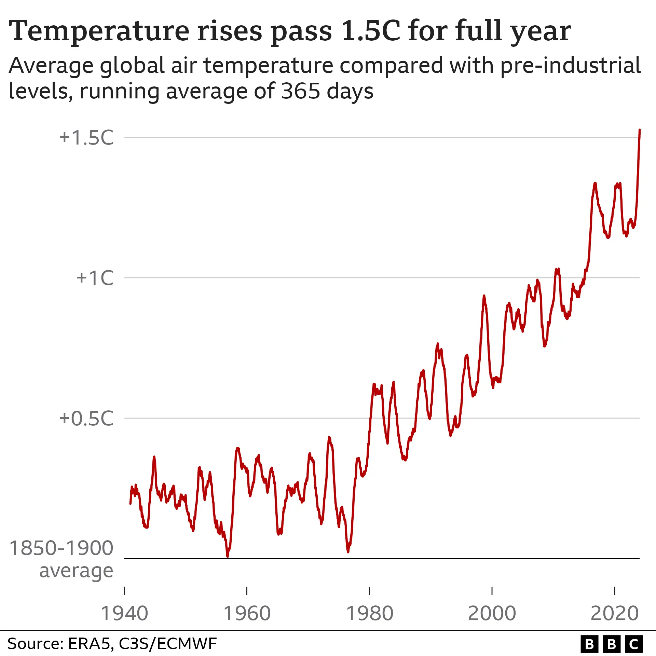 | 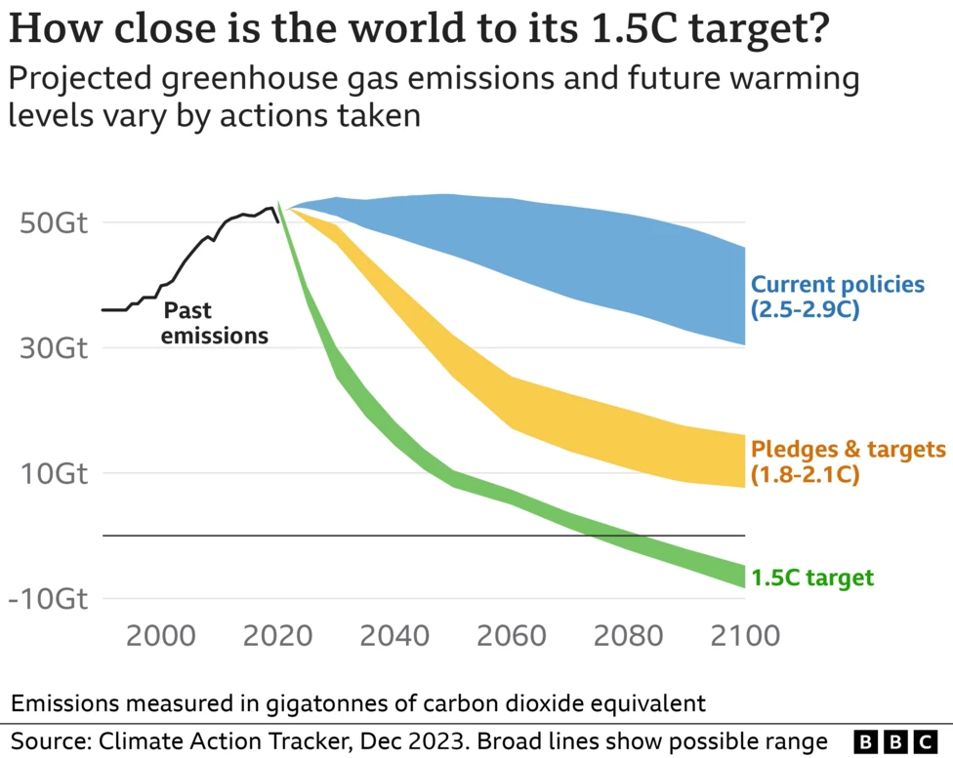
Table 5.3
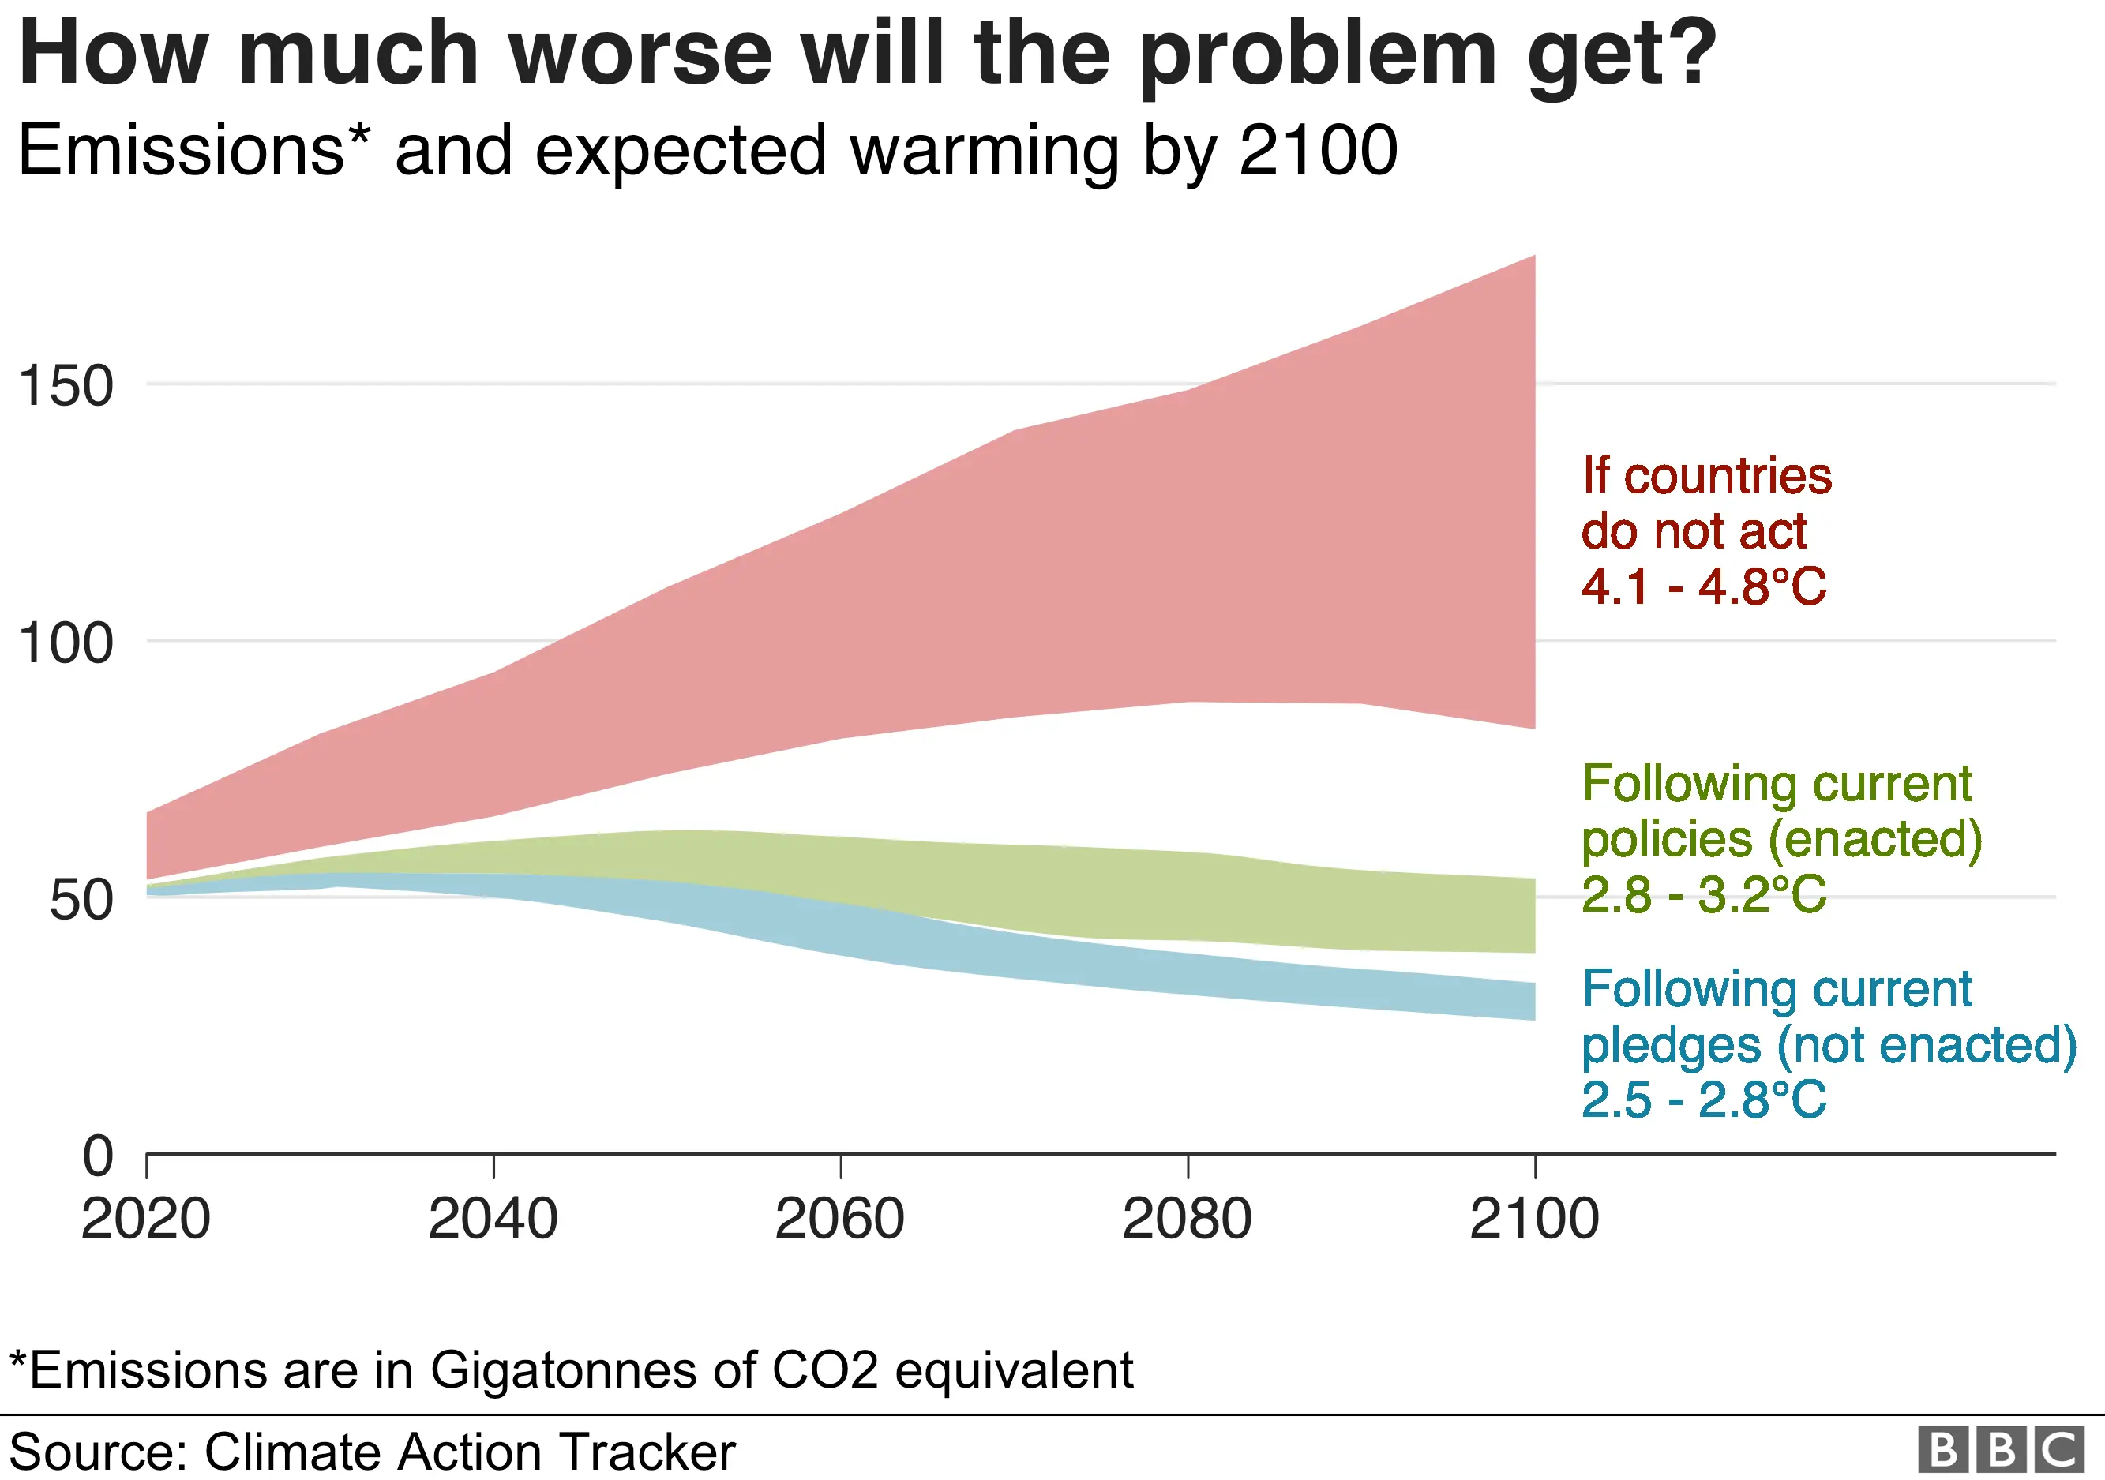

Key:
- Table 5.3 above shows the projected increase in greenhouse gases and the trend of rising high temperatures/year-warming in 1940/2020 and 2000/2100.
- The table indicates current and probable earth warming if greenhouse gases and CO2 policies are not matched with solid actions to contain them.

Comment 10: The gap in skill specialization between college and Technical/trade school education is beginning to gain momentum in public US local and national education.
Quote/Paraphrase: Workforce development and career and technical education (CTE) have long provided reliable pathways to middle-skill jobs and a gateway to the middle class. Given recent changes in middle-skill jobs, the education landscape, and federal policy priorities, the role of CTE in the U.S. educational landscape is evolving more rapidly, encompassing a broader range of education, and practices are changing ahead of research (Haviland & Robbins, 2021).
Essential Element: Workforce development, career and technical education (CTE), reliable pathways, middle-skill jobs, gateway to the middle class. the education landscape, federal policy priorities, the role of CTE in the U.S.
Additive/Variants Analysis: The additive is, “Workforce development and career and technical education (CTE) have long provided reliable pathways to middle-skill jobs and a gateway to the middle class.” Technical educational skills are practical as they are now sought after by industries and employers. They seem to be competing with college or university education.
Contextualization: Presently, employers are seeking graduates from technical schools in areas such as cyber security, project management, computer programming, AI coding specialists, and commercial pilots. Employees in these areas of skill specialization earn as much as or more than master's degree holders. They are hands-on deck, time, and cost-effective in onboarding compared to college or university graduates versed in principles.
Source Six: Moslimani, M., & Passel, J. S. (2024). What the data says about immigrants in the
the US.
Comment 11: The most noticeable US population trend from 1970 to 2024 in Tables 6.1 and 6.2 is the educational disparity between migrants worldwide and American-born citizens.
Quote/Paraphrase: In 2022, immigrants ages 25 and older were about three times as likely as the U.S.-born to have not completed high school (25% vs. 7%). About half of immigrants from Mexico (51%) had not completed high school, and the same was true for 46% of those from Central America and 21% from the Caribbean. Immigrants from South Asia (72%) were the most likely to have a bachelor’s degree or more (Moslimani & Passel, 2024).
Essential Elements: Immigrants, U.S.-born, immigrants from Mexico (51%) high school, 46% from Central America, and 21% from the Caribbean. Educated immigrants from South Asia (72%).
Additive/Variant Analysis: The variant is, “About half of the immigrants from Mexico (51%) had not completed high school, and the same was true for 46% of those from Central America and 21% from the Caribbean. That is about 15% of the US population. This may look shocking to many. However, such disparities have their pros and cons.
Contextualization: Assuming the average number of uneducated immigrants is 40 million ( 51+46+21/3) = 40 (by approx.), most Mexicans, Central Americans, and Caribbeans will be involved in the local trading, farming, food, and agricultural sectors. Many will be working in low-paid restaurants, industrial cleaning, and sewage jobs that Americans are unwilling to do or take. However, the cost to taxpayers will be high to educate, care for, and rehabilitate most of them. Some may even be homeless.
Tables 6.1, 6.2, 6.3, and 6.4 show the population trends of about 72 million immigrants from around the world currently residing in the US.

Table 6.1 |  | Table 6.2
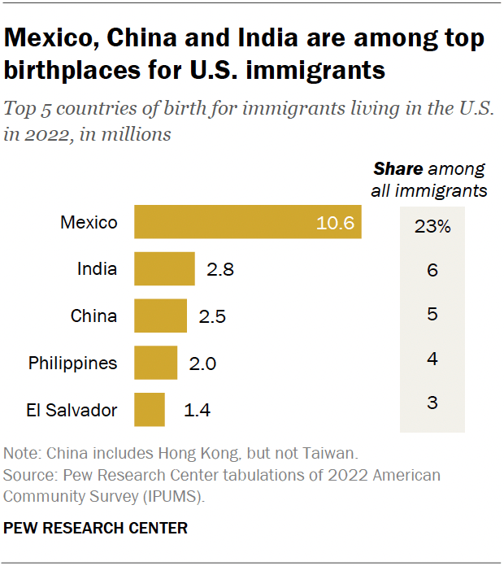 |  | 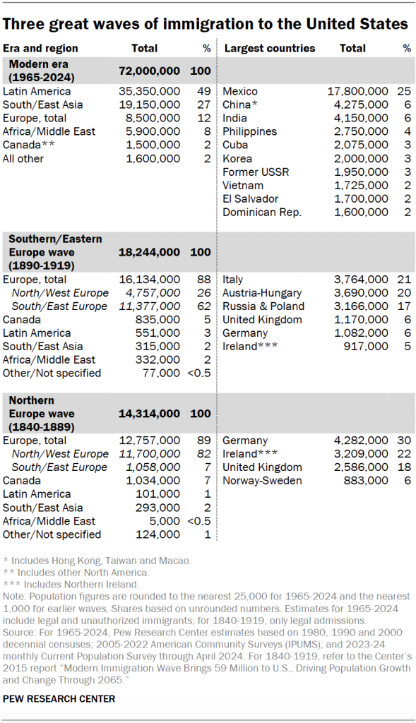  PEW RESEARCH CENTER
Key:
- Tables 6:1 and 6:2 show the great “waves” of immigrant population trends from 1995, 2022, to 2024.
- The largest immigrant groups are from Latin America (largely uneducated), Asia, Europe, and Africa (mostly educated).
Comment 4: Many Migrant workers from Asia and Africa in the US are educated as doctors, lawyers, professors, and teachers and have two-year college degrees, yet they still face issues of cultural and racial assimilation (partly silent and open).
Quote/Paraphrase: The U.S. healthcare system is increasingly dependent on immigrant physicians, but it is becoming harder for aspiring ones to work and settle in the U.S. Today, 1 in 4 doctors are foreign-born, international medical graduates. This immigrant workforce is critical to offsetting a dire physician shortage. The need for more doctors is due, in part, to America's growing and aging population, U.S.-born doctors' unwillingness to move to poorer and more rural areas, and U.S.-born doctors' lack of interest in going into primary care, which can be less lucrative and prestigious than other areas of medicine.
Essential Elements: The U.S. healthcare system, immigrant physicians, international medical graduates, immigrant workforce, dire physician shortage, aging population, U.S.-born doctors, and primary care areas of medicine.
Additive/Variant Analysis: The additive is, “Today, 1 in 4 doctors are foreign-born, and the American aging population.” The variant is that it still takes a foreign medical doctor 3 to 7 years to do a housemanship and pass the board exams. To many, this is tantamount to wasted resources. Doctors from some African countries are well-read, skilled, and specialized, yet they face such cultural and bureaucratic delays.
Contextualization: Premier medical schools in the UAE, Saudi Arabia, Israel, Egypt, or Nigeria, where you have Lagos University, Ibadan University, Edo State University, etc., are of top quality standard medical skills and practices comparable to Harvard, Oxford, and Princeton University. The slight exception may be access to digital equipment, like AI, robotics, or laser-generated surgeries. However, some private clinics for the rich in these countries have AI and laser scientific tools and equipment, but they are exclusively for the affluent.

Table 6.3
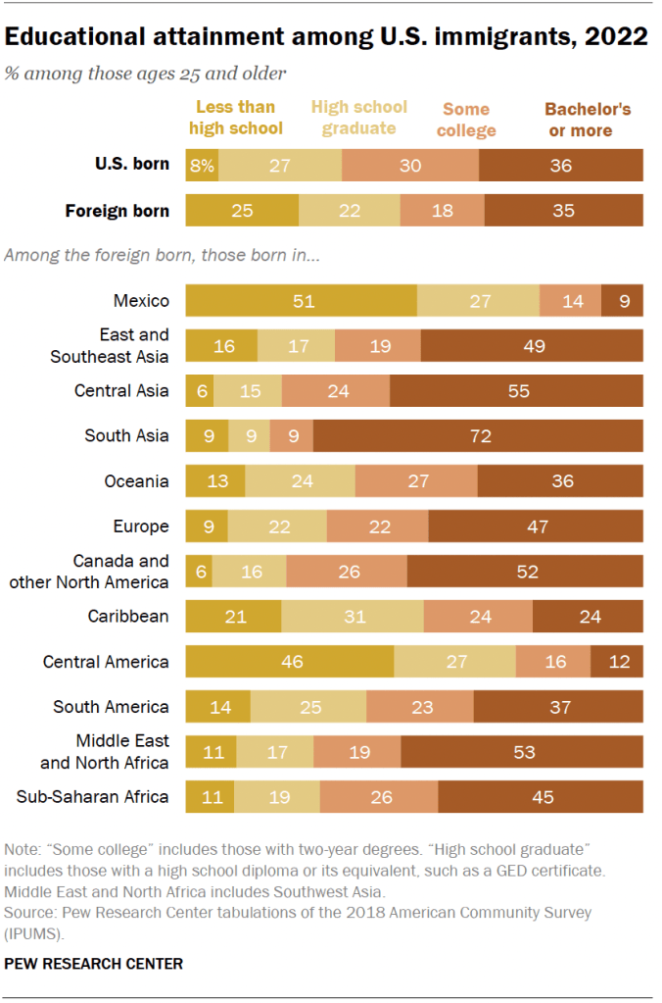

Table 6.4
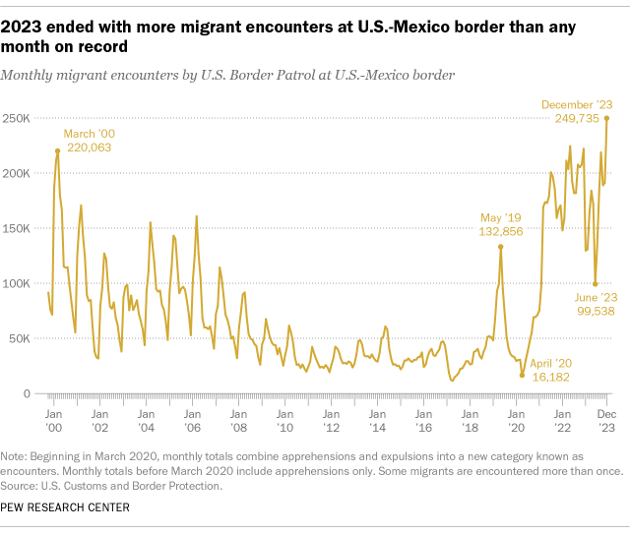

Point of Note:
- Table 6.3 shows that Migrants from Asia, Western Europe, the Middle East, and Africa are educated mainly. Studies show that some Asian and African migrants are doctors, lawyers, and nurses in critical health industries.
- Table 6.4 shows the spiraling migrants’ encounters at the borders, especially from 2022-2023.• The current US political climate may have spurred Mexico and some Latin American states to contain the migrant flows, perhaps for now.

Conclusion

Looking at the vast array of socio-economic opportunities that statistical research designs and methodologies (Bourikas, 2024; Hassan, 2022) offer, statistical applications have expanded their parameters into climate change and the natural ecosystem biometrics on a broad scale. The other compelling areas of interest include comparative immigration encounters and the immigrants’ educational disparities from the 70s to 2024. This study reveals that the academic landscape is fast changing from long years of college and university education to the hands-on deck and a mix of statistical software and fast-track Career and Technical Education (CTE), Coursera, etc. Moreover, modern organizations cannot get enough human capital (Bourikas, 2024; Hassan, 2022) in cyber coding and security, project management, digital marketing, commerce, and e-strategies. The AI-Quantum Nerds” in AI-coding and programming, digital computer programming, biostatistics, and hi-tech agro-engineering skill sets are much sought after by Microsoft, Google, and Yahoo. Others are X and Facebook, Nvidia Corp, Stock Exchange, etc. CTE integrates academic knowledge with technical and occupational hard and soft skills. This includes work ethics, time management, teamwork, problem-solving, etc. However, graduate and undergraduate apprenticeships and internships (Okoye & Hosseini, 2024),
would be some practical educational ways and models for fast-track multidimensional specializations that incorporate vast, complex applications simplified by statistical training and software.

Works Cited
BBC.com/news online (2024) Climate change: Where we are in seven charts and what
you can do to help. https://www.bbc.com/news/science-environment-46384067?fbclid=
IwAR38HM1yaxeGYbqoy3ZPd8nVoRMiNuTUHp3Dcd9LSeK8v7hx1jcAaUYmRcc.
Bourikas, I. (2024). Types of Research Design in 2024: Perspective and Methodological. https://research.com/research/types-of-research-design.
Hassan, M. (2022). Case study–Methods, examples, and guide. Research Methods. Net.
Haviland, S., & Robbins, S. (2021). Career and technical education as a conduit for skilled
Technical careers: A targeted research review and framework for future research. ETS Research Report Series, 2021(1), 1-42.
Hedlund, S. (2024). America is increasingly dependent on foreign doctors − but their path to
immigration is getting harder https://theconversation.com/profiles/selma-hedlund-
1509620.
Hunziker, S., & Blankenagel, M. (2024). Multiple case research design. In Research Design in Business and Management: A Practical Guide for Students and Researchers (pp. 171–186). Wiesbaden: Springer Fachmedien Wiesbaden.
Lobo, M. A., Moeyaert, M., Cunha, A. B., & Babik, I. (2017). Single-case design, analysis, and
Quality assessment for intervention research. Journal of Neurologic Physical Therapy, 41(3), 187-197.
Moslimani, M., & Passel, J. S. (2024). What the data says about immigrants in the US.
Mukherjee, S. P., Chattopadhyay, A. K., & Sinha, B. K. (2018). Statistical
Methods in social research. Springer. https://doi.org/10.1007/978-981-13-2146-7. [Amazon-Preview].
Okoye, K., & Hosseini, S. (2024). I am choosing Between Parametric and Non-parametric Tests in Statistical Data Analysis. In R Programming: Statistical Data Analysis in Research (pp. 87-98). Singapore: Springer Nature Singapore.
Pérez Bentancur, V., & Tiscornia, L. (2024). Iteration in mixed-methods research designs
Combining. experiments and fieldwork. Sociological Methods & Research, 53(2), 729-759.
Poynting, M (2024). World's first year-long breach of key 1.5C warming limit
https://www.bbc.com/news/science-environment-68110310.
Sheskin, D.J. (2011). Handbook of parametric and nonparametric statistical procedures. (5th ed.).
Chapman & Hall/CRC. [Seminal] [Amazon-Preview].
Stallard, E (2024). What is the Paris Climate Agreement, and why does 1.5C matter? BBC
News. https://www.bbc.com/news/science-environment-35073297.
Terrel, S.R. (2021). Statistics translated: A step-by-step guide to analyzing and interpreting data. Second Edition. New York. The Guilford Press. [Seminal][Amazon-Preview].https://www.amazon.com/Statistics-Translated-Second-Step-Step/.

