COM 968-32: Statistics for Social Research I
(Fall 2024, Sub term A)

Assignment No. 2
Developmental Reading

Dr. Peter Abraham Airewele DSL
Omega Graduate School
September 7, 2024

Professor

Dr. Sean Taladay EdD

Assignment #2 – Developmental Readings
1. Create Developmental Readings from seminal sources and scholarly peer-reviewed
journal articles. Review instructions for Assignment #3, the course essential elements,
and course readings to identify selections of books and journals to create entries.
a. Refer to the "Student Guide to Developmental Readings" in the General
Helps folder for updated information on sample comments, the grading rubric,
and key definitions related to developmental readings.

Assignment #2 – Developmental Readings
Introduction
Statistics is popularly known as the language of science and research. It equips students to conduct qualitative and quantitative social research and to communicate through the language of statistical data and information. “Students learn to use descriptive and inferential statistics and how to analyze populations through sampling and statistical analysis. The seminar methodology
includes instructions on using the Practical Statistics for Social Research (PSPPTM statistical
software package), Microsoft Word and Microsoft Excel (OGS.Edu & Taladay, 2024).
Students will not shy away from statistical computations, they have been simplified by the use of statistical software tools (Reichard, 2024), and the resources are vital in conducting research design methodology and dissertation foundations. This will be a welcome sign to many students who will find the software approach useful in their sophisticated working systems and environments.
Source One: Ravid, R. (2024). Practical statistics for educators. Rowman & Littlefield.
Comment 1: The roles of statistical practice assume broader and more diversified dimensions in quantitative and qualitative statistical applications.
Quote/Paraphrase: In the past, researchers were identified with qualitative and quantitative methodologies; today, the two paradigms are seen as complementary and support their use in mixed-design research studies (Ravid, 2024, pg. 6, para. 3).
Essential Elements: Researchers, qualitative, quantitative, paradigms, complementary, mixed-design research studies.
Additive/Variant Analysis: The additives are qualitative and quantitative research are complementary and supportive of each other. In the past, academia emphasized quantitative statistics as purely deductive, logical, and mathematical. Today, qualitative statistics, also known as inductive, are generative, and descriptive through observations, surveys, journals, charts, graphs, reports, etc.
Contextualization: The complementary functions suggest that quantitative statistical research is objective. The intent is to derive a logical solution to the issue through statistical probability formulas, H-testing, standard deviations, etc. Qualitative statistics is subjective and requires independent and group observations, surveys, and reports. Both can be expressed using historical or current data, histogram charts, graphs, and bell curves to drive home their points.

Comment 2: The connection between statistical research and theory through statistics will require some understanding.
Quote/Paraphrase: Statistics is the study of methods that use data to understand the world. Despite its ubiquitous use, its practitioners are perpetually accused of not actually understanding what they are doing. Statistics theory is, broadly speaking, about trying to understand what we are doing when we use statistical methods (Fithian, 2023, para. 3).
Essential Element: Statistics, study of methods, data, ubiquitous use, its practitioners, perpetually, Statistics theory, statistical methods.
Additive/Variant Analysis: The variant is the seeming mystery surrounding people's misunderstandings about statistics. However, the additive is that Professor Fithian attempts to simplify statistics understanding through the use of statistical theory involving the “use of statistical methods.” This sheds light on it.
Contextualization: To academia and professionals, statistics theory is a mathematical approach to describing and predicting events. It is used to analyze relationships or connections between things. It includes collecting, analyzing, and presenting numerical data. However, statistical research and theory are complimentary when applied as quantitative and qualitative data analysis.

Source Two: Ali, Z., Bhaskar, S. B., & Sudheesh, K. (2019). Descriptive statistics: Measures of central tendency, dispersion, correlation, and regression. Airway, 2(3), 120-125.
Comment 3: The Measures of Central Tendencies are crucial in modern statistical study analysis. They tend to branch into other areas of statistical functions of interest.
Quote/Paraphrase: The Mean, Median, and Mode are the three main measures of central tendency and Range. Percentile, variance, standard deviation, standard error, and confidence interval are measures of dispersion. Correlation and regression can be used to describe the relationship between two numerical variables. Correlation is a measure of association and regression is used for prediction. Regression analysis helps to assess 'influential' relationships between the data. Changes among one or more variables might affect other variables.
Essential Element: The Mean, Median, and Mode. measures of central tendency and Range. Percentile, variance, standard deviation, standard error, and confidence interval, measures of dispersion. Correlation and regression. numerical variables.
Additive/Variant Analysis: The measures of central tendencies, standard deviation, dispersion, and correlation constitute some of the bedrock in statistical analytical systems. Sometimes they either overlap or relate together. They also intersect in some multi-interdisciplinary ways in statistical research analysis.
Contextualization: The mean refers to the average number in groups of numbers or data. The median is the value that separates an arranged list of data values in half. Mode is the number that occurs most often in a set of data. They easily convey basic solutions to questions or issues of population, income, and health demographics. They do so without complex processes or referencing factors.

Comment 4: Measures of Dispersion are used in statistical data even when they appear very mathematical. They comprise a range, mean deviation, sample, and standard deviation.
Quote/Paraphrase: Measures of Dispersion have two distinct meanings; they refer to the variation among different values of a series. There is no dispersion if there is no difference between various values and averages. On the other hand, if various values are widely scattered around the average, dispersion is present to a greater extent. Dispersion is the statistical tool that measures the extent of variation in different values of a series among themselves. It should be based on all observations of a given series; it should not be affected by extreme observations, and no bias of the researcher or extreme values in the series (Bhardwaj, & Sharma, 2013).
Essential Element: Measures of Dispersion, variation among different values of a series, statistical tool, observations, no bias of the researcher or extreme values
Additive/Variant Analysis: The additive is “measures of dispersion refer to the variation among different values of a series. Dispersion is present to a greater extent”. It implies you have dispersion when there are different data values and variations. There are no variations when the range of values is the same.
Contextualization: The various measures of dispersion:
1. Range is the simplest possible measure of dispersion, the difference between the value of the largest and smallest item of the distribution. It's highly useful in quality control measures.

2. Mean deviation has practical usefulness in Economics, commerce, and statistics; Mean deviation is the arithmetic average of the deviation of all the series values taken from any of the measures of central tendency (Mean, Median, or mode.)

3. Standard Deviation is the positive square root of the arithmetic mean of the squares of the deviations of a given observation of their arithmetic mean. Standard deviation is capable of algebraic treatment, whereas mean deviation is not capable of algebraic treatment. Standard deviation is practically more useful in statistical analysis than mean deviation (Bhardwaj, &. Sharma, 2013).
Table 2.1
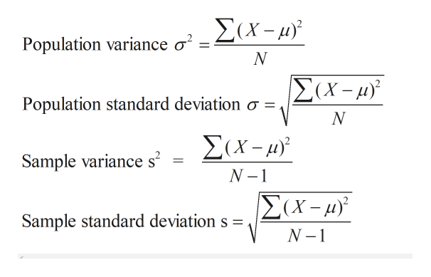

The Population Standard Deviation  σ = Population standard deviation  N = Number of observations in population  Xi = ith observation in the population  μ = Population means | The Sample Standard Deviation:  s = Sample standard deviation  n = Number of observations in the sample  xi= ith observation in the sample  x :Bar = Mean Average

Source Three: Abbadia, J. (2024) A Complete Overview of Levels of Measurement in Data Analysis. Master Scientific Data Visualization. Learn how to make data easier, unlock insights, and captivate audiences effectively. https://mindthegraph.com/blog/levels-of-measurement/.
Comment 5: The different levels of data measurement constitute some of the fundamental principles in statistical data analysis. They include, i) nominal, ii) ordinal,
iii) interval, iv) and ratio.
Quote/Paraphrase: Levels of measurement -hierarchy encompasses four primary types: nominal, ordinal, interval, and ratio. At the foundational level, nominal measurement classifies data into separate categories or labels without inherent order or quantitative significance. As we advance to ordinal measurement, data assumes a ranked or ordered structure, allowing for comparative analysis without precise intervals (Abbadia, 2024, para 2 and 4).
Essential Element: Levels of measurement, hierarchy, nominal measurement inherent order, or quantitative significance. Ordinal measurement ranked or ordered structure, Ratio.
Additive/Variant Analysis: The levels of statistical measurements share the commonality of data numerical and analysis. There is nominal or number classification, ordinal data ranking, and a range of data intervals. There is a ratio of zero measurements irrespective of the data sizes, like -5 degrees to 0 degrees temperatures, etc.
Contextualization: Each measurement level plays a specific role or function in data analysis. It holds apparent characteristics that define the value and span of quantitative or measurable assessment. Knowing the levels of measurement is essential in understanding and evaluating data correctly. These levels influence the statistical procedures appropriate to the data, prompting the selection of analytical methods and the level of awareness obtained from the data and information.
Comment 6: Knowing the difference between quantitative (the objective function) and qualitative research (the subjective function) is crucial in statistical applications.
Quote/Paraphrase: Two primary paradigms emerge within research methodologies: qualitative and quantitative approaches. Qualitative research involves in-depth observations, interviews, and analysis of non-numerical data. This methodology values subjective interpretations and aims to generate rich, descriptive insights that illuminate the intricacies of the studied subject. Quantitative research adopts a structured and objective approach to gathering numerical data, employing statistical analysis to identify patterns, correlations, and cause-effect relationships, with a level of impartiality that is crucial in the social sciences (Mohanasundari, 2023, p. 348, para. 1-3)
Essential Element: Two primary paradigms, research methodologies, qualitative and quantitative approaches, subjective interpretations, structured and objective approach, numerical data, employing statistical analysis, patterns, correlations, and cause-effect relationships, level of impartiality, social sciences.
Additive/Variant Analysis: The additive is “in Quantitative research, there is objective approach,” empirical, and geared toward determining the “cause and effects” of independent and dependent variables, such as phenomena and trends in blue jeans due to cowboy ads, numerical data on school enrolments tied to income demographics, and high or low Survey polls tied to policies or party manifestoes.
Contextualization: In Qualitative research data there is a subjective approach that focuses on the descriptive based on observations, records, and reports. A study shows that qualitative and quantitative statistics mutually complement each other to achieve expected or projected research outcomes. For example, while a study begins with qualitative descriptions of school dropouts based on income or social demographics, the quantitative analysis narrows the survey findings into statistical Excel data charts, graphs, and mathematical computations to drive home the points.

Source Four: Privitera, G. J. (2024). Research methods for the behavioral sciences. Sage Publications.
Comment 7: Most of the time research hypotheses begin with a well-articulated plan that is descriptive of the statistical process and methodologies.
Quote/Paraphrase: The research process begins when you identify a problem that can be resolved by making observations. The research hypothesis is a specific testable claim or prediction you expect to observe given a set of circumstances. Once a research hypothesis is stated, there is a need to test that hypothesis whether it is likely to be correct or not (Privitera, 2024, para. 12 - 15) Introduction.
Essential Element: Research process, observations, the research hypothesis, specific testable claim or prediction, a set of circumstances.
Additive/Variant Analysis: Privitera hints that every research process begins when you “identify a problem”. The overriding objective is to resolve issues. This initially starts by “making observations.” Such observations are usually descriptive, requiring qualitative analysis. Assuming, a college is witnessing a low turnout to physical classes. When the college authority decides to offer a hybrid style of classes, a mix of physical and virtual classes, there is an increase in class attendance.
Contextualization: In the process of study research observations, the root causes of the problems are detected. This by itself presents variables like the number of students willing and not willing to attend physical classes, perhaps because of jobs and other family appointments. The hybrid options of physical and virtual classes become independent variables. The number of students (data) opting for physical and virtual classes represents the dependent variables.

Comment 8: The significance and attributes of qualitative and quantitative research reveal their classical characteristic features, enabling them to be used interchangeably.
Quote/Paraphrase: The characteristics of qualitative research are elucidated through illustrative examples, emphasizing its naturalistic, inductive, and bottom-up approach. This method explores phenomena in-depth, using unstructured or semi-structured data collection, and often culminates in a descriptive report. In contrast, quantitative research, characterized by its scientific, deductive, and top-down approach, employs laboratory settings and structured data collection methods, concluding with statistical reports and emphasizing reliability and validity (Mohanasundari et al. 2023).
Essential Elements: The characteristics of qualitative research, elucidated,
naturalistic, inductive, and bottom-up approaches, unstructured or semi-structured data collection, descriptive report, quantitative research, characterized by its scientific, deductive, and top-down approach, laboratory settings structured data collection methods, statistical reports, reliability.
Additive/Variant Analysis: The additive is that “qualitative research is emphasizing its naturalistic, inductive, and bottom-up approach. Quantitative research is characterized by its scientific, deductive, and top-down approach. It employs laboratory settings and structured data collection methods, concluding with statistical reports.” These are striking conceptualized, characteristic features. Table 3.1 below presents accounts of the characteristic attributes of quantitative and qualitative data.
Contextualization: Table 3.1 is a great resource for comprehending qualitative and quantitative data attributes:
Table 4.1
Attribute | Qualitative Data | Quantitative Data
Nature of Data | Non-numerical, descriptive | Numerical
Analysis | Thematic content analysis | Statistical
Data Collection | Interviews, observations, focus groups, content analysis | Surveys, measurements, experiments
Representation | Themes, patterns, stories | Graphs, charts, numbers
Purpose | Exploring, understanding deep insights, context | Testing hypotheses, measuring
Examples | Interview transcripts, field notes, videos | Test scores, age, height

Table 3.1 above is culled from HelpfulProfessor.com.

Source Five: Frost, J. (2024). Discrete vs. Continuous Data: Differences & Examples –
Statistics Discrete Vs. Continuous Data: Everything You Need To Know
Comment 9: Discrete and continuous data are used to make informed decisions about organizational services in both profit and nonprofit organizations.
Quote/Paraphrase: Discrete variables can only assume specific values you cannot subdivide. Typically, you count them, and the results are integers like you count the number of cats, books you check out from the library, and the country's population. Continuous variables can assume any numeric value and be meaningfully split into smaller parts. Consequently, they have valid fractional and decimal values. Continuous data have an infinite number of potential values between any two points. Generally, you measure them using a scale (Frost, 2024, para. 5-10).
Essential Element: Discrete variables, specific values, integers, finite, Continuous variables, valid fractional and decimal values. An infinite number of potential values between any two points.
Additive/Variant Analysis: Although discrete and continuous data may be different, they share the commonality of numerical values. Discrete data is finite or fixed and not divisible, while continuous data are infinite and can be represented in decimals.
Contextualization: Continuous and discrete data play central roles. They can serve distinct purposes. Based on their valuable insight, informed decisions can be made during the study research application. Table 3.2 below shows the core differences between discrete and continuous data. Discrete data are distinct, clear, and countable as whole numbers, while continuous data are provided detailed, with measurable in decimals and fractions data and information, they can be.
Difference Between Discrete and Continuous Data Table 5.1
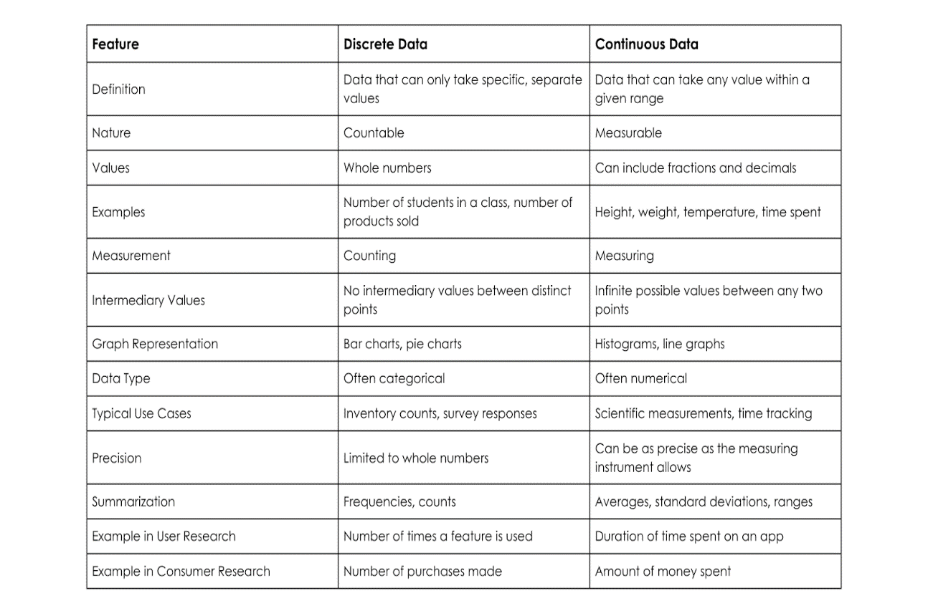
Table 3.2 is culled from Entropik.io (Discrete Vs. Continuous Data: Everything You Need To Know (entropik.io; Yashaswi, 2024, para. 12)
Comment 10: Statistical hypothesis testing and estimation have remained controversial despite their use in organizations and academic studies.
Quote/Paraphrase: A hypothesis is a premise or claim that we want to test. The notables are: Null Hypothesis: which can be quantified as zero or the default.
Ho: Hypotheses are currently accepted as values for parameters. Ha: Alternative Hypothesis Ha: also called research Alternative hypotheses involve the claim to be tested (Gibson, 2014).
Essential Element: A hypothesis, premise, notables, null hypothesis, zero, or the default, Ho: Hypotheses, values for parameters, Ha: Alternative Hypothesis, Research Hypotheses,
Additive/Variant Analysis: Jason Gibson reiterates the need to simplify hypothesis testing which many see as complex. He finds Ho and Ha as mathematical opposites. You either reject the Null Hypothesis (Ho) or fail to reject the Alternative Hypotheses (Ha). He further enlightens on Test Statistics: as calculation from sample data used to decide.
Contextualization: Gibson simplifies Hypothesis testing in the assumption items a – g, above. Hypothesis testing can be used in several areas of business and operations to determine the levels of confidence and significance of a project, business, or service. Software for hypothesis testing will be ideal to utilize.
The Issue at hand:
A company’s machine makes straws that are 4 mm in diameter. A worker believes the company no longer makes straws of this size and samples 100 straws to perform a hypothesis test of 99% confidence.
The Assumption is:
Ho: mean, μ = 5g. The machine probably makes chocolate bars.
Ha: mean μ # 5g. The Machine no longer makes chocolate bars.
Ho and Ha are mathematically opposites,
- Possible outcomes from the Tests.
- Reject Null Ho Hypotheses.
- Accept or not the Alternative Ha's Hypotheses.
- Test Statistics:
- Calculate from sample data used to decide. Example: 50 bars.
- Get Ave values and calculate test statistics.
- Statistically Significant: this is where you draw the line to make a decision.
- Level of Confidence: C = 95, 97, 99.
- Level of Significance: α = 1 – C.
- So, Level of confidence, LOC = 95%., C = 0.95, α = 1- C = 0.05.

Source Six: Tao, T., Hadfield, C., Tyson, N., & Goodall, J. (2022). Master Class. Random
Sampling Explained: What Is Random Sampling? https://www.masterclass.com/articles/random-sampling#1RmMlGTJYZSylXeY3Luthv.
Comment 11: Random Sampling application cuts across social, economic, political, and industrial services and operations.
Quote/Paraphrase: Random sampling is a method of data collection and analysis designed to select a representative sample of respondents out of a larger population every member of the population has an equal probability of being selected. Random sampling is used for phone surveys, political polling, epidemiology, tracking disease, gene pool mapping, and tracking public opinion. (Tao et al, 2022).
Essential Elements: Random sampling, data collection, and analysis, representative sample of respondents, larger population, equal probability, epidemiology, tracking disease, gene pool mapping, and tracking public opinion.
Additive/Variant Analysis: Additive, “Random Sampling is used for phone surveys, political polling, epidemiology” underscores its strategic relevance. Especially to the academia, profit, and non-profit organizations. It is directly or indirectly linked to other statistical methodologies in data dispersion and distributions.
Contextualization: There are four main types of random sampling techniques: i). Simple random sampling (random number creation), ii) Systematic sampling: (use fixed intervals to pick respondents from an entire population). iii) Cluster sampling (dividing a total population into smaller groups). iv) Stratified sampling: ( breaks prospective respondents into subgroups, and homogenous like gender, education language).
Comment 12: The intersection of statistical principles and applications with operational services and businesses provides solutions to issues of concern.
Quote/Paraphrase: In today’s digital landscape, the intersection of marketing and statistics has become more significant than ever, 60% of marketers believe that data-driven marketing is crucial to the success of their strategies. This precision leads to higher engagement rates and improved ROI. Data provides valuable insights into customer preferences and trends, enabling marketers to adapt their strategies quickly and effectively (Chakraborty, 2024).
Essential Element: Digital landscape, the intersection of marketing and statistics, Marketers, ROI (return on investments).
Additive/Variant Analysis: The additive, “intersection of marketing and statistics has become significant” is critical. It portrays the degree to which modern businesses are beginning to embrace the use of statistical inferences. The “insight” statistics provide” tends to facilitate the understanding of marketing trends, perhaps the competition in such a market.
Contextualization: Modern organizations incorporate digital statistical applications in their operational services. This is through designated software programs. Many academia and modern organizations train on statistical software to facilitate their services and operations.

Conclusion
Conducting a research study presents a continuum of statistical methodologies, including qualitative and descriptive plans, and a bottom-up-subjective approach. Others include the quantitative top-down objective approach. There are measures of central tendencies, mean, mode, and median, measures of dispersions, random sampling, standard deviation, research testing and so much more. This study shows that each of these statistical applications serves a specific purpose and offers solutions (Reichard, 2024), to issues of concern like price inflation, government, and business subsidies, import and export quotas, academic enrollments, unemployment, immigration, etc. Furthermore, statistical software is used simultaneously in some academic institutions. However, corporate organizations have a paradigm shift, from classical statistical methodologies to computerized, intelligent statistical software like IBM SPSS Statistics, JMP, Minitab, OriginPro, Statgraphics Centurion, etc. Statistical software is time and cost-effective (Chakraborty, 2024) and can process complex mathematical and statistical equations and processes (Abbadia, 2024) for prompt management and organizational decision-making. They come in readily handy in forecasting marketing and product competition, organizational development, political data and straw polling, and medical and health strategic planning.

Works Cited
Abbadia, J. (2024) A Complete Overview of Levels of Measurement in Data Analysis. Master
Scientific Data Visualization. Learn how to make data easier, unlock insights, and captivate audiences effectively. https://mindthegraph.com/blog/levels-of-measurement/.
Ali, Z., Bhaskar, S. B., & Sudheesh, K. (2019). Descriptive statistics: Measures of central
tendency, dispersion, correlation, and regression. Airway, 2(3), 120-125.
Bhardwaj, A. N. K. U. R., & Sharma, K. (2013). Comparative study of various measures of
dispersion. Journal of Advances in Mathematics, 1(1).
Chakraborty, P. (2024). Win Savvy. The Intersection of Marketing and Statistics: Trends for
2024. https://www.winsavvy.com/about-winsavvy/.
Drew, C. (2023) 15 Qualitative Data Examples. Helpful Professor.com. Htps://helpful
professor.com/qualitative-data-examples/.
Fithian, W. (2023). Statistics 210A: Theoretical Statistics (Fall 2023) Department of Statistics
Evans Hall University of California, Berkeley, CA 94720. Statistics 210A: Theoretical Statistics (Fall 2023) (berkeley.edu).
Frost, J. (2024). Discrete vs. Continuous Data: Differences & Examples - Statistics By Jim
Discrete Vs. Continuous Data: Everything You Need To Know Discrete Vs. Continuous
Data: Everything You Need To Know (entropik.io).
Gibson, J. (2014) Intro to Hypothesis Testing in Statistics - Hypothesis Testing Statistics
Problems & Examples.
Hadfield, C., Tyson, N., & Goodall, J. (2022). Master Class. Random Sampling Explained: What
Is Random Sampling?
Mohanasundari, S. K., Pratheeba, S., Preethi, S., Kasturi, V. K., Peter, M., Guru, P., & Dayal, E.
D. (2023). Key disparities between quantitative and qualitative research methodologies.
Privitera, G. J. (2024). Research methods for the behavioral sciences. Sage Publications.
Ravid, R. (2024). Practical statistics for educators. Rowman & Littlefield.
Reichard, J. (2024). Statistics as a Language: Overview of Statistical Test and Hypothesis
Testing. Video Tutorial.
Tao, T., Hadfield, C., Tyson, N., & Goodall, J. (2022). Master Class. Random
Sampling Explained: What Is Random Sampling? https://www.masterclass.com/articles
/random-sampling#1RmMlGTJYZSylXeY3Luthv.
Yashaswi, G. (2024) Discrete Vs. Continuous Data: Everything You Need To Know
Explore the differences between discrete and continuous data and their impact on
business decisions and customer insights.

