Library of Congress Pre-Candidacy Requirement

Jack Nicholson

Omega Graduate School

October 4, 2024

Professor

Dr. David Ward, Ph.D.

**Library of Congress Experience - Course Learning Journal**

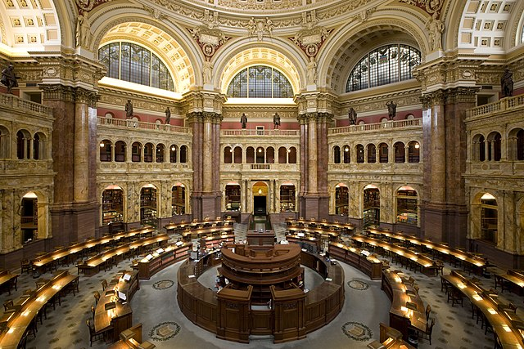

The trip to the Library of Congress was an incredible experience that enriched my understanding of how to do high-level doctoral research. The trip also set up an important breakthrough in terms of how I will approach the Literature Review for my dissertation and my professional development in the next season of my career.

Just being in the Library of Congress was impressive. The architecture was truly magnificent, and the world-class researchers provided the gravitas that our student group needed to fulfill the purpose for which we were there and focus on our specific tasks at hand. Dr. Ward was an outstanding coach for each of the students and we became a team, not just a student

group, working for the benefit of each other during the time that we were there. When I needed help with a technical matter or guidance in terms of research skills and information literacy, my fellow students and Dr. Ward were very gracious to provide me with their assistance. We stayed together at the Kellogg Conference Hotel on the Gallaudet University Campus and would take the train or walk to the Library of Congress every day. We ate our meals together and I got to know each of their leadership roles and the importance of their research to their life’s work. I especially enjoyed the walk that I took every day to and from the Library of Congress to Union Station in Washington D.C. Walking by the Senate offices, the Supreme Court, and the Congress on Capital Hill reminded me of the importance of the separation of powers provided for in our Constitution and to appreciate how essential our almost 250-year-old republic is to the freedom of our people and the world at large.

I enrolled in the Library of Congress trip to accomplish two major objectives: I wanted to learn the necessary research tools to complete the Literature Review for my dissertation and I wanted to develop my knowledge base to be a cutting-edge thought leader and practitioner in the field of transformational leadership. That vision and mission proved to be more difficult than I expected. I am a very intuitive learner and have spent most of my career in the coaching, counseling, and consulting professions. My academic limitations include dealing with linear processes, managing minute details, assimilating technology and information literacy. Spending a week at the Library of Congress, I would have to face all those demons.

The advance preparation for the LOC trip was helpful and the training orientation led by Laura Berberian, the Reference Librarian in the field of Sociology, provided an overview of the research tools and library resources that were available to us. The LOC overview of research

techniques were not that new to me because the Omega Graduate School does a good job of developing the research skills of its students. Through completing the developmental readings and course requirements, I had learned how to find research articles and books to support my essays and assignments. The difference at the Library of Congress was in accessing and evaluating the sheer mass of knowledge and information available within the largest research library in the world.

In the middle of the week, I experienced deep frustration with the search engines trying to find relevant articles and dissertations for my research questions. I was acquiring an overwhelming mass of information without finding what I needed to further my research project. It was a very tough day because I was beginning to feel incompetent. I remember texting my wife Melissa during my impasse and she was very kind and supportive of where I was struggling. Dr. Ward was also supportive and yet was surprised and encouraged by seeing all the articles and dissertations that I had gathered. His reaction was important for me to see because I had set my expectations too high. Gathering research is a very linear, tedious process that requires patience and perseverance. This was confirmed later when I met with Brian, one of the younger Research Assistants at the LOC, who helped me find a reference that I had difficulty producing with ProQuest. When I watched Brian work the search process, I realized that gathering research is not magical but methodical. Brian was very fast, but he wasn’t doing anything that I wasn’t trying to do.

After watching Brian I came to the realization that there is a big difference between sifting information and having a focused research strategy. I was attempting to find relevant articles from the bottom up instead of searching for what I needed from the top down. To write a

quality literature review, I needed to build the analytical outline that would provide me with the citations that the outline required. Filling holes in the dissertation outline is a far better way to gather the research than sifting through massive amounts of information to find nuggets that I might be able to use. I resolved to trust my thought processes, build out the logic of my argument, and then find the citations to support my analytical outline. This intuitive shift was a breakthrough for me, but probably obvious to Dr. Ward. He has been a masterful and methodical researcher for many years.

Maybe it took all the time, effort, and expense to travel to the Library of Congress to experience this kind of breakthrough with my mindset. I’m grateful for this important insight about academic research because it makes the process a means to an end rather than an end-in-itself. I can support my dissertation with the necessary citations to make the case for which I am passionate about rather than sifting through vast amounts of information to analyze, digest, and synthesize knowledge.

Dr. Ward has advocated for utilizing an Excel Spreadsheet to build the support required by the research question, allowing the analytical outline to evolve, and making the logical argument needed to defend the dissertation. I can visualize an iterative, back and forth process of building the analytical outline and curating relevant citations together. Filling holes in the logical argument as well as closing gaps in the dissertation outline makes for a workable research strategy. Despite my academic limitations, I can manage that dynamic research process and produce a proposal that will meet the standards of my dissertation committee. If it took a week-long trip to the Library of Congress to grasp at a deeper level a workable strategy to do my dissertation research, then it was worth it!