CHAPTER 4: FINDINGS AND RESULTS
The purpose of the study was to examine the potential relationship between race-related stress and the perception of injustice among middle-class African Americans in Chattanooga, TN. The quantitative correlational research study examined, via self-assessment inventories, middle-class African Americans’ race-related stress, perception of injustice, and the potential relationship between the two. A total of N = 62 respondents participated in this study.
The following research question guided the study was:
Research Question: What relationship, if any, exists between a middle-class African American's self-assessed level of race-related stress and self-assessed perception of injustice?
The following null hypothesis was tested:
H_{o}: No statistically significant relationship exists between a middle-class African Americans’ self-assessed level of race-related stress and self-assessed perception of injustice.
Data Collection
Informational letters and follow-up letters were composed in compliance with the American College of Education's Institutional Review Board (IRB) procedures. Once consent was obtained and approval granted, a summary of the purpose and participation requirements of the study and consent forms were provided to the participants (see Appendix G for the consent form and Appendix H for the permission letter). Data were collected from 62 participants over six (January 2024 – March 2024) weeks using on-line surveys. A confidential code and link took participants to surveymonkey.com. On-line surveys helped maintain data collection validity and reliability and were ecologically friendly (Dewaele, 2018).
The data collection method, surveys, provided information for correlational examination with minimal risk to participants. Participants did not complete the surveys anonymously to ensure that data from each survey was properly correlated. During the study, participants remained confidential. Participants' names were not revealed. Instruments used in the study were submitted to the IRB for review and approval.
After consent forms from the participate in the study were received, an e-mail was sent to thank participants for agreeing to take part in the study. Data was collected using on-line surveys; the e-mail contained directions on how to access the surveys on-line. Completed survey data was stored on a flash drive to be kept for three years. The information was retrieved and exported to SPSS for analysis. SPSS is a software package used for statistical analysis. Survey responses of participants were kept confidential.
IRRS-B data collection. Participants received a link to access the IRRS-B. The participants accessed and completed the survey via the link. An e-mail notification was generated to indicate that data were ready for collection.
PIQ data collection. Participants received a link to access the PIQ. The participants accessed and completed the survey via the link. An e-mail notification was generated to indicate that data were ready for collection.
Data Preparation
All participants answered every question on the IRRS-BI and PIQ surveys. The IRRS-B and PIQ data was downloaded into SPSS for preparation of analysis from survey monkey. Survey data was input into SPSS for analysis. Examining data allowed researchers to rectify the common issue of missing data. Preceding statistical analysis, handling of missing values, and data exclusion were executed. Frequency distributions for the variables were created and examined for typing errors, outliers, and missing data. The variables were assessed for distribution normality.
Reliability and Validity
The sample for the study consisted of 62 middle-class African Americans representative of Chattanooga, TN. A larger sample size could have yielded more generalizable findings and statistical significance. Convenience sampling from the total population of middle-class African Americans yielded a representative sample.
Construct validity from a systematic approach maintained the validity of the study by using appropriate methods for quantitative research (Mislevy, 2007). Sixty participants were selected based on the sample size calculation for a Pearson's r in G*Power. A convenience sample was used to select the first sixty participants to return a signed consent form. Sixty-two participant consented to participate in the research study.
Cronbach’s alpha was used to measure internal consistency and scale reliability.
Cronbach’s alpha for the study exhibited an expected alpha value between .70 and .90 (UCLA Institute for Digital Research & Education, 2019). The Cronbach’s alpha coefficients for the IRRS-B and PIQ demonstrated evidence of strong internal consistency. Internal reliability coefficients for the IRRS-B when validated were above the expected alpha value of .70, ranging between .75 and .87 (Utsey, 1999). The alpha value for the IRRS-B for this study was .90 (see table 2). The PIQ when validated demonstrated internal reliability coefficients above the expected alpha value with a first order scale mean of .87, ranging between .75 and .90 (Neumann, Berger, & Kizilhan, 2021). The alpha value for the PIQ for this study was .85 (see Table 2).

Descriptions of the Sample
Table 1 displays the frequency counts for the demographic variables. All participants were either Black/African American or Black/African American with an additional racial/ethnic designation. Ages of the respondents ranged from 30-40 years (11.3%) to 61+ years (30.6%) with the median age of Mdn = 55.50 years. There were somewhat more men (53.2%) than women (46.8%) in the sample. Sixty-one percent had an income of over $93,000/year. Job titles ranged from laborer/staffer (21.0%) to business owner (9.7%) with a median job title being management. Seventy-four percent had earned at least a master’s degree (see Table 1).
Table 1

Frequency Counts for the Demographic Variables
______________________________________________________________________________

Variable Category N %
_____________________________________________________________________________
Race
 | Black/African American | 60 | 96.8
 | Black/African American plus Other Race/Ethnicity | 2 | 3.2
Age Category ª
 | 30-40 years | 7 | 11.3
 | 41-60 years | 16 | 25.8
 | 51-60 years | 20 | 32.3
 | 61+ years | 19 | 30.6
Gender
 | Male | 33 | 53.2
 | Female | 29 | 46.8
Income Category
 | Under $66,000 | 5 | 8.1
 | Between $66,000 to $93,000 | 19 | 30.6
 | Over $93,000 | 38 | 61.3
Job Title
 | Laborer/Staffer | 13 | 21.0
 | Supervisor | 12 | 19.4
 | Management | 17 | 27.4
 | Executive | 14 | 22.6
 | Business owner | 6 | 9.7
Highest Education
 | College/College Graduate | 16 | 25.8
 | Master’s Degree | 30 | 48.4
 | Doctoral Degree | 16 | 25.8
______________________________________________________________________________
Note. N = 62.
ª Age: Mdn = 55.50 years.

IRRS-B Online System Analyses
Data collected via the IRRS-B online survey were used to create an Excel spreadsheet containing scores for each of the three IRRS-B domains: individual racism, institutional racism, and cultural racism. The domain scores were imported into SPSS. The composite (mean) scores were calculated for the race related stress variable. Descriptive statistical computations were performed for the IRRS-B to include the mean and standard deviation (see Table 2).

PIQ Online System Analyses
Data collected via the PIQ online survey were utilized to produce an Excel spreadsheet containing scores for each of the four PIQ domains: injustice experience, injustice perception, emotional and cognitive consequences, and revenge and forgiveness. The composite (mean) scores were computed for the perception of injustice variable. Descriptive statistics were computed for the PIQ to include the mean and standard deviation (see Table 2).
Table 2 displays the psychometric characteristics for the two scale scores. For race-related stress, the mean score was M = 3.32 on a five-point scale and for perceived injustice, the mean score was M = 2.67 on a five-point scale. The Cronbach alpha coefficients were both acceptable (Cronbach, 1951) (see Table 2).

Table 2

Psychometric Characteristics for the Scale Scores
______________________________________________________________________________

Scale Score Items M SD Skewness Kurtosis Min Max α
______________________________________________________________________________
Race-Related Stress | 22 | 3.32 | 0.75 | -0.03 | -0.95 | 1.68 | 4.68 | .90
Perceived Injustice Total Score | 24 | 2.67 | 0.44 | 0.61 | 0.22 | 1.79 | 3.92 | .85
______________________________________________________________________________
Note. N = 62.

Assumption Testing
According to the Laerd Statistics website (Laerd, 2024), there are five assumptions needed for Pearson correlations:
- Continuous variables
- Paired variables
- Linear relationship between the variables
- No significant outliers
- Normality
Assumption 1 (continuous variables) was met with both scale scores having Cronbach alpha scores greater than .70 (see Table 1). Assumption 2 (paired variables) was met by the study’s design with the respondent’s stress score being paired with the respondent’s injustice score. Assumptions 3 (linear relationship) and 4 (no significant outliers) were met after inspection of Figure 1. Figure 1 indicates a positive linear relationship was found between the o variables. In addition, no significant outliers were observed (see Figure 1).

Figure 1

Scatterplot to Test the Hypothesis
______________________________________________________________________________
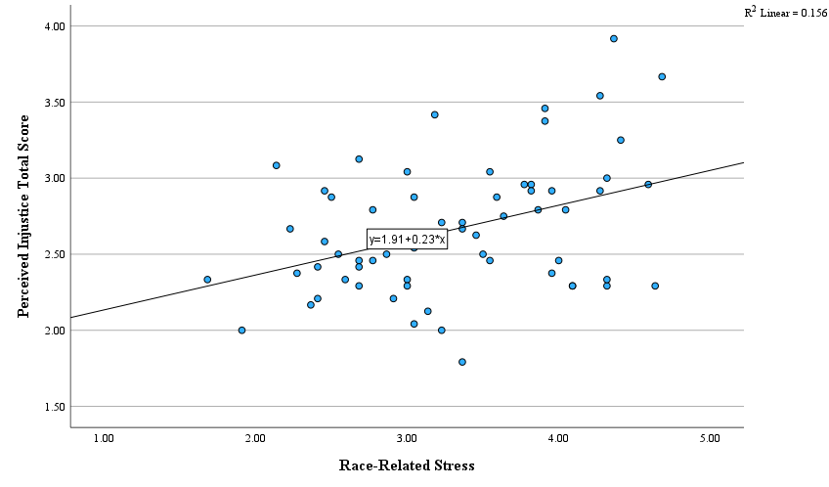
______________________________________________________________________________
Note. N = 62.
Note. Pearson correlation between the two variables: r (60) = .40, p = .001.
Note. Spearman correlation between the two variables: r_{s} (60) = .33, p = .008.
Note. Kendall tau correlation between the two variables: τ (60) = .24, p = .007.

Assumption 5 (normality) was addressed two ways: Skewness and kurtosis statistics (see Table 2) as well as normality statistics (See Table 3). The skewness and kurtosis statistics were within normal limits (± 1.0, Cronbach, 1951). In addition, three of the four statistics in Table 3 were not significant. With that, a decision was made to test the hypothesis using a Pearson’s correlation, Spearman’s correlation, and Kendall’s tau-b correlation for verification purposes.

Table 3

Normality Statistics for the Scale Scores
______________________________________________________________________________

Kolmgorov-Smirnov Shapiro-Wilk
___________________ ___________________

Scale Score Statistic df p Statistic df p
______________________________________________________________________________
Race-Related Stress | 0.09 | 62 | .20 | 0.97 | 62 | .18
Perceived Injustice Total Score | 0.11 | 62 | .04 | 0.97 | 62 | .09
______________________________________________________________________________
Note. N = 62.

Tests of the Research Question and Hypotheses
Research Question 1 was:
What relationship, if any, exists between a middle-class African American's self-assessed level of race-related stress and self-assessed perception of injustice?
The related null hypothesis was:
H_{o}: No statistically significant relationship exists between a middle-class African Americans’ self-assessed level of race-related stress and self-assessed perception of injustice.
A statistically significant positive correlation was found between stress and injustice for both the Pearson correlation (r [60] = .40, p = .001) and the Spearman correlation (r_{s} [60] = .33, p = .008) and the Kendall tau correlation, τ (60) = .24, p = .007. This combination of findings supported for rejecting the null hypothesis (see Figure 1).

Summary
This quantitative correlational study used survey data from 62 respondents to examine the potential relationship between race-related stress and the perception of injustice among middle-class African Americans in Chattanooga, TN. The primary hypothesis (stress related to injustice) was supported (see Figure 1). In the final chapter, these findings will be compared to the literature, conclusions and implications will be drawn, and a series of recommendations will be delineated.

