Action Research Project Title

Joseph Jay Breish

Omega Graduate School

5/27/24

Chair: Dr. David Ward

# Copyright

Copyright © 2024

Joseph Jay Breish

ALL RIGHTS RESERVED

# XXXX - Abstract

This research project, “Communities That Heal” was designed to address America’s Mental Health problems by developing safe communities armed with tools to heal group members and those around them. Research indicates the need for more lay-ministers able to address mental health needs. This project developed lay-ministers through the teaching of key tools in a communal setting.

# Dedication

To the Bride of Christ. You are more precious and vital than you know.

# Acknowledgments

I want to thank the many people who came alongside me on this doctoral research journey. Completing my Doctorate in Social Leadership would not have been possible without many people supporting me and recognizing the significance of my work.

First and foremost, I thank the Lord for calling me to His service. He was the one who helped me see the need for healthier individuals, families, and the Church. I was naive and oblivious before Christ. He led me to the experiences I needed to see the brokenness of mankind. He also led me to the answer: a healthy, spirit-led Church.

To my professors and colleagues at Omega Graduate School, thank you. Many phone calls and Zoom meetings went into clarifying and refining this work. Dr. Ward, Dr. McClane, and Dr. Hughes: your insight into faith, sociology, leadership, and prayer was vital to my success.

I’m eternally grateful to both sets of parents. Their encouragement, support, and belief in me cannot be understated. Without them, I would not have completed this research. You gave me what I needed in due season to complete this work.

I’m grateful for all my ministry partners and intercessors. May the Lord bless you for your prayers and support. May the Kingdom be richly blessed because of your quiet and often unrecognized work.

Lastly, I’m grateful to those who paid the highest price for this work’s completion: my family. To Hannah, you’re a gift beyond measure. You believed in me before anyone else did. I love you. To my girls, you are such precious gifts. I appreciate your patience with me as a Dad. May the Lord call you into His divine work just as He has me. May He bless you every day of your lives.

Table of Contents

Copyright 2

XXXX - Abstract 3

Dedication 4

Acknowledgments 5

CHAPTER 1: INTRODUCTION 10

Introduction 10

Statement of the Problem 12

CHAPTER 2: LITERATURE REVIEW 14

Background of the Problem 14

Problem Overview 14

Historical Context 16

Analysis through Sociological Theory 20

Faith-Based Analysis 21

CHAPTER 3: RESEARCH DESIGN 22

Designing the Intervention 22

Purpose and Objectives 23

Sociological Theory 23

Faith-Based Considerations 25

Target Group or Issue 27

Strategies and Activities 27

Resources Needed 29

Timeline 30

Anticipated Challenges 30

Measuring Success 30

Ethical Considerations 32

Adherence to Professional Ethics 32

Respect for Persons 32

Confidentiality and Privacy 33

Avoiding Harm 34

Cultural Sensitivity 35

Addressing and Disclosing Bias 36

Transparency and Accountability 37

Site Permissions 37

CHAPTER 4: FINDINGS 38

Delivery and Evaluation Plan 38

Implementation Steps. 38

Criteria For Evaluation. 41

Evaluation of Results 43

Assessing Effectiveness 43

CHAPTER 5: CONCLUSION 52

Reflection 52

Research Process 52

Challenges 52

Personal Learning Outcomes 53

Project’s Impact on social/faith-based perspectives 54

Effectiveness toward training goals 55

Conclusion 55

Future Research 56

Researcher Transformation 56

Summarize Findings 57

Final Remarks 58

References 59

Appendices 70

Appendix A: Nightly Training Schedule - Week 1 71

Appendix B: Action Researcher Weekly Class Reflection Template 73

Appendix C: Custom Database – Teacher Report Snapshot 74

Appendix D: Promotional Flyer 76

Appendix E: Pre-Interview Questionnaire 78

Appendix F: Post-Session Reflective Questions: Week #1 79

Appendix G: Room Request 81

Appendix H: Weekly Homework Email – Week 8 82

Appendix I: Action Research Project Training Timeline snapshot 83

Appendix J: Introductory Email with Flyer 84

Appendix K: Nightly Training Schedule – Week 6 85

Appendix L: Group Reflections – Week 9 86

Appendix M: Training Slides – Week 1 88

Appendix N: Homework - Week 1 91

Appendix O: Final Sectional Reflection Questions 92

Appendix P: Post-Session Reflection Questions – week 8 95

Appendix Q: Homework – Week 5 97

Appendix R: Graduation Certificate 98

# CHAPTER 1: INTRODUCTION

## Introduction

TODO: Remove conjunctions

Globally, with particular emphasis in the United States, Mental Health is noticeably deteriorating (B. Parker, 2023; The State of Mental Health in America, 2023; Mental Health By the Numbers | NAMI: National Alliance on Mental Illness, 2023). Loneliness, depression, fear, and trauma are increasingly prevalent (Siladi, 2023; Schaap-Jonker, 2022). Adding to this concern is the substantiated connection between the American Mental Health crisis and physical health deterioration (Rides & Shaw, 2023; Fusar-poli et al., 2020). As a result of declining Mental Health conditions, coupled with a generalized loss of community and spiritual connection, many individuals struggle to determine their identity and position in contemporary society (Maseko, 2018; Rides & Shaw, 2023; Kok et al., 2021). There is a pressing need for a solution that is community-based (Bareng, 2021; Costello et al., 2021; Nanthambwe, 2023; Rides & Shaw, 2023; Schaap-Jonker, 2022,), identity-centric (Wilder et al., 2020; Rides & Shaw, 2023; Nanthambwe, 2023), and spiritually grounded (Barnett, 2023; Bingham Musick, 2023; Pfeiffer et al., 2023; Olivia et al., 2021; Willey, 2019; Jacob 2022). This solution must also serve as a sanctuary conducive to healing (Banfield et al., 2022), aiming to rejuvenate individuals, the Church, and, consequently, the greater society.

This action research project aims to address the poor mental well-being observed within the Church through a communal, identity-centric, spiritual discipleship program. As a result of reduced emotional wellness, the American Church has been ineffective at fulfilling the Great Commission. Using this research, I intend to design a program that promotes a supportive, healing environment that addresses basic spiritual and Mental Health needs. An empathetic community, identity, prayer, and forgiveness are the focal domains of this initiative. This research aims to empower the Church to fulfill the Great Commission by healing and maturing its members through enduring healing communities. As the Church in America becomes healthier and embraces its God-given mission, the American people will also be transformed.

This researcher desires to positively impact the American Mental Health crisis by successfully creating these “Communities that Heal (CTH).” Instead of relying on the few to minister to the needs of the many, CTH groups empower the lay workers to minister to those around them, the outcome being an active church that transforms society.

Structural Functionalism (SF) is the primary sociological theory best suited to address the mental health problems in the American church. SF closely resembles the 1 Corinthians 12:12 concept of many members forming one body. SF and the Scriptures state that the individual parts make up and impact the whole. As such, the church members must individually take responsibility for their health and maturity for the church (the whole body) to be healthy. In many ways, American society was founded on the morals of the Church. Therefore, the Church has a responsibility to keep society healthy. (Nanthambwe, 2023)

When considering sociological frameworks with which to view the problem of the Mental Health crisis in America, two additional relative theories arose: the Thomas Theorem and the Labeling Theory. The Thomas Theorem claims, “If men define situations as real, they are real in their consequences” (Thomas & Thomas, 1928, p. 572; ). In other words, what you believe becomes real. Similarly, the Labeling theory identified that a person’s self-concept can be influenced by the way a person is labeled (Becker,1963). The Labeling theory and the Thomas Theorem both suggest that how a person see’s themselves impacts the way they will live. These frameworks are compatible with the Biblical idea of Proverbs 23:7, “For as he thinks within himself, so he is” (NASB, 2020). These theories in conjuction with the Scriptures were used to provide insight into why the American Church lacks maturity and emotional health.

## Statement of the Problem

Mental Health problems abound worldwide (Haddad et al., 2020), particularly salient in America and the American Church (Johnson, 2023; Shrodes, 2022; Vick, 2019). Research identified inadequate access to Mental Health services before COVID-19 (B. Parker, 2023; Barnett et al., 2018). The global pandemic exacerbated this shortage, negatively impacting Mental Health and adding trauma to the existing list of unresolved past hurts (Gruber, 2021; Humboldt et al., 2022; Bingham Musick, 2023).

Trauma is the emotional response to a terrible event (*Trauma*, 2022), often overwhelming a person’s coping ability (Davediuk Gingrich, 2017). Trauma exacerbates existing Mental Health issues by changing the brain and interrupting natural thinking processes (Bingham Musick, 2023), often forcing the individual to live in survival mode (Van der Kolk, 2015). Shrodes’ (2022) research identified that Adverse Childhood Experiences (ACEs) double the risk of Mental Health conditions in adults and that ACEs are common. For example, one-third of UK youth have experienced trauma (Shrodes, 2022, p. 77). The CDC identified that one in ten youth have been sexually assaulted or forced to be involved sexually with someone else (Kann et al., 2018). In 2022 it was reported that at least one in seven children have experienced neglect or abuse (*The State of Child Abuse in 2022*, 2022). While trauma often occurs in childhood (Rides & Shaw, 2023), the entire world was recently exposed to a potentially traumatizing event from COVID-19 (Gurney et al., 2023; B. Parker, 2023; Dube & Sibanda, 2022; Goodwin & Kraft, 2022; Humboldt et al., 2022; Gruber et al., 2021; Haddad et al., 2020). Although the Church should be a part of the Mental Health solution, it has had difficulty effectively responding because the same Mental Health issues existing in secular society exist within the Church (Shrodes, 2022; Willey, 2019; Davediuk Gingrich, 2017; Robbins, 2022). Furthermore, Church leaders often feel unequipped to address Mental Health issues without specialized ministries to reach those with emotional and mental problems (Johnson, 2023; Crisp, 2022; Shrodes, 2022; Costello et al., 2021; Wilder et al., 2020; Vick 2019).

This research intended to introduce Believers into a deeper, more intimate relationship with Jesus by developing a discipleship program to create enduring, replicable, healing communities. The desired outcome of these healing communities is reduced Mental Health issues. Safe, grace-based communities can help reframe past hurts into redemptive stories, and community members can support one another as new struggles arise. The group facilitator can role model the love of God and introduce believers to new methods of prayer, communication, counseling methodologies, and Biblical identity. The intent is to create a community with the tools to minister to its members and become a healing entity in society.

As a pastoral prayer counselor with Paraclete Mission Group, this research is significant to my professional context because there are more who need help than those who can provide it (NASB, 2020, Matthew 9:37-38). Secular models are only as effective to the extent that they are rooted, knowingly or unknowingly, in Biblical truths about the makeup of mankind. Even when they implement Biblical principles, they cannot, by definition, lead people to the Jehovah-Rapha, the God who heals (NASB, 2020, Isaiah 61:1-2). Nor can secular methodologies point people into deeper relationships with Jehova Mephalti, the God who delivers (NASB, 2020, Psalm 18:2). With the Mental Health crisis occurring not only in the United States but also worldwide, ministers who can lead people into an intimate, healing relationship with Jesus are in great demand.

Further complicating this problem is the backlog of unresolved trauma people have accumulated over the years. In modern society, people, especially children, are being traumatized at a disturbing rate (The State of Mental Health in America, 2023). With the breakdown of the family and the invention of the internet, children now have access to the worst parts of society, often without parental involvement (Banić & Orehovački, 2024). The educational systems and social media have frequently become our children’s “parenting” figures, further adding to their Mental Health needs. While the causative factors are debated, recent rises in homeschooling rates appear to be connected, at least in part, with the loss of religious freedoms and the desire for parents to reinstitute Biblical values in their children. (Watson, 2018).

As children are exposed to the world without a Biblical lens or parental connections to help filter what they are observing, children are experiencing trauma at an alarming rate (Bingham Musick, 2023). These ACEs, coupled with the Church of the 19th century losing its pastoral influence on society (Clebsch & Jaekle, 1994), led to many secular forms of Mental Health treatment that could not effectively address the deep spiritual and soul issues confronting people. Today’s post-COVID society is experiencing the fallout of a weak Church coupled with a strong secular mindset (Warrick, 2020). The Church needs to step in and become a part of America’s Mental Health Solution.

# CHAPTER 2: LITERATURE REVIEW

## Background of the Problem

### Problem Overview

Since the fall of man in Genesis chapter 3, mankind has wandered from God and attempted to usurp His role as king of kings. Mental Health issues began in the garden as Adam and Eve experienced shame, fear, and regret immediately following their disobedience (NASB, 2020, Genesis 3). God designed mankind to live in peace, safety, and perfect love, but they lost access to those things when they listened to the serpent and were removed from the garden.

The Biblical narrative describes the cyclical problems man faced by trying to rule themselves apart from a loving and righteous God. Mankind needed a savior and a loving God to lead them into all truth. God’s plan was to provide Jesus for salvation and the Holy Spirit for our daily comforter and guide (NASB, 2020, John 14-16).

God designed the Church to be the “salt” and “light” to the world, bringing the Good News of salvation and a restored relationship between God and man. The Church was to teach others how to walk with God and lead them into all truth. This Spirit-led existence began at Pentecost with tremendous success (NASB, 2020, Acts 4). However, over the centuries, the miraculous effectiveness of the Church’s impact on society appear to have waned. The enlightenment period delivered a fatal blow, and the Church abdicated its role in the “cure and care of souls” (Clebsch and Jekle, 1994, p. 41). Secular counseling and psychology replaced effective Biblical discipleship. Healthy Christ-like communities have slowly been replaced by clubs, entertainment, and psychologically motivated solutions to Mental Health issues. Americans are facting mental health cases at an alarming rate (Johnson, 2023, p. 12). Americans saw a 400% increase in antidepressant use between 1988 – 2008 (Pratt, 2011, p. 1). Between 2016 and 2022 youth anti-depressant usage increased by 66% (Chua et al., 2024). Americans frequently use drugs to alleviate Mental Health ailments, but suicide and depression continue to have significant impact on this country (Lee, 2023; “Suicide - National Institute of Mental Health (NIMH)”, 2024). This researcher believes that by returning to the Biblical mandate to make disciples, we can mitigate Mental Health conditions and transform American society for the better.

### Historical Context

The seminal author McGinn (1996) noted that the early Church knew the costly nature of associating with Christ. The Church understood that they lived in a “now and not yet” state, where they could suffer and die like Jesus at any moment (p. 24). Simultaneously, early Christians recognized that there would be a time when Christ would return and take away their suffering (McGinn, 1996, p. 24). With this in mind, the Church remained alert and ready. There was no place for complacency or comfortability. The Holy Spirit was essential to the believer’s spirituality (McGinn, 1996, p. 26). He was the comforter and guide to a Church in perilous times. McGinn (1996) notes that the Spirit was often thought of in communal terms, like the day of Pentecost, and that the highest form of experiencing the Spirit was in a loving community (p. 26).

For centuries, the Church appeared to function with this spiritual, communal, always-ready mindset. It wasn’t until the Enlightenment that culture became more material and science-focused rather than spiritually minded. Human intellect became humanity’s new guiding spirit. Clebsch and Jaekle (1994) note that during the Enlightenment, society shifted from resolving spiritual ailments to creating psychological explanations (p. 69). Formerly, the pastoral role provided the “Cure and Care of Souls,” helping people overcome impairments and move toward wholeness beyond their previous condition (p. 21, 79). During the Enlightenment, pastoral functions were relegated to secular modalities. Focusing on man’s intellect may have seemed “right in the people’s eyes” but directly contradicted Scripture (NASB, 2020, Judges 17:6). Individualism replaced community. Reason and skepticism replaced faith and obedience. The Church became comfortable and lost its “alert and ready” mindset. By the late 19th and early 20th centuries, Biblical authorities on the cure and care of souls became almost non-existent in literature. Secular psychological figures like Freud and Dostoyevsky replaced Biblical authorities (Clebsch and Jaekle, 1994, p. 41). With this modernized way of thinking, the Church began to lose its relevance in society.

Along with the loss of spiritual “readiness” from the Enlightenment period, there was an observable shift away from pastoral care and discipleship. The word “discipleship” involves more than learning, including coaching and attaching oneself to another (Brits, 2022, p. 2, 16). In other words, discipleship requires intimate and often lifelong relationships (Williams, 2023). Teaching from the pulpit is much easier than living in a close community. As culture became more comfortable, the Church began letting down its guard and transferring its pastoral role to those in the psychological fields. In the 21st century, many clergy feel unequipped to handle emotional and Mental Health needs (Costello et al., 2021). Yet scripture clearly states that God has given the Church everything for life and Godliness (NASB, 2020, 2 Peter 1:3). Jesus sent the Holy Spirit to guide us into all truth (NASB, 2020, John 16:13). The Holy Spirit’s fruits and gifts are what the Church needs.

As the care of souls was given over to secular authorities, the Church became inward-focused and curriculum-based (Willey, 2019). Evangelism became superficial rather than missional, without the intent to build intimate relationships for discipleship (Willey, 2019, p. 60). More than just teaching something, Biblical discipleship is about transmitting faith to the next generation (Willey, 2019, p. 21, 32; Moore, 2022). As the American Church became spiritually shallow, her evangelistic endeavors became numerically focused. The American Church failed to recognize its slow fading away from Biblical Christianity to some form of “lukewarm” religiosity that had little “light” to offer the world (NASB, 2020, Rev 3:16).

America has been experiencing a Mental Health crisis for some time. On average, one in five adults experience some form of mental illness (The State of Mental Health in America, 2023; Johnson, 2023). In some states, 30% of the population has a Mental Health issue (The State of Mental Health in America, 2023). Unfortunately, America’s youth are not exempt: One in ten American teens (16%) aged 12-17 years old are experiencing depression (The State of Mental Health in America, 2023). Additionally, six percent of American youth have a substance disorder. Of the teens that have Mental Health related conditions, nearly 60% of them will not receive any form of Mental Health treatment (The State of Mental Health in America, 2023). The Church must become a part of the solution (NASB, 2020, 1 Cor 9:22).

As mentioned earlier in this paper, COVID, among other sociological factors, has exacerbated America’s Mental Health crisis. Trauma, by nature, has a handicapping effect on the traumatized person, making it more difficult for them to think, function, and respond appropriately (Van der Kolk, 2015). As such, trauma impacts the individual and all those around them.

America’s Mental Health issues are not just a societal problem, but a Church problem. As Barnett (2023) notes, “No one should have to suffer alone” (p.23). “Faith communities should accompany people in their grief and trauma towards wholenss and healing” (Barnett, 2023, p. 23). Unfortunately, church leaders tend to have similar amounts of unresolved personal trauma as the general public making it difficult for them to fulfill the Great Commission (Shrodes, 2022).

According to Clebsch and Jaekle (1994), church pastors historically dealt with mental, emotional, and spiritual issues (pp. 31-23, 43). Humanistic methodologies became prominent when the Church lost its preeminent role as society’s soul healer. For nearly 300 years, secular modalities have been at the forefront of society. Nevertheless, a growing body of research has shown a strong correlation between spirituality and positive Mental Health outcomes (Dube and Sibanda, 2022). According to Dube and Sibanda (2022), post-COVID therapies need to “depend on a higher power [to] meet [society’s] complex challenges” (p. 129). Faith is “inextricably linked to Mental Health [and] well-being” and plays an integral role in how people understand themselves and make decisions in society (Goodwin and Kraft, 2022).

Rides and Shaw (2023) claim, “Healing is more than just one provider and one client (p. 7). Mental and emotional health needs are best met with holistic care, including community mobilization to create healing change (Rides and Shaw, 2023). Pfeiffer et al. (2023) agree, stating that Churches are uniquely positioned to become communities of care (p. 3). Ultimately, the increase in Mental Health cases has forced the Church to become more holistically minded, caring for people’s entire being (Johnson, 2023, p. 12).

In light of current research, healing communities equipped to care for society’s complex mental and emotional needs are required. Banfield et al. (2022) have identified that “non-clinical spaces,” which do not involve medical diagnosis or treatment but include peer support, can foster hope and healing for people in crisis (p. 2). Similarly, B. Parker (2023) identified that Christian lay counseling coupled with Inner-healing prayer (IHP) is a viable option to address post-pandemic Mental Health needs (p. 37).

Research shows that healing faith communities need to nurture member spirituality and provide safe spaces for prayer, reflection, and liturgy while remaining concerned with the development of the whole person (Barnett, 2023, pp. 23-24). Faith communities must build intentional, safe, and intimate relationships where trust can be established and sin can be confessed (Benjamin, 2021). Brown (2023) adds IHP as a necessary component of these faith communities, claiming that IHP has shown “significant efficacy” over licensed Mental Health practitioners (p. 100). Clark (2021) corroborated that IHP, also called Formational Prayer or Listening Prayer, has demonstrated significant efficacy in addressing trauma and personal brokenness. By helping connect the individual to the heart of God through His “still small voice,” prayer ministers foster a safe environment, allowing God to do miraculous healing in people’s souls and bodies. Furthermore, IHP helps establish individual and communal identity, further grounding the Body of Christ in the great commission.

Despite research showing clergy feel unequipped to promote Mental Health (Crisp, 2022), God has given us the tools and mindset the Church needs to tackle Mental Health issues in society. The problem isn’t that the Church doesn’t have the tools; the problem is it has become “weak in its ability to make disciples and missional communities” (Warrick, 2020, p. 6). The Church is immature due to its lack of prayer and discipleship (Willey, 2019). Changing Church culture is necessary to reach, equip, and disciple Church members (T.A. Parker, 2023). And as the Church heals internally, it will once again regain its ability to fulfill the Great Commandment and Great Commission, “Loving others as it loves itself” and “Making Disciples of all nations” (NASB, 2020, Matthew 22:37-39; Matthew 28, 19-20).

### Analysis through Sociological Theory

No single sociological framework will perfectly explain all societal experiences. Social issues are multifaceted and complex. That said, social theories are helpful in clustering and categorizing behaviors, beliefs, and problems into manageable groupings. This researcher selected Structural Functionalism (SF) as a sociological lens through which to view America’s social problems, namely, responding to Mental Health issues and extensive trauma.

SF views society from both macro and micro lenses. Macro in that society can function as a whole because there are shared values and goals, micro in that institutions and structures are created within society to maintain the good of the whole. SF views institutions as the building blocks of society, and they go by many names: government, educational systems, religion, and family, to name a few. With this in mind, this action research project sought to identify which institutions were primarily responsible for, or could most positively influence, societal change in the Mental Health arena. The two that were identified were the Church and the Family. Research supports the significance of these two institutions (Banić & Orehovački, 2024; De Villiers, 2020, p. 1; Ho et al., 2022).

By developing safe, grace-based communities within the Church, this researcher believes the Church can be re-established as the preeminent institution for Mental Health issues. The Church is uniquely positioned to support various institutions and sociological groups: individuals in crisis, families, children, the aging, etc. (Pfeiffer et al., 2023). Furthermore, the Church constitutes a significant portion of the population (REF). Utilizing many laypeople instead of developing a small number of expert-level workers is believed to have a greater sociological impact.

According to SF theory, the overall whole will improve when society's institutions are improved. This research focused on building up the Church as an institution so that it can effectively minister to community and societal needs. (VERBIAGE?).

## Faith-Based Analysis

During the late 19th and early 20th Centuries, God was actively involved in the American Church, revitalizing it through reintegrating the Holy Spirit’s gifts. Events like the Azusa Street Revival ushered in Pentecostalism, challenging the modern notion of Solo Scriptura (Nel, 2021). Then, in the 1950s, Agnes Sandford began her school of pastoral care, utilizing intimacy with the Holy Spirit and His gifts as a primary healing tool. Not long afterward, multiple ministries expanded on Agnes’ teachings to create what is known today as Listening Prayer (LP) or Inner Healing Prayer (IHP) (Wilder et al., 2020). Like contemplative prayer’s focus on communion with God, Christians practicing LP believe that God continues to speak and that His spoken (Rhema) word is as critical as the written(Logos) Word. IHP takes LP one step further by intentionally seeking God for guidance regarding emotional, physical, and spiritual issues. In the words of Clarke (2021), IHP is “a transformational encounter with Christ in the place of the individual’s deepest pain and greatest dysfunction” (p. 108). IHP helps facilitate deeper communion with God. In that way, it becomes a form of pastoral care for the brokenhearted (NASB, 2020, Isiah 61).

The Church has all the tools it needs to minister to its members and fulfill the great commission (NASB, 2020, 2 Peter 1:3). This researcher designed CTH to integrate faith-based tools with Biblical counseling techniques to Bind up the brokenhearted and equip the saints (NASB, 2020, Isiah 61:1-2; Ephesians 4:11-12).

# CHAPTER 3: RESEARCH DESIGN

## Designing the Intervention

Understanding the historical role the Church played as the authority in the care of souls, this researcher set out restore the early Church discipling mindset. Two foci became helping members understand their new identity in Christ and cultivate a dependent, active prayer life. Reflecting on the strengths of the early Church, coupled with current research, it was determined that a communal context would also be required for effective revival. (REFS?)

### Purpose and Objectives

CTH was designed to create Christ-centered discipleship communities that address the poor Mental Health conditions within the American church so that the Church can become a healing entity for society. The following objectives were established:

* CTH must teach the Bride of Christ (the Church) who she is relationally to Jesus (Identity in Christ).
* CTH would also role-model what a grace-based community should look like.
* Individuals within the CTH discipleship group would reflect on what specific gift sets and callings they have that would contribute to the betterment of the whole. (A transformational leadership mindset.)
* Students would be provided with tools to improve their mental, emotional, and spiritual health and then begin to serve one another. With practice, students would also look outside the group to support those in their spheres of influence. (An empathic, replication mindset.)
* CTH would begin to stabilize and mature the institution of the American Church through these safe, grace-based communities that heal and replicate.

### Sociological Theory

The purpose of creating Christ-centered discipleship communities that heal individuals is to ultimately lead others outside of their community into that same healing. As Church members become healthier, the Church can more effectively fulfill its call to impact society with the Gospel of Jesus Christ. The concept for healthy communities comes from the Biblical metaphor of one body with many members (NASB, 2020, 1 Cor 12:12), also seen in the “one flesh” image of Christ as the head of the Church (NASB, 2020, Eph 5:32).

Structural functionalism is the sociological theory best suited to address the problem of a weak and immature church. Like organs in the body, each with its purpose, structural functionalism states that larger societal systems comprise many parts contributing to the “survival of the whole” (Heddendorf & Vos, 2010, p. 53). Structural Functionalism assumes that each part is indispensable and provides a positive sociological function (Allan, 2011, pp. 225-226). Furthermore, the functionalist perspective stresses societal stability through structures, elevating the group over the individual (Heddendorf & Vos, 2010, pp. 53-54). Healthy, loving communities provide stability to society by meeting the needs of those around them (NASB, 2020, 1 Cor 9:19-23). Pfeiffer et al. (2023) agree that community-based support models can provide critical care to local neighborhoods with positive outcomes. Specifically, the Church is uniquely positioned to become communities of care (Pfeiffer et al., 2023, p. 3).

In addition to structural functionalism, the Labeling Theory, developed by Becker (1963), contributes to this research by adding that individuals tend to behave based on their societal labels (Randol, 2019, p. 22; Becker 1963). Becker’s research noted that when people are socially defined as “outsiders” or “deviant,” they are more likely to have deviant behaviors. Biblically speaking, when Christians get saved and continue to identify themselves as “sinners” as their core identity, they are more likely to be caught in habitual sin (NASB, 2020, Romans 6:1-2). Utilizing the Labeling Theory coupled with the Biblical belief of Christians being “new creations” in Christ, this researcher intended to promote the believer’s new Christ-centered identity to encourage a saintly lifestyle (NASB, 2020, 2 Corinthians 5:17).

Similar to the Labeling Theory’s concept that external labeling impacts individual behavior, the Thomas Theorem claims that one’s personal beliefs become self-fulfilling prophecies that direct one’s actions (Thomas & Thomas, 1928). “If men define situations as real, they are real in their consequences” (Thomas & Thomas, 1928, p. 572). This agrees with the Scriptures, “For as he thinks within himself, so he is” (NASB, 2020, Proverbs 23:7). Further supporting the concept of self-beliefs leading to effectual behaviors is the research on cognitive behavior therapy (CBT) by Beck & Beck (2011). They note that patients tend to have errors in their thinking, which they call “cognitive distortions” (Beck & Beck, 2011, p. 179). Therefore, this researcher’s discipleship communities focus on exposing lie-based beliefs and replacing them with Biblical truths. In addition to traditional CBT and Biblical counseling modalities, Inner-Healing Prayer (IHP) was taught within the discipleship group as a transformative methodology. IHP has repeatedly demonstrated efficacy in resolving mental and emotional health issues and, at times, with greater outcomes than traditional CBT (Brown, 2023; B. Parker, 2023; Barnhart, 2021; Clarke, 2021; Chiang, 2019; Luk, 2019; Moore, 2016; Davis, 2015; Ritchey, 2013; Johnson, 2004; Thiessen, 2003).

### Faith-Based Considerations

In his book Broken Signposts (2020), NT Wright describes a framework for understanding the world through a Biblical lens and participating in the work of Christ here on earth. He names seven “signposts” or themes that point to universal human longings. These longings point to humanity’s need for Jesus and, ultimately, Jesus’ lordship over every area of a person’s life. As New Testament believers, Wright says, we must frame our vocations around these seven signposts: justice, love, spirituality, beauty, freedom, truth, and power (Wright, 2020, p. 157).

Wright’s (2020) signposts have a place in how this researcher approached this action research project. For example:

* Love: As we learn to love God and ourselves well, we can better love others. Healing Communities must be full of empathy and compassion for others. In other words, we must love people well (p. 33).
* Spirituality: Spirituality provides a deep connection with the eternal we all long for. It is an active participation with God in us. To be a maturing spiritual community, we must develop an intimate and conversational relationship with God through the Holy Spirit (p. 57).
* Beauty: God created mankind in His image. While some of this has been lost due to the fall, much remains, and it is beautiful. The framework of beauty finds value in the people and places around us. Beauty gives us something to celebrate in every situation (p. 77).
* Freedom: CTH was a discipleship group geared toward understanding the freedom Christ bought for us on the cross and learning how to appropriate that freedom of choice in each moment. We used our newly found freedom to help others find freedom for themselves, including freedom from sin, shame, and spiritual death. (p. 96).
* Truth: Scripture teaches us to view the world through the lens of Biblical truth. We are not God. Only God has the wisdom to determine right and wrong. As a healing community, we pursued revelation from the Holy Spirit through the Scriptures relative to our everyday circumstances (Wright, 2020, p. 116; NASB, 2020, John 1:17, 8:31-32).

### Target Group or Issue

The church is the salt and light of the world (NASB, 2020, 5:13-16). In other words, the extent to which the Church can receive God’s truth and love is the extent to which it can share God’s truth and love with others. Scriptures inform us that knowing and living out God’s design brings freedom (NASB, 2020, Romans 8:28-29). Therefore, a mature and functioning church is the greatest protection for society (REF). The Church and its members are the people group this action research project focused on.

Specifically, this researcher was looking for Christians with the following characteristics:

* Believers who have a strong desire to grow in their walk with Jesus.
* People who are open to actively participating in an intentional community for personal, communal, and societal growth.
* Christians who believe God calls them to be a disciple and disciple others.
* Believers who recognize they have immature or broken areas in their lives and a willingness to pursue healing for those areas within a Christian community.
* Christians who are willing to get equipped, specifically with tools to heal spiritually, emotionally, and mentally. Once equipped, they would need to be willing to help others.

### Strategies and Activities

While designing this intervention, three main themes arose: Identity, Community, and Healing. Each of the twelve training sessions sought to incorporate these themes. The initial four sessions primarily focused on developing a Biblical framework for Identity in Christ. The next four sessions built upon individual identity and helped establish intimacy within the CTH community. The last four sessions focused on developing and practicing individual, group, and societal healing tools. The three themes, Identity, Community, and Healing, complemented the sociological theories utilized for this action research project: Structural Functionalism, Labeling Theory, and Thomas's Theorem.

Structural functionalism utilizes organ–body language, indicating that parts work together to comprise the whole. If the parts are not working correctly, the whole, or the body, cannot function properly. Christian community works similarly, requiring each member to do their part to strengthen the Church as a whole. For the Church to be healthy, it must work in unity with its members, each one knowing and fulfilling their own role.

Furthermore, for the Church to function healthily, it needs to think in healthy ways. The Labeling Theory (LT) and Thomas Theorem (TT) relate to how one thinks of oneself and others. While these theories are often attributed to symbolic interactionism, this researcher believes they were compatible with SF for this research project. LT and TT provide critical insights into how individuals think of themselves and how communities interact with one another. In that way, they become relevant to SF with its views on institutions making up the whole.

Specifically, LT and TT both relate to this project's theme of identity. If students of this community group can personally embrace what God says about them, they can begin to label others with a similar lens or perspective. As group members began to believe what was said about them, that they are Saints and children of God, their thoughts, emotions, and behaviors also improved.

Ultimately, improved mental, emotional, and physical health was the goal, both on the individual and communal levels. A loving community group rooted in Christian identity was established to promote healing. Then, Biblical counseling tools were provided for the students to practice on themselves for homework and then on one another in class practicums.

### Resources Needed

Limited resources were needed as the intervention was predominately a small group environment. Beyond finding engaged students, the most significant resource was finding a quiet meeting location. This researcher decided to use a consistent meeting location to prevent excess setup-tear-down needs and to make it as steady as possible for the students. Waymaker church provided the use of their training room for the twelve weeks and prayer rooms were used for breakout sessions as needed.

Beyond the meeting location, handouts were required each week. This researcher chose to print materials in-house to keep the costs down, limiting expenses to only a few dollars per student each week. The software and hardware required for creating student handouts were readily accessible to this researcher.

Technology for remote students was an unexpected and last-minute need. One of the students was in a severe car accident a few days before our first meeting. A decision needed to be made whether to exclude the hospitalized student or accommodate their unfortunate circumstances. After a brief discussion with the other students, a decision was made to move to a hybrid setup, utilizing Zoom with multiple cameras to capture the main classroom training times and at least one breakout session. Zoom permitted the hospitalized student to participate even though they couldn’t be physically present. The class also agreed to record Zoom meetings. This added the benefit of allowing students who had family emergencies or were out sick to get caught up with the class.

Lastly, light refreshments were provided each week. These were helpful as the meetings were in the evenings, and some students came immediately after work to get to the class on time. Students often offered to make homemade goods and bring coffee; both were welcome and helped build community.

### Timeline

After gathering the necessary class topics and developing a course training outline, this researcher determined that a twelve-week discipleship class would be required. Each week, students would attend a three-hour training consisting of homework reflection, break-out sessions, formal teaching, and question-with-answer times (See Appendix A - Nightly Training Schedule - Week 1). Before the class ended, each student was given time to evaluate what this class meant for them and provide feedback for any changes they thought would be helpful for future weeks.

### Anticipated Challenges

As with any sociological study, the people themselves are the most significant area for potential challenges and unexpected changes. Anticipated potential challenges included:

* The potential of students missing a class due to scheduling conflicts or sickness.
* Students may refuse or be unable to participate in practicums.
* Students may not complete their homework or reply to reflection questions.
* Students could drop out of class and potentially change the dynamics of the community group.

### Measuring Success

This research project aimed to reduce mental health issues within the church. A weak and unhealthy church is unable to impact society for Christ effectively. Success, therefore, was identified as anything that moves individuals and the group toward becoming more mature, “Christlike,” and emotionally healthier. Since the greatest commandments are to love God and then love our neighbor as we love ourselves, Church members must have a healthy self-image and self-care to care well for others (NASB, 2020, Matthew 22:35-40). Beyond just personal health, relational health within a community is also at stake. Overall, three areas were assessed for impact: individual, communal, and societal.

Individually, this researcher was looking for students to grow in their relationship with Christ, specifically a greater desire to mature in Christ, avoid their fleshly coping mechanisms, and heal from their past traumas. This researcher expected that as students grow in their relationship with Christ, their desire to become more involved in the Greatest Commandment and Great Commission would increase. On an individual level, success looked like students having more testimonies to share and a better understanding of their role in the body of Christ.

Communally, success was measured by how much the group gained tools to minister to and relationally bond with each other. One measure of success would be the establishment of an intimate community. If the group desired to continue fellowship post-CTH, that would be another measure of success. If the group were found ministering to each other outside of class, that would be another mark of successful implementation.

This researcher desired to see this group become a positive societal change agent. To do that, the group’s individuals must know who they are in Christ and how He has gifted and equipped them. Furthermore, the group must bond and effectively minister to one another communally before they can minister to those outside the group. Lastly, societally, the group would desire to be “salt” and “light” to their neighbors. As such, success could be measured by the group desired to incorporate new members into the group or serve those outside the group. The highest form of success would be this group ministering to those outside the group and replicating themselves in society while teaching others to do the same. True discipleship involves replication.

Urie Bronfenbrenner (1979)

## Ethical Considerations

As a Christian scholar-practitioner, this researcher must consider how my research may impact those I observe. Beyond just sociological due diligence, ethical considerations are relevant from a Biblical worldview, loving those who we serve (NASB, 2020, Matthew 22:39). More than just “caring for” those we are researching, we must also “care about” our research participants (Sud et al., 2024, p. 9).

### Adherence to Professional Ethics

Professional ethics refers to codes of behavior or sets of values concerning what is right and wrong (Hutchings, 2018, p. 5). As Miller and Miller (2021) note, the Church and its leadership have a critical role in establishing moral norms of society. “God’s law is the only perfect ethical standard for any society,” Bahnsen (2021). Therefore, Biblical and ethical values must be maintained as a Christian scholar-practitioner.

### Respect for Persons

In addition to the Biblical worldview of love as the highest standard for respecting others, an andrological approach was utilized in class. From the first meeting, students were instructed to “wrestle” with the content from their perspective and background. Students were reminded that CTH was as much a personal journey as a communal one. Additionally, dialog and even disagreement were encouraged among the students. Alternative views were welcomed as long as respect and honor were maintained in the students’ interactions. Students naturally had different denominational backgrounds, preferences, and spiritual maturity levels. As a spiritual class, the freedom to explore, personally adopt, and understand the Scriptures was critical.

In addition to welcoming various perspectives, students could opt out from sharing and participating in exercises. This most frequently looked like limiting the amount of dialog or feedback they share in group settings. Students had the choice not to do homework or participate in answering questions during break-out sessions.

### Confidentiality and Privacy

Maintaining confidentiality is an expectation for sociological research. In a digital age where a great deal of personal information is tracked and stored without permission, often for commercial gain, it is essential for social researchers to set a different trend. For CTH, students were informed in advance of any information being tracked. Furthermore, how that information was used and stored was also discussed before any data collection. Students then chose what they felt comfortable sharing or decided not to share.

CTH utilized reflective questioning as part of the student’s homework assignments. This served multiple purposes: firstly, to encourage student engagement with the materials and secondly, to provide the researcher with a greater understanding of where the students are in their journey. Additionally, it helped identify how students were applying the information personally. Emails with reflective questions were sent and replied to. Responses were stored on the researcher’s computer. Only the researcher had access to student feedback.

Zoom recordings of the training were kept on the researcher’s computer for research purposes. Only with student permission were the videos made temporarily accessible and only to the specific meeting a student had missed. Consent to record meetings was established with the understanding that they would not be shared outside of this class. There was complete consensus, which later proved valuable as some students with special needs children could also not attend specific meetings. Recorded sessions became a unifying tool for students with excused absences. While video recording technology was not originally an emphasis of the CTH design, it proved valuable after the fact.

All students verbally agreed not to share CTH testimonies and private discussions outside the class. Teacher notes on student reflections (see Appendix B: Action Researcher Weekly Class Reflection Template) were saved on the researcher’s computer, and student feedback was placed in a private, custom-built database, with all reports being anonymized (see Appendix C: Custom Database – Teacher Report Snapshot).

### Avoiding Harm

Iatrogenic interventions are interventions that cause harm to research participants. Iatrogenic interventions frequently occur when a participant isn’t aware of all their options or their choices are artificially limited within the research environment (Iudici et al., 2024, p. 12). Participants were given freedom in how they approached conversations and assignments to reduce harm. A mindset of “this is just one viewpoint” was promoted, encouraging students to personalize training and giving permission to think differently if they so choose. Additionally, students were made aware of their options when responding and given freedom to speak up or choose silence when they so choose. The Flyer (see Appendix D: Promotional Flyer) and Pre-interview (see Appendix E: Pre-Interview Questionnaire) were helpful ways to inform students of the process and expectations, allowing those not interested in reflective action research to opt-out. Ultimately, with the foundation of CTH built on love, identity in Christ, and empathy, students found themselves comfortable with the sometimes vulnerable conversations. This was reflected in their weekly feedback (see Appendix F: Post-Session Reflection Question: Week 1). “People are not defined by their problems” and “Each person’s journey will look different” were two themes regularly communicated to the students. With these perspectives in mind, CTH students reported feeling low pressure placed on them. As the teacher facilitator, this researcher adjusted the training style and rate as needed to accommodate the emotional posture of the group. These personalized content and delivery changes further bonded the group and role-modeled Christ-like love. Lastly, since this researcher had previously taught many of these topics, there was a lower concern for iatrogenic harm as the outcomes of the individual sessions had a positive historical precedent.

### Cultural Sensitivity

The design of CTH was to heal and mature the Church so it could positively influence society. Considering the body metaphor (NASB, 2020, 1 Corinthians 12:12-14), cultural diversity is a valuable asset to this group. Seeing how this was only a pilot program, student selection was based on those who met the criteria found in the flyer (see Appendix D: Promotional Flyer). Diversity in age, marital status, sex, spiritual maturity, and life experiences are all welcome. Since physical presence was a prerequisite, those who attended the group were geographically central. As such, the group was not vastly culturally diverse.

To promote cultural sensitivity within the CTH discipleship group, students had an opportunity to share their personal stories within the first half of the class. Session six focused on teaching and practicing empathetic listening skills, listening for the speaker's heart beyond just the word choices being used.

### Addressing and Disclosing Bias

According to Merriam-Webster’s online dictionary, bias can be defined as our “bent” or “tendency” toward something (*Definition of BIAS*, 2024). In social research, bias can skew research outcomes to a specific result. Furthermore, spiritual biases can become divisive rather than unifying in faith-based discourse. In either case, bias contradicts the purpose of scholarly research and potentially damages the people that social research seeks to support.

“Communities That Heal” (CTH) was designed to heal and mature the church by recentering Christian’s personal lives on Christ and what He has accomplished on the cross. Furthermore, it was intended to adopt wisdom through studying the scriptures and the guidance of the Holy Spirit in a communal setting. It was believed that by empowering individuals to live out of their God-given designs, remade in Christ, they would become leaders and influencers in their immediate social networks. The result being the betterment of society through the improved health of its members.

All researchers have some level of bias and preconceived ideas about their work. However, the detrimental effects of that bias can be reduced if they are acknowledged and disclosed. (Peters, 2022). The disclosed biases of this community group were as follows:

* A Biblical worldview is the most beneficial for personal and communal life.
* Each person is on a personal journey and is still growing, healing, and maturing. Therefore, no one person, including the teacher, has the “correct” perspective.
* This researcher’s vocational background includes working with teens, individuals, and families with trauma. Therefore, this researcher approaches many conversations from a Trauma-Informed approach: “What has happened to you?” vs. “What is wrong with you?”
* Each member joined this communal group volitionally to better themselves and help others.

To reduce damaging dogmatic mindsets, empathic listening skills in the context of “loving your neighbor as yourself” were taught and practiced. Empathetic listening skills rooted in identity allowed for varying opinions and approaches to group-dynamic problems. In the end, dogma was nearly non-existent in the group as students sought to learn from others rather than convince them of personal convictions.

### Transparency and Accountability

To maintain transparency and accountability for the outcome of the Communities That Heal discipleship group, this researcher met bi-weekly with his Chair to discuss outcomes and implementations. Feedback from students was requested each week, allowing them to voice concerns or to specify if any topics or implementation methods needed to change. Students were also given opportunities to discuss their feedback with each other, keeping an andragological framework for content and format. This research also facilitated discussions within the class to address the purpose and process of the training materials to remain transparent. Students, therefore, had buy-in and co-leadership in how the group functioned, which provided accountability for the group.

### Site Permissions

Consistency in format and location during the twelve-week discipleship group was crucial. Multiple locations and environments were considered for viability. The decision was made to utilize a local church’s training room. Permission was requested and received via email for use of the room with a security code to access the room off-hours. (see Appendix G: Room Request)

Initially, mass emails were sent out with flyers (see Appendix D: Promotional Flyer) regarding the class. Before being invited to CTH, students were interviewed and informed about the reflective process, homework, and this researcher's goals. They could decline participation if they did not feel it was appropriate for them.

# CHAPTER 4: FINDINGS

## Delivery and Evaluation Plan

This researcher designed CTH to develop enduring communities that produced healing inside and outside the group’s members. At the end of each session, students evaluated what they had learned and reflected on whether the group was fulfilling its mission. In addition to the weekly reflections and homework assignments, students were given three sectional questionnaires to reflect on the four prior weeks. The questionnaires, coupled with this researcher's observations, were used to determine the impact of CTH. As outlined earlier in this paper, three spheres were considered: individual, communal, and societal. If members indicated personal and communal healing, the group could be regarded as successful in two of the three spheres. Societal impact would be more challenging to evaluate, given the length of this research project. As such, shorter-term benchmarks were used to assess the societal impact of CTH.

### Implementation Steps.

After researching the historical problem of mental health and its relationship with the Church, this researcher focused on developing a plan to reduce mental health issues in a small group of people. Research indicated that communal environments are effective in helping people work through various mental health issues (Anderson & Skinner, 2019, pp. 2-3; Bingham Musick, 2023, p. 210; Pfeiffer et al., 2023; Nanthambwe, 2023; Rides & Shaw, 2023). Therefore, a communal approach was therefore adopted. Next, practical resources for responding to emotional and mental well-being were gathered. Finally, a sequential, twelve-session curriculum was developed.

A significant amount of time went into developing a training timeline and curricula. Each session needed to build upon the prior week while providing tools and engaging homework assignments for the students (see Appendix H: Weekly Homework Email). Class exercises were developed to support training topics. Homework needed to be thorough enough to support reflection and personal growth while being brief enough not to burden anyone’s busy schedules. After developing the Action Research Project Training Timeline (ARPTT), handouts were created and placed into student binders (see Appendix I: Action Research Project Training Timeline snapshot).

Next, this researcher began praying for students and contacting pastors, friends, and other local ministries about the CTH discipleship program. Former ministry connections and counselees were contacted. (see Appendix J: Introductory Email with Flyer) A flyer was developed, including a purpose statement, a short reason for the project, the location, and what the ideal student would look like (see Appendix D: Promotional Flyer). Criteria used for the ideal participant section of the flyer came from years of ministry experience. In short, a participant needed to be willing and able to grow. If they had no desire, or if some external circumstance prevented them from being committed to this kind of program, they would not be a good fit. Furthermore, if the participants had no experience with mental or emotional health issues, they likely would not value a discipleship program promoting mental health and change. The flyer provided a way for people to determine if the program was a good fit for them before joining the group.

Conversely, viable and interested students could “opt in” by contacting the researcher for more information. The flyer’s verbiage inspired potential students who were looking to “be a part of the solution” as “healing agents to society” (see Appendix D: Promotional Flyer). Instructions on the flyer indicated that the next step, if interested, was to contact the researcher for a pre-interview.

Interested students set up Zoom interviews with the researcher. (see Appendix E: Pre-Interview Questionnaire). While the questions were subjective, they allowed the students to begin developing a relationship with the researcher and clarify any questions or expectations they might have. Most students remained interested after this interview. The interview also provided the researcher with baseline information about the student's emotional well-being before the class began. The intent was to give a follow-up questionnaire after the class's conclusions for comparison purposes.

Reflective questioning is consistent with Action Research Project (ARP) expectations for participants, intentionally contributing to the ARP design and process. By participating in this class, students agreed to the reflective process. After the initial interview with the researcher, each student was personally invited to the class and provided instructions on when and where we would be meeting.

Students were given binders that they brought to class each week. Weekly handouts provided the schedule (see Appendix A: Nightly Training Schedule – Week 6), group reflective questions (see Appendix K: Group Reflections – Week 9), training materials (see Appendix L: Training Slides – Week 1), and homework assignments (see Appendix M: Homework – week 1). Each week would follow roughly the same format:

* Fellowship and light refreshments as students arrived
* Small group breakouts for reflection on the previous week’s homework and lesson
* Meeting as the entire group for discussion and application
* Formalized training of a new topic
* Practicums & Live demonstrations
* Open Question and Answer time
* Weekly Post-Session Reflection Questions
* Distribution of homework assignments

Classes began on March 11th, 2024, and continued until May 27th, 2024. The twelve-week class provided students ample time to share life with others, exposing them to others' struggles and success stories. The final session concluded with a celebration meal.

### Criteria For Evaluation.

CTH was designed to respond to America’s mental health condition by impacting three areas: the individual, communities (namely the Church), and eventually society. Scripture aligns with this concept: the Church should positively influence society (NASB, 2020, Matthew 5:13-16, 28:16-20). Furthermore, it aligns with Bronfenbrenner’s (1979) socio-ecological model, which describes how individual and institutional change contribute to societal change (p. 23). The three spheres mentioned above were evaluated to determine this program's effectiveness.

The foundational desired outcome for the individual was understanding their identity in Christ. Identity in Christ was defined as the cumulative effect of understanding who God is, who they are as new creations in Christ, and their relationship with God (REFs). Secondly, this class could be considered successful if a student’s connection and relationship with God improved. Thirdly, as students grow in their relationship with God, their role in the Church should become clearer, leading to them becoming active in their Church and Christian groups. In other words, as they better understand their gifts and divine design, they should become a positive healing force within their communities. Fourthly, students should gain tools to become more emotionally and mentally healthy. Lastly, as students grow closer to God and develop tools to support themselves mentally and emotionally, they should report better physical, emotional, psychological, and spiritual health.

Regarding community, four factors were evaluated. First, did the students develop relationships with other students? Secondly, was there an increased empathy for their classmates? Thirdly, did the tools they learned for self-care become tools they used to support other community members? Lastly, did they gain the confidence to share their personal stories? If healthy bonds were formed, it was expected that students would be able to share their mental health struggles without feeling condemnation or negative peer response. It was believed that sharing their personal journeys without shame was essential to replicating safe communities outside the CTH community.

The last area of evaluation to determine CTH’s effectiveness was societal change. To effectively assess societal change, a multi-group longitudinal study is required. That is outside the scope of this action research project. That said, short-term goals could be evaluated to determine if any societal influence occurred. It was believed that if the individual and communal levels identified growth, there would be a positive impact on American society. Success in the societal category was measured by members' empathy for those outside the group. Additionally, if group members apply their learning to non-CTH individuals, CTH can be considered a success in the societal sphere.

## Evaluation of Results

### Assessing Effectiveness

#### **Individually.**

##### ***Understanding Personal Identity in Christ.***

Before students were invited to the CTH community group, they were asked eleven questions (see Appendix E: Pre-interview Questionnaire). Two questions (#1 and #3) seemed relevant to getting a snapshot of students' understanding of their identity in Christ. Students responded on a range between five and eight (out of ten), indicating some level of understanding of being a new creation in Christ. Unexpectantly, however, students noted, both in class and in their questionnaires, that they frequently didn’t live out of this understanding. Despite their “head knowledge,” students found themselves insecure and, at times, their own worst critic.

The theme of identity was routinely discussed in class. There was a slow but steady frequency and confidence found in the students as they talked about themselves and their relationship with Christ. In week six, the students shared their testimonies in the front of the classroom. Multiple students noted a duality in their life, at times living for Christ and doing their own thing. The way they talked about their struggles, with less shame and insecurity than when they started the class, indicated an appropriation of God’s grace-based identity. Students began recognizing the places in their lives that were fleshly and lived without submission to God’s spirit. By the end of the class, students reported significant improvements in living out of their new identity in Christ. No student reported a score lower than seven out of ten for question #1 (see Appendix N: Final Sectional Reflection Questions). Likewise, every student reported an eight or higher when asked if they felt more connected to God (Q#9). Multiple students noted that identity was the most transformative topic taught in this class (Q#12).

##### ***God-Given Gifts and Design.***

The second evaluative point under individual growth is understanding their God-given design and skillset. This understanding is imperative for them to be contributing members of the CTH community and ultimately transformative members of society.

Before participating in the CTH community, students reported relatively low scores on how well they lived out of their God-given identity (Q#3); the highest score was a seven, and the lowest two out of ten. Students noted that they weren’t sure of the gifts they had to share with the group or were not using them. By week twelve, students reported scores of seven and higher (Q#10). CTH participants noted that they had a much better understanding of who they were and some of the unique ways God had wired them. They had been given and practiced tools that they said were immediately effective in their lives and helpful for the group's healing.

##### ***Personal Health and Tools Toward Personal Healing.***

During the pre-questionnaire (see Appendix E: Pre-Interview Questionnaire), each student reported one or more areas of their life that had room for improvement or needed healing (Q#7, Q#9). Each week, a post-session questionnaire (see Appendix O: Post-Session Reflection Questions – week 8) was provided to students where they were asked questions regarding how they felt physically, emotionally, relationally, and spiritually (Q#13, Q#14, Q#15, Q#16). Their responses varied from week to week. Upon further investigation, however, questions did not appear to correlate directly with the materials in the class. Students often referred to life circumstances, outside relationships, and ongoing medical issues as the cause for low scores. Likewise, positive scores were not necessarily related to class materials or CTH relationships.

On the other hand, spirituality, which was reported on average as 6.88 out of 10 before CTH started, was reported as an average of nearly 7.875 out of 10 by week eleven. Agreeing with the outcome of question #15 from week eleven, the post-evaluation question related to healing (Q#2) reflected an average score of 8.4 out of 10. Regarding the topic of health in general, it seems evident that CTH students reported being spiritually healthier after completing the training.

An essential part of the training was geared toward providing counseling tools to the students to help them walk through their own emotional and mental health issues. After teaching a topic during class, practice homework was assigned. The following week students discussed how the practice went the prior week. Measuring how equipped students felt to maintain and continue their mental health post-CTH was critical. Questionnaires, as well as in-class discussions, showed that students gained tools they could utilize for continuing in their mental health journeys. Question #5 in the first sectional questionnaire dealt explicitly with whether they were gaining tools for themselves. After the first four sessions, students reported an 8.0 out of 10 on average (Q#5). After the final class, students reported a 9.2 on the same question, indicating that they had gained tools to support their ongoing growth.

##### ***Overall Health.***

The topic of health is large, and this three-month action research project could not cover all facets of an individual’s health. That said, student feedback provided helpful insights regarding their health journeys. Starting with week two, students reported an average of 6.7 out of 10 in relational health (Q#16). By week eleven, students reported an 8.125 out of 10. This number was lowered by one outlier score of 5 out of 10. That student noted that God was revealing areas in their life that needed to become healthier, and they reported a low score. Relationally, it is clear students felt they had better relational health because they were attending CTH. Each week, students verbally commented on the value of the fellowship of the CTH group. Despite being held late Monday nights, a few students reported it was the one part of their week they looked forward to. The goal of healthier relationships was achieved.

Emotional health increased from 6.88 to 7.75 when considering question #14 across the class. Repeatedly, students commented on how they felt better in each week’s class than before. Students often felt calmer and more level-headed as they focused on the Word of God and prayer. As their identity became more rooted in Christ and they learned about the God-given role of emotions, they had a greater capacity to acknowledge and process them than before. Emotions had value, but students were less likely to be controlled by their emotions or life’s circumstances.

Students also reported greater physical health, moving from an average of 5.63 to 7.44 by the end of the class. It is important to note that CTH did not focus on prayer for physical healing, although students weren’t opposed to praying for physical needs as they arose. This researcher hypothesizes that this improvement in physical health may have been emotional in nature. In other words, the emotional and relational improvements of the group, coupled with an increased spiritual connection with God, may have alleviate some of the stressors in the students’ lives. Bodily impact by emotions is well documented (REF). Psycho-somatic connections are known to connect with physical ailments (?? REF) directly. Alternatively, students may have reported better health because they interpreted their circumstances differently. Further research is required in this area.

Interestingly, the area of spirituality saw the least significant increase when reviewing question #15 across the weeks. Students started by reporting a 7.13 out of 10 when they began the class and ended with a slight increase to 7.88. While positive, its less than the researcher expected. This is not the only gauge of spiritual growth, however. Students reported a 9.5 out of 10 on the final questionnaire regarding “I feel more connected to God.” (Q#9). Similarly, when asked what the most significant topics of the class were, students reported the training on Identity and Inner Healing Prayer (IHP)(Q#12). Students reported no topics as being unhelpful (Q#13).

#### **Communally.**

There were four areas that this researcher evaluated for communal goals: developing relationships, increasing empathy, gaining tools that can be used to nurture others, and gaining confidence in sharing their stories with others.

##### ***Develop Relationships.***

Initially, most of the students did not know each other, but each of them had some connection with the researcher. Students generally were from the local community, with some being college students who would return to their home state after their school year ended. All students had agreed to be onsite for the duration of the class. An exception was made, however, when one student was in a severe car accident days before the first meeting. Since the student was hospitalized for days before returning home for further care, CTH had to implement a hybrid classroom situation. Most weeks all but one hospitalized student was onsite.

When initially asked, “How connected do you feel to the members of the group?” (Q#13), students responded with generally low responses. The average score was only 5.63 out of 10. Some students commented that while they are getting to know each other, they are generally all strangers. This researcher assumed that their response to the same question would improve after teaching the initial three sessions on identity. By week four, students had increased their scores to 7.17 out of 10 (Q#12). Classroom dynamics followed the anticipated result, and the conversations became more vulnerable as the weeks continued. After students shared their testimonies in week six, their scores regarding being connected with group members increased again to 7.94 out of 10 (Q#12). By the final week, when students were asked again about how connected they felt to one another, they reported an 8.37 out of 10 (Q#12). Before week twelve, students started feeling anxious about the group ending. Some attempted to elongate the group by requesting more training material. Others asked if they were allowed to continue meeting after CTH concluded. This researcher took these questions as opportunities to highlight the group's purpose: CTH wasn’t developed to be a social group but to develop healthy church members who could help others around them. The student’s request was leaning into the desired direction and, therefore, encouraged.

CTH was designed to be an “enduring” group. Students were reminded, however, that the researcher would not host it perpetually. It needed to become a self-sustained group. As of today, this group has continued to meet for an additional seven weeks past its official end date, meeting at the same time, and rotating between different students’ homes. In light of the reflection questions and observed continuation of the group after its completion, this researcher is confident the goal of building relationships was met.

##### ***Increased Empathy.***

Another goal for the community was to develop empathy for one another as a practical application of “love your neighbor as yourself” (NASB, 2020, Matthew 22:37-39). This researcher hoped that increased empathy would necessitate ongoing service to community members. This belief was realized early in CTH’s journey, as demonstrated when one male student offered to mow a female student’s law when their mower broke. Other signs of empathy were routinely displayed. Students would often stick around after class, sometimes until 11:00 pm, to fellowship and encourage each other. As the weeks went on, students became more sensitive to each other’s needs, often texting each other in a group chat and checking in on each other. Empathy was also reflected in the questionnaires. Students reported feeling a 9.4 out of 10 for feeling understood and heard within the CTH group (Q#7). Students were frequently observed practicing the empathetic listening skills taught in week four and continue to this day.

##### ***Gaining of Tools to Help Others.***

CTH was designed with the mindset “many parts make up the whole.”. The assumption was that if the individual parts become healthy, the whole community would get healthy. On a micro level, this translated to individuals becoming healthier so the CTH group could become healthier. That goal was achieved. But the intention did not stop there. The American Church and the American people as a whole are struggling with mental health issues. This researcher asked, ”How do you help the American people?” The idea was to build a healthy community and provide the community with tools to help others. Initially, this would begin within the group itself, but ultimately, the desire was to extend outside the group. As such, questions about equipping and tools were frequently asked and focused on. (REPETATIVE?)

There were three sectional questionnaires used to summarize four weeks each. Question #6 of the sectionals specifically asked whether students had gained any tools to help others. Each sectional, the students replied with an 8.5 or higher. In the final questionnaire, the students unanimously responded with a 10 out of 10. Evidently, students felt they had gained tools and were better equipped to help others grow and heal.

##### ***Confidence in Sharing Their Stories.***

Scripture teaches about the power of sharing our testimony (NASB, 2020, Revelation 12:11, 2 Timothy 1:8). CTH follows that line of thought, helping students become more confident in who they are and who God is so they can share His goodness with others. This researcher focused on creating a grace-based, shameless community to build confidence. The trauma-informed mindset helped facilitate this as students learned to ask “what happened” rather than “what is wrong” (Papa and Robinson, 2023, p. 172). It is this researcher’s perspective that the Gospel is good news and that God is more concerned about calling out what is good and beautiful than focusing on sin. As students found relational safety and self-worth, they were better able to be honest about their faults and messes in life. When students shared their testimonies in week six, many reflected on the most painful times of their lives and how God redeemed them. Before sharing, students were reminded they didn’t need to share beyond what they wanted (see Appendix P: Homework – Week 5). Nevertheless, there was a consistent theme of sharing intimate details about their stories. This researcher had to reallocate more training time because of how long testimonies and post-discussions went. CTH participants were allowed to share as they felt led and dialog empathetically with what they were hearing. This deeply established a safe community and was felt for the remainder of the class.

After sharing their stories, this researcher noticed a palpable closeness when people arrived each week. Once the students’ secrets were no longer secrets and they were treated with respect and dignity, there was little reason for students to “put on a mask.” Students stayed longer and had deeper conversations after this point. They had gained confidence in sharing their stories within the group and, likely, a growing confidence with people outside the group.

#### **Societally.**

##### ***Utilizing CTH Tools To Help Outsiders.***

The societal impact of CTH depends upon the group's individuals moving outside of the classroom and taking what it has learned to the public. While the scope of the project is too limited to see long-term effects, there were notable changes in the students’ perceptions about Kingdom work and ministering to others during their three-month journey with CTH.

Responses varied significantly when students were asked in the first sectional questionnaire about CTH accomplishing its goal of becoming “healing change agents” (Q#14). Some students said the teaching was good but were doubtful it would catch on in the broader sphere. They noted that the setting or lack of connection within the group prevented effective momentum. Others took the opposite mindset and were very optimistic that this community group is exactly what the American Church needed. Still, others had a middle-of-the-road attitude that took a “wait and see” approach, stating that it could be effective if the trainer hosted many more groups or if churches would embrace this program.

The responses to the final sectional questionnaire were nearly unanimous. Students claimed the group had become a healing community and that it was becoming a part of the solution to ministering to the unhealthy American Church. Every response was affirmative to that end. Some noted that it continually takes action, but the realization of societal change felt within reach the students' grasp. This researcher agrees. Society will be impacted if the students continue to grow personally and communally, allowing the Holy Spirit to move them outside of this group.

This researcher was encouraged to hear that a few students were using CTH tools to minister to their friends and families a month after the class had ended. Furthermore, one CTH graduate mentioned that their interest in ministry was renewed and that they’ve seen healing in their marriage because of their transformation.

In the long term, many more CTH groups must be created to influence the American Church and society significantly. Not unlike Jesus and his twelve disciples’ ministry, true discipleship will lead to cities and even regions being transformed by the Good News (NASB, 2020, Acts 13:49).

# CHAPTER 5: CONCLUSION

## Reflection

### Research Process

Action research, by definition, requires reflection. This project adds student reflection to the researcher’s observations. Their feedback added valuable insight into the transformation process that everyone underwent during the CTH pilot program. This researcher is grateful for CTH students' hard work and dedicated effort.

Like many journeys, the research process has had many twists and turns. Dr. Ward’s input on the early church and Dr. McClane’s research for transformational leadership were critical in identifying how the problem came about and how to develop a solution. Furthermore, Omega Graduate School’s trip to the Library of Congress became instrumental in developing an action plan to move forward. This researcher is grateful for that trip.

### Challenges

When considering this ARP, two challenges come to mind. The first challenge was identifying participants willing to see this project to its conclusion. While many Christians claim they want to be a part of the solution, fewer appear eager to commit to three months of personal and communal work. Beyond attending classes, all ten students agreed to weekly homework and reflection times. Additionally, each indicated they were open to participating in vulnerable communities, albeit to different degrees.

Eight of the initial ten students completed the pilot program and continue meeting to this day. Only two students were unable to finish the entire twelve weeks. One dropped out in week seven due to family conflicts. The second student dropped out in week nine after the college semester ended. They went on summer break and never returned. Initially, this researcher was concerned that class dynamics would change or the communal feeling would lessen. In actuality, it did not. The remaining eight students continued to journey together while periodically checking in on those who could no longer attend.

Secondly, technological needs were an unexpected challenge. The week before starting CTH, one student was in a severe car accident. They were hospitalized for many days in a different state. There was limited time to develop a solution for this student who remained undeterred in their desire to attend. With the willingness of the rest of the class, the researcher implemented a multi-camera hybrid Zoom solution. While effective in supporting this hospitalized student, and at times for students who were sick, developing and setting up the technology each week was tedious. Initially, audio and connectivity issues added stress to this researcher’s already full schedule. The solution worked, and the long-distance student was extremely grateful. While not ideal, it demonstrated that technology could successfully be utilized to implement hybrid groups. The injured student completed all twelve weeks of CTH from home, even participating in the breakout sessions and practicing the tools learned in class. The local students consider this student an equal group member even though many have never met her face-to-face.

### Personal Learning Outcomes

The CTH pilot program identified that healing communities could be created methodologically. While the researcher has limited ability to effect transformation in an individual, this project identifies that, given specific criteria, positive outcomes can be achieved.

Firstly, an individual’s willingness is critical for their personal transformation. Identifying and inviting willing participants was a critical first step to building a thriving community. The flyer (see Appendix D: Promotional Flyer) and initial interview ( see Appendix E: Pre-Interview Questionnaire) were essential to identify willing participants. While the intent of initial interviews should never be to exclude prospective students, some individuals are not realistic in their ability to commit. Conversations with the students about what homework, reflection, and group dialog would look like were helpful for them to be cognizant and agreeable to the process. Secondly, finding people who saw the need for a healthier Church and members was critical. By embracing the vision of personal transformation for the betterment of the greater good, new students entering CTH were ready to work on their healing journey. They were also receptive to how their Mental Health, or lack thereof, impacts others. This research project validated these two criteria as necessary for developing healing communities.

The CTH pilot program also substantiated the significance of its two pillar topics: Identity in Christ and Listening Prayer. This researcher has seen the transformational impact of these two topics in separate environments. It therefore seemed reasonable to conclude that combining them would promote more profound healing and growth. This class demonstrated that combining these topics in a communal environment creates a powerful environment for mitigating Mental Health issues and a catalyst for developing further communities. The fellowship found in prayer and ministering to each other became an environment students continue to look forward to each week.

### Project’s Impact on social/faith-based perspectives

Omega Graduate School’s (OGS) focus is integrating faith and research. The goal is to lead social change through research. OGS students learn from their first classes that researchers must be people of faith and learning to lead social change. They must be willing to consider variant as well as additive perspectives. OGS students must ask hard questions that oppose their natural views and consider topics critically. The Communities That Heal project came from the desire to integrate faith with current research to diminish America’s, particularly the Church’s, Mental Health issues. With the curriculum from this class, many more healing communities can be established, empowering the Church to be all God has designed it to be.

### Effectiveness toward training goals

The now-graduated CTH students continue to meet, grow, and talk about how to help others. They are fulfilling the Isaiah 61 commission they received on their graduation night (see Appendix R: Graduation Certificate). In light of that observance, this researcher believes the project successfully shows that grace-based healing communities can be grown in an organic faith-based small group setting. Furthermore, there is reason to believe that instantiating more CTH groups will significantly impact the Church and society. Students are

## Conclusion

In one way, this research project has been under development for over a decade. Since the early 2000s, this researcher has asked, “How can we create communities that heal?” This project is the outworking of more than fifteen years of practical experience coupled with a master’s and now doctoral degree. Fifteen years ago, this researcher saw the need for mental, emotional, and spiritual healing within individuals, families, and the Church. Over time and with research, the value of community in people’s healing journeys became explicitly evident. CTH was an experiment to determine if providing a series of tools and training to a group of like-minded individuals could create an enduring, healing community. The hope was that teens, families, and communities would be transformed by the grace-based groups that were formed. In short, this project answered that question and now provides a methodology for creating future healing groups.

### Future Research

Time did not permit the detailed measurement of Church and societal change that this researcher desired. Practically, a multi-year, mixed-method, longitudinal study of multiple CTH groups is required to gain further insight into the effectiveness of CTH. Comparing different CTH groups over time would validate the program’s strengths and identify areas that need additional adjustments. While the formal process for this ARP has concluded, this researcher intends to continue informally studying and observing the effectiveness of the pilot group and those that follow afterward.

That said, the CTH pilot program was highly successful, as seen by its students' transformed lives and ongoing transformation. CTH graduates continue using their newly gained tools months after the class. Their empathy toward each other and desire to see the American Church transformed has not waned. In alignment with the vision, the graduates and this researcher continue discussing how to replicate this group’s experiences. The ARPTT remains a valid and effectual tool to that end.

### Researcher Transformation

The research process was transformational for this researcher. As one professor noted, the difference between the star athlete and the coach is their ability to understand what they do exceptionally and their capacity to transmit that knowledge to others. This researcher found the process of personal and group reflection enlightening. God illuminated strengths and transformed intuition into methodology through the practice of action research. Furthermore, the academic rigor brought greater awareness of societal problems and the often alignment between the Word of God and social science findings. Utilizing theories from across scientific fields and reflecting on their similarities helped strengthen this researcher's stance and resolve to find a solution. The Mental Health problem in America is significant, but God is greater. Researching the early Church’s methodology was particularly enlightening as it contrasted America’s current state quite distinctly.

### Summarize Findings

The conclusion of this project established several key findings. First and foremost was the power of a community. Beyond individualized counseling or mentoring, the community environment proved to solidify the materials deeply in students’ mindsets. While this researcher had taught many of these subjects before, it was in the CTH group environment that students embraced the content in rich, new ways. The dialog offered between students appeared to bind students together and help establish new ways of thinking. As the students wrestled through life issues together, all of them grew. Community is a powerful catalyst for individual growth and corporate growth.

Secondly, Listening Prayer (LP) provided an atmosphere for greater spiritual growth and a tool for lay people to minister to one another. With minimal teaching and a little practice, students could pray for each other in a way that improved Mental Health. Listening Prayer is a tool that students can use personally and corporately. They’ve even begun praying with people outside the group and reporting similar experiences. Armed with understanding their identity in Christ, students are starting to create their own small CTH groups.

Previously undiscussed, this researcher believes CTH has value in helping churches establish ministry teams within their congregations. The empathic, grace-based, spirit-led environment CTH establishes is ideal for church ministry teams. Beyond the ministry they provide to others through the Biblical counseling and prayer tools they’ve learned, CTH creates an environment of self-monitoring. As self-awareness and sharing each other’s burdens are key outcomes of CTH members, they naturally provide accountability and continual realignment. A heatlhy CTH team xxxx

### Final Remarks

This action research project aimed to address the poor Mental Health within the Church through a communal, identity-centric, faith-based discipleship program. After conducting the twelve-week program, reviewing researcher and student feedback, and following the group after its official conclusion, it is evident that a healing community was established. Furthermore, this group continues to minister to the needs of its members and has begun to help people outside the group. Students continue to embrace the CTH vision, using what they have learned to address mental, emotional, and spiritual needs. Furthermore, CTH graduates desire to host new CTH communities in the future.

There is a pressure differential between the Church and secular society. One voice is always louder, disseminating its ideals to the other. Through love, the Church is responsible for demonstrating its superior ability to care for the brokenhearted (NASB, 2020, Isaiah 61:1-2). Words are not enough. The Church must become the hands and feet of Jesus, where it demonstrates compassion, generosity, and service in profound ways (REF). As it does, it will see the world changed for Christ. The Church must become a healing community that has compassion for its members and all society. As such, CTH is ideally placed in today’s society to bring about healing change agents, able to bring the Good News to a lost and broken world.

# References

Allan, K. (2011). *The social lens: An invitation to social and sociological theory* (2nd ed). Pine Forge Press/Sage Publications.

Anderson, T. L., & Skinner, S. A. (2019). Feelings: Discipleship that understands the affective processes of a disciple of Christ. *Christian Education Journal: Research on Educational Ministry*, *16*(1), 66–78. <https://doi.org/10.1177/0739891318820333>

Banfield, M., Fitzpatrick, S. J., Lamb, H., Giugni, M., Calear, A. L., Stewart, E., Pavloudis, M., Ellen, L., Sargent, G., Skeat, H., Edwards, B., Miller, B., Gulliver, A., Ellis, L. A., Bliokas, V., Goj, P., Lee, M., Stewart, K., Webb, G., … Team, S. S. S. (2022). Co-creating safe spaces: Study protocol for translational research on innovative alternatives to the emergency department for people experiencing emotional distress and/or suicidal crisis. *PLOS ONE*, *17*(10), e0272483. <https://doi.org/10.1371/journal.pone.0272483>

Banić, L., & Orehovački, T. (2024). A Comparison of Parenting Strategies in a Digital Environment: A Systematic Literature Review. *Multimodal Technologies and Interaction*, *8*(4), 32. <https://doi.org/10.3390/mti8040032>

Bahnsen, G. L. (2021). *Theonomy in Christian Ethics* (Third Edition, 2002). Covenant Media Press.

Bareng, R. B. (2021). *An ethnographic study of faith-based recovery programs and the proposal of a one-day, gospel-centered, navy chaplain-led, restoration workshop for service members seeking lasting freedom from destructive behaviors* [D.Min., Regent University]. <https://www.proquest.com/pqdtglobal/docview/2606916386/abstract/20431A8B7DD748B4PQ/15>

Barnett, D. M., Mary Sue (Ed.). (2023). *Spiritual healing from sexual violence: An intersectional guide*. Routledge. <https://doi.org/10.4324/9781003323631>

Barnett, M. L., Lau, A. S., & Miranda, J. (2018). Lay Health Worker Involvement in Evidence-Based Treatment Delivery: A Conceptual Model to Address Disparities in Care. *Annual Review of Clinical Psychology*, *14*(1), 185–208. <https://doi.org/10.1146/annurev-clinpsy-050817-084825>

Barnhart, J. (2021). *Using developmental formational prayer to impact the emotional upheaval resulting from early childhood relational trauma* [Ashland Theological Seminary]. <http://rave.ohiolink.edu/etdc/view?acc_num=atssem1619825724363621>

Becker, H. S. (1963). *Outsiders: Studies in the sociology of deviance*. The Free Press.

Benjamin, M. A. (2021). *The discipleship band: Evaluating the transformative potential and best practices for seedbed’s model of discipleship bands among students at Asbury University* [Asbury Theological Seminary]. <https://place.asburyseminary.edu/ecommonsatsdissertations/1512/>

Bingham Musick, S. (2023). *Made in God’s image: The incest survivor’s embodied journey from deicide to resurrection* [Palm Beach Atlantic University]. <https://www.proquest.com/docview/2771063221/abstract/AB7F45DF70324A80PQ/1>

Blumenthal, S. (2022). Who Am I, Who Are We?: Individual and Group Identity through a Psychological Lens. *European Judaism*, *55*(1), 28–41. <https://doi.org/10.3167/ej.2022.550103> (top down religion, practiced religion changes USA)

Brits, S. (2022). *Loneliness and the Church: Creating effective discipleship systems for the next generation* [Southeastern University]. <https://firescholars.seu.edu/honors/154>

Bronfenbrenner, U. (1979). *The ecology of human development: Experiments by nature and design*. Harvard University Press.

Brown, D. H. (2023). *Toward wholeness: Discovering intimacy with Jesus through holistic healing* [George Fox University]. <https://digitalcommons.georgefox.edu/dmin/594>

Chiang, J. L. S. (2019). *The importance of inner healing and deliverance for effective discipleship: A working model for the local church*. WIPF AND STOCK. <http://search.ebscohost.com/login.aspx?direct=true&scope=site&db=nlebk&db=nlabk&AN=2580504>

Clark, R. (2013). *Study of the effects of Christian prayer*. <https://www.academia.edu/43109000/Study_of_the_Effects_of_Christian_Prayer>

Clarke, C. L. (2021). *An impact study of Formational Prayer in the lives of African American clergy spouses* [Ashland Theological Seminary]. <https://www.proquest.com/docview/2622768958/abstract/FA572E9240D74C7BPQ/1>

Clebsch, W. A., & Jaekle, C. R. (1994). *Pastoral care in historical perspective* (1st softcover ed). J. Aronson.

Costello, J., Hays, K., & Gamez, A. M. (2021). Using mental health first aid to promote mental health in churches. *Journal of Spirituality in Mental Health*, *23*(4), 381–392. <https://doi.org/10.1080/19349637.2020.1771234>

Crisp, C. S. (2022). *Senior Pastors’ Leadership Capacity to Support Healing & Wholeness Ministries in the Local Church* [Ph.D., Columbia International University]. <https://www.proquest.com/docview/2707617923/abstract/A951FD507C364637PQ/1>

Davediuk Gingrich, H. (Ed.). (2017). *Treating trauma in Christian counseling*. IVP Academic / InterVarsity Press.

Davis, I. (2015). *Inner healing prayer on Christian maturity* <https://www.proquest.com/docview/1842431278?pq-origsite=gscholar&fromopenview=true>

*Definition of BIAS*. (2024, June 15). <https://www.merriam-webster.com/dictionary/bias>

Dube, S., & Sibanda, S. P. (2022). Casting all your anxieties on him (1 peter 5:7): Assessing the impact of spirituality on mental health. *Pan-African Journal of Health and Environmental Science*, *1*(2), 129–143. <https://doi.org/10.56893/ajhes.2022-v1i2.233>

Fusar-Poli, P., Salazar de Pablo, G., De Micheli, A., Nieman, D. H., Correll, C. U., Kessing, L. V., Pfennig, A., Bechdolf, A., Borgwardt, S., Arango, C., & van Amelsvoort, T. (2020). What is good mental health? A scoping review. *European Neuropsychopharmacology*, *31*, 33–46. <https://doi.org/10.1016/j.euroneuro.2019.12.105>

Goodwin, E., & Kraft, K. (2022). Mental Health and spiritual well-being in humanitarian crises: The role of faith communities providing spiritual and psychosocial support during the COVID-19 pandemic. *Journal of International Humanitarian Action*, *7*(1). <https://doi.org/10.1186/s41018-022-00127-w>

Gruber, J., Prinstein, M. J., Clark, L. A., Rottenberg, J., Abramowitz, J. S., Albano, A. M., Aldao, A., Borelli, J. L., Chung, T., Davila, J., Forbes, E. E., Gee, D. G., Hall, G. C. N., Hallion, L. S., Hinshaw, S. P., Hofmann, S. G., Hollon, S. D., Joormann, J., Kazdin, A. E., … Weinstock, L. M. (2021). Mental Health and clinical psychological science in the time of COVID-19: Challenges, opportunities, and a call to action. *American Psychologist*, *76*(3), 409–426. <https://doi.org/10.1037/amp0000707>

Gurney, L., Chung, V., MacPhee, M., Chan, E., Snyman, C., Robinson, J., Bertoli-Haley, S., & Baron, E. (2023). Exploring the impact of storytelling for hospitalized patients recovering from COIVD-19. *Healthcare*, *11*(4), 589. <https://doi.org/10.3390/healthcare11040589>

Haddad, N., Hanson, E., & Koyiet, P. N. (2020). *The silent pandemic: The impact of the covid-19 pandemic on the mental health and psychosocial well-being of children in conflict affected countries*. [https://reliefweb.int/sites/reliefweb.int/files/  
resources/The%20Silent% 20Pandemic_final.pdf.](https://reliefweb.int/sites/reliefweb.int/files/resources/The%20Silent%25%2020Pandemic_final.pdf.)

Heddendorf, R., & Vos, M. (2010). Hidden threads: A Christian critique of sociological theory (2nd ed.). University Press of America.

Ho, Y.-C. L., Mahirah, D., Ho, C. Z.-H., & Thumboo, J. (2022). The role of the family in health promotion: A scoping review of models and mechanisms. *Health Promotion International*, *37*(6), daac119. <https://doi.org/10.1093/heapro/daac119>

Humboldt, S. von, Low, G., & Leal, I. (2022). Health service accessibility, mental Health, and changes in behavior during the COVID-19 pandemic: A qualitative study of older adults. *International Journal of Environmental Research and Public Health*, *19*(7), 4277. <https://doi.org/10.3390/ijerph19074277>

Hutchings, K. (2018). *Global Ethics: An Introduction* (2nd edition). Polity.

Iudici, A., Alecu, G., Quarato, M., & Neri, J. (2024). Early Support for People Who Hear Voices: Exploratory Research on Family Medicine Physicians’ Clinical Practice and Beliefs. *Behavioral Sciences*, *14*(5), 357. <https://doi.org/10.3390/bs14050357>

Jacob, M. (2022). Forgiveness and reconciliation: The Rwandan genocide and implications for mental Health. *Journal of Theta Alpha Kappa*, *46*(2), 39-52

[https://jtak.scholasticahq.com/article/37425-forgiveness  
-and-reconciliation-the-rwandan-genocide-and-implications-for-mental-health](https://jtak.scholasticahq.com/article/37425-forgiveness-and-reconciliation-the-rwandan-genocide-and-implications-for-mental-health)

Johnson, D. E. (2023). *Understanding the relationship between mental health and spiritual warfare for pastoral care ministry* [Bethel University]. <https://spark.bethel.edu/etd/965>

Johnson, F. C. (2004). *Experiencing Jesus: Inner healing prayer for personal transformation, church, and mission* [Ph.D., Fuller Theological Seminary, School of Intercultural Studies]. <https://www.proquest.com/docview/305046589/abstract/196B1AFF20444CF5PQ/1>

Kann, L., McManus, T., Harris, W. A., Shanklin, S. L., Flint, K. H., Queen, B., Lowry, R., Chyen, D., Whittle, L., Thornton, J., Lim, C., Bradford, D., Yamakawa, Y., Leon, M., Brener, N., & Ethier, K. A. (2018). *Youth Risk Behavior Surveillance—United States, 2017*. *67*(8).

Kok, J., & Swart, I. (2021). A social identity complexity theory reading of Philemon. *Hervormde Teologiese Studies*, *77*(4). <https://doi.org/10.4102/hts.v77i4.6621>

Luk, K. H. (2019). Holistic prayer for healing: Physical, psychological, spiritual and social perspectives. [Anglia Ruskin University].

Maseko, P. B. (2018). A transformative exploration of epistemic individual(istic) identity formation within a synergistic decolonial student support system. *Perspectives in Education*, *36*(2), 15–27. <https://doi.org/10.18820/2519593X/pie.v36i2.3>

McGinn, B. (Ed.). (1996). *Christian spirituality: Origins to the twelfth century*. Crossroad.

*Mental Health By the Numbers | NAMI: National Alliance on Mental Illness*. (2023, April). <https://www.nami.org/mhstats>

Miller, V., & Miller, S. (2021). Child Sexual Abuse, Integrity Systems and the Anglican Church: Truth, Justice and Love. *Journal of Anglican Studies*, *19*(2), 193–212. <https://doi.org/10.1017/S1740355321000103>

Moore, R. L. (2016). *Supernatural cure attribution, inner healing prayer, and self-reported health outcomes: A regression analysis and experimental study* [Ph.D., Northcentral University]. <https://www.proquest.com/docview/1822503324/abstract/6148950F05A343FAPQ/1>

Moore, T. L. (2022). *Youth discipleship framework for church revitalization* [Liberty University]. [https://digitalcommons.liberty.edu/cgi/viewcontent.cgi?  
article=4611&context=doctoral](https://digitalcommons.liberty.edu/cgi/viewcontent.cgi?article=5535&context=doctoral)

Nanthambwe, P. (2023). Theological basis of community development: A public inquiry from a practical theological view. *Verbum et Ecclesia*, *44*(1). <https://doi.org/10.4102/ve.v44i1.2750>

Nel, M. (2021). Comparison between the respective views of John Calvin and classical Pentecostals on the role of the Holy Spirit in reading the Bible. *Hervormde Teologiese Studies, 77(4)*, 1–9. <http://dx.doi.org/10.4102/hts.v77i4.6327>

*New American Standard Bible* (NASB). (2020). Lockman Foundation. (Original work published

1960)

Olivia, S., McIntosh, H. C., Krista, K., Snyder, C., & Bryan, T. (2021). Conflicting advice between spiritual leaders, friends and family, and mental health providers: Impacts on mental Health treatment-seeking behaviors. *Journal of Religion and Health*, *60*(4), 2608–2619. <https://doi.org/10.1007/s10943-020-01132-2>

Papa, A., & Robinson, K. (2023). Leadership and Trauma-Informed Care: Working to Support Staff and Teams. *Journal of Emergency Nursing: JEN*, *49*(2), 172–174. <https://doi.org/10.1016/j.jen.2022.11.001>

Parker, B. (2023). *The effectiveness of a church-based lay counseling center: A program evaluation* [Fuller Theological Seminary, School of Psychology]. [Https://www.proquest.com/pqdtglobal/docview/2770070444/abstract/  
598ceb61d69a4aa8pq/1](https://www.proquest.com/pqdtglobal/docview/2770070444/abstract/598CEB61D69A4AA8PQ/1)

Parker, T. A. (2023). *Develop a strategy for Stewartstown Baptist church to disciple young married couples with children* [Southeastern Baptist Theological Seminary]. In ProQuest Dissertations and Theses. <https://www.proquest.com/docview/2801870019/abstract/11193245CDCC44C6PQ/1>

Peters, U. (2022). What Is the Function of Confirmation Bias? *Erkenntnis*, *87*(3), 1351–1376. <https://doi.org/10.1007/s10670-020-00252-1>

Pfeiffer, J., Baba Djara, M., & Gillespie, T. (2023). A university-church-community look at community health using community-based-participatory research. *Religions*, *14*(6), 760. <https://doi.org/10.3390/rel14060760>

Randol, A. (2019). *The impact of stigma on adolescents willingness to seek treatment*. 62.

Rides, M., & Shaw, S. (2023). The other side of the ACEs pyramid: A healing framework for indigenous communities. *International Journal of Environmental Research and Public Health*, *20*(5), 4108. <https://doi.org/10.3390/ijerph20054108>

Ritchey, B. M. (2013). *An effectiveness survey study of Theophostic Prayer Ministry* [Ph.D., Liberty University]. <https://www.proquest.com/docview/1857949439/abstract/DB6C8A25B4F04DEBPQ/1>

Robbins, T. P. (2022). *Imago Dei interrupted: Christocentric measures to reintegrate American women into new communities after having survived commercial sexual exploitation* [Asbury Theological Seminary]. <https://www.proquest.com/docview/2681737553/abstract/C1A5616E5C7B4A58PQ/1>

Schaap-Jonker, H. (2022). How clinical psychology of religion can support mental Health: An ecological–existential view, illustrated by the case of shame. *Religions*, *13*(11), 1009. <https://doi.org/10.3390/rel13111009>

Shrodes, D. D. (2022). *The prevalence of unaddressed trauma in the lives of ministerial leaders and pastoral care-oriented steps to greater spiritual and emotional Health* [Southeastern University]. <https://www.proquest.com/docview/2656815138/abstract/EBA9C68D99514804PQ/1>

Siladi, P. (2023). Loneliness, solitude, community: insights from the Apophthegmata Patrum. *Religions*, *14*(3), 295. <https://doi.org/10.3390/rel14030295>

*Suicide—National Institute of Mental Health (NIMH)*. (2024, February). <https://www.nimh.nih.gov/health/statistics/suicide>

Sud, D., Bradley, E., Tritter, J., & Maidment, I. (2024). The impact of providing care for physical health in severe mental illness on informal carers: A qualitative study. *BMC Psychiatry*, *24*(1), 426. <https://doi.org/10.1186/s12888-024-05864-3>

Thiessen, W. J. (2003). *Praying in a new reality: A social constructionist perspective on inner healing prayer* [Thesis]. <https://uir.unisa.ac.za/handle/10500/837>

*The State of Child Abuse in 2022*. (2022, May 25). Mandated Reporter. [https://mandatedreporter.comhttps://mandatedreporter.com/blog/the-state-of-child-abuse-in-2022/](https://mandatedreporter.comhttps:/mandatedreporter.com/blog/the-state-of-child-abuse-in-2022/)

*The State of Mental Health in America*. (2023). Mental Health America. <https://mhanational.org/issues/state-mental-health-america>

Thomas, W., & Thomas, D. S. (1928). *The Child in America: Behavior problems and programs*. Alfred A. Knopf, Inc.

*Trauma*. (2022, August 3). Https://www.Apa.Org. <https://www.apa.org/topics/trauma>

Van der Kolk, B. A. (2015). *The Body keeps the score: Brain, mind and body in the healing of trauma*. Penguin Books.

Vick, N. (2019). *Developing an at risk youth mental health prevention model in local church*. <https://digitalcommons.liberty.edu/cgi/viewcontent.cgi?article=3330&context=doctoral>

Warrick, F. (2020). Motus Dei: Disciple-making movements and the mission of God. *Global Missiology, 2(17).* <http://ojs.globalmissiology.org/index.php/english/article/view/2309>

Watson, A. R. (2018). Is homeschool cool? Current trends in American homeschooling. *Journal of School Choice, 12(3)*, 401–425. <https://doi.org/10.1080/15582159.2018.1490378>

Wilder, E. J., Garzon, F., & Johnson, E. L. (2020). A Christian multi-modal approach to therapy utilizing Inner Healing Prayer: The Life Model. *Journal of Psychology and Christianity*, *39*(1), 49–64.

Willey, L. A. (2019). *Rethinking evangelism as discipleship: Equipping followers to live incarnational lives outside the walls* [George Fox University]. <https://digitalcommons.georgefox.edu/dmin/296>

Williams, A. (2023). *Social Media: A tool for discipleship* [Liberty University]. <https://digitalcommons.liberty.edu/cgi/viewcontent.cgi?article=5535&context=doctoral>

Wright, N. T. (2020). *Broken Signposts*.

# Appendices

## Appendix A: Nightly Training Schedule - Week 1

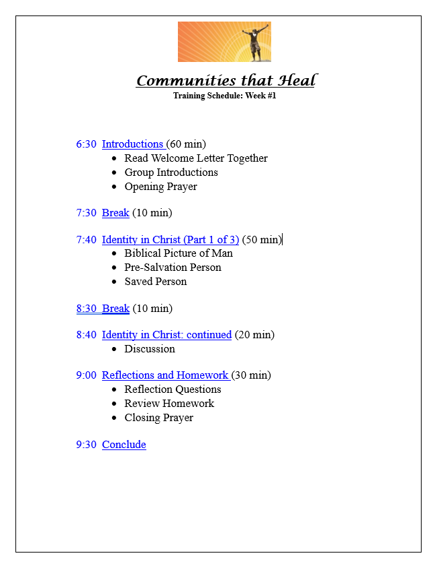

## Appendix B: Action Researcher Weekly Class Reflection Template

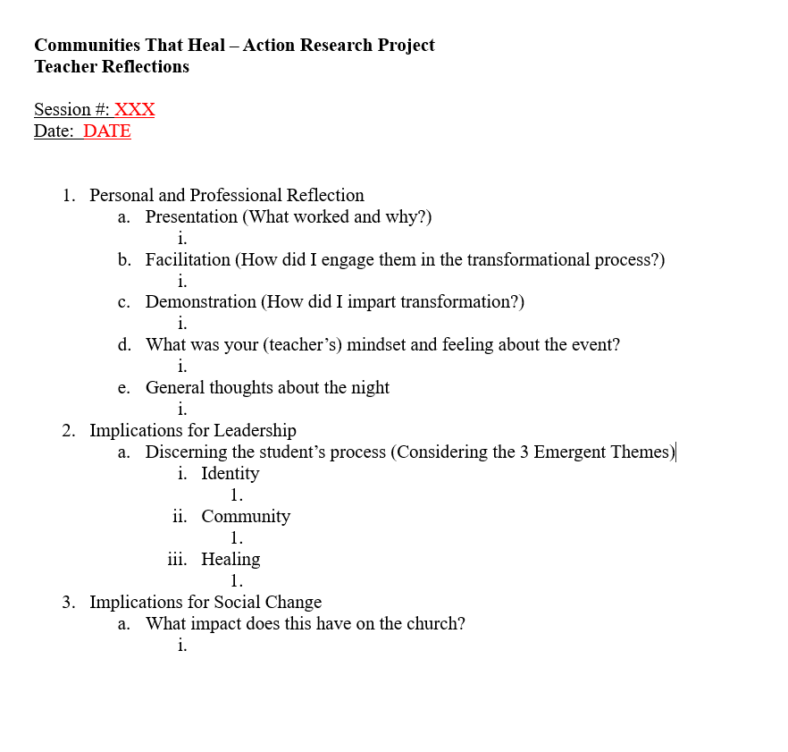

## Appendix C: Custom Database – Teacher Report Snapshot

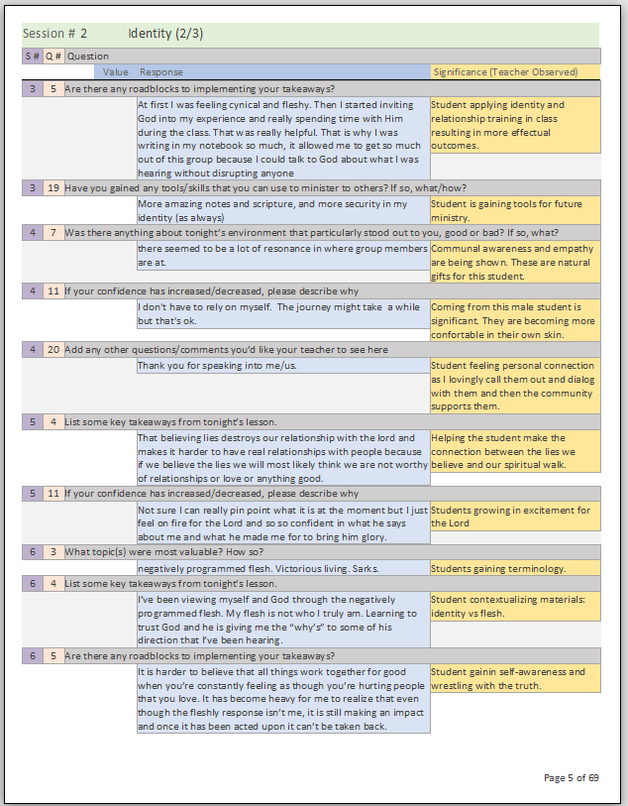

## Appendix D: Promotional Flyer

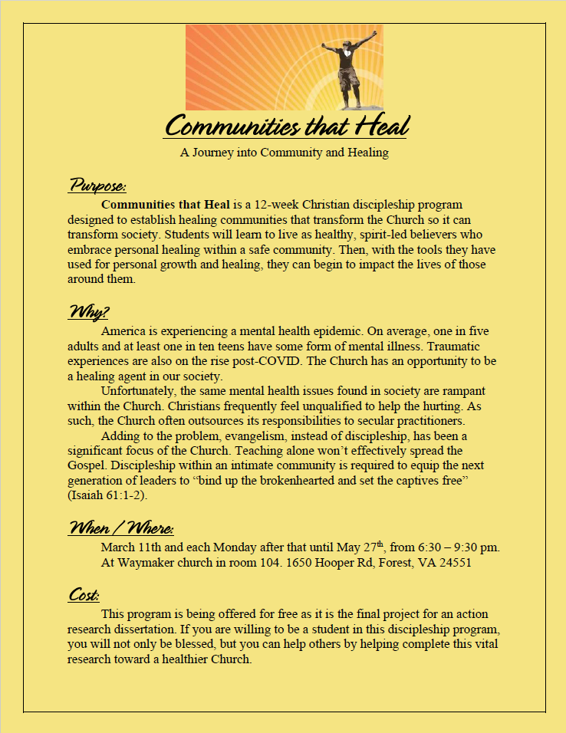

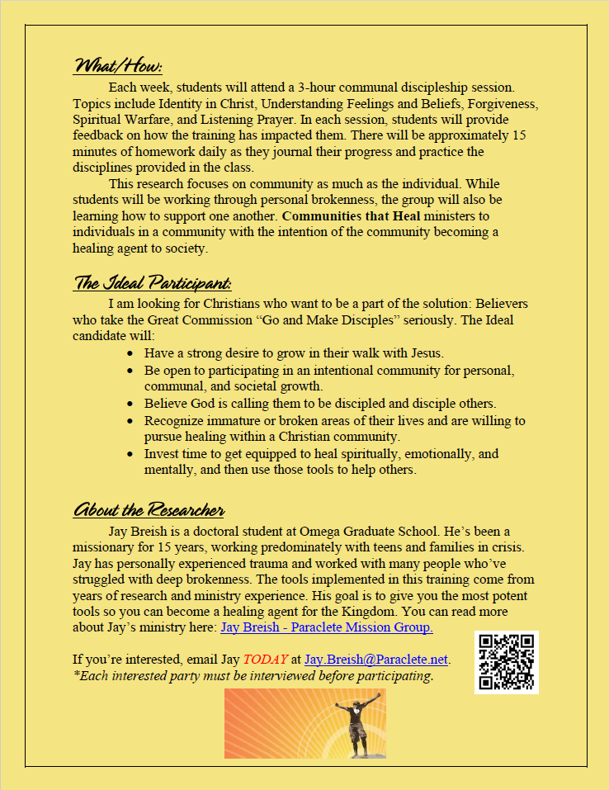

## Appendix E: Pre-Interview Questionnaire

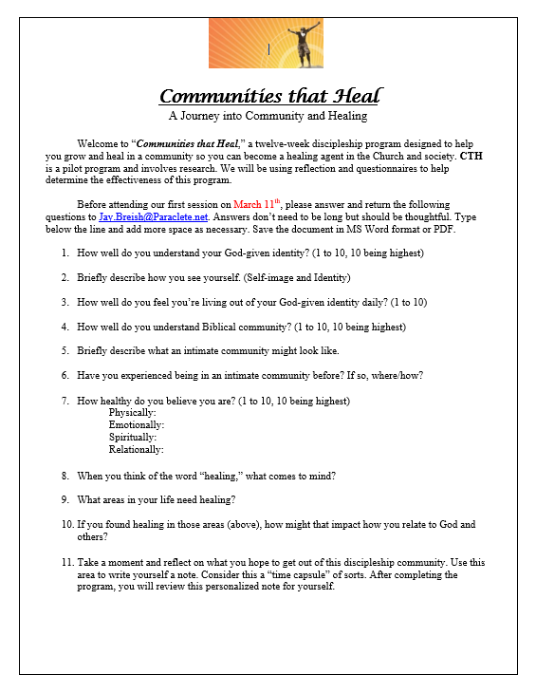

## Appendix F: Post-Session Reflective Questions: Week #1

(Emailed to students just before class started)

Students of CTH,

     At the conclusion of tonight's session, we will discuss reflective assignments. We will receive a questionnaire for each session to help improve the class. (So, wait until after we discuss this before filling it out!) There are 18 questions, but many of them are just a number scale. Thank you in advance for your thoughtful and reflective answers!

     Please answer the following questions and hit REPLY to send the answers back to me.

     DO NOT "REPLY ALL" unless you want everyone to see your responses!

Thank you!

Jay

Reflective Questions

Content

1. How familiar are you with the content presented today? (1 - 10: Least to Most)

1. If you’re familiar with the content, to what extent have you applied it in your life?

0. NA, 1. Not at all, 2. Very Little, 3. Somewhat, 4. Mostly, 5. Consistently

1. What topic(s) were most valuable? How so?

1. List some key takeaways from tonight’s lesson.

1. Are there any roadblocks to implementing your takeaways?
2. How valuable did you find tonight’s topic? (1 - 10: Least to Most)

Method and Environment

1. Was there anything about tonight’s environment that particularly stood out to you, good or bad? If so, what?

1. Do you have any comments regarding the method/format of training?

1. How valuable were the discussion/break-out times of this evening? (1 - 10: Least to Most)

Emergent Themes:

1. How confident are you in regards to communicating and living out of your identity in Christ? (1-10)
2. If your confidence has increased/decreased, please describe why.
3. How connected do you feel to the members of the group? (1 - 10: Least to Most)
4. How healthy are you feeling? (1 - 10: Least to Most)

Physically:

Emotionally:

Spiritually:

Relationally:

1. If you noticed your health scores have changed, please describe why.
2. Have you gained clarity on your God-given design and purpose? If so, how?
3. Have you gained any tools/skills that you can use to minister to others? If so, what/how?
4. Add any other questions/comments you’d like your teacher to see here.

## Appendix G: Room Request

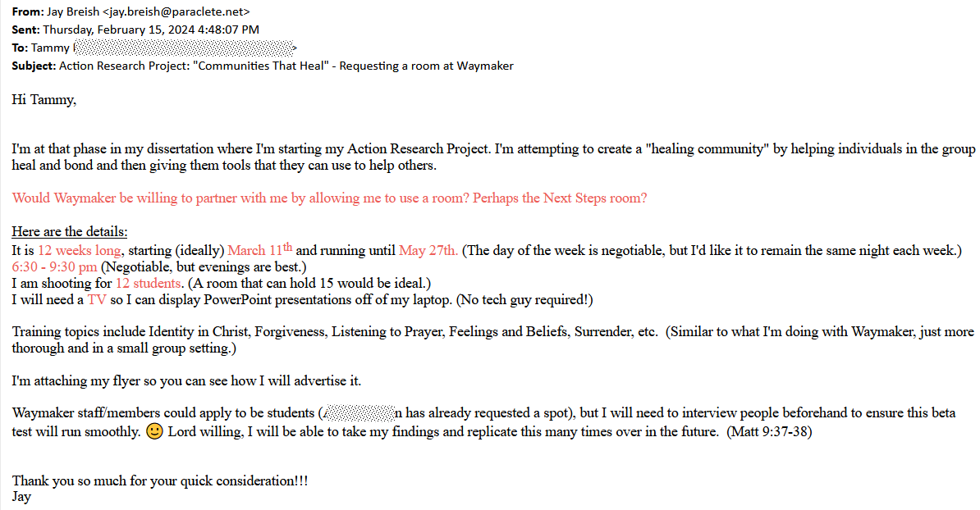

## Appendix H: Weekly Homework Email – Week 8

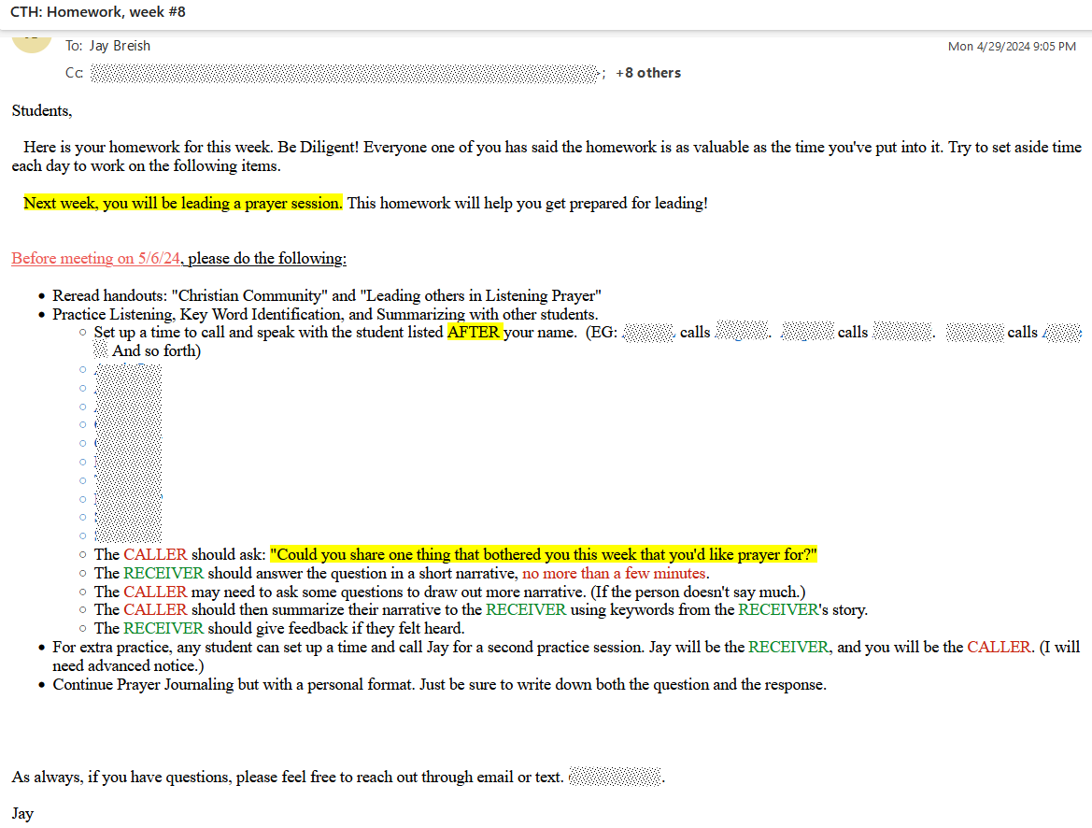

## Appendix I: Action Research Project Training Timeline snapshot

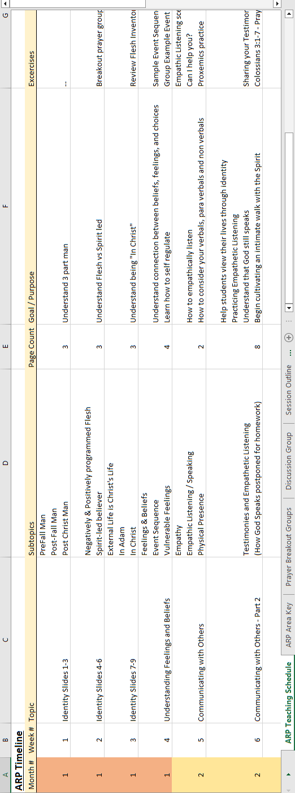

## Appendix J: Introductory Email with Flyer

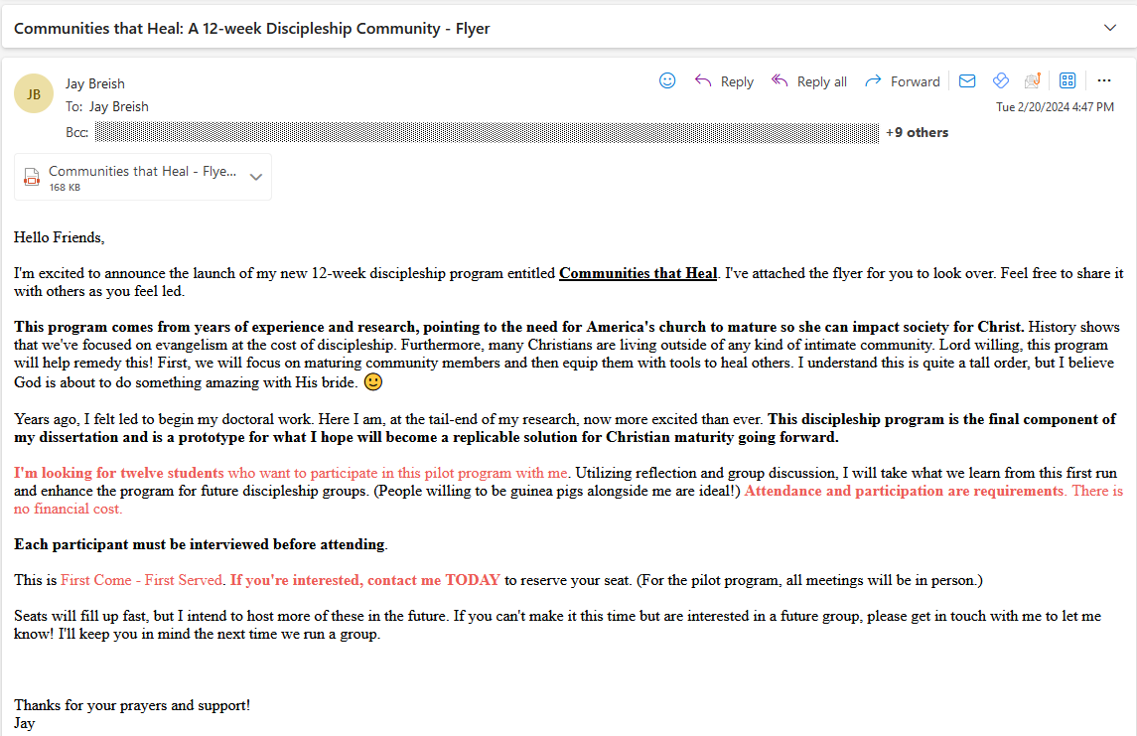

## Appendix K: Nightly Training Schedule – Week 6

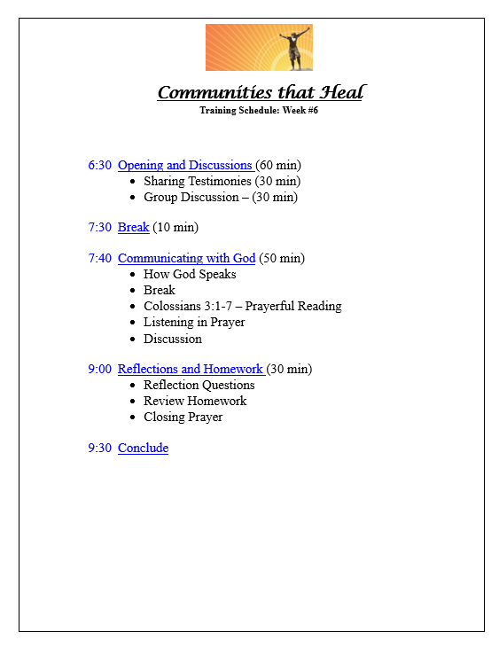

## Appendix L: Group Reflections – Week 9

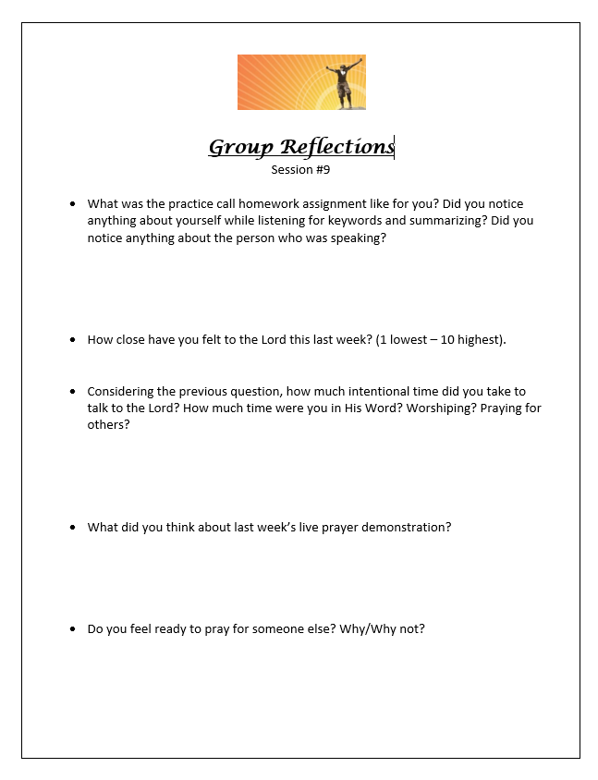

## Appendix M: Training Slides – Week 1

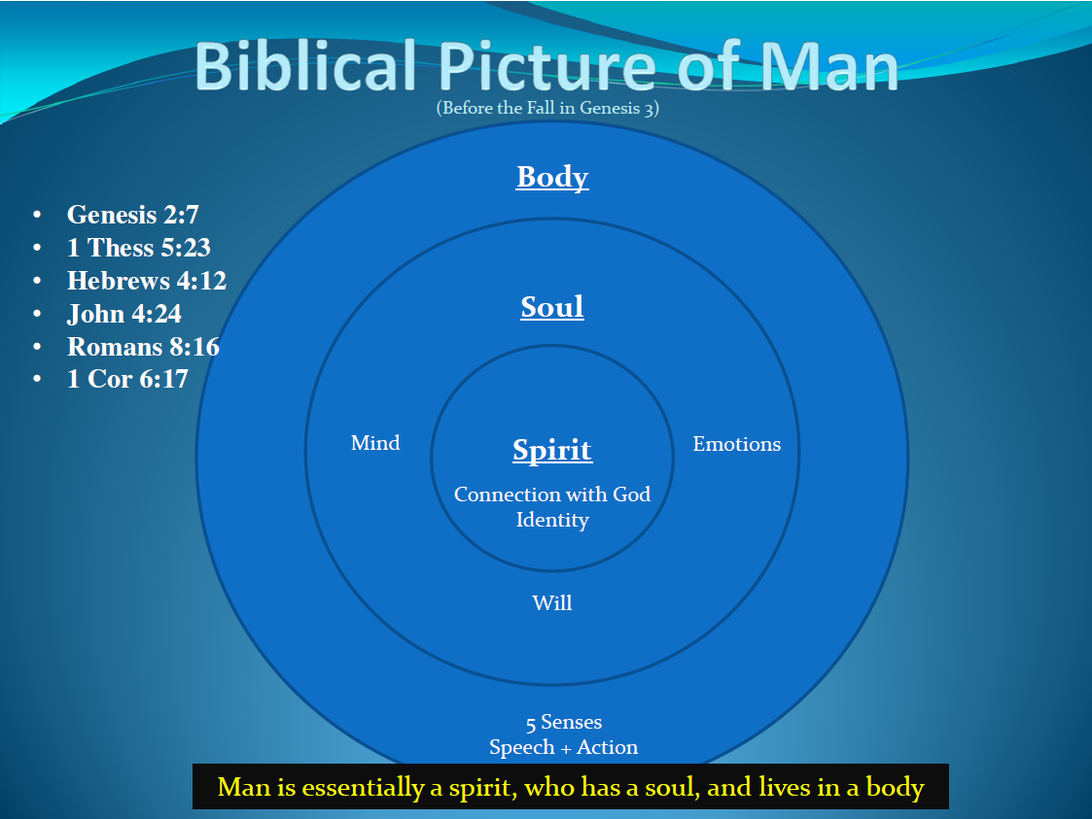

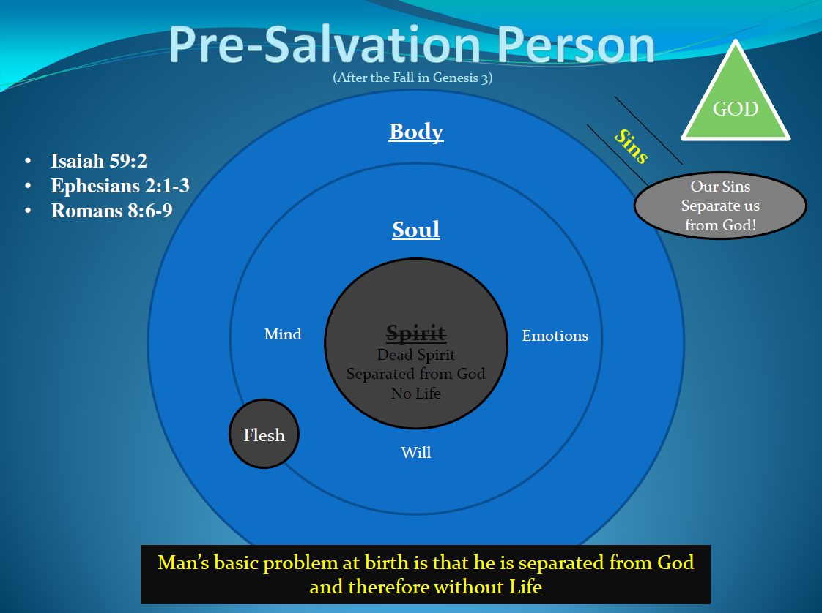

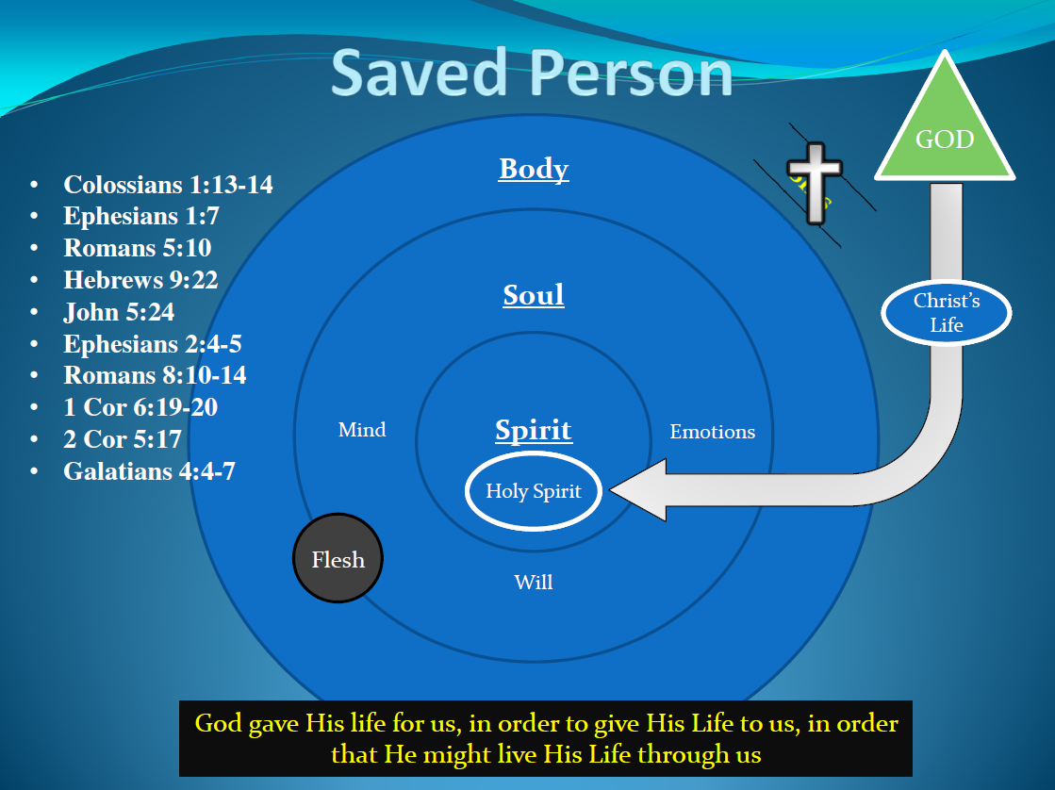

## Appendix N: Homework - Week 1

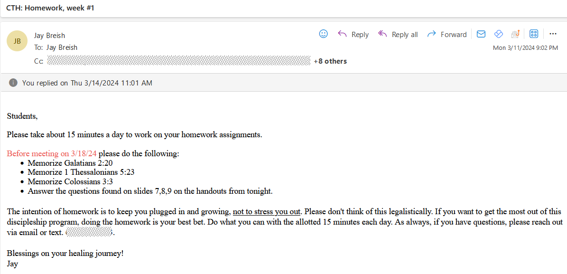

## Appendix O: Final Sectional Reflection Questions

<Sent via Email>

Friends,

      It's hard to believe we've completed our twelve-week discipleship class.  But here we are.

      Thank you for all the great feedback last night.  I'm asking questions for this final sectional to conclude the data collection portion.

Thanks in advance for your thoughtful responses.

Jay

**Numerical Questions**

1. During this last section of the class, I grew in my identity in Christ (1 - 10) (1 representing little to no growth at all, 10 being significant growth).

1. During this final third of the class, I was able to heal/grow from some of my emotional/mental/spiritual struggles (1-10).
2. I developed new friendships in this section of CTH (1-10).
3. How deeply did you connect with the community group during these last 4 sessions (1 - 10 most)?

1. I gained tools and perspective that I can use to grow/heal myself during the final 4 sessions (1-10).
2. I gained tools that I can utilize to help others grow/heal (1-10).

1. I felt understood and heard in our CTH group during these last four sessions (1-10).
2. The materials provided during these last four sessions were valuable (1-10).
3. I feel more connected to God (1-10).
4. I better understand how my gifts/talents can be used in the body of Christ (1-10).

**Short Answer Questions**

1. Has this community group met your expectations? How so?

1. What do you feel has been the most significant teaching of the group OVERALL? Why?

1. Has there been any part that hasn't been valuable or helpful? If so, what?

     -This group intends to become *healing change agents* in the church and society as a whole. To accomplish this, we must mature personally and communally.

1. Have we accomplished these goals? Consider where we are on the timeline, your personal growth, and the community. Can you envision this group becoming part of the solution to healing an immature Church? How so?
2. Overall, how seriously did you take the homework? Have you found it beneficial in your journey to healing?

6. Are there any areas or topics that you'd like more practice with in the future? How might we facilitate that practice?

7. Feel free to share any other comments with the instructor here:

8. Please consider writing a short note/testimony to future students. Why should they consider attending a CTH discipleship group? What should they expect? What would they gain if they took the CTH journey? (I may share your answer to this question for future groups, so respond accordingly. Names will not be used, so no one can trace your response back to you.)

9. Do you have any recommendations for future group additions, changes, or deletions?

10.  Overall, how glad are you that you took this class?  (1-10, short response)

## Appendix P: Post-Session Reflection Questions – week 8

(Sent via email to all students)

Students of CTH,

   Attached are the post-session reflection questions.

Thank you!

Jay

Reflective Questions

**Content**

1. How familiar are you with the content presented today? (1 - 10: Least to Most)
2. If you’re familiar with the content, to what extent have you applied it in your life?

0. NA, 1. Not at all, 2. Very Little, 3. Somewhat, 4. Mostly, 5. Consistently

1. What topic(s) were most valuable? How so?

1. List some key takeaways from tonight’s lesson.

1. Are there any roadblocks to implementing your takeaways?
2. How valuable did you find tonight’s topic? (1 - 10: Least to Most)

**Method and Environment**

1. Was there anything about tonight’s environment that particularly stood out to you, good or bad? If so, what?
2. Do you have any comments regarding the method/format of training?

1. How valuable were the discussion/break-out times of this evening? (1 - 10: Least to Most)

**Emergent Themes:**

1. How confident are you in regards to communicating and living out of your identity in Christ? (1-10)
2. If your confidence has increased/decreased, please describe why.

1. How connected do you feel to the members of the group? (1 - 10: Least to Most)
2. How healthy are you feeling Physically? (1 - 10: Least to Most)

1. How healthy are you feeling Emotionally? (1 - 10: Least to Most)

1. How healthy are you feeling Spiritually? (1 - 10: Least to Most)

1. How healthy are you feeling Relationally? (1 - 10: Least to Most)

1. If you noticed your health scores have changed, please describe why.
2. Have you gained clarity on your God-given design and purpose? If so, how?
3. Have you gained any tools/skills that you can use to minister to others? If so, what/how?
4. Add any other questions/comments you’d like your teacher to see here.
5. Has this content helped build identity and community or lead to healing? (Yes/No)  If so, How? (Short Answer)

## Appendix Q: Homework – Week 5

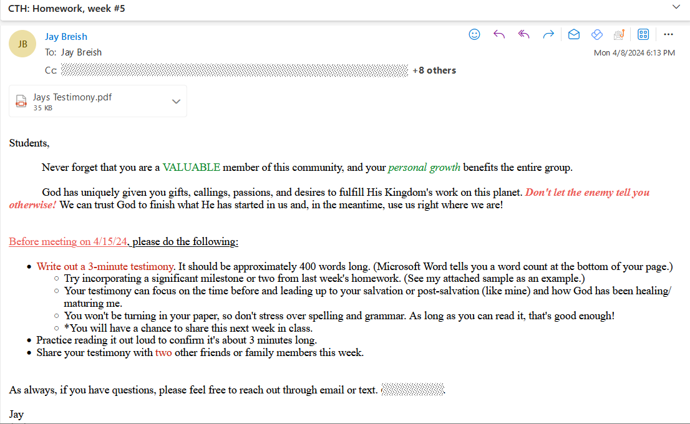

## Appendix R: Graduation Certificate

