LDR 810: Cross-Cultural Dynamics

Richard F. Gamble

Omega Graduate School

April 1, 2024

Professor

Jared Sorber, PhD

**Assignment #1 Instructions from LDR 810 Syllabus**

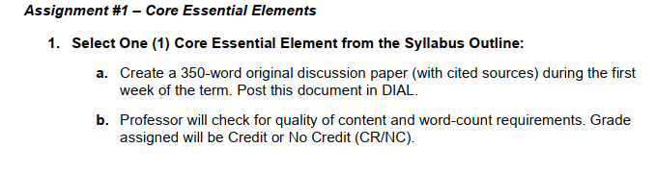

**LDR 810: Assignment 1**

**Selected Essential Element:**

Interdisciplinary Cross-Cultural Communication

**Discussion Paper**

Currently at Omega Graduate School (OGS), the staff serves students located in eight different countries spanning three different continents. This diversity of the student body, and the value the school places on diversity and inclusion, have always been areas that I have admired about OGS. Over the six years that I have worked at the school, I have had to grow in my understanding of both cross-cultural understanding and communication. For example, I began to notice that the way I needed to communicate with an American student was not the same way I needed to communicate the same information to a student in Ethiopia due to cultural differences. One of the reasons that I am excited about taking LDR 810 Cross-Cultural Dynamics is that I believe it will equip me to communicate better with the international students that I serve at OGS in my role as Registrar.

The essential element that I am choosing to discuss in this brief assignment #1 is interdisciplinary cross-cultural communication. I have found two helpful, peer-reviewed journal articles to help orient me to some of the issues that arise in this essential element. The first source, Mogea (2023), addressed roadblocks that exist in cross-cultural communication in organizations. Mogea (2023) focused on eight of these barriers:

* differences in background and experience, which cause different interpretations of the same communication;
* “selective listening”, in which the hearer only “attends” to what reinforces their belief system;
* making pre-emptive judgments about the communicator before they have had a chance to speak fully about what is on their mind;
* automatically accepting information from someone whom the hearer deems as trustworthy;
* groups using the same words in different ways;
* manipulating information so that negative information is heard positively by the listener;
* using language that only makes sense within a specific group;
* and differences in status that can distort information. (pp. 24-25)

I have been guilty of using in-group language when tutoring students. For example, OGS staff, including me, often use OGS-specific language, such as “tutorial method” or “contextualization,” when tutoring new students without explaining the specific meaning of those terms ahead of time. Or, in tutoring sessions with international master’s students, I have often used colloquial idioms from American sports to get points across without understanding that the student probably does not know what I am talking about. This is an area of improvement that I need to address.

The second source (Jakucionyte, 2020) focused on the differences in how people across American and Lithuanian cultures communicate gratitude and apology. Jakucionyte (2020) found that while both Americans and Lithuanians “use the speech acts of gratitude and apology,” there is a difference in the directness with which they are communicated (p. 175). Americans tended to communicate feelings of gratitude and apology *directly* and often. Lithuanians on the other hand do not communicate gratitude or apology as often or directly; instead, the feelings are often *implied* (p. 175). They conclude that “language learning” is not solely about learning “vocabulary or grammar or sentence structure” (p. 176). Rather, in addition to these foundations, it is essential for “language learners” to understand the “cultural norms, peculiarities of cross-cultural communication or creative reactions that are being expressed” (p. 176). This makes a lot of sense to me. It is not enough to know the words; it is crucial to know *when* and *how* to use them when communicating within a different culture.

**Word Count:** 565

**References**

Jakucionyte, V. (2020). Cross-cultural communication: Creativity and politeness strategies across cultures. A comparison of Lithuanian and American cultures. *Creativity Studies*, *13*(1), 164-178. <https://doi.org/10.3846/cs.2020.9025>

Mogea, T. (2023). Cross-cultural communication barriers in organizations. *CENDEKIA: Jurnal Ilmu Sosial, Bahasa dan Pendidikan*, *3*(2), 20-33. <https://doi.org/10.55606/cendikia.v3i2.951>