LDR 813: Organizational Dynamics

Richard F. Gamble

Omega Graduate School

April 1, 2024

Professor

James Strecker, PhD

**Assignment #1 Instructions from LDR 813 Syllabus**

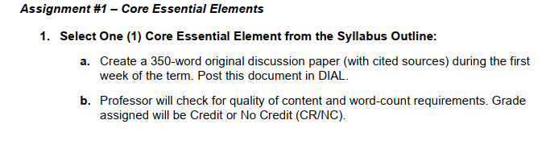

**LDR 813: Assignment 1**

**Selected Essential Element:**

Essential Elements of Management Theory and Practices

**Discussion Paper**

I have never occupied a formal managerial/supervisory role at any of the organizations at which I have been employed. After serving as a prayer team leader for my local church’s building capital campaign, however, I realized that my managerial skills were quite lacking. I did not have the knowledge base to understand how to delegate tasks and utilize the members of my team to the best of their abilities, which led to the team not functioning as smoothly as I wanted it to. Thus, I concluded that I had a lot to learn in the areas of leadership and best management practices. One of the reasons why I am looking forward to participating in LDR 813 Organizational Dynamics is because I believe I can use the course to begin to fill this gap in my knowledge.

For this Assignment #1 discussion paper, I have chosen the essential element of management theory and practices. I am utilizing two sources and will be contrasting their definitions of management. The first source is a college textbook on management (Williams, 2019) and the second source is a peer-reviewed article from an international business journal (Sumadi et al., 2020). On the one hand, Williams (2019) defines management simply as “getting work done through others” (p. 3). This definition makes it clear that it is not a supervisor’s job to get the work done for their team but to enable their team members to accomplish the work.

Sumadi et al. (2020), on the other hand, cite several definitions of management from the literature on management theory (p. 355) before offering the following summary:

The conclusion that can be drawn from these definitions is that management is a series of activities in which there is a different process of planning, organizing, actuating and controlling so that it can utilize existing resources to achieve goals effectively and efficiently. (p. 356)

This definition is more complicated than the one offered by Williams (2019) and focuses more on the actions that a manager must take to execute goals. One major difference between the two definitions is that Williams (2019) explicitly mentions the “others” through whom the manager is to accomplish the company goals (p. 3). In Sumadi et al. (2020), the supervisees are not mentioned outright; however, the reader is left to infer that the supervisees are among the “existing resources” that the manager is to use to accomplish goals. Thus, while both definitions are helpful to me in constructing a definition of management, the ethos of Williams’ (2019) definition seems more personal and team-focused, while Sumadi et al.’s (2020) definition seems less team-oriented and more focused on the manager themselves and their actions. I now know that management involves working through a team as well as some of the functions that I will need to learn to manage a team effectively. I intend to pursue more literature on management functions in my developmental readings.

**Word Count: 486**

**References**

Sumadi, S., Irawan, N., & Ma’ruf, M. H. (2020). Implementation of the concept and theory of management functions in efforts to improve quality. *International Journal of Economics, Business and Accounting Research*, *4*(2), 353-360. http://dx.doi.org/10.29040/ijebar.v4i02.1114

Williams, C. (2019). *MGMT: Principles of management* (11th ed.). Cengage