Statistics for Social Research I

Derrick Snow

Omega Graduate School

March 9, 2024

Professor

Dr. Taladay

Assignment #3 – Essay

In this assignment, you will work with the sample dataset from the fictional study "Religiosity and Social Behavior in a Diverse Community" and use PSPP statistical software to perform various analyses. Follow the steps below:

1. Introduction - Compose an overview of the sections of this assignment and justify why they are important for statistical analysis in research.

2. Levels of Measurement (1 page) - Begin by delineating the levels of measurement for each variable in the dataset. Identify which variables are nominal, ordinal, interval, or ratio. Explain the significance of understanding measurement levels in statistical analysis.

3. Independent and Dependent Variables (1 page) - Discriminate between independent and dependent variables within the dataset. Provide a clear explanation of which variables are independent (predictors) and which are dependent (outcomes or responses). Discuss the role of independent and dependent variables in statistical analysis.

4. Descriptive Statistics Using PSPP (2 pages) - Open the dataset in PSPP and conduct descriptive statistics for relevant variables. Include the following steps:

a. Calculate the mean and standard deviation for variables such as "Religiosity Level," "Community Service (Hours)," "Social Justice Attitudes," and "Social Cohesion Score."

b. Generate frequency distributions for categorical variables like "Race" to determine each category's frequency.

c. Create appropriate graphical representations (e.g., histograms, bar charts) for selected variables to visualize the data distribution.

d. Interpret the descriptive statistics, discussing central tendency, dispersion, and data distribution shape.

5. Conclusion and Reflection (1 page) - Summarize your findings from the descriptive statistics analysis. When conducting statistical analysis, reflect on the importance of understanding measurement levels and differentiating between independent and dependent variables. Discuss any insights gained from analyzing the sample dataset using PSPP.

Ensure your assignment is well-organized, concise, and supported with appropriate tables, graphs, and interpretations generated using PSPP. This assignment will help you apply your knowledge of measurement levels, variable differentiation, and descriptive statistics in a practical context using statistical software. Cite research design experts from your developmental readings and use proper APA formatting.

**Introduction**

Quantitative social research utilizes statistical analysis to make sense of the data collected and to examine what we can uncover from social empirical data. Statistics are used to describe data, test theory, and make inferences from our sample data to the larger social population. Some important concepts in statistics are the levels of measurement of variables, the type of variable whether independent or dependent, and descriptive statistics. These concepts help us as social researchers organize our research, understand the data we collect, and make decisions on how to handle data within the statistical analysis in our social research (Healey, 2016).

**Levels of Measurement**

The variables in this study of Religiosity and Social Behavior in a Diverse Community were Race, Religiosity Level, Community Service (Hours), Social Justice Attitudes (1-5), and Social Cohesion Score (1-10). The variable of Race is a demographic variable and is at the nominal level of measurement because it is a categorical or discrete variable (Terrell, 2021), coded with numeric values, white = 1, black = 2, and Asian = 3. The statistics used on nominal variables are frequency distributions. The variable of Religiosity Level and Social Justice Attitudes are at the ordinal level of measurement, where it is categorical, but has a logical order to the data, coded with numeric values of low (1) to high (5), or a rank variable (Terrell, 2021). For ordinal variables statistics that can be performed are mode, median, sometimes mean, range, and frequency distributions (Kumar, et al, 2021). The variables of Community Service Hours and Social Cohesion Score are at the ratio level of measurement, where the response data in quantitative and “…have an absolute zero point and the various points on the scale can be used to make comparisons between one another” (Terrell, 2021, p. 41). All statistical operations can be performed on ratio data.

Variables are classified in levels of measurement based on the characteristics of the variable. The levels of measurement are nominal, ordinal, interval, and ratio which identify the statistical operations that could be applied to the variable, this is the significance of understanding the levels of measurement of variables is knowing what appropriate statistics can be performed on the data.

**Independent and Dependent Variables**

Given our research questions; 1) To what extent does religiosity influence individuals' engagement in community service and volunteering?, 2) How does religiosity affect attitudes toward social justice issues in the community?, and 3) How does religiosity affect the level of social cohesion and interaction among community members?. We are asking how religiosity impacts or affects these other variables. Thus, in the dataset of Religiosity and Social Behavior in a Diverse Community, the independent variable is Religiosity Level, the predictor variable, and the dependent variables reflect the effect of the independent variable (Healey, 2016) are Community Service Hours, Social Justice Attitudes, and Social Cohesion Score.

In this study, we want to examine what effect the independent variable, Religiosity Level, how religious a person is, has on their participation in community service, their attitudes toward social justice, and their social cohesion. Ultimately do more religious people live their religious beliefs in action in community involvement and care for the community? To answer our research questions, we collect data and perform a correlational statistical analysis. We are examining the relationship of the predictor variable, the independent variable has on the criterion variables, the dependent variables.

**Descriptive Statistics Using PSPP**

Before we do our correlational analysis or hypothesis testing, we examine the data we have collected by utilizing descriptive statistics to understand our data and to see if there are any concerns that we need to address before we do our analysis. Descriptive statistics inform us a great deal about our data, it is a statistical analysis of provides a description, and a summary of the data (Siedlecki, 2020). Depending upon the level of measurement informs us on what descriptive statistics to utilize (Kumar, et al, 2021).

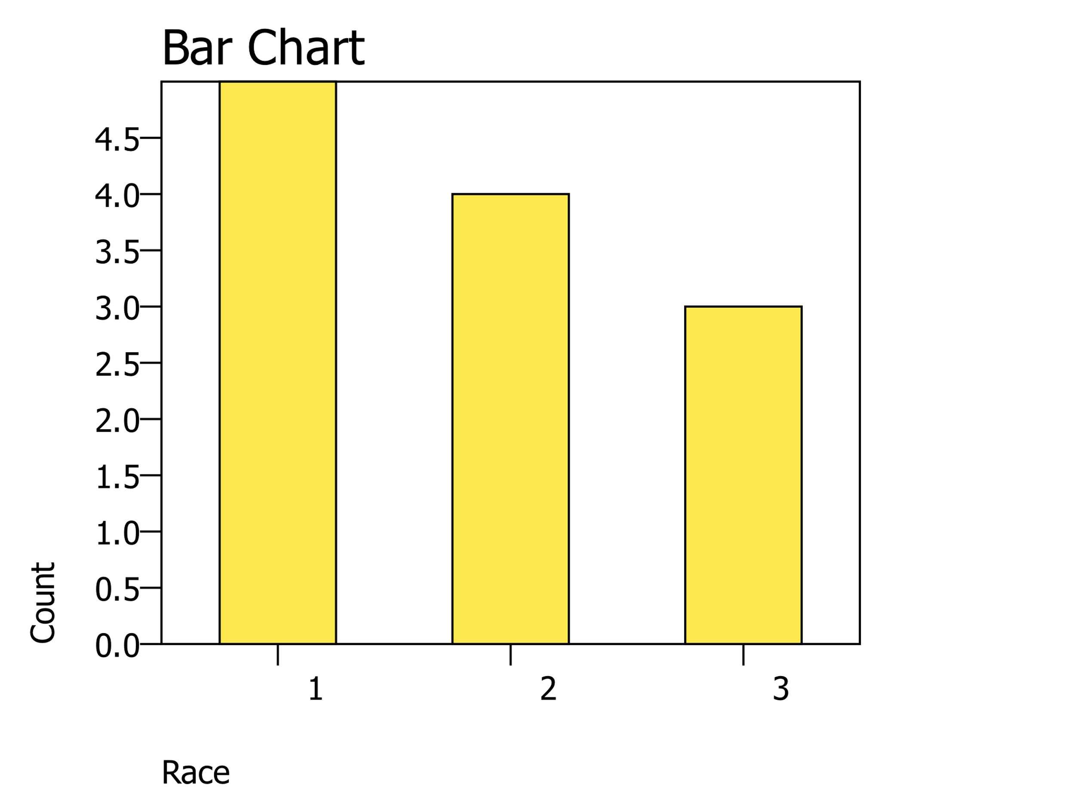Performing descriptive statistics on the nominal variable of Race with a frequency table and a bar chart, we find five (42%) participants identified as white, four (33%) identified as black, and three (25%) identified as Asian.

The ordinal variables of Religiosity Level (Relig_Level) and Social Justice Attitudes (Soc_Just) both use a scale of 1-5. Religiosity Level had a mean of 2.9 with a standard deviation of 1.5, this means that the respondent's religiosity level had a slight lean toward more religiosity, but had a wider spread given the standard deviations of 1.5. The variable Social Justice Attitudes had a mean of 3.7 and a standard deviation of 1.1 means that respondents seem to have more positive views on social justice issues given the mean approaching four and a smaller spread of the standard deviation of 1.

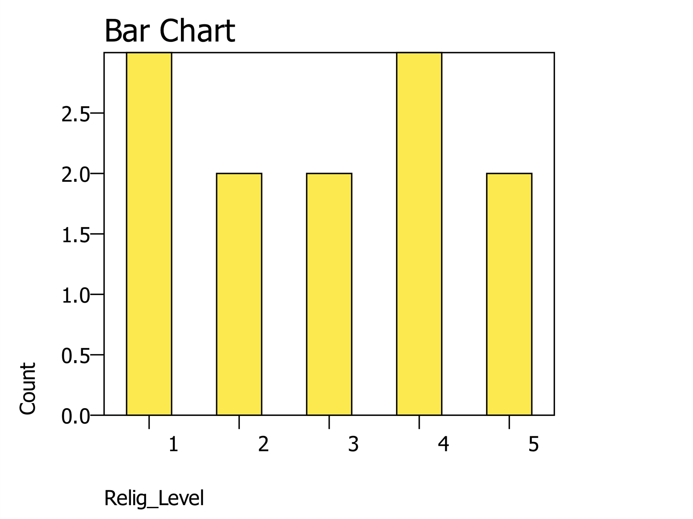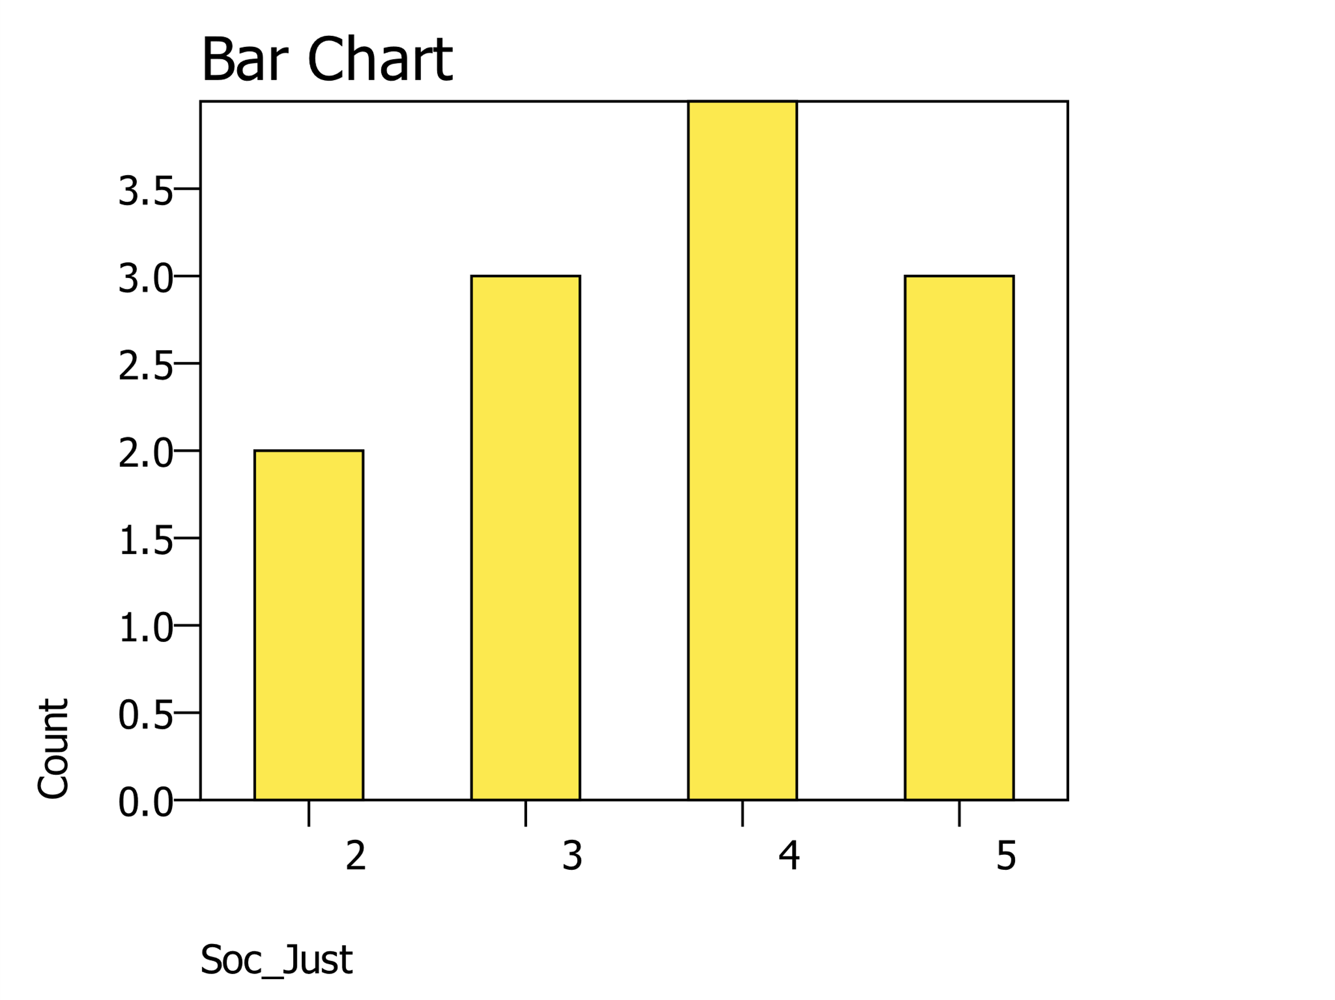

The ratio variables Community Service Hours (Comm_Serv) with a scale 1-20 and Social Cohesion Score (Soc_Coh) with a scale of 1-10. Using descriptive statistics, we found a mean of 10.3 and a standard deviation of 4.8 for Community Service Hours, this means that our respondents had a wide spread of reported community service hours, with a median of 10.5 and a mean of 10.3 the distribution is approximately normal. For the Social Cohesion Score there was and mean of 7.1 and a standard deviation of 1.4, as seen by the histogram there seems to be to groupings, one around the middle and one on the higher end. This means that the sample seems to have at least some social cohesion, and a few have a higher degree of social cohesion, with a mean of 7.1 which is high on a scale of 1-10.

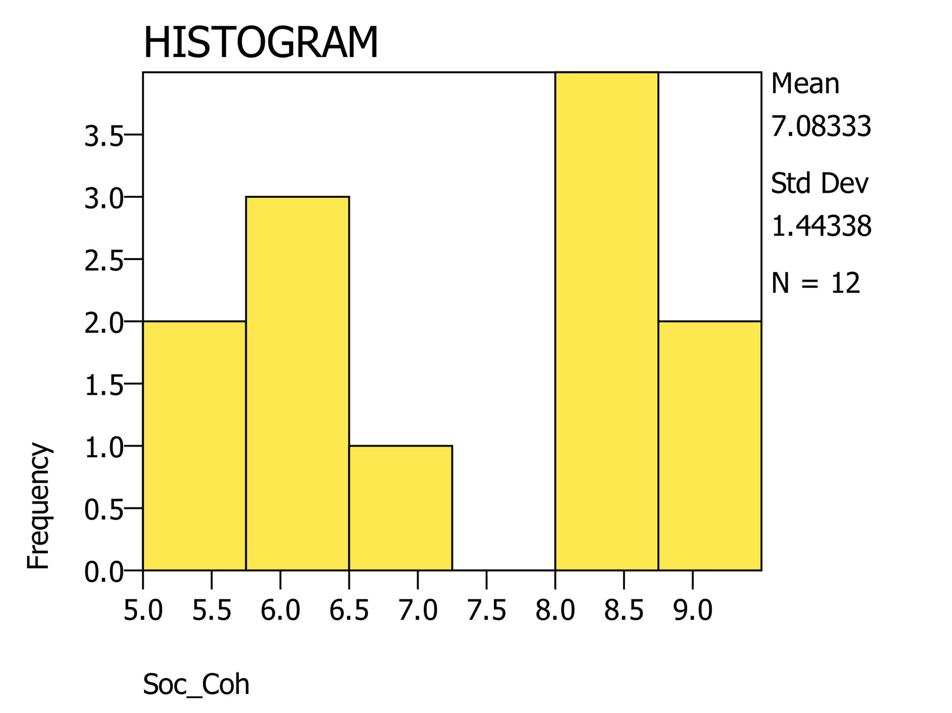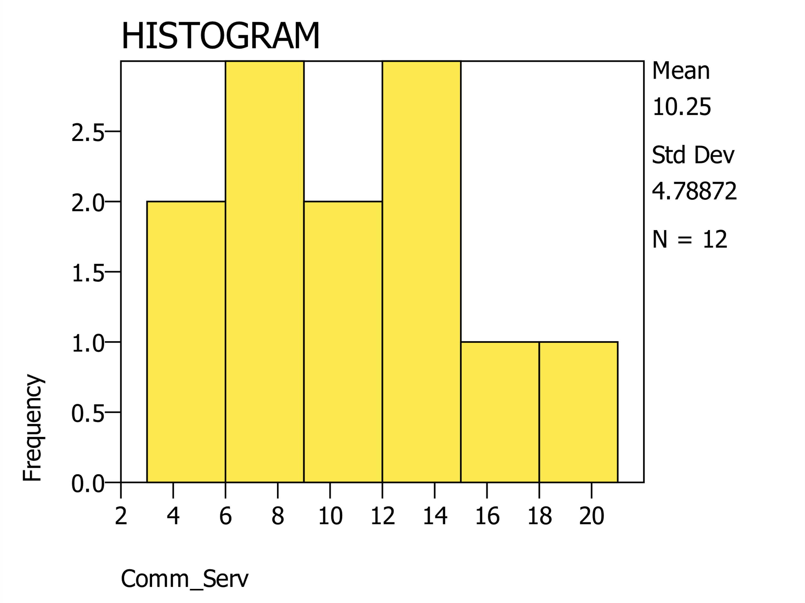

**Conclusion and Reflection**

From performing the descriptive statistics on this Religiosity and Social Behavior in a Diverse Community dataset we found that we have diversity in the data that will allow us to carry our correlation analysis in confidence to identify the answers to our research questions. The descriptive statistics performed do not provide us with the information to indicate whether or independent variable Religiosity Level is associated with higher levels of our dependent variables, Community Service, Social Justice Attitudes, and Social Cohesion. We could run crosstabs that might clue us into a relationship. However, we need to continue our research in performing correlation analysis to address the research questions. The researcher must have a good understanding of the level of measurement of variables to know the appropriate statistics that could be performed and how to handle the variables within the larger research. Likewise, an understanding of the type of variables, independent and dependent variables is needed not only to design the research but also to know how to appropriately handle each type of variable in the research, from examining the variables with descriptive statistics and performing the correlational study.

Utilizing statistical programs such as PSPP is a great tool for social researchers, which allows them to analyze many variables and many cases that would otherwise not be possible. However, the researcher must know the statistical principles and the understanding of interpreting statistical output and arriving at the correct conclusion. I have not used PSPP before, it is similar to SPSS and seems like a good program that social researchers could use without costs. PSPP does seem to have many powerful tools for statistics, with my limited use there seem to be fewer options than SPSS, but I look forward to learning and exploring more with PSPP as a research statistical program.

WORKS CITED

Healey, J. F. (2016). *The Essentials of Statistics: A Tool for Social Research*. Cengage Learning.

Kumar, G., Adams, A., Hererra, M., Rojas, E. R., Singh, V., Sakhuja, A., Meersman, M., Dalton, D., Kethireddy, S., Nanchal, R., & Guddati, A. K. (2021). Predictors and outcomes of healthcare-associated infections in COVID-19 patients. *International Journal of Infectious Diseases*, *104*, 287–292. <https://doi.org/10.1016/j.ijid.2020.11.135>

Terrell, S. R. (2021). *Statistics Translated: A Step-by-Step Guide to Analyzing and Interpreting Data*. Guilford Publications.

Siedlecki, S. L. (2020). Understanding Descriptive Research Designs and Methods. *Clinical Nurse Specialist*, *34*(1), 8–12. <https://doi.org/10.1097/NUR.0000000000000493>