Research for the 21st Century

Kevin W White

Omega Graduate School

February 21, 2024

Professor

Dr. David Ward

Assignment II
Submit to DIAL using the OGS Assignment Template to create a document containing the following:
- Obtain a library card from one local municipal library and one university or college library. Insert a picture of the library card into your Assignment document.
- Locate and establish a working relationship with one research librarian in each library. Provide the name and location of the libraries and research librarians you selected.
- Practice your online research skills in ProQuest, Google Scholar, Google Books, and
and Open Access These and Dissertations to create a starter Works Cited reference list in APA 7 format.
  - Use the OGS Library User’s Guide (2020) RESEARCH DATABASE
PASSWORDS to access the ProQuest database. Find a research journal article related to a topic of interest. Download it and provide an APA formatted bibliographic reference for the article: Last Name, First name initials. (Year).
Article title in sentence case. Journal Title, Vol.#(Issue #), pp. page range. Double spaced in a .5 inch hanging indent.
  - Use Google Scholar (https://scholar.google.com) Find a research journal article related to a topic of interest. Download it and provide an APA formatted bibliographic reference for the article like the ProQuest article.
  - Use Google Books (https://books.google.com) and find a book within the last 5 years about a topic of interest. Download it and provide an APA formatted bibliographic reference for the book: Last Name, First name initials. (Year). Book title in sentence case and italicized. Publisher. Double spaced in a .5 inch hanging indent.
  - Use Open Access Thesis and Dissertations (https://oatd.org) find a dissertation within the last 5 years about a topic of interest. Download it and provide an APA formatted bibliographic reference for the dissertation: Last Name, First name initials. (Year). Dissertation title in sentence case and italicized. [Doctoral Dissertation] Name of School. Double spaced in a .5 inch hanging indent.

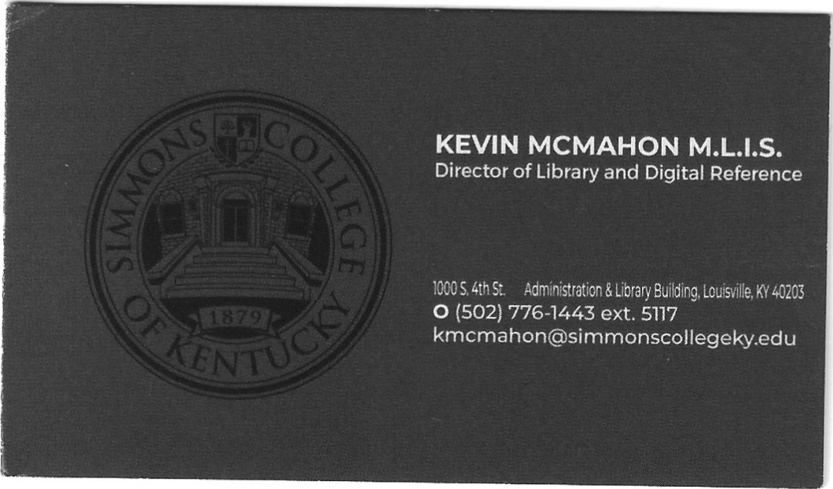
Simmons College of Kentucky (HBCU)
100 South 4th Street, Louisville, KY 40203
Kevin McMahon, Director/Research Librarian



Louisville Free Public Library
301 York Street, Louisville, KY 40203
Garrett Wilson, Library Research Assistant

Works Cited
ProQuest Research Journal Article
Barnes, Sandra L. Black church culture and community action. Social forces; 2005; 84, pp. 967-94. [DOI: https://dx.doi.org/10.1353/sof.2006.0003]
Google Scholar Research Journal Article

Bellamy, Brian Odem (2016). An examination of prevalent twenty-first century models
of community engagement by the black churches. Degree: PhD, University of Exeter
URL: http://hdl.handle.net/10871/24285
Google Books
Lester, J. R., (2022). Let's play #church: Gamify-ing black church revitalization for sustainable
success. Amazon Digital Services, LLC-Kdp.

Open Access Thesis and Dissertation(s)
Houston, B. S., (2023). Leadership Development in the African American Church. (Doctoral Dissertation). Liberty University. Retrieved from https://digitalcommons.liberty.edu/doctoral/4274 ; https://digitalcommons.liberty.edu/context/doctoral/article/5333/viewcontent/49_Houston_2C_20Barbara_20_28L23643774_29.pdf.
Shaonta’ E. A., (2023). Is the black church dead? Religious resilience and the contemporary functions of black Christianity. Religions, 14(4), 460. doi:https://doi.org/10.3390/rel14040460

