Research for the 21st Century

James Hollywood III

Omega Graduate School

February 13, 2024)

Professor

Dr. David Ward

Assignment #2 – Exercise
Submit to DIAL using the OGS Assignment Template to create a document containing the following:
1. Obtain a library card from one local municipal library and one university or college
library. Insert a picture of the library card into your Assignment document.
2. Locate and establish a working relationship with one research librarian in each library.
Provide the name and location of the libraries and research librarians you selected.
3. Practice your online research skills in ProQuest, Google Scholar, Google Books, and
and Open Access These and Dissertations to create a starter Works Cited reference list
in APA 7 format.
a. Use the OGS Library User’s Guide (2020) RESEARCH DATABASE
PASSWORDS to access the ProQuest database. Find a research journal article
related to a topic of interest. Download it and provide an APA formatted
bibliographic reference for the article: Last Name, First name initials. (Year).
Article title in sentence case. Journal Title, Vol.#(Issue #), pp. page range.
Double spaced in a .5 inch hanging indent.
b. Use Google Scholar (https://scholar.google.com) Find a research journal article
related to a topic of interest. Download it and provide an APA formatted
bibliographic reference for the article like the ProQuest article.
c. Use Google Books (https://books.google.com) and find a book within the last 5
years about a topic of interest. Download it and provide an APA formatted
bibliographic reference for the book: Last Name, First name initials. (Year). Book
title in sentence case and italicized. Publisher. Double spaced in a .5 inch
hanging indent.
d. Use Open Access These and Dissertations (https://oatd.org) find a dissertation
within the last 5 years about a topic of interest. Download it and provide an APA
formatted bibliographic reference for the dissertation: Last Name, First name
initials. (Year). Dissertation title in sentence case and italicized. [Doctoral
Dissertation] Name of School. Double spaced in a .5 inch hanging indent.

Hello Dr. Ward,
I hope this message finds you well. I wanted to provide you with an update on my progress with the assignment tasks.
While working on obtaining library cards from local municipal and university libraries, I encountered some difficulties. Unfortunately, due to residency requirements, I was able to obtain a library card from the local municipal library here in Maryland, but they did not do higher education research. Additionally, as I am not affiliated with any academic institution in Maryland, obtaining a library card from university libraries proved challenging.
However, I want to assure you that I still have access to research databases through Arkansas State University, as evidenced by the attached verification from my master's program. Although this grants me access to valuable resources, it does not provide a physical library card or establish a working relationship with a librarian in Maryland.
Despite this setback, I have made progress on other aspects of the assignment. I have thoroughly reviewed the developmental readings from seminal sources and scholarly peer-reviewed journal articles, extracting key insights into hermeneutics, policy change, and advocacy. These readings have provided a comprehensive understanding of the theoretical frameworks and practical approaches relevant to our assignment.
Furthermore, I have begun crafting comments integrating quotes or paraphrases from the readings, essential elements, additive/variant analysis, and contextualization. This process has enabled me to synthesize the knowledge gained from the readings and apply it effectively to our assignment objectives.

I am fully committed to completing all aspects of the assignment to the best of my ability. I am exploring alternative methods for accessing resources and will keep you updated on any developments in this regard.
Thank you for your understanding and support as I navigate through these tasks. Your guidance is greatly appreciated, and I am confident that I will overcome this hurdle and successfully fulfill the requirements of the assignment.

Warm regards,
James Hollywood III
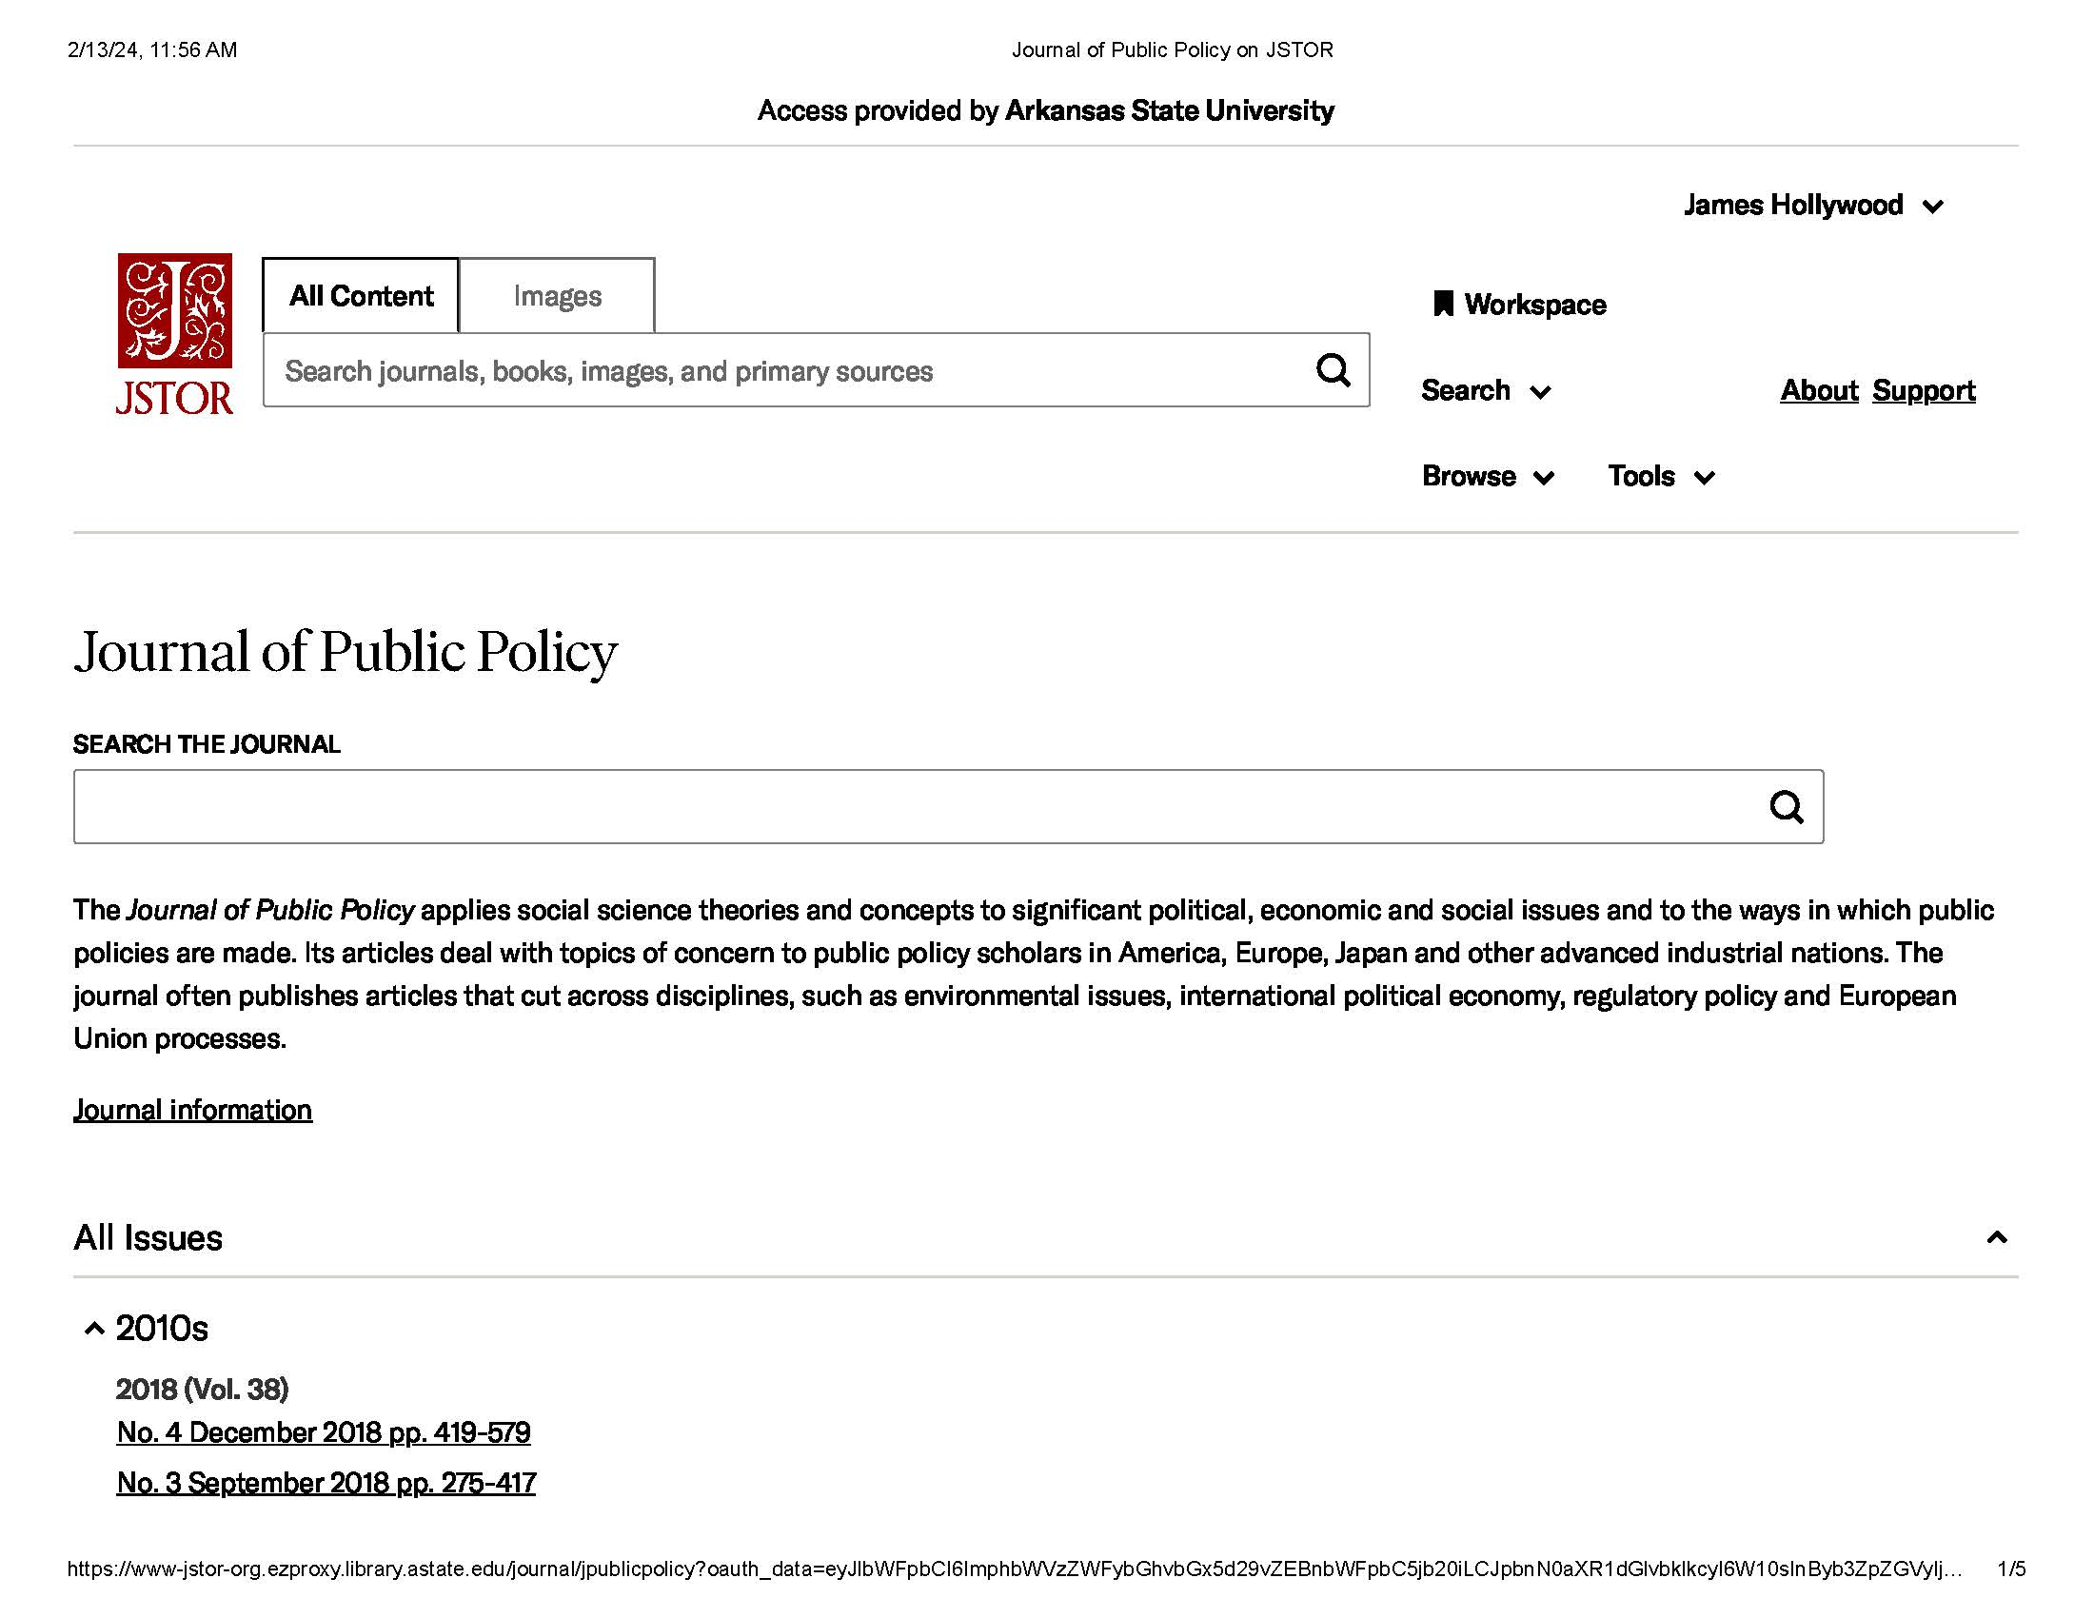
WORKS CITED
Lejano, R. P., & Leong, C. (2014). A Hermeneutic Approach to Explaining and Understanding Public Controversies. Palgrave Macmillan.

Morales, Celeste (2020). Public policy & political parties: A qualitative analysis of homelessness and poverty reduction frameworks in British Columbia [Doctoral dissertation, University of Victoria

Olsson, J., & Hysing, E. (2012). Theorizing inside activism: Understanding policymaking and policy change from below. Planning Theory & Practice, 13(2), 257-273.

Tietze, N., Gerhold, L., & Ibisch, P. L. (2023). Policy narratives in forest fire management. Environmental Research Letters, 18(11), 114023. https://doi.org/10.1088/1748-9326/acf6d2
Great job with your APA format except for the few minor corrections listed. Here are links and examples of the generic formatting for articles, books, and dissertations:
NOTE: This is the only class which focuses on learning how to lay out APA 7 Works Cited entries for different kinds of sources [books, articles, dissertations] because the formatting is unique for each kind. See below:
Books:
https://owl.purdue.edu/owl/research_and_citation/apa_style/apa_formatting_and_style_guide/reference_list_books.html

Author, A. A. (Year of publication). Title of work: Capital letter also for subtitle. Publisher Name. DOI (if available)
Articles:
https://owl.purdue.edu/owl/research_and_citation/apa_style/apa_formatting_and_style_guide/reference_list_articles_in_periodicals.html
Author, A. A., Author, B. B., & Author, C. C. (Year). Title of article. Title of Periodical, volume number(issue number), pages. https://doi.org/xx.xxx/yyyy
Dissertations (scroll down to theses & dissertations):
https://owl.purdue.edu/owl/research_and_citation/apa_style/apa_formatting_and_style_guide/reference_list_other_print_sources.html
Lastname, F. M. (Year). Title of dissertation/thesis (Publication No.) [Doctoral dissertation/Master’s thesis, Name of Institution Awarding the Degree]. Database or Archive Name.
Bookmark these 3 links, they will be handy!
If you have ANY academic questions, email me. I am not just your professor for SR 953, I am the Doctoral Programs Senior Tutor and also function like a traditional Library Research Resources Reference Specialist (I help find things and provide sources!). Dr. Geer, our Librarian, is also glad to help with online/library research questions as well <carolinegeer@gmail.com>. She is quite skilled.

]

