Research for the 21st Century

Yvette Mulkey

Omega Graduate School

Date (February 17, 2024)

Professor

David Ward, Ph.D., Th.M.

Assignment #2 – Exercise
Submit to DIAL using the OGS Assignment Template to create a document containing the following:
1. Obtain a library card from one local municipal library and one university or college
library. Insert a picture of the library card into your Assignment document.
2. Locate and establish a working relationship with one research librarian in each library.
Provide the name and location of the libraries and research librarians you selected.
3. Practice your online research skills in ProQuest, Google Scholar, Google Books, and
Open Access These and Dissertations to create a starter Works Cited reference list
in APA 7 format.
a. Use the OGS Library User’s Guide (2020) RESEARCH DATABASE
PASSWORDS to access the ProQuest database. Find a research journal article
related to a topic of interest. Download it and provide an APA formatted
bibliographic reference for the article: Last Name, First name initials. (Year).
Article title in sentence case. Journal Title, Vol.#(Issue #), pp. page range.
Double spaced in a .5 inch hanging indent.
b. Use Google Scholar (https://scholar.google.com) Find a research journal article
related to a topic of interest. Download it and provide an APA formatted
bibliographic reference for the article like the ProQuest article.
c. Use Google Books (https://books.google.com) and find a book within the last 5
years about a topic of interest. Download it and provide an APA formatted
bibliographic reference for the book: Last Name, First name initials. (Year). Book
title in sentence case and italicized. Publisher. Double spaced in a .5 inch
d. Use Open Access These and Dissertations (https://oatd.org) find a dissertation
within the last 5 years about a topic of interest. Download it and provide an APA
formatted bibliographic reference for the dissertation: Last Name, First name
initials. (Year). Dissertation title in sentence case and italicized. [Doctoral
Dissertation] Name of School. Double spaced in a .5 inch hanging indent

- I was able to obtain a library card from a local municipal library. Please see the picture below. However, university libraries I connected with only issue library cards to their students including the universities I once attended while earning my graduate and undergraduate degrees.
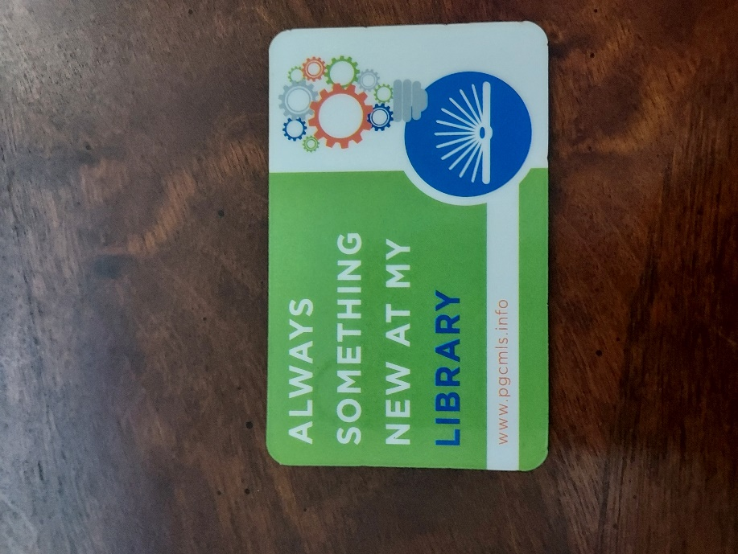
2. I have established a working relationship with Daniel Hampton, he is a member of the Prince George’s County Memorial Library System. He works at the Hillcrest Heights Branch Library. We will primarily be sending messages via email. His email is Daniel.hampton@pgcmls.info but I also have his business number to reach him for research inquiries that number is: (301) 699-3500 x1360.
3a. Access the ProQuest database. Find a research journal article related to a topic of interest. Download it. Provide an APA formatted bibliographic reference for the article.
- What’s health got to do with it?: Influencing cookstove uptake in Cambodia through behaviour change communication
- "C:\Users\13017\Downloads\What’s_health_got_to_do_with_i.pdf"

Bibliographic reference
Lambe, F., Johnson, O., Ochieng, C., Diaz, L., & Lee, K. (2019). What’s health got to do with it?: Influencing cookstove uptake in cambodia through behaviour change communication. Journal of Social Marketing, 9(1), 94-110. doi:https://doi.org/10.1108/JSOCM-03-2018-0027
3b. Use Google Scholar (https://scholar.google.com) Find a research journal article
related to a topic of interest. Download it and provide an APA formatted
bibliographic reference for the article.
- Why facts don't change minds: Insights from cognitive science for the improved communication of conservation research
- file:///C:/Users/13017/AppData/Local/Temp/1c0e9d97-393b-45c8-8f1b-d074cf72e41a_ScienceDirect_articles_11Feb2024_22-58-40.488.zip.41a/Why-facts-don-t-change-minds--Insights-from-cognitive-scien_2023_Biological-.pdf
Bibliographic reference
Toomey, A. H. (2023). Why facts don't change minds: Insights from cognitive science for the improved communication of conservation research. Biological Conservation, 278, 109886
3 c. Use Google Books (https://books.google.com) and find a book within the last 5
years about a topic of interest. Download it and provide an APA formatted
bibliographic reference for the book.
- Social Marketing and Sustainable Development Goals (SDGs) Case Studies for a Global Perspective
- https://www.google.com/books/edition/Social_Marketing_and_Sustainable_Develop/4crAEAAAQBAJ?hl=en&gbpv=1
Bibliographic reference
Social Marketing and Sustainable Development Goals (SDGs): Case Studies for a Global Perspective. (2023). Germany: Springer International Publishing.
3d. Use Open Access These and Dissertations (https://oatd.org) find a dissertation
within the last 5 years about a topic of interest. Download it and provide an APA
formatted bibliographic reference for the dissertation.
- Success and failure in social marketing programs: A qualitative exploration
- https://uwspace.uwaterloo.ca/bitstream/handle/10012/18810/Cook_Julie.pdf?sequence=1&isAllowed=y
Bibliographic reference
Julie Cook (2022). Success and failure in social marketing programs: A qualitative exploration. UWSpace. http://hdl.handle.net/10012/18810

NOTE: This is the only class which focuses on learning how to lay out APA 7 Works Cited entries for different kinds of sources [books, articles, dissertations] because the formatting is unique for each kind. See below:

Books:
https://owl.purdue.edu/owl/research_and_citation/apa_style/apa_formatting_and_style_guide/reference_list_books.html

Author, A. A. (Year of publication). Title of work: Capital letter also for subtitle. Publisher Name. DOI (if available)
Articles:
https://owl.purdue.edu/owl/research_and_citation/apa_style/apa_formatting_and_style_guide/reference_list_articles_in_periodicals.html

Author, A. A., Author, B. B., & Author, C. C. (Year). Title of article. Title of Periodical, volume number(issue number), pages. https://doi.org/xx.xxx/yyyy

Dissertations (scroll down to theses & dissertations):
https://owl.purdue.edu/owl/research_and_citation/apa_style/apa_formatting_and_style_guide/reference_list_other_print_sources.html

Lastname, F. M. (Year). Title of dissertation/thesis (Publication No.) [Doctoral dissertation/Master’s thesis, Name of Institution Awarding the Degree]. Database or Archive Name.
Bookmark these 3 links, they will be handy!

If you have ANY academic questions, email me. I am not just your professor for SR 953, I am the Doctoral Programs Senior Tutor and also function like a traditional Library Research Resources Reference Specialist (I help find things and provide sources!). Dr. Geer, our Librarian, is also glad to help with online/library research questions as well <carolinegeer@gmail.com>. She is quite skilled.

