Research for 21st Century

Milkias Taye Gutema

Omega Graduate School

February 07, 2024

Professor

Dr. David Ward

Assignment #2 – Exercise
Submit to DIAL using the OGS Assignment Template to create a document containing the
following:
- Obtain a library card from one local municipal library and one university or college library. Insert a picture of the library card into your Assignment document.
- Locate and establish a working relationship with one research librarian in each library. Provide the name and location of the libraries and research librarians you selected.
- Practice your online research skills in ProQuest, Google Scholar, Google Books, and Open Access These and Dissertations to create a starter Works Cited reference list in APA 7 format.
  - Use the OGS Library User’s Guide (2020) RESEARCH DATABASE PASSWORDS to access the ProQuest database. Find a research journal article related to a topic of interest. Download it and provide an APA formatted bibliographic reference for the article: Last Name, First name initials. (Year). Article title in sentence case. Journal Title, Vol.#(Issue #), pp. page range. Double spaced in a .5 inch hanging indent.
  - Use Google Scholar (https://scholar.google.com) Find a research journal article related to a topic of interest. Download it and provide an APA formatted bibliographic reference for the article like the ProQuest article.
  - Use Google Books (https://books.google.com) and find a book within the last 5 years about a topic of interest. Download it and provide an APA formatted bibliographic reference for the book: Last Name, First name initials. (Year). Book title in sentence case and italicized. Publisher. Double spaced in a .5 inch hanging indent.
  - Use Open Access These and Dissertations (https://oatd.org) find a dissertation within the last 5 years about a topic of interest. Download it and provide an APA formatted bibliographic reference for the dissertation: Last Name, First name initials. (Year). Dissertation title in sentence case and italicized. [Doctoral Dissertation] Name of School. Double spaced in a .5 inch hanging indent.

- Library Membership of Addis Ababa University (AAU) and Ethiopian Graduate School of Theology (EGST)
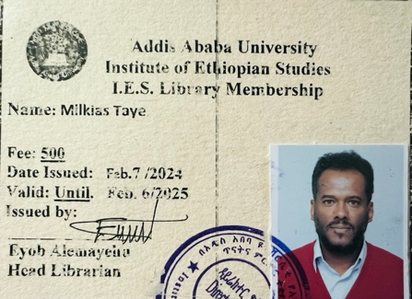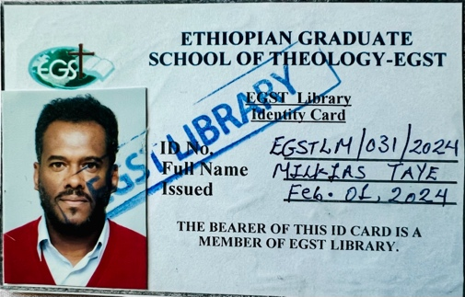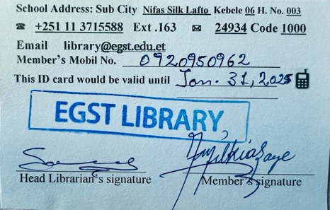
- I stablished a working relationship with two librarian, from Addis Ababa university with Desta Bellay and from EGST Library with Sara Abirham. EXCELLENT!
Journal titles and Volum are to be italicized in title case.
- ProQuest

Raoush, A. (2023). Transformational leadership impact on innovative behavior as perceived by healthcare workers in private hospitals in Jordan. Cogent Business & Management, Vol. 10(Issue 3), pp. 1-16.
- Google Scholar
Azimatova, I. (2023). Issues of development of management culture in leaders. International Bulletin of Applied Science and Technology, Vol. 2 (Issue 8), pp. 177-180.
- Google Books
Hieker, C., Pringle, J. (2020). The future of leadership development: Disruption and the impact of megatrends. Germany: Springer International Publishing.
- Open Access These and Dissertations
Charron, V. (2020). Leadership development: Creating a culture of developing leaders in the church. [Doctoral Dissertation] Liberty University.

