Research for the 21st Century

LaKeisha Bryant-Hall

Omega Graduate School

February 16, 2024

Professor

Dr. David Ward

Assignment #2

Assignment #2 – Exercise

Submit to DIAL using the OGS Assignment Template to create a document containing the

following:

1. Obtain a library card from one local municipal library and one university or college

library. Insert a picture of the library card into your Assignment document.

2. Locate and establish a working relationship with one research librarian in each library.

Provide the name and location of the libraries and research librarians you selected.

3. Practice your online research skills in ProQuest, Google Scholar, Google Books, and Open Access These and Dissertations to create a starter Works Cited reference list

in APA 7 format.

a. Use the OGS Library User’s Guide (2020) RESEARCH DATABASE

PASSWORDS to access the ProQuest database. Find a research journal article

related to a topic of interest. Download it and provide an APA formatted

bibliographic reference for the article: Last Name, First name initials. (Year).

Article title in sentence case. Journal Title, Vol.#(Issue #), pp. page range.

Double spaced in a .5 inch hanging indent.

b. Use Google Scholar (https://scholar.google.com) Find a research journal article

related to a topic of interest. Download it and provide an APA formatted

bibliographic reference for the article like the ProQuest article.

c. Use Google Books (https://books.google.com) and find a book within the last 5

years about a topic of interest. Download it and provide an APA formatted

bibliographic reference for the book: Last Name, First name initials. (Year). Book

title in sentence case and italicized. Publisher. Double spaced in a .5 inch

hanging indent.

d. Use Open Access These and Dissertations (https://oatd.org) find a dissertation

within the last 5 years about a topic of interest. Download it and provide an APA

formatted bibliographic reference for the dissertation: Last Name, First name

initials. (Year). Dissertation title in sentence case and italicized. [Doctoral

Dissertation] Name of School. Double spaced in a .5 inch hanging indent.

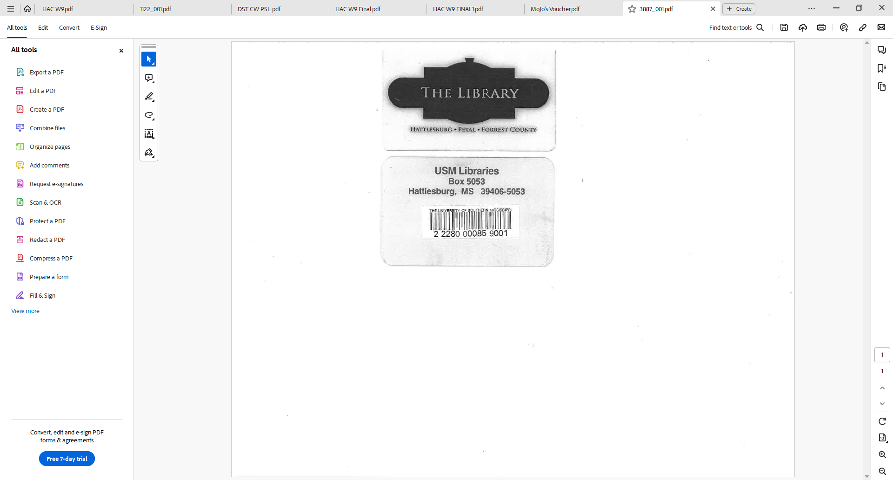

**The Library: Emma Semrau**

**USM Libraries Researcher: Hali Black**

Bibliographic References

A.

Tremblay, M. D., Sutherland, J. E., & Day, D. M. (2017). Fatherhood and delinquency: An examination of risk factors and offending patterns associated with fatherhood status among serious juvenile offenders. *Journal of Child and Family Studies*, *26*(3), 677–689*.* http://crossmark.crossref.org/dialog/?doi=10.1007/s10826-016-0590-7&domain=pdf

B. Dr. Ward, I promise I not trying to overthink this or complicate things, which is also why I emailed you the other day, but I am a little confused on the correct format for the article I pulled from Google Scholar. According to Google Scholar, the citing is listed as the first one; however, I like to double-check my work and I am seeing differences with double-checking it in several APA 7 resources, including the manual and cite generators. To play it safe, I am going to follow my first mind and just include both. My godmother passed and we have her funeral tomorrow, so I am going to go on and submit this now.

TenEyck, M.F., Knox, K.N. & El Sayed, S.A. Absent Father Timing and its Impact on Adolescent and Adult Criminal Behavior. *Am J Crim Just* **48**, 193–217 (2023). https://doi.org/10.1007/s12103-021-09640-x

TenEyck, M., Knox, K. N., & Sayed, S. a. E. (2021). Absent Father Timing and its Impact on Adolescent and Adult Criminal Behavior. *American Journal of Criminal Justice*, *48*(1), 193–217. https://doi.org/10.1007/s12103-021-09640-x

C.

Kennedy, T. D., Detullio, D., & Millen, D. H. (2020). *Juvenile delinquency: Theory, trends, risk factors and interventions.* Springer Nature.

D.

Yi, H. (2019). *Father absence and adolescents: a youth ministry approach.* [Doctoral Dissertation]. University of Pretoria.

**Great job with your APA format except for the few minor corrections listed. Here are links and examples of the generic formatting for articles, books, and dissertations:**

**NOTE:** This is the only class which focuses on learning how to lay out APA 7 Works Cited entries for different kinds of sources [books, articles, dissertations] because the formatting is unique for each kind. See below:

**Books:**

<https://owl.purdue.edu/owl/research_and_citation/apa_style/apa_formatting_and_style_guide/reference_list_books.html>

Author, A. A. (Year of publication). Title of work: Capital letter also for subtitle. Publisher Name. DOI (if available)

**Articles:**

<https://owl.purdue.edu/owl/research_and_citation/apa_style/apa_formatting_and_style_guide/reference_list_articles_in_periodicals.html>

Author, A. A., Author, B. B., & Author, C. C. (Year). Title of article. Title of Periodical, volume number(issue number), pages. https://doi.org/xx.xxx/yyyy

**Dissertations (scroll down to theses & dissertations):**

<https://owl.purdue.edu/owl/research_and_citation/apa_style/apa_formatting_and_style_guide/reference_list_other_print_sources.html>

Lastname, F. M. (Year). Title of dissertation/thesis (Publication No.) [Doctoral dissertation/Master’s thesis, Name of Institution Awarding the Degree]. Database or Archive Name.

Bookmark these 3 links, they will be handy!

If you have ANY academic questions, email me. I am not just your professor for SR 953, I am the Doctoral Programs Senior Tutor and also function like a traditional Library Research Resources Reference Specialist (I help find things and provide sources!). Dr. Geer, our Librarian, is also glad to help with online/library research questions as well <[carolinegeer@gmail.com](mailto:carolinegeer@gmail.com)>. She is quite skilled.