Research for the 21st Century

C. Brian Diggs

Omega Graduate School

Date: February 17, 2024

Professor

Dr. Ken Schmidt, Ph.D.

1. Obtain a library card from one local municipal library and one university or college library. Insert a picture of the library card into your Assignment document. 2. Locate and establish a working relationship with one research librarian in each library. Provide the name and location of the libraries and research librarians you selected. 3. Practice your online research skills in ProQuest, Google Scholar, Google Books, and Open Access These and Dissertations to create a starter Works Cited reference list in APA 7 format.
a. Access the ProQuest database by accessing the OGS Library User’s Guide (2020) RESEARCH DATABASE PASSWORDS. Find a research journal article related to a topic of interest. Download it and provide an APA formatted bibliographic reference for the article: Last Name, First name initials. (Year). Article title in sentence case. Journal Title, Vol.# (Issue #), pp. page range. Double-spaced in a .5-inch hanging indent.
b. Use Google Scholar (https://scholar.google.com) to Find a research journal article related to a topic of interest. Download it and provide an APA formatted bibliographic reference for the article, like the ProQuest article.
c. Use Google Books (https://books.google.com) and find a book within the last five years about a topic of interest. Download it and provide an APA formatted bibliographic reference for the book: Last Name, First name, initials. (Year). Book title in sentence case and italicized. Publisher. Double-spaced in a .5-inch hanging indent.
d. Use Open Access These and Dissertations (https://oatd.org) to find a dissertation about a topic of interest within the last five years. Download it and provide an APA formatted bibliographic reference for the dissertation: Last Name, First name, and initials. (Year). Dissertation title in sentence case and italicized. [Doctoral Dissertation] Name of School. Double-spaced in a .5-inch hanging indent.

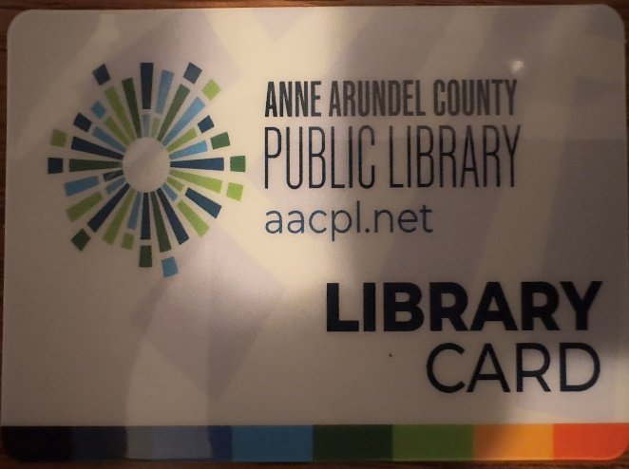
Severn Library – Anne Arundel County Public Library
2624 Annapolis Road, Severn, MD 21144
Johanna Doty
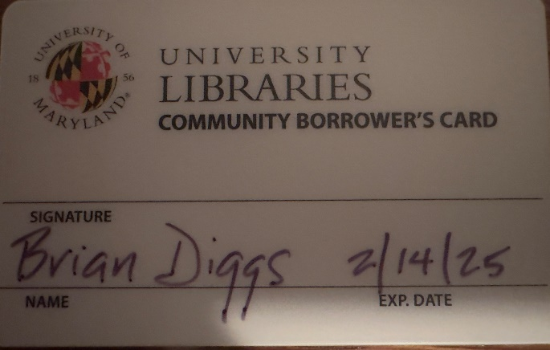
McKeldin Library-University of Maryland
7649 S. Library Lane, College Park, MD 20742
Tahirah Akbar-Williams

References
Ali, T. (2022). The relationship between community policing, police profiling and brutality, and how it relates to minority communities’ perceptions of police. [Doctoral Dissertation]. Retrieved from https://digitalcommons.nl.edu/diss/705 ; https://digitalcommons.nl.edu/context/diss/article/1756/viewcontent/auto_convert.pdf.
Dixon, P. J., & Dundes, L. (2020). Exceptional Injustice: Facebook as a Reflection of Race- and Gender-Based Narratives Following the Death of George Floyd. Social Sciences, 9(12), 231. https://doi.org/10.3390/socsci9120231
Graham, A., Haner, M., Sloan, M. M., Cullen, F. T., Kulig, T. C., & Jonson, C. L. (2020). Race and Worrying About Police Brutality: The Hidden Injuries of Minority Status in America. Victims & Offenders, 15(5), 549–573. https://doi.org/10.1080/15564886.2020.1767252
Ian, J. (2000). Making News of Police Violence. Bloomsbury Publishing USA.
NOTE: This is the only class which focuses on learning how to lay out APA 7 Works Cited entries for different kinds of sources [books, articles, dissertations] because the formatting is unique for each kind. See below:

Books:
https://owl.purdue.edu/owl/research_and_citation/apa_style/apa_formatting_and_style_guide/reference_list_books.html

Author, A. A. (Year of publication). Title of work: Capital letter also for subtitle. Publisher Name. DOI (if available)
Articles:
https://owl.purdue.edu/owl/research_and_citation/apa_style/apa_formatting_and_style_guide/reference_list_articles_in_periodicals.html

Author, A. A., Author, B. B., & Author, C. C. (Year). Title of article. Title of Periodical, volume number(issue number), pages. https://doi.org/xx.xxx/yyyy

Dissertations (scroll down to theses & dissertations):
https://owl.purdue.edu/owl/research_and_citation/apa_style/apa_formatting_and_style_guide/reference_list_other_print_sources.html

Lastname, F. M. (Year). Title of dissertation/thesis (Publication No.) [Doctoral dissertation/Master’s thesis, Name of Institution Awarding the Degree]. Database or Archive Name.
Bookmark these 3 links, they will be handy!

If you have ANY academic questions, email me. I am not just your professor for SR 953, I am the Doctoral Programs Senior Tutor and also function like a traditional Library Research Resources Reference Specialist (I help find things and provide sources!). Dr. Geer, our Librarian, is also glad to help with online/library research questions as well <carolinegeer@gmail.com>. She is quite skilled.

