**Investigating Southern New Jersey GARBC Church Leader’s Spiritual Formation and Transformational Leadership Practices**

**Dr. Sean Taladay**

Chair, Dissertation Committee

**Dr. David Ward**

Member, Dissertation Committee

**Dr. Curtis McClane**

Member, Dissertation Committee

A Dissertation Submitted in Partial Fulfillment

of the Requirements for the Degree of Doctor

of Philosophy

Omega Graduate School

Graduation Date

**Investigating Southern New Jersey GARBC Church Leader’s Spiritual Formation and Transformational Leadership Practices**

Erik M. Christensen

A Dissertation Submitted in Partial Fulfillment

of the Requirements for the Degree of

Doctor of Philosophy

Omega Graduate School

TBD

Dissertation Committee:

Sean Taladay, Chair

David Ward

Curtis McClane

Copyright 2024 by Erik M. Christensen. All rights reserved.

**Appendix A: G* Power Sample Size Calculation**

**Appendix B: GARBC Permission Letter**



**Appendix C: Recruitment Letter**

February 15, 2024

GARBC Church Leader

Dear Church Leader,

My name is Erik Christensen and I am a doctoral candidate with OMEGA Graduate School located in Crystal Springs, TN. I am inviting you to participate in a dissertation study designed to investigate if there is a relationship between church leaders’ spiritual formation and transformational leadership practices.

GARBC church leaders in the Southern New Jersey area will be asked to participate in the study. Church leaders are defined for this study as one of the following: Pastors, Elders, Deacons, Bible Teachers, or Ministry Team Leaders. The total population for this study is 42 church leaders from the Southern New Jersey GARBC churches. The minimum number of participants is 31. Convenience sampling methods will be used to select the first 35 participants to sign the study consent form.

The research is a quantitative correlational study using Pearson’s r bivariate to determine if there is a positive relationship between a church leader’s spiritual formation and transformational leadership practices. Information will be collected and analyzed using two instruments: the Leadership Practices Inventory (LPI) and the Spiritual Transformation Inventory 2.0 (STI). The surveys will take @ 10 to 15 minutes each to complete.

Participating in the study is voluntary. No risks are associated with the research, and you may withdraw from participating at any point. Results from the study may be published; however, your name and the information you provide will be confidential.

If you are currently serving in one of the roles mentioned above and are interested in participating in the study and have any questions, please email me at [Erikc71@gmail.com](mailto:Erikc71@gmail.com) or call me at 609-405-0809. Thank you for considering participating in this important dissertation study.

Erik Christensen

Doctoral Student

OMEGA Graduate School

**Appendix D: Participation Consent Form**

**Introduction**: I am Erik Christensen, a doctoral candidate at OMEGA Graduate School in Crystal Springs, TN. Please review this consent form carefully and let me know if you have any questions prior to or after agreeing to participate in this study. All the research conducted will be supervised by Dr. Sean Taladay from OMEGA Graduate School.

**Project Information**

**Title**: Investigating Southern New Jersey GARB Church Leader’s Spiritual Formation And Transformational Leadership Practices

**Researcher**: Erik M. Christensen

**Institution**: OMEGA Graduate School

**Email**: [Erikc71@gmail.com](mailto:Erikc71@gmail.com) **Phone**: 609-405-0809

**Purpose of the Research**  
The purpose of this correlational research study is to investigate if there is a relationship between a church leader’s spiritual formation and transformational leadership practices.

**Research Design and Procedures**

The research is a quantitative correlational study using Pearson’s r bivariate to determine if there is a positive relationship between a church leader’s spiritual formation and transformational leadership practices. Information will be collected and analyzed using two instruments: the Leadership Practices Inventory (LPI) and the Spiritual Transformation Inventory 2.0 (STI). The research will focus on Southern New Jersey General Assembly of Regular Baptist Church (GARBC) Leaders.

**Participant selection**

GARBC leaders in the Southern New Jersey area will be asked to participate in the study. The minimum number of participants is 31. Convenience sampling methods will be used to select the first 35 participants to sign the study consent form.

**Voluntary Participation**

Participating in this study is voluntary.

**Procedures**

Participants will be given a consent form, including a short series of demographic questions to be signed. Two inventories, the STI 2.0 and LPI, will be provided to participants to fill out. Directions will be emailed to participants on how to fill out the surveys.

**Time Involved**

The surveys will take @ 10 to 20 minutes each to complete.

**Risks**

There are no risks associated with this study.

**Benefits**

Participants will help determine if a connection exists between a leader’s spiritual formation and transformational leadership practices.

**Confidentiality**:

Each survey will be stored on a flash drive and only used for this study. The flash drive will be kept in a secure location. Data will be deleted after three years.

**Sharing the Results**:

Participants will receive research results after surveys have been filled out and returned. The results of the study will be shared with participants and explained. Results will be published.

**Right to Refuse or Withdraw:**

Participants may withdraw from this study at any time.

**Questions about the Study**:

Participants can contact Erik Christensen either by email or phone with any questions. The Institutional Review Board (IRB) of the OMEGA Graduate School has approved the research. The IRB exists to ensure participants in the study are protected from harm. Any questions for the committee may be addressed with the following **emails**: [cao@ogs.edu](mailto:cao@ogs.edu)and [doctoralcandidatetutor@ogs.edu](mailto:doctoralcandidatetutor@ogs.edu)

**Certificate of Consent**

I have read or have had read to me the information about this study. I understand why I have been invited to participate in the research. I have been given the opportunity to ask any questions about the study and have had my questions answered to my satisfaction. I certify that I am at least 18 years of age and voluntarily consent to participate in this study.

**Demographic Information**

Choose one of the following church leadership roles that best describe you:

Pastor _____ Elder _____ Deacon _____ Bible Teacher _____ Ministry Team Leader ______

How long have you served in a ministry leadership role? ________________

What is your highest level of ministerial education? ______________

Printed Name: **_______________________**  Date: **_________________**

Signature: ___________________________ Email: _________________________

The participant was informed and provided the opportunity to ask questions about the research. Questions have been answered to the best of my ability.

Voluntary consent from the participant has been obtained without coercion and a copy of the consent form has been given to the participant.

Lead Researcher (Print): ____________________________________

Signature of Lead Researcher**: ________________________________**

**NIH Certification**











**Appendix E: LPI Permission Letter**

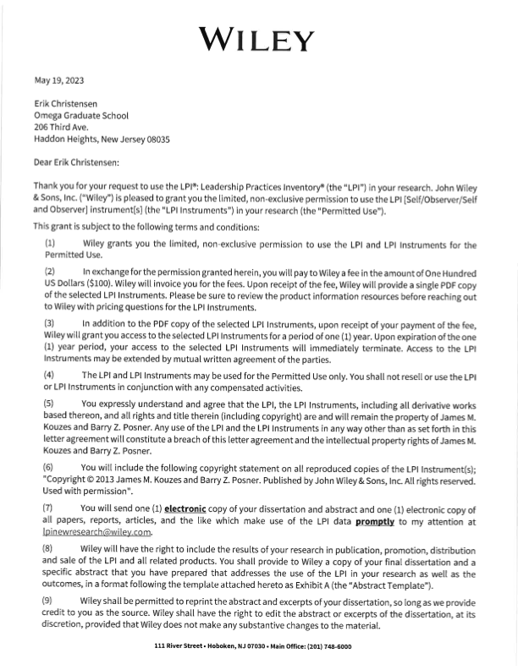

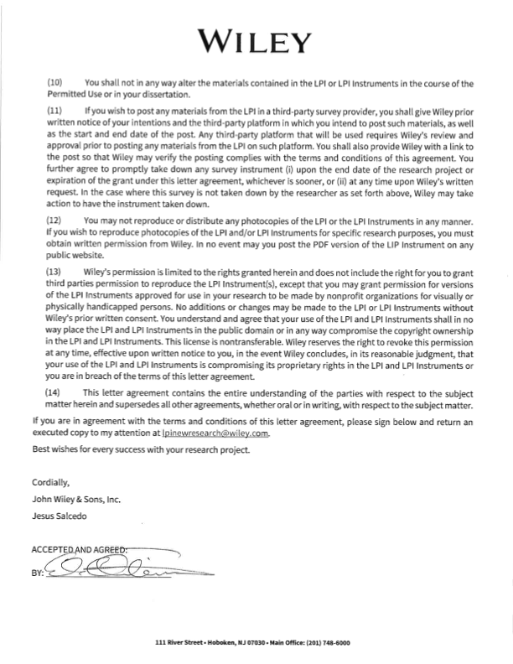

**Appendix F: STI Permission Letter**

**Leadership Practices Inventory Validity information**: (click link to go to article)

Posner B.Z. (2016). Investigating the reliability and validity of the leadership practices inventory®. *Administrative Sciences*, *6*(4), p. 17. <https://doi.org/10.3390/admsci6040017>

**Spiritual Transformation Inventory Validity information**: (see PDF attached with email)

Hall, T. W. (2015). *Technical report: Development and validation*. Retrieved from SpiritualTransformation.org

**Appendix G: Participant Thank-you Letter**

**Date: TBD**

Recipient Name

Email

Dear ____________________________,

Thank you for voluntarily participating in the research study to determine if a positive relationship exists between leaders’ spiritual formation and transformational leadership practices. Research investigating the potential relationship between spiritual formation and leader practices is essential. Your involvement in this study is greatly appreciated. You will receive a report summarizing the overall findings. I trust the information will be of value to you and the leaders in your church as you serve the Lord.

Sincerely,

Erik Christensen