**OFFICE OF THE ACADEMIC DEAN**

January 31, 2024

***IRB LETTER OF APPROVAL FOR COLLECTION OF DATA***

**NAME OF THE RESEARCHER**: Lynn Kronk

**TITLE OF THE RESEARCH PROJECT:**

*INFLUENCE OF FORMAL MENTORING ON ETHICAL AWARENESS*

*IN THE REAL ESTATE INDUSTRY*

**IRB APPROVAL FROM OMEGA GRADUATION SCHOOL INSTITUTIONAL REVIEW BOARD (Academic Team)**

This letter is to affirm endorsement of the Proposal of Research and the Data Collection Plan of *Lynn Kronk*. The Institutional Review Board has reviewed the Proposal and determined the research methodology and design meets the requirements for the protection of the rights and welfare of the selected population in accordance with 45 CFR 66 FDA regulations.

This letter also affirms that the Chair of *Lynn Kronk*’s dissertation committee has provided a recommendation to make this IRB request to begin the collection of data. The Proposal itself has also received approval for the next steps of research.

Finally, from the Academic Office, congratulations are in order for you as a researcher to have reached this important stage in the research process. We eagerly look forward to the finished research as we also anticipate graduation in the future!

May God bless you.

Grace, mercy, and peace from our Lord Jesus Christ,

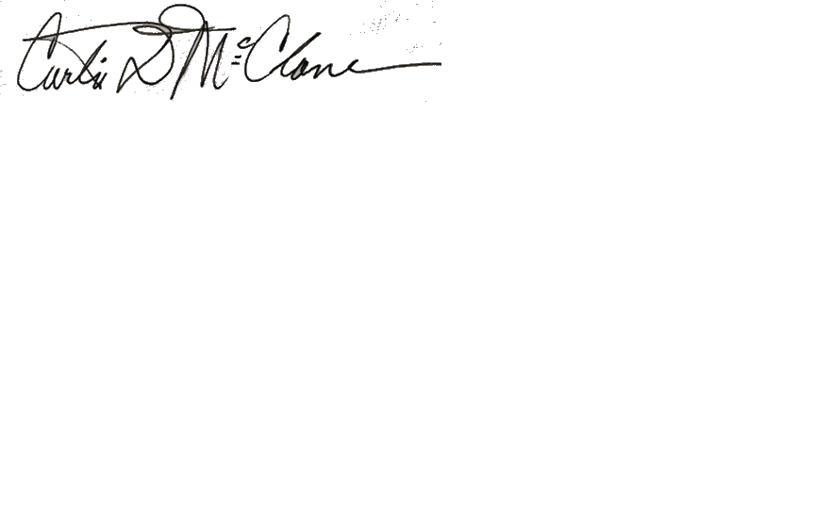

**Curtis D. McClane, Ph.D., D.Min., M.Div.**  
*Executive Vice-President, Chief Academic Officer (CAO)/Dean of Faculty,*

*Academic Team Oversight Facilitator of the OGS IRB Process*

**Omega Graduate School**  
American Centre for Religion/Society Studies (ACRSS)  
500 Oxford Drive, Dayton, TN 37321 USA  
Web: <https://www.ogs.edu/>