Susan Holmes

Omega Graduate School

Professor Sean Taladay

Submission Date: 04/30/2024

**Assignment #3 – Essay**

In this advanced statistics assignment, you will continue working with the sample dataset from the fictional study "Religiosity and Social Behavior in a Diverse Community." You will utilize PSPP statistical software to perform complex statistical analyses. Follow the steps below:

1. **Introduction** - Compose an overview of the sections of this assignment and justify why they are essential for statistical analysis in research.

2. **Splitting Data Based on Independent Variables** (1 page) - Start by splitting the dataset into groups based on selected independent variables. Explain your rationale for choosing these variables and how the dataset has been divided. Ensure you have distinct groups for comparison in subsequent analyses (for example, two racial or gender categories).

3. **Conducting Significant Difference and Correlational Procedures (2 pages)** - Choose appropriate statistical procedures to analyze the relationship between the independent and dependent variables.

a. Conduct analyses such as independent t-tests, ANOVA, or correlation analysis using PSPP.

b. Clearly describe the statistical procedures you are using.

c. Present the results, including statistical significance and effect sizes if applicable.

4. **Conducting Post-hoc Procedures (1 page)** - If your analyses reveal significant differences between groups, conduct post-hoc procedures (e.g., Tukey's HSD, Bonferroni correction) to identify specific group differences. Explain the post-hoc tests used and their purpose.

5. **Interpreting Results (2 pages)** - Interpret the results of your statistical procedures comprehensively. Discuss the practical significance of significant differences or correlations and how they relate to your research questions. Provide insights into the implications of your findings.

6. **Conclusion and Reflection (1 page)** - Summarize your findings and the key takeaways from your analysis. Reflect on the process of conducting complex statistical analyses using PSPP. Discuss how this analysis informs your research and contributes to understanding the dataset.

Ensure your assignment is well-structured, concise, and supported with appropriate statistical output generated using PSPP. This assignment will help you apply your knowledge of data splitting, advanced statistical procedures, post-hoc analysis, and results interpretation in a practical context using statistical software. The assignment should be 7-10 pages long. Cite research design experts from your developmental readings and use proper APA formatting.

**Introduction**

When mathematics is used to examine numeric data, it is called statistics. Statistics involves collecting, analyzing, interpreting, presenting, and organizing data using methods for summarizing and making inferences. Furthermore, the data is often used to understand patterns, relationships, and trends within a population or sample. Usually, this is done by conducting several statistical procedures involving independent and dependent variables. Independent variables are variables that are manipulated or controlled in a study. They are factors that researchers believe may affect the dependent variable, which is the outcome or response being measured (Terrell, 2021, p. 246).

In statistical decision-making, researchers use special programs like SPSS or PSPP to perform various procedures to make comparisons or correlations regarding their groups. These programs use the independent variables to study their influence on the dependent variable and to determine if there is a significant relationship between them. Independent variables can be split or divided into different groups or categories based on specific criteria to help researchers understand the relationships between variables and strengthen the validity of their findings.

If the researcher is conducting significant difference procedures, such as comparing means between groups or conditions, statistical tests like t-tests (for two groups) or analysis of variance (ANOVA, for more than two groups) are commonly used (Terrell, 2021, p. 248). Then, there are times when researchers conduct correlational procedures. This examines the relationship between two or more variables using statistical measures such as Pearson’s or Spearman’s rank correlation coefficient. These measures quantify the strength and direction of the relationship between variables, helping researchers understand if and how variables are related (Terrell, 2021, p. 344). Moreover, it is essential to choose the appropriate statistical procedure based on the research design, the nature of the variables (e.g., categorical or continuous), and the specific hypotheses being tested. Researchers can draw conclusions based on evidence rather than intuition by applying various statistical procedures. By quantifying uncertainty and variability in data, statistics helps reduce risks and make predictions with a certain level of confidence. Consequently, statistics is a fundamental tool for data analysis and decision-making across various domains, making it an essential discipline in modern research, business, and everyday life. In this case, it is being used to conduct an in-depth analysis of a fictional study, “Religiosity and Social Behavior in a Diverse Community.”

“Researchers in a diverse urban community aim to examine and explore the relationship between religiosity and social behavior among residents. The study seeks to understand how individuals' religious beliefs influence their interactions with others, their attitudes toward social issues, and their involvement in community activities. The data set contains information on participants’ religiosity level, engagement in community service, attitudes toward social justice issues, and social cohesion scores (Course Resources—).”

**Splitting Data Based on Independent Variables**

Splitting the dataset based on independent variables such as religiosity level, engagement in community service, attitudes towards social justice issues, and social cohesion can lead to several inferences, insights, and conclusions in a study. For example:

1. Religiosity Level and Social Behavior would allow the researcher to analyze how different religiosity levels correlate with community service engagement. For example, you might find that individuals with higher religiosity levels are more likely to participate in community service activities than those with lower religiosity levels.

2. Attitudes towards Social Justice Issues and Social Behavior would allow the researcher to explore how these attitudes influence social behavior. For example, the analysis may reveal whether individuals with more positive attitudes toward social justice are more actively involved in community service or exhibit higher social cohesion.

3. Social Cohesion and Social Behavior would allow the researcher to provide insights into how cohesive communities engage in collective social activities such as community service. For example, one might discover that communities with strong social cohesion exhibit higher engagement rates in community service.

4. Interaction Effects could also be explored between these independent variables; for instance, one might examine how religiosity level interacts with attitudes toward social justice issues to predict engagement in community service, revealing nuanced behavior patterns within different population segments.

5. Comparative Analysis is achieved by comparing subgroups based on these independent variables, which can help identify disparities or patterns across different demographic or belief-based categories. This comparative analysis can inform discussions about the role of religiosity, social attitudes, and community cohesion in shaping social behavior within a diverse community (Terrell, 2021, p. 263).

Splitting data based on independent variables allows the researcher to conduct various analyses, generating valuable insights into the complex dynamics between religiosity, social attitudes, community cohesion, and social behavior within the study context.

**Conducting Significant Difference and Correlational Procedures**

Statistical procedures that allow the researcher to analyze the relationship between the independent and dependent variables fall under the following purview:

1. Correlation Analysis, where the researcher uses Pearson's correlation coefficient or Spearman's rank correlation coefficient to examine the relationships between continuous variables such as religiosity level, engagement in community service, attitudes towards social justice issues, and social cohesion. This helps determine the strength and direction of associations between these variables. Correlation helps to explain how two variables are related to each other. A positive correlation indicates that when one variable goes up or down, the correlated variable also goes up or down. For example, as people age, their maturity, height, and weight also increase (Krishnan, 2019b).

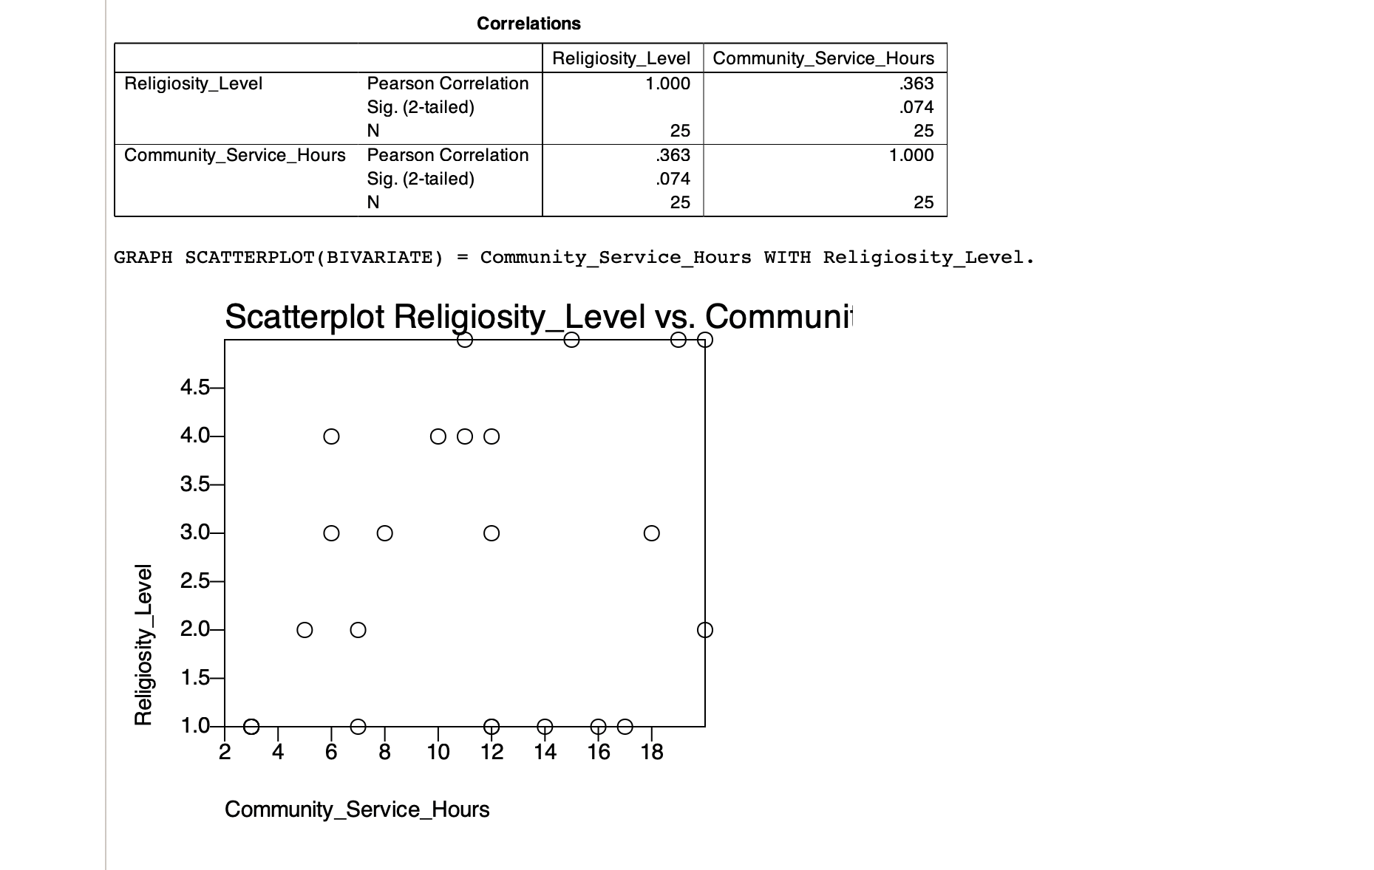

2. The Independent Samples t-test compares the means of two independent groups. For example, compare community service engagement between individuals with high and low religiosity levels. This test assesses whether there are significant differences in means between the groups.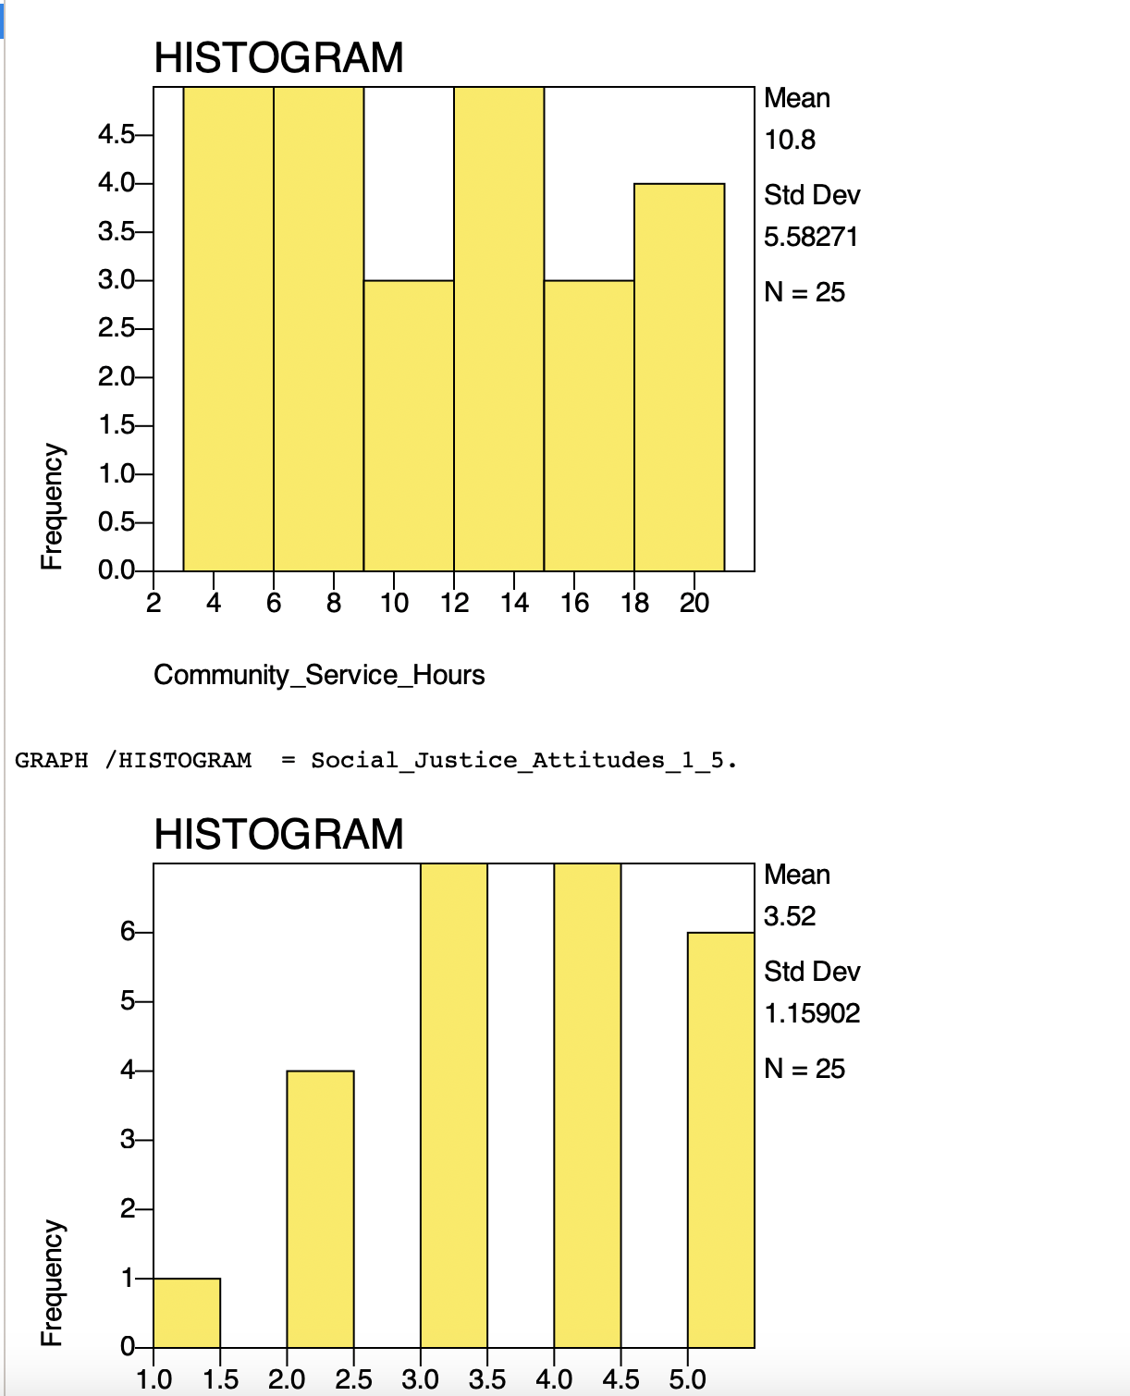

3. ANOVA (Analysis of Variance) can be used when comparing more than two groups. For example, one can use ANOVA to analyze differences in engagement in community service

among participants categorized by different levels of religiosity (e.g., low, moderate, high). If ANOVA indicates significant differences, post-hoc tests (e.g., Turkey's HSD) can identify which groups differ (Salkind & Frey, 2019, p. 243).

4. The Chi-Square Test of independence can be employed to assess relationships between categorical variables, such as examining the association between attitudes toward social justice issues (e.g., positive, neutral, negative) and engagement in community service (e.g., yes, no). This test determines whether there is a statistically significant association between the variables (Salkind & Frey, 2019, pp. 301–305).

5. Regression analysis allows you to predict a dependent variable (e.g., engagement in community service) based on one or more independent variables (e.g., religiosity level, attitudes towards social justice, social cohesion). Multiple regression can be particularly useful for examining the combined effects of various predictors on the outcome variable (Salkind & Frey, 2019, pp. 276–280) (Terrell, 2021, pp. 358–362).

**Conducting Post-hoc Procedures**

Post-hoc procedures like Tukey’s HSD Bonferroni correction, Scheffe’s test, and Dunnet’s test help identify pairwise differences between groups when the overall ANOVA or similar test indicates a significant difference but does not specify which groups differ. For example, suppose researchers are investigating the relationship between religiosity levels and engagement in community service across different age groups (e.g., young adults, middle-aged adults, and seniors). After conducting an ANOVA to analyze the differences, Tukey’s HSD test could be used to identify which age groups have significantly different mean levels of religiosity. Both Bonferroni correction and Tukey’s HSD test are valuable in ensuring the validity and accuracy of statistical comparisons in studies involving religiosity or any other variable being examined for multiple comparisons or group differences.

**Interpreting Results**

These statistical tests can provide quantitative insights and help you draw meaningful conclusions about the relationships and patterns within your dataset related to religiosity, social behavior, attitudes, and community cohesion. PSPP offers functionalities for conducting these analyses efficiently and interpreting the results effectively.

**Table 1 - Pearson’s Correlation Analysis - Religiosity Level**

| **SI. No** | **Variables** | **N** | **Correlation** | **Sig.** |
| --- | --- | --- | --- | --- |
| **1** | Comm. Serv. | 25 | 0.363 | 0.074 |
| **2** | Soc. Cohes. | 25 | 0.554 | 0.004 |
| **3** | Soc. Just. | 25 | 0.548 | 0.005 |

Table 1 indicates the results of the correlation analysis between religiosity level and other variables in the study. The results in the table above display that there is a positive correlation between religiosity level and three variables, i.e., engagement in community service (r =.363), social cohesion (r = .554), and social justice attitudes (r = .548) and that there is a statistically significant correlation between religiosity level and social cohesion and social justice attitudes at a high level (p<0.01). That is, as the social cohesion and social justice attitudes increase, so does their religiosity level. Furthermore, there is a positive correlation between the religiosity level and the number of community service hours. Still, the statistically significant level is moderate because it is slightly more than (p<0.05) (Krishnan, 2019b).

**Conclusion and Reflection**

The complex statistical analyses conducted using PSPP have enriched the understanding of the dataset by uncovering significant differences among groups and relationships between variables. These findings offer valuable insights into the research questions, contributing to a nuanced comprehension of the factors influencing the dataset's outcomes and providing direction for further exploration or interventions. In summary, leveraging PSPP for complex statistical analyses has revealed patterns, disparities, and relationships within the dataset, informing the research direction and enriching the understanding of the variables at play. It is essential to understand the significance of a relationship between variables and the nature of the relationship, e.g., positive or negative. Using a tool like PSPP is less time-consuming and ensures the accuracy of the statistical analysis. These insights are a foundation for future investigations and interventions in any field.

WORKS CITED

*Course Resources—Google Drive*. (n.d.). Retrieved April 21, 2024, from https://drive.google.com/drive/folders/1A-rksjuUCz064EkBeIn0LjcG5ttrUyzU

Krishnan, S. R. (2019a, November 30). *Understanding and performing an ANOVA test using PSPP/SPSS*. https://www.youtube.com/watch?v=H8ddpfM9xso

Krishnan, S. R. (2019b, December 13). *Correlation using PSPP/SPSS*. https://www.youtube.com/watch?v=S9j-wuPf1sI

Salkind, N. J., & Frey, B. B. (2019). *Statistics for people who (think they) hate statistics* (7th edition). SAGE Publications, Inc.

Terrell, S. R. (2021). *Statistics translated: A step-by-step guide to analyzing and interpreting data* (2nd edition)—the Guilford Press.