**SR. 812-78 Research Proposal**

**Core 7**

**Yvette Seales**

**Chapter 2**

**Introduction**

Preservation of Youths' Mental Health should be the concern of every society. A young, healthy population is an asset to national development since sound mental health positively affects one's thinking, behavior, emotions, and ability to cope with the typical demands of life. Youths' cognitive and emotional needs are as critical as their education.

             Researchers Mc Gorry et al. (2022) commented on youth mental health by referring to the mental health of young people aged 10 to 24 years as "the number one threat to the health, wellbeing, and productivity of these people (p. 61, para. 1)". Researchers Zuzuma et al. (2020), posited, that during adolescence, Depression and Anxiety are the leading causes of significant mental distress which affects the youth's educational and communal functioning (para.1). Researchers McGorry et al. (2022) also stated that their data showed that 50% of mental disorders occur before age 15 and 75% by age 25. This revelation is very worrying (p. 61).

            McGorry et al. (2022) expressed concern for the many young persons who develop mental illness and the lack of support from the Health Systems. They posited that some Health Systems appeared structured to assist persons with physical problems, not the mentally challenged.  These researchers also identified gaps in young persons' diagnosis and treatment stages, recognizing early intervention as critical. They recommended changes to the present system and the implementation of new structures to ensure consistent quality primary mental health care for the 12 to 25 age group. One of the recommendations for effective change was sensitizing the public through education about mental ill-health and how to prevent it (McGorry et al., 2022, p. 64).

One organization seeking interest in supporting young peoples' mental health is the Cotton On Foundation based in Australia. In their GOOD REPORT 2023, the goal is "every young person should have someone to turn to" (Good Report, p. 112/113). The foundation's esteem vision is to create access to mental health services for 10 million people by 2030. This goal is fundamental in ensuring that young people have support and camaraderie at this critical development period. (Good Report, p. 112/113).

            Some emotional disorders prevalent among young persons are Anxiety and Depression. The most pervasive is Anxiety. The World Health Organization (WHO) posited that 3.6% of 10 to 14-year-olds and 4.6% of 15 to 19-year-olds experience an anxiety disorder (para. 7). These disorders can hinder a student's performance at school. Depression can even lead to suicide if not dealt with early.

            According to the World Health Organization (WHO), "Adversity is one of the most influential and detrimental risks to mental health (p. 22)." Adversity can come in different forms, such as poverty, sexual abuse, physical abuse, and even the COVID-19 pandemic. McGorry et al. (2022), stated that young people have had worse mental health experiences since the COVID-19 pandemic; 75% reported that their mental health was worse than before. (McGorry et al., 2022, p. 61).

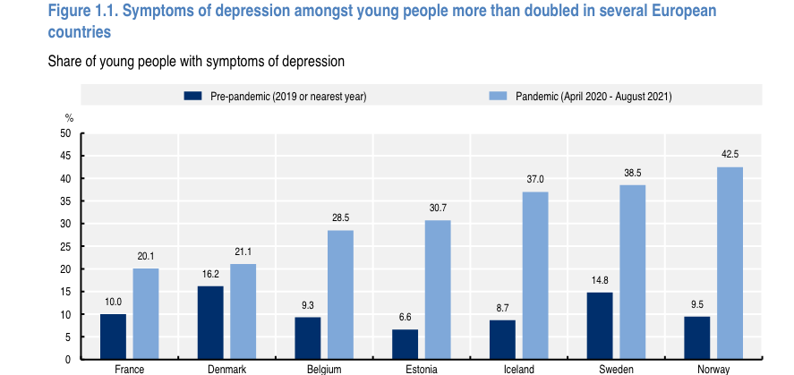

            It is interesting to note that researchers have postulated that religion has played a critical role in managing the emotions of young people. Goeke-Morey et al., 2014 & Wright et al., 1993 as cited in (Goodman and Dyer, 2023) stated that Research has submitted that young persons who have a personal relationship with God have fewer feelings of hopelessness and nervousness (p.3). Aggarwal et al. (2021) explained that adolescence is a unique period where the youth scrutinize various moral, social, and religious values related to their growth and development (Aggarwal et al., 2021, p. 2). The researchers posit that due to the widening of adolescence, these youths have the opportunity to have a greater understanding of that developmental period. Aggarwal et al. 2021 explained that involvement in spiritual practices can give adolescents a sense of expectation and purpose and contribute to emotional and mental wellbeing. Participation in these activities can also lead to positive behaviors due to social bonding and common doctrines (Aggarwal et al., p. 2). In their Research, Hardy et al. (2020) observed that young persons involved in religious practices had more positive emotional health than others, were full of vigor, and were less likely to be unsociable (Hardy et al., 2020, p. 1). Hardy & Nelson, et al., (2019 as cited in Hardy & Nelson, 2022) posited, "Religiosity seems to buffer adolescents and early adults against negative effects of difficult life circumstances and helps them make the most of such challenges" (p. 601).

            This Dissertation will study the relationship between the Mental Health of 18- to 24-year-old people in Trinidad and Tobago and their Religiosity during the COVID-19 Pandemic Lockdown. Experience as a Mental Health Counselor of fourteen (14) years created opportunities to study and interact with this age group under study and to help them cope with the mental and emotional challenges they encountered. This experience, coupled with teaching students 18 to 35 years in Introduction to Psychology, has ignited a passion for researching this intriguing topic.

            Because this study about Trinidad and Tobago has yet to occur, we will observe what resulted in other countries and replicate it in Trinidad and Tobago.

The use of the term "Religiosity:" Boczkowska and Zieba 2910; Iddagoda and Opatha 2017, (as cited in Pastwa-Wojciechowska et al. 2022) defined Religiosity as "the extent to which a particular person believes in and venerates the founder, gods, or goddesses of the relevant religion; practices the relevant teaching; and participates in the relevant activities" (p. 1). These researchers also state that some persons use "religiousness" as another term for Religiosity.

Colloquially, in Roget's Thesaurus, Religiosity is defined as spirituality, religiousness, and piousness, among others. Aggarwal et al. (2023) used other concepts to describe Religiosity, "formal religious practices and spiritual wellbeing" (p.3). Many other researchers use scales to divide Religiosity into subscales. The Duke University Religion Index, or DUREL, is one such instrument. It is a five-item scale that measures three ( 3) aspects of spiritual engagement. These are as follows: (1) Organizational Religiosity, (2) Non-Organizational Religiosity, (3) Intrinsic Religiosity. The DUREL measures each of these by using a different subscale. Organizational Religiosity involves public religious activity. Non-Organizational involves personal religious activities, such as prayer or reading the Scripture. Intrinsic Religiosity involves individual spiritual commitment.

**Literature Research Strategy**

The Literature reviewed was obtained from books and peer-reviewed journals from databases and libraries, including ProQuest, Elsevier, Wiley Online Library, PsyPost, Newspapers, Science Direct, Google Books, Google Scholar, Journal of Medical Internet Research, Genetic Literacy Project, the U.S. Embassy News, the Library of Congress Reference Library, the World Health Organization (WHO) and the Website of the Government of Trinidad and Tobago and the Library of The University of the West Indies Trinidad and Tobago.

**Background to the Problem**

As a global village member, Trinidad and Tobago always focused on international headlines. The most shocking report received was the onset of the deadly COVID-19 epidemic. The entire nation waited with bated breath for the inevitable visit of this fatal Virus to our shores. Sadly, but not shockingly, on March 12, 2020, the Ministry of Health officials announced that they had diagnosed the first case in Trinidad and Tobago: a national returning from vacation (M.O.H., 2021, para. 1).

The World Health Organization (WHO) declared the COVID-19 epidemic a pandemic on March 11, 2020. Within three months of its detection, the viral infection spread globally, resulting in many deaths worldwide. Trinidad and Tobago also experienced fatalities. After observing a gradual increase in cases and mortalities, on March 25, 2020, the Government put measures to mitigate the spread.

The measures came into effect from midnight on March 29, 2020, through a "Stay at Home" Order or lockdown (U.S. Embassy in Trinidad and Tobago, 2020, para. 1); this was due to end on April 15, 2020. All citizens would remain home unless they did business at groceries, banks, and pharmacies (Hutchenson-Jafar, 2021). The order excluded members of the essential services. The Government, however, extended the order to May 15, 2020. Still, on May 9, 2020, Prime Minister Dr. Keith Rowley announced that the Government had decided that the country would return to normalcy on a phased basis.

            "On May 10, 2021, the Government of Trinidad and Tobago, facing a spike in cases and a shortage of hospital beds, decided another lockdown was necessary. They made this decision in light of the concern for the deadly Brazilian P1 variant, which spread rapidly. They instructed supermarkets, pharmacies, and financial institutions to be open for a limited period each day. The number of cases was 11,313, and the deaths were 174 (Hutchenson-Jafar, 2021, para. 5). The authorities extended the restrictions, which included a state of emergency, to another ninety (90) days. In August 2020, the Prime Minister stated that the country had reached community spread and that it was time for further action. The Government decided to implement another lockdown:  teaching institutions, places of worship, gyms, beaches, and water parks were closed. They also advised against gathering families and friends at home. Funerals were allowed at least ten persons (Kissoon, 2020). However, at the end of that period, the situation remained critical. As of November 4, 2021, the death rate was 1698, and infections were 57329.

            The population, at this time, was wary of lockdowns and hoped the Government would introduce other measures to deal with the situation (Pierre, 2021, para. 10). However, it was apparent that they were unaware of the possible negative impact of lockdowns on the population as they tried to manage the crisis created by the Pandemic. On the contrary, however, Research has proven that lockdowns negatively impact citizens and that youths in the 12 to 25-year-old age group are most likely to develop mental health problems (Piper et al., 2021, p. 2).

During this crisis, residents could not attend worship services in person at their churches, temples, or mosques due to restrictions outlined by the State. Bahal et al. (2023) commented on these decisions by stating that though the authorities wanted to protect the population's health, they should have considered the cost of their worshippers' mental health, for there is a price to pay for that action (para. 4).

            Some religious institutions conducted worship services virtually to substitute for the absence of in-person services. The San Fernando Open Bible Church this student attends organized "drive-in-services" for its members in a large open area. Worshippers praised and worshipped from within their vehicles or stood outside. All health protocols were in place for the protection of all attendees. It was the only such type of service in the country. Bahal et al. (202)3, spoke about virtual services in their surveys conducted in the United States of America. They reported that those services were well attended and positively impacted worshippers' emotional and mental wellbeing (para. 5). The researchers posited that religion is essential in determining one's mental health. Fruehwirth et al. (2019 as cited in Bahal et al., 2023) indicated that there is a relationship between both religion and mental health and that an increase in Religiosity resulted in adolescents becoming less depressed.

This knowledge has given motivation to pursue Research to determine how the mental health and wellbeing of youths in Trinidad and Tobago have been adversely affected by the COVID-19 pandemic lockdowns and the role religiosity played in managing them.

In this section, the student will briefly explain the responsibility of the SARS-CoV-2 virus for COVID-19. We will examine the disease's origin, uniqueness, symptoms, treatment, and prevention.

**Origin of SARS-CoV-2**

            SARS-CoV-2 (Severe Acute Respiratory Syndrome Coronavirus 2) is a virus that is responsible for the COVID-19 virus (WHO, 2020, p. 1). SARS-CoV-2 is a member of the "Coronaviridae subfamily (CoV) of the Coronavirinae family of R.N.A. viruses" (Platto et al., 2020, p. 14). CoVs belong to a group of viruses, many of which may impair the normal functioning of the respiratory system. These ailments may range from influenza to serious complications like Severe Acute Respiratory Syndrome (SARS), detected in 2003, and the Middle East respiratory syndrome (MERS) in 2012. Both diseases have resulted in fatalities over time (WHO, 2020, p. 1).

            Four groups comprised the C.O.V.s. They are alpha-, beta-, gamma-, and delta-CoV. The first two, alpha- and beta-, are responsible for causing disease in human beings. Over the years, researchers have established that animals such as bats have been hosts for viruses and that transference occurs due to human interaction (Zagar, 2020, p.7). These CoVs are related to coronavirus genes from the bat population and, to be precise, from the genus Rhinolophus (WHO, 2020, p. 1). Another essential matter that one should note is that SARS-Cov-2 can bind itself to sensory receptors in the human body, which enables it to spread into the cells and, as a result, infect the human body. This fact is available by examining the sequence or order of bases or letters that make up a virus' genetic material (WHO), 2020, p. 1).

            The WHO published that the first cases of COVID-19, the coronavirus disease caused by SARS-Cov-2 in humans, were first announced in Wuhan, China, in December 2019. According to Hadi et al. 2020, at first, 2019-nCoV was the Virus's classification, then SARS-CoV-2 according to the International Classification of Viruses (cited I.C.V., 26-30); however, the WHO on February 11, 2019, named the Virus Covid.

Researchers document that the COVID-19 pandemic originated in Wuhan, China (Clemente-Suarez et al., 2019). They considered the World Military Games in Wuhan, held from October 18 to 27th, 2019, to be a contributor to the spread of the Virus. Over 10,000 athletes from 110 countries participated. Upon returning to their homes, many athletes from Italy, France, Sweden, the U.S.A., and China developed symptoms of the COVID-19 virus. "It was common knowledge that numerous spectators of the Games had been affected as well: in hindsight, the Games had acted as a super spreader of the infection" (Platto et al., 2021, p. 21).

**The Uniqueness of the Covid-19 Virus**

            COVID-19 has been considered the most infectious disease in the last century after the Spanish flu epidemic (Chowdhury et al., 2020, p. 163). This disease has been unique for various reasons: "For example, while COVID-19 primarily affects the respiratory system causing pneumonia, it has also been associated with gastrointestinal and neurological manifestations (Chowdhury in citing Christakis, 2020). Those infected may also mistakenly attribute their symptoms to influenza or other health conditions" (Chowdhury et al., 2020, p. 163).

**Symptoms**

            The infection impacts persons in different ways. Most persons experience flu-like symptoms, fever (>38 °C ), and dry cough. Others complain about body pains, soreness of the throat, blockages of the nasal passages, nausea, and even poor taste buds and smell. It takes approximately 5 to 6 days or even up to 14 days for a person to show symptoms (Hadi et al., 2020, p. 7235). Health officials note that polluted air, especially in confined areas, is the main reason for the spread of infections. The period when the conditions are most favorable is not when symptoms appear but in the early period (Di Perri, 2021, p. 5). Research also shows that adults and children who suffer from co-morbidities such as diabetes, cardiovascular problems, hypertension, cancer, and respiratory diseases are more susceptible to coronavirus infection (SanJuan-Reyes et al., 2021, p. 4

**Treatment and Prevention.**

The first and critical step in treating an infected person is isolation. This action is necessary to prevent the disease from being transmitted to other persons in their environment. However, treating mild cases at home ensures the ill receive appropriate medical attention. The World Health Organization (WHO) has published a guide to assist the public with critical care and management of ill persons (Hadi et al., 2020, p.7236).

**Contributions from Influential World Organizations**

Several world organizations expressed their views regarding the Pandemic and, more specifically, the lockdown and other measures suggested to cope with the challenges.  Some institutions were the United Nations, the drafters of the Great Barrington Declaration, and the World Health Organization.

**The United Nations**

On March 31, the United Nations (U.N.) Secretary-General described the COVID-19 crisis as the most significant collective test for the 'international community' since the U.N. formation. The Secretary-General of the United Nations urged developed countries to help less developed countries immediately to bolster their health systems and capacity to treat disease, especially COVID-19 transmission (Chowdhury et al. 2020, pp. 162, 163). He stated that if they did not heed the call, the infection could spread drastically in the Global South, leaving many casualties and resurfacing in countries that had already experienced it (Chowdhury et al., 2020, p. 163). The Secretary-General was prophetic; the developed countries did not heed the call, and the consequences were drastic.

            Researchers noted that when the WHO announced the onset of the Pandemic, a few countries took early action to mitigate the spread of the disease and avoided their countries resorting to lockdowns. These countries were East and South-Eastern Asian economies and Kerala state in south-west India. Researchers also stated that many other countries could have contained the Virus had they taken early action and used health protocols such as wearing masks and social distancing (Chowdhury et al., 2020, p. 165).

**Theoretical Framework**

The Biopsychosocial theories of mental illness and the Psychosocial theories of Religiosity and Youth frame this study.

**The BioPsychosocial theory of Mental Illness** guides us in understanding that a person's genetic makeup and how they manage their thoughts, feelings, behaviors, and social environment can impact their mental health (Cooper, Tatlow-Golden, 2023, pp. 214-218). According to Armstrong and Summers (2020) "biological, psychological, and social factors are all central to every mental illness." (p. 82).

Mental illness has been the main obstacle to the health, wellness, and productivity of young persons worldwide (McGorry et al., 2022, para.1). This includes the 18 to 25-year-olds on whom we focus our study. McGorry et al. posited that their data showed that 50% of mental disorders occur before age 15 and 75% by age 25. They also proposed that 50% of this age group is affected by age 25.

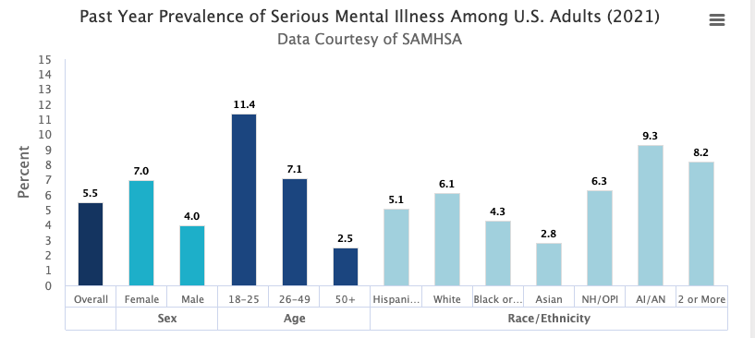

18 to 25 is the highest for serious mental illness

Graph as cited in National Institute of Mental Health

"Depression, Anxiety, and Behavioral disorders are among the leading causes of illness and disability among adolescents" WHO (2021 para.1). Some emotional conditions prevalent among young persons are Anxiety and Depression. The most pervasive is Anxiety. The World Health Organization (WHO) posited that 3.6% of 10 to 14-year-olds and 4.6% of 15 to 19-year-olds experience an anxiety disorder WHO (2021 para. 7). These disorders can hinder a student's performance at school. Depression can even lead to suicide if not dealt with early.

According to the World Health Organization Report (2022), "Adversity is one of the most influential and detrimental risks to mental health" (p. 22). Adversity can come in different forms, such as poverty, sexual abuse, physical abuse, and even the COVID-19 pandemic. McGorry et al. (2022) stated that young people have had worse mental health experiences since the COVID-19 pandemic; 75% reported that their mental health was worse than before (p. 61).

Interestingly, Research has proven that religion is vital in maintaining positive mental health (Xudoyqulova et al., 2023). These researchers also have observed that emotional practices such as self-examination, reflection, and confession have become established features in worship services (para. 1). They have also indicated that in Western and Eastern countries, using religion in psychotherapy is being considered (para. 1).

**The Psychosocial Theory of Religion and Youth** explains how a youth's religious involvement is associated with their psychosocial maturity.

Erik Erikson, a psychologist and psychoanalyst in the 1950s" s introduced the theory of Psychosocial Development. This theory is critical because it helps us understand the significance of the individual's journey through their lifespan. (Erikson, 1968 as cited in Sozer et al., 2022) posited that a crucial factor in youth development is their strength of character or distinctiveness (para. 4). This distinctiveness is essential in establishing their life's philosophy. Erikson, 1968; Roberts & Cote', 2014 (as cited in Sozer et al., 2022) stated that youth's philosophical, social, and religious awareness is critical in character development (para. 9). This theory also showed the importance of the sociocultural setting, which shapes the youth's character and behavior (Tetty et al., 2023, para.2). These researchers also indicated the importance of self-discovery and the critical role that parents and caregivers can play in empowering the youths and giving them a sense of self so that they could develop a positive personal identity (para. 2). Markstrom, (1999 as cited in Sozer et al., 2022) in referring to youth and spiritual values, stated that many writers are of the view that young persons who uphold spiritual principles may experience more worthwhile and prosperous lives (para. 9).

The leading theory about religious development is Fowler's Faith Development Theory. Fowler (1981 as cited in Hardy et al. 2022, p. 597) developed a structural approach using six styles of faith based on "theories of Piaget and Kohlberg and lifespan theories of Erikson and Kegan" (Hardy et al., 2022, p. 597). According to this development model, an adolescent's immediate social setting, congregation, and religious tradition positively influence his attitude and decision-making.

Another theory of importance in adolescent development is the Self-Determination Theory (S.D.T.). Hardy et al. 2020, noted that research-based was mainly focused on the engagement of youths in religious activities and their devoutness but suggested a change of focus by introducing the Self Determination Theory (S.D.T.). Kirkpatrick & Hood, (990 as cited in Hardy et al., 2020) explained that the underlying principle of this theory is that of empowering adolescents inherently so that they develop a passion to practise their beliefs by worshipping and serving God (para. 2). It also sought to identify the different types of religious empowerment strategies that can positively impact youths (para.1).

Research has proven that people can experience resilience during adversity through religiosity/ spirituality. Manning 2013 (as cited in Schwalm et al., 2021, p. 2) described spirituality "as a path to resilience." p. 2. Schwalm et al. referred to studies that have reported positive results in this area. They cited Moreira-Almeida et al., 2014 who identified "low levels of Depression, Anxiety, Stress, suicidal thoughts, and drug use" (p.2) as evidence of this fact. Mc Murdie et al., 2013 (as cited in Hardy et al. 2020) pointed out that religion can act as a shield against the negative symptoms of disorders such as Anxiety, Stress, and Depression. Gall et al., (2011 as cited in Schwalm et al., 2021) noted that religiosity/ spirituality can also enable patients who have been diagnosed with cancer to recover quickly.

Xudoyqulova et al. 2023, noted that religion helps people discover themselves and impacts their feelings, demeanor, and emotional wellbeing.  Xudoyqulova referenced American psychologist A. Boyzen, who believed "religion has the power to positively influence people to get out of crises in their lives" (para. 1). These researchers cited Dr. Benson, Harvard Medical School, who spoke about religion and mental wellness, stated that nothing more had affected the health of human beings like believing there is a God and talking to Him (para. 5).

Dyer et al. 2023 examined the effect of the stressors of the COVID-19 pandemic on adults, children, and adolescents. These researchers used the Stimulus-based model of Stress to determine the impact of the distressing events of the Pandemic, such as school disruption and the curtailing of social and recreational activities, on adolescents' mental health. They concluded that the results of these could have led to grave psychological disorders. However, their findings revealed that adolescents' Religiosity enabled fewer mental health challenges. This idea was also the conclusion of Fatima et al. 2022 who studied how young adults coped during the COVID-19 pandemic. Vishkin et al., (2014 as cited in Fatima et al. 2022) stated, "By shaping emotion regulation, religion eventually promotes well-being by effectively regulating cognitions and emotions in stressful situations" (para. 4).

**Part 2**

            The Research of interest in this project is the influence of lockdowns on youths, young adults, or young people 18 to 24 years old in different parts of the world. This Research will explore the adverse impact of Depression, Anxiety, and Stress of the COVID-19 Pandemic lockdown on their mental health and wellbeing and examine whether there was a relationship between their Mental Health and their Religiosity during the COVID-19 pandemic. Researchers will replicate the results in Trinidad and Tobago. Researchers have used various instruments to conduct Social Research on this crucial topic. This paper focuses on two: (1) The DASS-21 instrument and (2) The DUREL.

**Instrumentation**

This study will utilize two (2) instruments. (1) The DASS-21 instrument, which measures the severity of the symptoms of Depression, Anxiety, and Stress, using D (Depression), A (Anxiety), and S (Stress) subscales (Ahmed et al., 2022). (2) The researcher will use the Duke University Religion Index (DUREL) to measure Religiosity. The DUREL is a five-item assessment that measures the three significant elements of Religiosity: these are (1) organizational religious activity, (2) non-organizational religious activity, and (3) intrinsic Religiosity. The DUREL measures these dimensions by a separate "subscale" (Koenig et al., 2010 para. 1).

**Sociological Perspectives:**

            Many sociological and developmental theories suggest that religion contributes positively to youth development. Emile Durkheim, one of France's leading classical sociologists, produced the theory of social integration, which attests to this fact. Durkheim might be considered one of the first sociologists to recognize religion's important role in societies (Lawrence-Hart & Deezia, 2023, p. 195.) These researchers posited that Durkheim viewed religion much more than a custom or practice but as a system of beliefs that produced order and stability in a society and resulted in everyone's benefits (p. 197). Durkheim, according to these writers, believed that spirituality and community went hand in hand (p. 189)

Another influential sociologist, Max Weber, recognized religion's importance to society. Weber recognized its impactfulness and identified the religious leader as a significant influencer (p. 225). Researchers Lawrence-Hart and Deezia (2023) observed that Weber's spiritual focus was more on the communal effect of religion rather than the individual. Still, he commented that personal religion impacted the community.

Karl Marx's view on religion is also worth considering. Schabel et al., 2022, referred to his "Opiate of the Masses" concept, stating that religion helps people with their problems but prevents them from focusing on their source.

**Social Learning Theory**

The social learning theory assumes practicing spirituality is a learned behavior (O'Connor et al., 2020, para. 4). As life's situation changes, people's attitudes and values change, mainly by copying the examples of others and practicing new behaviors (para. 4). Children in a home have their first experience of religion through socialization by their mothers and fathers and other grown persons. Hunsberger et al. (1983 as cited in O'Connor et al., 2020). However, they no longer look to their parents as role models when they become teens; instead, they switch to their friends. This change can even affect their involvement in religion as they respond to changing situations. In like manner, friends sometimes impact religious ideologies and adults' decision-making (para. 4).

**Sociological Views on Society and COVID-19**

Rogers and Pilgrim (2021) highlight that one of the main principles of Sociology is that problems people encounter have their basis in society. Sociological contemporaries in the past focused on understanding peoples' issues apart from those of society. These writers refer to C. Wright Mills' position on this issue.

Wright Mills posited that personal problems, customarily considered private, should be regarded as public matters of concern and believed they emerged from deep societal issues (p. 9). Singh (2022 as cited in Staubmann, 2021), who postulated that societal issues burden individuals, unaware that they eventually affect them (p. 298). He viewed Mill's teachings on "Sociological Imagination" as one that came to the fore with the advent of the COVID-19 pandemic.

Singh 2022 discussed the Sociological Imagination of COVID-19 by examining the insignificant and significant aspects of the Pandemic. The writer explained that it was essential to understand the causes of the Virus and how it was related to individuals in their sociocultural and historical settings. He posited that challenges persons experienced could only be conceptualized by understanding the many contributing factors of COVID-19 and that understanding people's personal experiences contributes to a better understanding of COVID-19 (p. 298). He further explained that to know how the problem became an international matter, we need to know how it originated and the personal action taken in that sociocultural setting. Singh cited Hernimus-Wendt and Wallace, 2009 who stated that societal problems occur because of inappropriate decisions made within the society. The writer reviewed the COVID-19 situation by saying, "It is the social circumstances that have created the COVID-19 problem in society, and at the same time, it is the individuals and societies who are trapped in it" Singh 2022, p. 300.

**Faith Perspective**

Religion is one of the main predictors of resilience, according to Manning, 2013 Smith et al. 2012; Vierra (2010 as cited in Schwalm et al., 2021).  Resilience is a vital resource that is needed to help individuals to cope with stressful situations. It is a protective factor against mental disorders such as Anxiety, Depression, and other cognitive disorders. It is also a risk factor for several health concerns, e.g., suicide.

Lawrence-Hart and Deezia 2023 in discussing the "Psychological Functions of Religion," refer to religion's critical role in times of difficulty. Interestingly, they describe religion as "a child's security blanket," referring to its prayers as a source of comfort and strength to those who are distressed (p. 25). They also note religion's role in faith groups, where members support one another during grief and loss. Religion even plays a physiological function by reducing the blood tension in the arteries and thus lessening the chances of cardiovascular problems (p. 25). (Jibeen et al. 2018 & Koenig et al. (2000 as cited in Fatima et al., 2022), referred to early Research that showed religion had a powerful impact on emotional wellbeing and positive mental health (p. 158).

Over the years, religion has played an integral role in young people's social, intellectual, behavioral, and ethical development (Aggarwal et al., 2023). These authors view religion as a source of hope, assisting youths to develop positive values like generosity and courtesy. According to Gurba et al. (2022), the transition from adolescence to early maturity significantly changes how young people deal with their relationship with God and their involvement in worship.

Researchers Del Castillo et al. 2023 posited that several research studies revealed that religious people tend to have better mental health than non-religious. These researchers stated that religion plays a critical role in the lives of Filipinos. The society is multireligious but mainly Catholic and pays great attention to their spirituality. Researchers Del Castillo et al., 2023 investigated the effect of spirituality on their youth's mental health in the Philippines and postulated that prayer contributes to positive mental health. Alviar and del Prado (2022 as cited in Castillo) supported this view by stating that members of the American Catholic faith experience relief through prayer and trust in God, even before they access help from mental health personnel. Francis (2021, as cited in Del Castillo) noted that prayer can restore peace, humility, compassion, and forgiveness and, together with the Word of God, can support persons with mental and emotional challenges.

Del Castillo et al., 2023 gave examples of how effective prayer is in the lives of youth in other countries. They cited Graham and Truscott, who stated that in Australia, students use prayer to calm their emotions. Rubinart et al., (2017 as cited in Del Castillo) posited that in Spain, students report that reciting a prayer of Jesus helped to calm their Anxiety.

Keonig (2012 as cited in Del Castillo et al., 2023) presented a model referred to as the "R/S causal pathways for M.H. model" (p. 4). This model shows how Religion and Spirituality affect mental health. The model explains that a religious person who believes in God practices the beliefs and principles of his faith daily, and prays will experience positive emotional well-being and sound mental health (Del Castillo et al., 2023, p. 4).

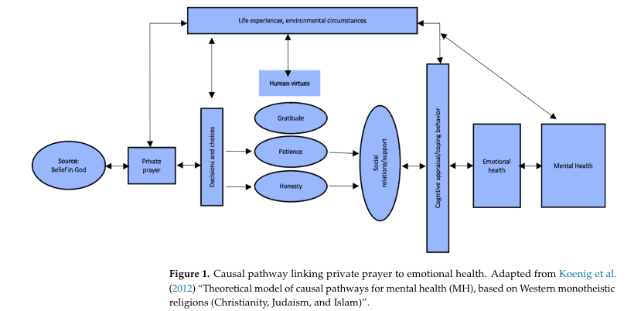

            O'Connor et al. 2020, in their work entitled "The Relative Influence of Youth and Adult Experiences on Personal Spirituality and Church Involvement," raised the question of how to influence children so that their Christian growth and development in their youth and adult years can be effective. The researchers also wanted to know why some youths remained faithful in church attendance while others did not. These were some of the questions included in a survey done in middle-class churches in the United States of America (para. 1).

            These questions are pertinent as we reflect on youth's Religiosity and how they coped during the COVID-19 pandemic. One of the theories researchers identified that can help us understand what is responsible for an individual's religious development and participation in the Church is the Social Learning Theory we referred to earlier. Smith 2005 cited in (Goodman & Dyer, 2020) posited that Research in the Sociology of Religion stated that the most critical factor in transmitting spiritual values to youths is the exemplary lives taught and demonstrated by their parents. These researchers underscored these vital points: 1. Religious practices of the family: These practices included prayer, the study of God's Word, and devotion and highlighted religious modeling by parents. 2. Youths' attributes: These are affected by their predisposition to mental disorders, which can determine their level of spiritual engagement. 3. Parental attributes: Parents who have a friendly and personal relationship with their youths are better able to transmit religious values than those who do not (Goodman and Dyer, 2020, p. 179, 180).

            During the COVID-19 Pandemic lockdown, young people's Religiosity came to the fore as they had to cope with enormous adverse life-threatening conditions. Youths who were from a religious orientation coped more successfully than those who were not. Pargament et al., (2005 as cited in Fatima et al., 2020) used the term "religious coping." This term meant using religious beliefs or practices to cope with stressful situations. He posited that there were positive and negative styles of coping. He referred to positive religious coping as obtaining strength, courage, and fortitude from God in critical and challenging times. He also viewed negative coping as lacking in communication with the Supreme Being and having an inability to cope with life's challenges. Negative coping can lead to the development of mental health disorders; this idea was posited by Francis et al., (2019 as cited in Fatima et al., 2020). However, Bentzen 2019, 2021 Oles and Wozny, 2017 Pirutinsky et al. (2020 as cited in Fatima et al. 2020) stated that research showed that there are people who turn to religion in times of crisis to cope with the uncertainty of disasters and social disruption. This was evident during the COVID-19 Lockdown (p. 159).

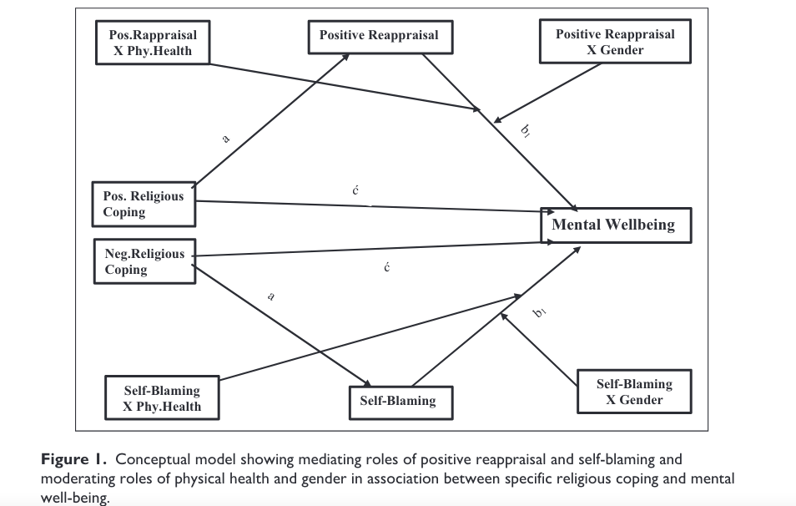

            Exciting information released by Ruan et al. 2023 showed that COVID-19 affected the spiritual atmosphere of many countries. China is one of them, where the COVID-19 Lockdown had positively impacted the levels of spirituality, especially in areas where religion is practiced and affected mainly by the Pandemic. Even though China is one of the few nations where the religious environment is under control, and most of the population is non-religious, the central coping resource has been religion.

**Mental Health and The Church**

What can the Church do to educate its congregants about mental health? This question is a very critical one that leaders should deal with expeditiously.

According to Campbell (2021), religious leaders hold positions of influence. Because of their authority as spiritual leaders, they have the privilege to plan intervention strategies and organize mental health programs in their congregations. Hayes (2018 as cited in Campbell 2021),stated that religious leaders are the ones who congregants look to when having challenges with their mental and emotional well-being (p. 2). Wong et al. (2018 as cited in Campbell, 2021), stated that in the United States, 25% of Americans seek spiritual support from their congregation to deal with mental health problems. However, the writer raised the issue of the stigma of mental health and cited Mayer et al. 2021, who noted that because of stigma, some persons keep challenges secretly, withdraw, and are not willing to seek professional help. Religious leaders must help in this regard.

Onaiwu (2022) reminded readers that one of Jesus's commands to the Church is to heal the sick and that mental ill health is a sickness that needs healing, but most churches do not take up the challenge. Onaiwu (2022) posited that pastors need to increase their understanding of how to cope with this most critical issue. This writer noted that many researchers posit that the Church is a source of support for persons with mental health challenges. Onaiwu also suggested that the Church can play a tremendous, supportive role in recovering persons who receive mental health treatment by teaching the Word, praying, and singing hymns (p. 19).

In Hale (2020), Dr. Hale, a clinical psychologist, addressed this issue when he dealt with the disorder- Depression. Dr. Hale revealed that he had two severe encounters with Depression requiring urgent medical and behavioral health care (p. 11). He admitted that it was when he started to work with persons who were very depressed that he became aware that persons with the greatest need for help with Depression sit in the congregation, enduring deep pain and struggling alone (p. 91). Dr. Hale posited that churches and other faith groups needed to help their membership deal with the problem of Depression and stated that " every year, more than 10% of adults experience a major depressive disorder" (Hale 2020, p. 91). Dr. Hale, who suffered from Depression after a divorce, willingly accepted invitations from Pastors to share with their congregations on the topic. He recommended that churches organize seminars to discuss mental health issues and invite professionals to educate the congregation about symptoms and treatment. This recommendation is essential for all religious leaders to adopt in educating congregants on matters related to mental health.

The San Fernando Open Bible Church in Trinidad is a religious organization that has adopted this model. The Church has a Counseling Agency and has invited its counselors to present mental health topics to its congregation on the third Wednesday of every month. This initiative is called "Wellness Wednesday.'" Some topics have been Grief and Loss, Depression, Stress, and Anxiety. Members of the Church have opportunities to ask questions and to have one-on-one sessions as needed. Presentations are done in person and online (Wellness Wednesday view.yololiv.com)..



**Synthesis of Current Literature**

**Mental Health and Religiosity**

            "Mental Health is an integral component of health and wellbeing that underpins our individual and collective abilities to make decisions, build relationships, and shape the world we live in" (WHO, 2022, p. 1). The WHO (2022 as cited in Castillo et al.2023) stated that 1 in 8 people live with a mental health challenge, most often either Anxiety or Depression.

Exposure to unfavorable circumstances and conditions can cause an individual's mental health to be compromised. These adverse situations can place that person at risk for developing mental health conditions inclusive of mental disorders and psychosocial challenges. These disorders include Anxiety Disorders, Depressive Disorders, and Posttraumatic disorders (Miller, 2023, para 2). All age groups in societies are prone to experiencing these adverse effects; however, the WHO has posited that adolescence is an extraordinary period. It is one where adolescents face challenges with various disorders, such as emotional, psychological, and depressive disorders; these can contribute to them becoming seriously ill, even leading to impairment.

The WHO has also stated that emotional instability is one of the leading causes of sickness among this group, and among the 15 to 29-year-olds, the suicide rate is at its highest. (WHO, 2021, para.1). Owens et al. 2022 also wrote about the difficulties experienced by adolescents and young adults in the age group 14 to 24 years and described it as a delicate period when mental health challenges appear. They posited that approximately half of disorders appear during the teenage period, and three-quarters occur by age 24 (p. 2).



**Social Isolation and Mental Health**

Panchani et al. 2021 reviewed the challenges experienced by the 4 billion Italian population during the first pandemic lockdown. Schools, businesses, offices, parks, and eating places were all closed, and authorities issued severe penalties to persons who broke the law. The entire population had to remain indoors except for emergencies. As in other countries, the whole country was under lockdown and forced isolation (Panchani et al., 2021, p.1).

Cacioppo and Patrick (2008 as cited in Panchani et al. 2021), described social isolation as "an objective physical separation from others and is different from loneliness, which is a subjective feeling of disconnectedness" (Panchani et al., 2021, p. 2.) These researchers stated that being isolated for a short period can have adverse emotional effects. Baumeister and Learie, 1995 & Holt-Lunstad et al. (2010 cited in Panchani) posited that a lengthy period of isolation could cause a person to become depressed, develop suicidal ideations, and even result in death (p. 2).

Williams (2009 as cited in Panchari et al.) referred to "The Temporal Need-Threat Model." This model states that people become resigned and feel they cannot move forward when isolated for lengthy periods.

Panchani et al. 2023 reported on studies about the effects of the lockdown in China. The result showed that there were adverse effects on mental health in areas such as feelings and attitudes about life, emotional Stress, and sleeplessness. Hervalejo et al. (2020 as cited in Panchani et al. 2021) stated that in Spain, the lockdowns affected families negatively by causing them to be anxious and lonely. Ammar et al. (2020 as cited in Panchari et al. reported on a study of several countries that showed emotional challenges, such as sleep deprivation and sedentary behaviors. Hubei province was the worst affected in China during the COVID-19 pandemic. Gao et al., (2020 as cited in Panchari et al., 2023) posited that Anxiety and not Depression were frequent in that province.

Another contributing factor to mental health was the size of the residences. Researchers Pancharie et al. 2023, considered the peoples' living accommodations when studying the effect of isolation on their mental health during the first wave of the epidemic. The researchers cited WHO/Europe 2007 standards for living accommodation. Also, they cited Jones-Rounds et al. 2014, who suggested that living accommodations that were limited in space and with poor lighting impact people's mental and emotional wellbeing (p. 3). This is was occurred in China.

**The Impact of the Covid-19 Lockdown and isolation on youth mental health**

"Quarantines and lockdowns are states of isolation that are psychologically distressing and unpleasant for anyone who experiences them" (Panchal et al., 2021para. 1).

Researchers posited that these lockdown measures (also called quarantines) instituted to protect the population from the spread of the Virus have negatively affected youths' psychological wellbeing.

Incarceration in most countries seeks to prepare inmates for restoration into society. Still, research shows that in doing so, inmates suffer from a deleterious effect on their mental health and well-being (Cunha et al., 2023, p.1). Quandi and Jones, 2021, state that incarceration affects people negatively by separating them from their social setting. They further posit that the characteristics of incarceration include adverse effects on their cognitive and emotional well-being, detachment from families, loss of freedom, listlessness, lack of motivation, and insecurity as regards their surroundings.

The effects of isolation that prisoners experience are similar to the social isolation that youths experienced during the COVID-19 pandemic lockdown. However, prisoners pay for their misdeeds by being isolated in prison, but the youths isolated during the COVID-19 pandemic were innocent.

"Prepare for increased Depression and anxiety in youth due to Covid-19 lockdown" (Knopf, 2020, p. 2). He stated that countries should expect to see a high rate of symptoms of Anxiety and Depression in young persons, due to lockdowns and other related measures. He referred to data from Research that stated 50% of youths 18 to 24 are very lonesome during lockdowns and that there is a relationship between loneliness and mental health "(p. 3). In his research, Knopf reported that solitude and aloneness increased the possibility of a youth becoming depressed and more than likely becoming anxious. He also posited that, "loneliness was more strongly associated with elevated depressive symptoms in girls, and with elevated social anxiety in boys" (p. 4)

Chaudhary et al., 2022, reported on the steps taken by the Government of India to attempt to curb the transmission of the infections caused by the COVID-19 virus. The Government initiated a total quarantine from March 25, 2020, to May 31, 2020. During this period, all educational institutions were closed. The researchers expressed concern for youths, and the possible effects the lockdown and the increasing number of infections can have on their mental health.  This crisis resulted in fearfulness, discouragement, and apprehension among students. The researchers investigated the impact that the restrictions had on the student's mental health and the level of fear that the crisis created among them. The results showed that Anxiety, Depression, and fear were extreme among the students (p. 7).

Table 3. Caterization of the severity of fear of COVID-19, anxiety and depression among the participating students according to their scale cutoff scores

________________________________________________________________________

Symptom and Severity Value, n (%)

**Fear of COVID-19**

High 223 (68.8)

Low 101 (31.2)

**Depression**

Minimal 142 (43.8)

Mild 89 (27.5)

Moderate 46 (14.2)

Moderately severe 33 (10.2)

Severe 14 (4.3)

**Anxiety**

Minimal 157 (48.5)

Mild 90 (27.8)

Moderate 38 (11.7)

Severe 39 (12)

The above study showed a shocking image of the effect that the COVID-19 pandemic and lockdown had on students' mental health, with 223 of 324 (68.8%) having high fear of COVID-19, 93 students (28.7%) having moderate to severe Depression and 167 students (51.5%) having mild to severe G.A.D.

In a study conducted to assess the psychological problems and the associated factors related to the Covid-19 pandemic lockdown among college students in the Amhara region, Ethiopia, researchers Tadesse et al. 2020 revealed that the levels of Anxiety, Stress, and depressive disorders were high (p. 1). The study involved 408 students over the age of 18 years. The response rate was 96.6%. The researchers indicated that "77.2%, 71.8%, and 48.5% of students experienced depression, anxiety, and stress-related psychological problems during the lockdown, respectively" (p.1).



Val-Roque et al. (2021) researched the impact of the COVID-19 pandemic lockdown on Eating Disorder Risk and Emotional Distress among adolescents and young persons in Spain (p. 345). In their study, 2847 persons aged 14 to 35 participated. The results showed that approximately one-quarter of the sample experienced challenges with Depression, Anxiety, and Stress. These data included persons who suffered psychological harm due to their inability to experience closure at the death of their loved ones during the pandemic outbreak. This failure was due to the strict lockdown-type measures at hospitals, resulting in cases of complex grief (p. 359). Cao et al. 2020, Liang et al. 2020, and Rajkumar (2020 as cited in Val-Roque et al. 2021) noted that recent studies have revealed that COVID-19 lockdowns have resulted in "anxiety, depression stress, posttraumatic stress disorder, and disturbed sleep." Liu et al. (2020) as cited in Val-Roque et al. 2021) identified women and youths as most seriously affected (p. 346).

This study by Khetan et al. 2020, was done to show the effect of the COVID-19 lockdown on the mental health of pre-medical students of Maharashtra, India. A survey was conducted using the Depression, Anxiety and Stress Scale (DASS-21). 324 students responded. The results showed that students who were less than 20 years old suffered more from Depression in comparison to those who were above 20 years. The study also showed that 44 students below 20 years and 25 above had significantly increased levels of Anxiety. As regards Stress, this was so for females under 20 years old with very high levels recorded. To conclude, the COVID-19

Pandemic lockdown posed a challenge to the mental health of the pre-medical students of Maharashtra.

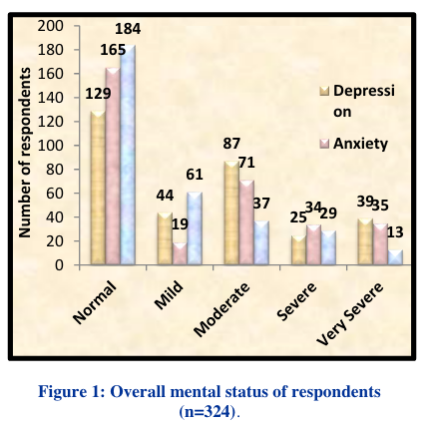

Figure 1 describes the overall mental status of the respondents. Out of 324 respondents 44 (13.58%) had mild depression, 87 (28.85%) had moderate, 25 (7.71%) had severe and 39 (12.03%) had very severe depression. Whereas if we see on the anxiety scale 19 (5.86%) had mild, 71 (21.91%) had moderate, 34 (10.49%) had severe and 35 (10.80%) of them had very severe anxiety. According to the stress scale 61 (18.82%) people had mild, 37 (11.41%) had moderate, 29 (8.95%) had severe and 13 (4.01%) had very severe stress. But overall 129 on depression scale, 165 on anxiety and 184 on stress scale were reported to be completely normal on DASS-21 Scale.

Like many countries, Switzerland put plans in place to prevent the spread of the Covid-19 disease. These plans included stay-at-home measures and complete lockdowns. Mohler-Kuo et al. (2021) studied the challenges youths (1627) aged 19 to 24 years, children, and adolescents aged 12 to 17 experienced in that country due to the arrangements of their first lockdown. Researchers expressed concern for the challenges posed by the lockdown that could have impacted the mental health of youth. Some of these were (1) sudden extreme changes in their way of living. (2) temporary school closures and uncertainty of resumption. (3) inability to have in-person contact with tutors and friends. (4) exasperation. (5) family challenges due to living conditions. (5) worry about contracting and transmitting disease at home. (6) Family conflict.

Researchers concluded that these challenging circumstances were most certain to cause mental ill health among the youth. Mohler-Kuo et al. (2021) reported that as a result of the lockdown measures implemented, in the survey, youths, in particular females, revealed that they experienced severe mental health challenges. Of the youths who participated in the survey, 53.7% of females and 34.8% of males reported feelings of Depression. Also, 4.67 % of females and 33.1% of males showed indicators of Anxiety. The most frequently reported symptom was Depression. They also noted that more females were affected.

Owens et al. (2022) researched 18 to 24-year-old University students in the United Kingdom to ascertain whether their mental health and wellbeing were affected by the COVID-19 lockdown. These researchers were alarmed by the fact that the mental health and wellbeing of young people, particularly those in the age group 18 to 24, were affected after the first month of lockdown. They identified the age group 14 to 24 as being a susceptible period for mental health challenges and expressed grave concern for them.  They noted that statistics show that fifty percent of mental health challenges surface during teen years and seventy-five percent by age 24. Their results showed that students experienced health challenges, especially mental health, which hindered them from attaining their full potential (p. 2). Some had problems with "depression, stress, rumination, sleep disturbance, and lower wellbeing" (Owens et al., 2022, p. 9). Data showed that mental health challenges were so acute that students needed to receive therapy for nine months into the pandemic lockdown (p. 9).

Researchers Fernandes et al. 2020 examined the impact of lockdown on internet use in adolescents by comparing their behaviors before the Pandemic. These researchers, Xiang, Zhang, & Zuwahara, (2020 as cited in Fernandes et al. 2020) stated that young people were experiencing the adverse effects of the lockdown actions taken by authorities to protect the population from the Virus; this resulted in them becoming very inactive. Kira'ly et al., (2020 also cited in Fernandes et al. 2020) highlighted that young people used the Internet to cope, which resulted in them withdrawing from everyone around them. The researcher referred to this as "escapism" (p. 60). Alimoradi et al. (2019 as cited in Fernandes et al., 2020) observed that compulsive computer use results in serious sleep issues (p. 60). Wong et al. 2020 also cited in Fernandes) posited that problematic internet use, being hooked on game-playing, is associated with sleep challenges and mental disorders such as Anxiety, Depression, and Stress (p. 60). One hundred and eighty-five (185) adolescents aged 21 participated in the survey. They were mainly from Mexico, India, the Philippines, and Malaysia. Their findings revealed that the COVID-19 Pandemic hurt youth's internet usage, ability to sleep soundly, and mental health wellness.

The Covid-19 pandemic lockdowns have placed the youth population at significant risk of experiencing Anxiety. Cielo et al. (2021) reported this is true for youths aged 18 to 30 surveyed in Spain, Italy, and Asia. The researchers expressed concern about the anticipated increase in online time due to being locked down at home. They were also concerned that youths might use the Internet to deal with life's stresses. The longitudinal study showed that students who tended to worry significantly increased their anxiety levels. It also reported that females displayed increased levels compared to males. A study showed that younger students also had much higher levels of Stress, Anxiety, and Depression than those who were older (p. 12). The study also revealed that youths in the towns showed more Anxiety than those in the countryside. During the lockdowns, some young persons also had challenges with family relationships, living conditions, and noisy environments, which increased their anxious moments. Controlling this psychological problem was a challenge for some youths. Coping using religious means to release their pent-up feelings were some of the standards used to manage Anxiety.

Sampogna et al. 2021, studied the effect of the pandemic lockdown as a contributing factor to the negative impact of loneliness on young adults 18 to 34 years old in Italy. They posited that Mental Health officials failed to give thought to the vulnerability of young persons, which would result in them being affected mentally, emotionally, and socially by the imposed restrictions (p.3). These restrictions led to a lack of regular interaction with family and friends, curtailment of everyday pursuits, home confinement, and lengthy school disruptions. The resultant effect led to isolation and loneliness (p.6). Research showed that levels of loneliness in young people were very high during the first wave of the COVID-19 lockdown (p. 6).

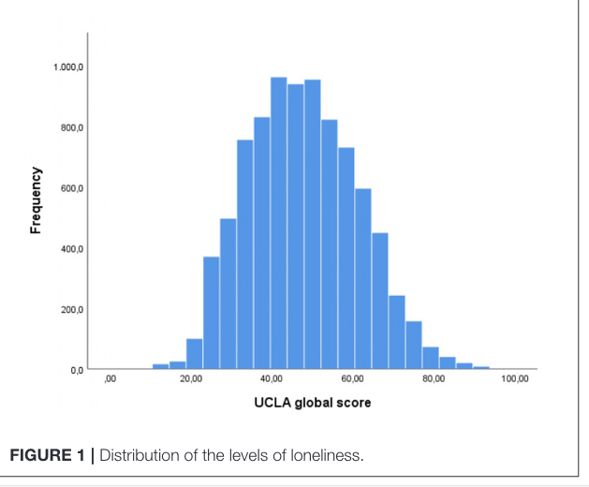

Denche-Zamorano et al., 2022, expressed concern over the high levels of inactivity of young people 15 to 35 years old due to measures taken by the authorities in Spain to deal with the effects of the spread of the COVID-19 virus.  In their Research, they discussed the relationship between physical activity and disorders, namely Anxiety, Depression, and other mental health disorders. Zamorano et al. attempted to show that there was a likelihood that inactive young people would develop mental health challenges based on their lack of physical fitness. They posited that this lack of physical activity led to the increased usage of cell phone devices, the Internet, computer games, video watching, overeating, and other sedentary behaviors (p. 1). The researchers presented research findings that showed that in 2020, 14% of the world's youth population was diagnosed with mental health problems, the most pronounced being Anxiety. Anxiety affects about 12 to 20% of the population worldwide (p. 2). Lack of physical activity is consistent with poor physical health and chronic diseases such as heart problems, diabetes, and mental health disorders in young people. Researchers found that the highest rate of mental health disorders in young people with low levels of physical activity: (1). Depression - 8.7% (2).  Chronic Anxiety - 4.8% (3). Other Mental disorders - 3.9%. Researchers concluded that there is a relationship between lack of physical activity and mental health problems.

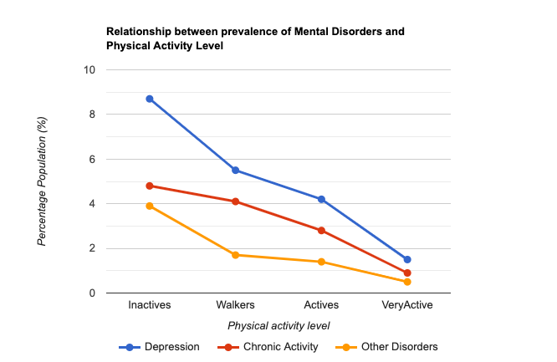

Researchers Bahal et al., 2023, expressed their dismay at the calamity caused by the COVID-19 Pandemic lockdown. They acknowledged that this crisis posed a threat to the mental health of people worldwide but added that religion was a critical means of restoring positive mental health (p.1). Fruehwirth et al. (2019 as cited in Bahal et al. 2023) posited that a relationship between religiousness and a person's mental wellbeing and suggested that religion was critical in preventing young people from becoming despondent. Crabtree, 2010 and Newport, (2015 also cited in Bahal et al., 2023) surveyed American society and found that 65% of Americans believed that religious beliefs and practices were essential to their daily lives. Sahgal and Connaughton (2021 also cited in Bahal) found that 36% of Americans attended their places of worship each week. Based on these findings, Bahal et al. concluded that Religiosity was critical in determining people's mental wellbeing in the United States of America. Since there is a gap in the relationship between religion and mental health, we can replicate the study's findings from the United States of America to Trinidad and Tobago.

Bahal et al., 2023, also discovered in their study that attendance at worship services was the main factor that positively impacted attendees. They also observed that participation in online services during the lockdown increased as attendees replaced in-person worship with those online. The researchers concluded that online services nullified any adverse relationship between COVID-19 and mental challenges.

Arya 2023 reflected on the colossal impact of COVID-19 on the lives of individuals everywhere and said that religion gave inspiration and determination to persevere. Arya 2023 cited some researchers and their comments. Firstly, he cited Jeanet Bentzen 2020, who studied reports from 95 countries and noted people's strong desire for prayer. He also cited Tim Wyatt 2020 who reflected on religious leaders and organizations and their devotion and care for those at risk. Arya cited Simon Dein et al. 2020 and their Research on religion and its effect on persons' emotional health, reactions of leaders of the faiths, and their theological perspectives (p. 1).

            Arya 2023, questioned what made it possible for people to observe religious practices in light of the policies of the pandemic lockdown. He referred to the studies on this topic done in the United Kingdom from a Christian perspective. He referred to researcher Pete Phillips and others in the "Centre for Digital Theology, University of Durham." These researchers used investigations to determine which religious activities were engaged in during the COVID-19 lockdown. The results showed that there was a significantly high participation in online worship. It showed that 1 in 4 persons were regular worshippers online and that 50% of 18 to 34-year-old young persons were also active participants.

            Arya 2023, investigated the effect of the first three months of the COVID-19 lockdown on worship in the United Kingdom. Participants in the survey were persons who belonged to the religious grouping. Three significant factors emerged from the survey. They were: 1. Limitations and other negatives from the Pandemic caused participants to ponder their religious beliefs very deeply for the first time. 2. Digital Worship: Participants were willing to access religious worship through digital technology as was being done socially. 3. Religious Material Objects: Participants shared the importance of using objects in their worship experiences. They explained that those objects created an atmosphere suitable for worship. Some items used in worship were "statues, pictures or images of deities, holy books, candles, prayer mats, prayer beads." These items gave a feeling of comfort and holiness. For example, The Christians cherished the Holy Bible, as it replaced the sermon.

Captari et al., 2022 examined the debilitating effect of the Pandemic and its restrictions on the resources of nations around the globe, but more specifically regarding those of the less economically viable Global South. Captari et al. 2022 studied the relationship between the challenges that religious persons experienced with their mental health during the early lockdown period in Columbia and South Africa. During the lockdown, people experienced religious and spiritual struggles in the form of anguish, suffering, and loss, as well as feelings of being deserted by God, questioning whether there was a higher power, and believing that COVID-19 was a punishment from God. The people even failed to take health measures seriously but left it up to God.

Dura'-Vila' & Dein, (2009 as cited in Captari et al. 2022) stated that spiritual support, even during a dark period like the pandemic, can lead to hopefulness. Pargament et al., 1998, p. (710 as cited in Captari et al. 2022) posited that this can be possible with "positive religious coping" (p.2). However, if it is left unaddressed, it can result in mental health challenges. Captari highlighted the critical factor of hope. Ferrari et al., 2012; Sandage et al., 2014& Sicoli et al., (2011 as cited in Captari et al. 2022) stated, "Hope is associated with greater self-regulation, mental health, relational maturity, and well-being."

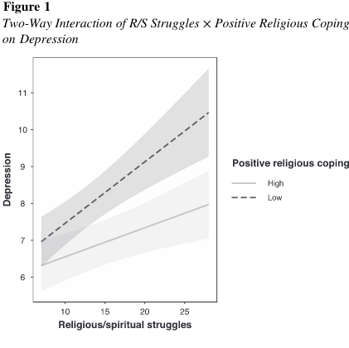

In this study, researchers examined the relationship between (R/S) Religious/Spiritual struggles, positive religious coping and depression among Columbian men and women, during the initial COVID-19 lockdown at their country. Based on results proving that there is a relation between R/S and Depression, (Currier et al., 2019), researchers envisaged that R/S would be associated with Depression.

(Captari et al., 2022, p. 6).

Figure 2 Three-Way Interaction of R/S Struggles × State Hope × Gender on Depression

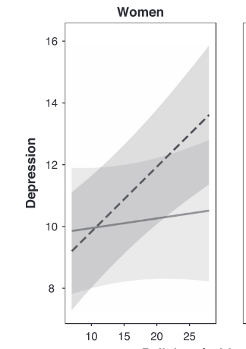

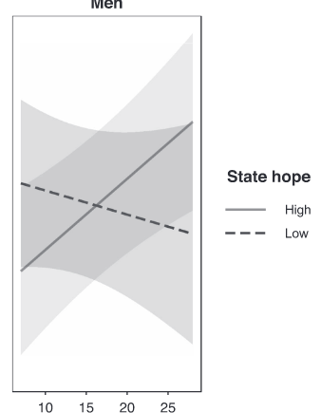

Religious and Spiritual Struggles

To measure Depression and Religious Spiritual Struggles, the Depression Subscale of the BSI-18 was used and the negative religious coping subscale of the Brief RCOPE (Pargament et. al., 1998). The Adult State Hope Scale (ASHS; Snyder et al., 1996) was used. The findings revealed a two-way interaction of R/S struggles x State hope on Depression. Findings show that positive religious coping across both genders and state hope (for women) can be used to support the mental health of people in the Global South who experience R/S during the COVID-19 pandemic. Recommended that Psychospiritual resources be used during the crisis ( Captari et al., p. 10).

**Variant Perspective**

Globally, varying views refuted the actions taken by leaders of nations to implement lockdowns as a control measure against the spreading of the COVID-19 virus.

Clemente-Sua'rez et al. (2021) referred to the startling statistics of the worldwide epidemic in September 2021 as having approximately 219 million confirmed cases, 4.55 million deaths, only 30.7% of the world population immunized, and also many problems resulting from confinement measures. These challenges included mental and emotional problems, sleep, and economic, social, and domestic issues (Clemente-Sua'rez et al., 2021, p. i). The researchers quoted from a survey done with 190 million U.S. citizens, which showed that there was an increase in individual and familial matters such as domestic violence, self-destruction, child abuse, drug abuse, and mental health issues. These problems occurred from mid-March to October 2020 during the COVID-19 Pandemic, compared with the same period in 2019 (Clemente-Sua'rez et al., 2021, p. 2).

**Variant Views of Influential World Organizations**

Several world organizations expressed their views regarding the Pandemic and, more specifically, the lockdown measures implemented.

**A World Health Organization Report.**

The World Health Organization released a scientific report on the COVID-19 epidemic, which stated that within one (1) year, the world population's diagnosis of Anxiety and depressive disorders increased by 25 percent. (WHO, 2022, para. 1). After reviewing reports on the effect of COVID-19, this august body referred to the challenges caused by lockdown conditions, which prevented citizens from socializing and supporting one another (para. 4). The WHO also presented evidence that young people were severely affected and were at risk of developing suicidal behaviors (para. 6).

**Organization for Economic Co-operation and Development Union Report**

The OECD's report on COVID-19 on six (6) European nations on June 13th, 2022, entitled "COVID-19 cohorts on mental health across six nations," has condemned the measures implemented by authorities to curtail the spread of the COVID-19 virus. This organization has implied that there is a damaging effect of "fear, uncertainty, prolonged periods of social isolation and disruption to education and employment" and other effects on the Mental Health of young people (Unnarsdo'ttir et al.,2022, p. 20). The OECD report identified countries, France, Denmark, Estonia, Iceland, Belgium, Sweden, and Norway, that indicated doubled levels of Anxiety and Depression in 18 to 29-year-olds (Unnarsdo'ttir et al., 2022, p.20, 21).



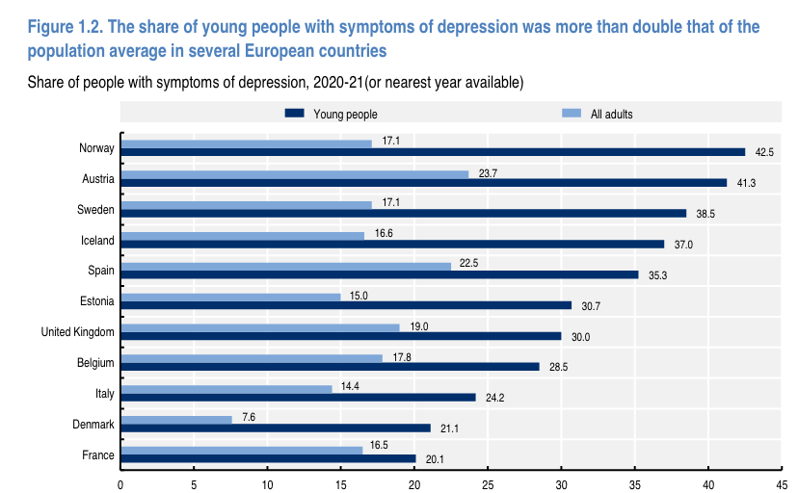

**Impact on educational institutions**

Lockdowns negatively affected many educational institutions worldwide. The United Nations Educational Scientific and Cultural Organization, UNESCO, estimated that about 1.6 billion students from approximately 190 countries were affected by the shutdown of educational institutions, negatively affecting years of educational advancement (Simlandy, 2021. p. 2).  Panchal et al., 2021) referred to lockdowns as "psychologically distressing" (para. 2). They posited that young persons have a greater possibility of developing mental illness than older persons because of the adverse effects of lockdown measures of isolation caused by school quarantines, affecting social contact and intermingling with friends (para. 2).

During the COVID-19 lockdown, universities and other educational institutions changed their standard method of instruction to online tuition for their students. McLure et al. (2020) spoke about this change and noted unsatisfactory comments on the new education delivery method. The researchers also examined studies on the impact of online tuition on student performance of 1241 Indian university students. They noted that the results showed a decline in performance and that 60% had problems focusing (McLure et al., 2020, p. 1).

Felfe et al. (2022) referred to children specialist physicians who, in responding to the challenge of youth mental health during the COVID-19 lockdown, described it as a "national emergency" (para. 1). Felfe et al. (2022) noted that by "mid-April 2020, more than 1. 13 billion children and adolescents across the globe, corresponding to 72% of all enrolled learners, were exempted from in-person education" (para. 2). Felfe et al. 2020 commented on surveys that showed schools closed for lengthy periods contributed to mental health in youths. They stated that the problem was more evident in boys, students who were not quite mature, and families with limited home space. They posited that studies reported that Anxiety, Depression levels were twice as high in children and adolescents during that period (para 2).

Felfe et al. (2020) reminded us that the closing of schools did not occur by itself; it impacted families unprepared to cushion the effect of these measures. In measuring the impact on youth mental health, these researchers based their conclusions on the disparity in reopening procedures used by schools in the German Federal States, on data on youth mental health before and during the pandemic lockdown, and also on data from the crisis helpline, which enabled them to become aware of the many problems youths were experiencing.

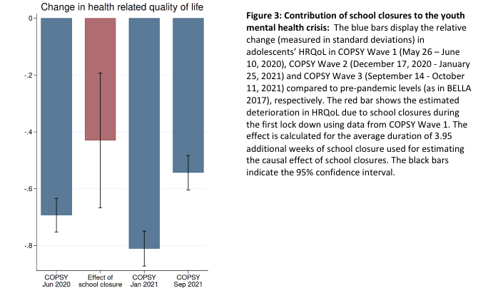

**Impact on World Economies**

Das et al. (2022) posited, "Covid-19 has had an unprecedented impact on businesses and daily life. The Virus forced the whole world into lockdown" (Das et al., 2022, p. 1).

Das et al. (2022) commented on the negative impact of the Pandemic on the business sector and the population worldwide. They noted the devastation economies suffered and identified the tourism and airline industries as greatly affected. In 2020, job loss amounted to approximately 255 million worldwide (Das et al., 2022, p. 1).

Robinson et al. (2021) wrote about the disease and lockdown policies implemented by countries to control its spread, which negatively affected economies. These strong policies significantly declined employment, especially in the service industries, which reduced Gross Domestic Product (G.D.P.). However, economic recovery eventually became a reality as the effect of the Pandemic lessened, and lockdown restrictions were relaxed (Robinson et al., 2021, p. 2).

**The Effect of Lockdowns on the Brain**

There is evidence to prove that lockdowns affect the Brain. A study published by Dolan (2021) stated, "Social isolation and reduction in physical activity caused by COVID-19 lockdowns appeared to have negatively impacted brain metabolism" (p. 1). Dolan (2021) also noted that younger adults experienced this negative impact on the brain (para. 8).

Guedj et al. (2021) researched whether chemical changes occurred in persons with abnormal brain function due to the 55-day national lockdown in France. Dr. Guedj, a biophysicist and nuclear medicine professor at Timone Hospital and Aix-Marseille University, agreed that the lockdown contributed to mental and emotional reactions. (Guedj et al. 2021 cited Florenzato et al. 2021), who posited studies confirm that curtailment of regular activities and lack of social interaction during lockdown negatively impact the brain health of people under 45.

**Literature Gap**

This writer has spent considerable time researching this study regarding the relationship between the Mental Health of 18 to 24-year-old young people in Trinidad and Tobago and their Religiosity during the COVID-19 Pandemic Lockdown.

In pursuing this Research, the writer has discovered a qualitative study on the topic, "Youth perspectives on mental health during COVID-19 lockdown in a small island developing state: implications for emergency response" by Murphy et al. 2024. This study, conducted in Trinidad and Tobago, interviewed 64 participants aged 18 to 24, with results showing adverse effects on their mental health.

Studies have yet to be found regarding this study on the relationship between the Mental Health of 18 to 24-year-old people in Trinidad and Tobago and their Religiosity during the COVID-19 Pandemic Lockdown.

This unique study will assist authorities in our country, Trinidad and Tobago, in making decisions regarding future lockdowns. It will be a study that religious groups, especially the Church, should appreciate as a reminder of the importance of imparting religious values to young people, which will benefit them in challenging times.

**Summary and Conclusion**

**Summary**

Researching the relationship between the Mental Health of 18 to 24-year-old people in Trinidad and Tobago and their Religiosity during the COVID-19 Pandemic Lockdown had been very informative and intriguing.

The introduction presented the importance of preserving young people's mental health as future leaders of nations. It also examined some disorders that impacted them, even from as early as age 10 to 14 years old. The literature showed that religiosity is a buffer that helps young people overcome adverse life circumstances.

The problem's background began with the WHO Declaration that the COVID-19 epidemic was considered a pandemic. From the Literature, it was clear that lockdown or isolation were measures countries worldwide, including Trinidad and Tobago, put in place to mitigate the spread of the Virus. These measures, despite their intent, were detrimental to the mental health of young people.

The Theoretical Perspective reflected the theoretical foundation of this study. The Biopsychosocial theories of mental illness and also the Psychosocial theories of Religiosity and Youth framed this perspective, both discussed in detail.

Next, the Sociological and Faith perspectives introduced a broader social and faith implication to the study.

The synthesis of current Literature revealed that approximately sixty (60) sources, comprising journals and books, contain relevant information to support the topic under study.

Members of society, researchers, and organizations have expressed their feelings regarding the Government's action to impose lockdowns in their countries and the effects on the population, especially young people. One of them, the Great Barrington Declaration, gives an interesting, varied perspective of the signatories, some of whom were medical doctors and others trained in science.

The Literature Gap showed that studies have yet to be found regarding this study on the relationship between the Mental Health of 18 to 24-year-old people in Trinidad and Tobago and their Religiosity during the COVID-19 Pandemic Lockdown.

**Conclusion**

This Dissertation studied the relationship between the Mental Health of 18- to 24-year-old people in Trinidad and Tobago and their Religiosity during the COVID-19 Pandemic Lockdown.

This topic enabled researchers and readers to understand the subject from both a human and a spiritual perspective. The message reminded leaders of nations that their decisions can impact millions of lives. We know of approximately 5 million deaths worldwide that occurred during the COVID-19 pandemic lockdown. Another is that our young people need special care. Their mental health is at risk.

This Dissertation reminded leaders of the Church that worshipping and preaching the Word is very therapeutic and that parents should be encouraged to teach their children about developing a relationship with God. It should remind them also that there might be persons in their congregations who are silently crying out for help because of a mental health challenge and do not know how to deal with it. This study should place a burden on the heart of each religious leader to organize mental health programs with professional assistance for their congregation and community. Salvation is not only about forgiveness of sins but also about removing guilt and fears. The message is that God is interested in impacting the Soul, which is the Will, Mind, and Emotion, so therefore the Church should pay more attention to people's emotions.

Works Cited

Aggarwal, S., Wright, J., Morgan, A., Patton G., Reavley, N. (2023). Religiosity and

spirituality in the prevention and management of depression and anxiety in

young people: a systematic review and meta-analysis. *BMC Psychiatry.*

23, 1-33. <https://doi.org/10.1186/s12888-023-05091-2>.

Arya, R (2023). Religion in lockdown: worship in the time of Covid-19. *Journal of*

*Contemporary Religion* 38(3) 533-551https://doi.org/10.1080/13537903.2023.

2262210

Bahal, G., Iyer, S., Shastry, K., Shrivastava, A. (2023). Religion, covid-19 and mental

health. *European Economic Review.* **160,**104621. https://doi.org/10.1016/j.euroecorev. 2023.104621

Bhattacharya, J., Gupta, S., Kulldorff, M. (2020, January 23). Focused protection: The

middle ground between lockdowns

Campbell, A. D. (2012). Clergy perceptions of mental illness and confronting stigma in

congregations. *Religions*.**12**(12) 110. https:// doi.10.3390/rel12121110

Captari, L., Cowden, R. G., Sandage, S. J., Davis, E B., Bechara, A, O., Joynt, S.,

Counted, V. (2022). Religious/spiritusl struggles and depression during COVID-19

Pandemic lockdowns in the global south: Evidence of moderation by positive

religious coping and hope. *Psychology of Religion and Spirituality* 14(3) 325-337

https:// doi. 10.1037/re10000474

Chaudhary, A., Sonar, N. S., Tr, J., Banerjee, M., Yadav, S. (2021). Impact of theCOVID-19 pandemic on the mental health of college students in India: Cross- sectional web-based study. *JMIRx Med 2(3)* e28158. http:www.doi. 10.2196/28158

Chowdhury, A. Z., Jomo, K. S. (2020). Responding to the COVID-19 pandemic in

developing countries: lessons from selected countries of the global south. *Development.***63**(2-4), 162-171. <http://dx.doi.org/10.1057/s41301-020>

Cielo, F., Ulberg, R., Giacomo, D. D. ( 2021) Psychological impact of the COVID-19

outbreak on mental health outcomes among youth: A rapid narrative review.

*International Journal of Environmental Research and Public Health*. **18**(11) 6067

<http://dx.doi.org/10.3390/> ijerph181

Cunha, O., Rodrigues, A., Caridade, S., Dias, A, R., Almeida, T, C., Cruz, A, R., Peixoto,

M, M. (2023). The impact of imprisonment on individuals’ mental health and

Society reintegration: study protocol. *BMC Psychology* **11**(1) 215.

https://doi.org/10.1186/s40359-023-01252-w

Cooper, V., Tatlow-Golden. (2023). *An introduction to childhood and youth studies and*

*Psychology*. Taylor & Francis.

Cotton On Foundation, *Cotton On Group*. https://cottonongroup.com.au/the-good-w

Das, R., Hasan, M. R., Daria, S., Islam, M. R. (2021). Impact of covid-19 pandemic on

mental health among general Bangladeshi population: a cross-sectional study. *BMj*

*open.* **11**(4), e045727. <https://doi.10.1136/bmjopen-2020-045727>

Del Castillo, F. A., Del Castillo, C. D B., Koenig, H. G. (2023). Associations between

prayer and mental health among Christian youth in the Philippines. *Religions* **14**(6)

806. <https://doi>.10.3390/rel14060806

Denche-Zamorano, A., Franco-Garcia, J, M., Carlos-Vivas, J., Mendoza-Munoz, M.,

Pereira-Payo, D., Pastor-Cisneros, R., Merellano-Navarro, E., Adsuar, J, C..

(2022). Increased risks of mental disorders: Youth with inactive physical activity.

*Healthcare* **10**(2) 237 https://doi.10.3390/healthcare10020237

De Perri, G. (2021). Sars-Cov-2 infection: What makes it so different? *Romanian Archives*

*of Microbiology and Immunology.* **80**(1), 5-6. <https://www.proquest>. com/docview/257

Fatima, S., Arshad, M., Mushtaq, M. (2022). Religious coping and young adult’s mental

well-being during Covid-19.Testing a double moderated model. *Archive for the*

*Psychology of Religion* **44**(3) 158-174https://doi 10.1177/00846724221121685

Fernandes, B., Biswas, U. N., Mansukhani, R. T., Casrin, A. V., Essau, C. A. (2020). The

impact of COVID-19 lockdown on internet use and escapism in adolescents. *Revista de Psicologia Clinica con Ninos y Adolescents*. **7**(3) 59-65https://doi 10.21134/rpcna.2020. mon.2056

Goodman, M. A., Dyer, W. J. (2023). How does religious faith impact positive youth

outcomes. *Religions*. **14** (7), 881. <https://10.3390/rel>14070881

Government of the Republic of Trinidad and Tobago. Ministry of Health. (2021). First

confirmed case of UK covid-19 variant. https://health.gov.tt/first-confirmed-case..

Gurba, E., Czyzowska, D., Topolewska-Siedzik, Cieciuch, J. (2022). The importance of

Identity style for the level of religiosity in different development periods.

*Religions.* 13 (2), 157. <https://doi.org/10.3390/rel13020157>

Hadi, A, K, M. (2020). A review on covid-19: origin, spread, symptoms, treatment and pr

prevention. *Biointerface Research in Applied Chemistry.* 10(6), 7234-7242. http://

10.33263/BRIAC106.72347242

Hale, W. D. (2020). Depression-out of the darkness and into the light. *Gatekeeper Press*

https://read.amazon.com/?asin=80886DV8...

Hardy, S. A., Nelson, J. M., Frandsen, S. B., Cazzell, A. R., Goodman, M. A. (2020).

Adolescent religious motivation: A self-determination theory approach.

*The international Journal For The Psychology of Religion.* 32, 1-15.https://doi.org/ 10.1080/10508619.2020.1844968

Hardy, S., Nelson, J. (2022). Religious development across adolescence and early

adulthood. *Research Gate.* <https://doi:10.1037/0000298-036>

Hutchenson-Jafar, L. (2021, May 5). Trinidad and Tobago tightens lockdown as covid-19

cases surge. *Reuters*. <https://www.reuters.com/world/america>

Isaac, V., Cheng, T., Townsin, L., Assareh, H., Li, A., Mc Lachlan, C. S. (2021).

Association of the initial COVID-19 lockdown on self-reported happiness and worry about developing loneliness: A cross-sectional analysis of rural regional and urban Australian communities. *International Journal of Environmental Research and Public Health* 18 (18) pp 9501 <https://www>. doi 10.3390/ijerph18189501

Kissoon, Carolyn. (2020, August 16). T&T begins closing down again: masks to become

mandatory. *Daily Express.* <https://trinidadexpress.com/newsextra/>...

Knopf, A. (2020). Prepare for increased depression, anxiety in youth due to COVID-19

lockdown. *The Brown University Child & Adolescent Psychopharmacology*

*Update*. 22(8) 1-4.https//www.doi10.1002/cpu.30511

Kulldorff, M., Gupta, S., Bhattacharya, J. (2020). Great barrington declaration. *Great*

*Barrington Declaration*. https://gbdeclaration.org/

McGorry, P. D., Mei, C., Chanen, A., Hodges, C., Alvarez-Jimenez, M., Killackey, E.

(2022). Designing and scaling up integrated youth mental health care. *World*

Psychiatry. 21 (1), 61-76, https: 10. 1002/ wp. 20938

McLure, F, I., Koul, R, B., Fraser, B, J. (2022). University students’ classroom emotional

Climate and attitudes during and after COVID-19 lockdown. *Education Sciences*

12(1) 31. <https://www.doi> 10.3390/educsci12010031

Miller, S. (2023). Mental health and the law. What else is needed for particularly

vulnerable contexts facing armed conflict and development obstacles?

*International Review of the Red Cross*.105 (922) 434-448. <https://doi>.org/

10.1017/51816383122000947

Murphy, M. M., Pemberton, C., Gulston, L. D., Kerr-Layne, O., John, A., Baksh, B.,

Thomas, G., Allen, C. F. (2024). Youth perspectives on mental health during

COVID-19 lockdown in a small island developing state: implications for

emergency response. *Frontiers in Psychiatry*. 14, 1285399. http:www.10.3389/

fpsyt.2023.1285399

National Institute of Mental Health (2023). Transforming the understanding and treatment of

mental illness. https://www.nih.gov/health/statistics/ mental-illness

O’Connor, T.P., Hoge, D. R., Alexander, E. (2020). The relative influence of youth and

adult experiences on personal spirituality and church involvement. *Journal for*

*the Scientific Study of Religion.*

Ochnik, D., Rogowska, A., Arzensek, A., Benatov, J. (2022). Can fear of covid-19 be

predicted by religiosity and trust in institutions among young adults? A prospective cross-national study*. International Journal of Environmental Research and Public Health.* 19(11), 6766. http://www.10.3390/ijerph19116766

Onaiwu, B. (2022). Benefits of Mental Illness Training Programs in the Church. *Liberty*

*University John W. Rawlings School of Divinity.*

Pancani, L., Marnucci, M., Aureli, N., Riva, P. (2021). Forced social isolation and mental

health. A study on 1,006 Italians under COVID-19 lockdown. *Frontiers in Psychology*. 12. https://doi.10.3389/fpsyg.2021.663799

Panchal, N., Kamal, R., Cox, C., Garfield, R. (2021. The implications of COVID-19 for

mental health and substance use. KFF. https://www.kff.org/cotonavirus-covid-19

Papanikolopoulos, P, Kaptinis, S. G. (2022). Religiosity and mental health of

adolescents and young adults: a review. *Psychiatrike*. 33(2), 157-165.

<https://doi.org/10.22365/jpsych.2021.036>

Pastwa-Wojciechowska, B., Grzegorzewska, I., Wojciechowska, M. (2021). The role of

religious values and beliefs in shaping mental health and disorders. *Religions*

12(10), 840. <https://doi.org/> 10.3390/rel12100840

Piper, S., Davenport, T. A., LaMonica, H., Ottavio, A., Lorfino, F. (2021). Implementing a

digital health model of care in Australian youth mental health services: protocol

for impact evaluation. *BMC Health Services Research* 21.1-9.http://dx.doi.org/

10.1186/s12913-0..

Platto, S., Wang, Y., Zhou, Z, Carafoli, E.(2021). History of the covid-19 pandemic:

origin, explosion, worldwide spreading. *Biochemical Biophysical Research*

*Communications*. 538, 14-23.10.1016/j.bbrc.2020.10.087

Quandi, K., Jones, A. (2021). Research Roundup: Incarceration ca cause lasting damage to

mental health. *Prison Policy Initiative*. https//www.prisonpolicy.org/blog/2021/…

Rogers, A., Pilgrim, D. (2021). *A sociology of mental health and illness.* *McGraw-Hill*

*Education*

Roget’s Thesaurus,

<https://en.wikipedia.org › wiki › thesaurus>

Ruan, R., Vaughan, K. R., Han, D. ( 2023). Trust in God:The COVID-19 pandemic’s

Impact on religiosity in China. *Journal fort he Scientific Study of Religion* 62 (3)

523-548 https:/doi 10.1111/jssr.12839

Sampogna, G., Giallonardo, V., Del Vecchio, V., Luciano, M., Albert, U., Carmassi, C.,

Carra, G., Cirulli, F., Dell’Osso, B., Menculini, G., Murri, M.B., Pompili, M.,

Sani, G.,Volpe, U., Bianchini, V., Fiorillo, A. (2021). Loneliness in young adults

during the first wave of COVID-19 lockdown: Results from the multicentric comet study. *Frontiers in Psychiatry* 12. 788139 https://doi10.3389/fpsyt.2021.788139

SanJuan-Reyes, S., Gomez-Olivan, L. M., Islas-Flores, H. (2021). Covid-19 in the

environment. *Chemosphere*. 263.127973. <https://10.1016/j>. chemosphere.2020.

127973

Schwalm, F., Zandavalli, R., Filho, E., Lucchetti, G. ( 2021). Is there a relationship

between spirituality/religiosity and resilience? A systematic review and

meta-analysisi of observational studies. *Journal of Health Psychology*.

27. 135910532098453 https://www.10.1177/1359105320984537.

Simlandy, S. (Ed.). (2021). *Economic crisis and mentality of youth in post-pandemic*

*period.* *PS Opus Publication.*

Singh, S. (2022). Future of work and business in covid-19 era: Proceedings of IMC-2021.

(R.N. Subudhi, Ed.). (S. Mishra, Ed.) (A. Saleh, Ed.) (D. Khezrimotlagh, Ed.).

*Springer.*

Sinnott-Armstrong, W., Summers, J. S. (2020). Which biopsychosocial view of mental

illness? In Savulescu, J., Roache, R., Davies, W. (Eds). *Psychiatry reborn: biopsychosocial psychiatry in modern medicine* (pp. 82-C6. P83). Oxford University Press. https//doi.org/10.1093/med/97801

Toscanelli, C., Shino, E., Robinson, S, L., Thalmayer, A, C. (2022). Religiousness

worldwide: translation of the Duke University Religion Index into 20

Languages and validation across 27 nations. *Measurement Instruments*

*for the Social Sciences.* 4 (1),13. <https://doi.org/10.1186/s42409-022-00041-2>

Unnarsdo’ttir, A, B., Lovik, A., Fawns-Ritchie, C., Ask, H., Koiv, K. (2022). Cohort profile:

Covidment: COVID-19 cohorts on mental health across six nations. *International Journal of Epidemiology*. 51(3) e108-e122. <https://doi> 10.1093/ije/dyab234

US Embassy in Trinidad and Tobago. (2020). Information on government of Trinidad and

Tobago stay at home order/public health ordinance. <https://tt.usembassy.gov/>

Information-on-

Vall-Roque,’ H., Andre’s, A., Saldana, C. (2021).The impact of COVID-19 pandemic and

lockdown measures on eating disorder risk and emotional distress among adolescents and young people in Spain. *Psicologia Conductual*. 29(2) 345-364

<http://dx.doi.org/10.51668/bp.8321208n>

Wellness Wednesday view.yololiv.com

WHO (2021) Mental health of adolescents. <https://www.who.int/news-room/fact>

WHO (2022) COVID-19 pandemic triggers 25% increase in prevalence of anxiety and

depression worldwide. *WHO*. https://www..who.int/news/item/02-03-20

Xudoyqulova, S., Saydaliyeya, M. (2023). Religious beliefs as a factor of personal

Psychological and physiological health. *International Bulletin of Engineering and Technology.* <https://doi.org/10.5281/zenodo.10021740>

Zagar, M. (2020). Impacts of the sars-cov-2 virus and covid-19 pandemic on societies,

sciences and minorities. *Razprave in Gradivo:Journal of Ethic Studies*. 85, 5-

32.http://dx.doi.org/10.36144/RIG85. Dec2.

Zuzuma, N., Fiol-Veny, A., Roman-Juan, J., Balle, M. ( 2020). Emotion regulation style and daily rumination: potential mediators between affect and both depression and anxiety during adolescence. *International Journal of Environmental Research and Public Health*. 17 (18), 6614. <http://dx.doi.org/10.3390/ijerph> 171.