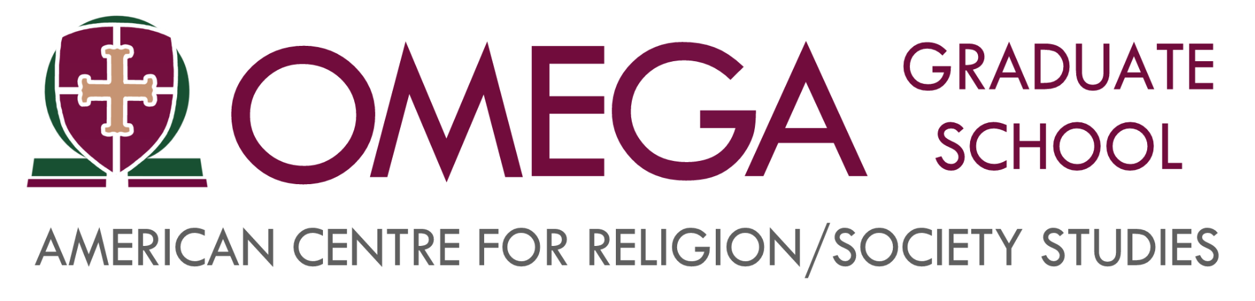

**Asynchronous Courses Roadmap**

**Fall 2023 - Subterm A**

Dear Students,

On behalf of the administration, faculty and staff of the Omega Graduate School, I wish to welcome you to the Fall 2023 Subterm A asynchronous courses. We know that you worked hard to get here and we want you to feel God’s calling to enact constructive social change in your areas of influence. We trust that you will find learning experiences designed with your need and style in mind. You will be immersed in practical skills of social research for leading social change. Omega Graduate School uses the Oxford Method for Educating Graduate-level Adult-learners. Our tutorial process will provide a personalized and relationally-oriented learning experience. Since 1980, Omega Graduate School has served world-changers. World changers recognize their career as a calling, strive to serve God by making a difference in the world, and care about leading social change. We are glad you have joined us!

Starting in the Fall 2023 term, courses in Cores 2 & 4 will be offered asynchronously to provide greater flexibility to the schedules for adult learners. By using the term “asynchronous,” we mean that there will not be any live sessions for these courses offered during the Subterm A weekend residency. Instead, students will begin their courses by watching videos recorded by their professors that will explain course content and assignments. The recorded videos do not mean, however, that there will be no opportunities for community engagement and discussion for the asynchronous course students. Quite the contrary! Students taking asynchronous courses will still attend the Subterm A Orientation session, All Core Pre-Assignment meetups, Chapel services, and Forum Presentations where they will be able to share what they are learning, ask questions, and engage in discussions with fellow students and faculty.

**Curtis D. McClane, Ph.D., D.Min., M.Div.***Executive Vice-President, Chief Academic Officer (CAO)/Dean of Faculty, OGS Chaplain*

**Omega Graduate School**

#### Subterm Asynchronous Course Listing

**PhD/DSL Core 2**

● PHI 815 History of Integration of Religion & Society

● PHI 805 Faith-Learning Integration and Interdisciplinary Studies

**PhD Core 4**

● COM 968 Statistics II

● SR 958 Research Design & Methodology II

**DSL Core 4**

● SR 890 Action Research Project Prospectus

### August 14-19 Requirements

* 8/14 Attend Subterm A Orientation Session (7:00 pm – 8:30 pm) to meet fellow students and course professors
* Review syllabus for asynchronous course(s) and note instructions for each assignment
* Watch professor recorded video for asynchronous course(s)
* 8/19 Submit Assignment #1 discussion post in DIAL

### Community Engagement Schedule: Subterm A

8/15 Chapel (7:00 pm - 8:00 pm)

8/31 Pre-Assignment #2 Meetup (7:00 pm - 8:30 pm)

9/7 Forum Paper Presentation #1 (7:00 pm - 8:30 pm)

9/12 Chapel (7:00 pm - 8:00 pm)

9/14 Pre-Assignment #3 Meetup (7:00 pm - 8:30 pm)

9/21 Forum Paper Presentation #2 (7:00 pm - 8:30 pm)

10/5 Forum Paper Presentation #3 (7:00 pm - 8:30 pm)

### Fall 2023 Subterm A Assignment Due Dates (All Cores)

Subterm A (8/14/2023 - 10/8/2023)

* Assignment #1: 8/19/2023
* Assignment #2: 9/9/2023
* Scholar’s Porch 9/23/2023
* Assignment #3 9/30/2023
* Assignment #4 10/7/2023

Final Assignment Deadline Subterm A (10/08/2023)