CHAPTER 4: SUMMARY OF RESULTS

Chapter four summarizes the study's results on Youth Entrepreneurial Readiness: Entrepreneurial Self-Efficacy and the Moderating Role of Entrepreneurial Training.  This study aimed to test if a statistically significant difference existed in youth entrepreneurial readiness to start or develop a business based on entrepreneurial self-efficacy between those who have taken EDI entrepreneurship training and those who have not.   The chapter comprises an introduction, the preparation of raw data for analysis and tests assumptions, a summary of assumptions tests for the Mann-Whitney U Test, a descriptive summary of the participants and the ESE scale, hypothesis testing, and a summary.

The researcher first describes how the raw data was cleaned, the steps taken and outcomes of the data cleaning, and the data preparation for analysis.  Then, the researcher explains the assumption tests required for independent samples of the Mann-Whitney U Test and describes in narrative form how each assumption was tested and the outcome of each test presented.  A summary of the demographic data that describes and summarizes the general characteristics of the sample data is presented.  Finally, the null hypothesis was tested, and the research question was answered.

**Introduction**

This research study compared EDI-trained and non-trained individuals in entrepreneurship and was guided to answer the following research question and two hypotheses to address the research space:

RQ: What differences exist in youth entrepreneurial readiness based on entrepreneurial self-efficacy related to entrepreneurship training?

 H0: No statistically significant difference exists in entrepreneurial readiness to start or develop a business based on entrepreneurial self-efficacy between those who received entrepreneurship training and those who did not.

Ha: A statistically significant difference exists in entrepreneurial readiness to start or develop a business based on entrepreneurial self-efficacy between those who received entrepreneurship training and those who did not.

The hypothesis was analyzed using the samples to determine whether there was a statistically significant difference in entrepreneurial self-efficacy scores between those who had taken the EDI training and those who had not. The result was analyzed using the Mann-Whitney U test to determine if there was a significant difference between the groups.  The Mann-Whitney U test compared the means of the two groups.

The 20-item entrepreneurial self-efficacy scale served as the dependent variables, comprising creativity (five items), planning (three items), marshaling (three items), managing ambiguity (five items), and financial literacy (four items).  Respondents were asked to indicate their confidence level with each item on a scale of seven that included the options of not very confident, below average confident, slightly below average confident, average confident, slightly above average confident, above average confident, and very confident; and the values increased up to seven for very confident.  The categorical variable of trained and not trained is the independent variable.

**Preparation of Raw Data for Analysis**

After the SurveyMonkey created to collect the data was closed, the researcher imported the raw data into SPSS.  Data cleaning took place to remove outliers and missing data. The researcher collected 132 responses; however, two participants did not consent and exited from the survey.  Four respondents’ ages were above 35; therefore, they were removed because they did not meet the survey inclusion criteria.  The final sample size in this research study included 126 participants who submitted complete data sets and were used for data analysis: 62 were EDC trained, and 64 were on a waiting list.

**Assumptions Tests for Mann-Whitney U Test**

The Mann-Whitney U test compares differences between two groups of rank-based nonparametric data to determine if the differences are significant on a continuous or ordinal dependent variable. It is often used when the independent samples t-test assumptions are unmet (Lund & Lund, 2023). The Mann-Whitney U test has four assumptions, and one has to check if the study design meets the assumptions' criteria.   The researcher reviewed each assumption to determine if the Mann-Whitney U test was appropriate to analyze the data.

Assumption 1: The dependent variable should be measured at the ordinal or continuous level.  This study uses a 7-point scale Likert items (7 "Strongly agree" through to 1 "strongly disagree") (Lund & Lund, 2023).  Therefore, the assumption 1 criterion is fulfilled.

Assumption 2: The independent variable includes two categorical independent groups (Lund & Lund, 2023).  This study uses the entrepreneurial readiness “yes” and “no” categories and the “EDC trained” and “waiting list” categories for the moderating variables.  Therefore, the assumption 2 criterion is fulfilled.

Assumption 3: The two groups should be independent, with no participant in more than one group (Lund & Lund, 2023).  The two groups in the present study are mutually exclusive.   Whether one is trained or on a waiting list is the moderating variable.   Therefore, the assumption 3 criterion is fulfilled.

Assumption 4: The two groups are not normally distributed.  If the two groups have the same or similar shape, we can use the test to compare the median of the dependent variables.  Determining whether the distributions of scores for the two groups of independent variables have the same shape was conducted using SPSS.  If the two shapes are not similar, we can compare the mean ranks, not the median (Lund & Lund, 2023)

|  |  |  |  |  |
| --- | --- | --- | --- | --- |
| Table 8.  *Mann-Whitney Test of a Rank of Non-Trained and EDC Trained Respondent* | | | | |
| ESE | Non-Trained Vs. Trained on Entrepreneurship | N | Mean Rank | Sum of Ranks |
| Not Trained | 64 | 51.88 | 3320.50 |
| EDC Trained | 62 | 75.49 | 4680.50 |
| Total | 126 |  |  |

The Rank Table shows the mean rank and sum of ranks for the two groups tested (i.e., the trained and non-trained groups).  The group with the highest mean rank has higher readiness than the waiting list group.

|  |  |
| --- | --- |
| Table 9.  *Normality Test Statistics of the Grouping Variable a* | |
| Normality Testing | Entrepreneurial Self-Efficacy Scale |
| Mann-Whitney U | 1240.500 |
| Wilcoxon W | 3320.500 |
| Z | -3.629 |
| Asymp. Sig. (2-tailed) | .000 |
| a. Grouping Variable: Non-Trained Vs. Trained in Entrepreneurship | |

Table 9 shows us the actual significance value of the test. Specifically, the Test Statistics table provides the test statistic, U statistic, and the asymptotic significance (2-tailed) *p*-value. From this data, it can be concluded that entrepreneurial readiness in the trained group was statistically significantly higher than in the non-trained group (U = 1240, p = .000).

**Summary of Assumptions Tests for Mann-Whitney U Test**

The research study's design and data met the first three assumptions for the Mann-Whitney U test. Assumption 1 is one dependent variable measured at the rank level of ESE scores of trained and non-trained participants, so Assumption 1 met the criterion.

Assumption 2 is one independent variable consisting of two categorical, independent groups (those who answered “yes” or “no” to the readiness questions). Therefore, EDC-trained and non-trained participants, so Assumption 2 was met.

Assumption 3 is independence of observations, which is met by having different participants in the two groups. EDC-trained participants are mutually exclusive groups from those on the waiting list, and those who expressed readiness differ from those who expressed non-readiness, so Assumption 3 was met.

Assumption 4 is the distribution of scores for both groups of the independent variable that have the same or a different shape. The researcher assessed the shapes of the independent variables via a population pyramid. While the shapes were not precisely the same, they were pretty similar, so Assumption 4 was met. As a result, all four assumptions of the Mann-Whitney U test are met, so the researcher used this test to analyze if there were differences in ESE scores between EDC-trained and not-trained participants.

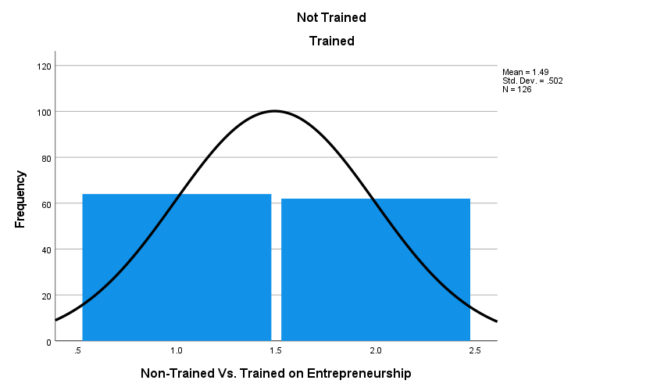

Figure 3: The Distribution Score of Not-Trained and Trained Variables

**Descriptive Statistics of the Participants**

One hundred twenty-six participants completed the dataset for this research study. Table 10 shows 66 participants (28 EDC trained and 38 not trained) were women, representing 52%, and 60 (34 EDC trained, 26 not trained) were men, representing 48% of the sample. (See Table 10 and Figure 4.)

Table 10.

*Respondents’ Gender*

|  |  |  |  |
| --- | --- | --- | --- |
| Gender | EDC Trained vs. Not Trained | N | % |
| Man | EDC-Trained | 34 | 47.6% |
| Not-Trained | 26 |
| Woman | EDC-Trained | 28 | 52.4% |
| Not-Trained | 38 |

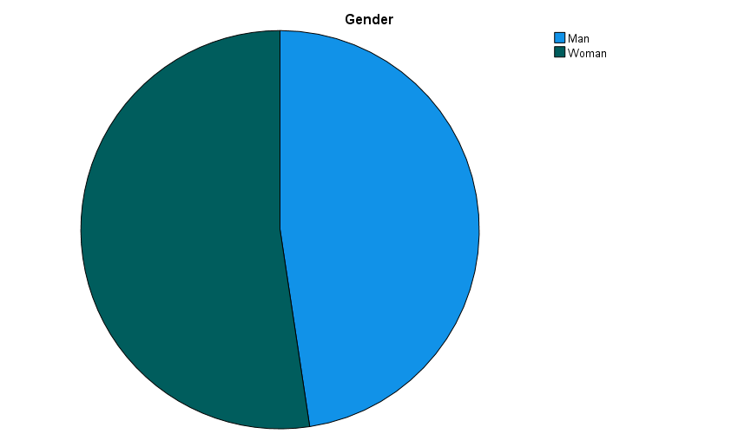

Figure 4: Respondents’ Gender

The largest group of respondents was in the age category of 26-35, 94 (54 EDC trained and 40 not trained) representing 75%, and 32 (8 EDC trained and 24 not trained) were 18-25, representing 25% of the sample. (See Table 11 and Figure 5.)

Table 11.

*Respondents’ Age Group*

|  |  |  |  |
| --- | --- | --- | --- |
| Age group | Trained vs. Not Trained | N | % |
| 18-25 years | EDC-Trained | 8 | 25.4% |
| Not-Trained | 24 |
| 26-35 years | EDC-Trained | 54 | 74.6% |
| Not-Trained | 40 |

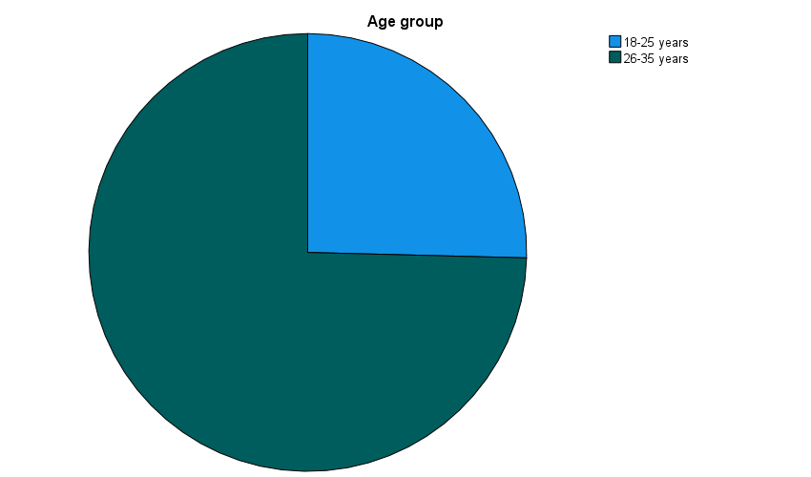

Figure 5: Respondents’ Age Group

Respondents were asked to describe their level of education. The majority, 75 (31 EDC trained and 44 not trained), were college/university graduates, representing 60%; 41 (30 EDC trained and 11 not trained) had done post-graduate studies, representing 33%; 7 not trained had done vocational studies representing 6%; and 3 (1 EDC trained and two not trained) had completed secondary school representing 2% of the sample. (See Table 12 and Figure 6.)

Table 12.

*Respondents’ Level of Education*

|  |  |  |  |
| --- | --- | --- | --- |
| Level of Education | Trained vs. Not Trained | N | % |
| Secondary | EDC-Trained | 1 | 2.4% |
| Not-Trained | 2 |
| Vocational | EDC-Trained | 0 | 5.6% |
| Not-Trained | 7 |
| College/University | EDC-Trained | 31 | 59.5% |
| Not-Trained | 44 |
| Postgraduate | EDC-Trained | 30 | 32.5% |
| Not-Trained | 11 |

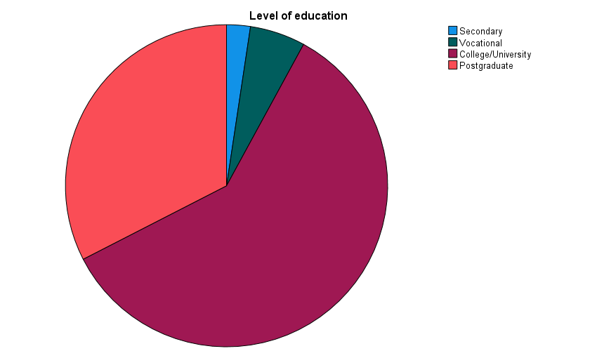

Figure 6: Respondents’ Education Level

Respondents were asked how long they had been active in any work experience. Fifty (35 EDC trained and 15 not trained) had 6 to 10 years, representing 40%; 32 (14 EDC trained and 18 not trained) had 3 to 5 years, representing 25%; 28 (6 EDC trained and 22 not trained) had two or fewer years representing 22%, 10 (7 EDC trained and three not trained) had 11 to 15 years representing 8%, and 6 of not-trained had never had any work experience representing (5%). (See Table 13 and Figure 7.)

Table 13.

*Respondents’ Work Experience*

|  |  |  |  |
| --- | --- | --- | --- |
| How long have you been active in any work experience? | | | |
| Work Experience | Trained vs. Not Trained | N | % |
| 0 years | EDC-Trained | 0 | 4.8% |
| Not-Trained | 6 |
| Up to 2 years | EDC-Trained | 6 | 22.2% |
| Not-Trained | 22 |
| 3-5 years | EDC-Trained | 14 | 25.4% |
| Not-Trained | 18 |
| 6-10 years | EDC-Trained | 35 | 39.7% |
| Not-Trained | 15 |
| 11-15 years | EDC-Trained | 7 | 7.9% |
| Not-Trained | 3 |

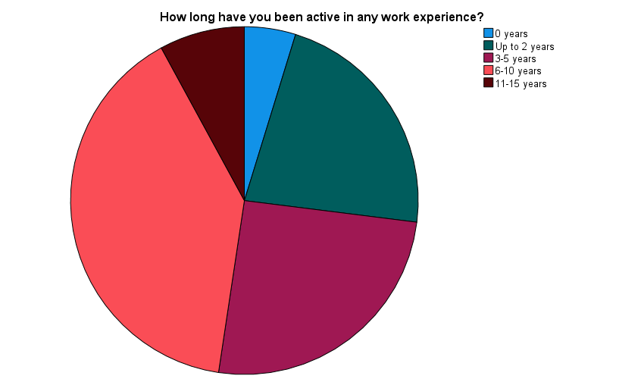

Figure 7: Respondents’ Work Experience

Respondents were asked to rate their annual gross income level based on Ethiopia's average living standard.  The majority, 86 (44 EDC trained and 42 not trained), reported being in the low or medium category, representing 68%, and 30 (10 EDC trained and 20 not trained) stated they were in a very low-income category, representing 24%, whereas 10 (8 EDC trained and two not trained) reported a high or very high-income level representing 8% of the sample. (See Table 14 and Figure 8.)

Table 14.

*Respondents’ Annual Gross Income Level*

|  |  |  |  |
| --- | --- | --- | --- |
| How do you rate your annual gross income level based on the average standard of living in Ethiopia? | | | |
| Income Level | Trained vs. Not Trained | N | % |
| Very low | EDC-Trained | 10 | 23.8% |
| Not-Trained | 20 |
| Low or medium | EDC-Trained | 44 | 68.3% |
| Not-Trained | 42 |
| High | EDC-Trained | 6 | 5.6% |
| Not-Trained | 1 |
| Very high | EDC-Trained | 2 | 2.4% |
| Not-Trained | 1 |

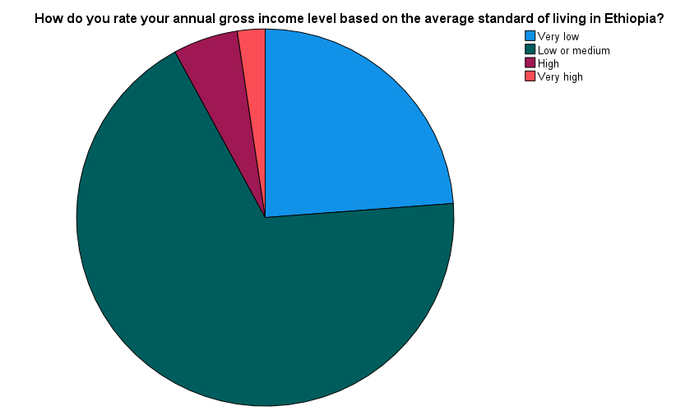

Figure 8: Respondents' Gross Income Level

According to SalaryExplorer.com, Ethiopia’s average monthly salary distribution shows that those who earn 4623 birr/month are in the 25% percentile low salary category. The median salary is 9060 birr/month, which is in the 50% distribution of salary, while those who earn 24,878 are in the 75% percentile, and those who earn 39,721 birr/month are in the maximum salary distribution of all jobs. (See Figure 9.)

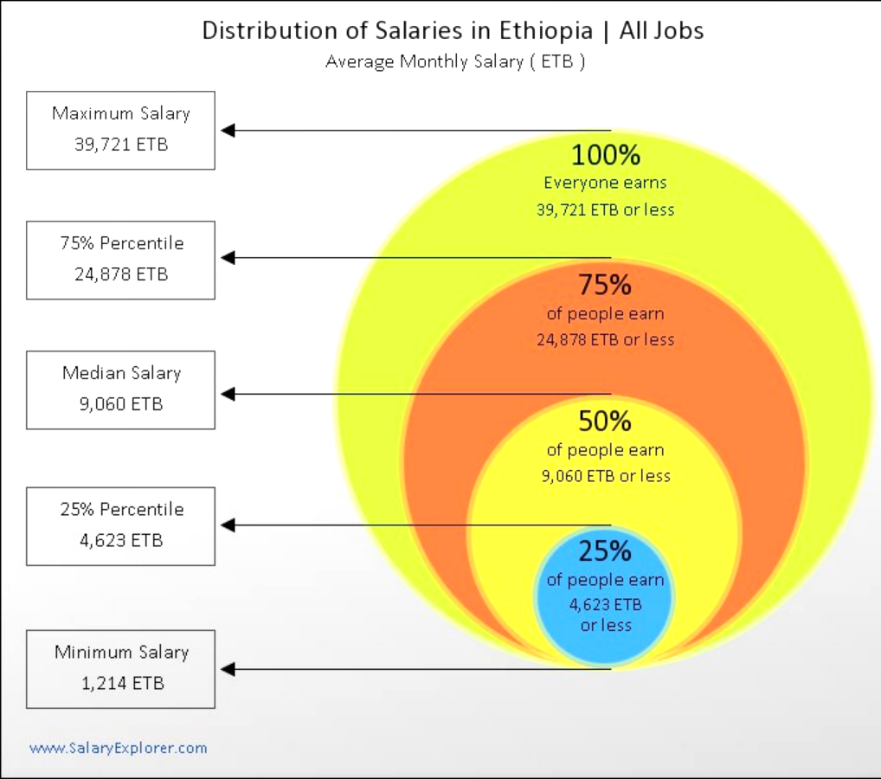

Figure 9: Distribution of Salaries in Ethiopia

Respondents were asked if they had ever received any entrepreneurial education or training.  About half of the study participants, 62 (49%), took the training at an EDC training center, 42 (33%) never had entrepreneurial education or training, 20 (16%) had taken some education in college/university, and 2 (2%) had it in high school. (See Table 15 and Figure 10.)

Table 15.

*Respondents’ Entrepreneurial Education or Training*

|  |  |  |  |
| --- | --- | --- | --- |
| Have you ever received any entrepreneurial education or training? | | | |
| Entrepreneurial Education or Training | Trained vs. Not Trained | N | % |
| No never | EDC-Trained | 0 | 33.3% |
| Not-Trained | 42 |
| Yes, in high school | EDC-Trained | 0 | 1.6% |
| Not-Trained | 2 |
| Yes, in college/university | EDC-Trained | 0 | 15.9% |
| Not-Trained | 20 |
| Yes, at a training center | EDC-Trained | 0 | 49.2% |
| Not-Trained | 62 |

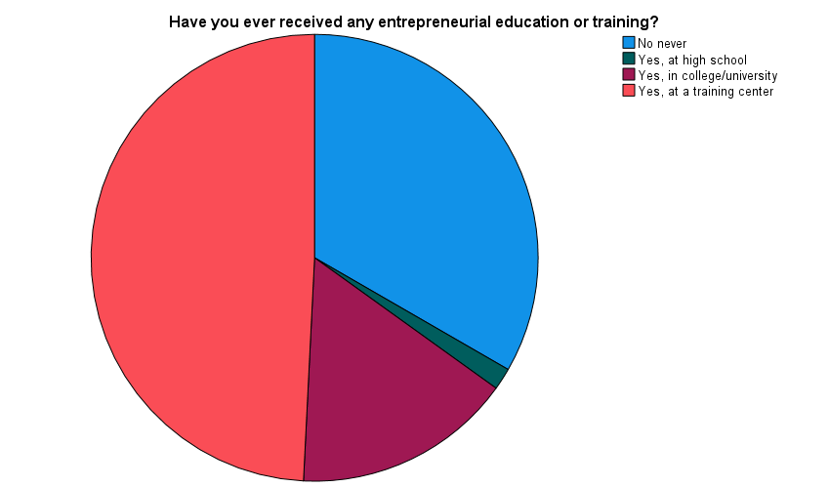

Figure 10: Respondents' Entrepreneurial Training

Respondents who took the EDC entrepreneurial training or had some education in entrepreneurship were asked to assess if the training they had taken resulted in starting or developing their business.  Out of the 126 participants, the majority, 66 (56 EDC trained and ten not trained), responded that they had either started or developed their businesses as a result of training, representing 52 of the sample.  However, 18 (6 EDC trained and 12 not trained), representing 14%, stated that the entrepreneurial training/education they had received did not help them.  Only 42 (33%) had never had training. (See Table 16 and Figure 11.)

Table 16.

*Respondents’ Training Outcome*

|  |  |  |  |
| --- | --- | --- | --- |
| If you have done training, has it helped you to start or develop your business? | | | |
| Outcome of Training | Trained vs. Not Trained | N | % |
| Yes | EDC-Trained | 56 | 52.4% |
| Not-Trained | 10 |
| No | EDC-Trained | 6 | 14.3% |
| Not-Trained | 12 |
| Did not take training | 42 | | 33.3% |

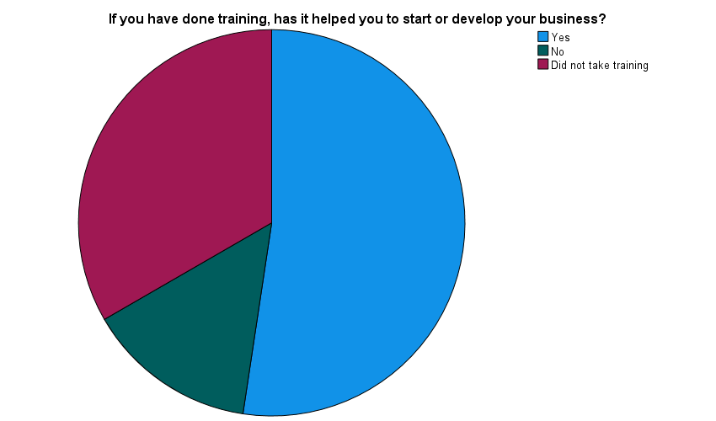

Figure 11: Outcome of Training to Start or Develop a Business

There are two groups for comparison: 62 individuals (49%) who received training at EDI and 64 individuals (51%) who are on the waiting list to be trained. (See Table 17 and Figure 12.)

Table 17.

*EDC-Trained Vs. Not-Trained*

|  |  |  |
| --- | --- | --- |
| EDI Trained on Entrepreneurship Vs. Not-Trained (Waiting List) | | |
|  | N | % |
| Not Trained | 64 | 50.8% |
| EDC Trained | 62 | 49.2% |

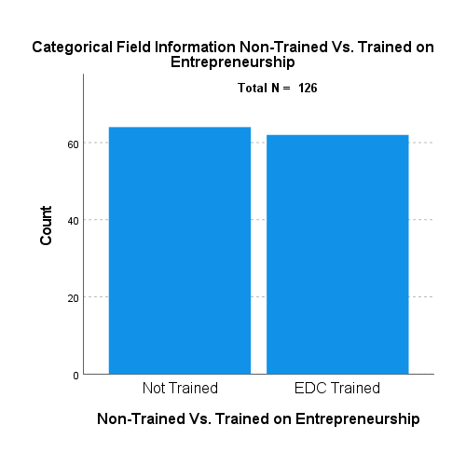

Figure 12: EDC Trained vs. Not Trained

Respondents were asked if they had any entrepreneurs within their close family, such as parents, grandparents, siblings, or relatives.  Sixty-nine (30 EDC trained and 39 not trained) responded that they did not have entrepreneurial family members, representing 55%, and 57 (32 EDC trained and 25 not trained) stated they have entrepreneurial relatives, representing 45% of the sample. (See Table 18 and Figure 13.)

Table 18.

*Presence of Entrepreneur Family Member*

|  |  |  |  |
| --- | --- | --- | --- |
| Is there any entrepreneur within your close family (parents, grandparents, siblings, relatives? | | | |
| Entrepreneur family | Trained vs. Not Trained | N | % |
| Yes | EDC-Trained | 32 | 45.2% |
| Not-Trained | 25 |
| No | EDC-Trained | 30 | 54.8% |
| Not-Trained | 39 |

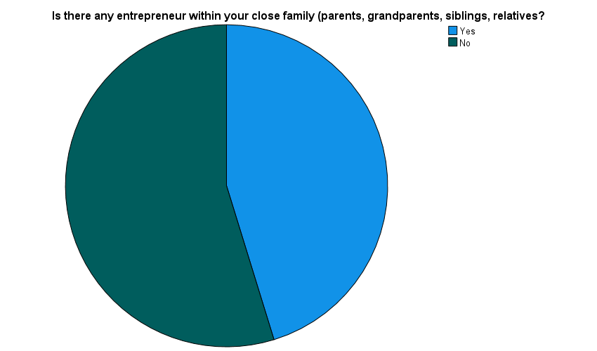

Figure 13: Presence of Entrepreneur in Family

Respondents were asked if they had an entrepreneur in their friends’ circle.  Eighty-seven (48 EDC trained and 39 not trained) responded that they have an entrepreneur friend representing 69%, and 39 (14 EDC trained and 25 not trained) of them stated they do not have representing 31% of the sample. (See Table 19 and Figure 14.)

|  |  |  |  |  |
| --- | --- | --- | --- | --- |
| Table 19.  *Presence of Entrepreneur Friend* | | | | |
| Are some of your friends entrepreneurs? | | | |
| Entrepreneur Friend | Trained vs. Not Trained | N | % |
| Yes | EDC-Trained | 48 | 69.0% |
| Not-Trained | 39 |
| No | EDC-Trained | 14 | 31.0% |
| Not-Trained | 25 |

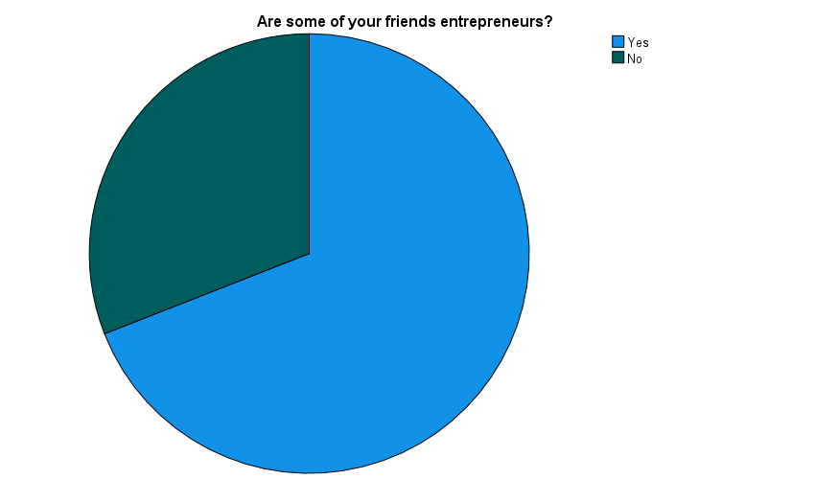

Figure 14: Entrepreneur Friend

Respondents were asked if they believed entrepreneurial training would help the youth start or develop their businesses.  The majority, 121 (62 EDC trained and 59 not trained), believe that training helps to start or develop a business, representing 96%, but 5 (4%) not trained did not believe training would help. (See Table 20 and Figure 15.)

Table 20.

*The belief that Training in Entrepreneurship would help Youth to Start/Develop Business*

|  |  |  |  |
| --- | --- | --- | --- |
| Do you believe entrepreneurial training will help the youth to start or develop their business? | | | |
| Belief in Training for Youth Business | Trained vs. Not Trained | N | % |
| Yes | EDC-Trained | 62 | 96.0% |
| Not-Trained | 59 |
| No | EDC-Trained | 0 | 4.0% |
| Not-Trained | 5 |

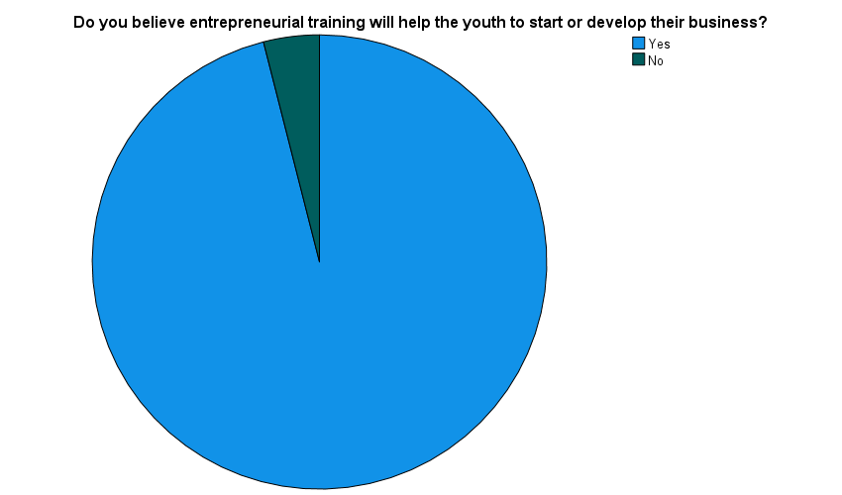

Figure 15: Belief in Training for Youth Business

For the non-trained and trained, Table 21 presents descriptive statistics for the five cognitive process ESE variables. For each indicator, the average total entrepreneurial efficacy score of trained individuals was more significant than that of EDC not-trained individuals. (See Table 21.)

Table 21.

*Respondents’ Description of Non-trained and Trained Statistics*

|  |  |  |  |  |  |
| --- | --- | --- | --- | --- | --- |
| ESE Subscales | Non-Trained Vs. Trained in Entrepreneurship | Cases | | | |
| N | Mean | Median | SD |
| Creativity | Not Trained | 64 | 4.51 | 4.20 | 1.556 |
| EDC Trained | 62 | 5.24 | 5.50 | 1.376 |
| Planning | Not Trained | 64 | 4.48 | 4.67 | 1.610 |
| EDC Trained | 62 | 5.41 | 6.00 | 1.395 |
| Marshaling | Not Trained | 64 | 4.82 | 5.00 | 1.646 |
| EDC Trained | 62 | 5.57 | 6.00 | 1.365 |
| Managing Ambiguity | Not Trained | 64 | 4.47 | 4.30 | 1.608 |
| EDC Trained | 62 | 5.25 | 5.60 | 1.271 |
| Financial  Literacy | Not Trained | 64 | 4.23 | 3.75 | 1.658 |
| EDC Trained | 62 | 5.57 | 5.88 | 1.068 |

**Null Hypotheses Analysis**

H0: No statistically significant difference exists in entrepreneurial readiness to start or develop a business based on entrepreneurial self-efficacy between those who received entrepreneurship training and those who did not.

A Mann-Whitney U Test was applied to determine if there was a statistically significant difference in the entrepreneurial readiness to start or develop a business based on entrepreneurial self-efficacy between those who received entrepreneurship training and those who did not. The null hypothesis was not accepted. A statistically significant difference (U = 1240, p = 0.000) exists in total entrepreneurial self-efficacy scale values among respondents in different trained and not-trained categories. (See Tables 22.)

Table 22.

*ESE Hypothesis Test*

|  |  |
| --- | --- |
| Mann-Whitney U | 1240.500 |
| Wilcoxon W | 3320.500 |
| Z | -3.629 |
| Asymp. Sig. (2-tailed) | .000 |

a. Grouping Variable: Non-Trained Vs. Trained in Entrepreneurship

The mean rank for respondents in the not-trained category was 51.88, and for respondents in the EDC trained category, it was 75.49. (See Table 23.)

Table 23.

*ESE Mean Rank in Not Trained and EDC Trained on Entrepreneurship*

|  |  |  |  |  |
| --- | --- | --- | --- | --- |
| Not-Trained Vs. Trained on Entrepreneurship | | N | Mean Rank | Sum of Ranks |
| ESE | Not Trained | 64 | 51.88 | 3320.50 |
| EDC Trained | 62 | 75.49 | 4680.50 |
| Total | 126 |  |  |

The hypothesis testing at the ESE subscales level also shows similar results in the five subscales.  The distribution of creativity in entrepreneurial self-efficacy is the same across categories of not-trained and trained in entrepreneurship to start or develop a business is not accepted (U = 1424, p = 0.006).  The distribution of planning in entrepreneurial self-efficacy is the same across categories of not-trained and trained in entrepreneurship to start or develop a business is not accepted (U = 1325, p = 0.001).  The distribution of marshaling in entrepreneurial self-efficacy is the same across categories of not-trained and trained in entrepreneurship to start or develop a business is not accepted (U = 1473, p = 0.012). The distribution of managing ambiguity in entrepreneurial self-efficacy is the same across categories of not-trained and trained in entrepreneurship to start or develop a business is not accepted (U = 1431, p = 0.007).   The distribution of financial literacy in entrepreneurial self-efficacy is the same across categories of not-trained and trained in entrepreneurship to start or develop a business is not accepted (U = 1067, p = 0.000).  A statistically significant difference exists in creativity, planning, marshaling, managing ambiguity, and financial literacy of entrepreneurial self-efficacy scale values among respondents in different trained and not-trained categories. (See Tables 24 and 25.)

Table 24.

*Mann Whitney U Test Hypothesis Test Summary*

|  |  |  |  |  |
| --- | --- | --- | --- | --- |
|  | Null Hypothesis | Test | Sig. a,b | Decision |
| 1 | The distribution of Creativity is the same across categories of Not-Trained Vs. Trained in Entrepreneurship. | Independent-Samples Mann-Whitney U Test | .006 | Reject the null hypothesis. |
| 2 | The distribution of Planning is the same across categories of Not-Trained Vs. Trained in Entrepreneurship. | Independent-Samples Mann-Whitney U Test | .001 | Reject the null hypothesis. |
| 3 | The distribution of Marshaling is the same across categories of Not-Trained Vs. Trained in Entrepreneurship. | Independent-Samples Mann-Whitney U Test | .012 | Reject the null hypothesis. |

|  |  |  |  |  |
| --- | --- | --- | --- | --- |
|  | Null Hypothesis | Test | Sig. a,b | Decision |
| 4 | The distribution of Managing Ambiguity is the same across categories of Not-Trained Vs. Trained in Entrepreneurship. | Independent-Samples Mann-Whitney U Test | .007 | Reject the null hypothesis. |
| 5 | The distribution of Financial Literacy is the same across categories of Not-Trained Vs. Trained in Entrepreneurship. | Independent-Samples Mann-Whitney U Test | .000 | Reject the null hypothesis. |
| a. The significance level is .050. | | | | |
| b. Asymptotic significance is displayed. | | | | |

Table 25.

*Mann-Whitney Test Statistics of ESE Sub Scales between Respondents*

|  |  |  |  |  |  |
| --- | --- | --- | --- | --- | --- |
| Test Stat of ESE | Creativity ESE | Planning ESE | Marshaling ESE | Managing Ambiguity  ESE | Financial Literacy ESE |
| Mann-Whitney U | 1424.000 | 1325.500 | 1473.000 | 1431.000 | 1067.500 |
| Wilcoxon W | 3504.000 | 3405.500 | 3553.000 | 3511.000 | 3147.500 |
| Z | -2.736 | -3.226 | -2.504 | -2.702 | -4.482 |
| Asymp. Sig. (2-tailed) | .006 | .001 | .012 | .007 | .000 |
| a. Grouping Variable: Non-Trained Vs. Trained in Entrepreneurship | | | | | |

The mean rank for respondents in the ESE creativity subscale of the not-trained category was 54.75, and for respondents in the EDC trained category was 72.53; the ESE planning subscale of the not-trained category was 53.21, and for respondents in the EDC trained category was 74.12; the ESE marshaling subscale of the not-trained category was 55.52 and for respondents in the EDC trained category was 71.74; the ESE managing ambiguity subscale of the not-trained category was 54.86, and for respondents in the EDC trained category was 72.42; the ESE financial literacy subscale of the not-trained category was 49.18, and for respondents in the EDC trained category was 78.28. (See Table 26.)

Table 26.

*Mann-Whitney Test of the ESE Mean Ranks between the groups that are Not-Trained or Trained in Entrepreneurship*

|  |  |  |  |  |
| --- | --- | --- | --- | --- |
| ESE Subscale | Not-Trained Vs. Trained in Entrepreneurship | N | Mean Rank | Sum of Ranks |
| Creativity | Not Trained | 64 | 54.75 | 3504.00 |
| EDC Trained | 62 | 72.53 | 4497.00 |
| Total | 126 |  |  |
| Planning | Not Trained | 64 | 53.21 | 3405.50 |
| EDC Trained | 62 | 74.12 | 4595.50 |
| Total | 126 |  |  |
| Marshaling | Not Trained | 64 | 55.52 | 3553.00 |
| EDC Trained | 62 | 71.74 | 4448.00 |
| Total | 126 |  |  |
| Managing Ambiguity | Not Trained | 64 | 54.86 | 3511.00 |
| EDC Trained | 62 | 72.42 | 4490.00 |
| Total | 126 |  |  |
| Financial  Literacy | Not Trained | 64 | 49.18 | 3147.50 |
| EDC Trained | 62 | 78.28 | 4853.50 |
| Total | 126 |  |  |

The creativity ESE subscale shows a statistically significant difference between EDC-trained and the not-trained groups (u =2544; *p =* 0.006) in creativity to start and develop a business. (See Table 27 and Figure 16.)

Table 27.

*Creativity ESE Subscale Across Non-Trained Vs. Trained in Entrepreneurship*

|  |  |
| --- | --- |
| Independent-Samples Mann-Whitney U Test Summary of Creativity ESE Subscale | |
| Total N | 126 |
| Mann-Whitney U | 2544.000 |
| Wilcoxon W | 4497.000 |
| Test Statistic | 2544.000 |
| Standard Error | 204.649 |
| Standardized Test Statistic | 2.736 |
| Asymptotic Sig. (2-sided test) | .006 |

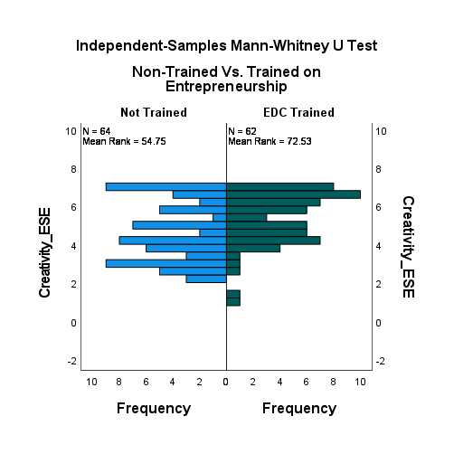

Figure 16: Creativity ESE Sub Scale

The planning ESE subscale shows a statistically significant difference between the EDC-trained and the not-trained groups (u =2642; *p =*0.001) in planning to start and develop a business. (See Table 28 and Figure 17)

Table 28.

*Planning ESE Subscale Across Not-Trained Vs. Trained in Entrepreneurship*

|  |  |
| --- | --- |
| Independent-Samples Mann-Whitney U Test Summary of Planning ESE Subscale | |
| Total N | 126 |
| Mann-Whitney U | 2642.500 |
| Wilcoxon W | 4595.500 |
| Test Statistic | 2642.500 |
| Standard Error | 204.113 |
| Standardized Test Statistic | 3.226 |
| Asymptotic Sig. (2-sided test) | .001 |

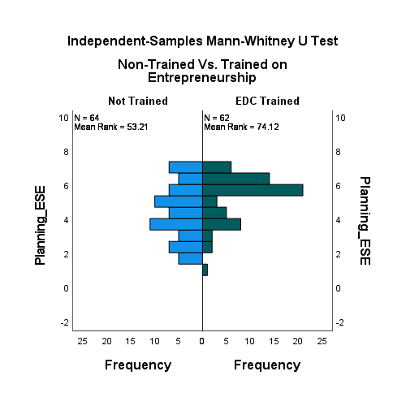

Figure 17: Planning ESE Subscale

The marshaling ESE subscale shows a statistically significant difference between the EDC-trained and the not-trained groups (u =2495; *p* = 0.012) in marshaling resources to start and develop a business. (See Table 29 and Figure 18.)

Table 29.

*Marshaling ESE Subscale Across Not-Trained Vs. Trained in Entrepreneurship*

|  |  |
| --- | --- |
| Independent-Samples Mann-Whitney U Test Summary of Marshaling ESE Subscale | |
| Total N | 126 |
| Mann-Whitney U | 2495.000 |
| Wilcoxon W | 4448.000 |
| Test Statistic | 2495.000 |
| Standard Error | 204.043 |
| Standardized Test Statistic | 2.504 |
| Asymptotic Sig. (2-sided test) | .012 |

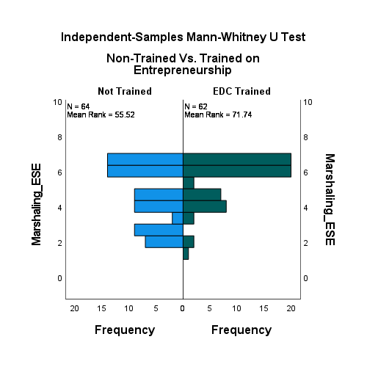

Figure 18: Marshaling ESE Subscale

The managing ambiguity ESE subscale shows a statistically significant difference between the EDC-trained and the not-trained groups (u =2537; *p=* 0.007) in managing change and uncertainty to start and develop a business. (See Table 30 and Figure 19).

Table 30.

*Managing Ambiguity ESE Subscale Across Non-Trained Vs. Trained in Entrepreneurship*

|  |  |
| --- | --- |
| Independent-Samples Mann-Whitney U Test Summary of Managing Ambiguity ESE Subscale | |
| Total N | 126 |
| Mann-Whitney U | 2537.000 |
| Wilcoxon W | 4490.000 |
| Test Statistic | 2537.000 |
| Standard Error | 204.637 |
| Standardized Test Statistic | 2.702 |
| Asymptotic Sig. (2-sided test) | .007 |

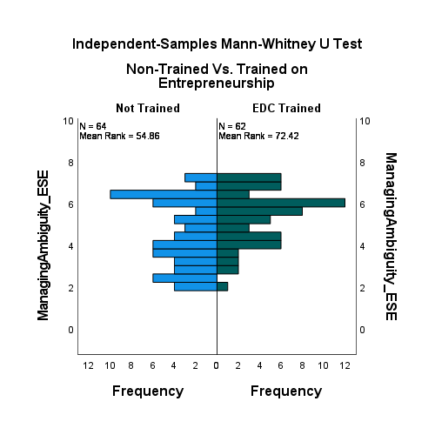

Figure 19: Managing Ambiguity ESE Subscale

The financial literacy ESE subscale shows a statistically significant difference between the EDC-trained and the not-trained groups (u =2900; *p=* 0.000) in having financial literacy to start and develop a business. (See Table 31 and Figure 20)

Table 31.

*Financial Literacy ESE Subscale Across Non-Trained Vs. Trained in Entrepreneurship*

|  |  |
| --- | --- |
| Independent-Samples Mann-Whitney U Test Summary of Financial Literacy ESE Subscale | |
| Total N | 126 |
| Mann-Whitney U | 2900.500 |
| Wilcoxon W | 4853.500 |
| Test Statistic | 2900.500 |
| Standard Error | 204.489 |
| Standardized Test Statistic | 4.482 |
| Asymptotic Sig. (2-sided test) | .000 |

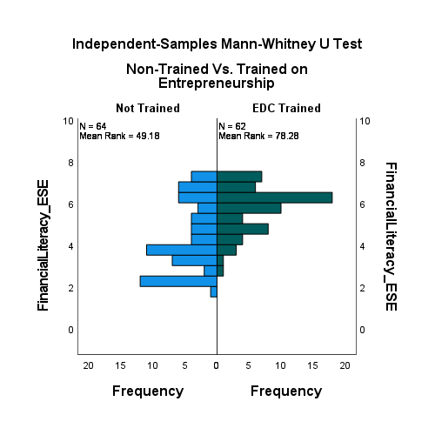

Figure 20: Financial Literacy ESE Subscale

**Moderating Variable**

The entrepreneurship training was used to moderate youth entrepreneurial readiness.  Out of the 84 participants who had some training or education in entrepreneurship, 66 (79%) responded that they had either started or developed their business, whereas 18 (14%) stated that the training/education in entrepreneurship did not help them. See Table 32 and Figure 21.

Table 32.

*Respondent’s Training Outcome*

|  |  |  |
| --- | --- | --- |
| If you have done training, has it helped you to start or develop your business? | | |
|  | N | % |
| Yes | 66 | 78.6% |
| No | 18 | 21.4% |

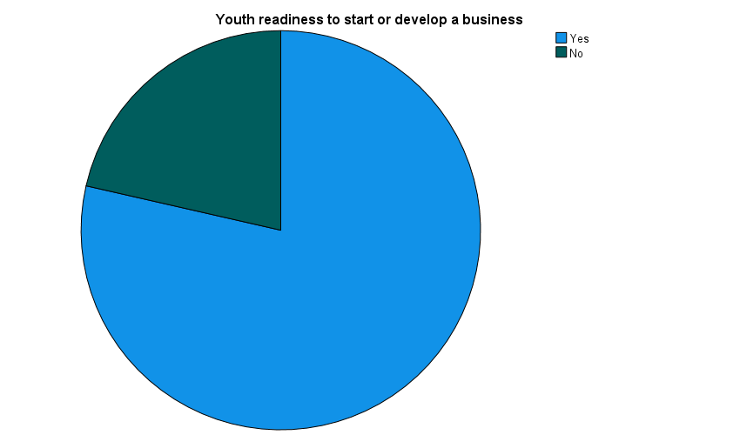

Figure 21: Training Outcome of Readiness to Start/Develop a Business

The readiness mean scores of the 84 entrepreneurship-trained participants show above-average mean value in all the ESE subscales: creativity (=5.3), planning (=5.34), marshaling (=5.54), managing ambiguity (=5.2), and financial literacy (μ=5.4). (See Table 33.)

Table 33.

*Respondent’s Readiness Statistics*

|  |  |  |  |  |  |  |
| --- | --- | --- | --- | --- | --- | --- |
| Readiness Stat | | Creativity ESE scale | Planning ESE scale | Marshaling ESE scale | Managing Ambiguity ESE scale | Financial Literacy ESE scale |
| N | Valid | 84 | 84 | 84 | 84 | 84 |
| Missing | 0 | 0 | 0 | 0 | 0 |
| Mean | | 5.30 | 5.34 | 5.54 | 5.1952 | 5.3958 |
| Std. Deviation | | 1.339 | 1.422 | 1.350 | 1.31789 | 1.24681 |
| Minimum | | 1 | 1 | 1 | 2 | 2 |
| Maximum | | 7 | 7 | 7 | 7 | 7 |
| Sum | | 445 | 448 | 466 | 436.40 | 453.25 |

In addition, the non-parametric Mann-Whitney U test shows a statistically significant difference (U = 289, p = -0.169) in the belief in entrepreneurial training for youth to start or develop their business values among respondents in different trained and not-trained categories.

Table 34.

Result of Belief if Entrepreneurial Training Result in Business Creation/Development

|  |  |
| --- | --- |
| a. Grouping Variable: Do you believe entrepreneurial training will help the youth to start or develop their business? | |
|  | ESE: Dependent Variable |
| Mann-Whitney U | 289.000 |
| Wilcoxon W | 7670.000 |
| Z | -.169 |
| Asymp. Sig. (2-tailed) | .866 |

Additional moderating test was conducted if there is a difference in youth entrepreneurial readiness between entrepreneurial trained individuals to start and develop their business. Table 35 shows there is a significant difference among the ones that reported training helped them to start or develop their business from those who claimed training did not make a difference.

Table 35.

Training Moderation Test

|  |  |  |  |  |  |  |  |  |
| --- | --- | --- | --- | --- | --- | --- | --- | --- |
| Moderating Test: Do you believe entrepreneurial training will help the youth to start or develop their business? | | | | | | | | |
|  | | Estimate | Std. Error | Wald | df | Sig. | 95% Confidence Interval | |
| Lower Bound | Upper Bound |
|  | Readiness to start or develop a business | -.985 | .281 | 12.297 | 1 | .000 | -1.536 | -.435 |
| EDC_non-trained_trained =1] | .084 | .488 | .030 | 1 | .863 | -.872 | 1.040 |
| EDC_non-trained_trained=2] | 0a | . | . | 0 | . | . | . |
| Link function: Logit. | | | | | | | | |
| a. This parameter is set to zero because it is redundant. | | | | | | | | |

**Summary**

Quantitative research was used to describe the socio-demography of research participants and to investigate whether there is a significant difference between youth readiness to start or develop a business based on the entrepreneurial self-efficacy of those who have taken EDI entrepreneurship training and those who have not. The study used a non-experimental research design, non-parametric data, and the Mann-Whitney U Test to examine the difference between the two groups.   The null hypothesis was tested, and the assumption that no statistically significant difference exists in entrepreneurial readiness to start or develop a business based on entrepreneurial self-efficacy between those who received entrepreneurship training and those who did not was not accepted.  In addition, the training outcome of those trained was assessed if training resulted in either starting or developing their business, and results show readiness exists in those trained. Therefore, the answer to the research question is that a difference does exist in youth entrepreneurial readiness based on entrepreneurial self-efficacy related to EDI entrepreneurship training.