Appendices

Seble Hailu Diglu

Omega Graduate School

SR 912-78: Dissertation Writing Publication (Fall 2023)

**Title of Appendix**

Appendix A: Socio-demographic and Entrepreneurial Self-Efficacy Measurement Tool

Appendix B: Site Permission Letter

Appendix C: Recruitment Letter

Appendix D: Consent Form

Appendix E: Permission to Use Entrepreneurial-Self Efficacy Tool

Appendix F: Human Research Protection Foundational Training Certificate

Appendix G: Curriculum Vitae

Appendix A: Socio-demographic and Entrepreneurial Self-Efficacy Measurement Tool

**THE QUESTIONNAIRE**

**Section 1: Socio-Demographic Items**

|  |
| --- |
| **S1. Gender**  S1.1. Man 🗖  S1.2. Woman 🗖 |
| **S2. Age group**  S2.1. 18-25 years 🗖  S2.2. 26-35 years 🗖 |
| **S3. Level of education**  S3.1. Primary 🗖  S3.2. Secondary 🗖  S3.3. Vocational 🗖  S3.4. College/University 🗖  S3.5. Postgraduate 🗖 |
| **S4. How long have you been active in any work experience?**  S4.1. 0 years 🗖  S4.2. Up to 2 years 🗖  S4.3. 3-5 years 🗖  S4.4. 6-10 years 🗖  S4.5. 11-15 years 🗖  S4.6. 16-20 years 🗖  S4.7. 21 and + years 🗖 |
| **S5. How do you rate your annual gross income level based on the average standard of living in Ethiopia?**  S5.1. Very low 🗖  S5.2. Low or medium 🗖  S5.3. High 🗖  S5.4. Very high 🗖 |
| **S6. Have you ever received any entrepreneurial education or training?**  S6.1. No never 🗖  S6.2. Yes, at high school 🗖  S6.3. Yes, in college/university 🗖  S6.4. Yes, at a training center 🗖 |
| **S7. If you have done training, has it helped you to start or develop your business?**  S7.1. Yes 🗖  S7.2. No 🗖  S7.3. Did not take training 🗖 |
| **S8. Is there any entrepreneur within your close family (parents, grandparents, siblings, relatives?**  S8.1. Yes 🗖  S8.2. No 🗖 |
| **S9. Are some of your friends’ entrepreneurs?**  S9.1. Yes 🗖  S9.2. No 🗖 |
| **S10. Do you believe entrepreneurial training will help the youth to start or develop their business?**  S10.1. Yes 🗖  S10.2. No 🗖 |

**Section 2: Entrepreneurial Self-Efficacy Scale (ESE)**

|  |  |  |  |  |  |  |  |  |  |
| --- | --- | --- | --- | --- | --- | --- | --- | --- | --- |
| **Ser. No.** | | **Items** | Not very confident | Below average confident | Slightly below average confident | Average confident | Slightly above average confident | Above average confident | Very confident |
| **I have confidence in my ability to . . .** | | | | | | | | | |
| **Creativity** | | |  |  |  |  |  |  |  |
| **ESE1** | | Identify ways to combine resources in new ways |  |  |  |  |  |  |  |
| **ESE2** | | Brainstorm (come up with) new ideas |  |  |  |  |  |  |  |
| **ESE3** | | Think outside the box |  |  |  |  |  |  |  |
| **ESE4** | | Identify opportunities for new ways to conduct activities |  |  |  |  |  |  |  |
| **ESE5** | | Identify creative ways to get things done with limited resources |  |  |  |  |  |  |  |
| **Planning** | | |  |  |  |  |  |  |  |
| **ESE6** | | Manage time in projects |  |  |  |  |  |  |  |
| **ESE7** | | Set and achieve project goals |  |  |  |  |  |  |  |
| **ESE8** | | Design an effective project plan to achieve goals |  |  |  |  |  |  |  |
| **Marshaling** | | |  |  |  |  |  |  |  |
| **ESE9** | | Put together the right group/team in order to solve a specific problem |  |  |  |  |  |  |  |
| **ESE10** | | Form partnerships in order to achieve goals |  |  |  |  |  |  |  |
| **ESE11** | | Network (i.e. make contact with and exchange information with others) |  |  |  |  |  |  |  |
| **Managing Ambiguity** | | |  |  |  |  |  |  |  |
| **ESE12** | | Improvise when I do not know what the right action/decision might be in a problematic situation |  |  |  |  |  |  |  |
| **ESE13** | | Tolerate unexpected change |  |  |  |  |  |  |  |
| **ESE14** | | Persist in the face of setbacks |  |  |  |  |  |  |  |
| **ESE15** | | Manage uncertainty in projects and processes |  |  |  |  |  |  |  |
| **Ser. No.** | **Items** | | Not very confident | Below average confident | Slightly below average confident | Average confident | Slightly above average confident | Above average confident | Very confident |
| **I have confidence in my ability to . . .** | | | | | | | | | |
| **ESE16** | | Work productively under continuous stress, pressure and conflict |  |  |  |  |  |  |  |
| **Financial Literacy** | | |  |  |  |  |  |  |  |
| **ESE17** | | Read and interpret financial statements |  |  |  |  |  |  |  |
| **ESE18** | | Persist in the face of setbacks |  |  |  |  |  |  |  |
| **ESE19** | | Control costs for projects |  |  |  |  |  |  |  |
| **ESE20** | | Estimate a budget for a new project |  |  |  |  |  |  |  |

Appendix B: Site Permission Letter

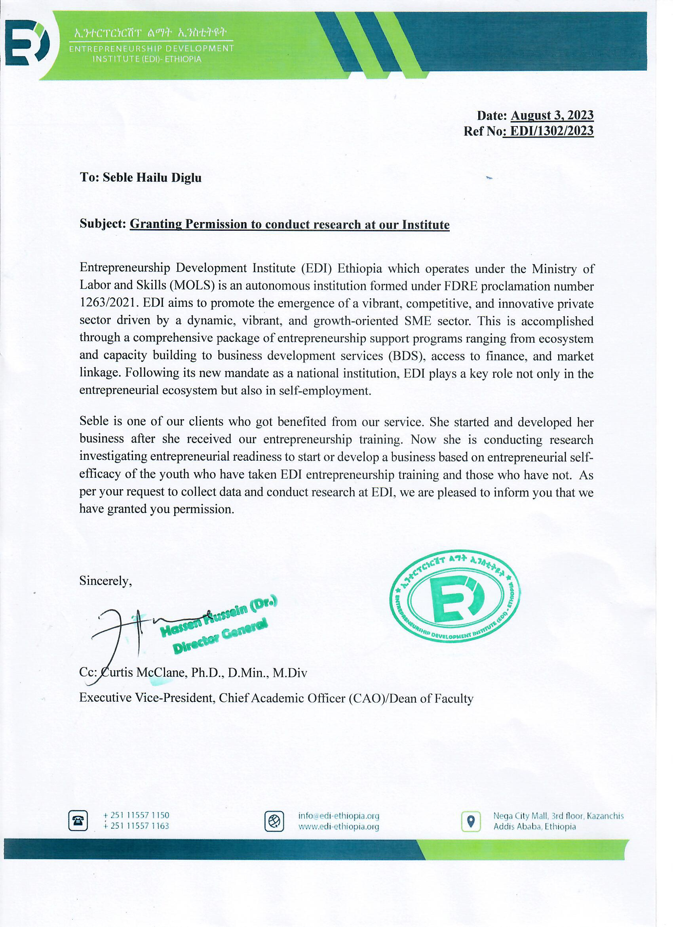

Appendix C: Recruitment Letter

You are invited to participate in a research project by Seble Hailu Diglu at Entrepreneurship Development Institute entitled: Youth Entrepreneurial Readiness: Entrepreneurial Self-Efficacy and the Moderating Role of Entrepreneurial Training. I am currently enrolled in the Doctoral Program at The Omega Graduate School, Dayton, Tennessee, and in the process of writing my dissertation.

The purpose of the research is to determine if youth entrepreneurial readiness derives from entrepreneurial self-efficacy as moderated by entrepreneurial training conducted by EDI. The enclosed questionnaire has been designed to collect information in socio-demographic areas and entrepreneurial self-efficacy.

There is no particular benefit to you if you participate, but the researcher may get information that can help advocate for scaling up training interventions for youth and young adults to start or develop their businesses. The major risk to you is the inconvenience of having to take the time to fill out the survey for a maximum of 15 minutes. Your participation in this research project entirely voluntary. You may decline altogether or leave to submit your answers at the end.

There are no known risks to participation beyond those encountered in everyday life. Your responses will remain confidential and anonymous. Data from this research will be kept secure and reported only as a collective combined total. All responses are anonymous; no one will know your answers to this questionnaire. If you agree to participate in this project, please answer the questions on the questionnaire as best as you can. It should take a maximum of 15 minutes to complete. The survey will be administered through the link below on Survey Monkey. Upon submission of the survey, you won’t need to do anything else.

If you have any questions about this project, please contact Dr. Curtis McClane, cmcclane@ogs.edu, Dissertation Chair and Academic Dean. Information on the rights of human subjects in research is available through the Omega Graduate School Institutional Review Board 1 307 871-4569, irb@ogs.edu.

Appendix D: Consent Form

**TITLE OF STUDY**

Youth Entrepreneurial Readiness: Entrepreneurial Self-efficacy and the Moderating Role of Entrepreneurial Training

**RESEARCHERS**

Seble Hailu Diglu, Doctoral Candidate and Lead Researcher/Primary Investigator (PI), Omega Graduate School, +(251) 911 606055, [seble.hailu@gmail.com](mailto:seble.hailu@gmail.com); Dr. Curtis McClane, Chief Academic Officer, Academic Dean, and Committee Chair, Omega Graduate School and contact person for subjects +(1) 423-775-6599; Dr. Joshua Reichard (president@ogs.edu) faculty advisor, Dr. Sean Taladay (sean.taladay1@gmail.com), faculty advisor, and Dr. Worku Tuffa Birru (workutuffa@aau.edu.et), Content Advisor.

**RESEARCHERS’ STATEMENT**

We are asking you to be in a research study. This consent form gives you the information you will need to help you decide whether to be in the study. The purpose of the research, what we would ask you to do, the possible risks and benefits, and your rights as a volunteer are stated in the Form. This process is called “informed consent.” Before you decide to participate in this study, it is essential that you understand why the research is being done and what it will involve. Please read the following information carefully.

**RESEARCH PARTICIPANT RECRUITMENT**

The target population for this study is 127 individuals who took EDI training from January to March 2023 in Addis Ababa. Out of these, 75 were aged 18-35. Conducive sampling will ensure eligible participants meet the inclusion criteria to select between ages 18 and 35 until a sample size of 63 is attained. To participate, you must be between ages 18 and 35 when you took the training at Entrepreneurship Development Institute.

**PURPOSE OF STUDY**  
  
This study investigates the difference between entrepreneurial readiness to start or develop a business based on entrepreneurial self-efficacy of the youth who have taken EDI entrepreneurship training and those who have not to determine if there is a significant difference in entrepreneurial readiness among youth in Addis Ababa, Ethiopia. Participation in this study will help to demonstrate whether the training moderates entrepreneurial readiness for new venture creation or business development. Study results will be used to inform the Country better about the need to develop more awareness of the youth to engage in entrepreneurship as a potential career choice and help them be active in the economic development of Ethiopia. This will also help to scale up the training activities to meet the entrepreneurial needs of the Country. Your participation in the research is voluntary, anonymous, and confidential, and there is no right or wrong answer. If anything is unclear or you need more information, please contact the Researcher at the address above.

**STUDY PROCEDURES**  
The entrepreneurial readiness questionnaire consists of two sections: ten socio-demographic questions and 20 entrepreneurial self-efficacy questions. It will take 15 minutes to fill in. The research data will be collected within two weeks.

All responses are identified only by a number and associated with you only by a unique code associated with your record. The data is used for academic purposes, research, and potential funding for future projects to improve entrepreneurial training and startup businesses. The completed questionnaires will be secured for at least three years.

**RISKS**  
There will not be any harm to those who will respond to the questionnaire. The person who fills out the questionnaire will not write his/her name. The information filled in the questionnaire will be used for research purposes. The research does not involve any vulnerable groups.  
  
**BENEFITS**

There will be no direct benefit to you for your participation in this study. However, we hope that the information obtained from this study may benefit from assessing Ethiopia’s efforts to meet the sustainable goal by 2030 by identifying how the youth and young adults are contributing to the economic development efforts of the Country.

**CONFIDENTIALITY**

Your responses to this survey will be anonymous. Please do not write any identifying information on your questionnaire. Every effort will be made by the researcher to preserve your confidentiality for participating in the research.

Data collected in this research will be provided to a personal repository for future use by other researchers. This data will not contain information that could directly identify you.

**CONTACT INFORMATION**   
  
If you have questions at any time about this study, or you experience adverse effects as a result of participating in this study, you may contact the researcher whose contact information is provided on the first page. If you have questions regarding your rights as a research participant, or if problems arise, which you do not feel you can discuss with the Primary Investigator, please contact one of the Institutional Review Board members at + 1 307 871-4569. If you have questions about your rights as a research subject, you can call the Human Subjects Division at + 1 206 543-0098.

**VOLUNTARY PARTICIPATION**  
  
Your participation in this study is voluntary. It is up to you to decide whether to participate in this study. If you decide to take part in this study, you will be asked to sign a consent form. After you sign the consent form, you can withdraw anytime without giving a reason. Withdrawing from this study will not affect your relationship with the Researcher, if any. If you withdraw from the study at any time of data collection, your data will age.

**SUBJECT’S STATEMENT**

I understand the purpose of the research and volunteered to take part in this research. If I have questions later about the research I can contact one of the researchers listed on the first page of this consent form. If I have been harmed by participating in this study, I can report to OGS internal review board. If I have questions about my rights as a research subject, I can call the Human Subjects Division at (+206) 543-0098.

I have received an electronic copy of this consent form.

The printed name of the Subject Signature of the Subject Date

The printed name of the Researcher (PI) Signature of the Researcher (PI) Date

Appendix E: Permission to Use Entrepreneurial-Self Efficacy Tool

Request Permission to Use Validated Instrument of ESE

|  |  |  |  |  |  |
| --- | --- | --- | --- | --- | --- |
| |  | | --- | | Seble Hailu <seble.hailu@gmail.com> | | Tue, Jun 13, 7:48 AM | |  | https://mail.google.com/mail/u/0/images/cleardot.gif  https://mail.google.com/mail/u/0/images/cleardot.gif |
| to Kåre Moberg <Kaare@ffefonden.dk> | |
|  | | | |

Dear Dr. Moberg,

I am Seble Hailu Diglu, a doctoral candidate at Omega/Oxford Graduate School, living in Ethiopia.

I wanted to use an updated version, validated, and reliable instrument on the "Entrepreneurial Self-Efficacy" Tool.    
  
I need to get permission from authors/publishers to use the tool, so this is to request you to allow me to use the tool for my dissertation, entitled, "YOUTH ENTREPRENEURIAL READINESS: THE ROLE OF SELF-EFFICACY, ENTREPRENEURIAL SELF-EFFICACY AND ENTREPRENEURIAL TRAINING."  
  
I appreciate your support!  
Seble

|  |  |  |  |  |
| --- | --- | --- | --- | --- |
| |  | | --- | | Kåre Moberg <Kaare@ffefonden.dk> | | Jun 13, 2023, 9:36 AM |  | https://mail.google.com/mail/u/0/images/cleardot.gif  https://mail.google.com/mail/u/0/images/cleardot.gif |
| |  | | --- | | to mehttps://mail.google.com/mail/u/0/images/cleardot.gif | | | |

Dear Seble,

I am happy to hear that you are interested in my research. You are hereby granted permission to use the scale I have developed that you refer to in this email.

Wishing you good luck with your research!

//Kåre

|  |  |  |  |  |
| --- | --- | --- | --- | --- |
| |  | | --- | | Seble Hailu <seble.hailu@gmail.com> | | Jul 4, 2023, 9:13 AM |  | https://mail.google.com/mail/u/0/images/cleardot.gif  https://mail.google.com/mail/u/0/images/cleardot.gif |
| |  | | --- | | to Kåre Moberghttps://mail.google.com/mail/u/0/images/cleardot.gif | | | |

Dear Dr. Moberg,

Greetings from Ethiopia!  Hope you are doing well.

I need help.  I was asked by my dissertation committee to provide proof of using a validated instrument.  Where can I find the proof for ESE?

Best regards,

Seble

|  |  |  |  |  |
| --- | --- | --- | --- | --- |
| |  | | --- | | Kåre Moberg | | Jul 17, 2023, 12:39 PM |  | https://mail.google.com/mail/u/0/images/cleardot.gif  https://mail.google.com/mail/u/0/images/cleardot.gif |
| |  | | --- | | to me | | | |

Dear Seble,

 You find the paper here: <https://www.researchgate.net/publication/255856876_An_Entrepreneurial_Self-Efficacy_Scale_with_a_Neutral_Wording>

You could also refer to my [dissertation](https://www.researchgate.net/publication/340162116_Assessing_the_Impact_of_Entrepreneurship_Education_-_From_ABC_to_PhD) or the [ASTEE project](https://www.researchgate.net/publication/339617268_How_to_assess_and_evaluate_the_influence_of_entrepreneurship_education), where it is used, but in a slightly adjusted version.

Appendix F: Human Research Protection Foundational Training Certificate

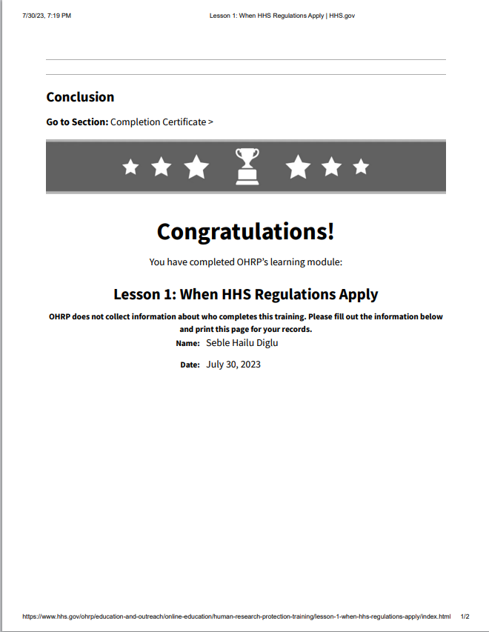

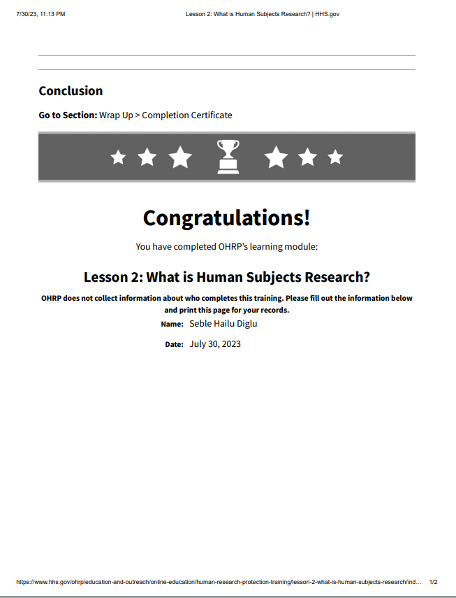

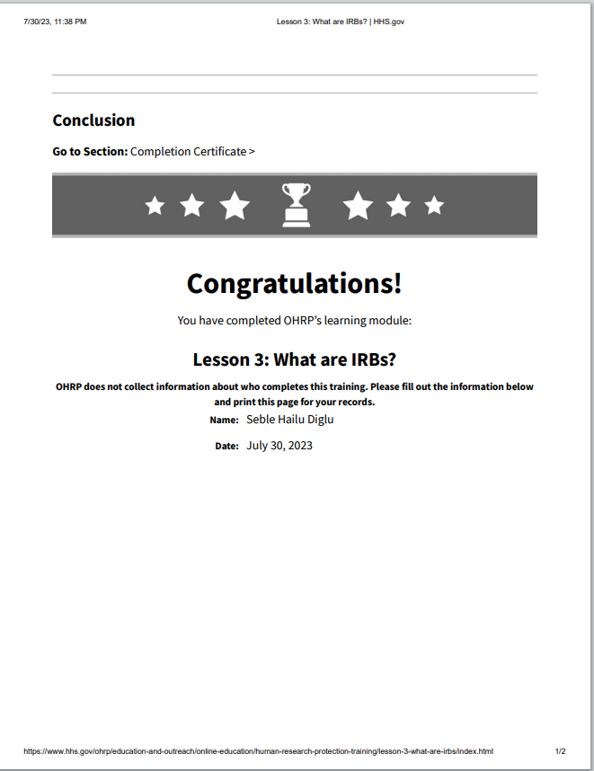

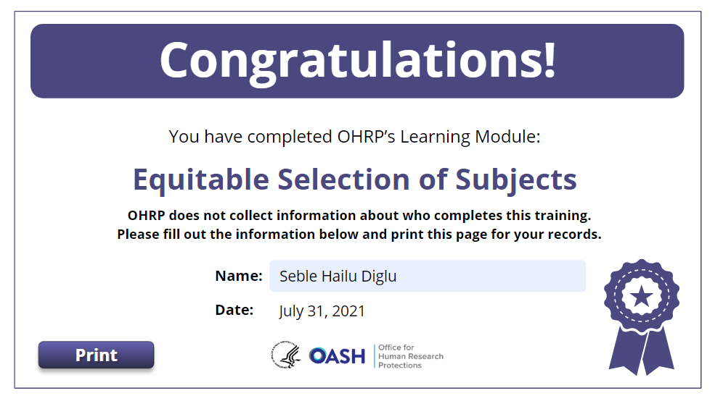

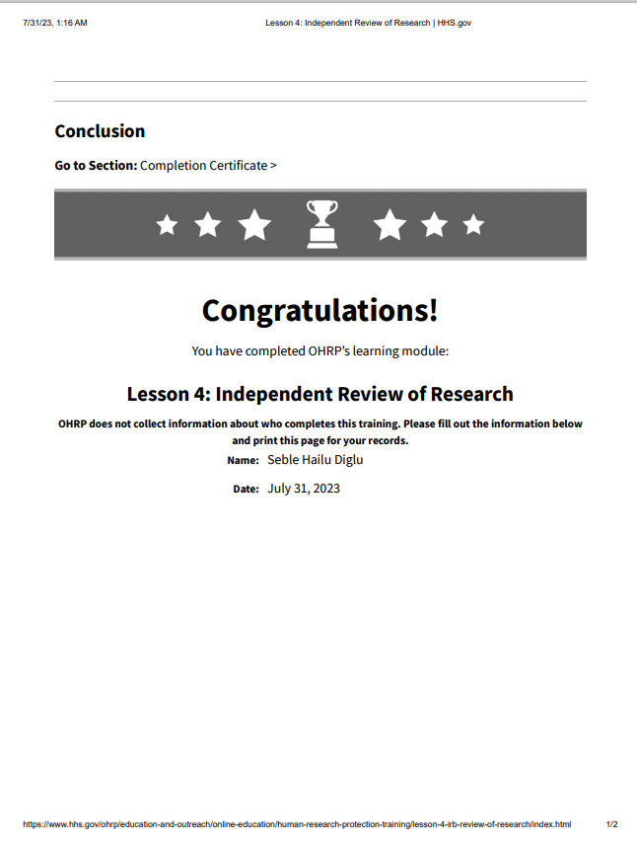

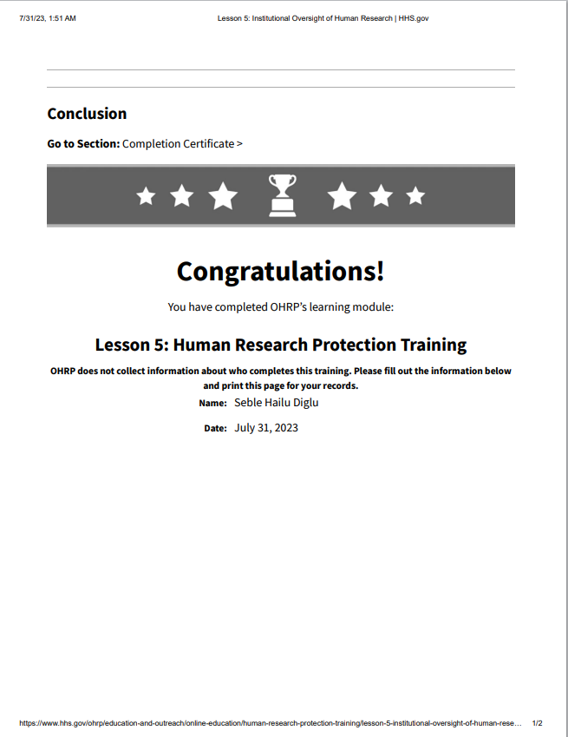

Appendix G: Curriculum Vitae

**Seble Hailu Diglu**

|  |
| --- |
| **Contact Information**   * Cellular +(251) 911 60 60 55; Office +(251) 941 90 90 90 * E-mail: [seble.hailu@gmail.com](mailto:seble.hailu@gmail.com); * Skype: seblehailu, |
| **Education Background**   1. **Doctoral Studies in Sociology – Ph.D. (candidate),** Omega (Oxford) Graduate School, Dayton, Tennessee, USA, March 2017 – September 2023 2. **Master of Arts in Counseling and Human Relations,** Liberty University, Virginia, USA, 2001-2005 3. **Master of Arts in Educational Psychology,** Addis Ababa University – School of Graduate Studies, Addis Ababa, Ethiopia, 2001-2003 4. **Bachelor of Theology Degree,** Evangelical Theological College, Addis Ababa, Ethiopia, 1995-1999 5. **Bachelor of Arts in Management and Public Administration,** Addis Ababa University, Addis Ababa, Ethiopia, 1983-1987 |
| **Core Areas of Expertise**   * **Psychological counseling**: providing individual, couple, family and group counseling and psychotherapy * **Management consultancy:** providing consultancy services to several governmental and non-governmental organizations in various fields, including organizational and leadership development, strategic planning, project management, customer relations management, human resources management, and knowledge management. * **Education:** providing classroom teaching, advising students, training to professionals, as well as preparing materials including manuals, training aids, and guidelines, writing, and documentation. * **Research:** Conducting assessments, surveys, and evaluations including mapping, organizational analysis, situational analysis, knowledge, attitude and practice reviews and mid-term or final project evaluations. * **Training:** Combining psychology and management to provide pieces of training in a range of specialized fields including management-related topics, strategic planning, project planning and implementation, psychological counseling, gender policy formulation, community mobilization, positive psychotherapy, EMDR therapy, and peace psychology. |
| **Work Experience**   1. Endaee Communication, Consultancy, Counseling, and Training Services (ECCCTS) PLC – General Manager since June 2016 – present. 2. Director General, Ethiopian Reconciliation Commission, February 16, 2021 - March 11, 2022. 3. Wudassie Diagnostic Center (WDC) - Marketing Manager and Counselor, Sept. 2013 – May 2016. 4. United Nations Educational Scientific Cultural Organization (UNESCO) – National Program Officer for HIV and AIDS, February 2011 – August 2013. 5. Freelance Consultant - Management, Psychology, HIV/AIDS, Counseling, February 2010 – 2011. 6. Save the Children/USA, seconded to Management Sciences for Health - Training Manager, HIV/AIDS Care, and Support Program, November 2007 – February 2010. 7. United Nations International Labor Organization (ILO) - National Project Coordinator, HIV/AIDS Workplace Education Program, December 2004 – October 2007. 8. Bethzatha College of Health Sciences - Program Coordinator, August 2003 – December 2004. 9. Evangelical Theological College - Director of Administration, Finance and Information Services, September 2000 -August 2001Registrar and Instructor, August 1995 – 2000. 10. Ministry of Mines and Energy – Junior to Senior Management Expert, September 1988 - July 1995. |