OFFICE OF THE ACADEMIC DEAN

**RE**: Candidacy Recognition

**TO**: Thuam Khai

**DATE**: March 6, 2023

______________________________________________________________________

Thuam:

This letter confirms that you completed the requirements for candidacy for the doctoral program, effective March 6, 2023. Candidacy requires clearance by the Business Office; students must remain financially clear for candidacy to be active and receive assistance from their research advisors. Congratulations on reaching this important step!

The Graduate Research Council will direct the supervision of your research until graduation. You may now use the degree initials after your name (Ph.D. or DPhil, used interchangeably for OGS graduates), qualified by (c), for ‘candidacy,’ in parentheses. Please contact Dr. McClane or your committee chair with any questions about your research. All candidates must maintain academic progress and, if pertinent, stay current with federal aid regulations by attending a Dissertation Workshop each term until graduation.

This Candidacy status will expire on (March 6, 2025). If the candidacy expires before submission of the final dissertation, students are required to (a) repeat relevant Core 5/7 courses (Core 5 Statistics or Qualitative Data Analysis, Research Design, Core 7B/C), (b) submit a new preproposal, and (c) then attend the LOC or another accessible research library to demonstrate library-based research time in updating the literature review. Participating in a Core 7 Dissertation workshop each term is also necessary. If prescribed, tuition for courses will be determined at the time of entry into the pre-candidacy phase. On behalf of the Academic Affairs Council and Faculty, congratulations on completing this important step in your doctoral degree program. It is our pleasure to have you in the program and as a part of the OGS community of world-changers!

Approved,

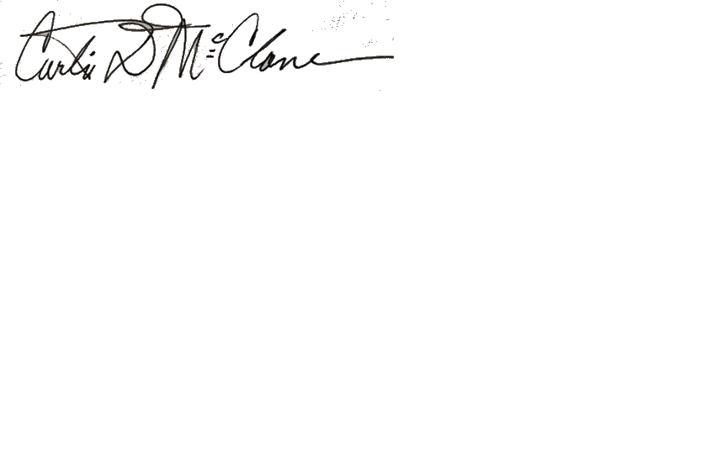____________________________________________March 6, 2023

Dean of the Faculty for GRC Date

Dr. Curtis D. McClane

Chief Academic Officer

Chair, Academic Affairs Council

[cmcclane@ogs.edu](mailto:cmcclane@ogs.edu)

cc: AAC Meeting Minutes

Student Academic File

Registrar, Business Office