Cerita Buchanan

Omega Graduate School

Professor Name

Dr. David Ward

Submission Date:

April 2, 2023

20-Day – Library Resources and Writing Labs  
1. Exercise Submission: Complete the following brief Purdue Owl training topics and exercises (press control [ctrl] and click on each of the following underlined topics or right-click to pull up a menu and select ‘open hyperlink’):  
  
a. Sentence Structure (click on and review each topic under the Sentence  
Structure headings [five topics])  
b. Writing Conciseness (click on and review each topic under the Sentence  
Structure headings [four topics])  
c. Active and Passive Voice (click on and review each topic under the  
Active and Passive Voice heading [seven topics and a downloadable  
poster]  
  
2. Submit to DIAL a Word document containing the following:  
  
a. Obtain a library card from one local municipal library and one  
university or college library. Locate and establish a working relationship with one research librarian in each library. Provide the name and location of the libraries and research librarians you selected.  
b. A statement that you completed the online training sessions listed in #1  
above.  
c. An annotated (1-2 sentence description) outline of what you learned from EACH of the three sets of online training sessions (#b).  
  
3. Structure (Assignment evaluation includes the following structure below).  
  
a. Download the “OGS APA Course Assignments Template 7th Ed 2021” template  
from the General Helps folder in the AA-101 The Gathering Place Course on  
DIAL. Using the template, create the following pages.  
b. Title Page (not included in page count).  
c. Copy and paste the assignment instructions from the syllabus starting  
on a new page after the title page, adhering to APA 7th edition style   
(APA 7 Workshop, Formatting, and Style Guide, APA 7 Quick Guide).  
d. Document all sources in APA style, 7th edition (APA 7 Reference Example, APA 7 Quick Guide)   
e. Include a separate Works Cited page, formatted according to APA style, 7th edition (not included in page count).  
  
4. Submit through DIAL to the professor.

1. Library membership was established at The University of the West Indies Main Library at the Open Campus. The Open Campus operates an online/virtual library only, with the support of campus location libraries. Therefore the researcher has membership also at The University of the West Indies Main Library at the Mona Campus, Mona Kingston 7. A relationship was built with Head librarian Mrs. Adele Merritt Bernard. We conversed about possibilities for the researcher’s study, how to utilize the library, contacting a reference librarian and using the digital platform in the physical library and online. Membership was also garnered at the Kingston and St Andrew Public Library Service at Tom Redcam Drive in Kingston, Jamaica. The senior librarian Mrs. Brown seems supportive of learning and resource management. Though the reference library is currently closed for renovations and there are not many tertiary books available in the library she was confident that the library could assist with the research interest and needs even to a smaller extent. The University Library does not issue a library card, as staff/student identification card will suffice. However, the public library issues a library card (see appendix p. 6).
2. The researcher successfully completed the Purdue owl online training sessions around sentence structure, writing conciseness/concision and active and passive voice. Though she commenced the activities thinking she had some mastery of these areas on academic writing, she was pleasantly surprised at the new learning and important reminders that the activities provided.
3. Sentence Structure (1-2 sentences)

Sentence structure is important to clarify sentence fragments, clauses, correct subject-verb agreement for logical sequencing and clarity of thought. These exercises were a good reminder of the importance of punctuation which changes the meaning of sentences. Correct punctuation is important to avoid compound sentences and the use of conjunctions such as *and*, *but* and others are useful to clarify sentences (Purdue Owl, 2022, Sentence Structure).

Writing Conciseness/Concision

Writing concision is an area that was most useful and often most difficult for the researcher, she will return to these activities throughout her studies. In writing concision, the strongest and most effective words must be used to:

* “Eliminate vague, ambiguous or repetitive words using a thesaurus or other research tool (Purdue Owl, 2022, Concision: Eliminating words);
* Change phrases into single words, change unnecessary *that, who* and *which* clauses into phrases, change passive verbs into active verbs; ((Purdue Owl, 2022, Concision: Avoid Pitfalls, para 2)

and

* Avoid common pitfalls such as overuse of expletives (e.g. it is and there are), overuse of noun forms of verbs, unnecessary infinitive phrases and use of circumlocutions or roundabout expressions” (Purdue Owl, 2022, Concision: Avoid Pitfalls)

Active and Passive Voice

In academic writing, active voice is encouraged where “the subject of the sentence performs the action expressed in the verb” (Purdue Owl, 2022, Active and Passive Voice, para 1); passive voice is less direct, because it masks the subject of the sentence and is often wordy and cumbersome. Using active voice gives more clarity to the reader and often putting the subject first (i.e. the actioner), creates more direct speech and more clarity.

**Appendix**

Picture 1 – My Public library Card

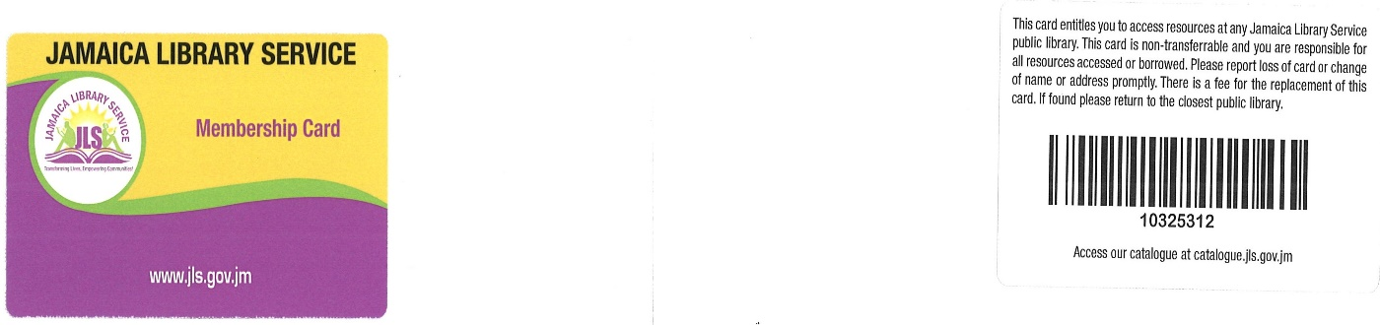

**Works Cited**

Purdue Owl (2022). Active and Passive Voices. Purdue University. Retrieved March

20, 2023, from <https://owl.purdue.edu/owl/general_writing/academic_writing/active_and_passive_voice/index.html>

Purdue Owl (2022). Concision. Purdue University. Retrieved March 20, 2023, from

<https://owl.purdue.edu/owl/general_writing/academic_writing/conciseness/index.html>

Purdue Owl (2022). Sentence Structure. Purdue University. Retrieved March 20, 2023,

From <https://owl.purdue.edu/owl_exercises/sentence_structure/index.html>