COMPARATIVE ANALYSIS of APPLICANT TRACKING SYSTEM AND ALTERNATIVE PRE-SCREENING METHODS FOR

STEM DIVERSE EMPLOYMENT CANDIDATES

Gina M. Marshall-Johnson

Dr. David Ward

Chair, Dissertation Committee?

TBD

Member, Dissertation Committee?

Dr. Tamara Goyea

Member, Dissertation Committee

A Dissertation Submitted in Partial Fulfillment

of the Requirements for the Degree of Doctor

of Philosophy

Omega Graduate School

Graduation Date

COMPARATIVE ANALYSIS of APPLICANT TRACKING SYSTEM AND ALTERNATIVE PRE-SCREENING METHODS FOR

STEM DIVERSE EMPLOYMENT CANDIDATES

Gina M. Marshall-Johnson

A Dissertation Submitted in Partial Fulfillment

of the Requirements for the Degree of

Doctor of Philosophy

Omega Graduate School

March 2023

Dissertation Committee:

Dr. TBD

Dr. Tamara Goyea

Dr. David Ward

Copyright 2023 by Gina M. Marshall-Johnson. All rights reserved.

(please see [www.loc.gov](http://www.loc.gov) for how to copyright)

TABLE OF CONTENTS

TABLE OF CONTENTS 1

LIST OF TABLES 3

LIST OF FIGURES 4

CHAPTER 1: INTRODUCTION 5

Background of the Problem 6

AI Impact on Workforce Shortfall 6

AI Ethics Principles 7

Problem Statement 12

Setting of this Research 12

Thesis Statement 20

Research Hypothesis 20

Scope of the Research 20

Research Assumptions 20

Significance of the Research 20

CHAPTER 2: REVIEW OF LITERATURE 22

CHAPTER 3: RESEARCH DESIGN AND METHODOLOGY 25

Problem Statement 25

Thesis Statement 25

Null Hypotheses 26

Hypothesis 1 26

Operational Definitions 27

Assumptions About Methodology 27

Limitations of the Study 28

Ethical Compliance 28

Procedures for Gathering Data 28

The Sample 28

Instrument(s) 29

Data Collection 29

Time Schedule 29

Procedures for Analyzing Data 30

Organization of the Data 30

Analysis of the Data 30

WORKS CITED 31

RELATED WORKS 43

LIST OF TABLES

Table 1 *A Sample Table Showing Correct Formatting* 5

When you update the list of tables, the table number and title will come in without a period between them; you will need to manually add that period after all table numbers, as shown for Table 1. In addition, the title will retain the italics from the narrative when the List of Tables is updated. Once your list is finalized, select the entire list and change it all plain type.

LIST OF FIGURES

Figure 1. Figure caption goes here xx

The List of Illustrations is not set up to automatically update. If you have figures in your document, type them in manually here, following the example above.

**Sample Outline from Thesis**

APPENDIX C: Interview Questionnaire 62

CHAPTER 1: INTRODUCTION

The workforce in the United States has been shrinking for decades. The aftermath of the COVID-19 pandemic has accelerated the lack of availability for employees to fill all the public and private sector positions available. If this workforce shortage persists, the number of available workers will no longer support the current levels of Gross Domestic Product growth for the US economy (Hetrick, 2021). To accelerate both the productivity of existing employees and replace employees with automated functions, Artificial Intelligence (AI) enabled systems have become more commonplace. Since the appearance of these AI-enabled systems, there have been several reports indicating bias in processes where the systems are applied. Of note, the Human Resources (HR) resume pre-screening process has replaced human reviewers with Applicant Tracking Systems (ATS) which typically apply AI-enabled pattern matching algorithms to determine whether a candidate is qualified for a given position. Further, empirical evidence suggests according to Holderman, that a resume written by AI to be a 100% match for a clinical scientist job description was ranked by the ATS as only meeting 43% of the qualifications, ranking too low to justify an interview within most companies (Holderman, 2014).

The AI-enabled ATS may be exacerbating the workforce shortage problem. This study is a quantifiable comparative analysis of candidates pre-screened with AI-enabled resume screening tools vs. human-enabled pre-screening methods to determine who moves on to the interview stage. The study particularly focuses on Science, Technology, Engineering and Mathematics (STEM) diverse employment candidates who are in very short supply based on the positions available. The results of this study are intended to aid recruiters, managers and leaders engaged in attracting and retaining diverse candidates in STEM fields.

Background of the Problem

AI Impact on Workforce Shortfall

A current study was done by jointly by Accenture and the Harvard Business School which showed that there are 27 million workers outside of the workforce because applicant tracking systems, which use artificial intelligence, have eliminated their resumes from consideration. (Fuller, 2021, p.3). Additionally, of the more than 2400 companies interviewed worldwide for the Hidden Worker study, the majority understand that their ATSs are eliminating qualified workers from consideration. “They exclude from consideration viable candidates whose resumes do not match the [Applicant tracking system] criteria but who could perform at a high level with training. A large majority (88%) of employers agree, telling us that qualified high-skills candidates are vetted out of the process because they do not match the exact criteria established by the job description. That number rose to 94% in the case of middle-skills workers.” (Fuller et al., 2021,p.3).

Bias in resume screening, in part, has created a huge number of people who are qualified and available to work, but have been rejected. We can no longer afford to maintain this bias if we are to continue to provide economic growth as a country and for its citizens [assertion, include reference].

The un- or under-employment of people due to the criteria used for AI-enabled pre-screening of resumes is a world-wide problem. “In February 2020, just before Covid-19 triggered global lockdowns, employers struggled to fill positions as the economy approached “full employment”. The number of unemployed persons per job posting in the United States stood at 0.8, with 7 million positions open in the U.S., while 5.8 million people remained unemployed, and an equal number were underemployed. In the United Kingdom, there were 721,000 job vacancies during the December 2019-February 2020 period, during which there were 1.4 million unemployed people. Similarly, there were 712,000 job vacancies in Germany in February 2020, while 2.3 million people were unemployed (Fuller et al., 2021,p.7). Given these developed countries have significant numbers of people who will be economically insecure, the countries themselves will suffer with economic growth and stability. We can see through history when large segments of the population are denied opportunity it causes instability in the foundational fabric of the societies [delete or expand upon with references].

Ensuring that all people qualified for positions are fairly evaluated and considered to fill those positions is foundational to societal economic stability and prosperity. Changing our approach to matching qualified candidates with open positions is critical, whether its AI driven or manual candidate screening. This research evaluates the rate of interview selection as it varies by resume pre-screening type.

AI Ethics Principles

The use of AI-enabled systems in many areas has demonstrated bias results which unfairly cause harm to minorities. Several noteworthy examples are in Facial Recognition which has a high error rate when facial matching women of color compared to facial matching for white men Raji et al., 2020). Additionally, the COMPAS prison sentencing system over-predicts repeat offenses for African American men compared to white men (Flores, 2016). This consistency in racial and gender-based bias for AI-enabled systems has given rise to the development of many, many published AI Ethical guidelines or principles. These are principles to follow to ensure the resulting algorithms do not disadvantage one group over another.

As the ethical implications of AI used in resume pre-screening are considered, it is important to examine the AI Ethics principles that were established by the public and private sector as they grapple with trying to ensure their AI-enabled systems meet a high ethical standard. An analysis was done of 21 Ethical guidelines and principles documents released over the period of 2016-2020. A heat map was created for prevalence of the dominant principles. (Hagendorff, 2019)



Figure 1: Heatmap of AI Ethics Guidelines (Hagendorff, 2019)

The top 5 most prevalent principles. Each of the principles are written with very broad “Ethical” language which leaves interpretation very open and implementation very fuzzy. The terms for some of the principles have similar meanings so they are clustered together. The 5 most prevalent principles or categories of principles are:

1. Privacy
2. Fairness, Non-discrimination, Justice
3. Transparency and Openness
4. Accountability
5. Safety and Cyber Security (Hagendorff, 2019)

In the area of privacy, depending on the values of the company the expressions are slightly different. As an example, Microsoft focuses on systems being secure and respecting the privacy of people (Microsoft, 2018). IBMs expressed values around privacy has to do with protecting the rights of the user’s data and preserving the users access and use of their data (IBM, 2018). This is increasingly more important as the UK has made protecting users’ data a legal requirement under GDPR, General Data Protection Rights. (Houser et al., 2018) The state of California enacted a similar law protecting user data called CCPA, or California Consumer Privacy Act (Barrett, 2019). It’s expected as this wave of focus on AI and Ethics grows there will be greater policy-based emphasis on protecting users’ data. As you build algorithms with user data make sure you understand the privacy protection requirements. For healthcare there are HIPPA and PII protection regulations. It’s important to engage domain experts to help you evaluate your ethical responsibility.

Similarly, in fairness, non-discrimination and justice depending on the company or organization there are different expressions of ethical values. In the DoD their ethical principles state “DoD should take deliberate steps to avoid unintended bias in the development and deployment of combat or non-combat AI systems, that would inadvertently cause harm to persons.” (Board, 2019). The implications there are the development community understand in the design that the training data in supervised learning or algorithms assigning attributes for correlation in unsupervised learning are not unintentionally biased against one population or another. When that is applied in the private sector the expressions for fairness are AI should treat all people fairly or AI must minimize bias and promote inclusive representation. Again, it’s important to have a broad view of the application of the AI so that as the system is being designed you have a good understanding of the population affected by the decisions. Again, this may extend beyond the software developers knowledge base so it’s important to engage domain expert, product managers and other stakeholders in the decisions about data used and expected results from the AI-enabled system early in the design process.

Of all the AI Ethics principles Transparency and Openness has had the most enduring discussions. It encompasses making sure the AI is explain-able, meaning can you explain why every outcome occurs and that those outcomes align with your original design intent. The range of considerations here for transparency and openness range from having an open discussion during the design process with experts in all areas to being able to explain decisions that are made years after the systems are deployed. The beauty of AI is it learns, the challenge of AI is understanding overtime if the learning aligns with the ethical values you set out to accomplish. The DOD defines this principle as “ the AI engineering discipline should be sufficiently advanced such that technical experts possess an appropriate understanding of the technology, development processes, and operational methods of its AI system, including transparent and auditablemethodologies, data sources and design procedures and documentation.” (Board, 2019). It requires understanding the development lifecycle end to end and documenting your understanding sufficient to stand up under an audit. Microsoft simply states “Transparent-AI systems should be understandable.” (Microsoft, 2018). IBM states “AI should be designed for humans to easily perceive, detect and understand its decision process.” (IBM, 2018). So the ethical values around transparency and openness all point to understanding the end-to-end system design such that you can explain the decisions being made and in the case of DOD you can explain it to an auditor.

The ethical value of accountability is really a culmination of compliance for all the other principles. Microsoft states AI systems should have algorithmic accountability. (Microsoft, 2018). IBM states “All designers and developers are responsible for considering AI design development, decision processes and outcomes.” (IBM, 2018). And DOD has the notion of responsible AI which states “Human beings should exercise appropriate levels of judgement and remain responsible for the development, deployment, use, and outcomes of DOD AI systems. (Board, 2019). The auditability pointed out by DOD earlier is a mechanism to make sure there is accountability. “Microsoft points to the algorithm accountability, IBM and the DOD the end to end from development to use to outcomes of AI systems. Regardless of the ethical principal definition it points to being accountable or responsible for having a full understanding of the AI-Enabled systems performance.

Finally, the 5th and most prevalent AI Ethical principle is that of the AI being Secure and having Cyber Security built in from the beginning. The DoD definition is “DoD AI systems should have an explicit, well-defined domain of use, and the safety, security, and robustness of such systems should be tested and assured across their entire life cycle within that domain of use.” (Board, 2019). As we discussed Microsoft combines the security discussion with privacy.

The principles are all written very generally, but with an intent to ensure ethical standards are considered when going through the end-to-end lifecycle development process.

As we consider the unintended consequences of the AI-enabled systems where there is racial and gender disparity in outcomes, it does not appear these ethical principles are being followed by the designers.

Problem Statement

The problem statement for the research being conducted measures the differences between AI-enabled resume pre-screening as compared to traditional methods of manual pre-screening to determine whether there is unintended bias. The problem statement simply stated is: It is unknown whether AI-driven resume pre-screening influences the number of STEM diverse candidates’ interview selection rates.

Setting of this Research

While the workforce shortage and potential for inadvertently eliminating qualified candidates is a problem in developed countries world-wide, the setting for this research will be in the United States. The open STEM positions will be based on openings in the United States and the experimental design will consider new STEM graduates from Federally funded Title IV, US-based colleges and universities. The table below shows open technical positions in the United States according to Indeed, on 8/1/22.

|  |  |  |  |  |  |  |
| --- | --- | --- | --- | --- | --- | --- |
|  |  | United States | Maryland | California | Texas | Washington |
| Software Engineer | | 220,762 | 7173 | 34462 | 18,600 | 14075 |
| Software Developer | | 220,721 | 7173 | 34464 | 18600 | 14072 |
| Software Architect | | 46,488 | 1362 | 5561 | 4161 | 1065 |
| Data Scientist |  | 24,842 | 715 | 4654 | 1622 | 1946 |
| Hardware Engineer | | 89,954 | 4564 | 20,091 | 6546 | 4,351 |
| Cyber Security |  | 45,862 | 2595 | 4360 | 4078 | 1141 |
| IT |  | 324,217 | 12,296 | 38195 | 26796 | 10,591 |
| RF |  | 38,802 | 1354 | 6405 | 3023 | 906 |
| Cloud |  | 240,239 | 6,910 | 29977 | 21558 | 11,486 |
| Recruiter |  |  | 608 | 3788 | 2895 | 887 |
|  |  |  |  |  |  |  |
| Total Tech Openings |  | 1,031,125 | 36,969 | 143,707 | 86,384 | 45,558 |

**Table 1: Indeed Open Technical Positions as of 08/2022**

STEM fields include biological and biomedical sciences, computer and

information sciences, engineering and engineering technologies, mathematics and statistics, and physical sciences and science technologies. (US Dept of Education, National Center for Education Statistics, 2022).

According to the US Department of Education, National Center for Education Statistics. There were 1.8M Bachelor’s degrees conferred in 2016 from Federally funded Title IV post-secondary schools, of which 18% or 324,000 were in STEM disciplines. Of the total STEM degrees awarded, 12% were to Black students, 33% to Asian students, 15% to Hispanic students, 15% to Pacific Islander, 14% to American Indian/Alaska Native , and 20% ti 2 or more races. The data is shown in figure 2 below.

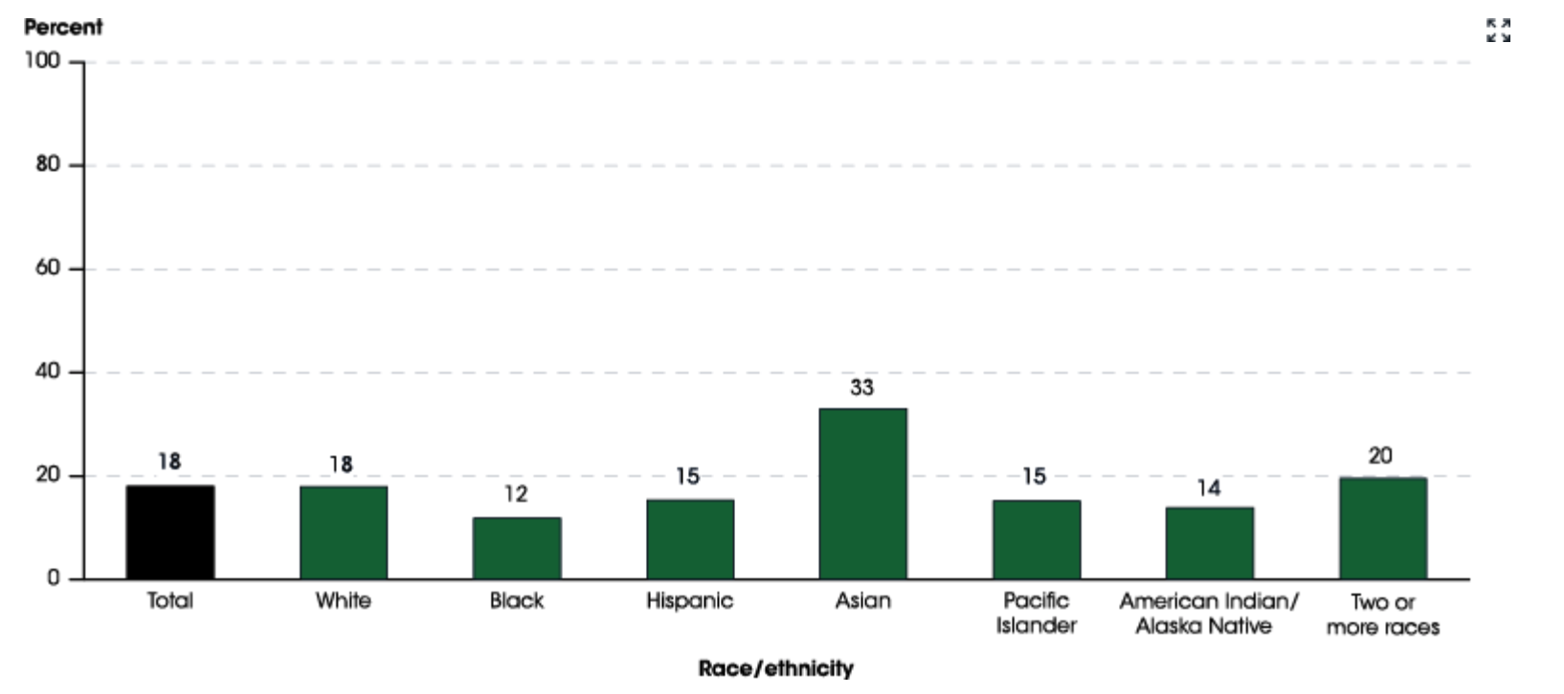

**Figure 2: US Department of Education NCES STEM Degrees by Race**

<https://nces.ed.gov/programs/raceindicators/indicator_reg.asp>

Further analysis of the US Department of Education, National Center for Education Statistics report reveals the distribution of STEM degrees by gender. Interestingly, the total degrees awarded were 42% male and 58% female but when looking at STEM related degrees only it shifts to 64% male and 36% female. As you examine race and ethnicity the report shows for whites 66% male and 34% female, for Blacks 55% male and 45% female, for Hispanics 63% male and 37% female, for Asian 60% male and 40% female, for Pacific Islanders 64% male and 36% female, for American Indian/Alaska Native 62% male and 38% female, and for 2 or more races 60% male and 40% female. A graphical representation is shown in Figure 3.

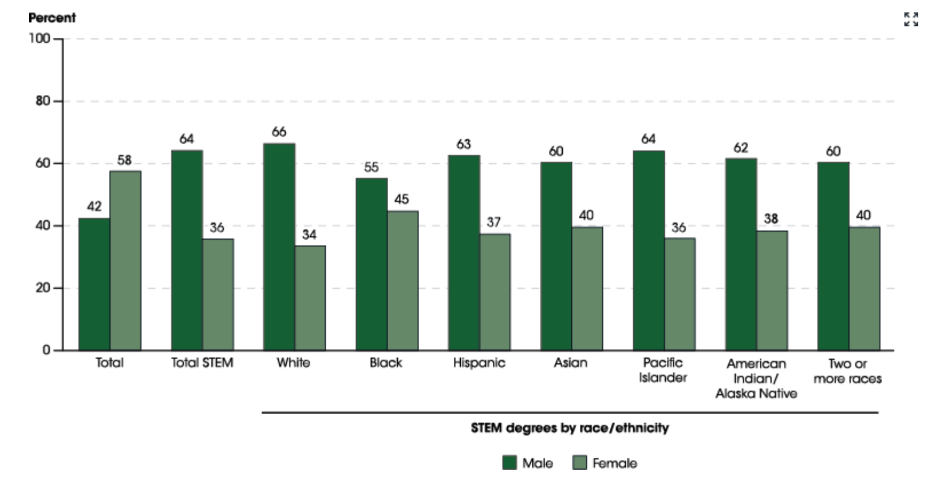

**Figure 3: US Department of Education NCES STEM Degrees by Gender**

<https://nces.ed.gov/programs/raceindicators/indicator_reg.asp>

Research from Statistica.com further expands to STEM degree awards to include all degree categories to include Masters, Doctorate, Associate and below Associate degrees. The good news is overall the number of STEM degrees awarded appears to be increasing overall over time. The bad news is just a subset of available positions posted are 32% higher than the number of graduates available to fill the growing need for STEM talent. A graphical representation is shown in Figure 4.

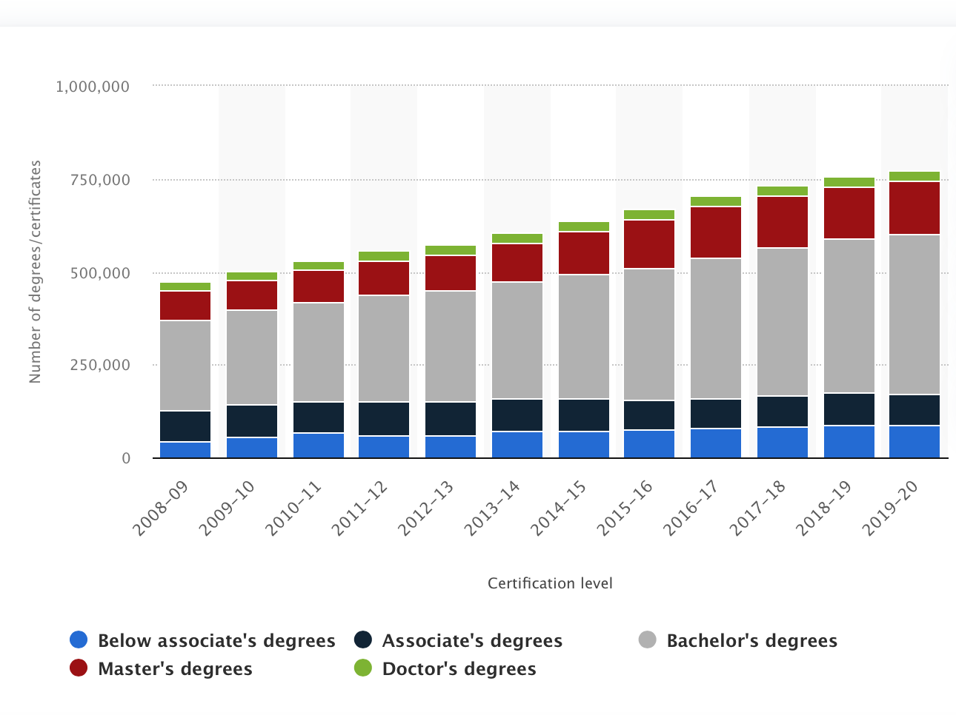

Statistica.com, 2022

**Figure 4: STEM Degree Trend from 2008-2020**

Since the number of degrees awarded are far short of the openings, it becomes even more imperative that each person evaluated for hire needs to be evaluated fairly.

Reporting from the PEW Research Center further decomposes the STEM degrees into discipline and reveals the race and ethnic distribution by STEM degree type. This more recent data shows that there are 3% fewer Blacks, 7% fewer Hispanics and 20% fewer Asians working in STEM jobs then there were graduates in STEM related fields inn 2016. This comparison coupled with the fact that the number of graduates has been increasing since 2016 indicates that the population available is greater than those employed. There may be various reasons driving the lower number of workers in STEM jobs then the percentage of graduates, but it is certainly an indication of under-employment.

**Figure 5: STEM Job Type by Race/Ethnicity (**PEW Research Center, 2021)

<https://www.pewresearch.org/fact-tank/2021/04/14/6-facts-about-americas-stem-workforce-and-those-training-for-it/>

Figure 5 further indicates that relative to the average per ethnicity working in STEM number of Blacks and Hispanics working in Math are average at 9 and 8%, respectively. The number of Asians working in Math is slightly above Asians working in STEM at 13%. In computer science, however, the number of Blacks is below average, while Hispanics still are at average levels and Asians are 7% above their average at 20%. The field of AI is dominated by Mathematicians and Computer Scientist. As the study more narrowly focuses on populations which could influence AI as domain experts, the study will examine jobs available in software development, software engineering, software architecture and IT related fields.

The PEW Research Center also examines the number of women in the STEM related fields trended over time. Interestingly, it appears that the number of women working in Computer Science has reduced from 32% down to 25% between 1990 and 2019. The field of Computer Science has exploded in the number of jobs over this period. In the Mathematics related fields it appears women have increased slightly, by 4% over the same period. It seems women have been gravitating to the Life and Physical Sciences disciplines within STEM. The movement of women’s working in Life and Physical Sciences has been from 34 to 48% and 22 to 40%, respectively, over the same period as shown in Figure 6.

Figure 5: Trend in women’s representation in STEM by discipline (PEW Research Center, 2021)

<https://www.pewresearch.org/fact-tank/2021/04/14/6-facts-about-americas-stem-workforce-and-those-training-for-it/>

Given the shortfall in overall candidates working to fill jobs in Software and IT related STEM fields, and given the percentages of graduates are greater than the percentage of those working in the field, this study will examine comparatively two methods of screening candidates for employment to determine if we can learn lessons that would lead to increasing the population of non-minorities working in STEM.

Thesis Statement

This study will evaluate the factors of STEM diverse candidate resumes pre-screening methods on interview selection rates.

Research Hypothesis

There is a difference in interview selection rates between AI driven resume pre-screening and alternate methods for diverse candidates in STEM fields.

Scope of the Research

The research will be focused on STEM workforce minority and women candidates applying for available openings in the computer and IT disciplines. It will further study the difference in qualification assessment between AI-enabled pre-screening and manual human resource prescreening. The population sample will be from the US.

Research Assumptions

The research assumptions are yet unknown

Significance of the Research

As of August 2022, there are over one million unfilled positions in the computer and IT related STEM fields. Additionally, research shows that diverse perspectives on innovation teams lead to better outcomes. Specifically, there is bias in AI which under-represents minorities in facial recognition, prison sentencing and resume screening. This research will quantify the differences between resume pre-screening methods to guide in the optimization the available minority resources in the under resourced job market for Computer Scientists and IT workers. The findings from the study may help private and public businesses meet their technology sector hiring needs, and adhere to AI ethics principles established to ensure equity across all populations regardless of race, ethnicity or gender.

CHAPTER 2: REVIEW OF LITERATURE

This study seeks to understand the relationship between manual and Artificial Intelligence driven resume pre-screening recommendations on diverse candidate interview selection rates for candidates in STEM fields. With the increased use of AI enabled systems to improve profitability in business operations companies must also ensure equity in diverse candidate resume pre-screening to meet diversity hiring objectives, and ensure adherence to AI Ethics guidelines designed to create sustainable equity in the operation of AI-enabled systems.

The literature review explores factors contributing to greater equity in hiring across diverse populations, particularly in STEM fields because there is a shortage of workers in this sector (Nithithanatchinnapat et. al, 2019). The shortage is documented in developed countries around the globe (Horbach et al., 2020; Nithithanatchinnapat et. al, 2019. The literature also documents through the survey of over 2400 companies around the world where Artificial Intelligence driven Applicant Tracking Systems (ATS) are used to pre-screen resumes. Also highlighted is 88% of those companies surveyed believe the ATSs are screening out qualified candidates (Fuller et al., 2021). A historical review of shortages in the technology sector revels that a short-term fix to the technology sector labor shortage is higher salaries, but increasing supply is the longer-term solution (Arrow et al., 1959). Current documented trends indicate the US is increasing salaries of technology workers but there is inadequate attention to increasing the supply of technology workers (Fuller et al., 2021). Literature reviews show there are over one million technology sector jobs in the computer and engineering sectors available in the US (Indeed, 2022). The literature also shows the entire new STEM population of graduates entering the workforce is about a third of the openings for positions. (Dept of Ed, NCES, 2018). The PEW Research Center further reveals that the minority population for Blacks and Hispanics is under-represented in these STEM fields. Further the literature reveals that the number of women are not only under-represented but also reducing in number over the past 20 years. (PEW, 2021)

The literature reveals many studies showing that human resume screening creates bias in pre-screening of resumes (Bo, 2020; Derous, 2018). A technological evolution was made attempting to remove human bias by using mathematical algorithms to make less biased decisions(Cowgill, 2020; Bui, 2020; Christian, 2021). The literature also shows that historically mathematical modelling of God’s natural law by Isaac Newton and other that mathematicians has stood the test of time (Feingold, 2019; Grant, 2000; Maglo, 2007). The literature shows that modern day machine learning instruction teaches the philosophy used to create projections is based on human beliefs and not nature law and therefore there is inherent uncertainty in the results (Christian, 2021; Kearns 2020). There is literature arguing for and against the use of ATS systems presented which discuss the benefits and the risks (Cowgill, 2020; Christian 2021; Kearns, 2020; Ruehle, 2020).

Several frameworks discussing artificial intelligence dimensions of uncertainty were examined (Rotenberg, 2020) . They ultimately were expressed as AI Ethics principles. The literature shows private sector and public sector organizations issued a flurry of AI Ethics principles to prevent the emerging evidence that AI-enabled systems create unpredictable and potentially damaging results. The 5 most prevalent AI Ethics principles published were to improve:Privacy , Fairness, Non-discrimination, Justice, Transparency and Openness, Accountability and Safety and Cyber Security (Hagendorff, 2019).

The literature examines a number of instruments for the study which have been validated through earlier resume pre-screening studies using traditional pre-screening methods. The SPIDER-framework (Sample, Phenomenon of Interest, Design, Evaluation, Research type) for research retrieval and evaluation (Cooke, Smith, and Booth 2012) was chosen to frame the design and analysis for this research study. Blind sample data collection on over 200 resumes will be sent to companies with ATS systems to determine the call-back percentages for majority vs. minority candidates with obvious indicators like name, school attendance (i.e. HBCUs, Minority Serving Institutions, etc.). The percentages will be compared with traditional resume screening call-backs. There may also be variations in resumes to see if improvements in call-backs can be achieved. There will be further analysis of the findings using the SPIDR-framework. The literature also discusses factors causing resumes to be excluded from consideration. Recommendations will be made based on both the findings and literature that guides HR and technical professionals in improving the requirements on software suppliers of ATS systems. The literature presented will also discuss the implications of keeping the supply of technology sector candidates artificially low on the GDP growth in the US to emphasize the sense of urgency in addressing this ongoing problem.

CHAPTER 3: RESEARCH DESIGN AND METHODOLOGY

This chapter will discuss the research design and methodology. The framework for the design will follow the SPIDR-framework **(**Sample, Phenomenon of Interest, Design, Evaluation, Research type) for research retrieval and evaluation (Cooke et al., 2012). The frameworkadheres to the following standards: (i) the ‘Sample’ criterium is limited to gender, ethnic and racial minorities; (ii) the ‘Phenomenon of Interest’ criterium is restricted to taste-based and statistical discrimination; (iii) the ‘Design’ and ‘Research type’ criteria were limited to primary, quantitatively oriented empirical studies; and (iv) the ‘Evaluation’ criterium was restricted to labour market outcomes (e.g. interview selection, hiring, promotion, firing) (Lippens, 2022, p.7). Taste-based discrimination is that seen in the manual resume pre-screening process where an individual HR representative makes a go/no go judgement in offering an interview. Statistical discrimination will be attributed to AI-enabled decisions that makes go/no go judgement on offering an interview. The labor market outcome measured will be based on the interview selection rate.

Problem Statement

The problem statement for the research is: It is unknown whether AI driven resume pre-screening influences the number of STEM diverse candidates’ interview selection rates.

Thesis Statement

The Thesis statement for the research is: This study will evaluate the factors of STEM diverse candidate resumes pre-screening methods on interview selection rates

Null Hypotheses

Hypothesis 1

There is no difference in interview selection rates between manual and AI driven candidate resume pre-screening methods for diverse candidates in STEM fields.

Operational Definitions

|  |  |
| --- | --- |
| Definition | Source |
| AI is a branch of computer science dealing with the simulation of intelligent behavior in computers, (2) the capability of a machine to imitate intelligent human behavior. | Artificial Intelligence. 2022, In Merriam-Webster.com. Retrieved August 3, 2022 from <https://merriam-webster.com> |
| AI is a computer system that can learn from experience by discerning patterns in data fed to it and thereby make decisions. | Smith, B., Brown, C. (2020). *TOOLS AND WEAPONS: the promise and the peril of the digital age*. Amazon. <https://www.amazon.com/Tools-Weapons-Promise-Peril-Digital/dp/1984877712>. |
|  |  |
|  |  |
|  |  |
|  |  |
|  |  |

Assumptions About Methodology

There has not been such penetration of applicant tracking systems in HR organizations that it will be difficult to find traditional manual pre-screening of resumes.

It is assumed that is a company is a customer of a large ATS that all resumes are screened using the ATS.

It is assumed that if a company does not have an advertised ATS that the method of resume screening is without an ATS.

The rate of interview selection acts as a proxy for not limiting the candidate pool excessively before they get into the interview process.

Limitations of the Study

There may be insufficient balance in ATS users and non-ATS users to have a balanced sample for the two groups being measured. Group 1 is HR organizations that use ATS’s. Group 2 is HR organizations that do not use ATS’s.

Sending resumes to companies without absolute assurance of the type of screening they use will have to be mitigated.

Ethical Compliance

Procedures for Gathering Data

Blind study by sending resumes to companies who advertise openings for STEM positions but do not know they are being tested.

Population

Of the 1.8 million STEM new graduates in 2016, 324,000 were diverse. The distribution among ethnicities is shown in the table 2 below.

The Sample

1 % of the total US Population of new graduates



**Table 2: Sample population derived from Dept of Ed NCES and PEW RC** **Statistics**

Instrument(s)

The instrument used was derived from Busetta’s experiment decomposing discrimination in hiring by separating statistical and taste-based discrimination. (Busetta et al., 2020). In Busettas’ study it was applied first and second generation immigrants and similar demographics were used. This experiment will use resume preparation with varied names, experience, schools, professional associations, however the qualifications for the position will be aligned with the job posting on Indeed. The nature of the experiment will be blind to the HR representative reviewing the resume or the AI-enabled system evaluating the resume. The call-back will be captured via phone message or email message.

Data Collection

Two-hundred and twenty-one resumes will be prepared according to the population sample distribution in the table above. The depended variable or call-backs for interviews will be collected using emails and phone numbers on the resumes.

Time Schedule

New Grad hiring is at the peak between September and December prior to the year of graduation. Therefore, the data collection will be over those three months. An additional month, January, will be allowed to compensate for the holiday break.

Procedures for Analyzing Data

Organization of the Data

The data will be organized by independent and dependent variables. The independent variables are divided into two groups. The first group is resumes pre-screened manually. The second group is resumes pre-screened with AI-enabled ATS’s. The depended variable is the interview selection or call-back rate for each group.

The data will be labeled in excel for each candidate. The persons demographics, school attended, years of professional experience, extracurricular or volunteer positions, etc. will be labeled for each applicant. The labeled data will be imported to WINKS for later analysis.

Analysis of the Data

The data will be analyzed using the independent t-test using ordinal or binary data. The sample size or N=221 which represents approximately 1% of the entire population of new STEM graduates. The number of submissions will be aligned with the percentage of race, ethnicity and gender in the STEM field. The distribution between companies using manual and AI-enabled screening methods will be approximately 50% manual and 50% automated. The data analysis will be done using WINKS.

WORKS CITED

Abdurrahman, F. N. (2021). Black holes: Finding them, building instruments that help you look, and how systemic racism can prevent you from doing any of that [Ph.D., University of California, Berkeley].

https://www.proquest.com/docview/2572617614/abstract/1F164ECA2834C83PQ/1

Adya, M., & Kaiser, K. M. (2005a). Early determinants of women in the IT workforce: A model of girls’ career choices.

Agrawal, A., Gans, J. S., & Goldfarb, A. (2019). Exploring the impact of artificial Intelligence: Prediction versus judgment. Information Economics and Policy, 47, 1–6. https://doi.org/10.1016/j.infoecopol.2019.05.001

Arrow, K. J., & Capron, W. M. (1959). Dynamic shortages and price rises: The engineer-scientist case. The Quarterly Journal of Economics, 73(2), 292. https://doi.org/10.2307/1883726

Artificial Intelligence. 2022, In Merriam-Webster.com. Retrieved August 3, 2022 from<https://merriam-webster.com>

Barrett, C. (2019). Are the EU GDPR and the California CCPA becoming the de facto global standards for data privacy and protection?. *Scitech Lawyer*, *15*(3), 24-29.

Benson, J. & Clark, F. (1982). A guide for instrument development and validation. Journal for Occupational Therapy. https://doi.org/10.2307/248922

Biblica. (1984). *The Holy Bible: New International Version*.

Bo, C. (2020). Bias and productivity in humans and algorithms: Theory and evidence from resume screening. <http://conference.iza.org/conference_files/MacroEcon_2017/cowgill_b8981.pdf>

Board, D. I. (2019). AI principles: Recommendations on the ethical use of Artificial Intelligence by the Department of Defense: Supporting document. *United States Department of Defense*.

Bondarouk, T., & Fisher, S. L. (Eds.). (2020). Encyclopedia of electronic HRM. De Gruyter.

Borup, D., & Schütte, E. C. M. (2022). In search of a job: Forecasting employment growth using Google trends. Journal of Business & Economic Statistics, 40(1), 186–200. https://doi.org/10.1080/07350015.2020.1791133

Branscombe, N. R., & Smith, E. R. (1990). Gender and racial stereotypes in impression formation and social decision-making processes. Sex Roles, 22(9), 627–647. https://doi.org/10.1007/BF00288239

Brougham, D., & Haar, J. (2018a). Smart Technology, Artificial Intelligence, Robotics, and Algorithms (STARA): Employees’ perceptions of our future workplace. Journal of Management & Organization, 24(2), 239–257. https://doi.org/10.1017/jmo.2016.55

Brown, V. M. (2021). Organizational justice and Machine Learning: From the voices of generation Z [Ph.D., Pepperdine University]. https://www.proquest.com/docview/2506683507/abstract/F6BAD1EE74A2411FPQ/1

Bui, C. K. T. (2021). Exploring bias against women in Artificial Intelligence: Practitioners’ views on systems of discrimination. https://www.duo.uio.no/handle/10852/88551

Bursell, M. (n.d.). What’s in a name? - A field experiment test for the existence of ethnic discrimination in the hiring process. 29.

Busetta, G., Campolo, M. G., & Panarello, D. (2020). The discrimination decomposition index: A new instrument to separate statistical and taste-based discrimination using first- and second-generation immigrants. International Journal of Social Economics, 47(12), 1577–1597. https://doi.org/10.1108/IJSE-02-2020-0055

Christian, Brian.(2021). *Alignment problem: how can machines learn human values?* Atlantic Books.

Cowgill, B. (2020). Bias and productivity in humans and algorithms: Theory and evidence from resume screening.

Derous, E., & Ryan, A. M. (2018). When your resume is (not) turning you down: Modelling ethnic bias in resume screening. Human Resource Management Journal, 29(2), 113–130. https://doi.org/10.1111/1748-8583.12217

Derous, E., Nguyen, H.-H. D., & Ryan, A. M. (2020). Reducing ethnic discrimination in resume-screening: A test of two training interventions. European Journal of Work and Organizational Psychology, 30(2), 225–239. https://doi.org/10.1080/1359432x.2020.1756907

Feingold, M. (2019). The religion of the young Isaac Newton. Annals of Science, 76(2), 210–218. https://doi.org/10.1080/00033790.2018.1549686

Fetzer, J. H. (1990). What is Artificial Intelligence? In J. H. Fetzer (Ed.), Artificial Intelligence: Its Scope and Limits (pp. 3–27). Springer Netherlands. <https://doi.org/10.1007/978-94-009-1900-6_1>

Floridi, L., Cowls, J., Beltrametti, M., Chatila, R., Chazerand, P., Dignum, V., Luetge, C., Madelin, R., Pagallo, U., Rossi, F., Schafer, B., Valcke, P., & Vayena, E. (2018). AI4People—An ethical framework for agGood AI Society: opportunities, risks, principles, and recommendations. *Minds and Machines*, *28*(4), 689–707. <https://doi.org/10.1007/s11023-018-9482-5>

Fuller, J. B., Raman, M., Sage-Gavin, E., & Hines, K. (2021). Hidden workers: Untapped talent. Harvard Business School, September.

Grant, E. (2000). God and natural Philosophy: The late middle ages and Sir Isaac Newton. Early Science and Medicine, 5(3), 279–298. https://doi.org/10.1163/157338200X00236

Hagendorff, T. (2019, October 11). The **et**hics of AI **e**thics -- An **e**valuation of **g**uidelines. *arXiv.org.* <https://arxiv.org/abs/1903.03425>.

Heric, M. (2018). HRs new digital mandate. https://www.bain.com/contentassets/3dea09cc27fd426abfb35f9caa0e97dc/bain_brief_-hrs_new_digital_mandate.pdf

Holderman, J. (2014). The Impact of Applicant Trcking System on Job Search. *Career Planning and Adult Development Journal*, *30*, 154.

Horbach, J., & Rammer, C. (2020). Labor shortage and Innovation. SSRN Electronic Journal. https://doi.org/10.2139/ssrn.3545776

Houser, K. A., & Voss, W. G. (2018). GDPR: The end of Google and Facebook or a new paradigm in data privacy. *Rich. JL & Tech.*, *25*, 1.

Houser, Kimberly. (2019). Can AI Solve the Diversity Problem in the Tech Industry: Mitigating Noise and Bias in Employment Decision-Making?

Hsu, J. (2020). Can AI hiring systems be made antiracist? Makers and users of AI-assisted recruiting software reexamine the tools' development and how they're used - [News]. IEEE Spectrum, 57(9), 9–11. https://doi.org/10.1109/mspec.2020.9173891

IBM. (2018). Everyday ethics for artificial intelligence. https://www.ibm.com/watson/assets/duo/pdf/everydayethics.pdf

Kasbe, T. (n.d.). You Shall Love Your Neighbor as Yourself: Ethics of Artificial Intelligence, Robotics and Supra-intelligence [D.Min., Duke University]. Retrieved June 25, 2022, from <https://www.proquest.com/docview/2402948743/abstract/A5D6D19A1F4E441DPQ/1>

Kerns, M., & Roth, A. (2020). *The ethical algorithm: The science of socially aware algorithm design*. Oxford University Press.

Koteswari, B., & Padmaja, P. (2020). Use of Applicant Tracking System (ATS) in Talent Acquisition

Lewis, N. (2018). Will AI Remove Hiring Bias? <https://www.shrm.org/resourcesandtools/hr-topics/talent-acquisition/pages/will-ai-remove-hiring-bias-hr-technology.aspx>

Lin, Y.-T., Hung, T.-W., & Huang, L. T.-L. (2021). Engineering Equity: How AI Can Help Reduce the Harm of Implicit Bias. *Philosophy & Technology*, *34*(S1), 65–90. <https://doi.org/10.1007/s13347-020-00406-7>

Lippens, L., Baert, S., Ghekiere, A., Verhaeghe, P.-P., & Derous, E. (2022). Is labour market discrimination against ethnic minorities better explained by taste or statistics? A systematic review of the empirical evidence. Journal of Ethnic and Migration Studies, 0(0), 1–34. https://doi.org/10.1080/1369183X.2022.2050191

Ma, T. (2021). On the Origin of Artificial Intelligence: An Overview of AI Ethics in Communications [M.F.A., Pratt Institute].

Maglo, K. (2007). Force, Mathematics, and Physics in Newton’s Principia: A New Approach to Enduring Issues. Science in Context, 20(4), 571–600.

Marler, J. H., & Boudreau, J. W. (2016). An evidence-based review of HR analytics. The International Journal of Human Resource Management, 28(1), 3–26. https://doi.org/10.1080/09585192.2016.1244699

Microsoft. (2018). The future computed: artificial intelligence and its role in society / by Microsoft : with a forward by Brad Smith and Harry Shum, Redmond, WA. pp. 11-77.

Miller, T. (2019). Explanation in artificial intelligence: Insights from the social sciences. *Artificial Intelligence*, *267*, 1–38. <https://doi.org/10.1016/j.artint.2018.07.007>

Mirza, R. M. and B. (2021, September 12). Deconstructing the great resignation. SHRM. https://www.shrm.org/hr-today/news/hr-news/pages/deconstructing-the-great-resignation.aspx

Moody, K. (2021). Report: Applicant tracking systems may exclude whole segments of candidates. HRDIVE.

Mujtaba, D. F., & Mahapatra, N. R. (2019). Ethical considerations in AI-based recruitment. 2019 IEEE International Symposium on Technology and Society (ISTAS), 1–7.

Nithithanatchinnapat, B., Joshi, K. D. (2019). A global view of what fixes information technology skills shortage: Panel data analyses of countries’ human and technology resources. *Journal of Global Business Insights*, *4*(1), 59–77. <https://doi.org/10.5038/2640-6489.4.1.1058>

Raji, I. D., Smart, A., White, R. N., Mitchell, M., Gebru, T., Hutchinson, B., … Barnes, P. (2020, January 3). *Closing the AI Accountability Gap: Defining an End-to-End Framework for Internal Algorithmic Auditing*. arXiv.org. <https://arxiv.org/abs/2001.00973>.

Raghavan, M., Barocas, S., Kleinberg, J., & Levy, K. (2020). Mitigating bias in algorithmic hiring: Evaluating claims and practices. Proceedings of the 2020 Conference on Fairness, Accountability, and Transparency, 469–481. <https://doi.org/10.1145/3351095.3372828>

Raji, I. D., Gebru, T., Mitchell, M., Buolamwini, J., Lee, J., & Denton, E. (2020). Saving Face: Investigating the ethical concerns of facial recognition auditing. *ArXiv:2001.00964 [Cs]*. <http://arxiv.org/abs/2001.00964>

Report: Applicant tracking systems may exclude whole segments of candidates. (n.d.). HR Dive. Retrieved June 25, 2022, from https://www.hrdive.com/news/report-applicant-tracking-systems-may-exclude-whole-segments-of-candidates/606614/

Responsible conduct in data management: data collection. Data collection. (2022). Retrieved January 9, 2022, from https://ori.hhs.gov/education/products/n_illinois_u/datamanagement/dctopic.html

Rotenberg, M (2020). The AI policy sourcebook 2020. Washington, DC: Electronic Privacy Information Center, pp. 44-60

Ruehle, C. R. (n.d.). Understanding the Complex Ethical Landscape of Artificial Intelligence Adoptions [D.B.A., University of South Florida]. Retrieved June 25, 2022, from https://www.proquest.com/docview/2451421102/abstract/79D48DB19A3D474CPQ/1

Self, W. T., Mitchell, G., Mellers, B. A., Tetlock, P. E., & Hildreth, J. A. D. (2015a). Balancing fairness and efficiency: The impact of identity-blind and identity-conscious accountability on applicant screening. PLOS ONE, 10(12), e0145208. https://doi.org/10.1371/journal.pone.0145208

Smith, Brad, Browne, Carol Ann (2020). TOOLS AND WEAPONS: the promise and the peril of the digital age. Amazon., xxii. https://www.amazon.com/Tools-Weapons-Promise-Peril-Digital/dp/1984877712.

Stafford-Cotton, N. (2021). Exploring How Organizations Ensure the Hiring Process Is Conducted Appropriately to Avoid Legal Issues [Ph.D., Walden University].

The impact of applicant tracking systems on job search—Gallaudet University. (n.d.). Retrieved June 25, 2022, from https://wrlc-gal.primo.exlibrisgroup.com

Tylka, L. M. (2014). An assessment of the effectiveness of a corporate website/social media effort to inform and recruit job applicants [M.A., Gonzaga University]. In ProQuest Dissertations and Theses. https://www.proquest.com/docview/1679222803/abstract/DB3EB81897D94237PQ/1

Vakkuri, V., & Abrahamsson, P. (2018). The key concepts of ethics of Artificial Intelligence. https://arxiv.org/pdf/1809.07027.

Winston, B. E. (2018). Biblical principles of hiring and developing employees. Springer International Publishing. https://doi.org/10.1007/978-3-319-70527-9

Zschirnt, E., & Ruedin, D. (2016). Ethnic discrimination in hiring decisions: A meta-analysis of correspondence tests 1990–2015. Journal of Ethnic and Migration Studies, 42(7), 1115–1134. https://doi.org/10.1080/1369183x.2015.11

RELATED WORKS

Carlsson, M. (2010a). Experimental evidence of discrimination in the hiring of first- and second-generation Immigrants. LABOUR, 24(3), 263–278. https://doi.org/10.1111/j.1467-9914.2010.00482.x

Ciecka, J. E. (2018). The first probability-based hypothesis test and God reviews and cases of note. Journal of Legal Economics, 24, 43–50.

Giermindl, L. M., Strich, F., Christ, O., Leicht-Deobald, U., & Redzepi, A. (2021). The dark sides of people analytics: Reviewing the perils for organisations and employees. European Journal of Information Systems, 1–26. https://doi.org/10.1080/0960085x.2021.1927213

Grobelny, J., Frontczak, P., Pawlak, K., & Skorodzillo, U. (2020). A conceptual model of the influence of resume components on personnel decisions: A policy-capturing study on resume screening. Journal of Management Information and Decision Sciences, 23(2).

Hiring by Machine. https://aiethics.princeton.edu/wp- content/uploads/sites/587/2018/12/Princeton-AI-Ethics-Case-Study-5.pdf. (2019). https://aiethics.princeton.edu/wp- content/uploads/sites/587/2018/12/Princeton-AI-Ethics-Case-Study-5.pdf.

Holderman, J. (n.d.). The impact of Applicant Tracking Systems on job search.

Khasawneh, O. Y. (2018). Technophobia without boarders: The influence of technophobia and emotional intelligence on technology acceptance and the moderating influence of organizational climate. Computers in Human Behavior, 88, 210–218.

Kleinberg, J., Lakkaraju, H., Leskovec, J., Ludwig, J., & Mullainathan, S. (2017). Human decisions and machine predictions. https://doi.org/10.3386/w23180

Kordzadeh, N., & Ghasemaghaei, M. (2021). Algorithmic bias: Review, synthesis, and future research directions. European Journal of Information Systems, 1–22. https://doi.org/10.1080/0960085x.2021.1927212

Lavrakas, P. (2008). Research hypothesis. Encyclopedia of Survey Research Methods. https://doi.org/10.4135/9781412963947.n472

Nunley, J. M., Pugh, A., Romero, N., & Seals, R. A. (2015). Racial discrimination in the labor market for recent college graduates: Evidence from a field experiment. The B.E. Journal of Economic Analysis & Policy, 15(3), 1093–1125.

Oberst, U., De Quintana, M., Del Cerro, S., & Chamarro, A. (2020). Recruiters prefer expert recommendations over digital hiring algorithm: A choice-based conjoint study in a pre-employment screening scenario. Management Research Review, 44(4), 625–641. https://doi.org/10.1108/MRR-06-2020-0356

Ötting, S. K., & Maier, G. W. (2018). The importance of procedural justice in Human–Machine Interactions: Intelligent systems as new decision agents in organizations. Computers in Human Behavior, 89, 27–39. https://doi.org/10.1016/j.chb.2018.07.022

Peaco, B. (2019). Assessment of Job Applicants Facebook Profile: A Case Study by the Hiring Manager [Ph.D., Northcentral University]. Retrieved June 25, 2022, from https://www.proquest.com/docview/2026209659/abstract/4F7AC4EFDB944CFFPQ/1

Plano Clark, V., & Creswell, J. (2015). Understanding research: A consumer's guide. Pearson.

Rep. Clarke, Yvette D., 2019, H.R. 2231 – Algorithmic Accountability Act of 2019, https://trackbill.com/bill/us-congress-house-bill-2231-algorithmic-accountability-act-of-2019/1739905/

Schuler, M. (n.d.). How to Properly Wear a Tin Foil Hat: A Call for Epistemic Humility in the Creation of Artificial Intelligence, in Applications of Neuroprosthetics, and in the Debate over Scientific Realism [Ph.D., The University of Arizona]. Retrieved June 25, 2022, from https://www.proquest.com/docview/2158003632/abstract/F2CCCD4C8F334F1DPQ/1

Zimmermann, F., Sieverding, M., & Müller, S. M. (2011a). Gender-related traits as predictors of alcohol use in male German and Spanish university students. Sex Roles, 64(5–6), 394–404. https://doi.org/10.1007/s11199-010-9897-9