Algernon Lewis

Omega Graduate School

Professor Dr. Cathie Hughes

Submission Date: August 8, 2023

20-Day Submission

1. Provide verification of LOC Reader’s Card, including card number and expiration date
2. Provide the dates of attendance
3. Document the number of hours spent in the LOC performing research
4. Provide verification of LOC Reader’s Card, including card number and expiration date

My assigned Library of Congress card number is R5125301 with an expiration date of June 21, 2024.

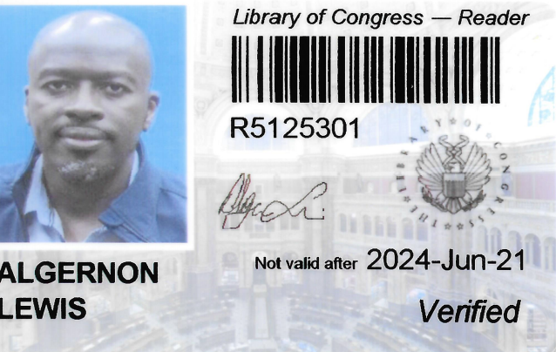

1. Provide the dates of attendance.

The Library of Congress visit took place on June 19-25, 2022.

1. Document the number of hours spent in the LOC performing research

While I am unable to provide details of the number of hours spent at LOC and Gallaudet University. However, I was present for all the planned and required sessions that were assigned for our group.