Cecil Thompson

Omega Graduate School

Prof. Richard Nti, MS

Dr. Cathy Hughes, PhD

September 2, 2023

1. **Review** the following section of the WINKS Reference Manual
2. **Part 4**: t-test (pp.82-107)
3. **Part 4**: Correlation (pp. 119-124)
4. **Part 4**: Goodness-of-Fit Analysis, Chi-Square (pp.!25-139)
5. **Using the referenced tutorial** in WINKS (see links in Online #2) complete the following and paste the printout in the assignment (see instruction below).
6. **Review** the paired t-test using the DIET.SDA data set. Analyze the data in WINKS and display the output. Copy and paste the analysis printout into the assignment document.
7. **Review** the independent Group t-test using the FERTILIZ.DBF data set. Analyze the data in WINKS, and display the output. Copy and paste the analysis printout into the assignment document.
8. **Review** the Mann-Whitney test using the FERTILIZ.SDA data set. Analyze the data in WINKS and display the output. Copy and paste the analysis printout into the assignment document.
9. **Review** the Kruskai-Wallis using the KRUSKAL.DBF data set. Analyze the data in WINKS, and display the output. Copy and paste the analysis printout into the assignment document.
10. **Review** the Pearson’s Correlation Coefficient using the CAR data set, Analyze the data in WINKS, and display the output. Copy and paste the analysis printout into the assignment document. Note the Correlation Coefficient applies to and the Pearson and the Spearman coefficients.
11. **Review** the Chi-Square test using the SALARY.SDA data set. Analyze the data in WINKS, and display the output. Copy and paste the analysis printout into the assignment document.

1. **Structure** (Assignment evaluation includes the following structure below).
   1. **Download** the “OGS APA Course Assignment Template 7th Ed 2021” template from the General Helps folder in the AA-101 The Gathering Place Course on DIAL. Using the template, create the following pages.
   2. **Title Page** (n Not included in page count).
   3. **Copy and paste** the assignment instructions from the syllabus starting on a new page after the title page (adhering to APA 7 Quick Guide).
   4. **Start the assignment** on a new page after the copied assignment instruction.
   5. **Document** all sources in APA style in the guide as shown above.
   6. **Include** a separate page in APA style guide as shown above.

1. **Submit** through DIAL to the professor.
2. Retrieve the paired t-test using the DIET.SDA. Analyze the data in WINKS and display the analysis. Copy and paste it in the Word document.

WINKS 7.0.9 PROFESSIONAL Edition August 28,2023

---------------------------------------------------------------------------

Repeated Measures Analysis Summary

-------------------------------------------------------------------------

Number of repeated measures is 2

Number of subjects read in 8

Means and standard deviations for 2 repeated measures:

1)REP1: mean = 169.625 s.d. = 8.07001

2)REP2: mean = 150.25 s.d. = 11.04213

Mean Difference = 19.375 s.d.(difference) = 14.78356

95% C.I. about Mean Difference is (7.01367, 31.73633)

Calculated t = 3.70687 with 7 D.F. p = 0.0076 (two-sided)

Note: For a one-sided test, you must adjust the p-value according to

the direction of your alternative hypothesis.

1. Retrieve the paired t-test using the FERTLIZ.SDA. Analyze the data in WINKS and display the analysis. Copy and paste with graph in the Word document.

Grouping variable is GROUP

Analysis variable is OBS

Group Means and Standard Deviations

-----------------------------------

1: mean = 51.4571 s.d. = 4.7476 n = 7

2: mean = 54.9667 s.d. = 4.7944 n = 6

Mean Difference = -3.50952 Pooled S.E. = 2.65319

Test for Equality of Variance

-----------------------------

This preliminary test determines which version of the t-test to perform.

Test equality of variance: F = 1.02 with (5, 6) D.F. p = 0.961

Independent Group t-test on OBS

---------------------------------------------------------------------------

Equal variance: Calculated t= -1.32 with 11 D.F. p = 0.213 (two-tail)

Unequal variance: Calculated t= -1.32 with 10.7 D.F. p = 0.214 (two-tail)

Note: t-test unequal variance reference: Welch-Satterthwaite test Neter (1990)

(For a one-sided test, you must adjust the p-value according to

the direction of your alternative hypothesis.)

Confidence Interval

-------------------

A 95% Confidence Interval about the mean difference is: ( -9.3493 to 2.3302)

CI is based on a standard error of 2.6532 and a tabled t-value of 2.201 with 11 d.f.

Effect Size Measures

---------------------

Cohen's d = -0.8, a small effect size. (Ref:Rosenthal and Rosnow, 1991)

Hedge's g = -0.734 (an adjustment of Cohen's d for sample sizes <10.)

1. Review the Mann-Whitney test using the FERTILIZ.SDA data set. Analyze the data in WINKS and display the analysis. Copy and paste with graph in the Word document.

WINKS 7.0.9 PROFESSIONAL Edition September 1,2023

--------------------------------------------------------------------------

Non-Parametric Independent Group Comparison

C:\Program Files (x86)\TexaSoft\WINKS7\FERTILIZ.SDA

--------------------------------------------------------------------------

Results of Non-Parametric analysis:

Group variable = GROUP Observation variable = OBS

Mann-Whitney U' = 24. U = 18.

Rank sum group 1 = 46. N = 7 Mean Rank = 6.57

Rank sum group 2 = 45. N = 6 Mean Rank = 7.5

Significance estimated using the z statistic.

Z = .357 p = 0.721

(Note:This Z calculation uses a correction for continuity.)

1. Review the Kruskal-Wallis using the KRUSKAL.SDA. Analyze the data in WINKS and display the analysis. Copy and paste with graph in the Word document.

WINKS 7.0.9 PROFESSIONAL Edition August 28,2023

--------------------------------------------------------------------------

Non-Parametric Independent Group Comparison

C:\Program Files (x86)\TexaSoft\WINKS7\KRUSKAL.SDA

--------------------------------------------------------------------------

D. Kruskai-Wallis test (KRUSKAL.DBF).

Results of Non-Parametric analysis:

Group variable = GROUP Observation variable = OBS

Kruskal-Wallis H = 24.48

P-value for H estimated by Chi-Square with 3 degrees of freedom.

Chi-Square = 24.5 with 3 D.F. p < 0.001

Rank sum group 1 = 28. N = 7 Mean Rank = 4.

Rank sum group 2 = 77.5 N = 7 Mean Rank = 11.07

Rank sum group 3 = 171. N = 7 Mean Rank = 24.43

Rank sum group 4 = 129.5 N = 7 Mean Rank = 18.5

Critical q

Tukey Multiple Comp. Difference Q (.05)

------------------------------------------------------------------------

Rank(3)-Rank(1) = 20.4286 4.647 2.639 *

(SE used = 4.3964)

Rank(3)-Rank(2) = 13.3571 3.038 2.639 *

(SE used = 4.3964)

Rank(3)-Rank(4) = 5.9286 1.349 2.639

(SE used = 4.3964)

Rank(4)-Rank(1) = 14.5 3.298 2.639 *

(SE used = 4.3964)

Rank(4)-Rank(2) = 7.4286 1.69 2.639

(SE used = 4.3964)

Rank(2)-Rank(1) = 7.0714 1.608 2.639

(SE used = 4.3964)

Homogeneous Populations, groups ranked

Gp Gp Gp Gp

1 2 4 3

------

------

------

This is a graphical representation of the Tukey multiple comparisons

test. At the 0.05 significance level, the means of any two groups

underscored by the same line are not significantly different.

1. Review the Pearson’s Correlation Coefficient using the CAR data set.

Analyze the data in WINKS and display the analysis. Copy and paste with

Graph in the Word document.

WINKS 7.0.9 PROFESSIONAL Edition August 28,2023

---------------------------------------------------------------------------

Correlation Coefficients C:\Program Files (x86)\TexaSoft\WINKS7\car.sda

---------------------------------------------------------------------------

Variables used : MPG(N) and SIZE(N)

Number of cases used: 38

Mean(SD) MPG(N) = 24.7605(6.5473)

Mean(SD) SIZE(N) = 177.2895(88.8768)

Pearson's Correlation analysis results

--------------------------------------

Pearson's r (Correlation Coefficient) = -0.7860 R-Square = 0.6179

(Pearson's) t = -7.629493 with 36 d.f. p < 0.001

(A low p-value implies that the slope does not = 0.)

95% C.I. on rho is (-0.884, -0.623)

Spearman's Correlation (nonparametric results)

---------------------------------------------

Spearman's Rank Correlation Coefficient = -0.8385

(Spearman's) t = -9.2318 with 36 d.f. p < 0.001

95% C.I. on Spearman's rho is (-0.913, -0.709)

1. Review the Chi-square test using the SALARY.SDA data set. Analyze the data in WINKS and display the analysis. Copy and paste with graph in the Word document.

WINKS 7.0.9 PROFESSIONAL Edition September 2,2023

---------------------------------------------------------------------------

Frequency Tables C:\Program Files (x86)\TexaSoft\WINKS7\SALARY.SDA

---------------------------------------------------------------------------

Number of records in data set = 175

Frequency Table for SEX

Cumulative Cumulative

SEX Frequency Percent Frequency Percent

-----------------------------------------------------------

1 67 38.29 67 38.29

2 108 61.71 175 100.0

Frequency Table for DEGREE

Cumulative Cumulative

DEGREE Frequency Percent Frequency Percent

-----------------------------------------------------------

1 114 65.14 114 65.14

2 61 34.86 175 100.0

Frequency Table for RACE

Cumulative Cumulative

RACE Frequency Percent Frequency Percent

-----------------------------------------------------------

1 83 47.43 83 47.43

2 75 42.86 158 90.29

3 2 1.14 160 91.43

4 13 7.43 173 98.86

5 1 0.57 174 99.43

6 1 0.57 175 100.0

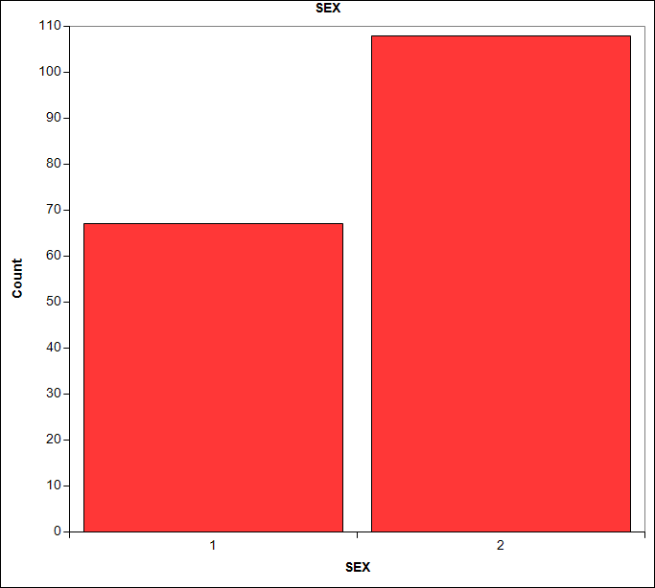

Works Cited

Elliott, Alan C. (2011). *TexaSoft, WINKS SDA Software 7th ed.* Cedar Hill Texas.

Jacobsen, J (2015, Feb 22). *Introduction to statistics* [Video file]. You Tube.

[https://www.youtube.com/watch?y=LMSiAJm99g[seminal](https://www.youtube.com/watch?y=LMSiAJm99g%5bseminal)]. 12 mins.

Rokingson-Szapkiw, A. (2013, August 26). Introduction to statistics. What are they?

And, how do I know which one to choose? {Video file]. YouTube. <https://www.youtube.com/watch?y=HpyBEDOO> [Seminal] 40 mins.

Sheskin, D.J. (2011). Handbook of Parametric and nonparametric statistical procedures.

(3rd ed.). Chapman & Hall/CRC [Seminal].

Terrel, S.R. (2021). Statistics translated: A step-by-step guide to analyzing and

interpreting data. The Guilford Press. [ Amazon-previewed].