**OFFICE OF THE ACADEMIC DEAN**

May 03, 2023

***IRB LETTER OF CONSENT***

**NAME OF THE RESEARCHER**: Lynn Kronk

TITLE OF THE RESEARCH: Influence of Mandatory Mentoring Programs on Ethical Awareness in the Real Estate Industry

**PURPOSE OF THE STUDY**  
You are invited to take part in this dissertation research study. But before you accept, we would like to help you understand the research and what participation you will be involved in. Please read through this informed consent and feel free to let us know if you need some clarifications.

**STUDY PROCEDURES**  
Should you wish to participate, we will ask you for your personal information and your educational background. Then, you will answer a series of demographic questions in order to evaluate and correlate population findings. You will be engaged in taking a survey and/or interview questions.

**CONFIDENTIALITY**

You need not worry about privacy as we will not share the information we have gathered from this study other than statistical and non-identifiable personal information. The final integrity of the researcher demands that such confidentiality will be faithfully adhered to as promised.

**DURATION**  
This study will take more or less 20 minutes per individual, consisting of the quick survey questions and/or personal interview which takes more or less about 1-2 minutes, and the rest for the answering of the survey questionnaire.

**VOLUNTARY PARTICIPATION**  
Please understand that your participation here is purely voluntary. You will decide whether you will participate or not. In case you decide to participate, you will be required to fill out the section below for your consent as an affirmation of your participation. Should you decide to withdraw during the study, please do inform us. Your withdrawal will not affect your relationship with us. In case you withdraw from this study before completion of the data collection, all information, including the consent will be deleted.

**CONTACT INFORMATION**  
This study was approved by the Academic Dean’s Office. If you have questions or concerns about this study, you can get in touch with the Academic Dean, Dr. Curtis D. McClane. You can contact him at [cmcclane@ogs.edu](mailto:cmcclane@ogs.edu), or phone 865-599-0203.

**CONSENT**

I voluntarily give my consent to participate in this study. I have read the information above or the said information was read to me. I was given the opportunity to ask questions and these were answered satisfactorily and to my contentment.

Name __________________________________________________

Signature of Participant____________________________________

Date_________________________

Name__________________________________________________

Signature of Researcher____________________________________

Date_________________________

IRB Consent Letter Issued from the Academic Dean’s Office

Sincerely,

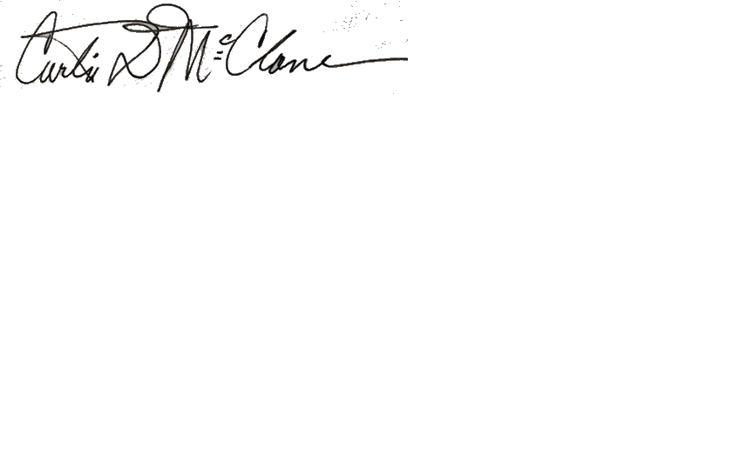_______________________May 03, 2023

Dean of the Faculty Date

Dr. Curtis D. McClane

Chief Academic Officer

Chair, Academic Affairs Council

[cmcclane@ogs.edu](mailto:cmcclane@ogs.edu)