The relationship between multicultural church attendees’ Cultural Intelligence and response to racism

Jared Marshall Sorber

Dr. Andrew Alexson, Chair, Dissertation Committee

Dr. Brenda Davis, Member, Dissertation Committee

Dr. Raymond Chang, Member, Dissertation Committee

A Dissertation Submitted in Partial Fulfillment

of the Requirements for the Degree of Doctor

of Philosophy

Omega Graduate School

May 2023

The relationship between multicultural church attendees’ Cultural Intelligence and response to racism

Jared Marshall Sorber

A Dissertation Submitted in Partial Fulfillment

of the Requirements for the Degree of

Doctor of Philosophy

Omega Graduate School

May 2023

Dissertation Committee:

Dr. Andrew Alexson, Chair

Dr. Brenda Davis

Dr. Raymond Chang

Copyright 2023 by Jared Sorber. Writer. All rights reserved.

(please see [www.loc.gov](http://www.loc.gov) for how to copyright)

ABSTRACT

Division between races and cultures exists throughout American society. Most churches in America continue to meet separately along racial lines despite believing in the same God who calls his followers to unity in him. Multicultural churches, which are growing in number and size, seek to unify diverse groups of people around the gospel of Jesus Christ with the hope of bringing that unity to the world around them.

The purpose of this quantitative research study is to explore if there is a relationship between multicultural church attendees' Cultural Intelligence (CQ) and response to racism. Four hundred twenty-nine multicultural church attendees participated in the study, completing the demographic survey and instruments used in the correlational analysis. The tools used were the Anti-Racism Behavioral Inventory (ARBI) and the Short Form Cultural Intelligence Survey (SFCQ).

Findings indicated a positive monotonic relationship between CQ and anti-racism behaviors. Follow-up research is proposed to build on this study, determining the nature of the relationship and ultimately leading to how Cultural Intelligence and anti-racism behaviors can be best fostered in churches. Other research is needed to identify spirituality's influence on multicultural church attendees' CQ and anti-racism behaviors.

DEDICATION

To my wife, Amie, your love, support, patience, and hard work made this possible. To my sons, Joel and Jacob; may my example of faith, perseverance, and hard work encourage you to pursue your passions, dreams, and calling continually.

To my parents, Marshall and Sheila Sorber, your sacrifice and love is the foundation this is built upon.

ACKNOWLEDGEMENTS

I am thankful to all those who supported me and made the completion of this educational journey possible. This journey would not have begun without Dr. David Anderson's encouragement. Thank you, Dr. Anderson, for your support, for helping me find a way to pursue this dream, cheering me on, sharing your wisdom, giving access to the population I wanted to study, and being the ultimate example of Gracism. The faculty and staff at Omega Graduate School were instrumental in my success. Dr. David Ward's always encouraging voice helped me find the direction and foundation for my research. Dr. Curtis McClane provided words of wisdom and encouragement throughout the process. Dr. Cathie Hughes was a cheerleader, strategist, sage guide, and much more. There were many times when I thought she was more excited about my research than I was. Dr. Sean Taladay provided practical guidance and assurance that I was on the right path at times when I felt lost in the details. Dr. Andrew Alexson chaired my dissertation committee and provided many helpful illustrations, stories, jokes, and antidotes that helped me understand where I needed to progress. His attentiveness and efficiency were extremely helpful and greatly appreciated. Dr. Brenda Davis went above and beyond being on my dissertation committee by checking in with me regularly and providing words of encouragement and guidance. Dr. Raymond Chang was an essential part of my dissertation committee providing outside expertise on the subject matter. In just a few short conversations, Dr. Joshua Reichard provided encouragement and insight with his perceptive understanding of the subject matter.

I want to thank others who have played a significant role in my completion of the doctoral program and my dissertation. Dr. Jim Strecker traveled this journey with me from beginning to end. Thanks for your wisdom, encouragement, guidance, and example. To Karen Eastham, who seemed to sincerely want to read everything I wrote for school. Your encouragement and grammatical insight gave me confidence in my writing ability. To Theresa LaMotte, your willingness to read my dissertation and provide feedback from your expertise and experience means so much to me.

Thank you to Pastors, Ministers, Elders, Elders Counsel of Women, leaders, staffers, partners, and attendees of Bridgeway Community Church. So many of you have encouraged me, and it means the world to me that you would participate in my study. Gaining access to a large enough sample of multicultural churches in the mid-Atlantic was daunting. I am grateful to the following pastors and churches for granting me access to their congregations: Pastor Marshall Boney at ReIgnite Church in Virginia Beach, VA; Pastors Marshall Benbow and Jacob Sorber at Grace Community Church in Greensboro, NC; Pastor Joel Kurz at the Garden Church in Baltimore, MD; Pastor Naeem Fazal at Mosaic Church in Charlotte, NC; Pastors Joel Solomon and Kevin Turpin at New Life Church in Virginia Beach, VA; Pastors Don Colman and Nathan Walton at East End Fellowship in Richmond, VA; Pastor Matthew Watson at Christ City Church in Washington, DC; Pastor Ian McFadden at Saint Moses Church in Baltimore, MD; Pastor Mark Tindle at Seneca Creek Community Church in Gaithersburg, MD; David Schmidgall at National Community Church in Washington, DC; and Pastor Andrew Chung at Washington Christian Fellowship in Washington, DC.

I cannot thank my family enough. Thank you, Amie, Joel, and Jacob, for your support!

EPIGRAPH

"But the end is reconciliation; the end is redemption; the end is the creation of the beloved community. It is this type of spirit and this type of love that can transform opposers into friends. The type of love that I stress here is not eros, a sort of esthetic or romantic love; not philia, a sort of reciprocal love between personal friends; but it is agape which is understanding goodwill for all men. It is an overflowing love which seeks nothing in return. It is the love of God working in the lives of men. This is the love that may well be the salvation of our civilization."

Dr. Martin Luther King Jr.

TABLE OF CONTENTS

ABSTRACT v

DEDICATION [Optional] vi

ACKNOWLEDGEMENTS [Optional] ii

EPIGRAPH [Optional] ii

TABLE OF CONTENTS i

LIST OF TABLES vi

LIST OF FIGURES vii

CHAPTER 1: INTRODUCTION 1

Problem Statement 2

Background of the Problem 2

Thesis Statement 3

Research Hypothesis 3

Hypothesis 3

Framework 3

Assumptions 5

Significance 6

CHAPTER 2: REVIEW OF LITERATURE 8

The History of Racism 10

The Church and Racism 13

Opposing Racism 19

A Biblical Perspective on Race 19

The Church Opposing Racism 23

The Homogenous Church in America 25

The Multicultural Church in America 26

Practices of Multicultural Churches 28

Assimilation 28

Skill Development 30

Christian Education in Multicultural Churches 31

The Leadership of Multicultural Churches 33

Challenges of Multicultural Church Leaders 35

Benefits of Multicultural Churches 35

Drawbacks of Multicultural Churches 38

Threats to the Multicultural Church 39

Anti-racism 41

Definition 41

Development and Education 42

Benefits of Anti-Racism 45

Barriers to Opposing Racism 46

Motivation 46

Anti-Racism, the Church, and Christians 47

Assessing Anti-Racism 47

Examples of the ARBI’s Use 48

Cultural Intelligence 49

Definition 49

Dimensions of CQ 50

Development of CQ 51

Motivation 53

CQ in Leadership 53

Benefits of CQ 54

Measuring CQ 57

Summary 59

Sources Consulted 60

CHAPTER 3: RESEARCH DESIGN AND METHODOLOGY 61

Problem Statement 61

Thesis Statement 62

Null Hypothesis 62

Operational Definitions 62

Assumptions About Methodology 64

Limitations Of The Study 65

Ethical Compliance 65

Procedures For Gathering Data 66

Population 66

The Sample 66

Instruments 67

Data Collection 70

Procedures For Analyzing Data 71

Organization of the Data 71

Analysis of Data 71

Hypothesis 72

Test of the Hypothesis 72

Summary 72

CHAPTER 4: SUMMARY OF RESULTS 74

Descriptions of the Sample 74

Data Collection 75

Response Level 75

Demographic Data 75

Tests of the Hypothesis 77

Tests and Results of the Hypothesis 77

Analysis Process 79

Other Observations 81

Chapter Summary 81

CHAPTER 5: CONCLUSIONS AND RECOMMENDATIONS 83

Findings, Interpretations, and Implications 83

Cultural Intelligence 87

Response to Racism 90

Other Findings 92

Online and In-person Comparison. 92

Response by Race. 94

Future Research 97

Conclusion 98

WORKS CITED 99

APPENDIX A: THE ANTI-RACISM BEHAVIORAL INVENTORY 122

Instructions and Instrument 122

Scoring Procedure: 123

Interpretation 124

Permission to use the Instrument 125

Appendix B: THE SHORT FORM CULTURAL INTELLIGENCE SCALE 125

Instructions and Instrument 125

Permission to use the Instrument 127

APPENDIX C: RESPONDENT DEMOGRAPHIC QUESTIONNAIRE 127

APPENDIX D: INFORMED CONSENT FORM 131

APPENDIX E: OFFICE FOR HUMAN RESEARCH PROTECTION 133

APPENDIX F: RAW DATA 134

Table 9 134

CURRICULUM VITAE 136

LIST OF TABLES

Table 1. Schedule 70

Table 2. Church Attendees Demographics 76

Table 3. Test of Normality for the SFCQ 78

Table 4. Test of Normality for the ARBI 78

Table 5. Descriptive Statistics 79

Table 6. SFCQ and ARBI Domain Correlation 80

Table 7. SFCQ and ARBI Correlation 80

Table 8. Domain Correlation 85

Table 9. Demographic Survey Raw Data 134

Table 10. ARBI Raw Data 134

Table 11. SFCQ Raw Data 135

LIST OF FIGURES

Figure 1. Study Participants by Race 87

Figure 2. Comparative SFCQS Composite Scores 88

Figure 3. Comparative ARBI Composite Scores with Domains 90

Figure 4. ARBI and SFCQ by Attendance Type 92

Figure 5. ARBI and SFCQ by Race 94

WORKS CITED

Abdeldayem, M. M., Hameed Aldulaimi, S., & Alazzawi, A. (2022, March 22-25). *Leadership Cultural Intelligence to improve decision making process in cross-cultural work atmosphere.* [Paper presentation]. International Conference on Decision Aid Sciences and Applications (DASA), Chiangrai, Thailand. <https://doi.org/10.1109/DASA54658.2022.9764993>

Abdeldayem, M. M., Keir, M. Y. A., & Aldulaimi, S. H. (2022b). Cultural Intelligence and diversity in higher education: A case study from Bahrain. *International Science Letters: An International Jurnal,* 11(3), 925-931. [doi:10.18576/isl/110323](https://www.naturalspublishing.com/Article.asp?ArtcID=25051#:~:text=doi%3A10.18576/isl/110323)

Abrams, L. S., Garcia-Perez, J., Brock-Petroshius, K., & Applegarth, D. M. (2021). Racism, colorblindness, and social work education: An exploratory study of California MSW student beliefs and experiences. *Journal of the Society for Social Work and Research*, *12*(2), 41. <https://doi.org/10.1086/714830>

Afsar, B., Al-Ghazali, B. M., Cheema, S., & Javed, F. (2020). Cultural Intelligence and innovative work behavior: The role of work engagement and interpersonal trust. *European Journal of Innovation Management*, *24*(4), 1082–1109. <https://doi.org/10.1108/EJIM-01-2020-0008>

Agner, J. (2020). Moving from cultural competence to cultural humility in occupational therapy: a paradigm shift. *American Journal of Occupational Therapy*, *74*(4), 1–7. <https://doi.org/10.5014/ajot.2020.038067>

Al Dhaheri, A. (2022). Does being culturally intelligent make you a transformational and adaptable leader? Journal for Multicultural Education, 16(4), 387–398. <https://doi.org/10.1108/JME-12-2021-0235>

Alexandra, V. (2018). Predicting CQ development in the context of experiential cross-cultural training: The role of social dominance orientation and the propensity to change stereotypes. *Academy of Management Learning & Education*, *17*(1), 62–78. <https://doi.org/10.5465/amle.2015.0096>

Alexandra, V. (2022). Optimizing Cultural Intelligence development by considering different types of change. *The International Journal of Human Resource Management*, *0*(0), 1–25. https://doi.org/10.1080/09585192.2022.2081060

Alifuddin, Moh., & Widodo, W. (2022). How is Cultural Intelligence related to human behavior? *Journal of Intelligence*, *10*(1), 3. <https://doi.org/10.3390/jintelligence10010003>

Anderson, D., & Heiliger, D. (2023). *Gracism: The art of inclusion* (Revised & Expanded). IVP. <https://www.ivpress.com/gracism>

Ang, S., & Van Dyne, L. (2008). *Handbook of Cultural Intelligence: Theory, measurement, and applications*. M.E. Sharpe. <http://dx.doi.org/10.4324/9781315703855>

Apgar, D. (2021). Using mutual help to address racism in undergraduate students. *College Teaching*, *0*(0), 1–10. <https://doi.org/10.1080/87567555.2021.1915237>

Arneback, E., & Jämte, J. (2022). How to counteract racism in education: A typology of teachers’ anti-racist actions. *Race Ethnicity and Education*, *25*(2), 192–211. <https://doi.org/10.1080/13613324.2021.1890566>

Ayoob, M., & Alsultan, A. (2017). Cultural Intelligence as a moderator of acculturative stress to health among college students. *Journal of Science & Research,* *6*(4), 1905-1910. [https://doi:10.21275/art20172777](https://www.researchgate.net/publication/337077151_Cultural_Intelligence_as_a_Moderator_of_Acculturative_Stress_to_Health_among_College_Students)

Badru, E. (2022). *A predictive correlational study of collegiate educational leader’s cultural orientations and their Cultural Intelligence scores* [Doctoral dissertation, Liberty University]. Liberty University Digital Commons. <https://digitalcommons.liberty.edu/doctoral/3397>

Bal, N. G. (2022). Cultural Intelligence of english language learners and their perceived strengths and weaknesses in intercultural communication. *The Electronic Journal for English as a Second Language*, *26*(2), 1–18. <https://doi.org/10.55593/ej.26102a3>

Baltaci, A. (2017). Relations between prejudice, Cultural Intelligence and level of entrepreneurship: A study of school principals. *International Electronic Journal of Elementary Education*, *9*(3), 645–666. <https://eric.ed.gov/?id=EJ1134208>

Banks, J. A. (2014). Multicultural education and global citizens. In *The Oxford handbook of multicultural identity* (pp. 379–395). Oxford University Press. <https://doi.org/10.1093/oxfordhb/9780199796694.001.0001>

Binder, N. (2018). *Promoting and assessing students’ intercultural competence development: The role of self-reflection, peer-learning, and multi-method assessment* [Doctoral dissertation, Bremen University]. Bremen State and University Library. <https://media.suub.uni-bremen.de/handle/elib/1570>

Bock, D. L. (2020). *Cultural Intelligence: Living for god in a diverse, pluralistic world*. B&H Academic.

Bonilla-Silva, E. (2021). What makes systemic racism systemic? *Sociological Inquiry*, *91*(3), 513–533. <https://doi.org/10.1111/soin.12420>

Borges, M., Rosado, A., Lobinger, B., Freitas, F., & de Oliveira, R. F. (2022). Cultural Intelligence in sport: An examination of football coaches’ cross-cultural training needs. *German Journal of Exercise and Sport Research*. <https://doi.org/10.1007/s12662-022-00825-y>

Boyce, W. E. (2022). *Outsiders on the inside: Understanding racial fatigue, racial resilience, and racial hospitality in our churches*. Wipf and Stock Publishers.

Bradford, C. (2021). A gospel-centered approach to the issue of racism: race, ethnicity, and the gospel’s influence towards racial reconciliation. *Southwestern Journal of Theology*, *63*(2), 101.

Brock-Petroshius, K., Garcia-Perez, J., Gross, M., & Abrams, L. (2022). Colorblind attitudes, empathy, and shame: preparing White students for anti-racist social work practice. *Journal of Social Work Education*, *0*(0), 1–15. <https://doi.org/10.1080/10437797.2022.2045233>

Brown, A. W. (2019). Racism and the Christian Church in America: Caught between the knowledge of good and evil. *Social Work in Public Health*, *34*(1), 134–144. <https://doi.org/10.1080/19371918.2019.1566111>

Bowser, B. P. (1995). *Racism and anti-racism in world perspective. Sage series on race and ethnic relations* (Vol. 13). SAGE Publications, Inc. <https://eric.ed.gov/?id=ED403366>

Burdick, B. H. (2018). The status of the Church in North America. *Review & Expositor*, 115(2), 200–213. <https://doi.org/10.1177/0034637318771354>

Burnett-Bowie, S.-A. M., Zeidman, J. A., Soltoff, A. E., Carden, K. T., James, A. K., & Armstrong, K. A. (2022). Attitudes and actions related to racism: the anti-racism (ARC) survey study. *Journal of General Internal Medicine 37,* 2337–2344. <https://doi.org/10.1007/s11606-021-07385-1>

Came, H., & Griffith, D. (2018). Tackling racism as a “wicked” public health problem: Enabling allies in anti-racism praxis. *Social Science & Medicine*, *199*, 181–188. <https://doi.org/10.1016/j.socscimed.2017.03.028>

Cane, T. C., & Tedam, P. (2022). ‘We didn’t learn enough about racism and anti-racist practice’: Newly qualified social workers’ challenge in wrestling racism. *Social Work Education*, *0*(0), 1–23. <https://doi.org/10.1080/02615479.2022.2063271>

Caputo, A., Ayoko, O. B., & Amoo, N. (2018). The moderating role of Cultural Intelligence in the relationship between cultural orientations and conflict management styles. *Journal of Business Research*, *89*, 10–20. <https://doi.org/10.1016/j.jbusres.2018.03.042>

Chandler, D. J. (2020). Spiritual formation: race, racism, and racial reconciliation. *Journal of Spiritual Formation and Soul Care*, *13*(2), 156–175. <https://doi.org/10.1177/1939790920960540>

Chatman, J. A., & Choi, A. (2022). Measuring organizational culture: Converging on definitions and approaches to advance the paradigm. *Handbook of Research Methods for Organisational Culture*. <https://doi.org/10.4337/9781788976268.00014>

Chen, L., Grounard, D., & Tanner-Anderson, S. (2022). A call for social justice work: how three women of color experienced their administrator preparation program to the assistant principalship. *International Journal of Educational Leadership Preparation*, *17*(1), 162–188. <https://eric.ed.gov/?id=EJ1345888>

Chenyang, L. (2021). Meta-analysis of the impact of cross-cultural training on adjustment, Cultural Intelligence, and job performance. *Career Development International, 27*(2) 185-200. <https://doi.org/10.1108/CDI-09-2020-0247>

Christerson, B., & Emerson, M. (2003). The costs of diversity in religious organizations: An in-depth case study. *Sociology of Religion*, *64*(2), 163–181. <https://doi.org/10.2307/3712369>

Christerson, B., Emerson, M. O., & Edwards, K. L. (2005). *Against all odds: The struggle for racial integration in religious organizations*. NYU Press.

Church of All Races. (1946). *Ebony*, *3*.

Clingan, P. D. (2020). Anti-racism in the criminal justice system, a brief literature GAP: Review. *Sustainable Solutions and Society,* 1(1). <https://spast.org/ojspath/article/view/7>

Compton, D. M. (2021). Effects of perceived racism, Cultural Intelligence, and personality: Student characteristics and views at an Evangelical Christian University. *Psychology*, *12*(10), 1642–1677. <https://doi.org/10.4236/psych.2021.1210101>

Cook, H. R. (2016). *Color-blind racial ideology and antiracist action* [Doctoral dissertation, The University of Akron]. ProQuest Dissertations and Theses Global. <https://tinyurl.com/4prr88n4>

Craig, M. A., Rucker, J. M., & Richeson, J. A. (2018). The pitfalls and promise of increasing racial diversity: Threat, contact, and race relations in the 21st Century. *Current Directions in Psychological Science*, *27*(3), 188–193. <https://doi.org/10.1177/0963721417727860>

Creswell, J. W., & Creswell, J. D. (2018). *Research design: Qualitative, quantitative, and mixed methods approaches* (5th edition). SAGE Publications, Inc.

Davis, A. (2019). Historical knowledge of oppression and racial attitudes of social work students. *Journal of Social Work Education*, *55*(1), 160–175. <https://doi.org/10.1080/10437797.2018.1498419>

Davis, C. H., Krafft, J., Hicks, E. T., & Levin, M. E. (2021). The role of psychological inflexibility and perspective taking in anti-racism and anti-sexism. *Personality and Individual Differences*, 1-25. <https://doi.org/10.1016/j.paid.2021.110724>

DeYoung, C. P., Emerson, M. O., & Yancey, G. (2004). *United by faith: The multiracial congregation as an answer to the problem of race*. Oxford University Press. <http://dx.doi.org/10.1093/acprof:oso/9780195152159.001.0001>

Dougherty, K. D., Chaves, M., & Emerson, M. O. (2020). Racial diversity in U.S. congregations, 1998–2019. *Journal for the Scientific Study of Religion*, *59*(4), 651–662. <https://doi.org/10.1111/jssr.12681>

Driskill, G. W. C., & Jenkins, J. (2019). The most integrated hour in America: Reframing the organizational discourses of church purpose. *Communication Studies*, *70*(4), 433–452. <https://doi.org/10.1080/10510974.2019.1628083>

Duell, N., Christophe, N. K., & Martin Romero, M. Y. (2022). Risk taking profiles among college students: An examination of health-risk taking, anti-racism action, and college functioning. *Journal of American College Health*, 1–9. <https://doi.org/10.1080/07448481.2022.2077636>

Dunlow, J. (2017). Disciples of all nations: The challenge of nurturing faith in multi-ethnic congregations. *Christian Education Journal*, *14*(2), 285–307. <https://tinyurl.com/y6ctfxwh>

Earley, P. C., & Ang, S. (2003). *Cultural Intelligence: individual interactions across cultures*. Stanford University Press.

Earley, P. C., Ang, S., & Tan, J.-S. (2006). *CQ: developing Cultural Intelligence at work*. Stanford University Press.

Edwards, K. L. (2008). *The elusive dream: The power of race in interracial churches* (Illustrated edition). Oxford University Press.

Edwards, K. L. (2013). Much ado about nothing? Rethinking the efficacy of multiracial churches for racial reconciliation. In J. Russell Hawkins (Ed.), *Christians and the color line*. Oxford University Press. <https://doi.org/10.1093/acprof:oso/9780199329502.003.0011>

Edwards, K. L. (2019). Deconstructing a research journey: Methods and lessons of the religious leadership and diversity project. *Sociology of Religion*, *80*(4), 415–434. <http://dx.doi.org/10.1093/socrel/sry043>

Edwards, K. L., & Kim, R. (2019). Estranged pioneers: The case of African American and Asian American multiracial church pastors. *Sociology of Religion*, *80*(4), 456–477. <http://dx.doi.org/10.1093/socrel/sry059>

Emerson, M. O., & Kim, K. C. (2003). Multiracial congregations: An analysis of their development and a typology. *Journal for the Scientific Study of Religion*, *42*(2), 217–227. <https://www.jstor.org/stable/1387838>

Emerson, M. O., & Smith, C. (2001). *Divided by Faith: Evangelical Religion and the Problem of Race in America*. Oxford University Press.

Engle, R. L., & Crowne, K. A. (2014). The impact of international experience on Cultural Intelligence: An application of contact theory in a structured short-term programme. *Human Resource Development International*, *17*(1), 30–46. <https://doi.org/10.1080/13678868.2013.856206>

Ernaningrum, N. (2022). Diversity in unity: An analysis of multicultural and multi-religious in a biblical gender perspective. *International Journal Of Humanities Education and Social Sciences*, *1*(6). <https://doi.org/10.55227/ijhess.v1i6.155>

Faran, S., Dastgeer, G., & Akhtar, S. (2021). Analyzing the relationship between Cultural Intelligence and life satisfaction: Mediating role of career engagement. *Journal of Management and Business*, *8*(2), Article 2. <https://doi.org/10.30537/sijmb.v8i2.735>

Franks, D. N. (2020). *Examining the predictors of the White racial justice advocate* [Doctoral dissertation, Louisiana Tech University]. Louisiana Tech Digial Commons. <https://digitalcommons.latech.edu/dissertations/865>

Gardner, H. E. (1993). *Multiple intelligences: The theory in practice, a reader*. Basic Books.

Goleman, D. (1995). *Emotional intelligence*. Bantam Books.

Gooden, D. J., Creque, C. A., & Chin-Loy, C. (2017). The impact of metacognitive, cognitive and motivational Cultural Intelligence on behavioral Cultural Intelligence. *International Business & Economics Research Journal*, *16*(3), 223–230. <https://doi.org/10.19030/iber.v16i3.10006>

Gozzoli, C., & Gazzaroli, D. (2018). The Cultural Intelligence Scale (CQS): A contribution to the Italian validation. *Frontiers in Psychology*, *9*, 1–8. <https://doi.org/10.3389/fpsyg.2018.01183>

Güner, Ş. İ., Karaaslan, S., Güner, S., Orhun, R., & Ulay, G. (2022). The analysis of the relationship between the Cultural Intelligence and the feeling of compassion in the health staff. *Eastern Journal Of Medicine*, *27*(1), 95–104. <https://doi.org/10.5505/ejm.2022.48344>

Hall, C. (Ed.). (2000). *Cultures of empire: A reader : Colonisers in Britain and the empire in nineteenth and twentieth centuries* (1st edition). Manchester University Press.

Hardison, R. (2014). A theological critique of the multi-ethnic church movement: 2000 – 2013 [Doctoral dissertation, Southern Baptist Theological Seminary]. Southern Baptist Theological Seminary Repository. <https://repository.sbts.edu/handle/10392/4853>

Hayward, L. E., Tropp, L. R., Hornsey, M. J., & Barlow, F. K. (2017). Toward a comprehensive understanding of intergroup contact: Descriptions and mediators of positive and negative contact among majority and minority groups. *Personality & Social Psychology Bulletin*, *43*(3), 347–364. <https://doi.org/10.1177/0146167216685291>

Heberle, A. E., Wagner, A. C., & Hoch, N. (2022). Adolescent mental health in relation to anti-racism critical action. *Journal of youth and adolescence*. <https://doi.org/10.1007/s10964-022-01589-2>

Hendrickson, C. S. (2018). Ending racial profiling in the Church: Revisiting the homogenous unit principle. *Mission Studies*, *35*(3), 342–365. <https://doi.org/10.1163/15733831-12341589>

Hochman, A. L., & Suyemoto, K. L. (2020). Evaluating and dismantling an intervention aimed at increasing White people’s knowledge and understanding of racial justice issues. *American Journal of Orthopsychiatry*, *90*, 733–750. <https://doi.org/10.1037/ort0000506>

Hong, J. (2022). The Asian American movement and the Church. *Journal of Asian American Studies*, *25*(1), 63–94. <https://doi.org/10.1353/jaas.2022.0002>

Hope, E. C., Volpe, V. V., Briggs, A. S., & Benson, G. P. (2022). Anti-racism activism among Black adolescents and emerging adults: Understanding the roles of racism and anticipatory racism-related stress. *Child Development*, *93*(3), 717–731. <https://doi.org/10.1111/cdev.13744>

Hunter, H. (2021). the limited impact of Pentecostal interracialism on systemic racism in the USA. *Spiritus: ORU Journal of Theology*, *6*(1). <https://digitalshowcase.oru.edu/spiritus/vol6/iss1/10>

Iseminger, S. (2021). Converting White Christian congregations to sites of anti-racism. *Christian Education Journal*, *18*(1), 6–21. <https://doi.org/10.1177/0739891320919852>

Isgar, T., & Isgar, S. (1969). *Racism in Higher Education*. United States National Student Association.

Jain, P. (2022). Cultural Intelligence and innovative work behavior: Examining multiple mediation paths in the healthcare sector in India. *Industrial and Commercial Training*. Vol. 54 No. 4, pp. 647-665. <https://doi.org/10.1108/ICT-08-2021-0061>

Jannesari, M. T., Zolfagharian, M., & Torkzadeh, S. (2022). Effect of social power, Cultural Intelligence, and socioeconomic status on students’ international entrepreneurial intention. *Psychology Research and Behavior Management*, *15*, 1397–1410. <https://doi.org/10.2147/PRBM.S360901>

Jennings, W. J. (2010). *The Christian imagination: Theology and the origins of race*. Yale University Press.

Kalbasi, F. (2022). Cultural Intelligence and cross-cultural differences in writing ability for English learner. *International Journal of Cultural and Religious Studies*, *2*(1), 01–13. https://doi.org/10.32996/ijcrs.2022.2.1.1

Karataş, K. (2022). The mediating role of Cultural Intelligence in the relationship between social justice and global citizenship. *Critical Questions in Education, 13*(1). <https://www.researchgate.net/publication/353430167>

Karataş, K., & Han, B. (2022). Role of social justice in the relationship between Cultural Intelligence and attitude toward teaching profession. *Journal of Teacher Education for Sustainability*, *24*(1), 87–104. <https://doi.org/10.2478/jtes-2022-0007>

Keenan, J. F. (2021). The color line, race, and caste: Structures of domination and the ethics of recognition. *Theological Studies*, *82*(1), 69–94. <https://doi.org/10.1177/0040563921992550>

Keum, B. T. (2021). Does witnessing racism online promote individual and institutional anti-racism advocacy among White individuals? The role of White empathy, White guilt, and White fear of other races. *Cyberpsychology, Behavior, and Social Networking, 24*(11). <https://doi.org/10.1089/cyber.2020.0629>

Khanam, K. Z., Srivastava, G., & Mago, V. (2022). The homophily principle in social network analysis: A survey. *Multimedia Tools and Applications*. <https://doi.org/10.1007/s11042-021-11857-1>

King (Jr.), M.L. (1957, April 7). Birth of a new nation [speech audio recording] YouTube. <https://www.youtube.com/watch?v=O1QaSFm6Hhk>

King (Jr.), M. L. (1981). *Strength to Love*. Fortress Press.

Kishimoto, K. (2018). Anti-racist pedagogy: From faculty’s self-reflection to organizing within and beyond the classroom. *Race Ethnicity and Education*, *21*(4), 540–554. <https://doi.org/10.1080/13613324.2016.1248824>

Knowles, R. T., & Hawkman, A. M. (2020). Anti-racist quantitative research: Developing, validating, and implementing racialized teaching efficacy and racial fragility scales. *The Urban Review*, *52*(2), 238–262. <https://doi.org/10.1007/s11256-019-00526-1>

Kour, S., & Jyoti, J. (2022). Cross-cultural training and adjustment through the lens of Cultural Intelligence and type of expatriates. *Employee Relations: The International Journal*, *ahead-of-print,* 44(1), 1-36. <https://doi.org/10.1108/ER-07-2020-0355>

Kromidha, E., Altinay, L., Kinali Madanoglu, G., Nurmagambetova, A., & Madanoglu, M. (2022). Cultural Intelligence, entrepreneurial intentions and the moderating role of the institutional environment. *International Journal of Entrepreneurial Behavior & Research*, *28*(6), 1581–1608. <https://doi.org/10.1108/IJEBR-02-2022-0109>

Ladhani, S., & Sitter, K. C. (2020). The revival of anti-racism. *Critical Social Work*, *21*(1), 54–65. <https://doi.org/10.22329/csw.v21i1.6227>

Le, H., Jiang, Z., & Nielsen, I. (2018). Cognitive Cultural Intelligence and life satisfaction of migrant workers: The roles of career engagement and social injustice. *Social Indicators Research*, *139*(1), 237–257. <https://doi.org/10.1007/s11205-016-1393-3>

Li, G., & Middlemiss, W. (2022). Effects of Cultural Intelligence and Social Support on Adjustment of International Students in Higher Education. *International Journal of Teaching and Learning in Higher Education. 33*(2), 143-152. <http://www.isetl.org/ijtlhe/>

Liao, Y., & Thomas, D. C. (2020a). Conceptual and measurement issues. In Y. Liao & D. C. Thomas (Eds.), *Cultural Intelligence in the world of work: Past, present, future* (pp. 51–63). Springer International Publishing. <https://doi.org/10.1007/978-3-030-18171-0_4>

Liao, Y., & Thomas, D. C. (2020b). Measuring Cultural Intelligence. In Y. Liao & D. C. Thomas (Eds.), *Cultural Intelligence in the world of work: Past, present, future* (pp. 31–49). Springer International Publishing. <https://doi.org/10.1007/978-3-030-18171-0_3>

Ligocki, D. T., Martin, R. A., & Scott, C. L. (2021). A Call to Action: Introducing the Initiative for Eradicating Racism. *Journal of Business Diversity*, *21*(2), 174–183. <https://tinyurl.com/9pun4jx4>

Livermore, D. A. (2011). *The Cultural Intelligence difference -special ebook edition: master the one skill you can’t do without in today’s global economy*. AMACOM.

Malott, K. M., Schaefle, S., Paone, T. R., Cates, J., & Haizlip, B. (2019). Challenges and coping mechanisms of Whites committed to antiracism. *Journal of Counseling & Development*, *97*(1), 86–97. <https://doi.org/10.1002/jcad.12238>

Mangla, N., & Singh, K. (2022). Relationship between Cultural Intelligence and learning organization. *International Journal of Cross Cultural Management*, *22*(1), 189–205. <https://doi.org/10.1177/14705958221089275>

Marti, G. (2009). Affinity, identity, and transcendence: The experience of religious racial integration in diverse congregations. *Journal for the Scientific Study of Religion*, *48*(1), 53–68. <https://doi.org/10.1111/j.1468-5906.2009.01429.x>

Martinez, B. (2018). The integration of racial and ethnic minorities into White congregations. *Sociological Inquiry*, *88*(3), 467–493. <https://doi.org/10.1111/soin.12215>

Matthews, G., Reinerman-Jones, L. E., Burke, C. S., Teo, G. W. L., & Scribner, D. R. (2018). Nationalism, personality, and decision-making: Evidence from an SJT for military multi-national teaming scenarios. *Personality and Individual Differences*, *127*, 89–100. <https://doi.org/10.1016/j.paid.2018.01.045>

Maxwell, S. S. (2021). *Religious racial socialization: The approach of a Black pastor at an historic Black Baptist Church in Orange County, California* [Doctoral dissertation, Antioch University]. OhioLINK. <https://tinyurl.com/5hfwz4hu>

McCormack, B. R. (2022). *The possible church: Stories of those who have led White churches into a multiethnic reality* [D.Min., Duke University]. ProQuest Dissertations & Theses Global. <https://tinyurl.com/4kft4vep>

McGavran, D. A. (1980). *Understanding church growth*. Eerdmans.

Miller, K., & Polson, E. C. (2019). Exploring the social justice beliefs of Baptist Christians. *Journal of Religion & Spirituality in Social Work: Social Thought*, *38*(3), 239–258. <https://doi.org/10.1080/15426432.2019.1590292>

Mohammed, I. J. (2022). Iraqi EFL university students’ Cultural Intelligence and language proficiency: A correlational study. *Journal of Language Studies*, *5*(3), 10. <https://www.iasj.net/iasj/download/0594c4ac8a92807a>

Mohanty, M. S. (2022). Effect of church attendance during youth on future psychological capital endowments: The US evidence. *Education Economics, 30*(2), 129–154. <https://doi.org/10.1080/09645292.2021.1951172>

Munn, C. W. (2019). Finding a seat at the table: How race shapes access to social capital. *Sociology of Religion*, *80*(4), 435–455. <http://dx.doi.org/10.1093/socrel/sry042>

*NIV, Holy Bible*. (2011). Zondervan.

Nosratabadi, S., Bahrami, P., Palouzian, K., & Mosavi, A. (2020). Leader Cultural Intelligence and organizational performance. *Cogent Business & Management*, *7*(1). <http://dx.doi.org/10.1080/23311975.2020.1809310>

Ofluoglu, G. (Ed.). (2021). *Current approaches in management and organization in the process of globalization*. Iskad Publishing House.

Okuwobi, O. F. (2019). “Everything that I’ve done has always been multiethnic”: Biographical work among leaders of multiracial churches. *Sociology of Religion*, *80*(4), 478–495. <http://dx.doi.org/10.1093/socrel/sry058>

Otaigbe, O. O. (2016). *Building Cultural Intelligence in church and ministry: 10 ways to assess and improve cross-cultural competence in church, ministry and the workplace*. AuthorHouseUK.

Oyakawa, M. (2019). Racial reconciliation as a suppressive frame in Evangelical multiracial churches. *Sociology of Religion*, *80*(4), 496–517. <http://dx.doi.org/10.1093/socrel/srz003>

Paiko, L. (2022). *The role of White guilt and White shame in awareness of privilege and anti-racism* [Doctoral dissertation, State University of New York at Albany]. ProQuest Dissertations & Theses Global. <https://tinyurl.com/yc5wxvjz>

Paiuc, D. (2021). Cultural Intelligence as a core competence of inclusive leadership. *Management Dynamics in the Knowledge Economy.* 9(3), 363-378, <https://doi.org/10.2478/mdke-2021-0024>

Pawlicka, P., Kazmierczak, M., & Jagiello-Rusilowski, A. (2019). Empathy and social closeness toward refugees from Syria: The mediating role of Cultural Intelligence. *Journal of Community Psychology*, *47*(5), 1014–1031. <https://doi.org/10.1002/jcop.22169>

Perkins, T. L. (2021*).* Centering anti-Black racism: Developing racial knowledge as stance. *Journal of Cultural Marketing Strategy,* 5(2), 129-142. <https://tinyurl.com/47us686s>

Pidduck, R. J., Shaffer, M. A., Zhang, Y., Cheung, S. S. Y., & Yunlu, D. G. (2022). Cultural Intelligence: An identity lens on the influence of cross-cultural experience. *Journal of International Management*, *28*(3). <https://doi.org/10.1016/j.intman.2022.100928>

Pittman, R. H. (1945). Building an interracial church. *Sociology and Social Research*, *29*(4), 297–303.

Pieterse, A., Utsey, S., & Miller, M. (2016). Development and initial validation of the anti-racism behavioral inventory (ARBI). *Counselling Psychology Quarterly*, *29*, 1–26. <https://doi.org/10.1080/09515070.2015.1101534>

Polson, E. C., & Dougherty, K. D. (2019). Worshiping across the color line: The influence of congregational composition on Whites’ friendship networks and racial attitudes. *Sociology of Race and Ethnicity*, *5*(1), 100–114. <https://doi.org/10.1177/2332649218757804>

Polson, E. C., & Gillespie, R. (2019). The bridging activity of multiracial congregations. *Religions*, *10*(3), 1-14. <http://dx.doi.org/10.3390/rel10030204>

Poojitha, D. S. (2022). An empirical study on Cultural Intelligence and its implications. *International Journal of Early Childhood Special Education*, *14*(03), 3877-3881. [https://doi.org/10.9756/INT-JECSE/V14I1.162](https://www.int-jecse.net/abstract.php?id=397)

Poort, I., Jansen, E., & Hofman, A. (2021). Cultural Intelligence and openness to experiences pave the way for cognitive engagement in intercultural group work. *Journal of Studies in International Education*. *0*(0), 1-21. <https://doi.org/10.1177/10283153211042091>

Priest, K. B., & Edwards, K. L. (2019). Doing identity: Power and the reproduction of collective identity in racially diverse congregations. *Sociology of Religion*, *80*(4), 518–541. <http://dx.doi.org/10.1093/socrel/srz002>

Qualtrics. (2020, May 21). *Sample size calculator & complete guide in 2022*. Qualtrics. Retrieved November 14, 2022, from <https://www.qualtrics.com/blog/calculating-sample-size/>

Rah, S.-C. (2010). *Many colors: Cultural Intelligence for a changing church*. Moody Publishers.

Reddie, A. (2020). Reassessing the inculcation of an anti-racist ethic for Christian ministry: From racism awareness to deconstructing Whiteness. *Religions*, *11*(10), 497–497. <https://doi.org/10.3390/rel11100497>

Reise, S. P., Moore, T. M., & Haviland, M. G. (2010). Bifactor models and rotations: Exploring the extent to which multidimensional data yield univocal scale scores. *Journal of Personality Assessment*, *92*(6), 544–559. <https://doi.org/10.1080/00223891.2010.496477>

Resane, K. T. (2020). Difficult dialogue: A tool towards racial harmony in a multicultural church. *In die Skriflig/In Luce Verbi*, 54(1), 1-8. <https://doi.org/10.4102/ids.v54i1.2547>

Rhodes, M. J. (2020). Arranging the chairs in the beloved community: The politics, problems, and prospects of multi-racial congregations in 1 Corinthians and today. *Studies in Christian Ethics*, *33*(4), 510–528. <https://doi.org/10.1177/0953946819859715>

Roche, C., & Passmore, J. (2022). Anti-racism in coaching: A global call to action. *Coaching: An International Journal of Theory, Research and Practice*, *0*(0), 1–18. <https://doi.org/10.1080/17521882.2022.2098789>

Roux, P. (2021). Developing Cultural Intelligence (CQ) in blended environments: Towards an appraisal of experiential learning. *International Journal of Educational Media and Technology*, 15(1), 95-106. <https://www.researchgate.net/publication/353637108>

Saini, G. (2018). Cultural Intelligence: Consanguinity to thinking styles, personality and curiosity. *Journal of Psychosocial Research*, *13*(1), 1–10. <https://tinyurl.com/yc3nf4m3>

Schenk, L., Sonntag, P.-T., Beck, P., Khan, Z., Peppler, L., & Schouler-Ocak, M. (2022). Organisational and staff-related effects on cultural competence in the hospital setting: A cross-sectional online survey of nursing and medical staff. *BMC Health Services Research*, *22*(1), 1-9. <https://doi.org/10.1186/s12913-022-07947-x>

Schlaegel, C., Richter, N. F., & Taras, V. (2021). Cultural Intelligence and work-related outcomes: A meta-analytic examination of joint effects and incremental predictive validity. *Journal of World Business*, *56*(4), 1-27. <https://doi.org/10.1016/j.jwb.2021.101209>

Scott, R. (2021). Accepted power: Black authority and the multiethnic church*. On Knowing Humanity Journal* 5(2), 47-62. <http://dx.doi.org/10.18251/okh.v5i2.133>

Sendayu, F. H. S., Mappiare, A., Muslihati, M., & Atmoko, A. (2022). Level of Cultural Intelligence for counselor candidates and its implications for education. *Pegem Journal of Education and Instruction*, *12*(2), 71–76. <https://doi.org/10.47750/pegegog.12.02.06>

Seonwoo, H. (2022). Finding rhythm for multicultural worship: Heartful indwelling with God and God’s creation. *Religions*, *13*(5), 1015. <https://doi.org/10.3390/rel13050410>

Shan, J., Konishi, M., Pullin, P., & Lupina-Wegener, A. (2021). Effects of Cultural Intelligence on multicultural team effectiveness: The chain mediation role of common ingroup identity and communication quality. *Journal of Theoretical Social Psychology*, 5, 519-529. <https://doi.org/10.1002/jts5.115>

Shepherd, D. (2019). Teaching about American slavery and its connections to Christianity and the Bible. *Social Studies Research and Practice*, *14*(2), 225–237. <https://doi.org/10.1108/SSRP-04-2019-0021>

Sterman, J., Njelesani, J., & Carr, S. (2022). Anti-racism and occupational therapy education: Beyond diversity and inclusion. *Journal of Occupational Therapy Education*, *6*(1), 1-22. <https://doi.org/10.26681/jote.2022.060103>

Sternberg, R. J., & J, S. R. (1985). *Beyond IQ: A Triarchic Theory of Human Intelligence*. CUP Archive.

Sternberg, R. J., Siriner, I., Oh, J., & Wong, C. H. (2022). Cultural Intelligence: What is it and how can it effectively be measured? *Journal of Intelligence*, *10*(3), 1-19. <https://doi.org/10.3390/jintelligence10030054>

Sun, Z., Yuan, T., Wu, C.-C., & Qu, Y. (2021). Explore the emediation effect of CQ, Self-consciousness and self reflection on the process of culture shock. *Turkish Journal of Computer and Mathematics Education. 12*(11), 3994-4004. <https://tinyurl.com/2dvcvvj6>

Tapia, A. G. (2019). Primary care physician clinical empathy and Cultural Intelligence: Bridging the gaps in medical care of ethnically diverse patient populations [Doctoral dissertation, William James College]. In *ProQuest Dissertations and Theses*. <https://tinyurl.com/2ecdtu7u>

Tharapos, M., & O’Connell, B. T. (2022). What processes do academics undertake in an international teaching experience that reveal their Cultural Intelligence? *Accounting Education*, *0*(0), 1–33. <https://doi.org/10.1080/09639284.2022.2028641>

Thomas, D. (2008). *Cultural Intelligence: People Skills for Global Business* (Large Print 16 pt edition). ReadHowYouWant.

Thomas, D. C. (2017). Measuring Cultural Intelligence: Implications and opportunities. *Rutgers Business Review*, 2(2), 205–211. <https://ssrn.com/abstract=3014703>

Thomas, D. C., & Inkson, K. (2004). *Cultural Intelligence: People skills for global business*. Berrett-Koehler.

Thomas, D. C., & Inkson, K. C. (2017). *Cultural Intelligence: Surviving and thriving in the global village*. Berrett-Koehler Publishers.

Thomas, D. C., Liao, Y., Aycan, Z., Cerdin, J.-L., Pekerti, A. A., Ravlin, E. C., Stahl, G. K., Lazarova, M. B., Fock, H., Arli, D., Moeller, M., Okimoto, T. G., & van de Vijver, F. (2015). Cultural Intelligence: A theory-based, short-form measure. *Journal of International Business Studies*, *46*(9), 1099–1118. <https://doi.org/10.1057/jibs.2014.67>

Tikoft, S. (2021). Multicultural church-Why try? *Lutheran Theological Journal*, *55*(2), 102–105. <https://tinyurl.com/mt62z49w>

Tisby, J., & Moore, L. (2019). *The color of compromise: The truth about the American Church’s complicity in Racism*. Zondervan.

Tisby, J. (2021). *How to Fight Racism: Courageous Christianity and the Journey Toward Racial Justice*. Zondervan.

U.S. Census Bureau (n.d.). *20.6 million people in the U.S. identify as Asian, Native Hawaiian or Pacific Islander*. Retrieved from <https://www.census.gov/library/stories/2022/05/aanhpi-population-diverse-geographically-dispersed.html>

U.S. Census Bureau Bureau (n.d.). *American Indian and Alaska Native Data Links*. Retrieved from <https://www.census.gov/about/partners/cic/resources/data-links/aian.html>

Varela, S. A. (2019). Cultural Intelligence: A Proxy for Wisdom in Intercultural Exchanges. *Asian Journal of Business Research*, *9*(1), 1-20. <https://doi.org/10.14707/ajbr.190053>

Velarde, J. M., Adams, D., & Ghani, M. F. A. (2020). School leadership in multicultural secondary schools: Using Cultural Intelligence in leading culturally diverse learning organizations. *International Online Journal of Educational Leadership*, *4*(2), 4–17. <https://ejournal.um.edu.my/index.php/IOJEL/article/view/25886>

Venusamy, K., Selvarani, D. A., & Sivanesan, D. G. (2021). Measuring and cultivating Cultural Intelligence: Need of an hour. *Elementary Education Online*, *20*(5), 5652–5656. <https://doi.org/10.17051/ilkonline.2021.05.638>

Wallis, J., & Stevenson, B. (2017). *America’s Original Sin: Racism, White Privilege, and the Bridge to a New America* (Reprint edition). Brazos Press.

Wang, C., Shakespeare-finch, J., Dunne, M. P., Hou, X.-Y., & Khawaja, N. G. (2021). How much can our universities do in the development of Cultural Intelligence? A cross-sectional study among health care students. *Nurse Education Today*, 103, 1-6. <https://doi.org/10.1016/j.nedt.2021.104956>

Warouw, W. N. (2021). God’s ultimate purpose to his people: To be blessed and to be a blessing. *Klabat Theological Review*, *2*(1), 104–112. <https://doi.org/10.31154/ktr.v1i2.550.104-112>

Wilkerson, I. (2020). *Caste: The origins of our discontents*. Random House Publishing Group.

Winslow, A. B. (2021). *Awoken in Christ: An examination of the factor structure of the Anti-racism Behavioral Inventory in a White Christian population* [Doctoral dissertation, Wheaton College]. ProQuest Dissertations and Theses Global. <https://tinyurl.com/bebjdt4y>

Woolverton, G. A., & Marks, A. K. (2022). An integrative model for the development of anti-racist behavior in White adolescents. *Journal of Adolescent Research*, *00*(0), 1–33. <https://doi.org/10.1177/07435584221091492>

Yancey, G. (1999). An examination of the effects of residential and church integration on racial attitudes of Whites. *Sociological Perspectives*, *42*(2), 279–304. <https://doi.org/10.2307/1389630>

Yancey, G. (2001). Racial attitudes: Differences in racial attitudes of people attending multiracial and uniracial congregations. *Research in the Social Scientific Study of Religion*, *12*, 185–206.

Yancey, G. A. (2009). *One body one spirit: Principles of successful multiracial churches*. ReadHowYouWant.com.

Yang, J., Yu, M., Tang, J., & Ma, J. (2022). Cognitive Cultural Intelligence and entrepreneurial alertness: Evidence from highly educated, employed immigrants in the USA. *Cross Cultural & Strategic Management*, *29*(2), 427–447. <https://doi.org/10.1108/CCSM-03-2021-0048>

Yang, P. Q., & Smith, S. (2009). Trends in Black-White church integration. *Ethnic Studies Review*, *32*(1), 1–29. https://doi.org/10.1525/esr.2009.32.1.1

Young, C. A., Haffejee, B., & Corsun, D. L. (2017). The relationship between ethnocentrism and cultural intelligence. *International Journal of Intercultural Relations*, *58*, 31–41. <https://doi.org/10.1016/j.ijintrel.2017.04.001>

Zimmerman, M. A., & Astor, R. A. (2021). Racism obstructs the path to school safety and educational equity: The need for an anti‐racism focus in school violence prevention. *Journal of School Health*, *91*(6), 443–446. <https://doi.org/10.1111/josh.13018>

APPENDIX A: THE ANTI-RACISM BEHAVIORAL INVENTORY

Instructions and Instrument

Please indicate how much you agree with the following statements by using the response format below. There are no right or wrong answers. Just respond as honestly as you can.

Strongly Disagree Disagree Neutral Agree Strongly Agree

1 2 3 4 5

1. When I hear people telling racist jokes and using negative racial stereotypes, I usually confront them.

2. I give money to organizations working against racism and discrimination.

3. I actively seek to understand how I participate in both intentional and unintentional racism.

4. I feel guilty and ashamed when I think of the history of racism and slavery in the US.

5. I actively seek to educate myself about the experience of racism.

6. When I read in articles in newspapers or magazines that are perpetuating racist ideas, I generally write a letter to the editor.

7. I interrupt racist conversations and jokes when I hear my friends talking that way.

8. I am actively involved in exposing companies that uphold exclusionary and racist practices.

9. It bothers me that my country has yet to acknowledge the impact of slavery.

10. I have challenged acts of racism that I have witnessed in my workplace or at school.

11. The US should offer some type of payment to the descendants of slaves.

12. I make it a point to educate myself about the experience of historically oppressed groups in the US (e.g. slavery, internment of Japanese, American Indians and the trail of tears etc.).

13. The US has not acknowledged the impact of slavery.

14. Because of racism in the US Blacks do not have the same educational opportunities as compared to Whites.

15. I often speak to my friends about the problem of racism in the US and what we can do about it.

16. Within the US racism, is largely perpetuated by the White racial majority.

17. I write letters to local and state politicians to voice my concerns about racism.

18. I do not like to talk about racism in public.

19. I volunteer with anti-racism or racial justice organizations.

20. I interrupt racist conversations and jokes when I hear them in my family.

21. The police unfairly target Black men and Latino’s.

Scoring Procedure:

1. Reverse score item 18 (5=1, 4=2, 3=3, 2=4, 1=5)
2. Sum items for subscales scores
3. Sum all items for total ARBI score

Awareness of Racism = 4, 9, 11, 13, 14, 16, 21

Individual Advocacy = 1, 3, 5, 7, 10, 12, 15, 18, 20

Institutional Advocacy = 2, 6, 8, 17, 19

Interpretation

Items are designed to tap into awareness of racism and behaviors associated with active involvement in challenging racism and anti-racism activism. Higher scores reflect more of the construct being measured such that a higher score on awareness means greater levels of racism awareness, and higher scores on individual and institutional advocacy mean higher levels of engagement in anti-racism activism in those domains.

Permission to use the Instrument

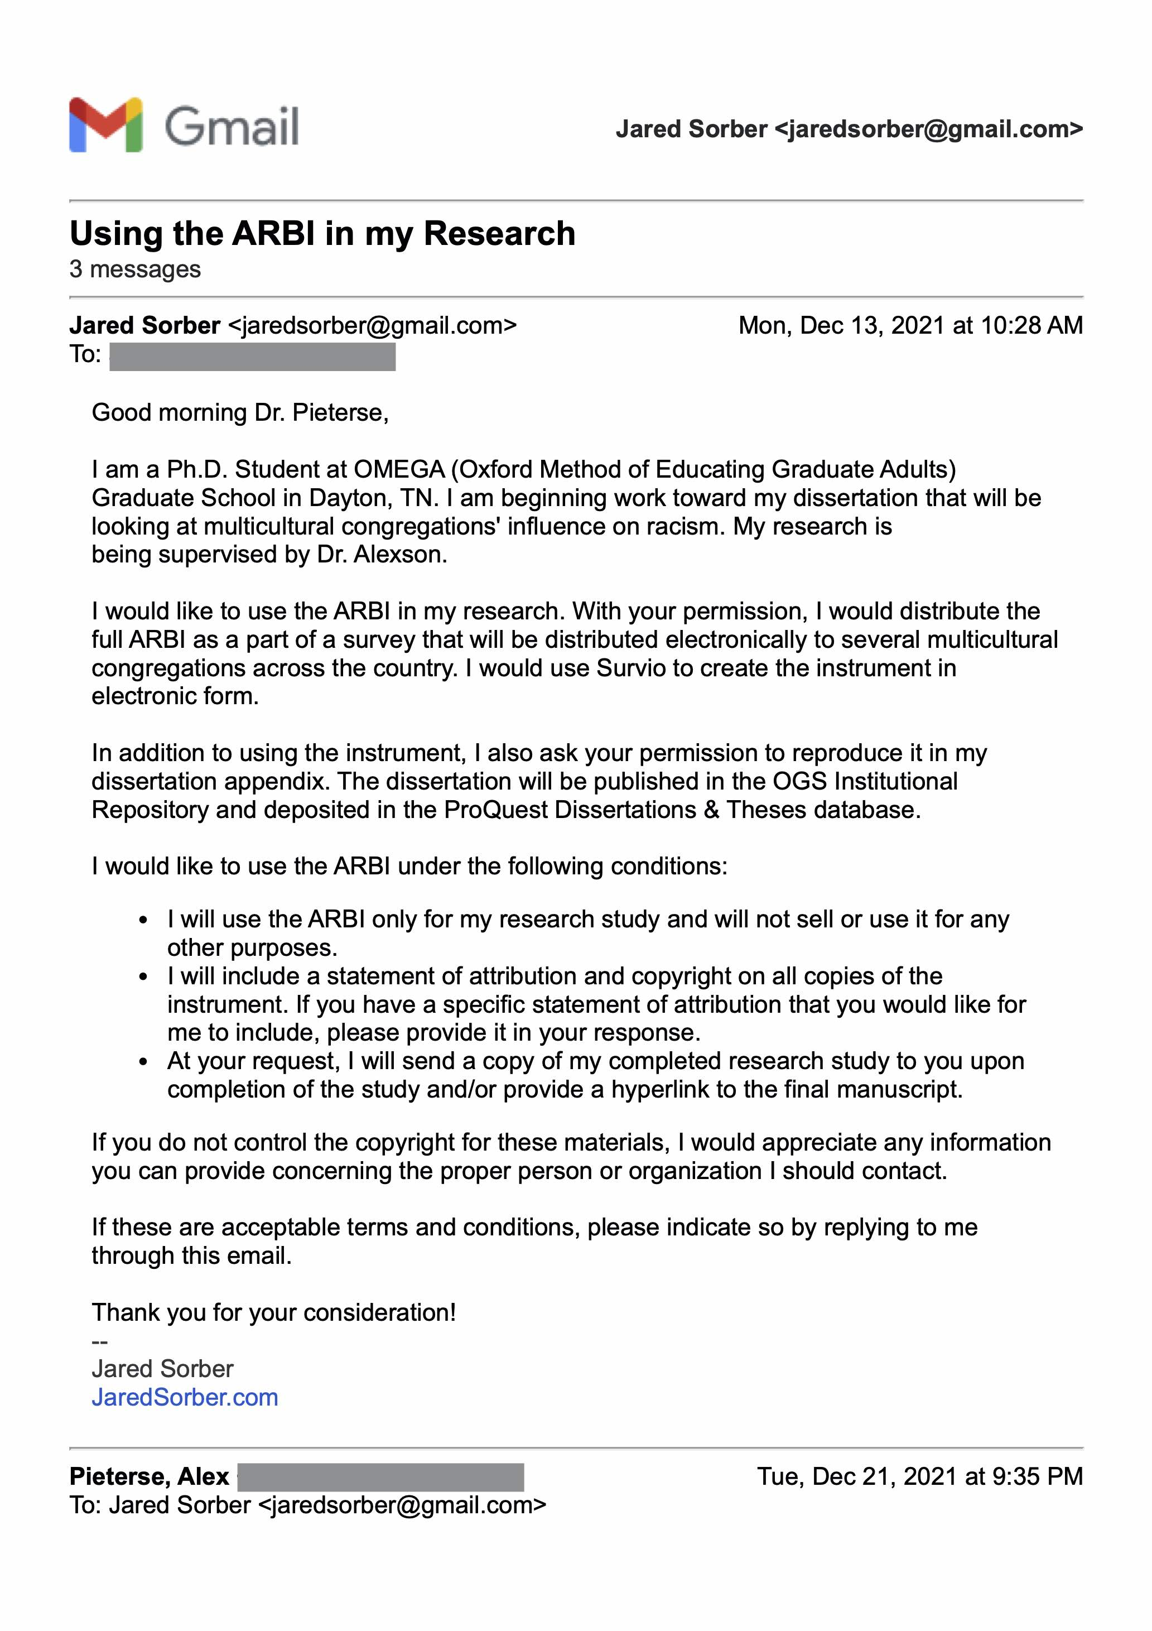

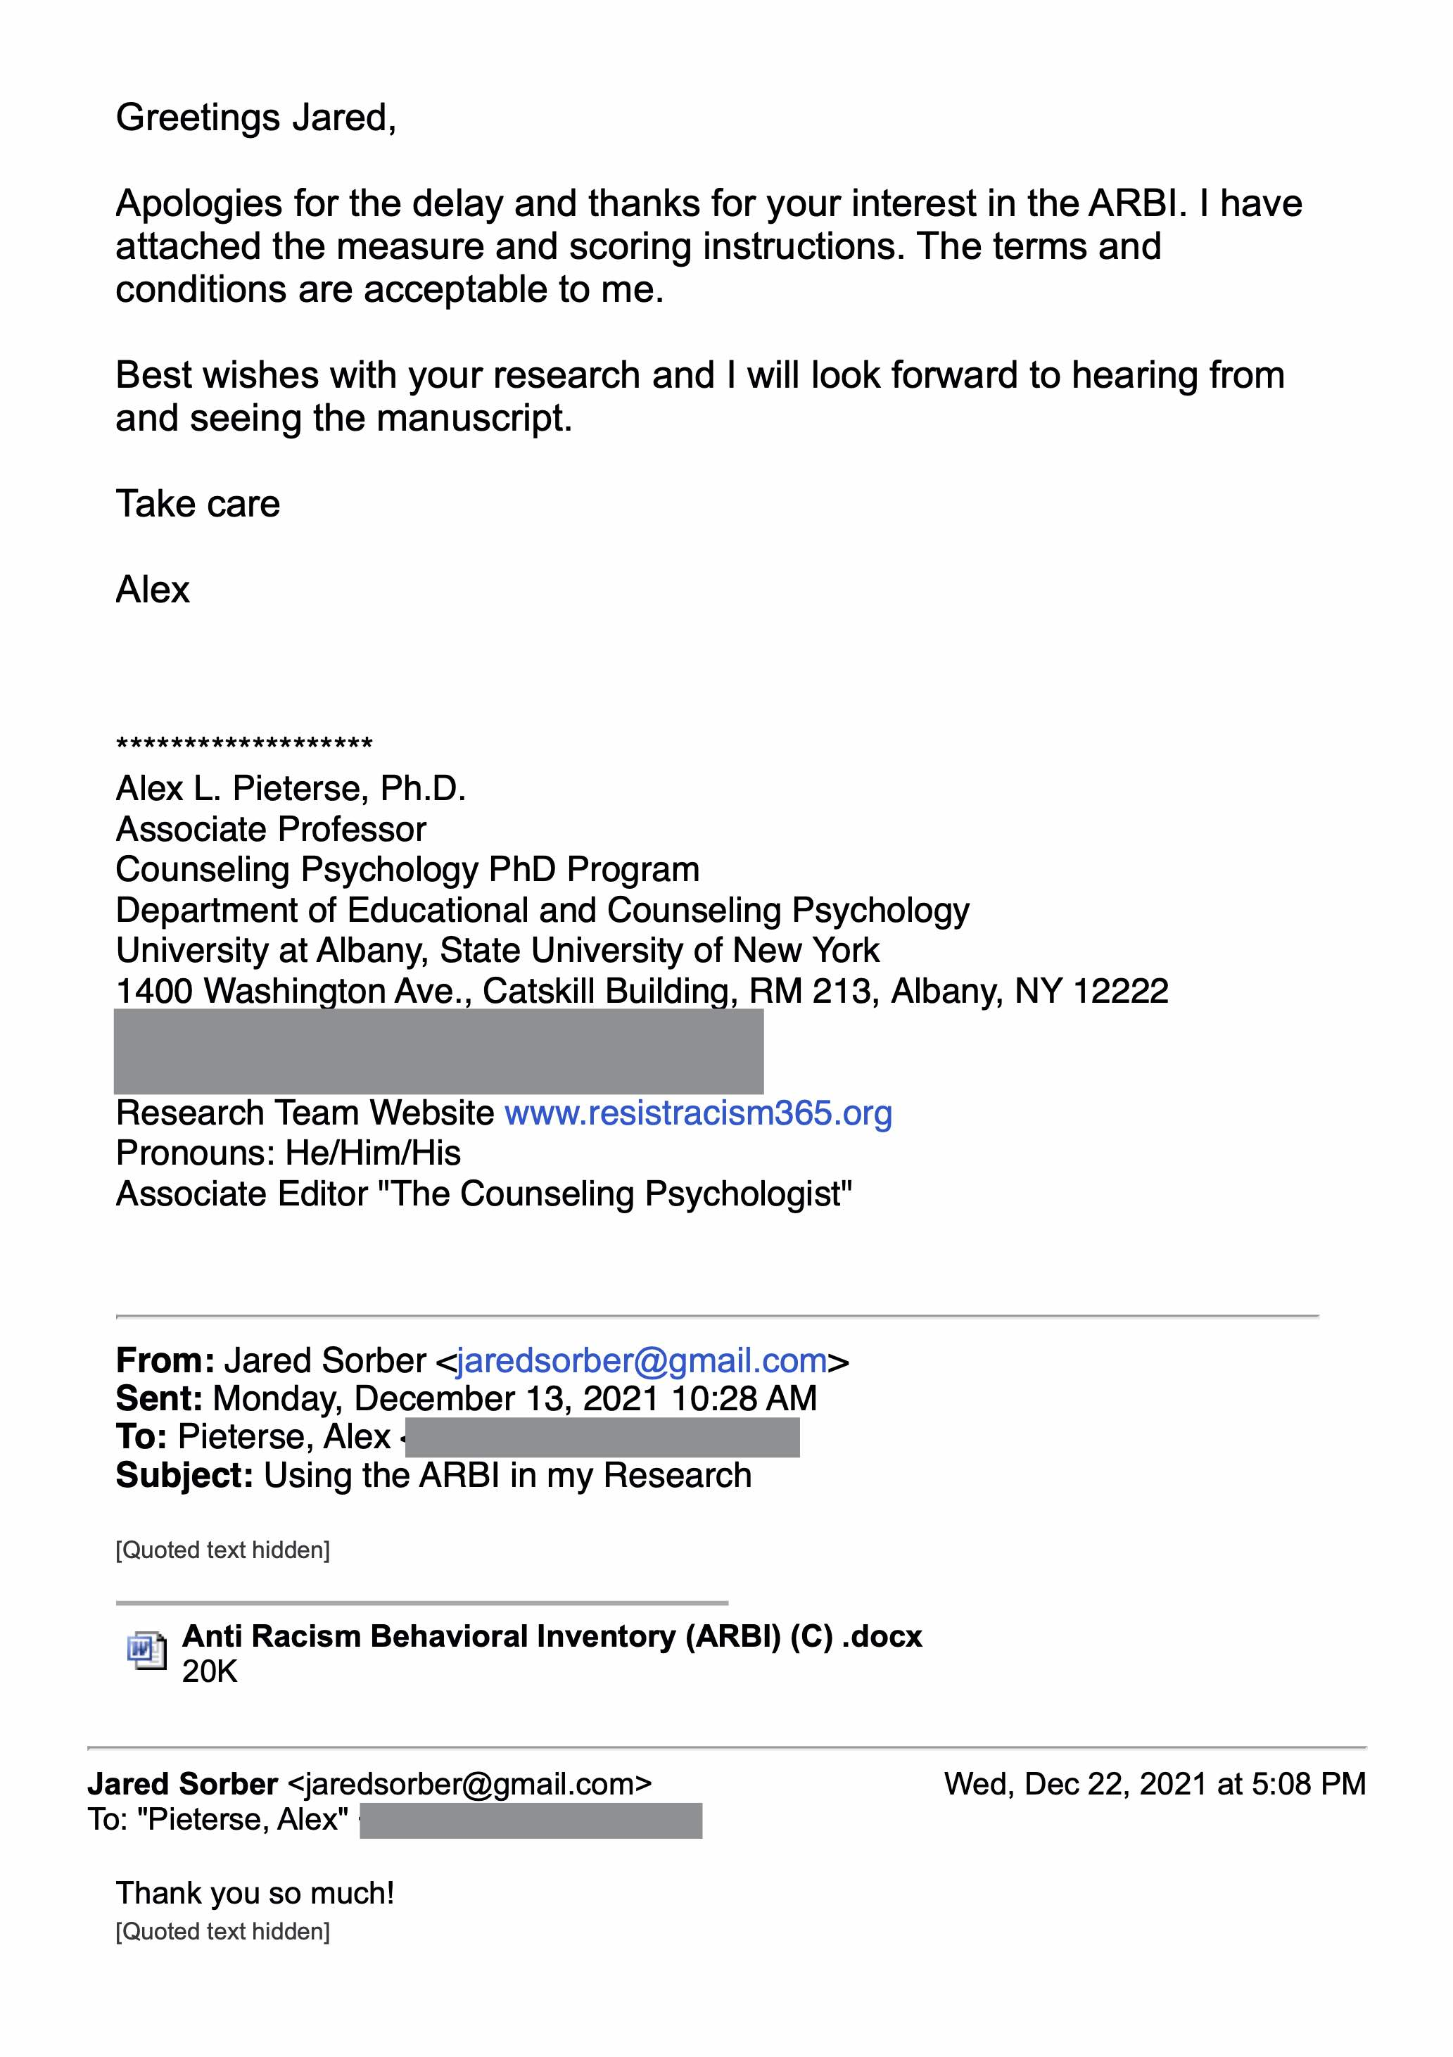

Appendix B: THE SHORT FORM CULTURAL INTELLIGENCE SCALE

Instructions and Instrument

Cultural Intelligence David C Thomas et al. (2015)

Instructions: Below are 10 statements about one’s experience when interacting with people from other cultures. Please indicate to what extent each of the following statements describes you.   
1=Not at all; 2=A little; 3=Somewhat; 4=A lot; 5=Extremely well

1. I know the ways in which cultures around the world are different. (K)
2. I can give examples of cultural differences from my personal experience, reading, and so on. (K)
3. I enjoy talking with people from different cultures. (S)
4. I have the ability to accurately understand the feelings of people from other cultures. (S)
5. I sometimes try to understand people from another culture by imagining how something looks from their perspective. (S)
6. I can change my behavior to suit different cultural situations and people. (S)
7. I accept delays without becoming upset when in different cultural situations and with culturally different people. (S)
8. I am aware of the cultural knowledge I use when interacting with someone from another culture. (M)
9. I think a lot about the influence that culture has on my behavior and that of others who are culturally different. (M)
10. I am aware that I need to plan my course of action when in different cultural situations and with culturally different people. (M)

K = Knowledge Item.  
S = Skill Item.  
M = Metacognition Item.

Permission to use the Instrument

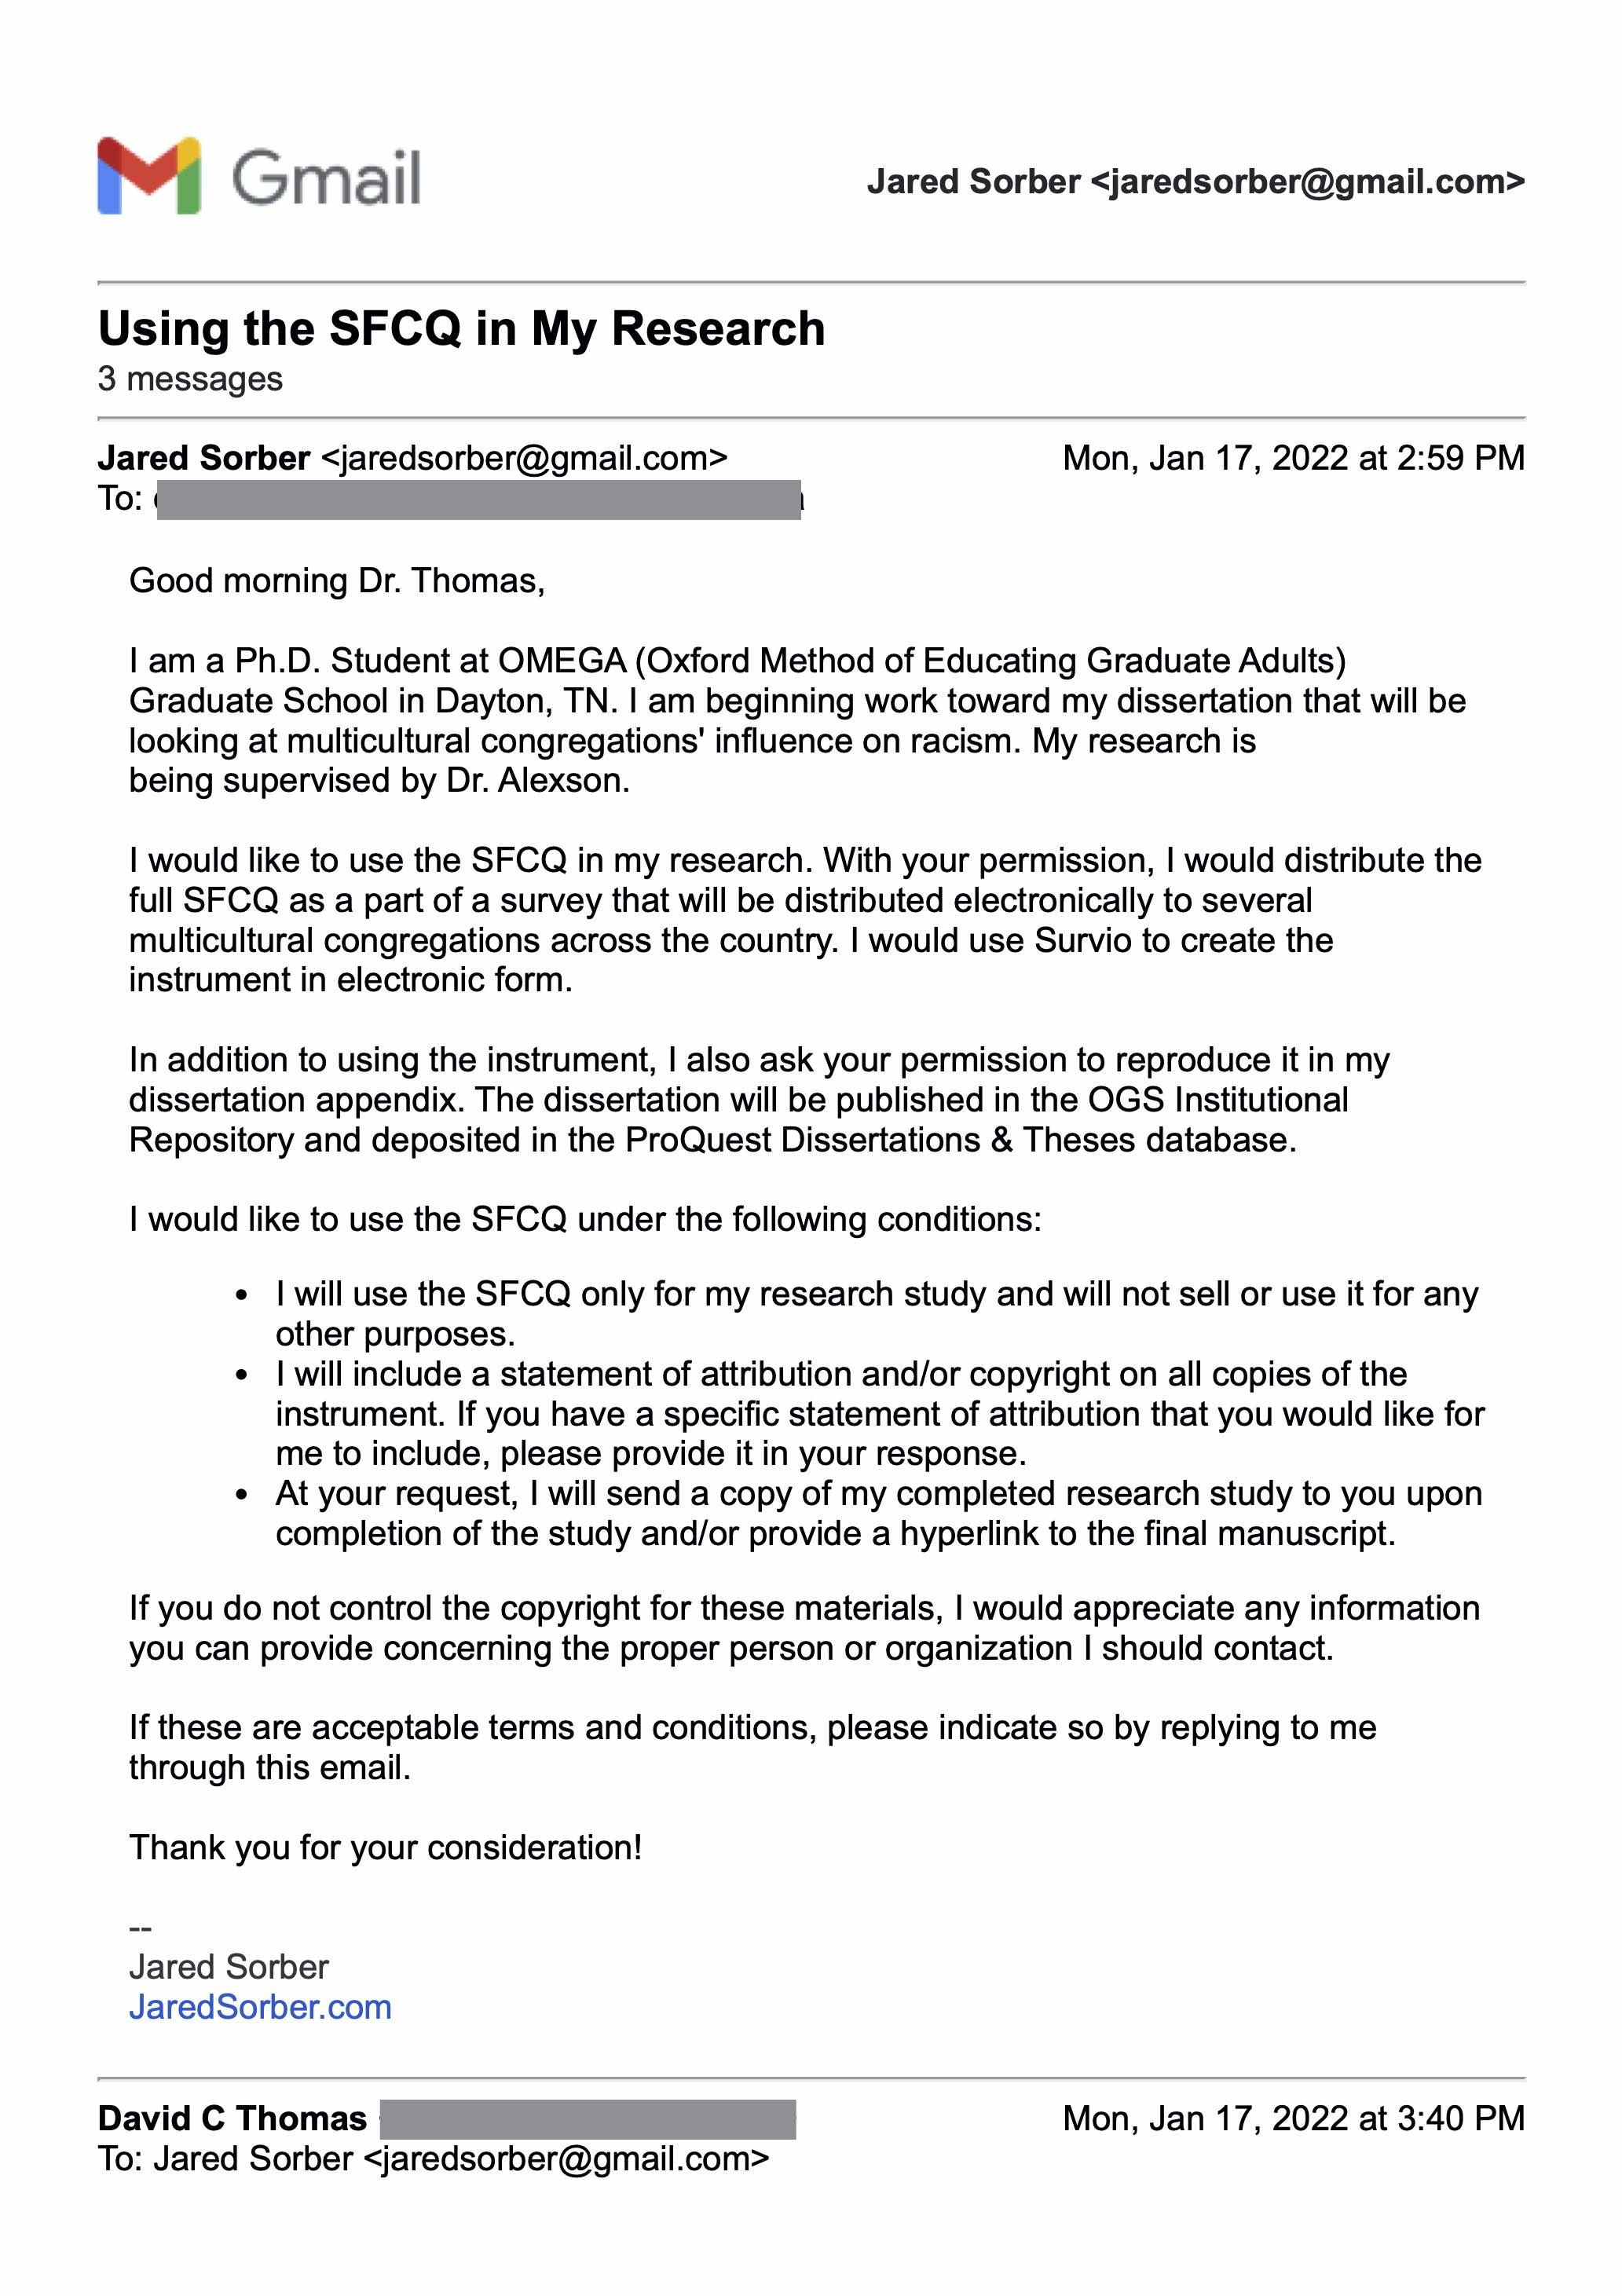

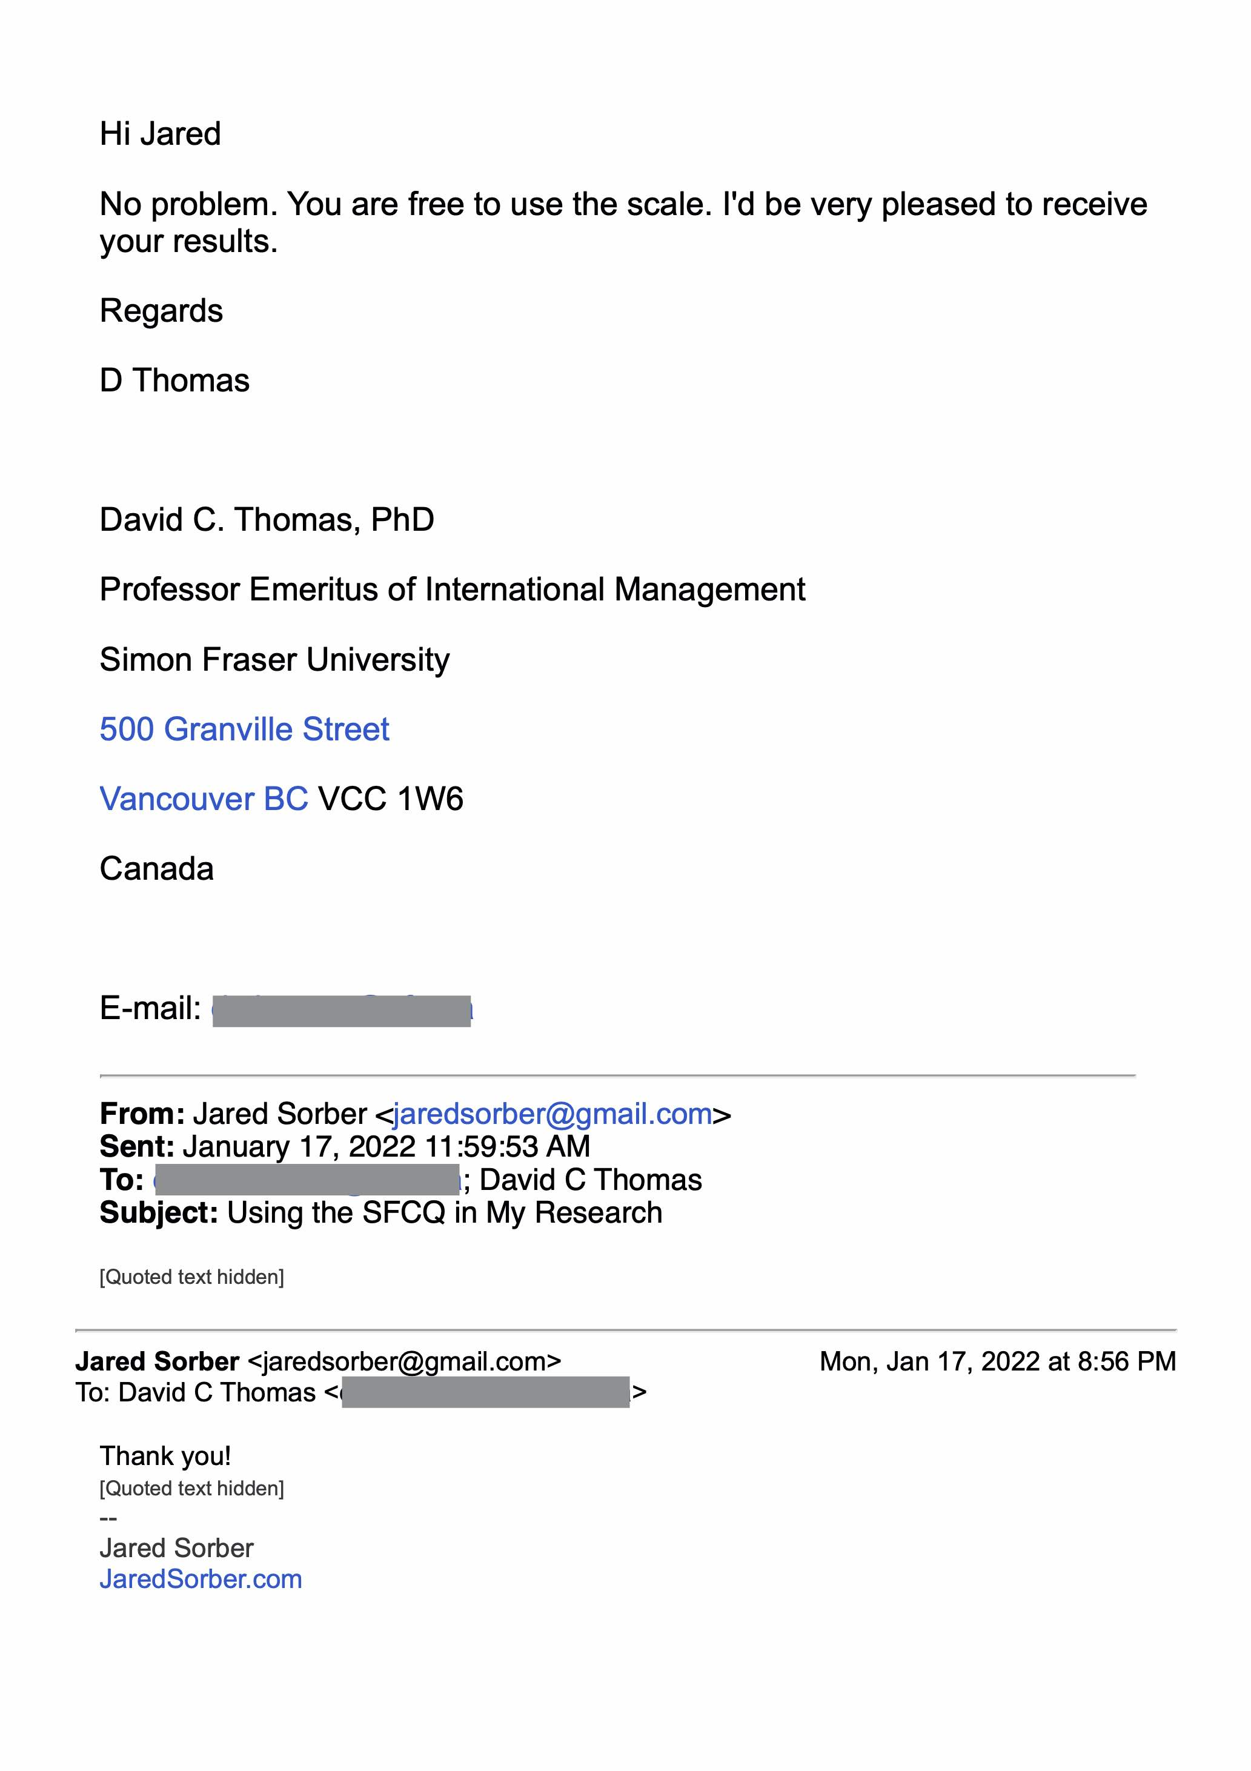

APPENDIX C: RESPONDENT DEMOGRAPHIC QUESTIONNAIRE

1. What is your age, in years?

* 18-29
* 30-44
* 45-59
* 60-74
* 75+

1. What is your gender?
   * Male
   * Female
   * Other: _____________
2. Which of the following describes your race/ethnicity (choose one)?
   * American Indian or Alaska Native (non-Hispanic)
   * Asian or Asian American (non-Hispanic)
   * Black or African American (non-Hispanic)
   * Hispanic
   * Native Hawaiian or Other Pacific Islander (non-Hispanic)
   * White or Caucasian (Non-Hispanic)
   * Biracial or Multi-Racial (please specify): _______________
   * Other (please specify): _______________
3. What is the highest-level education you completed?
   * Did not complete high school
   * High school diploma or equivalent
   * Trade School Certificate or Associates Degree
   * College (BA or BS or equivalent)
   * Masters or equivalent
   * PhD, MD, or other Terminal Degree
4. How long have you been a Christian?

* I am not a Christian
* 4 years or less
* 5 to 9 years
* 10 to 19 years
* 20 to 30 years
* More than 30 years

1. What language(s) do you speak fluently?

* English
* Spanish
* Chinese
  + Cantonese
  + Mandarin
  + Hokkien
  + Other:
* Korean
* French
* Other:

1. In what country were you born?

* United States
* Other (please specify): ______________

1. Are you currently a citizen of the United States?

* Yes
* No (please list your country or countries of citizenship): _________________

1. What church do you attend most regularly?

* Bridgeway Community Church
  + Columbia, MD
  + Owings Mills/Reisterstown, MD
* Grace Community Church, Greensboro, NC
* New Life Church, Virginia Beach, VA
* Reignite Church, Virginia Beach, VA
* The Garden Church, Baltimore, MD

1. For how long have you attended the church you selected above?

* 0-3 years
* 4-7
* 8-11
* 12+

1. Is your church diverse? (multicultural/multiethnic)

* Yes
* No

1. Which of the following best describes your recent church attendance?

* At least once a week,
* two to three times a month,
* Monthly,
* Holidays and special occasions.

1. I regularly attend church…

* In-person
* Online
* Both in-person & online
* I don’t attend regularly

1. Is your spouse of the same ethnicity as you?

* Yes
* No
* I am not married

1. What is your role at your church (check all that apply)?

* Attendee
* Member
* Volunteer
* Ministry Leader
* Staff
* Clergy

APPENDIX D: INFORMED CONSENT FORM

**INFORMED CONSENT FORM  
SOCIAL SCIENCE RESEARCH STUDY**

The relationship between multicultural church attendees’

Cultural Intelligence and response to racism.

**Researcher:** Jared Sorber, Doctoral Candidate, Omega Graduate School

**Researchers’ statement**

I am asking you to be in a research study. The purpose of this consent form is to give you the information you will need to help you decide whether to be in the study or not. Please read the form carefully. You may ask questions about the purpose of the research, what we would ask you to do, the possible risks and benefits, your rights as a volunteer, and anything else about the research or about this form that is not clear. When I have answered all your questions, you can decide if you want to be in the study or not. This process is called “informed consent.” I will give you a copy of this form for your records.

**Purpose of the study**

This study aims to evaluate the potential relationship between multicultural church attendees’ Cultural Intelligence (CQ) and response to racism. Participation in this study will help expand knowledge on the relationship between Cultural Intelligence and the response to racism of multicultural church attendees, equipping attendees to address racism and bridge cultural divides in their family, community, church, and society.

**Study Procedures**

The study consists of completing a demographic questionnaire and answering two survey question sets consisting of a total of 31 items. The surveys are self-assessed; one asks questions about your Cultural Intelligence (10 questions), and the other asks about your response to racism (21 questions). In total, the demographics survey and questionnaires should take approximately 15 minutes to complete. The data you provide is used for academic purposes, further research, and potential funding for future projects intended to improve multicultural churches and how they cross cultures and respond to racism.

**Alternatives to participating in this study**

Participation in this study is voluntary; you have the option not to participate or stop filling out the instruments at any point. Only 100% completed questionnaires will be used in the study.

**Benefits of the study**

The expected benefits of this study are to inform and aid the multicultural church in increasing its attendees' Cultural Intelligence and responding to racism.

**Confidentiality of research information**

All of the information you provide will be confidential. All data is coded by a unique identifier associated with your answer. The researcher has no access to identifiable data. The data collection does not elicit information that would require mandatory reporting (e.g. about child abuse, elder abuse, or harm to self or others).

**Contact information:**

Should you have any questions or concerns, please contact the researcher. Jared Sorber, Email: [JaredSorber@gmail.com](mailto:JaredSorber@gmail.com), Phone: 443-812-4147

An Institutional Review Board (“IRB”) is overseeing this research. An IRB is a group of people who perform an independent review of research studies to ensure the rights and welfare of participants are protected.

The Omega Graduate School Institutional Board of Review has reviewed my request to conduct this research project. If you have any concerns about your rights in this study, please contact the OGS IRB at ogsirb@ogs.edu.

**Subject’s statement**

This study has been explained to me. I volunteer to take part in this research. I have had a chance to ask questions. If I have questions later about the research or if I have been harmed by participating in this study, I can contact the researcher or the IRB.

Your Name:

Date:

Are you 18 years or older?

Informed consent statement:

By clicking yes, you are consenting that you are willing to participate in this study.

APPENDIX E: OFFICE FOR HUMAN RESEARCH PROTECTION





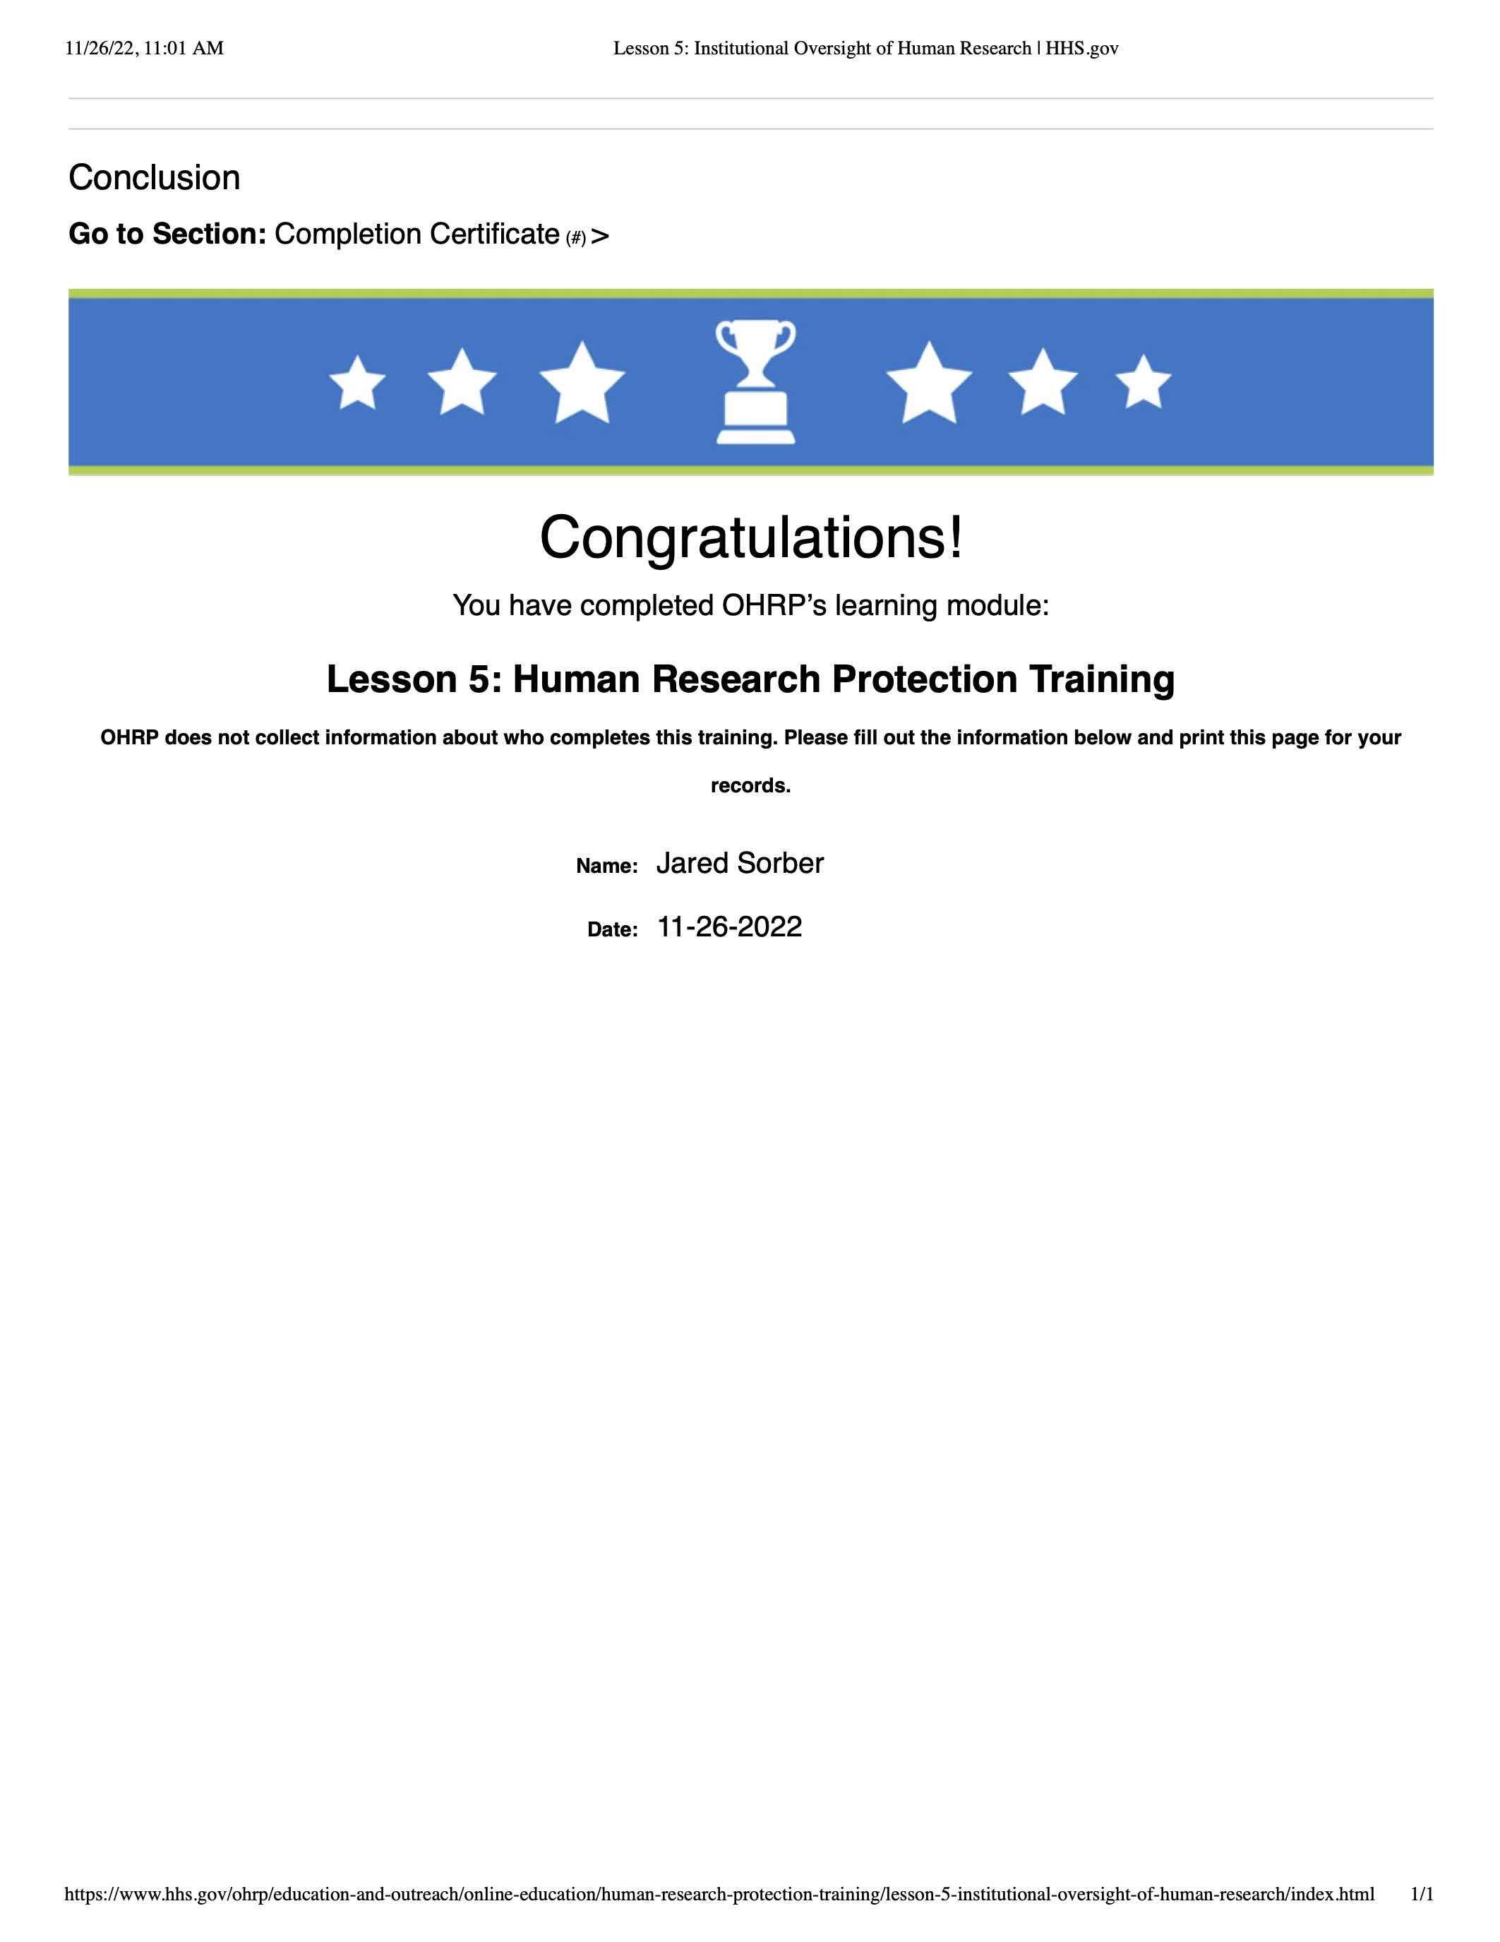

APPENDIX F: RAW DATA

Table 9

*Demographic Survey Raw Data*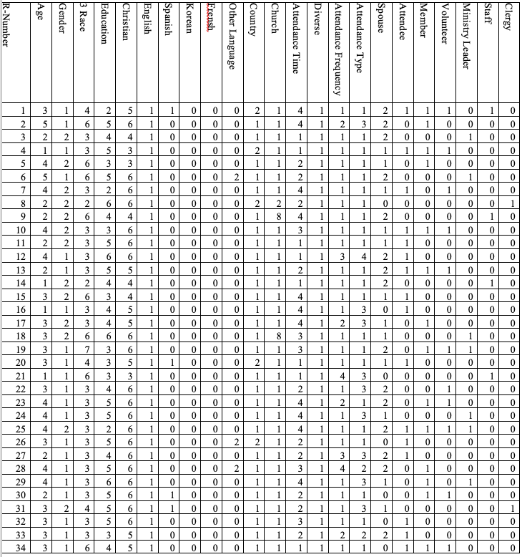

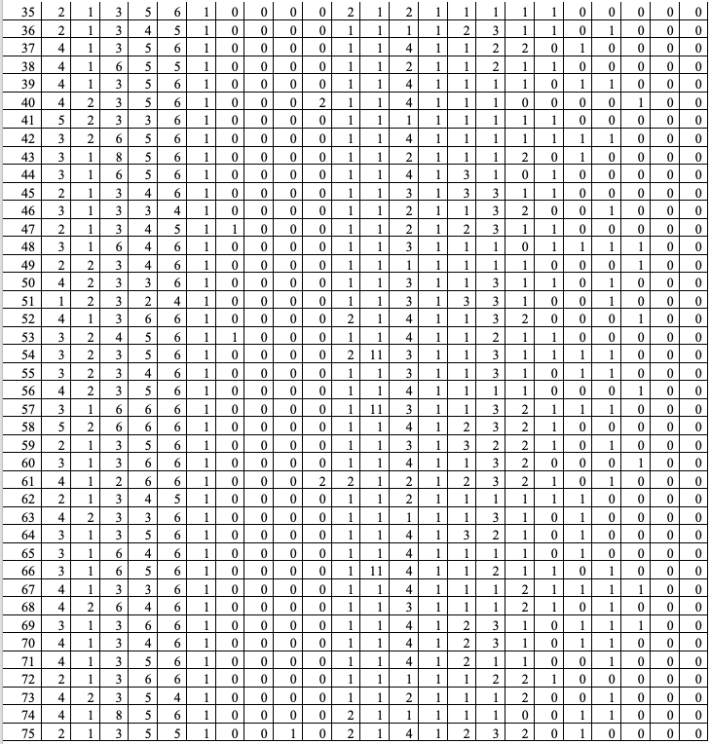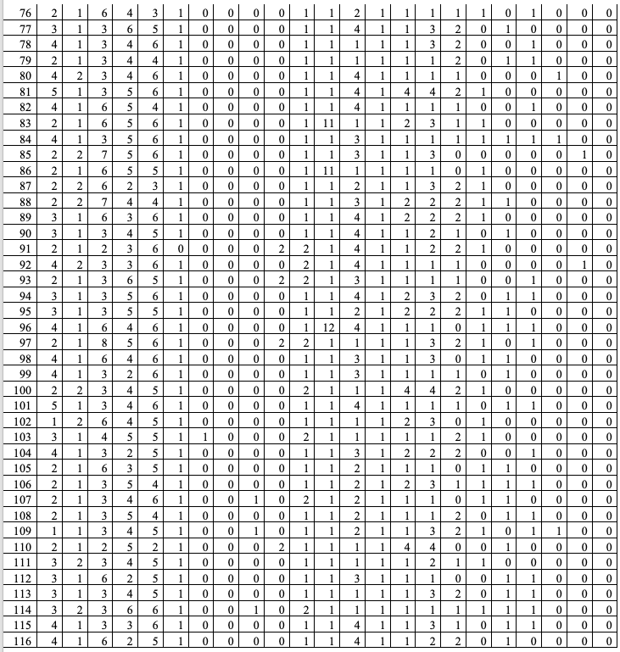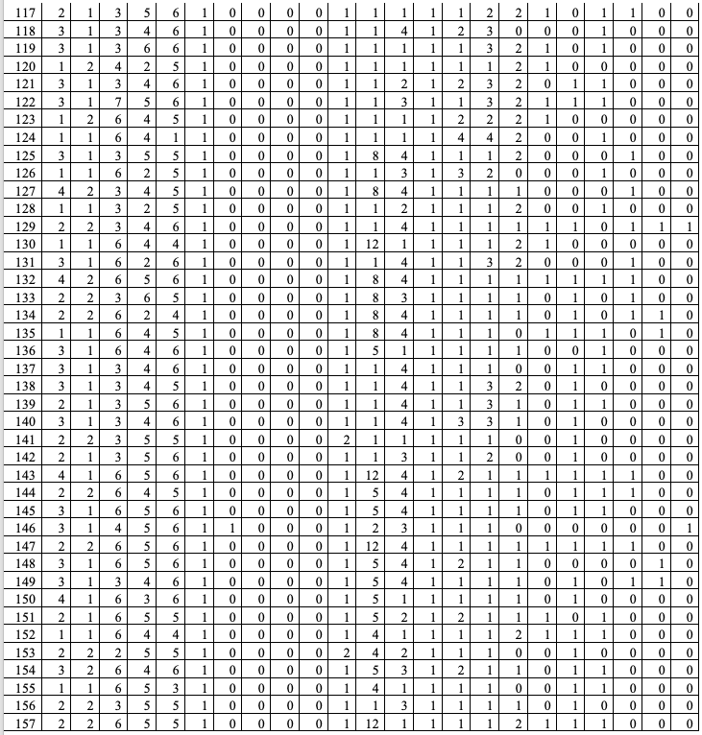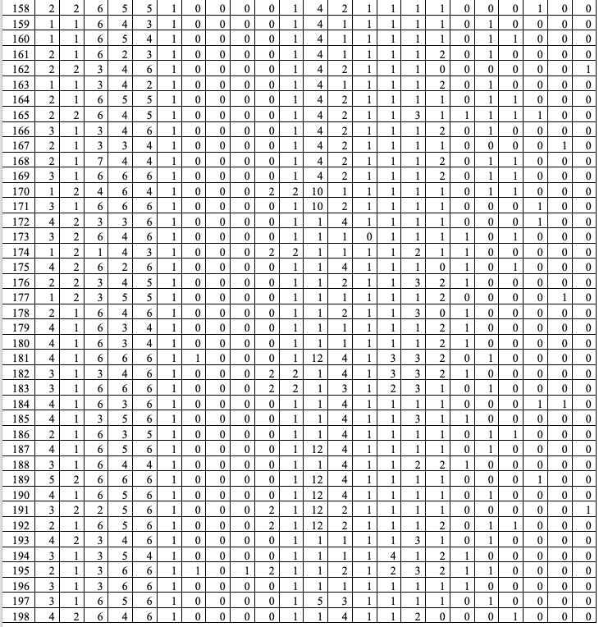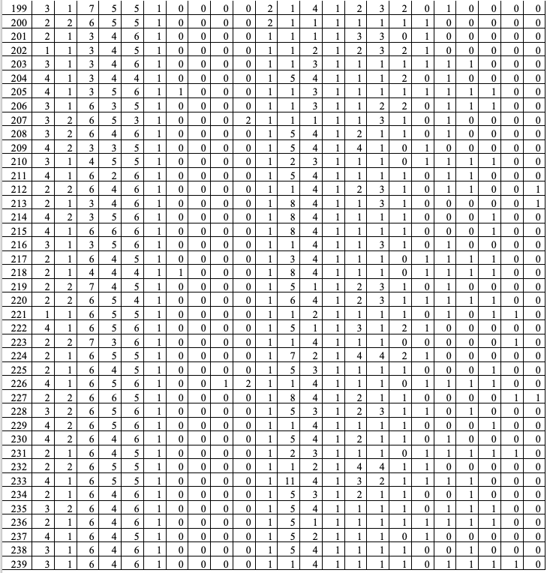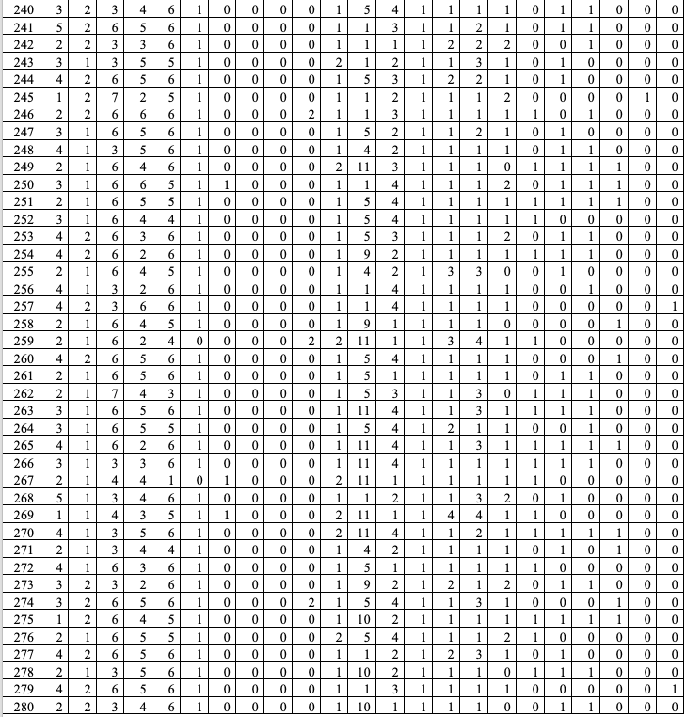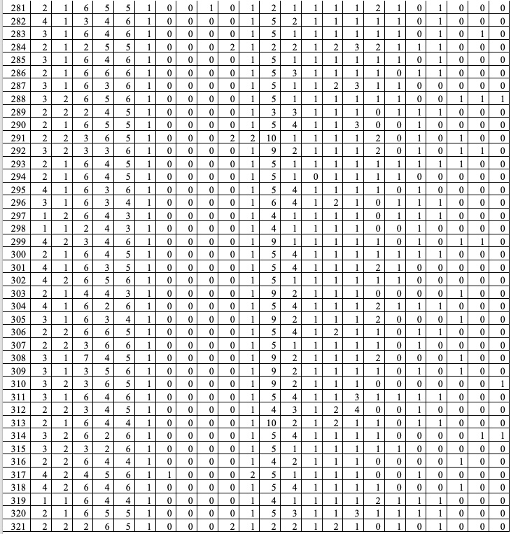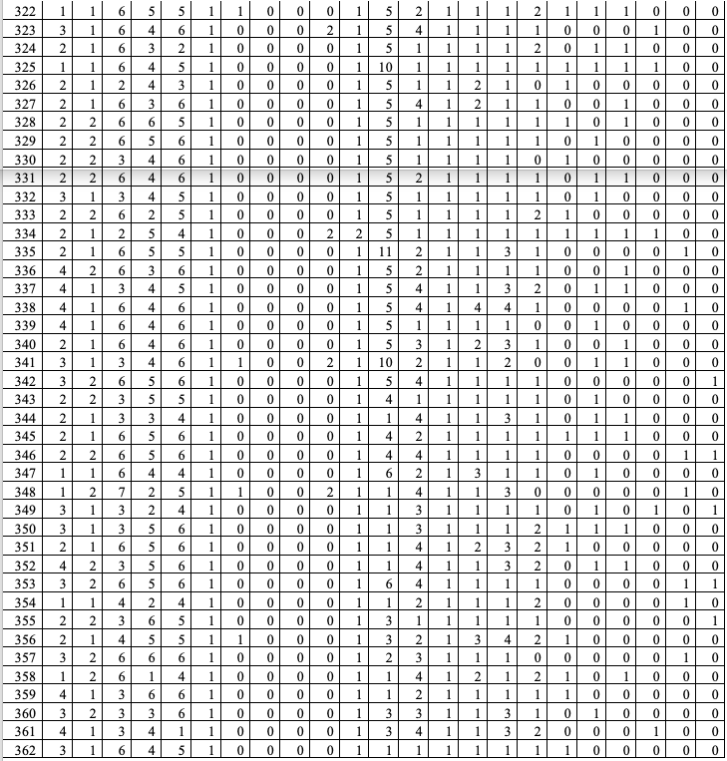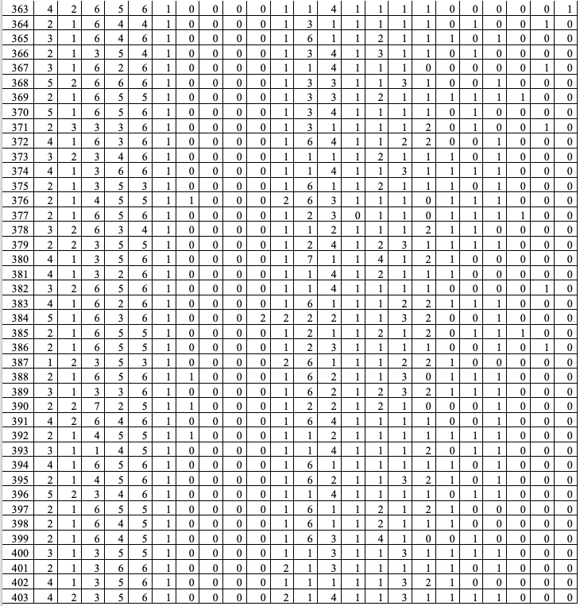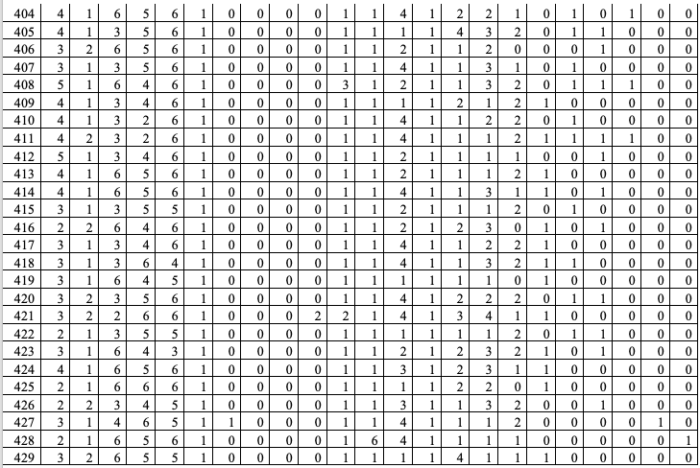

**Table 10**

The Anti-Racism Behavioral Inventory Raw Data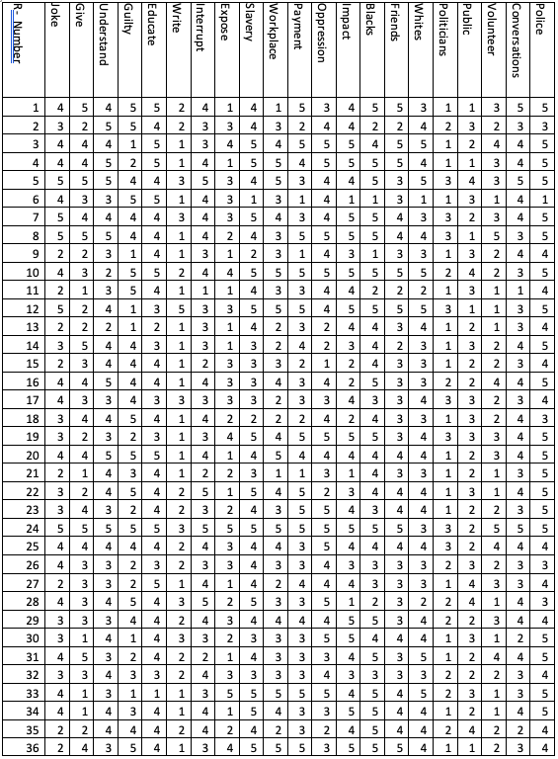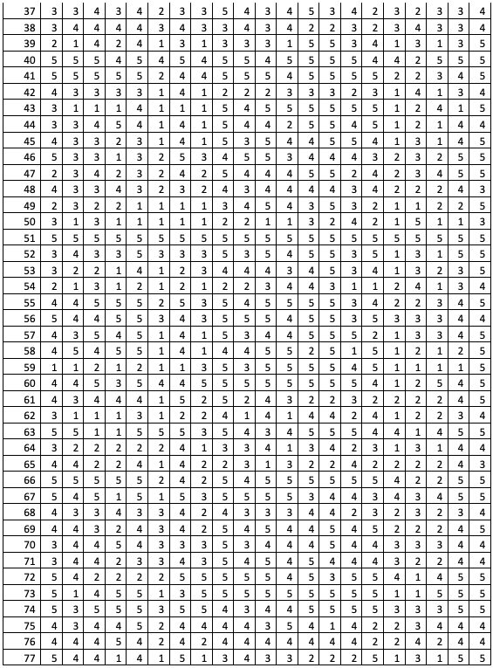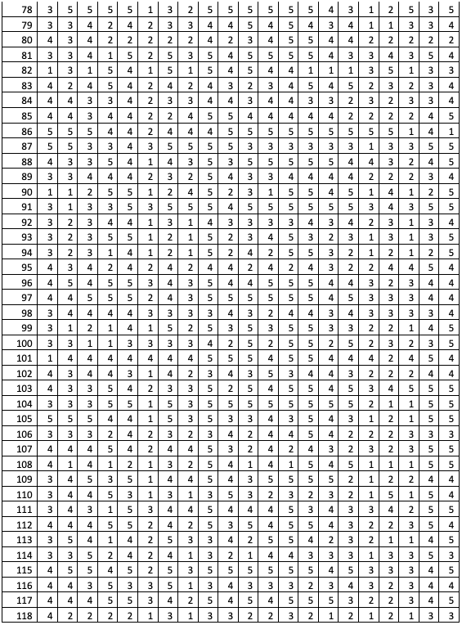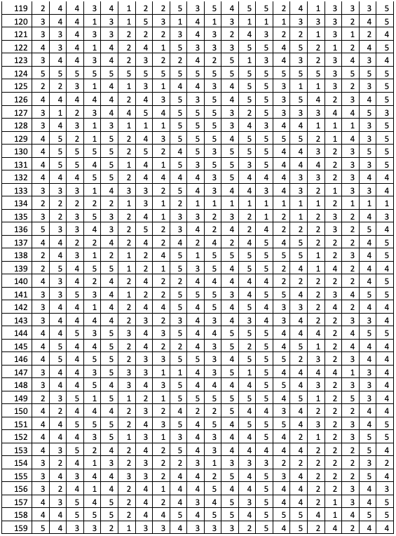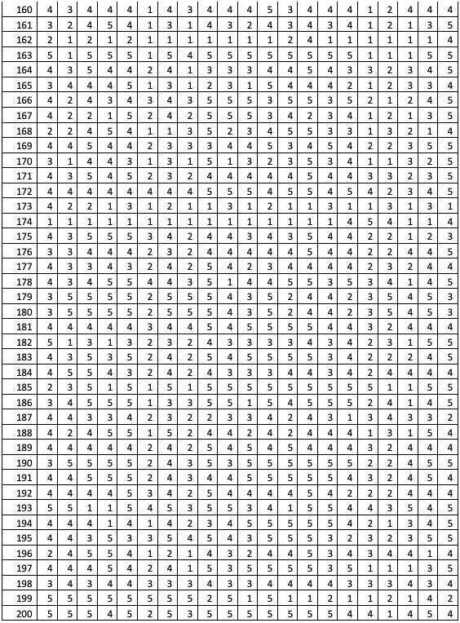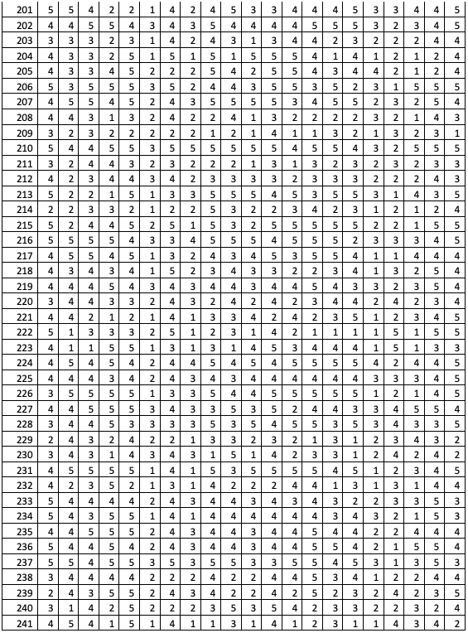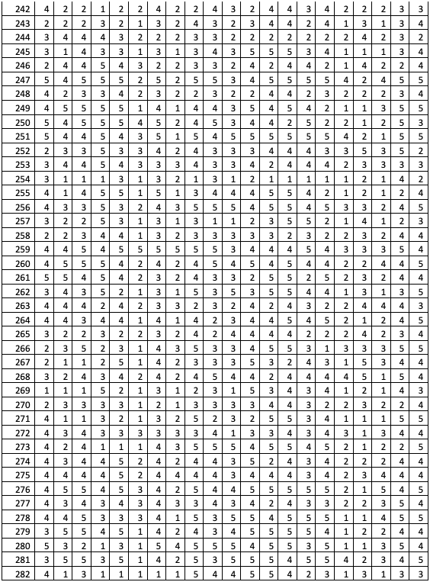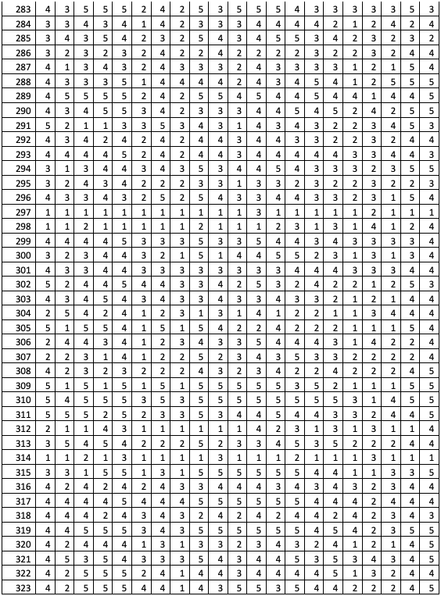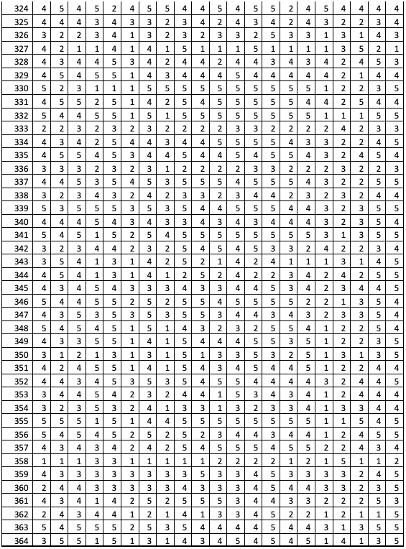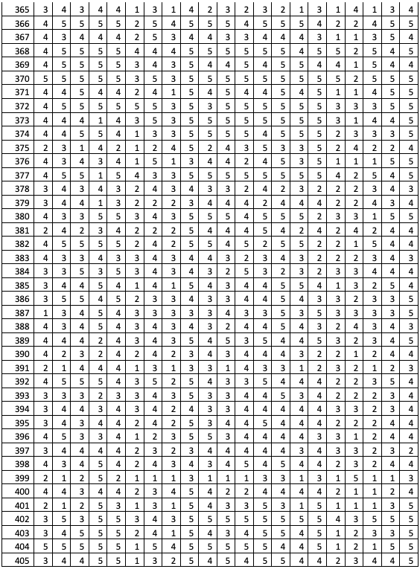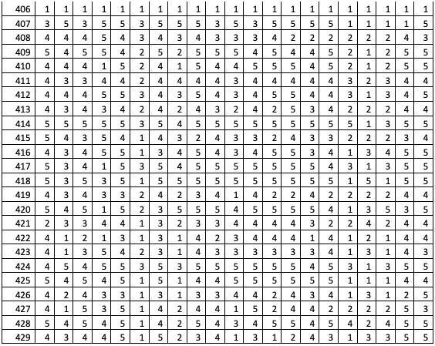

**Table 11**

*The Short Form Cultural Intelligence Survey Raw Data*

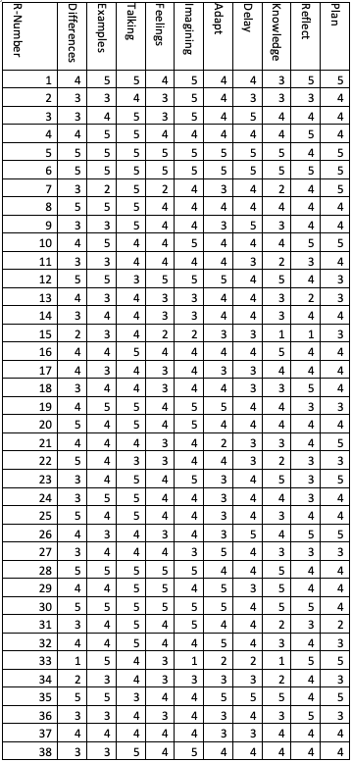

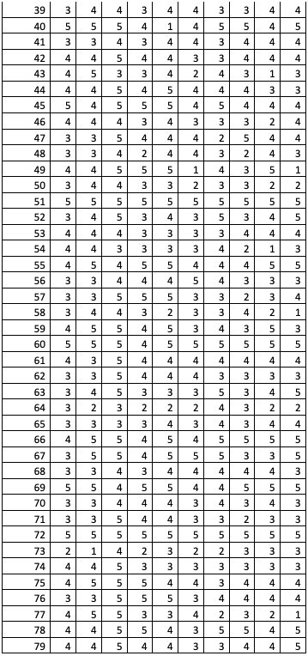

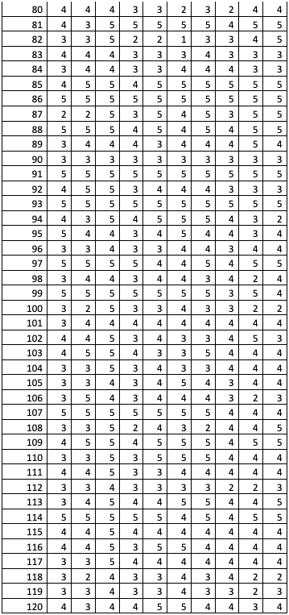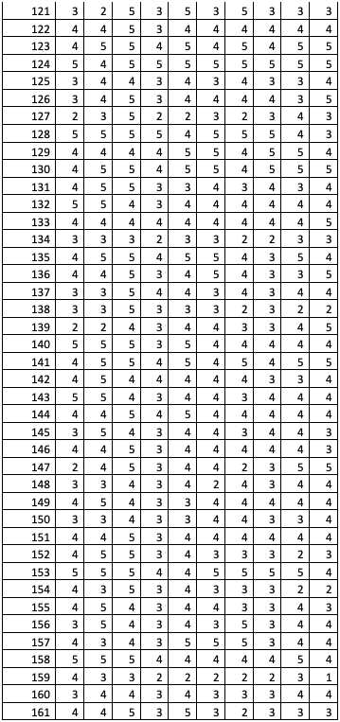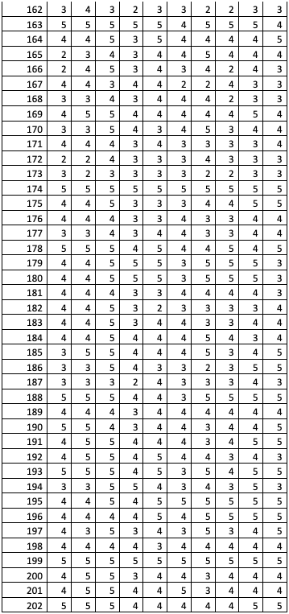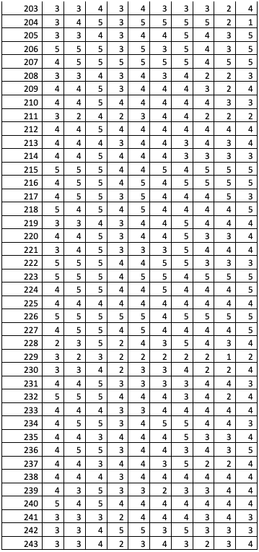

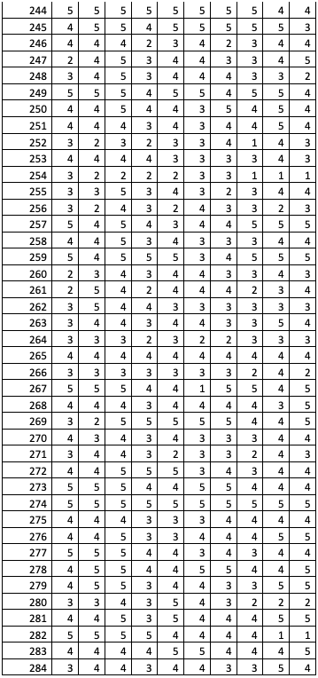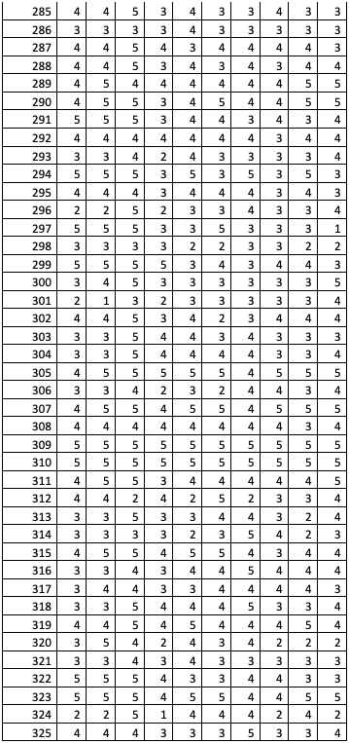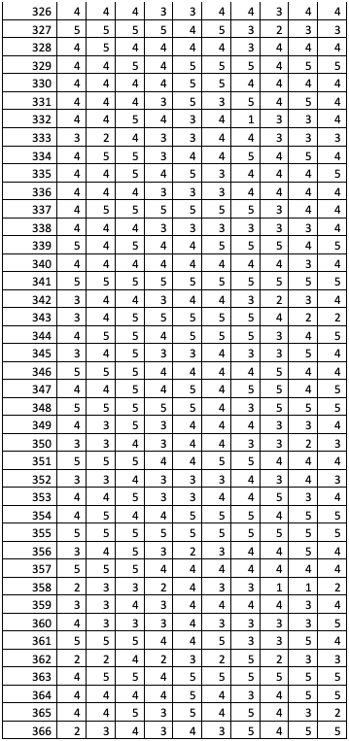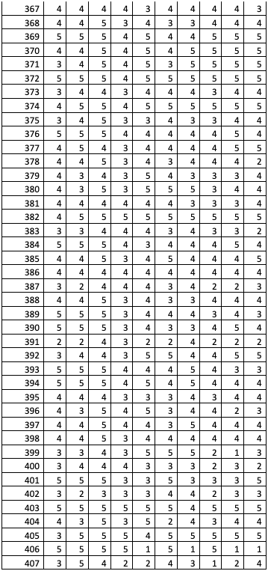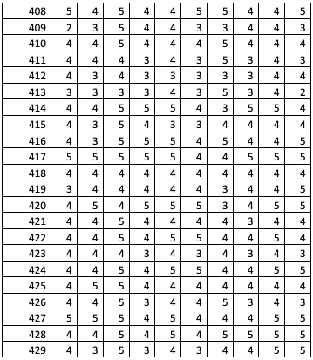

CURRICULUM VITAE

Jared Sorber received his Bachelor of Religious Education from Davis College in Binghamton, New York, in 2000. He received a Master of Arts degree in Ministry in 2008 from Moody Graduate School in Chicago. He attended Omega Graduate School from 2019 through 2023, during which he completed a doctoral program, receiving a PhD. in the integration of religion and society. Sorber has worked at Bridgeway Community Church in Columbia, MD, since 2000. While at Bridgeway, Sorber has held many leadership positions, including the director of Student Ministries, Pastor of Family Ministries, Pastor of Events and Logistics, Creative Arts Pastor, Missions Pastor, and has served on the senior leadership team. In 2003 Sorber was licensed as a minister of the gospel, and in 2006 was ordained as a Pastor. Sorber has written for ministry publications on multicultural effectiveness, cross-cultural bridge-building, and racial reconciliation. His writings include a curriculum on living the life of a reconciler and a chapter on youth ministry in the Multi-Cultural Ministry Handbook (Anderson & Cabellon, 2010). Sorber has spoken at local, regional, national, and international conferences on multicultural effectiveness, cross-cultural bridge-building, and racial reconciliation, particularly in their application to youth ministry, family ministry, and missions. He has developed partnerships with leaders and organizations around the world, believing that when diverse groups of people from different backgrounds and perspectives work together in relationship, the ministry impact is more significant, and the journey is more fulfilling for everyone. Partnerships have been established in Kenya, Mexico, Romania, Ukraine, and Peru.