**The Dwindling Attendance and Church Growth in the U.S.**

**The Socio-Cultural Contextualization**

**PHI 923 Contextualization for Social Change (Spring 2023)**

**Peter Abraham Airewele**

**Omega Graduate School**

**Professor David Moser (CAO’s, TA)**

**April 8, 2023**

**100 Day – Assignment**

Write an 8-10 page essay on a contextualization issue for social change. Page count does not include the cover and works cited pages. The essay should demonstrate scholarly work and cover the subject sufficiently to communicate a solid understanding of applying foundational.

Christian worldviews, and proper APA 7 style documentation for the resources (works cited). Follow these steps to develop the essay.

1. Develop your essay according to the outline in the Strategy Worksheet found in the

100-Day assignment document.

○ Identify a social issue or phenomenon needing a Christian contextualized response.

○ Reflect on Stage 5 of the Interdisciplinary Research Process

○ Consider the Five Spheres of Life as you consider your strategy for

contextualizing a social concern.

○ See sample essays on Contextualization in the PHI 923 Course Resources

folder.

2. Structure (Paper Evaluation includes the following structure below).

a. Download the “OGS APA Course Assignments Template 7th Ed 2021” template

from the General Helps folder in the AA-101 The Gathering Place Course on

DIAL. Using the template, create the following pages.

b. Title Page (not included in page count).

c. Copy and paste the assignment instructions from the syllabus, starting on a new

page after the title page, adhering to APA 7th edition style (APA 7) Workshop,

Formatting, and Style Guide, APA 7 Quick Guide).

d. Start the introduction on a new page after the copied assignment instructions.

3. Be sure to meet the following expectations.

a. Document all sources in APA style, 7th edition (APA 7 Reference Example, APA 7 Quick Guide).

b. Include a separate Works Cited page, formatted according to APA style, 7th edition (not included in page count).

c. Use at least seventeen scholarly research sources (three to four books and the remaining peer-reviewed journal articles).

4. Submit the completed paper to DIAL.

3. Review the Examples of Contextualization provided in the PHI 923 Course Resources in DIAL. Then, provide responses to the following Strategy Worksheet based on your selected cultural issues or phenomenon.

* A. Present Situation of Social Concern – describe the situation requiring a contextualized Christian response to a cultural situation or phenomenon.
* B. Social Analysis: (Family, Church, Society) – Using the Five Spheres of Life, develop a cultural analysis to comprehensively describe aspects of the situation or phenomenon.
* C. Theological/Moral Evaluation – Identify Biblical areas or Kingdom principles relevant to the issue.
* D. Issues to Address – Identify underlying/related issues that must be addressed in the contextualization strategy.
* E. Spectrum of Critical Contextualization (address only relevant ones)

a. Condemnation – includes issues condemned by Scripture (i.e., erroneous doctrine,

idolatry, or Syncretism)

b. Correction of Erroneous Emphases – cultural beliefs/practices containing true

insights but are diluted with the wrong focus.

c. Conversion of Themes – beliefs/practices with no significant negative influence but

can be used to point to Christ

d. Commendation of Good Belief and Practices – beliefs/practices in a culture that

are entirely consistent with Scripture but exists without a religious warrant are to

be commended

*F. Strategy for Contextualized Communication/Action for Social Change - develop a strategy by considering all the practical considerations below.

a. Stakeholders - Identify the people or groups who have a stake in the phenomenon

or issue.

b. Venues of Communication - These could be written or spoken and could involve

media, or social or organizational networks.

c. Resources - Identity available and needed resources.

d. Timelines - Begin to think through the timeline or logistical issues involved in

implementing a contextualization strategy.

e. Obstacles to Anticipate - Anticipating obstacles can add practical aspects to a

a strategy that can help it to succeed.

**Point of Note:**

* **The graphical, illustrative diagrams in Fig. 111 to Fig. 116** and extracts on the impact of Generational Change and Decline in Church membership on pg 4-9 of this Study are culled from:

Jones, J. M. (2021). U.S. church membership falls below the majority for the first time. *Gallup News*.

* Jones, J. M. (2021) writes: The two major trends driving the drop in church membership -- more adults with no religious preference and falling rates of church membership among people with a religion -- are apparent in each generation over time. Since the turn of the century, there has been a near doubling in the percentage of traditionalists (from 4% to 7%), baby boomers (from 7% to 13%), and Gen Xers (11% to 20%) with no religious affiliation.

**STORY HIGHLIGHTS**

* In 2020, 47% of U.S. adults belonged to a church, synagogue or mosque
* Down more than 20 points from the turn of the century
* The change is primarily due to the rising in Americans with no religious preference (Jones, 2021).

**Fig 111**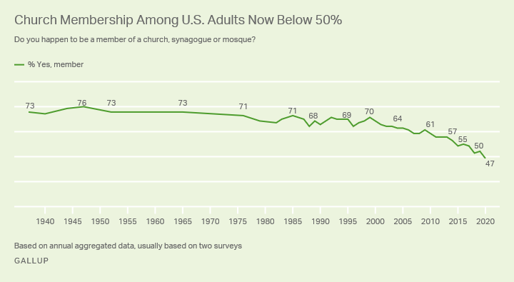

* Americans' membership in houses of worship continued to decline last year, dropping

below 50% for the first time in Gallup's eight-decade trend. In 2020, 47% of Americans

said they belonged to a church, synagogue, or mosque, down from 50% in 2018 and

70% in 1999. U.S. church membership was 73% when Gallup first measured it in 1937 and remained near 70% for the next six decades before beginning a steady

decline around the turn of the 21st century.

**Fig. 112**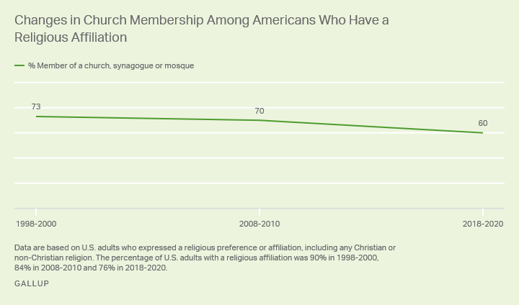

**Changes in Church Membership by Generation, Over Time**

**Fig. 113**

|  | **1998-2000** | **2008-2010** | **2018-2020** | **Change since**  **1998-2000** |
| --- | --- | --- | --- | --- |
|  | % | % | % | pct. Pts. |
| Traditionalists (born before 1946) | 77 | 73 | 66 | -11 |
| Baby boomers (born 1946-1964) | 67 | 63 | 58 | -9 |
| Generation X (born 1965-1980) | 62 | 57 | 50 | -12 |
| Millennials (born 1981-1996) | n/a | 51 | 36 | n/a |
| Note: Given that Gallup's polls are based on the 18+ U.S. adult population, the 1980-2000 period would have included only a small proportion of the millennial generation, and the 2018-2020 period includes only a small proportion of Generation Z (born after 1996). | | | | |
| GALLUP | | | | |

The two major trends driving the drop in church membership -- more adults with no religious preference and falling rates of church membership among people who do have a religion -- are apparent in each generation over time.

* Since the turn of the century, there has been a near doubling in the percentage of traditionalists (from 4% to 7%), baby boomers (from 7% to 13%), and Gen Xers (11% to 20%) with no religious affiliation.

**Fig. 114**

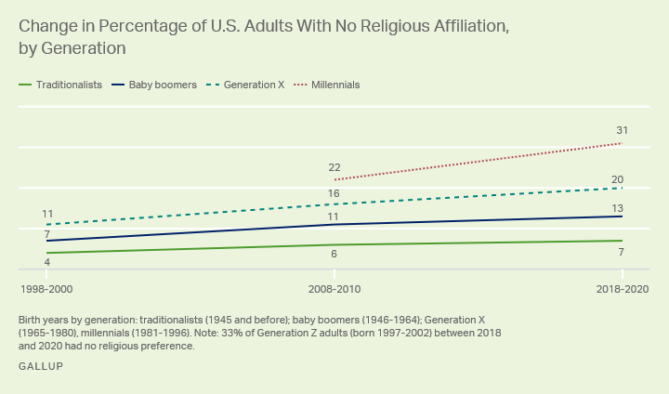

**Fig. 115**

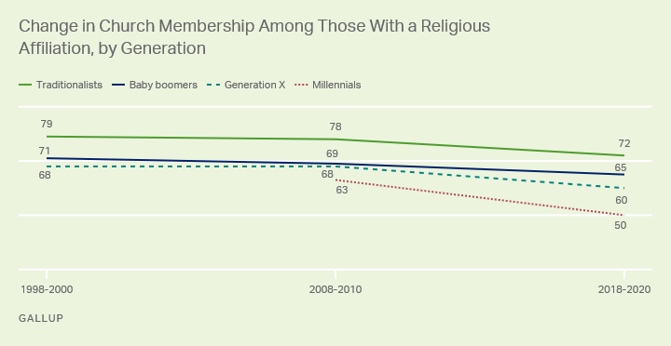

* Among religious groups, the decline in membership is steeper among Catholics (down 18 points, from 76% to 58%) than Protestants (down nine points, from 73% to 64%). This mirrors the [historical changes in church attendance](https://news.gallup.com/poll/232226/church-attendance-among-catholics-resumes-downward-slide.aspx) Gallup has documented among Catholics, with sharp declines among Catholics but not among Protestants. Gallup needs more data to analyze the trends for other religious faiths.

**Changes in Church Membership by Demographic Subgroup**

**Fig. 116**

|  | **1998-2000** | **2008-2010** | **2018-2020** | **Change, 1998-2000**  **to 2018-2020** |
| --- | --- | --- | --- | --- |
|  | % | % | % | pct. pts. |
| Men | 64 | 58 | 46 | -18 |
| Women | 73 | 65 | 53 | -20 |
| Non-Hispanic White adults | 68 | 62 | 52 | -16 |
| Non-Hispanic Black adults | 78 | 70 | 59 | -19 |
| College Graduate | 68 | 65 | 54 | -14 |
| Not college graduate | 69 | 60 | 47 | -22 |
| Married | 71 | 68 | 58 | -13 |
| Not married | 64 | 55 | 42 | -22 |
| Republican | 77 | 75 | 65 | -12 |
| Independent | 59 | 51 | 41 | -18 |
| Democrat | 71 | 60 | 46 | -25 |
| Conservative | 78 | 73 | 64 | -14 |
| Moderate | 66 | 59 | 45 | -21 |
| Liberal | 56 | 46 | 35 | -21 |
| East | 69 | 58 | 44 | -25 |
| Midwest | 72 | 66 | 54 | -18 |
| South | 74 | 70 | 58 | -16 |
| West | 57 | 51 | 38 | -19 |
| Protestant | 73 | 72 | 64 | -9 |
| Catholic | 76 | 73 | 58 | -18 |
| GALLUP | | | | |

* The smaller declines seen among conservatives and other subgroups are largely attributable to more modest changes among older generations within those groups. For example, conservatives in older generations have shown drops in church membership between five and 13 points since 1998-2000, compared with the 20-point change among all U.S. adults. Again, however, the influence of generation is apparent in that church membership is lower in each younger generation of conservatives than in each older generation -- 51% of conservative millennials, 64% of conservative Gen Xers, 70% of conservative baby boomers, and 71% of conservative traditionalists in 2018-2020 belong to a church.

**Thesis**

Several Churches in the U.S. are plagued with dwindling attendance and congregational sizes due primarily to “population changes, and generational preferences”(Jones, 2021), geographical relocation, and social changes. Other sociological factors responsible include the evolving demographics, unemployment, loss of income, and lack of socialization. Moreover, political controversies about abortion and LGBTQ discrimination are typically sensitive and continually advance the decline in Church membership faster beyond the clergies’ humble kingdom imagination. The question is, what about the Church culture and traditions of doing things or business? How appealing, accommodating, and innovative is the leadership approach for empathy and building relationships with the Church members? Are there rooms for minority representations, praise and worship songs in their local or vernacular languages, etc.? This Study will investigate the functionalities and the social structures of Christian denominations and Churches to determine what and why some of these issues are either overlooked or not well resolved. The roots of many new paradigm Churches may lie in the sixties. However, it is a mistake to think that today's churches represent the socially marginal counter values, or they may not have evolved in the last three decades (Miller, 2023, pg. 12, para. 1) . The church leadership seems to under-estimate the colossal influence the new generations of worshippers play in the affairs of Christianity within a given environment. The five significant generations include the i) Gen Z, iGen, or Centennials: 1996 – 2015; ii) Millennials or Gen Y: 1977 – 1995; iii) Generation X: 1965 – 1976; iv) Baby Boomers: 1946 – 1964; v) Traditionalists or Silent Generation: 1945. Moreover, it will determine how the US Churches can accelerate multi-cultural adaptation and the capacity to drive undiluted Biblical doctrines, and sermons that resonate with the ethnic, dominant and minority groups,

**The Dwindling Attendance and Church Growth in the U.S.**

**The Socio-Cultural Contextualization**

**Introduction**

The US Christian denominations and Churches, Catholics, Pentecostals and the Evangelicals are facing remarkable changes in population, and generational preferences causing tremendous decline in membership and Church growth for some time. This study will determine what measures can be implemented to create sustainable social structures, relationship-building, cultural diversity, and inclusion to stave off the issues identified. It will investigate why local Baby Boomers and traditionalists are primarily attracted to conservative Biblical principles and style; and why others may not. However, Mega Churches, also called Celebrity churches, attract mostly Gen Z/Centennials, Gen Ys, and some Gen Xs. There may be a conflict between biblical conservativism and progressive postmodernism. The ideals of religious conservativism appeal to Gen X, baby boomers, and traditionalists due to the seeming raw, positioned, conservative doctrines and sermons preached that identify with their belief systems and worldviews. The multigenerationalsare seemingly healthy on the surface; in reality, the generations act like ships that pass by one-at night (Allen, Lawton, & Seibel, 2023, Chapter 1, para. 12). It implies that the relationship between the Churches and the new generations may be at the lowest ebbs in local Churches. At the same time, the liberal progressive Christians find the youthful charisma and sermons delivered by Mega Church preachers colorful and one of practical Christianity. They find the sermons about the culture of wealth and riches based on giving and working cleverly most compelling. This study essay is serialized in five parts, namely:

1. Presents the Situation of Social Concern – the situation requiring a contextualized Christian response to a cultural situation or phenomenon.
2. The Study probes the Social Analysis: (Family, Church, Society) – Using the Five

Spheres of Life, to develop a cultural analysis to describe aspects of the situation or phenomenon comprehensively.

1. Theological/Moral Evaluation – To Identify Biblical areas or Kingdom principles

relevant to the issue.

1. Issues to Address – To Identify the underlying/related issues that need to be addressed in

the contextualization strategy.

**E)** Finally, to address some aspects of the Spectrum of Critical Contextualization ones).

**A) Presents the Situation of Social Concern that requires a Contextualized Christian**

**response to a cultural situation or phenomenon.**

There are some prevailing social and emotional issues about the loss of congregational trust in most modern US Christian denominations, like the Catholics, Pentecostals, and Evangelicals. In contrast, Mega or Celebrity Churches attract millennials and youths in their 20s, 30s, and 40s. “Pluralization not only affects general culture but also characterizes developments in the field of religion as well as in the field of Christianity. -the church crisis, - is not only a crisis of credibility but also a crisis of faith and a crisis of the language of faith (Kortner, 2023). The additives, "pluralization and secularization," seem to capture the essence of the issues. Recently, the Catholic dioceses, mainly in the U.S., are witnessing the conflict of Celibacy torn apart. BishopAccountability.org (2023) writes, As of May 1, 2023, BishopAccountability.org

has identified 100 Catholic bishops worldwide accused of sexual crimes against

children and 47 publicly accused of sexual wrongdoings. -In the Catholic Church,

"sexual corruption is conferred from the top down-from men in power,” wrote celibacy

scholar Richard Sipe. - and as Bishop Anthony J. O’Connell admitted doing, this may

establish what Sipe called “a genealogy of abuse,” setting up “a pattern of institutional

secrecy.” (Saturday, May 20, 2023, para. 1 and 4). Publication.

Some Christian hardliners and progressives may argue that the Catholic papacy must consider doing away with Celibacy; the honorable institution is grossly abused because the young priests, nuns, and mass servers are easily vulnerable to corrupting Bishops and rank and file of certain dioceses of senior cadre priests and nuns. Celibacy mixed with adultery is like grieving the Spirit. Ephesians 4:17-32 states: Do not grieve the Holy Spirit of God, with whom you were sealed for the day of redemption. Fee, G. D. (2023) writes that “all too often, our orthodoxy has been either diluted by an unholy alliance with a given political agenda or diminished by legalistic or relativistic ethics entirely unrelated to the Character of God or rendered ineffective by pervasive rationalism in an increasingly non-rationalistic world (para. 2). Overture. The author, Fee, posits the problems as ones subject to secular and religious causatives. These arrays of problems, legal suits, and sexual abuse by some bishops, Nuns, Fathers, and Mothers of parishes frustrate the congregations, causing them to lose confidence and trust in Christianity.

**B) Probing the Social Analysis: (Family, Church, Society) – Using the Five Spheres of**

**Life, to develop a cultural analysis to describe aspects of the comprehensively**

**situation or phenomenon.**

The Family, Church, and society are the primary foundations, structural systems, and environments a person learns and develops moral behaviors, basic attitudes, and Character before being a church member. However, despite evidence that spirituality is essential, the literature must adequately address the intersections of spiritual, leader, and moral development. A whole-person and integrated approach to these three types of development seems beneficial to individuals (Allen & Fry, 2023). Abstract. Dr. Ward's models of faith and coreconcep**t** of crises offer two areas of (Contextualization: i) In Critical Contextualization, Dr. Ward emphasizes the processes of faith learning integration and moral/ethical development in a family, Church, and society. ii) In the sphere of Life, Dr. Ward highlights the contextualizing of Christ in family, Church, and society through primary core areas of intervention. This includes utilizing and embracing the spiritual relations with God, developing and applying Character and strength, and accepting weakness for support-counseling. Moreover, design capabilities and limitations serve as guardrails for discipline. Parental training and discipline can help prepare families, churches, and society to stave off immorality in modern churches. According to Agbogun, A.J. (2023), The-parents recognize and accept their responsibilities of training and disciplining children in the family according to the bible teaching. Abstract/Finding.

**C) Theological/Moral Evaluation – To Identify Biblical areas or Kingdom principles**

**relevant to the issue.**

Godly families are the bedrock of any spiritual community, and having godly children is a blessing many parents long for. The big question many are asking is how one produces a godly family. Parenting and family discipline are not easy to advise on because hard and fast rules are difficult to follow" (Hall, Jim & Hall, Jessica, 2017, para. 1). But, on the biblical dimension, according to [Dr. Stanley Vasu](https://www.sermoncentral.com/contributors/dr-stanley-vasu-profile-6233), S. (Dr.) (Nov 3, 2002), The five Kingdom Principles are:

1) Principle of Promise: Psalm 127:1 Genesis 11:1-9: - is the fundamental principle

in the Kingdom of God. To seek the counsel of God in our endeavors without pride. 2)

Principle of Patience: Hebrews 6:12 Psalm 105:19 touches on endurance and tolerance.

3) Principle of Praise: Psalm 22:3, Joshua 6:20, Acts 16:25-26, Numbers 32:13: God

inhabits the praises of His people. 4) Principle of Provision: Matthew 6:33, Luke 5:1-11,

II Corinthians 9:7, Luke 6:38. When we put God First, He is faithful to meet our needs.

5) Principle of Promotion: Through humility and service, Luke 14:11, Matthew 18:1-4. However, the five deduced principles from Jim and Jessica (underlined) offer slightly similar

precepts: i) Godly families begin with marriages: Genesis 1-11, ii) Raising Godly

children is a Parent’s Mandate and Responsibility: Proverbs 13:24. iii) Discipleship in a

Godly family: is about living in obedience to God’s will and purpose; Ephesians 5:22–26:

iv) Maintaining a Right Attitude: Do not argue or carry a bad attitude with each other:

Luke 17:21; v) Praying as a family. It can be a cliché, but families pray and stay together.

The Kingdom Principles are great reminders to modern Christian denominations in this study analysis. They have outstanding reserves of untapped resources to explore, meditate on, and contextualize in the biblical doctrines shown in this Study. The institutions of Marriage and family discipline are enshrined in the promises and provisions and Characters of God. This is where the societal foundation is structured. Promises and provisions exemplify God's exploitable opportunities to Churches, the seeming vast reservoirs of simple discipline, obedience, and humility. Others are ethical morality and integrity, mercy, kindness, and forgiveness. (De Bruin, et al., 2022) Abstract.

**D) Issues to Address – Identify underlying/related issues that need to be addressed in the**

**contextualization strategy.**

Macro-Cultural Pluralism at Stake**:**  Theology that starts from culture and where culture is the determining factor will undoubtedly end in Syncretism. Adventist theology does not start from the cultural context but from the biblical text. A valid approach to Contextualization demands a commitment to biblical authority (Martin, 2022). Summary. (para, 1).Yes, Biblical authority is prudent, but Martin seems to put the cart before the horse. This is why Gen Zs and youths are turned off from modern Christianity. Bibliblica doctrines are not imposed but preached and subject to discipleship, Christ's Salvation, and Character examples lived by Christ.Jesus did not start preaching the Gospel to the Samarian woman by the well (John 4:5-30). Jesus knows the Jewish tradition forbids mixing with a Samarian or Gentile, yet, i) He perfected the principles of human engagement through conversations. ii) He established relationship building, iii) He showed the woman respect with humor and interaction so that the woman would be comfortable and relatable in their discussions. iv) Jesus was not judgmental like some modern Christian denominations towards minorities, openly exhibiting racial and ethnic discrimination, inequality, and inequity. Most Christian denominations in the 21st century are missing the mark in human socialization and lacking in their approach to sustaining discipleship, the True Gospel, and congregational loyalty. When clergies denigrate the LGBTQs, gays, and lesbians, many quit attending Churches. Some churches expel women involved in abortion and even discussions. Jesus did not discriminate in his ministry. These people are expelled before stepping inside the churches or listening to the Gospel sermons.

Structural, Political Barriers in Churches: The - “19th-century evangelical missionaries -erected barriers that hindered the Gospel's spread due to their lack of cross-cultural skills (Prill, 2023). It is obvious that "Western imperialism and colonialism have tremendously affected the epistemological conception.- On the contrary, they imposed Western epistemologies and theological images” (Igboin, B. O. (2023). Religious adaptation refers to finding ways to express the Gospel in forms and ideas familiar to a culture so that they fit in. This Study shows the importance of socio-cultural adaptation and cultural intelligence (Arli et al., 2023).

**E. Spectrum of Critical Contextualization (address only relevant ones).**

**Condemnation & Religious Syncretism, issues condemned by Scripture (i.e., erroneous**

**doctrine, idolatry, or Syncretism)**

i) The Spectrum of Critical Contextualization is said to be vibrant and objective in its orderly, articulate application. However, it is still prone to human errors and abuse sometimes by ethnocentric actors not sufficiently biblically and culturally sensitive. Olatoyan, I. O. (2023) argues that The examination of relevant biblical texts on Syncretism reveals that God condemns the worship of many gods and curses anyone who sacrifices to carved images and bows to them in worship. To overcome the threats of syncretic practices among -Christians, there is a need to establish a sound theological and missiological framework to address the associated problems. Whereas Anderson, A. H. (2017) writes that Pentecostalism has a fairly good record of contextualizing its message and mission - through its offer of the power of the Spirit to enable every believer to witness to the ends of the earth provides a contemporary example of the contextual flexibility of Christian mission in proclamation and practice. Wilkinson, M., & Haustein, J. (Eds.) (2023): As Allan Anderson stated recently, "Contextualization is dynamic and not static. It allows for constant change (2017, 33)-Joseph Bosco Bengora discussed the term critical contextualization and stated, "this model does not pre-judge which aspect of human cultures are considered useful” by people (2020 64). (Bachmann, J, 2023) Chapter 15, Introduction. (para. 2). Bachmann’s seeming paradigm that "Critical contextualization may not "pre-judge a culture," is partly right in principles to avoid being tagged ethnocentric. The people's culture must be respected and embraced through affiliated services. The praise and worship can be partly customized in the peoples' local language. And the bible is translated into the local language/s. Nevertheless, the doctrines must not be distorted. Häde, W. (2023). Brotherson defines “contextualization” as “appropriate articulation and applications of Scripture” and “syncretism” as “inappropriate articulation and applications of Scripture” The additives in Hade's statement, "appropriate articulation and application of Scripture” imply preaching the sermons the way it is, but not discounting the culture, but in local and translated vernacular language, if necessary.

ii) Correction of Erroneous Emphases – cultural beliefs/practices containing true insights

Nevertheless, they are diluted with the wrong focus**:**

Often, ethnocentrism and conflict of theological, Liturgical religiosity (Sacraments, ritualization) can create obstacles to Christian missional work, congregational mistrust, and a decline in Church growth. This Study shows that the major causes of some U.S. Church decline or failures in modern times are attributed to the followings: i) The churches are not well grounded in local and “foreign missional work, fitting in squarely in a culturally pluralistic environment and the Christian culture.” ii) There is a lack of mainstream faith integration. iii) There are no traditionalized styles of communication whereby sermons, bible studies, praise, and worship songs, are translated into dialect or vernacular languages. iv) Contextualization is foundational to transforming Christian theology into a missional one. Many post-modernists debunk this philosophical thought. Nevertheless, "Contextualization must be at its core theological and go beyond theology" (Morea, 2007). The debunking of foundational Contextualization must have some merits. Missionaries or existing clergies do not dump religious doctrines on congregations; foundational, critical Contextualization is crucial, or things fall apart.

**F. Strategy for Contextualized Communication/Action for Social Change - develop a**

**strategy by considering all the practical considerations below.**

a) Stakeholders - Identify the people or groups who have a stake in the phenomenon

The essential stakeholders in missional Christianity are i) The congregation of saints. ii) The believers. iii) And non-believers, iv) the community location of such missions. Until the Christian denominations, clergies, Priests, and Pastors see themselves as Servant leaders in their Church or mission, there will be a decline in Church growth for a lack of relatable leadership, lack of pluralistic engagement, interaction, and communication.

b) Venues of Communication - These could be written or spoken, could involve media, or

social or organizational networks**.**

i) Resources - Identify available and needed resources: The US Christian denominations and Churches would require a complete cultural shift whereby each church management, services, praise and worship, and sermons represent at least two major predominant ethnic groups, especially in the language spoken. The Churches must have vocational training in multicultural diversity and inclusion for all new and existing members on their agenda to create a safe environment and mutual respect for others.

c) Timelines of 90-180 Days - Consider the timeline or logistical issues in implementing a contextualization study strategy: A Church facing congregational decline and growth must engage local veteran religious consultants with track records for success and expertise to conduct program and service consultancy. To examine, assess, and evaluate the multicultural diversity and inclusion, the clergy or pastorate culture and the style of bible training, communication flow, sermons preached, and attitude towards straight and LGBTQs. Utilize questionnaires to extract valuable data and information from the congregations. Engage the Church leadership and volunteers in conversation, and note the ethnicity, Choir members, and group leaders to derive as much data and information as possible to build a sound report.

c) Obstacles to Anticipate - Anticipating obstacles can add practical aspects to a strategy that

can help it to succeed­: i) Obstacles may arise from Church leadership interference in the study report in progress or upon completion in their attempt to stifle the study report. They may take it for granted, suspicious of it as a liberal or progressive stunt adverse to conservativism (comfort zones). ii) Church members may not respond sufficiently to the questionnaires. iii) The Church or denomination may not readily share confidential data and information about the Church management and operational policies for fear of secrecy violation. iv) Changing a Monolithic cultural system to a pluralistic one is complex and sometimes slow to implement. iv) Leadership may taint or compromise the final report or fail to execute the proposals requiring strategic or short planning and implementation. v) Budget constraints in finances for recommended projects or programs, social media connectivity, correspondences to old, existing, and potential members, etc. Dean M. et al. (2022) argue that “Most preachers preach in the language of Canaan,” and most people speak the language of Babylon”-What is needed is for preachers to preach better Babylonian languages (Ian Pete Watson, 52). p.9, para.3). Dean implies critical socio-cultural and language Contextualization. That is, to meet the congregation where they are, this is crucial. Religious conversion requires nov (i) novel relevant information interaction with missionaries; (ii) changes in the utility -accepting a new religious creed; and (iii) prior beliefs, favoring religious faiths- (Regoli, 2023).

**Conclusion**

This report considers the main factors responsible for Church congregational and growth decline and finds that pluralistic cultural change, cultural and emotional intelligence, and relationship building are barely or fully observed or nonexistent in some US Churches. Modern US Churches consist of people from all continents of the world: Africa, America, Europe, Asia, and Australia. So if you have more Africans or Asians, or South Americans in a local or large Church, embracing multicultural diversity and inclusion is expedient. To enable both the majority and minorities to have sermons and services that reflect their culture and languages. If need be, provide translated Bibles to non-English speaking members with a simple translation. The Choirmaster designs praise and worship songs in two major languages, English and Spanish or English and French. Including Bible studies in local languages. It is expedient for existing or potential Churches and denominations to adopt Servant Leadership to lead and manage from the bottom up with utmost obedience, confidence, and humility. Study shows that clergies or Pastors or ministers get trapped in rampant socio-political debates and pro-choice and pro-life arguments. Church leadership must not discriminate against LGBTQs who attend their churches. Instead, lead them to Christ's Salvation like everyone else. The Church must remain a place of prayers, support, and education. It must earn the respect and trust of members. There should be evident significant resources and opportunities for marital counseling, single clubs planning for Marriage, and job support programs. Furthermore, US Churches must be enterprising. They should engage members who are entrepreneurs to organize job fairs bi-weekly or monthly. Also important is using social media to boost the Church's image, increase charitable support programs for the homeless, support or have in-house food banks, and support charities. Technological development has made social networking a powerful resource and tool for building relationships and improving collaboration (Kaspersky & Blau, 2023). Organizing community Christian fellowship, Bazaars, awarding scholarships for Church vocational school for adults, supporting drug and alcohol rehabilitation, etc., will enhance the social good and benefits of the Christian denomination and the Church. “Social ventures have the potential to contribute to economic growth and social innovation- dual mission and legitimacy issues of social-venture performance (Kimakwa, Gonzalez, & Kaynak, 2023). Social media outreach must target the Gen Zs, iGens, or Centennials: 1996 – 2015; Millennials or Gen Y: 1977 – 1995; and Gen Xs: 1965 – 1976 (See details in Figs 111-116, pg4 -9 of this Study). It should include compelling social media ads, sports, and religious recreations. Social - entrepreneurship is an underutilized leadership tool and strategy in US Churches. Nevertheless, it is a masterpiece of a key to winning back millions of lost flocks quietly craving for social and religious relationships.

**WORKS CITED**

Allen, H. C., Lawton, C., & Seibel, C. L. (2023). *Intergenerational Christian formation:*

*Bringing the whole Church together in ministry, community, and worship*. InterVarsity

Press.

Allen, S., & Fry, L. W. (2023). A framework for leader, spiritual, and moral

development. *Journal of Business Ethics*, *184*(3), 649-663.

Anderson, A. H. (2017). Contextualization in Pentecostalism: A multicultural

perspective. *International*

*Bulletin of Mission Research*, *41*(1), 29-40.

Agbogun, A. J. (2023). Examination of Fatherly Responsibility in Children's Moral Training:

Contextualizing Ephesians 6: 4 among Baptist Families in Abraka Metropolis. *Journal of*

*Religious and Cultural Dynamics*, *2*(1), 1-10.

Igboin, B. O. (2023). Contextuality, interculturality, and decolonization as schemes of power

relations. *HTS Teologiese Studies/Theological Studies*, *79*(4), 7645.

BishopAccountability.org (Saturday, May 20, 2023) Bishops Accused of Sexual Abuse and

Dean, M., Moreau, S., Russell, S., & Scheuermann, R. (2022). Communication in Mission:

Global Opportunities and Challenges. Misconduct. A Global Accounting.

Fee, G. D. (2023). Paul, the Spirit, and the People of God. Baker Books.

Gatlin, J. (2023). *A Brief Walk Through Christian History: Discover the People, Movements, and*

*Ideas That Transformed Our World*. Tyndale House Publishers.

Häde, W. (2023). Contextualization or Syncretism? The Use of Other-Faith Worship Forms

in the Bible and Insider Movements, written by Derek Brotherson. *Mission*

*Studies*, *40*(1), 177-178.

Jones, J. M. (2021). U.S. church membership falls below the majority for the first time. *Gallup*

*News*.

Kaspersky, R., & Blau, I. (2023). Social Capital in high schools: teacher-student relationships

within an online social network and their association with in-class interactions and learning. *Interactive Learning Environments*, *31*(2), 955-971.

Kimakwa, S., Gonzalez, J. A., & Kaynak, H. (2023). Social entrepreneur Servant leadership and

social venture performance: How are they related? *Journal of Business Ethics*, *182*(1), 95-

118.

Körtner, U. H. (2023). What Kind of Theology Does the Church of the Future Need? Reflections

in a European Context. *Religions*, *14*(3), 329.

Jones, J. M. (2021). U.S. church membership falls below the majority for the first time. *Gallup*

*News*.

Martin, C. G. (2022). Toward a Faithful Contextualization. *Revista Estrategias para el*

*Cumplimiento de la Misión*, *20*(1), 53-83.

Miller, D. E. (2023). *Reinventing American Protestantism: Christianity in the new millennium*.

Univ of California Press.

OGS.edu (2023). Critical Contextualization. Supplemental Study Guide.

Olatoyan, I. O. (2023). *The Effects of Religious Syncretism on African Christianity* (Doctoral

Dissertation, Midwestern Baptist Theological Seminary).

Prill, T. (2023). Evangelical Missionaries and the Lack of Cross-Cultural Competence: An

Historical Perspective. *Evangelical Review of Theology*, *47*(2).

Rigoli, F. (2023). The Computations Underlying Religious Conversion: A Bayesian Decision

Model. *Journal of Cognition and Culture*, *23*(1-2), 241-257.