SR 963-78 Assignment #3 Proposal Defense
Summary Document
Maria Cecilia Mohammed

Date of Proposal Defense:

August 19, 2021

Please see screenshot below of the email from Dr. David Ward (Committee Chair) regarding the proposal defense date:
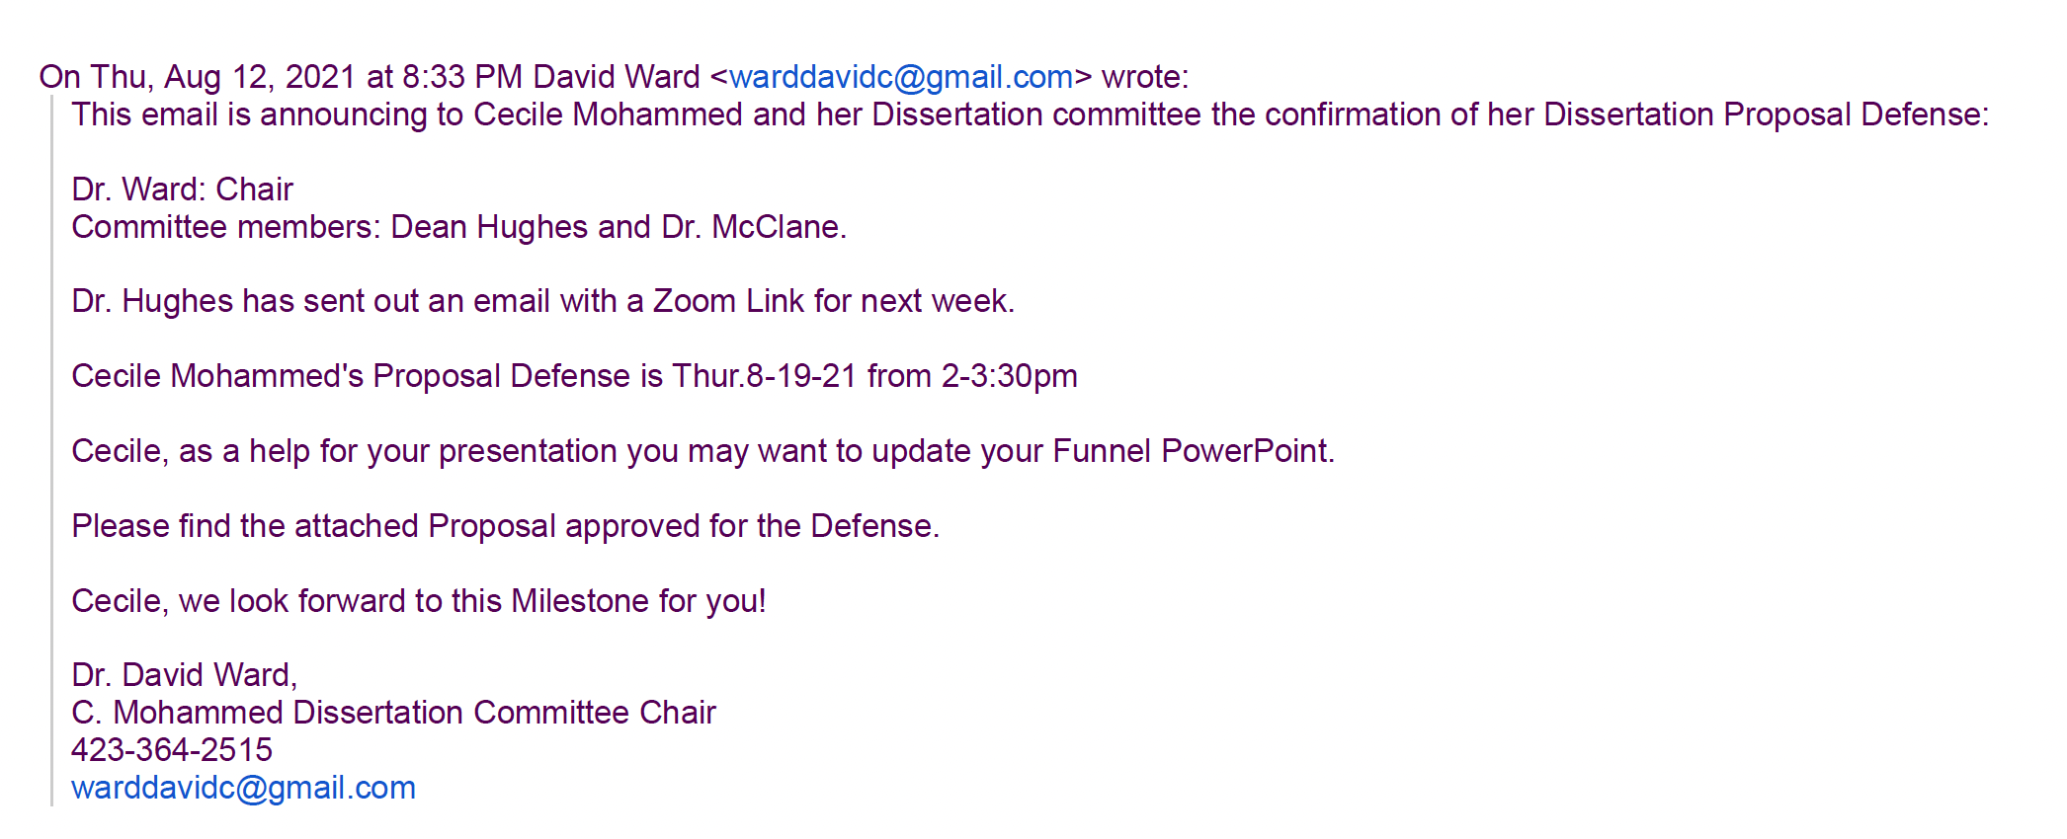

Dissertation Committee Members Present:

- Dr. David Ward (Committee Chair)
- Dr. Cathie Hughes
- Dr. Curtis McClane

Photo taken during Cecile’s Proposal Defense on 19th August 2021:
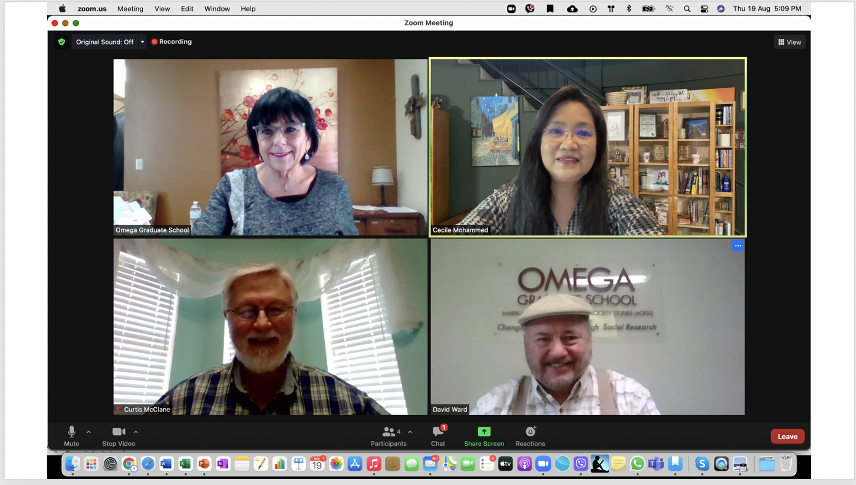

Detailed Outcome of Defense, including recommendations provided by the Committee:

Research Funnel submitted for Proposal Defense on Aug 19, 2021:

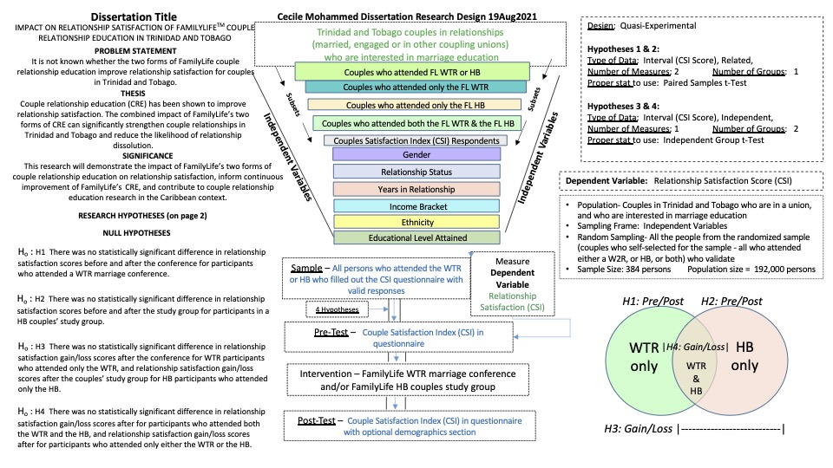

Proposal Defense Follow-Up from Dr. Ward (GRC Committee Chair) on Aug 19, 2021:
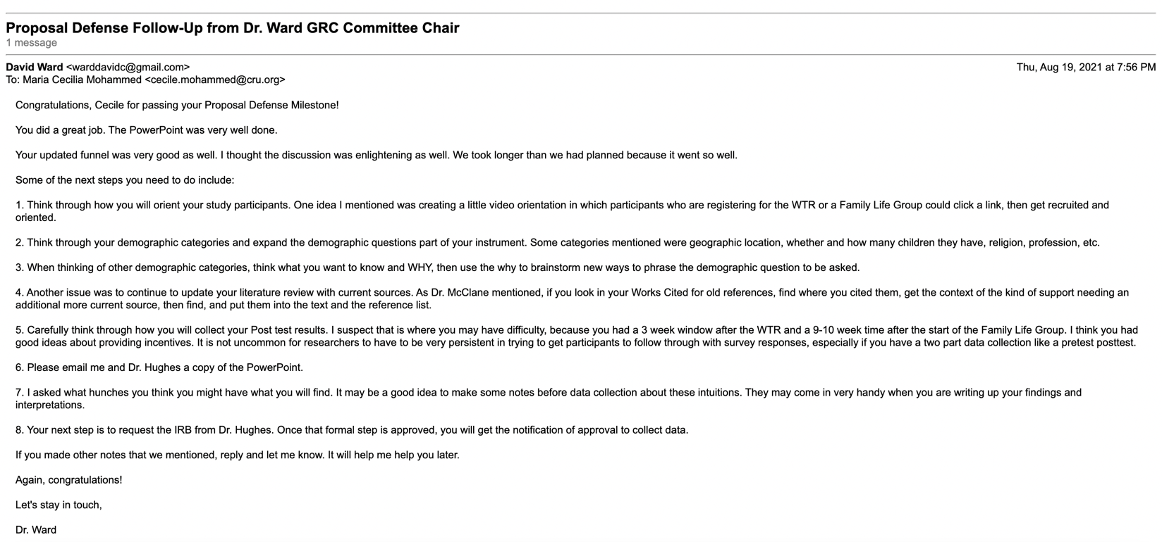
(please see screenshot below, with recommendations from the committee).

