Title: Family Life Education Research Paper

Harriet Warner

Oasis University

**Table of contents**

Topic research/Research Problem 3

Topic Significance 5

Literature Review 7

Research Design and Data Collection Method (s) 17

Data Presentation and Interpretation 20

Conclusions and Recommendations 24

Works cited 26

Appendices 29

**Topic Research/Research Problem**

The study of family life education has exemplified the critical importance of family life in the development of a healthy adult. The focus on parenting pivots on the foundation of the family for producing successful children. Further, the quality of the society is built on the families that live there and the investments made at school and at home. This research will explore and examine the work done with parent coordinators in during the practicum. The training equipped the participants to positive ways of build stronger relationships with the school and to increase awareness of the school dynamic. The main goal is to improve the triad relationship, student-school-parent, for academic achievements enabling healthy relationship and improving the quality of the community.

The first parent coordinator was introduced to the Ministry of Education five years ago and piloted in one Secondary school for a year. The following year they were introduced to all the government secondary schools within the Ministry of Education. An Australian research summaries parent coordinators as being part of the administrative team that works for school principals. They work closely with school staff, school leadership teams, parent associations, community groups, and parent advisory councils to engage families and involve them in school communities (Processing Parental Engagement, 2015). The main role is to make the connection between the school-student-parent. The ensuring proposal to train parent coordinators afforded a meeting with the supervisor of the department where concerns and needs for training were expressed. The meeting revealed that the parent coordinators had communication issues both with students and parents; the effectiveness of their work was a concern. The work of the parent coordinator is important to the school as campus sizes grew and parent engagement was critical to the success of every student. The intention of schools to use a positive behaviour approach heightened the need of the parent coordinators to improve communication skills transferable to students and parents. Since, this was a new area within schools role definition was important to the school coordinators and administration. Training would provide understanding and improvement to the overall attitude of the work environment.

Training becomes effective when participants engage with new material or methods and make an internal decision to change. The expectation is that the parent coordinator does some introspection and makes personal internal adjustments to improve the quality of the service that they offer to the students and parents. While the Ministry of Education offers professional development for the parent coordinators, personal development is an individual personal responsibility. Thus, the personal nature of the training will improve their personal responsibility individually; then those skills are transferred for the same guaranteed results in their work. Therefore, further studies will enhance the provider and the quality of service that they offer.

The focus of study for the researcher is Family Life Education and the specific area is parenting education. Therefore, the interest in training the parent coordinators is directly linked to establishing improved parental skills in the student’s educational aspirations. The parent coordinators will actively engage with community groups to share the information and positively encourage parents who may not be responsive to the school. Parents will be ignited and may become very involved in the school. In societies where there is an uneven distribution of wealth community support and scholarships can propel students to academic achievements. This is possible as parents interact with schools and get support from resources available in the community.

**Topic Significance**

The training was developed with the needs, roles and responsibilities of the parent coordinator. The main objectives that guided the training curriculum were: 1. Train Parent Coordinators in the Secondary Schools in the Antigua. 2. To clarify role definition of the parent coordinators. 3. To improve communication skills between parent and school for the benefit of the student’s social and educational goals. The flow of the curriculum focused on the self, the laws guiding the role and responsibilities, communication and conflict, and the opportunities for implementation in the school plant.

The importance of the person was examined by addressing self-awareness, encouraging participants to know themselves and establishing healthy boundaries is critical to emotional intelligence. Intra and inter personal skills are of paramount importance to the workplace. It helps one to identify their ability to work in groups to achieve the goals of the establishment. Thus, recognizing that learning patterns have changed the primary focus of teaching methodology into social emotional learning is an important aspect for students and parents. Being self-aware improves life skill development and clarifies communication challenges. Communicating effectively is important for this student-school-parent connection. Thus, communicating through the life span and understanding the stages of development and the needs assessment of the stages improves the quality of the communication shared by the parent coordinator.

Group synergy involves working the team towards the guiding principles that bring significance and connectedness to the work of the parent coordinator. According to the provisions made for the parent coordinators there were no direct laws that specifically guide their work. However, the Education Act of Antigua and Barbuda of 1973 addresses the needs, role and responsibilities of students and parents. This is the framework in which the parent coordinators work and set their boundaries. It is also the guiding principle for school administration to delegate work responsibility. Further, according to the CRC (Convention of the Rights of the Child) children have rights and responsibilities expressed in the social strata of the ecological system. Urie Bronfenbrenner’s ecological systems theory focuses on human development exposure to a system of cultural, social, economic and political elements (Shelton, 2018). Similarly, the student-school-parent relationship forms part of a micro and macro systems where the laws influence the community. It is a system where the parent coordinator is member and leader in terms of group dynamics.

As a group develops into a unified system to achieve their goals there will be communication barriers called conflicts. These are addressed effectively working through issues that will build a stronger group. Personal growth, resilience and unity are evidence of a strong group synergy working towards goal achievements. Setting healthy boundaries is the responsibility of each team member, parent coordinator. When an individual is self-aware it increases empathy that exudes the professional expectation. Therefore, there is a sense genuine interest as the students and parents are connected.

The parent coordinator has a support team in the implementation process. There is the expectation of the support team that students will be referred to the appropriate agency for assistance. The end result is a disciplined student with good work habits that will achieve great rewards for their efforts. Helping the students develop a healthy work ethic and taking responsibility for timely assignment submission is the making of a good citizen. The general school behavioural plan should reflect the home behavioural plan with positive communication between administration and students. School administration, through a team effort with the parent coordinators can assists parents in reaching the children in this changing digital generation.

**Literature Review**

The success of students is established on a foundation of purposeful parenting and positive engagements at school with teachers and their peers. Family life has a major role is developing a healthy adult by providing parenting that supports the fabric of the education essentials where the student is engaged. This research will explore and examine the research for the training done with parent coordinators during the practicum. The training equipped the participants to be positive, to build stronger relationships with the school and increase awareness of the school dynamic. The main goal is to improve the triad relationship, school-student-parent, for academic achievements enabling healthy relationship improving the quality of the community. The dynamic of the role of the parent coordinator is built on effective communication between the school-student-parent.

Communication was examined from the work of Adler and Rodman in which they wrote Understanding Human Communication. Communication is critical to developing healthy people skills, the book explains “improving interpersonal relationship is important, but one has to examine the depth of self-disclosure. However, self-disclosure happens more in dyads” (Adler & Rodman, 1991, p.171). Self-disclosure happens where there is an established relationship with trust and boundaries. Participants experienced self-disclosure during the training where some were able to share personal stories and experiences with students. Additionally, Adler and Rodman emphasized that when a group becomes too large for self-disclosure then it is public speaking, that is, a group larger than twenty (Adler & Rodman, 1991). As time changed so did communication mediums and some research was done on the percentage of people who do use emails to communicate with their families. Adler and Towne found that computer mediated communication improves the quantity and quality of interpersonal communication (Adler & Towne, 2001). Moreover, social media is such a common medium of connecting with people that it would be difficult to imagine life without it.

The impact of some mediums on the communication styles is yet to be researched. For example, since the use of WhatsApp how has language used in communication changed? How has Instagram influenced regular face to face communication patterns? The research as to the impact on the change in communication for Millennial generation (anyone born 1981-1996) and Generation Z (anyone born 1997-2012) age groups could provide more guidance for communication effectiveness and not just for economic marketing purposes. In a recent journal within the last 10 years, Baily asserts, “social media mining draws on many disciplines with the aim of studying the market and human behaviour patterns to ascertain emerging concepts for future advertising or advocacy” (Baily, 2017, p.4). Similarly, social media is more than a communication tool, but an entertainment centre, entrepreneurial opportunity and a career path. One key observation is that the basic form of communication, sender and receiver, remains the essence through the changing times. Transactional communication model is more than sender and receiver. It involves the simultaneous relationship of sender, receiver, feedback and perception.  It is difficult to isolate one aspect of communication as it happens simultaneously in the brain (Adler & Towne, 2001).   However, transactional communication pervades the way that people communicate reflecting some similarities through new mediums.

In communicating, the art of listening is a skill and it is important to teach and practice good listening habits. Adler and Rodman states, “hearing is the process whereby sound waves strike the eardrum and cause vibrations that are transmitted to the brain.  Listening occurs when the brain reconstructs these electrochemical impulses into a representation of the original sound and then gives them meaning” (Adler & Rodman, 1991, p.91). In addition, listening provides feedback that indicates that you are being heard; self-disclosure is the result of good listening and is accepted in the relationship. Burley-Allen solidifies listening as an important skill in relationships that should not be forgotten. Burley-Allen believes that listening can validate a person, reduce stress and improve self-esteem (Burley-Allen, 1995). Therefore, listening is an important skill in communication and is also part of the transactional process of communication. Perspective and meaning to words brings clarity for both the sender and receiver. For instance, “effective listening helps talkers reduce their emotional level so they can think the problem through” (Burley-Allen, 1995, p.5). Through effective listening is the ability to clarify one’s thoughts and become more self-aware; hence, one sets clearer boundaries which improves life skill, personal and professional development. Therefore, listening is an active process where both parties provide feedback when messages are received. In support, Brown asserts that communication does not have a direct passage; it cannot flow from one mind to the other.  The only areas where it is fixed would be in Arithmetic or the traffic lights (Brown, 1996). Brown’s argument suggests that in verbal and nonverbal communication messages are sent and received by words or expressions. Providing feedback through listening, messages can become distorted and present barriers that inhibit the flow of the message and those barriers are called conflicts. Those barriers are caused by several external factors and perception can present some limitations in the communication process.

A conflict is a disagreement between two persons and the resolutions are achieved in various ways. Moore posits “conciliation is the psychological component of mediation in which the third party attempts to create an atmosphere of trust and cooperation that is conducive to cooperation” (Moore, 1986, p. 124). Creating the right atmosphere for resolution on a platform of understanding and respect sends a message of assertive communication. Assertive collaboration is the ability to express concerns about the issues without targeting the person. This is an effective approach since it will assist colleagues to gain respect for each other and strengthen relationships. Additionally, “it is our nature to be assertive.  Until children are conditioned, they respond to life very assertively, asking for what they want, saying no, being persistent, and going after what they desire” (Burley-Allen, 1983, p.63). The social culture and parenting shapes and defines how censored children are and how the family also models conflict resolution skills is replicated at school and play. In support, Becvar states, “The system must constantly interact with the environment in which it exists and boundaries are the means by which that system accepts useful information and screens information deems unacceptable” (Becvar, 1999, p.15). The social system informs the character of the child, norms and a sense of belongingness.

Parenting techniques should bring a balance of demandingness and responsiveness to the needs of the child and model a healthy conflict resolution style. Popkin explains that conflicts can occur in parenting style between parents and it is important to work out the counterbalance to help children define limits clearly (Popkin, 1987). The challenge in parenting is to balance the right parenting style with the appropriate situation. However, are the social norms similar to parenting expectations? In contrast, Dinkmeyer and McKay, asserts “parents should try not to interfere in children's relationship since this is how they learn to be accountable for their own behaviour and develop independence” (Dinkmeyer & McKay, 1989, p.93). Even in conflicting situations parents should communicate in such a way that children own their behaviours and learn from them. Parents approach to conflict will impact the response of children in their peer relationships. Therefore, Dinkmeyer and McKay asserts that, “you can build a good relationship with your child by showing respect, having fun, giving encouragement, and showing love” (Dinkmeyer & McKay, 1989, p.18). The benefit of a behaviour plan as a discipline tool that outlines expectations, rewards, and consequences in a positive management system is effective for assertive communication.

Positive behaviour management is “a set of strategies or procedures designed to improve behavioral success by employing non-punitive, proactive, systematic techniques which are implemented throughout the school” (UNICEF, 2017, p. 44). This program is also a connection between the home and the school. Students resolve conflicts in the classroom the same way it is resolved at home. The school is playing a role in behavioural management, and the school has to engage the parents, so that the behavioural plan has its similarities. “Parental engagement recognizes that both parents and teachers play an important role in children’s learning, development and wellbeing, and that children generally do better when there are positive connections between the different spaces they learn in” (Processing Parental Engagement, 2015, p. 1). The impact of the parent in the behaviour plan is significant; the balance is with the approach to behaviour change that allows the child to own their behaviour in an environment where they can be meaningful change. Educational stakeholders unite around the common goal to manage behaviour in ways that are respectful, proactive and effective (UNICEF, 2017). The collaborative effort produces a child who can engage in healthy peer relationships well into their teens and adult life. Thus, the community morals are increased when stakeholders are required to model expected behaviours. Parental engagement with the school and community identifies gaps where support can be given and community groups can offer extra-curricular activities to children engaging the student-home-school unit for success of the same. Moreover, it is important to collaborate with communities to develop “strategies that coordinate resources and services from the community to strengthen school programs, family practices, and student learning and development, and provide services to the community” (Processing Parental Engagement. 2015, p. 4). While some strategies may be culturally bound to available resources in a particular geographical location, it is possible to transfer the strategies where resources may be limited, but foster an implementation process where school, home and community can benefit.

The Caribbean is dominantly rich of single parent families with the mother being the breadwinner. These families have produced some great Caribbean leaders, but the pattern of parenting does not form a defined ideal. A research based in Barbados reveals, “the sexual unions of Europeans and black Caribbean persons had an effect upon the type of unions and relationships they fostered with each other. The slave master exercised total authority over the female slaves. This was one of the factors which assisted in undermining the Caribbean family situation” (Waite, 1995, p. 22). However, the single parent units evolved and those units have been matriarchal in the Caribbean. The visiting union, the common law union and the marital union have existed throughout Caribbean history, with movements transforming from one to the other, and it has influenced sexuality of the partners and their offspring (Waite, 1995). How have those family units collaborated with the community in the past? The paternal partner held several families and as a social norm in the Caribbean they were accepted in community. Waite expresses that women need to be affirmed of the power they possess to use it as a catalyst for change and behaviour modification.  Affirming her independence allows them to make independent decisions for themselves to boost their integrity, dignity and individual pride (Waite, 1995). This explains how the Caribbean woman exudes strength and confidence in her family and parenting skills. The evidence is suggesting that the Caribbean woman continued in single parent relationship contexts even with her dignity and individual pride. Perspective may vary since “what may be labeled dysfunctional by someone from another culture, may be looking at the Caribbean family from his own bias or social perspective, may very well be a coping mechanism which Caribbean families have developed” (Waite, 1995, p. 23). Stakeholders in education will face a challenge to implement behaviour plan models because of Caribbean history appears to have originated in another cultural setting. Stakeholders have to understand the context in which they operate and the resources that are available. It is also important to understand the child who is socially and educationally exposed to a diet of international stream through the internet. Globally, the internet and social media has brought a type of universal language that reflects development along the life span. Thus, while the implementation of international programs is challenging the Caribbean history of parents, it may very well be the language of the children.

Understanding the life span and the stages of development is critical; knowing the needs of children and how to communicate using appropriate language is important for implementation. Cavanaugh and Kail states, “human development is the multidisciplinary study of how people change and how they remain the same over time” (Cavanaugh & Kail, 2010, p. 3). The stages of development 0 – 20 are important for parents, care workers, and those who interact with children to understand their behaviours and the brain development and output. Erikson’s theory focused on psychosocial development while Kohlberg focused on moral development. Erikson taught that birth appears to introduce into the psyche a sense of inner division (mistrust) and universal paradise (trust).  Trust must maintain itself throughout life with a sense of having been deprived, divided and abandoned (Erikson, 1950). The child learns to trust his environment based on the initial response of his parents, his mother, to his needs and wonders if he can trust the world. During this stage the child will decide if they can trust, but may have fears if their needs are not met and may develop mistrust. Unfortunately, mistrust will follow the child throughout adulthood where “life is happening to the individual rather than being lived by his initiative; his mistrust leaves it to the world, to the society and indeed to psychiatry to prove that he does exist in a psychosocial sense” (Erikson, 1968, p. 169). However, Kohlberg focused on moral development on the foundation of cognitive development by Jean Piaget. Piaget asserts “By moving beyond an analysis of intellectual development in terms of number of right answers to an analysis in terms of differences in structure, Piaget transformed the study of cognitive development” (Kohlberg, 1984, p. 10). Kohlberg expanded Piaget’s work by looking at the moral and social experiences of an individual. He posits, “principled morality is not created or supported by sheer cognitive comprehension of the social and moral world ... personal experience is involved in the movement to stage 5” (Kohlberg, 1984, p. 457). It requires more than intellect to take a person through the proposed five stages of development; it is the sum of total their experiences interacting in the world that moves them through the stages.

Erikson was concerned about what he called the identity crisis at the stage of psychosocial development of a teen 13-19 years, a period also known as adolescence. “Identity formation employs a process simultaneous reflection and observation, a process taking place on all levels of mental functioning, by which the individual judges himself in the light of what he perceives to be the way in which others judge him in comparison to themselves and to a typology significant to them” (Erikson, 1968, p. 22). Erikson believed that role confusion could arise if there is no guidance when they experiment with ideas and viewpoints to find their identity. Conversely, Kohlberg examines moral development in life experiences and as an adolescent self-interest is more important than conformity, rights and wrongs of society. What intellectual basis guides moral judgments? He states, “to find ‘moral character’ or an internally organized and consistent disposition to moral action, one must find an internally organized system of judgment and relate this to action” (Kohlberg, 1984, p. 508). These two theories help us to understand the adolescent and life span development as the perspectives surround varying aspects of an individual’s experience. Life presents us with various challenges and having an understanding of human development prepares one to face uncertainties. One of the recent catastrophes that shut down the world was the pandemic, COVID-19.

COVID-19 had a profound physical, social and psychological impact on societies. The rebuilding of lives has begun, but the lasting impact is yet to be measured. People learned to communicate differently; they depended on the online platforms to communicate with family and friends locally and internationally. People were displaced and families experienced severe loss in some places. Many experienced “lockdowns, income loss, and confinement to small places, increased threats to the safety and well-being of children – including mistreatment, gender-based violence, exploitation, social exclusion and separation from caregivers” (You et al., 2020, p. 6). The commonality for the world was lockdowns; this was an experience that stopped the world trading and all international business at the same time. In some places where families were displaced authorities tried to maintain the unity by putting families back together. Every generation around the world will be able to speak to their children about the COVID-19 experience. Many stories were written and examination questions asked about the daring pandemic. However, the full impact of the effects of COVID-19 is immeasurable with the psychological impact being the most challenging.

The impact of the impressionable adolescence mental health was measured among psychologist at a University in Netherlands. Psychologist discovered that the “autonomy development is a hallmark of adolescence and emerging adulthood, and the pandemic might comprise a major setback for normative development” (Mastrotheodoros, 2020, p. 14). As a result, there was a reduction in face to face socializations which is believed to have future impact on the human development. The research states clearly that the “studies support one of the core ideas in resilient research, that people with better pre-pandemic adjustment and with more access to resources and assets might be affected to a lesser extent by the pandemic, compared to less well-adjusted youth” (Mastrotheodoros, 2020, p. 15). Therefore, the disenfranchised youth have to be addressed politically and socially. “Youth services and centres could focus on developing, promoting and fostering access to online or alternative forms of interventions to promote a sense of belonging and social connectedness in isolated youth” (Mastrotheodoros, 2020, p. 16). Moreover, the world has moved to a digital platform that many have become comfortable with the ease of access and time management that it provides. This informs future educational goals towards a digital world. The mental health experiences could shift worldviews as the human naturally adjusts to life. “If students are to play an active part in all dimensions of life, they will need to navigate through uncertainty, across a wide variety of contexts: in time (past, present, future), in social space (family, community, region, nation and world) and in digital space” (Skovsgaard, 2018, p. 6). Skovsgaard concedes to Erikson’s view of the adolescent as resilient in this description, “the adolescent mind is essentially a mind of the moratorium, a psychological stage between childhood and adulthood, and the morality learned by the child and the ethics to be developed by the adult” (Erikson, 1950, p. 262-263). Therefore, the future of education will look more intensely at personal responsibility and life skill building. Skovsgaard speaks to the future of holistic education, he asserts, “dealing with novelty, change, diversity and ambiguity assumes that individuals can think for themselves and work with others. [We are] equally creativity and problem-solving requires the capacity to consider the future consequences of one’s actions, to evaluate risk and reward, and to accept accountability for the products of one’s work” (Skovsgaard, 2018, p. 7). This is the future of education connecting school-student-parent triad relationship.

**Research Design and Data Collection Method (s)**

The parent coordinators did not have a formal curriculum; the topics were determined based on the needs and competency of the participants. This was also a new area for career development by the Ministry of Education, hence the limitations of an available contextual curriculum. In this review, the topics used in training were guided by job description and related fields of study. Evidence based practices in other places with the experience of parent coordinators in schools were very applicable to understanding their roles and responsibilities. In research, topic areas were sourced from books and evidence based curriculum with recent evaluations reflecting the relevance of the material. The training used various types of sources including internet research and some information was culturally limited to its geographical location where its implementation is determined by the available resources.

Internship Proposal

OBJECTIVES: 1. Train Parent Coordinators in the Secondary Schools in the Antigua.

2. To clarify role definition of the parent coordinator.

3. To improve communication skills between parent and school for the benefit of the student’s social and educational goals.

METHODOLOGY: In person group interactive sessions

(Power point presentations, activities and personal reflections)

ORGANIZATION’S NAME: Permanent Secretary, Mrs. Rosa Greenaway

Ministry of Education, Sports and Creative Industries

ORGANIZATION’S ADDRESS: Queen Elizabeth Highway, St. John’s, Antigua

INTERNSHIP SUPERVISOR / POSITION IN ORGANIZATION:

Ms. Cindy Price

BSc. Sociology; MA Social Work and Social Care; Master Teacher, Student Support Services

Supervisor of Parent Coordinators

DURATION OF INTERNSHIP: Four weeks (4 days per week -2 1/2 hours per session)

SCHEDULE: 7th November – 1st December 2022 (2:00 – 4:30pm)

TARGET GROUP: Parent Coordinators (Secondary School)

TEAM MEMBERS (IF ANY): None

Student evaluation of Internship Instructor:

|  |  |  |  |  |
| --- | --- | --- | --- | --- |
| **Details** | **Strongly Agree (4)** | **Agree (3)** | **Disagree (2)** | **Strongly Disagree (1)** |
| 1. Instructor effectively explained and illustrated course concepts. | 10 | 1 |  |  |
|  |  |  |  |  |
| 2. Instructional methodology and tutorial procedures were easy to follow. | 11 |  |  |  |
|  |  |  |  |  |
| 3. The class sessions were carefully planned. | 10 | 1 |  |  |
|  |  |  |  |  |
| 4. Examples were relevant and useful. | 11 |  |  |  |
|  |  |  |  |  |
| 5. Dialogue and support were sufficient to address problem during class. | 8 | 3 |  |  |
|  |  |  |  |  |
| 6. I would recommend this course to others. | 10 | 1 |  |  |
|  |  |  |  |  |
| 7. The instructor provided helpful comments on applications of the course. | 7 | 4 |  |  |
|  |  |  |  |  |
| 8. The instructor encouraged student’s involvement during class session. | 7 | 4 |  |  |
|  |  |  |  |  |
| 9. Online teaching facilities were easy to use. | 2 | 7 | 1 | 1 |
|  |  |  |  |  |
| 10. I would recommend this instructor to others. | 11 |  |  |  |
|  |  |  |  |  |
| 11. The instructor was knowledgeable in the subject area. | 11 |  |  |  |
|  |  |  |  |  |
| 12. Overall, the instructor was an effective teacher. | 11 |  |  |  |
|  |  |  |  |  |
| 13. Instructor internet connection was stable. | 4 | 3 | 2 | 2 |
|  |  |  |  |  |
| 14. I completed all reading assignments and expectations on time. | 6 | 4 | 1 |  |
|  |  |  |  |  |

**Data Presentation and Interpretation**

The following presentation reflects observational data in a training of parent coordinators, gaining insight into feelings and thoughts shared by participants and an instructor evaluation at the end of the training. Thematic areas of the intervention and participant’s experience will be presented collectively. Trends and similarities of content will be reflected in the observation shared in realistic data to reflect the value of the intervention. Trainer interaction and perspective gathered will be presented.

The schools in Antigua were experiencing severe conflicts in terms of verbal, physical fights and cyber bullying among students on and off the school compound. The former Minister of education decided to provide an intermediary to the home in the form of parent coordinators. This is a field where person can enter without specific skill set, but communication being the most valuable asset for efficiency in achieving school-student-parent interaction. The model used was a replica of a model used in high schools in the USA; the roles and responsibilities used were the same as those in the model. The job requirements and entry level education was considered prior to curriculum development for the training. There were no formal study conducted in Antigua as to the level of involvement of the parents and community with the schools. There are no researched evidenced about what community groups were involved at the school level. It had to be determined which schools were experiencing severe violent acts and what actions have been taken to deal with the issues. During this process the period of time given for the behaviour change was unrealistic. There was also no evidence to suggest parental involvement at any level of the conflict. Further, what department in the schools or supporting agency was responding to the violence on and off the school compound? There were no questions asked. There are major gaps in terms of local research informing policy and decisions made by stakeholders in Education.

The training provided an intervention for parent coordinators in regards to their roles and responsibilities. The parent coordinators were engaged in the open discussion about what is their documented responsibilities were compared to what school administration required of them on the school plant. The uncertainties were unanimous among the participants with clarity in some areas. There were opportunities to discuss each role in detail, setting boundaries where the responsibilities overlap with another department or role definition. The participant expressed the frustrations of not knowing how to deal with students issues and knowing when to refer to the counsellor. In many cases the participant had developed a relationship with the student where they were unhealthy attachments and they understood the importance of referrals prior to trying to help a situation for which they can only provide limited intervention. Also, the challenge of a student (client) having to retell the story and possibility of re-traumatization helped participants understand why referrals need to be timely and important. This was clarified during the training and knowing when to refer a student, including a method as to how to refer were discussed during the training. Activity templates were created and distributed among the various parent coordinators. This training also observed that students come to school from various backgrounds where circumstances are beyond the normal scope of engagement; hence, referrals are recommended to guidance counsellor, school nurse or truancy officer. The parent coordinator makes the right connections for the student to benefit from the appropriate agency.

The Education Act provides some legal guidance for those who are involved in education and for the rights and responsibilities of students and parents. Participants, parent coordinators, understood that this Education Act guides their work and governs their role and responsibilities on the school plant. Antigua and Barbuda Children (Care and Adoption) Act of 2015 protects and guides the treatment of children on the school plant and at home and in the community. This is valuable information for students to be aware of how they are to be treated and for the community responsibility to the rights of children. Another law is the Electronic Crimes Act of Antigua and Barbuda 2018 which guides electronic use and the consequences for violating personal boundaries using electronic devices. Consequently, there is protection against cyber-crimes, and other related crimes. The participants were exposed to the laws that govern the parameters of their scope of work; the rate of change of electronic devices and artificial intelligence is very high on the technological improvement scale.

Many participants shared in the comments section about their personal growth and how the training has impacted the desire for behaviour change. They expressed that they had a better understanding of their role and felt competent to work more efficiently; they intend to use the information in the future. Also, some unanimously agreed that the information will affect their life and work, while others were very thankful for the training to broaden their scope. Many suggested this training at least once a year. There is the need for regular training because trends and methods change very often. It was also suggested that the time of the day for training be revisited to their regular work hours. During the training these comments were share openly with various moments of answered questions from interaction or information presented.

The training provided an intervention in the area of communication. Participants interacted with the material and information and began to consider making appropriate application. The activities in the different sessions allowed participants to personalize the change that needed to be made.

Communication is inevitable, but effective communication is a skill that should be taught. When the components of communication was defined and explained there was deep reflection in the room with some level of murmuring and acceptance. As communication skills are practiced among participants through activities and group assignments the change was apparent. The participants discussed personal experiences during many student interactions and recognized that communication required that the student comprehend their instructions. Moreover, they recognized that the environment and use of language is a factor for healthy communication. During the training at different intervals communication failed among the participants and in an attempt to seek understanding participants sought resolutions. They were able to communicate the problem where reflecting improved self-awareness skills. Further, as a group participants were supportive and gave insight to difficult situation among their team. At this point the group became stronger and more cohesive (Stewart, 1986). Behaviour change is never easy; it requires work and patience with self to see the reality. Participants learnt to understand and respect each other.

The participants’ interest in the student life was reflected in their displeasure with some punitive measures of discipline that is still used in some schools. They expressed how ineffective the methods are among students, but honestly reported that personally they still believed in some of those punitive measures being used appropriately. The interaction with laizze-faire parents, the handmaid and gift-giving parents, via the telephone was a challenge for many participants and this was at the point of work frustration. Therefore, a few discussions evolved out of the telephone conversation with some parents; so telephone etiquette and boundaries were established. Participants shared their struggles as colleagues listened and offered support referring to the training material.

**Conclusions and Recommendations**

Parent coordinators showed up daily for training and attentively received all the information learning from discussions. The trends in schools were changing, while the social media culture was invading the school environment and issues of cyber bullying became the cause of many arguments and fights. Collaborating with school administration and communicating with students were major challenges. The ability to communicate in a digital world with ever-changing AI technology was a challenge for some participants. This meant that there was the inability to communicate with students on that platform. In contrast, there were unclear expectations of the participants since they needed clarity about their roles and responsibilities on the school plant. This uncertainty led to many conflicts and unsettled emotions among parent coordinators.

The sessions were filled with excitement and participants jumped into the activities and began to share their situations; slowly recognizing that there was so much similarity among the conflicts they faced. The participants shared openly by the end of the first week and even more as the time progressed. The group developed so well together that the synergy held the momentum of the group together throughout the training period.

The objectives were met in the communication and conflict research, and role and responsibilities clearly outlined and discussed. The inability to be able to refer to statistical evidence of the violence on the school compound is an area for further research and guidance in policy decision and best practices available. The legal framework that guides the work of parent coordinators needs to be specifically addressed. Interacting with students on a school plant has proven to be a risk factor based on news items and violent acts and it would be proactive to have laws that guide the consequences of certain action.

This research opened questions on certain areas for further research that can help the parent coordinators to work more effectively. To this end the following recommendations were made:

* It is highly recommended that the training would be available once per year as a refresher course with updated information about students, school and parent changes and challenges.
* The Ministry of Education should move towards developing a training manual for parent coordinators. The reality of the position will eventually be defined as entry positions where persons would upgrade their skill set and transfer into other areas of the school plant.
* Create incentives to motivate the parent coordinators. Healthy competition will balance the monotony and increase parent involvement in the school. Award the school and parent coordinator with the highest percentage increase of parental involvement. This can be measured through the PTA and other fund-raising committees within the school plant.
* Mental Health balance and Stress Reduction: Pair coordinators together so that they can debrief in a safe space and with the colleague who understands the concern. Supervisor can do check-ins so that serious cases can be referred for counseling.

**Works cited:**

Adler, R. B. & Rodman G. R. (1991). *Understanding Human Communication*. Holt, Rinehart, and Winston.

Adler, R. B. & Towne, N. (2001). *Looking out/Looking In*. Harcourt Brace College Publishers.

Andriole, S. J. (1983). *Handbook of Problem Solving : An Analytical Methodology*. Petrocelli Books.

Becvar, R. J. (1999). *Systems Theory and Family Therapy : A Primer*. University Press of America.

Biały, B. (2017). “Social Media—From Social Exchange to Battlefield.” *The Cyber Defense Review* 2(2):69–90. [jstor.org/stable/pdf/26267344.pdf?acceptTC=true](https://www.jstor.org/stable/pdf/26267344.pdf?acceptTC=true)

Brown, G. (1996). *Speakers, Listeners and Communication: Explorations in Discourse Analysis*. Cambridge University Press.

Burley-Allen, M. (1995). *Listening: The Forgotten Skill: A Self-Teaching Guide*. 2 edition. Wiley.

Burley-Allen, M. (1983). *Managing Assertively : How to Improve Your People Skills*. Wiley.

Cavanaugh, J. C. & Kail R. V. (2010). *Human Development: A Lifespan View*. 5th Ed. Wadsworth Cengage Learning.

Dinkmeyer, D. C. & McKay, G. D. (1989). *The Parent’s Handbook : STEP, Systematic Training for Effective Parenting*. American Guidance Service.

Dyer, William G. (1995). *Team Building : Current Issues and New Alternatives*. 3rd ed. Addison-Wesley.

Erikson E. H. (1950). *Childhood and Society*. Norton and Compny Inc.

Erikson, E. H. (1968). *Identity, Youth, and Crisis*. W. W. Norton.

Kohlberg, L. (1984). *The Psychology of Moral Development : The Nature and Validity of Moral Stages*. Harper & Row.

Mastrotheodoros, S. (2020). “*The Effects of COVID-19 on Young People’s Mental Health and Psychological Well-Being.”* Utrecht University [pjp-eu.coe.int/documents/42128013/72351197/Effects-COVID-Youth-Mental-Health-Psychological-Well-Being.pdf](https://pjp-eu.coe.int/documents/42128013/72351197/Effects-COVID-Youth-Mental-Health-Psychological-Well-Being.pdf)

Moore, C. W. (1986). *The Mediation Process : Practical Strategies for Resolving Conflict*. Jossey-Bass.

Popkin, M. (1987). *Active Parenting : Teaching Cooperation, Courage, and Responsibility*. Perennial Library.

Processing Parental Engagement. (2015). *Building a Strong Culture of parent School Engagement*. ACT Education and Training [http://www.det.act.gov.au/__data/assets/pdf_file/0005/807431/150897-Building-a-Strong- Culture-of-Parent-School-Engagement_2.pdf](http://www.det.act.gov.au/__data/assets/pdf_file/0005/807431/150897-Building-a-Strong-%20Culture-of-Parent-School-Engagement_2.pdf).

Shelton, L. (2018). *The Bronfenbrenner Primer*. 1 Edition. Routledge.

Skovsgaard, J. (2018). “*The Future of Education and Skills: Education* 2030.” 23. [oecd.org/education/2030/E2030 Position Paper (05.04.2018).pdf](https://www.oecd.org/education/2030/E2030%20Position%20Paper%20(05.04.2018).pdf)

Stewart, J. D. (1986). *The Power of People Skills : A Manager’s Guide to Assessing and Developing Your Organization’s Greatest Resource*. J. Wiley.

UNICEF. 2017. *Implementing CFS Framework in Eastern Caribbean schools.* United Nations Children’s Fund Office for the Eastern Caribbean Area. [www.unicef.org/barbados](http://www.unicef.org/barbados)

Waithe, N. (1995). *Caribbean Sexuality: A Counsellor Looks at Family Patterns and the Influences of Culture on Caribbean People*. Neverjen Consulting Inc.

Waithe, N. (1995). *Family Relationship*. The Moravian Church in America.

You, D., Lindt, N., Allen R., Hansen C., Beise, J., & Blume, S. (2020). “*Migrant and Displaced Children in the Age of COVID-19: How the Pandemic Is Impacting Them and What Can We Do to Help.”* (2):8. [unicef.org/media/83546/file/Migrant-and-displaced-children-in-the-age-of-COVID-19.pdf](https://www.unicef.org/media/83546/file/Migrant-and-displaced-children-in-the-age-of-COVID-19.pdf)

**Appendices:**

1. **Internship proposal**

# INTERNSHIP PROPOSED SCHEDULE

| **Proposed Date 2022** | **Unit** | **Topic** | **Lesson # / Description** |
| --- | --- | --- | --- |
| 7-10th November | I |  | -Self-awareness and inter/intra-personal skills  -Group Dynamics (personality styles, group synergy)  -Social emotional learning  -Understanding child development (life cycle 0-20) |
| 14th – 17th November | II | Lawyer | -The Education Act of Antigua and Barbuda  -The Child Care and Adoption Act of Antigua and Barbuda  -Role and responsibility of Parent Coordinators  -School-student-parent responsibility and relationship |
| 21st – 24th November | III |  | -Communication skills (listening; social media protocols; )  -Conflict Resolution skills (Working with  difficult parents)  -Referrals: understanding when to refer |
| 21st – 24th November | III |  | -Communication skills (listening; social media protocols; )  -Conflict Resolution skills (Working with difficult parents)  -Referrals: understanding when to refer |
| 28th November –  2nd December | IV | Dr. Desiree Antonio (PBM) | -Positive Behaviour Management (PBM)  -Impact of the Digital World on Parenting  -Opportunities for parental involvement  -Time Management and scheduling |
|  |  |  |  |

1. **Pictures of activities during the training:**

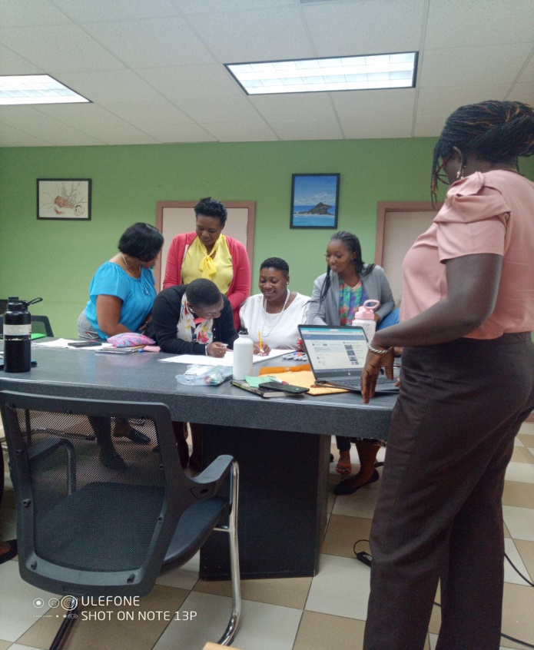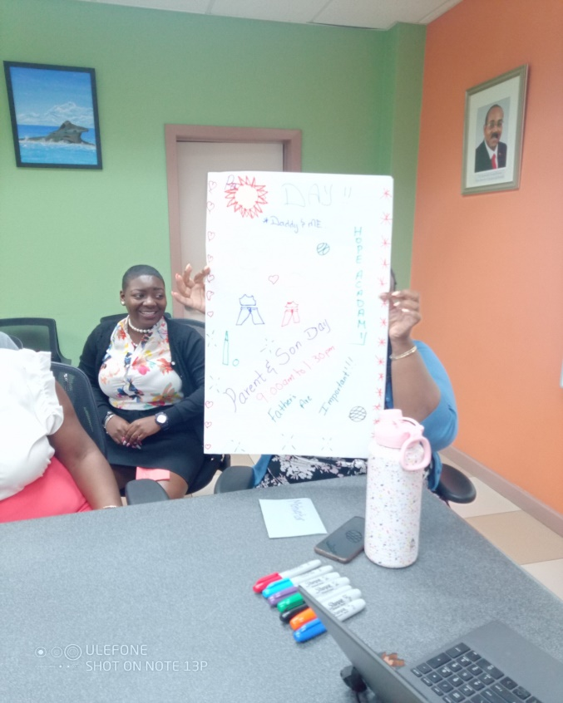

Group Dynamics Activity: working with different personalities and still achieve your goals

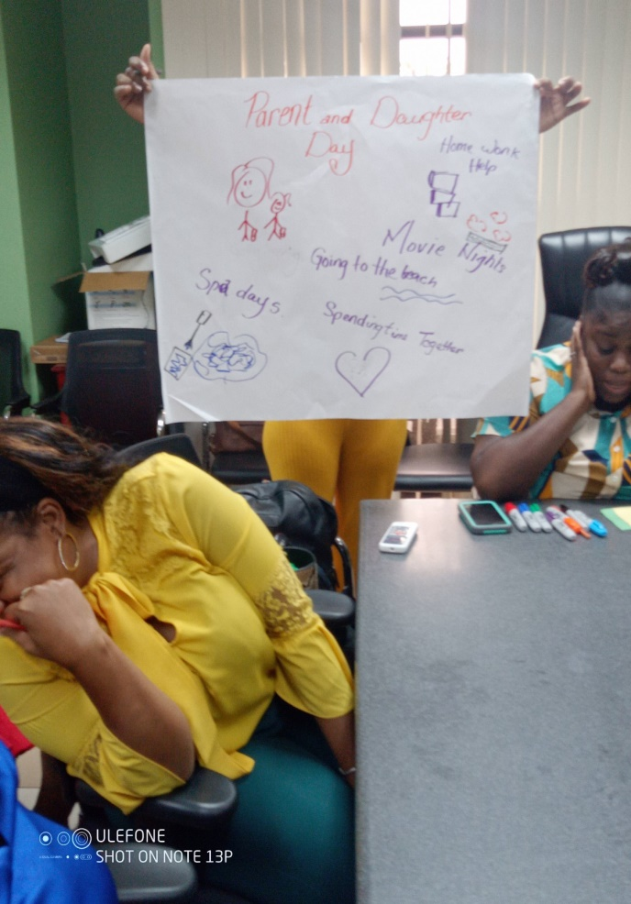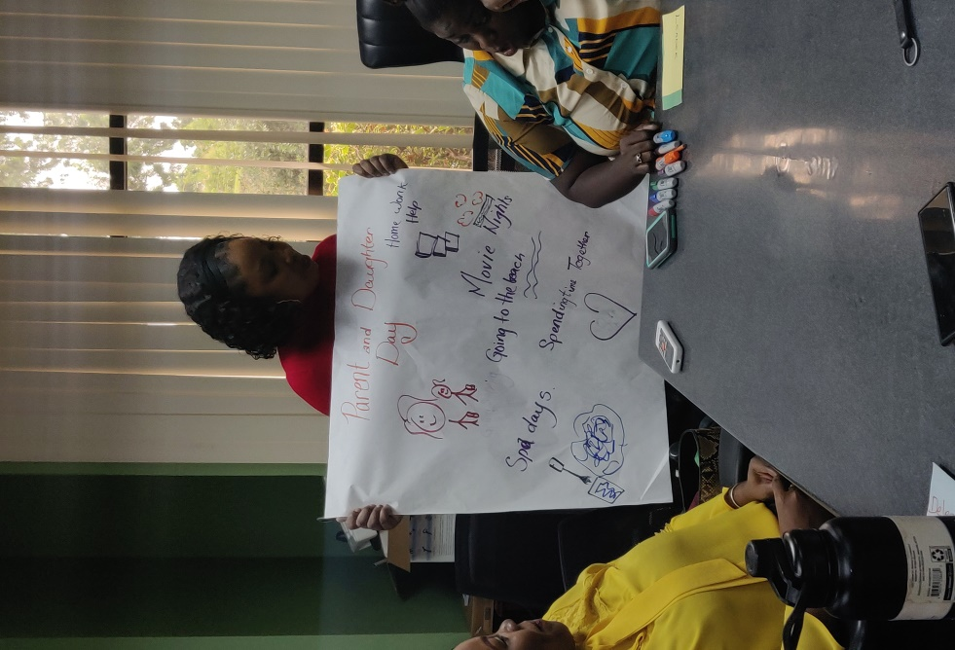

Group Leader is having a hard time (LOL)

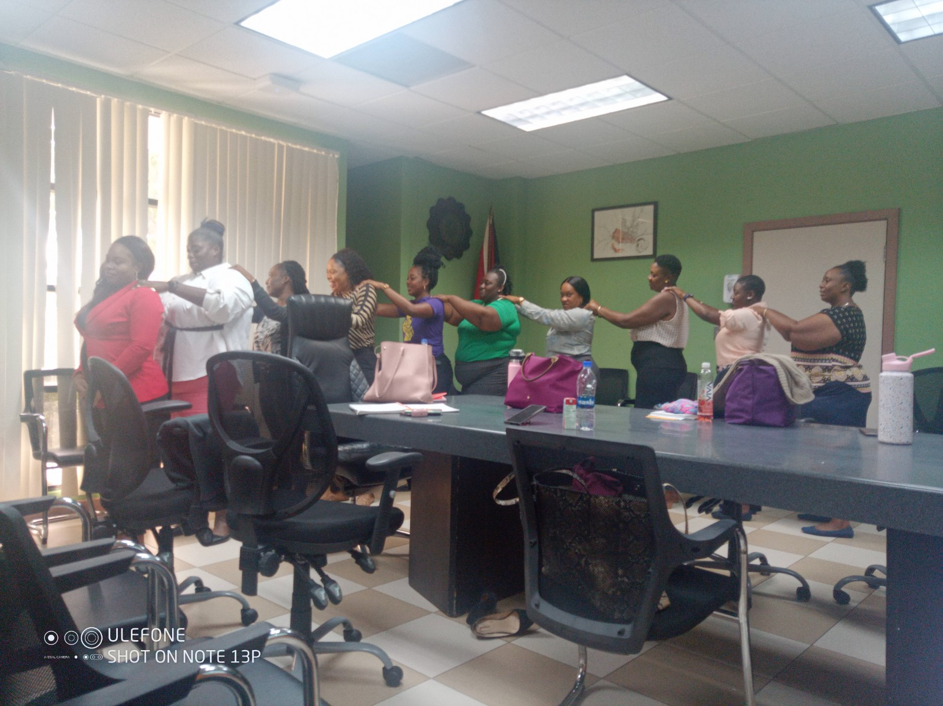

Support is connecting with each other and understanding.

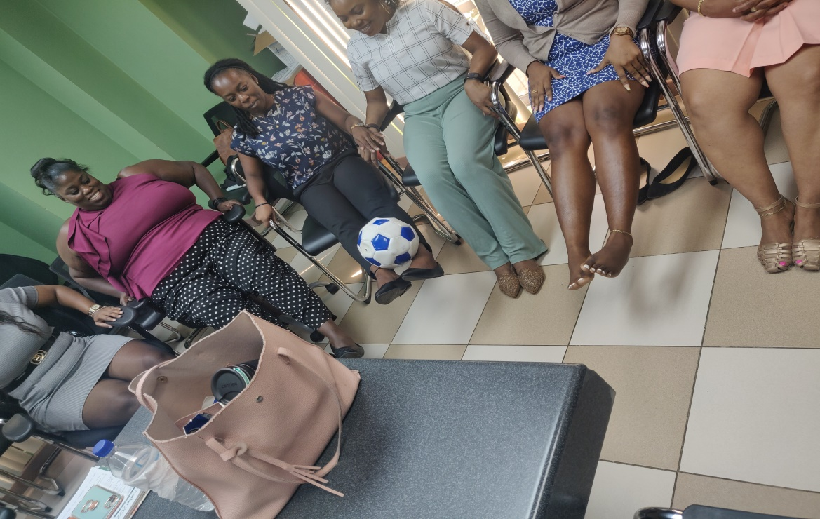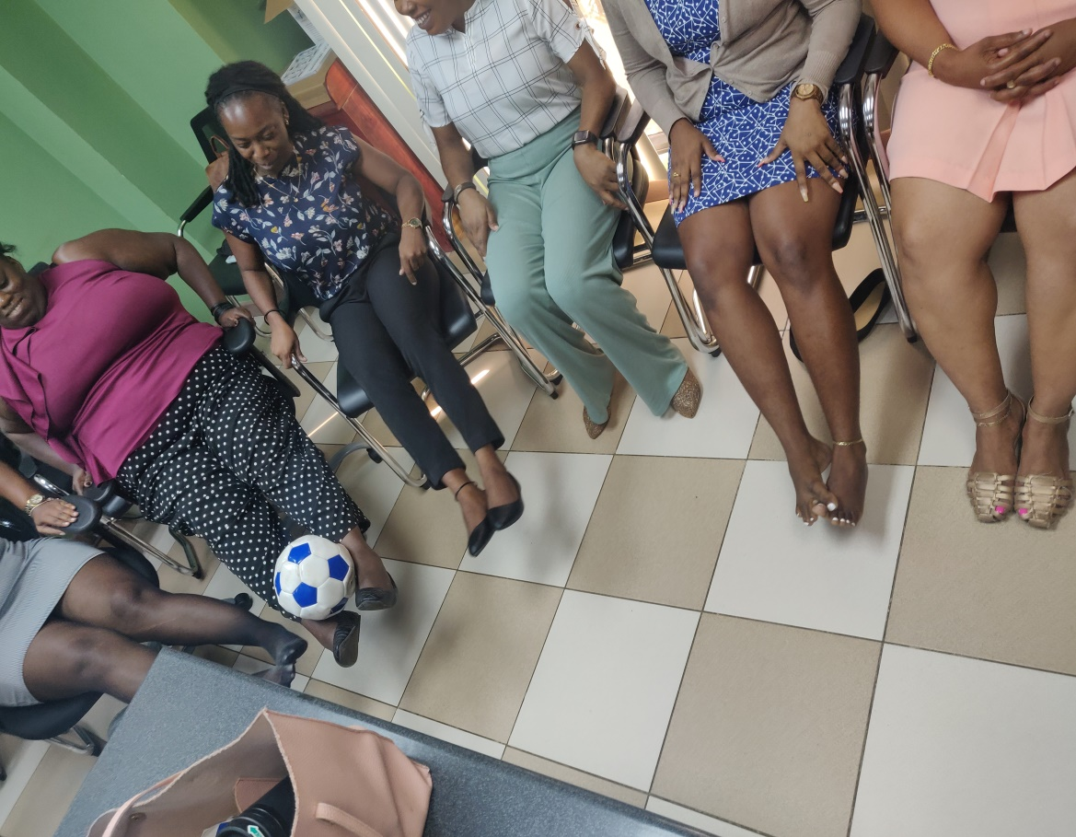

The ball represents the student and you cannot drop the ball. Students must be handled with care.

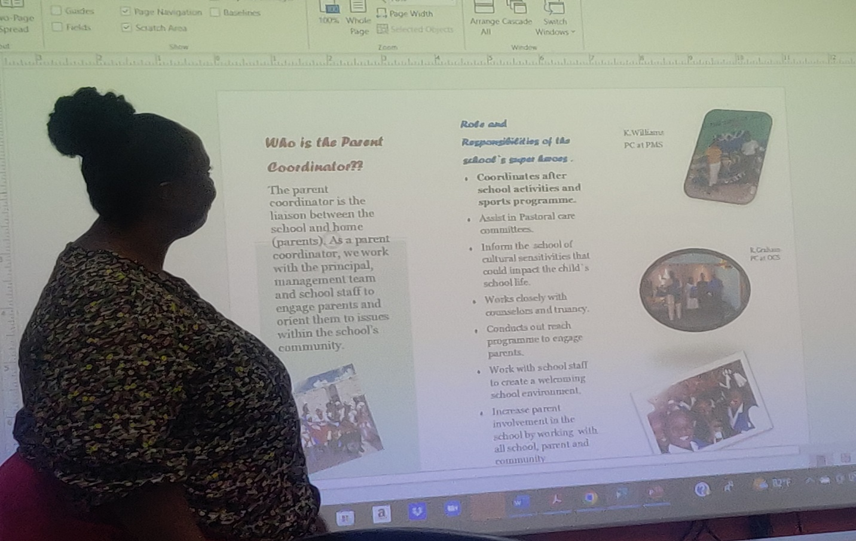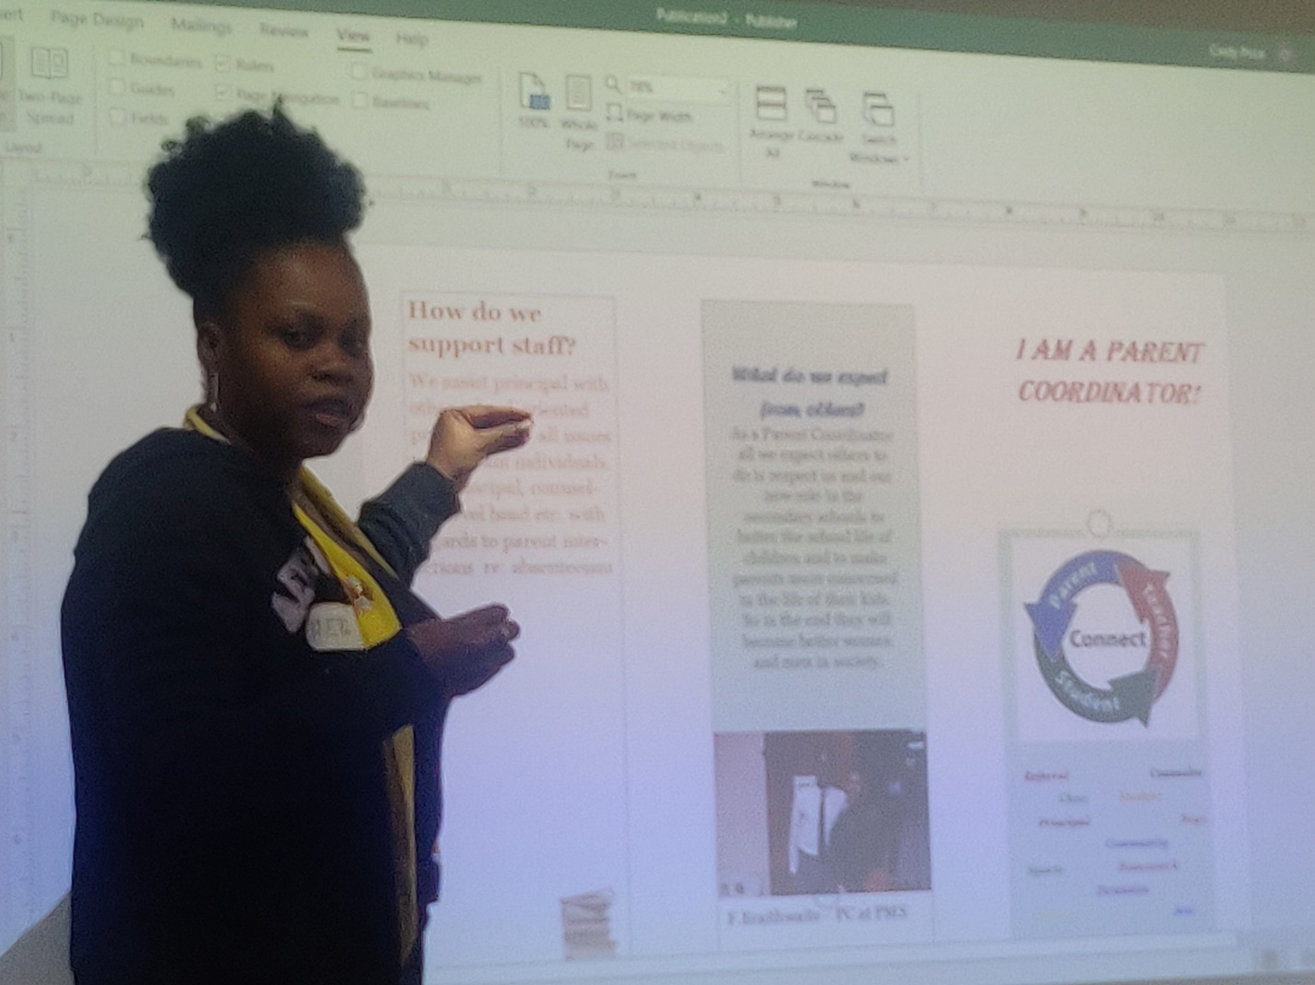

1. **Parent Coordinator Brochure**

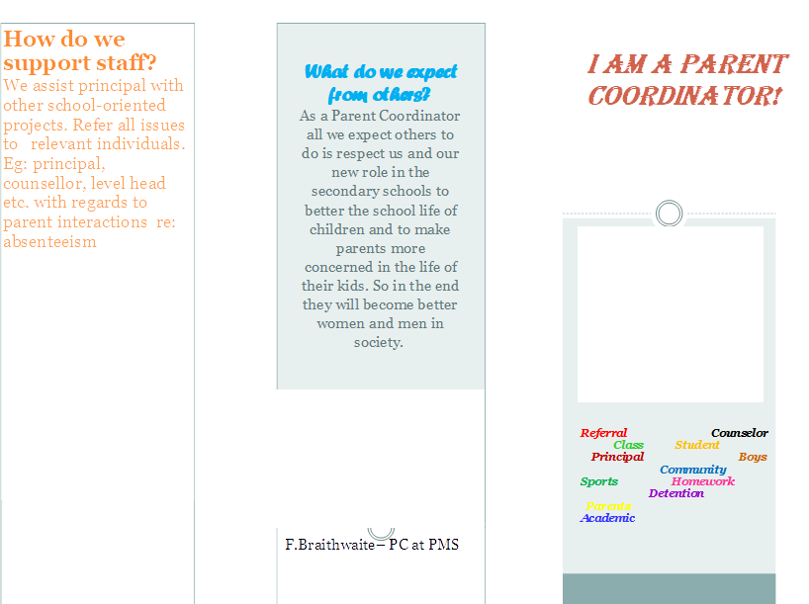

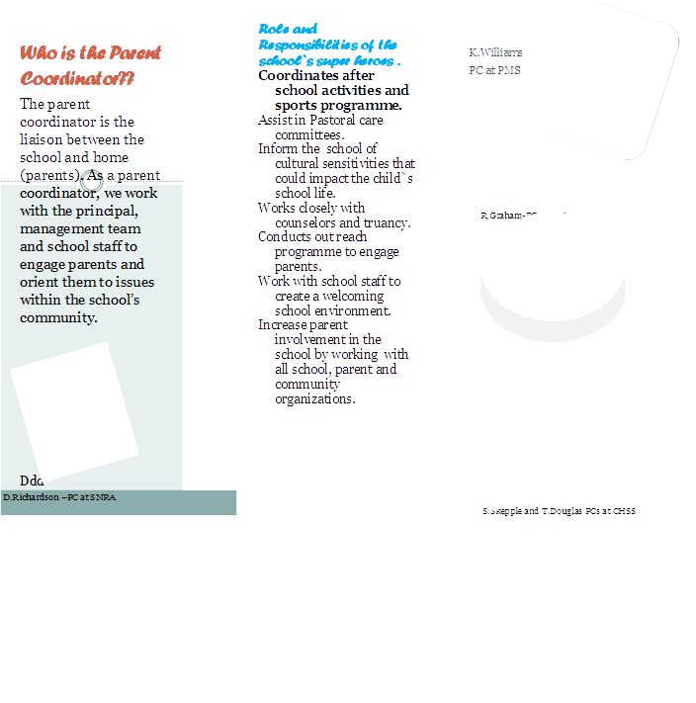

1. **Glimpse of presentations for four weeks sessions**

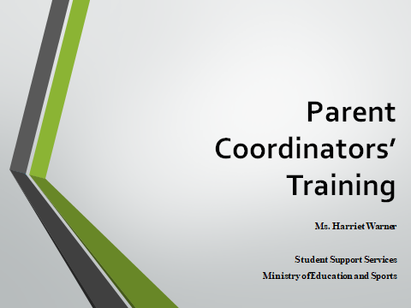 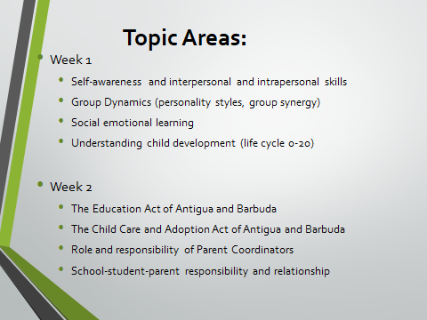

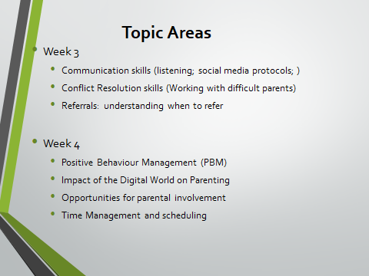 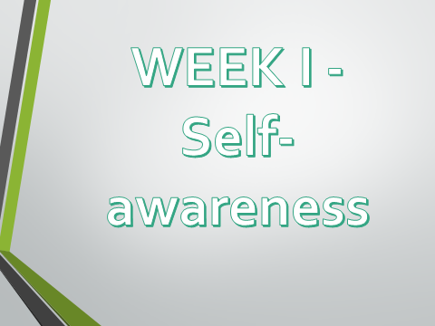

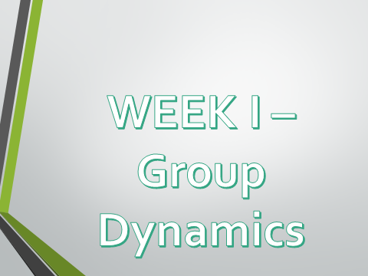 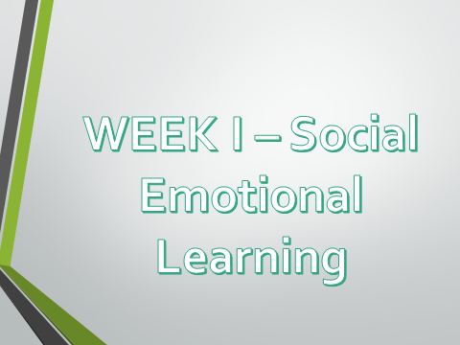

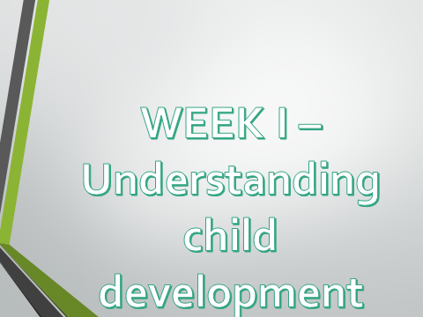

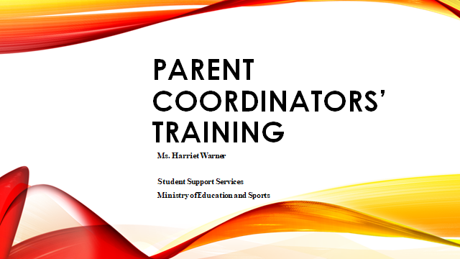

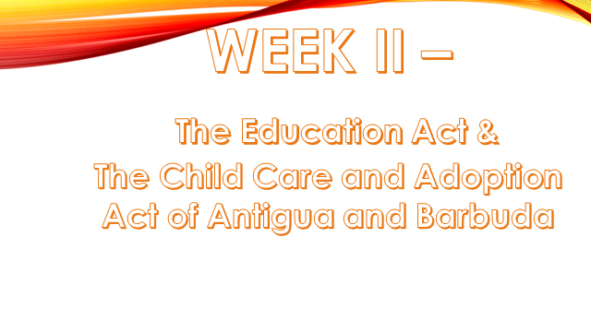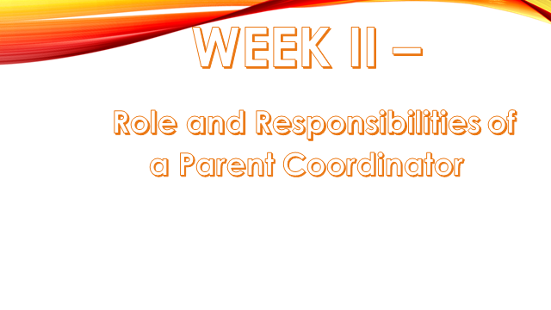

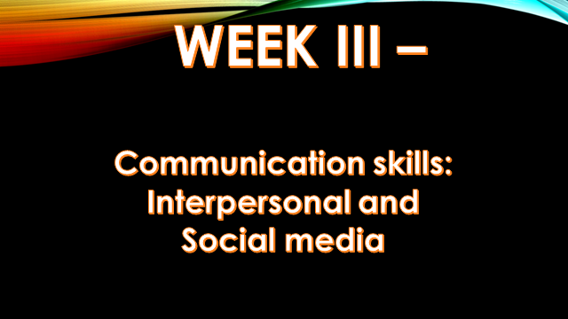

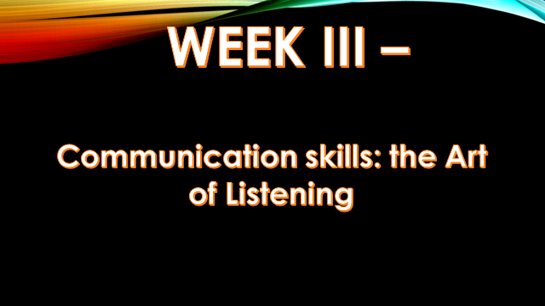

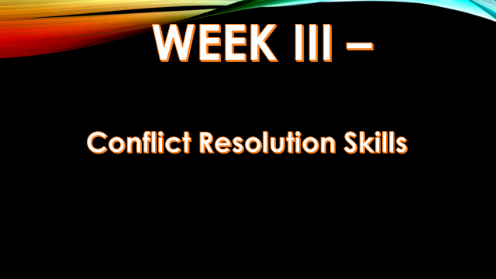

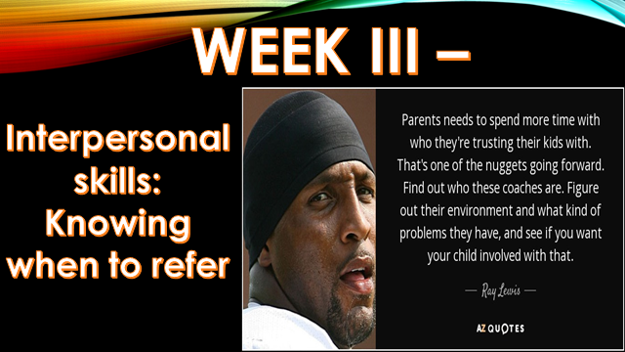

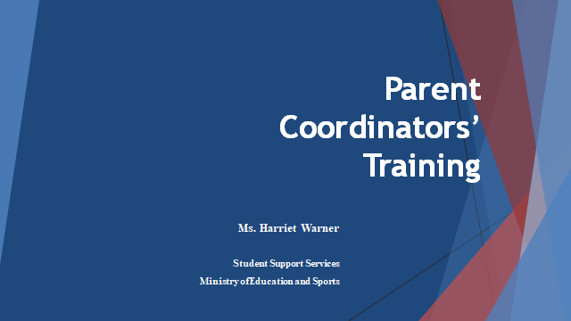

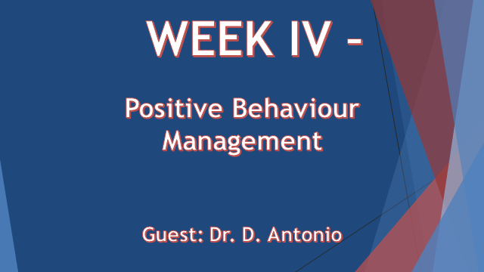

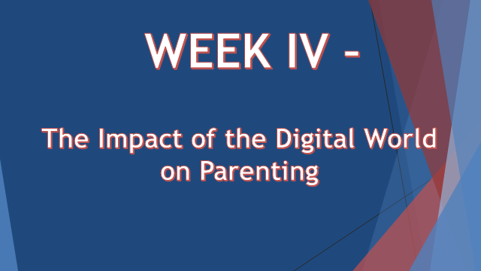

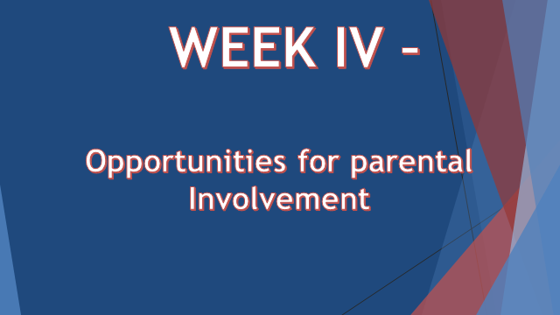

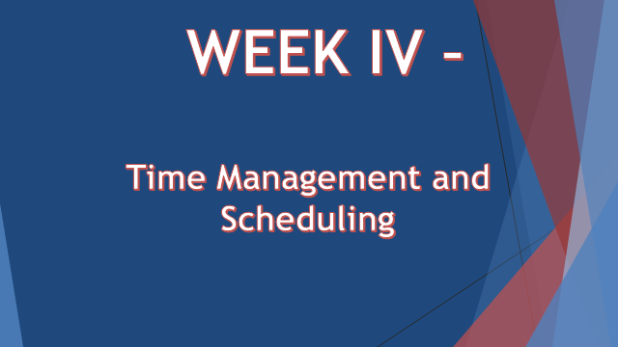

1. **Certificates presented by Permanent Secretary**

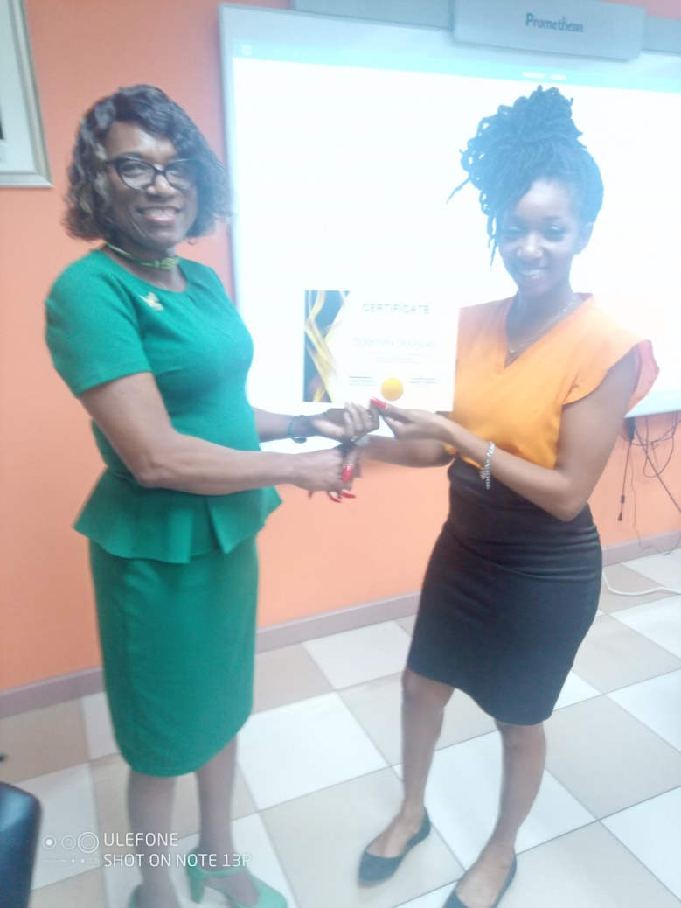

1. **Student Evaluation Form**

STUDENT EVALUATION OF

Internship: Training of Parent Coordinators in Antigua and Barbuda

7th -30th, November 2022.

Instructor: Ms. Harriet Warner

Please rate the following statements: Strongly Agree - 4; Agree - 3; Disagree - 2; strongly Disagree - 1

1. Instructor effectively explained and illustrated training concepts. 4 3 2 1

2. Instructional methodology and tutorial procedures were easy to follow. 4 3 2 1

3. The sessions were carefully planned. 4 3 2 1

4. Examples were relevant and useful. 4 3 2 1

5. Dialogue and support were sufficient to address problem during training. 4 3 2 1

6. I would recommend this training to others. 4 3 2 1

7. The instructor provided helpful comments on applications of the materials.

4 3 2 1

8. The instructor encouraged student’s involvement during sessions. 4 3 2 1

9. Online teaching support were easy to use. 4 3 2 1

10. I would recommend this instructor to others. 4 3 2 1

11. The instructor was knowledgeable in the subject area. 4 3 2 1

12. Overall, the instructor was an effective teacher. 4 3 2 1

13. Instructor internet connection was stable. 4 3 2 1

14. I completed all assignments and expectations on time. 4 3 2 1

15. Your written comments:

16. Recommendations: